Amateur singing benefits speech perception in aging under certain conditions of practice: behavioural and neurobiological mechanisms.

Maxime Perron^{1,2}, Josée Vaillancourt³, Pascale Tremblay^{1, 2}

1. CERVO Brain Research Center, Quebec City, Canada, G1J 2G3
2. Université Laval, Faculté de Médecine, Département de Réadaptation, Quebec City, Canada, G1V 0A6
3. Université Laval, Faculté de Musique, Quebec City, Canada, G1V 0A6

Supplementary Information 1: Descriptive statistics for the SPiN task

Characteristic | Non-singers |  |  |  |  |  | Singers
Characteristic | N | M | SD | Min | Max |  | N | M | SD | Min | Max
Accuracy (%) | 35 | 80.06 | 6.11 | 66.00 | 91.00 |  | 35 | 81.43 | 6.92 | 66.00 | 91.00
d’ | 35 | 1.92 | 0.50 | 0.87 | 2.93 |  | 36 | 2.00 | 0.58 | 0.84 | 2.94
c | 36 | 0.11 | 0.28 | -0.45 | 0.86 |  | 34 | 0.10 | 0.18 | -0.23 | 0.38
RT  (square root transformed) | 36 | 73.48 | 10.56 | 52.75 | 98.49 |  | 34 | 69.74 | 9.70 | 51.01 | 92.27
Notes. M = mean, SD = standard deviation of the mean, N = number of participants per group.

Supplementary Information 2: a and b pathways for accuracy

Summary results for the “a pathways” and “b pathways” for each singing parameter for accuracy: a) a₁ pathway represents the age effect on the ROI anatomy (surface, volume, thickness). b) a₂ pathway represents the effect of singing on the ROI anatomy. c) a₃ pathway represents the Age x Singing interaction on the ROI anatomy. d) b₁ pathway represents the relationship between ROI anatomy and SPiN. e) b₂ represents the effect of singing on SPiN. f) b₃ represents the ROI anatomy x Singing interaction on SPiN. Only significant results are represented in colour.

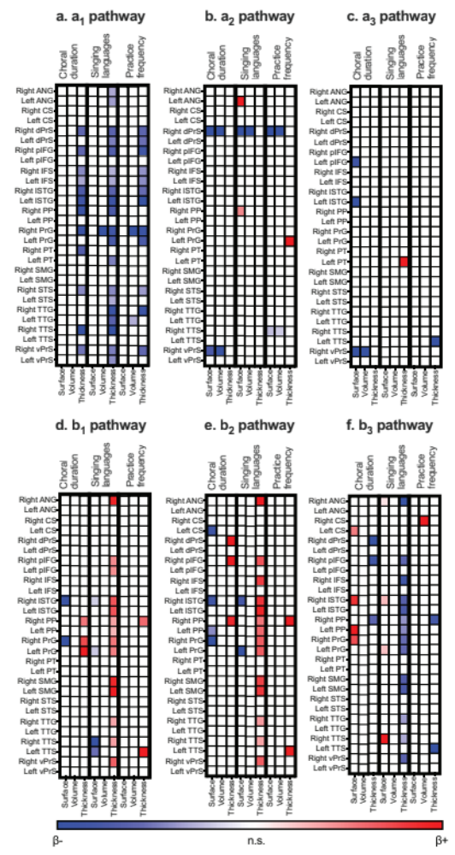
Supplementary Information 3: a and b pathways for sensitivity (d’)

Summary results for the “a pathways” and “b pathways” for each singing parameter for sensitivity (d’): a) a₁ pathway represents the age effect on the ROI anatomy (surface, volume, thickness). b) a₂ pathway represents the effect of singing on the ROI anatomy. c) a₃ pathway represents the Age x Singing interaction on the ROI anatomy. d) b₁ pathway represents the relationship between ROI anatomy and SPiN. e) b₂ represents the effect of singing on SPiN. f) b₃ represents the ROI anatomy x Singing interaction on SPiN. Only significant results are represented in colour.
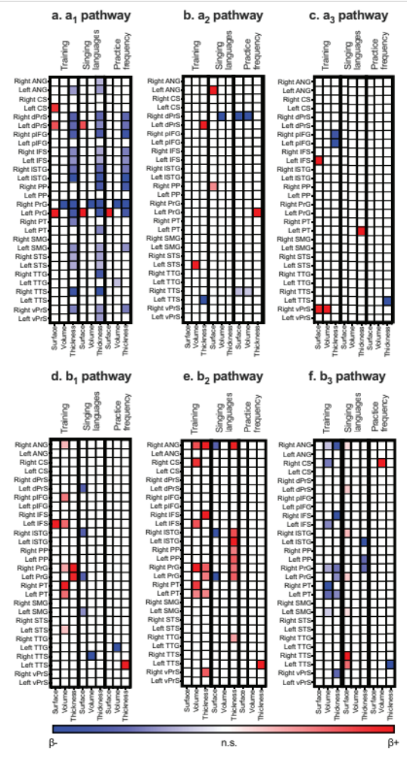

Supplementary Information 4: c’ pathways

Summary results for the age effect on SPiN (direct or c’ pathway) for each singing parameter for (a) accuracy and (b) sensitivity (d’). Only significant results are represented in colour.

