Supplementary Information (SI)

Study area and economic sub-divisions
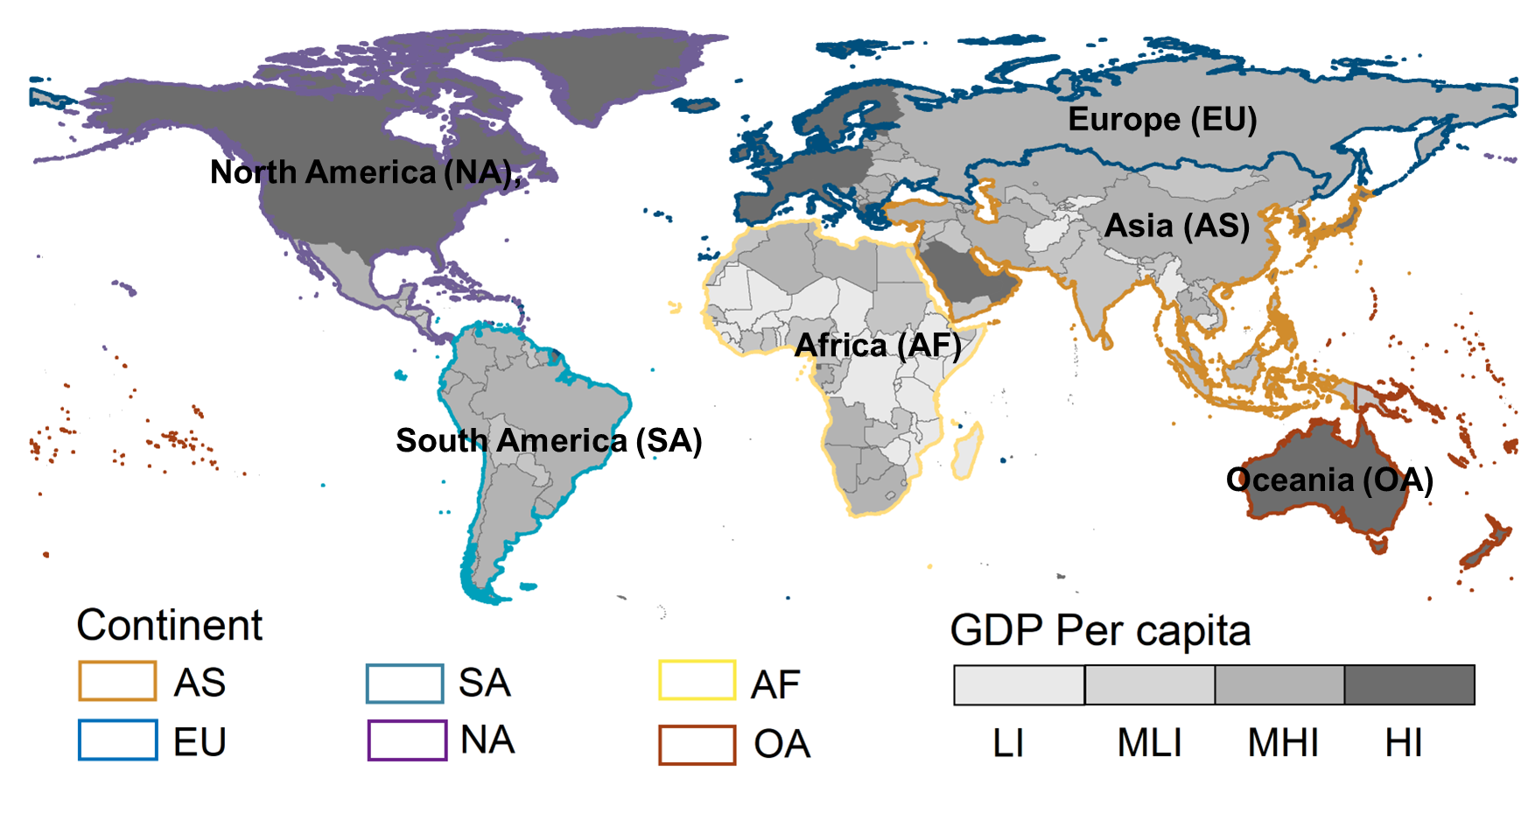
Figure S1 Study areas. The boundaries in different colors indicate the six geographic regions according to physical geography and regional characteristics; the various shades of gray fill in the economic regions according to the World Bank's income grouping criteria for economies.
Table S1 Economic divisions based on World Bank income grouping criteria for economies
Economic subregion | Criteria for division
High-income (HI) countries | GNI per capita > $12,536
Upper middle income (MHI) countries | GNI per capita $4046 - $12,535
Lower middle income (MLI) countries | GNI per capita US$ 1036 - 4045
Low-income (LI) countries | GNI per capita < $1035
Note: GNI stands for Gross National Income.
- Selection of air quality-related sustainable development goals
Managing air pollution is closely tied to the achievement of multiple SDGs. Effective air pollution control policies and practices not only contribute to public health improvement, gender equality, and sustainable economic and social development but also combat climate change, ultimately supporting the overall goals of the sustainable development agenda. The following academic studies provide strong evidence supporting the close link between air quality improvement and the realization of multiple SDG targets.
Table S2 Relationship between air quality and associated SDGs
Air-SDGs | Relationship to air quality
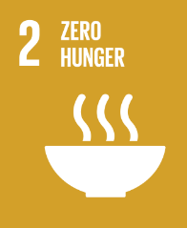 | Air pollution, particularly ozone pollution, has been shown to negatively affect agricultural production. Ozone, as a strong oxidizing agent, can reduce crop yields by inhibiting photosynthesis and damaging plant cells. For example, studies have shown that ozone pollution may reduce global wheat and rice yields¹. This directly threatens food security and contradicts the goals of SDG 2.
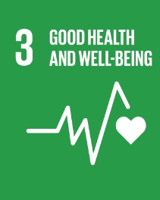 | Air pollution is a major global factor contributing to diseases and premature deaths. Exposure to air pollutants such as particulate matter (PM2.5), nitrogen dioxide (NO2), and ozone (O3) is closely associated with cardiovascular diseases, respiratory illnesses, and premature mortality². Therefore, improving air quality is a core measure to achieve the objectives of SDG 3.
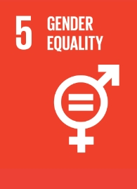 | Air pollution has a significant impact on gender equality. In developing countries, women and children are more exposed to indoor air pollution due to the use of traditional fuels (such as wood and coal), which not only affects their health but also limits their opportunities to engage in other socio-economic activities³. Therefore, promoting the use of clean energy and improving air quality is crucial for advancing gender equality.
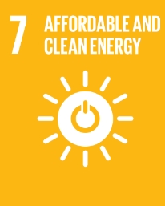 | The development and promotion of clean energy, such as solar and wind power, is a key pathway to reducing air pollution. Studies have shown that the use of traditional fossil fuels is a major source of urban air pollution, especially from transportation and power generation⁴. By transitioning to clean energy, not only can air pollution be reduced, but the impacts of climate change can also be mitigated, aiding in the achievement of SDG 7.
 | Industrial emissions are one of the main sources of air pollution. Through technological innovation and the adoption of cleaner production processes, pollution from industrial activities can be significantly reduced⁵. Additionally, investing in sustainable infrastructure, such as low-emission public transportation systems, can help reduce urban air pollution and achieve the goals of SDG 9.
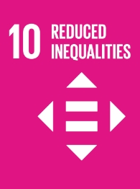 | The impacts of air pollution vary significantly across different socio-economic groups. Vulnerable populations often live in more polluted areas, face higher health risks, and typically lack resources to address these risks⁶. Therefore, improving air quality, particularly in low-income communities, can help reduce social inequalities.
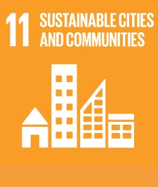 | Air pollution is particularly severe in urban areas. During urbanization, transportation, industrial, and construction activities are major sources of pollution. By promoting low-emission vehicles, enhancing building energy efficiency, and improving urban planning, urban air pollution can be effectively reduced, thereby improving the quality of life for urban residents⁷.
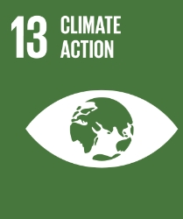 | There is a complex interplay between air pollution and climate change. For example, short-lived climate pollutants like black carbon are major air pollutants that also contribute significantly to global warming⁸. By reducing emissions of these pollutants, both air quality and climate change can be improved, achieving the dual goals of SDG 13.
- Spatial distribution of all-cause mortality attributed to PM2.5 pollution
Fig.4 details the spatial characteristics of all-cause deaths attributed to PM_{2.5} pollution globally. Overall, during the study period, an average of approximately 16,530 people per year died from PM_{2.5} exposure, with an average rate of change of 0.06. Spatially, the number of premature deaths due to PM_{2.5} exposure significantly decreased in OA (-103.9 number/yr), EU (-165.1 number/yr), and NA (-50.0 number/yr) countries. In contrast, Asia (1477.0 number/yr), Africa (127.2 number/yr), and South America (65.4 number/yr) are still regions where the population of premature deaths due to PM_{2.5} exposure is rapidly increasing. Particularly, China in East Asia (32,678.9 number/yr), India in South Asia (26,260.2 number/yr), Pakistan (3,208.2 number/yr), and Indonesia in Southeast Asia (2,311.6 number/yr) are the countries with the fastest growth in premature deaths due to PM_{2.5} exposure. Similar to the spatial distribution of exposure risk, health risks caused by PM_{2.5} exposure also show significant regional inequalities across economic zones. During the study period, the number of all-cause deaths due to PM_{2.5} in HI regions significantly decreased (-130.3 number/yr), while in MLI, MHI, and LI regions, the number of all-cause deaths due to PM_{2.5} continuously increased at rates of 766.4 number/yr, 554.6 number/yr, and 105.8 number/yr, respectively. Notably, China in the MHL region and India in the ML region are among the global leaders in the rate of change in all-cause deaths due to PM_{2.5}.
Figure S2 shows the spatial distribution of all-cause mortality attributed to PM_{2.5} pollution. (a)The spatial distribution of global all-cause mortality trends attributed to PM_{2.5} pollution from 2000 - 2019; (b)- (e)show the temporal changes in all-cause mortality attributed to PM_{2.5} pollution from 2000 - 2019 for HI (b), LI (c), MHI (d), MLI (e).
- Spatial heterogeneity in global population-weighted concentrations of PM_{2.5} (PWAC)
Figure S3 illustrates the spatiotemporal patterns of global PWAC. Over 30% of the global regions exhibit PWAC levels exceeding 25 μg/m³, predominantly concentrated in Asia and Africa. Specifically, 65% of Africa and over 36% of Asia fall within this concentration range. Correspondingly, the proportion of low-income and lower-middle-income regions within this range is also the highest, at 76% and 63%, respectively. In contrast, Oceania, North America, and Europe each have less than 5% of areas within this PWAC concentration range, resulting in the lowest proportion observed in high-income regions, at 8.5%.The regional distribution of multi-year average PWAC shows similar disparities. Africa and Asia have the highest multi-year average PWAC, at 33.2 μg/m³ and 22.7 μg/m³, respectively, while Oceania, North America, and Europe have the lowest, at 5.8 μg/m³, 7.9 μg/m³, and 12.3 μg/m³, respectively. The multi-year average PWAC is highest in low-income and lower-middle-income regions, at 36.9 μg/m³ and 33.2 μg/m³, respectively, while high-income regions exhibit the lowest average, at 12.3 μg/m³.
Figure S3: Spatiotemporal characteristics of global PWAC from 2000-2019. (a)Spatiotemporal characteristics of global PWAC from 2000-2019; (b)Temporal trends of PWAC for different income levels from 2000-2019; (c)Temporal trends of PWAC for different continents from 2000-2019.

References
- Van Dingenen, R., Dentener, F. J., Raes, F., Krol, M. C., Emberson, L., & Cofala, J. (2009). The global impact of ozone on agricultural crop yields under current and future air quality legislation. Atmospheric Environment, 43(3), 604-618.
- Cohen, A. J., Brauer, M., Burnett, R., Anderson, H. R., Frostad, J., Estep, K., ... & Forouzanfar, M. H. (2017). Estimates and 25-year trends of the global burden of disease attributable to ambient air pollution: an analysis of data from the Global Burden of Diseases Study 2015. The Lancet, 389(10082), 1907-1918.
- Smith, K. R., Bruce, N., Balakrishnan, K., Adair-Rohani, H., Balmes, J., Chafe, Z., ... & Rehfuess, E. (2013). Millions dead: how do we know and what does it mean? Methods used in the comparative risk assessment of household air pollution. Annual Review of Public Health, 35, 185-206.
- Shindell, D., Faluvegi, G., Koch, D. M., Schmidt, G. A., Unger, N., & Bauer, S. E. (2012). Improved attribution of climate forcing to emissions. Science, 326(5953), 716-718.
- Ramanathan, V., & Feng, Y. (2009). Air pollution, greenhouse gases and climate change: Global and regional perspectives. Atmospheric Environment, 43(1), 37-50.
- Clark, L. P., Millet, D. B., & Marshall, J. D. (2014). National patterns in environmental injustice and inequality: Outdoor NO2 air pollution in the United States. PLOS One, 9(4), e94431.
- World Health Organization (WHO). (2016). Ambient air pollution: A global assessment of exposure and burden of disease. World Health Organization.
- Bond, T. C., Doherty, S. J., Fahey, D. W., Forster, P. M., Berntsen, T., DeAngelo, B. J., ... & Zender, C. S. (2013). Bounding the role of black carbon in the climate system: A scientific assessment. Journal of Geophysical Research: Atmospheres, 118(11), 5380-5552.

