Supplementary file - Effect of eicosapentaneoic acid on innate immune responses in Atlantic salmon cells infected with infectious salmon anemia virus
Ingrid Holmlund, Samira Ahmadi, Bente Ruyter, Tone-Kari Knutsdatter Østbye, Marta Bou and Tor Gjøen
September 09, 2024
This supplementary file provides sample information and exploratory plots for the manuscript “Effect of eicosapentaneoic acid on innate immune responses in Atlantic salmon cells infected with infectious salmon anemia virus”. It shows the results from the fatty acid analysis and RNAseq count data distributions, replicate correlations and sample clustering. The analysis has been performed using the R statistical programming language and R BioConductor packages (a complete list is given in the bottom of the document (Session info)). This supplementary file was generated using the knitr R package under Windows 10.

Figure S1
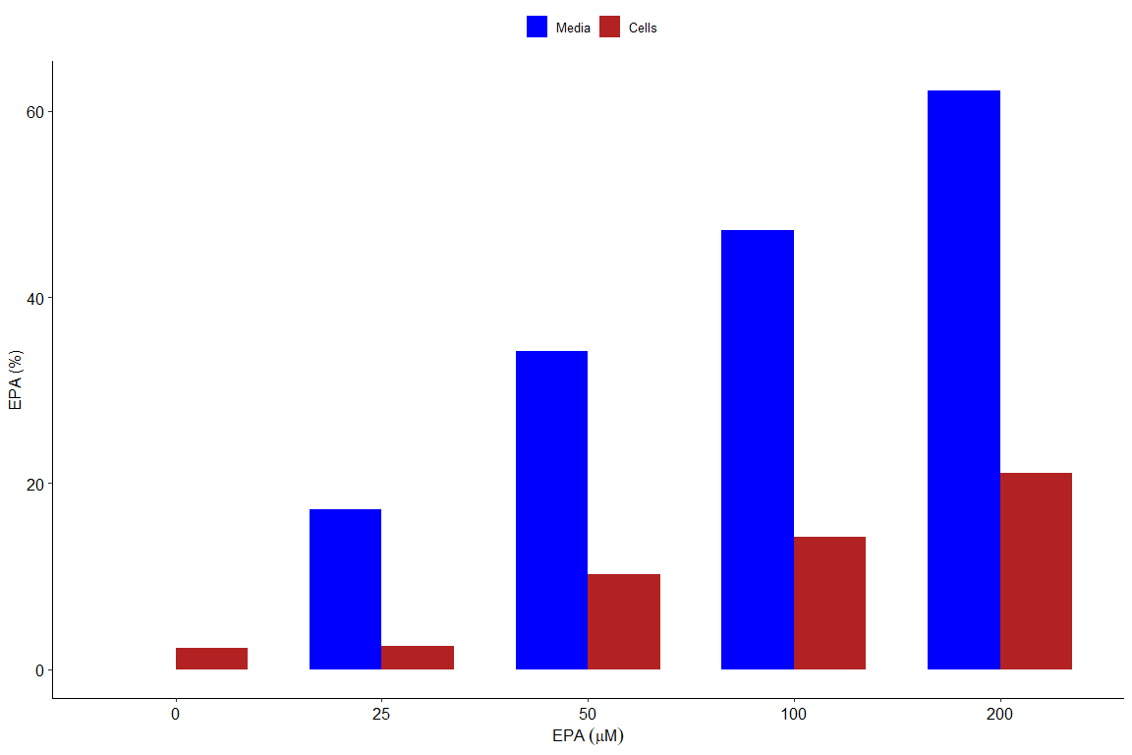
Barplot display of EPA (%) in media and cells. The Folch method was used to extract the total lipids of cells and cell media after one week of cultivation. Increasing levels of EPA added to the media affects both the media and cell fatty acid composition.

Figure S2
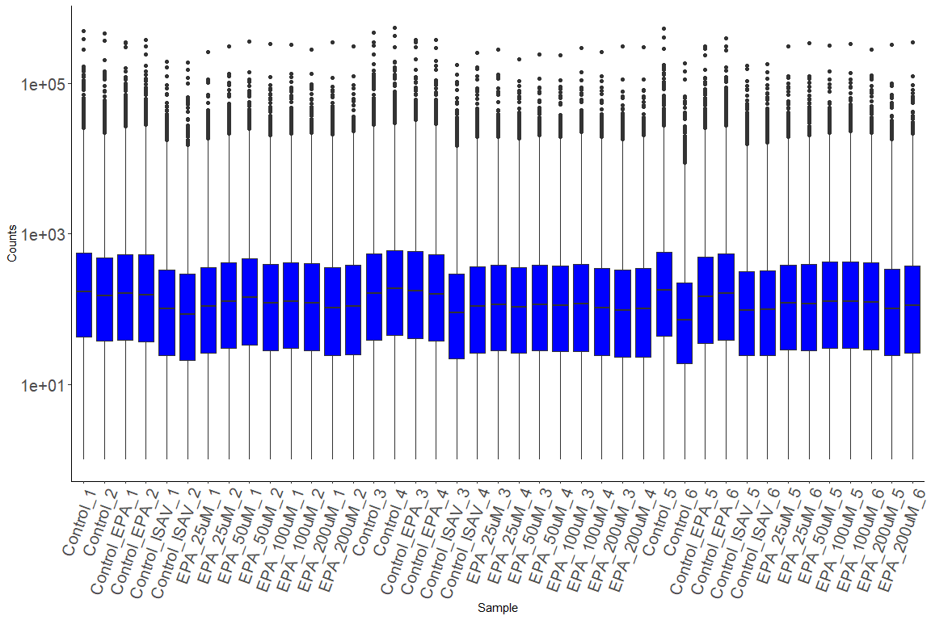
Boxplot display of the distribution of counts in each sample. Mean and variance were comparable in all samples.

Figure S3
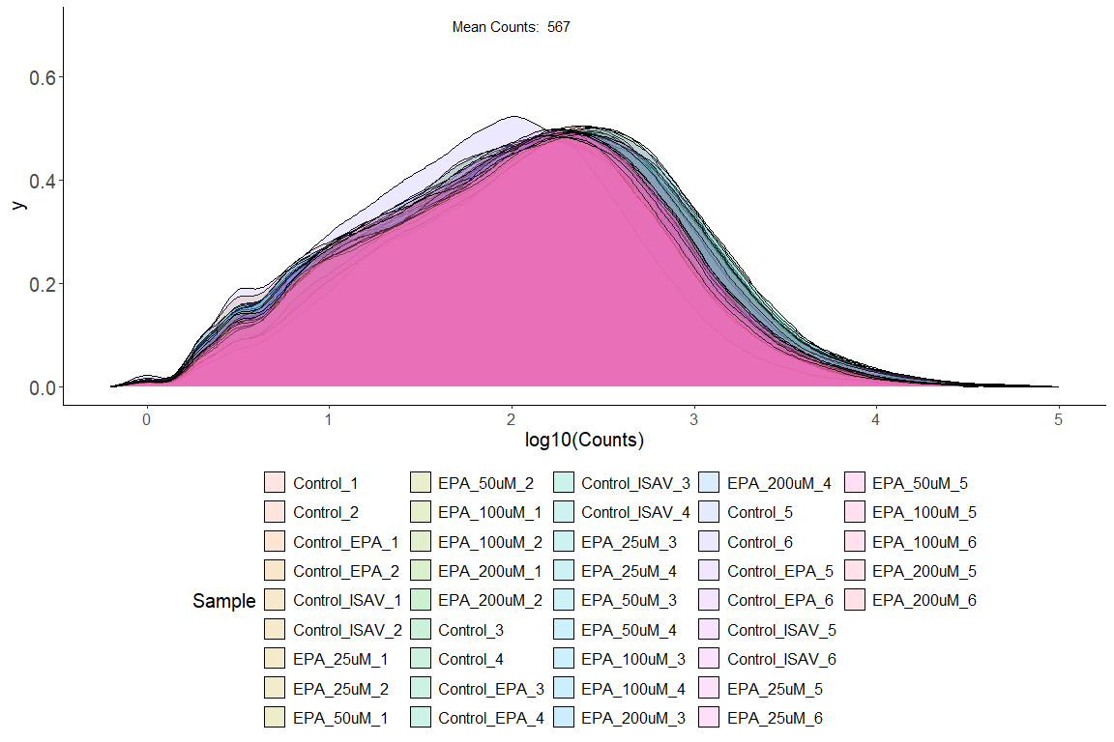
Density plot comparing the distribution of log10 raw counts in each sample.

Figure S4
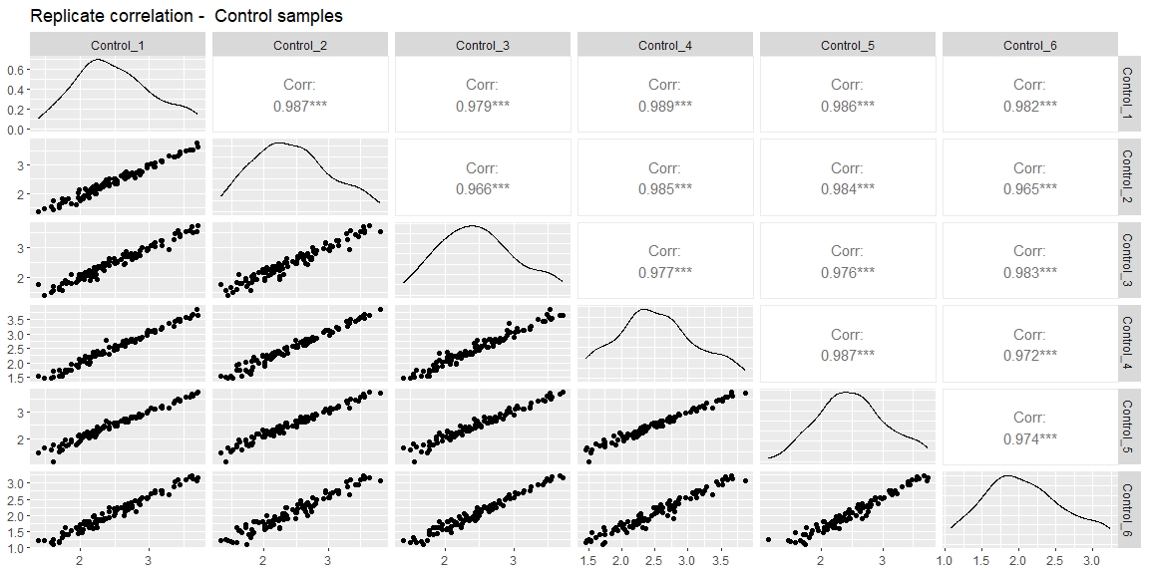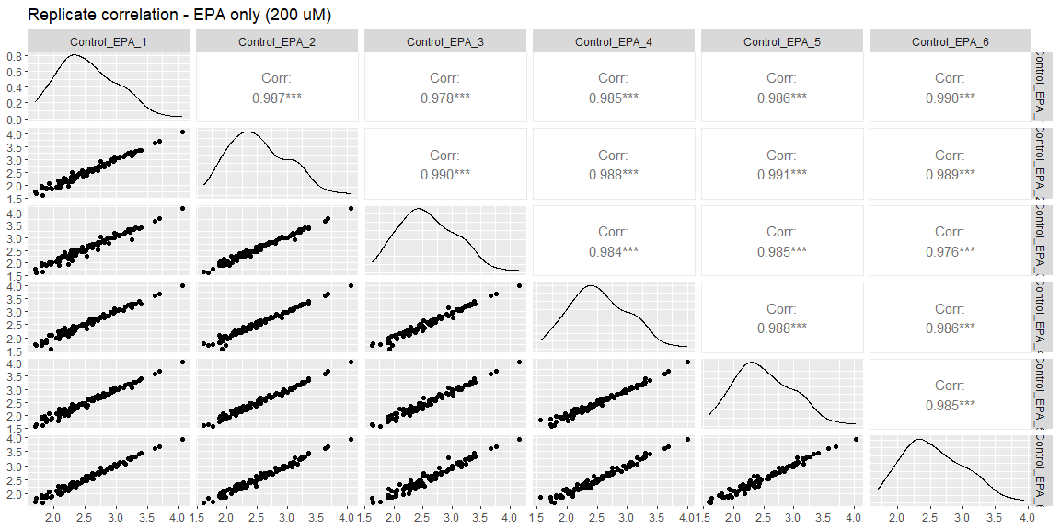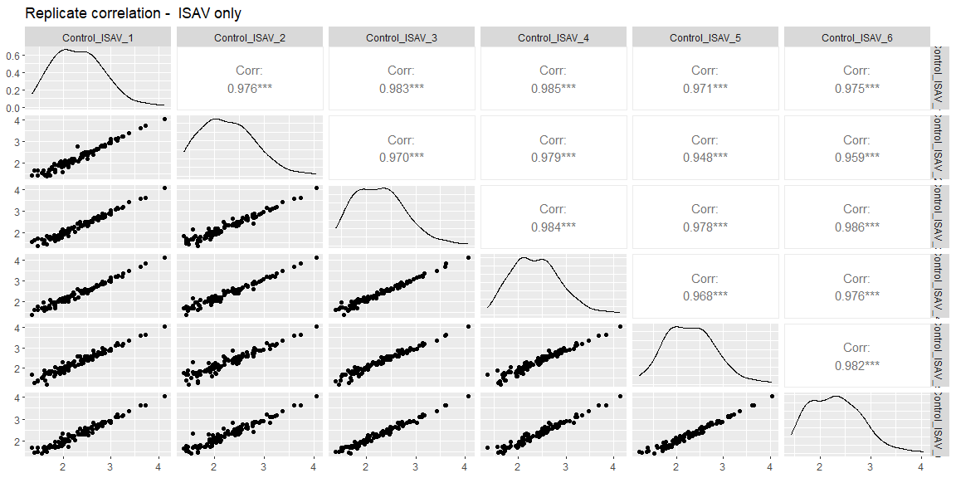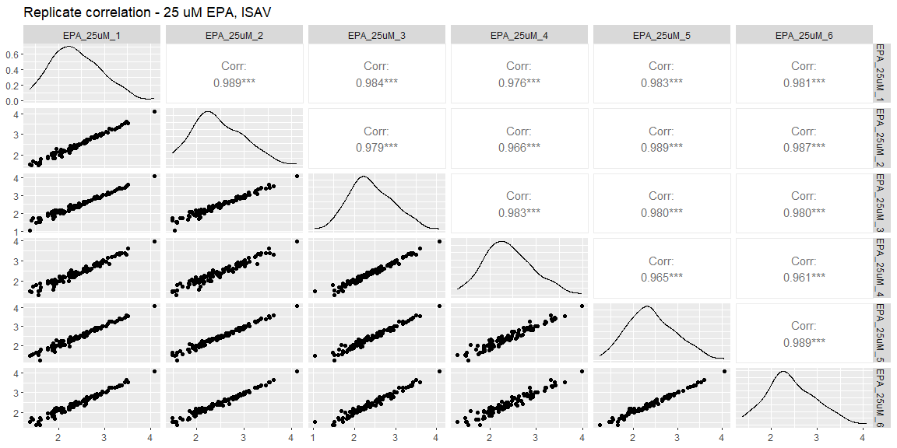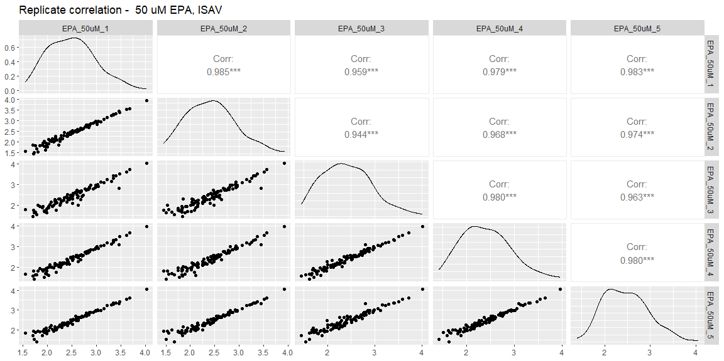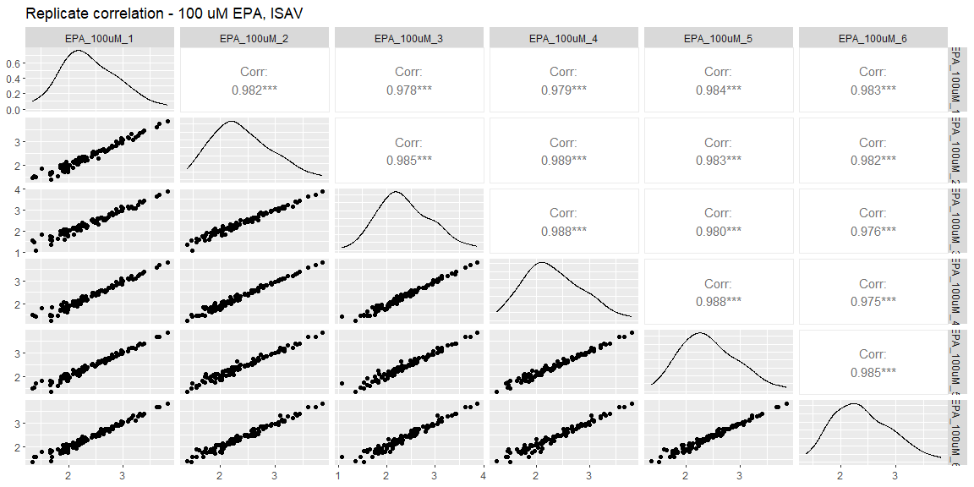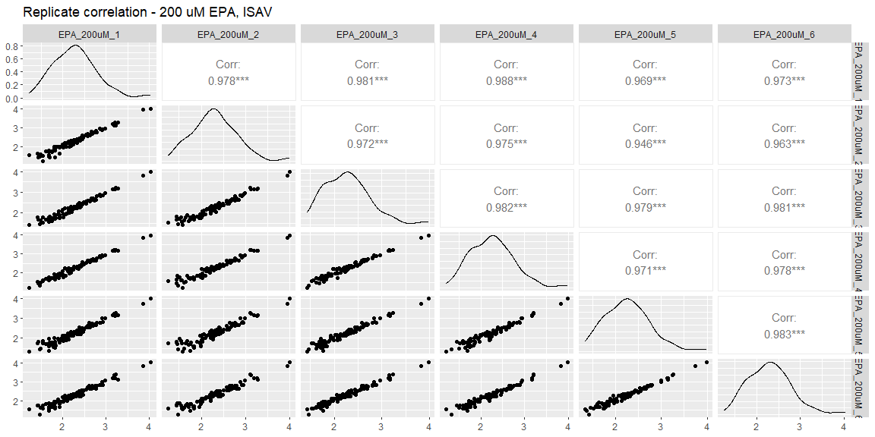
Plots showing sample data correlation between 100 randomly selected genes with at least 10 counts in all samples for each experimental group. The panels along the diagonal display the density distribution of counts in the selected samples, and the right side of the panel shows the Pearson correlation coefficient for each sample pair.

Figure S5
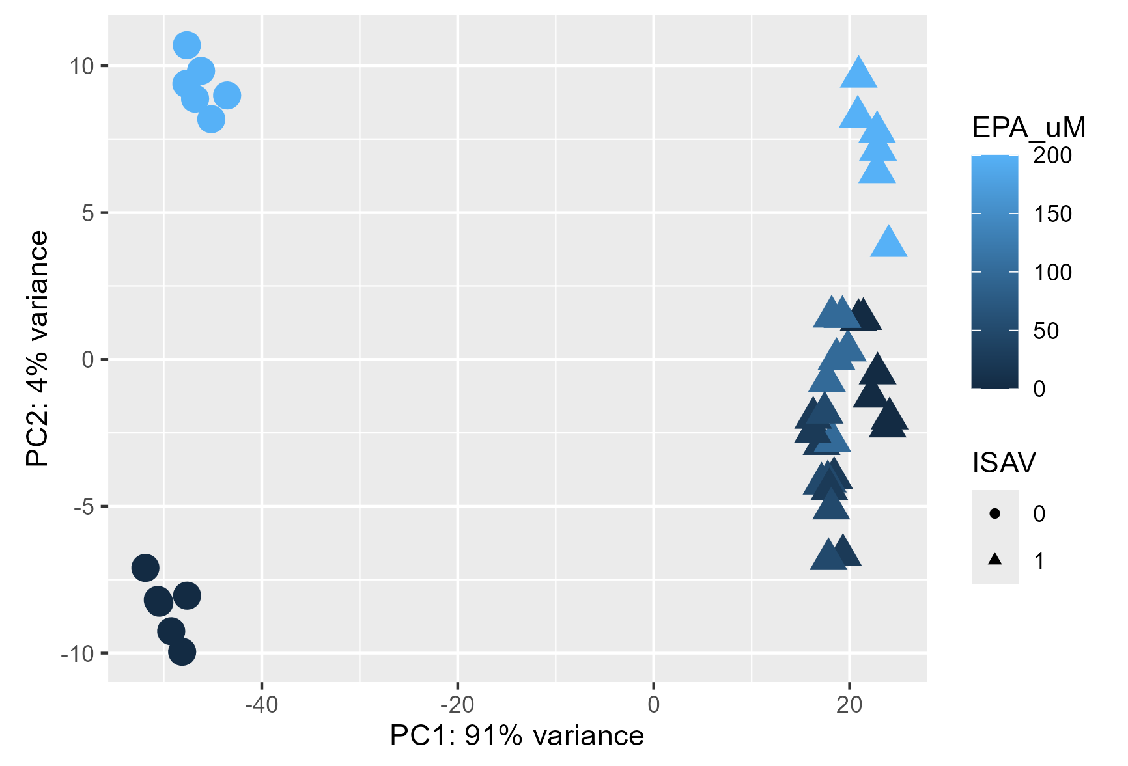
Principal component analysis of VST transformed gene expression values (50 most variable genes) shows that most of the variation in gene expression could be assigned to ISAV. The level of EPA also contributes to variation in the dataset.

Figure S6
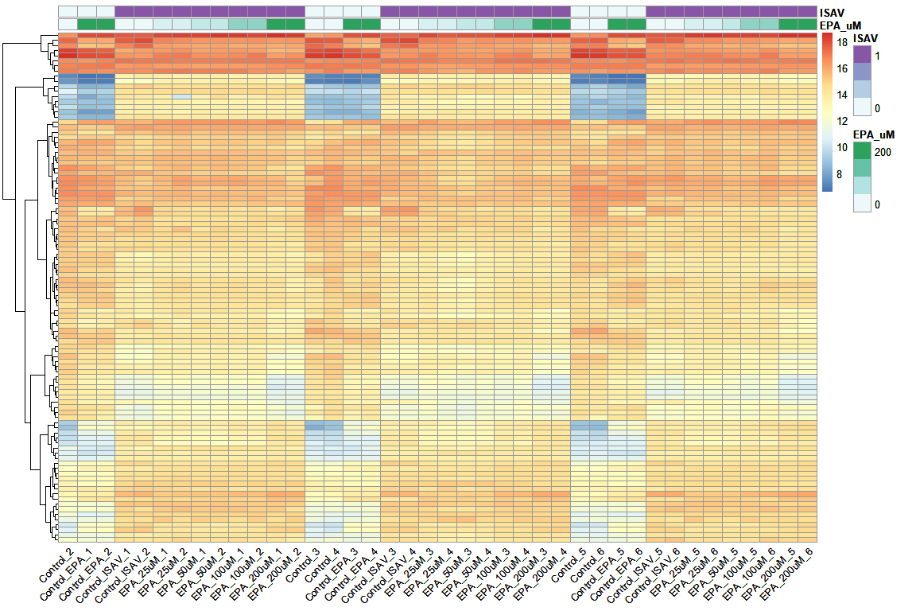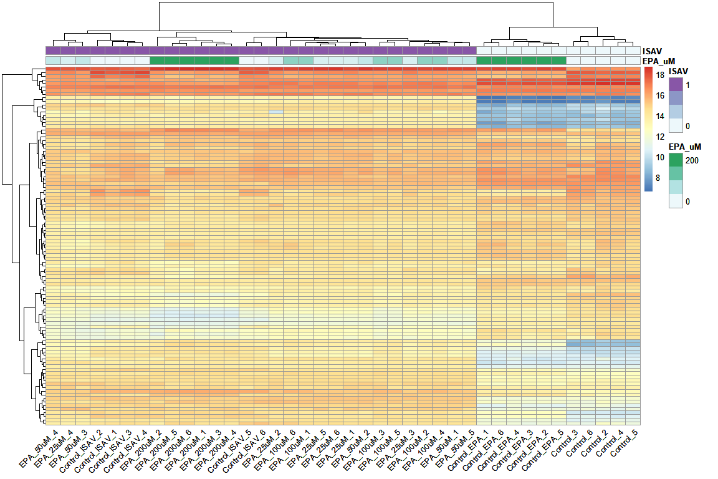
Hierarchical clustering heatmap (euclidian distance) of VST transformed counts from the 100 most variable genes. Upper panel shows clustering of genes into mainly two groups (sensitive to ISAV). Lower panel also clusters samples into mainly two groups affected by ISAV.

Figure S7
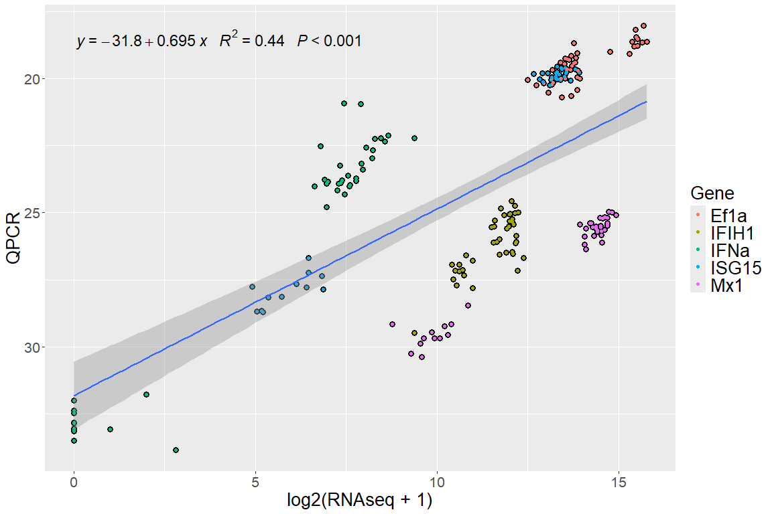
Correlation between qPCR (Ct values) and RNAseq (log2( count+1)) analyses of Atlantic salmon head kidney cells incubated with or without ISAV.

Session information with list of R packages
## R version 4.3.2 (2023-10-31 ucrt)
## Platform: x86_64-w64-mingw32/x64 (64-bit)
## Running under: Windows 10 x64 (build 19045)
##
## Matrix products: default
##
##
## locale:
## [1] LC_COLLATE=Norwegian Bokmål_Norway.utf8
## [2] LC_CTYPE=Norwegian Bokmål_Norway.utf8
## [3] LC_MONETARY=Norwegian Bokmål_Norway.utf8
## [4] LC_NUMERIC=C
## [5] LC_TIME=Norwegian Bokmål_Norway.utf8
##
## time zone: Europe/Oslo
## tzcode source: internal
##
## attached base packages:
## [1] stats4 stats graphics grDevices utils datasets methods
## [8] base
##
## other attached packages:
## [1] ggpmisc_0.5.6 ggpp_0.5.7
## [3] ggsignif_0.6.4 data.table_1.14.10
## [5] polynom_1.4-1 pheatmap_1.0.12
## [7] readr_2.1.5 ggpubr_0.6.0
## [9] readxl_1.4.3 png_0.1-8
## [11] pander_0.6.5 drc_3.0-1
## [13] MASS_7.3-60.0.1 DESeq2_1.40.2
## [15] SummarizedExperiment_1.30.2 Biobase_2.60.0
## [17] MatrixGenerics_1.12.3 matrixStats_1.2.0
## [19] GenomicRanges_1.52.0 GenomeInfoDb_1.36.4
## [21] IRanges_2.34.1 S4Vectors_0.38.1
## [23] BiocGenerics_0.46.0 genefilter_1.82.1
## [25] factoextra_1.0.7 GGally_2.2.1
## [27] dplyr_1.1.4 kableExtra_1.4.0
## [29] tidyr_1.3.1 reshape2_1.4.4
## [31] ggplot2_3.5.1
##
## loaded via a namespace (and not attached):
## [1] RColorBrewer_1.1-3 rstudioapi_0.15.0 magrittr_2.0.3
## [4] TH.data_1.1-2 farver_2.1.1 rmarkdown_2.25
## [7] zlibbioc_1.46.0 vctrs_0.6.5 memoise_2.0.1
## [10] RCurl_1.98-1.14 rstatix_0.7.2 htmltools_0.5.7
## [13] S4Arrays_1.0.5 plotrix_3.8-4 broom_1.0.5
## [16] cellranger_1.1.0 plyr_1.8.9 sandwich_3.1-0
## [19] zoo_1.8-12 cachem_1.0.8 lifecycle_1.0.4
## [22] pkgconfig_2.0.3 Matrix_1.6-5 R6_2.5.1
## [25] fastmap_1.1.1 GenomeInfoDbData_1.2.10 digest_0.6.34
## [28] colorspace_2.1-0 AnnotationDbi_1.62.2 confintr_1.0.2
## [31] RSQLite_2.3.4 labeling_0.4.3 fansi_1.0.6
## [34] httr_1.4.7 abind_1.4-5 mgcv_1.9-0
## [37] compiler_4.3.2 bit64_4.0.5 withr_2.5.2
## [40] backports_1.4.1 BiocParallel_1.34.2 carData_3.0-5
## [43] DBI_1.2.1 ggstats_0.5.1 highr_0.10
## [46] quantreg_5.97 DelayedArray_0.26.7 gtools_3.9.5
## [49] tools_4.3.2 glue_1.7.0 nlme_3.1-163
## [52] grid_4.3.2 generics_0.1.3 gtable_0.3.4
## [55] tzdb_0.4.0 hms_1.1.3 xml2_1.3.6
## [58] car_3.1-2 utf8_1.2.4 XVector_0.40.0
## [61] ggrepel_0.9.5 pillar_1.9.0 stringr_1.5.1
## [64] vroom_1.6.5 splines_4.3.2 lattice_0.22-5
## [67] survival_3.5-7 bit_4.0.5 annotate_1.78.0
## [70] SparseM_1.81 tidyselect_1.2.0 locfit_1.5-9.8
## [73] Biostrings_2.68.1 knitr_1.45 svglite_2.1.3
## [76] xfun_0.41 stringi_1.8.3 yaml_2.3.8
## [79] evaluate_0.23 codetools_0.2-19 tibble_3.2.1
## [82] cli_3.6.2 xtable_1.8-4 systemfonts_1.0.5
## [85] munsell_0.5.0 Rcpp_1.0.12 XML_3.99-0.16
## [88] parallel_4.3.2 MatrixModels_0.5-3 blob_1.2.4
## [91] bitops_1.0-7 viridisLite_0.4.2 mvtnorm_1.2-4
## [94] scales_1.3.0 purrr_1.0.2 crayon_1.5.2
## [97] rlang_1.1.3 KEGGREST_1.40.1 multcomp_1.4-25

