Supporting Information for
Discrimination of Quarry Blasts from Micro Earthquakes in the Surendranagar region of Saurashtra Horst, Northwestern India

Contents:
Figures S1 to S3

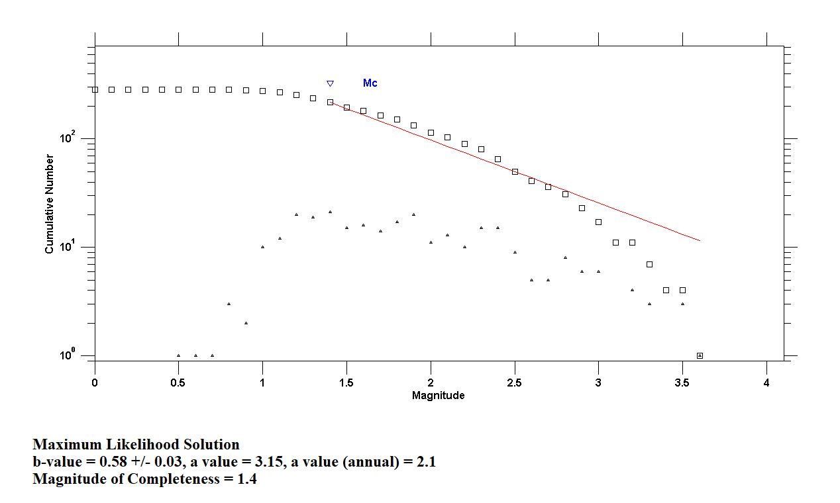

Figure S1: Cumulative (squares) and Non-cumulative frequency-magnitude distribution (triangles) of the Surendranagar catalog and the estimation of completeness magnitude Mc. Red line represents the GR law with a and b value estimated on the base of the completeness magnitude Mc.

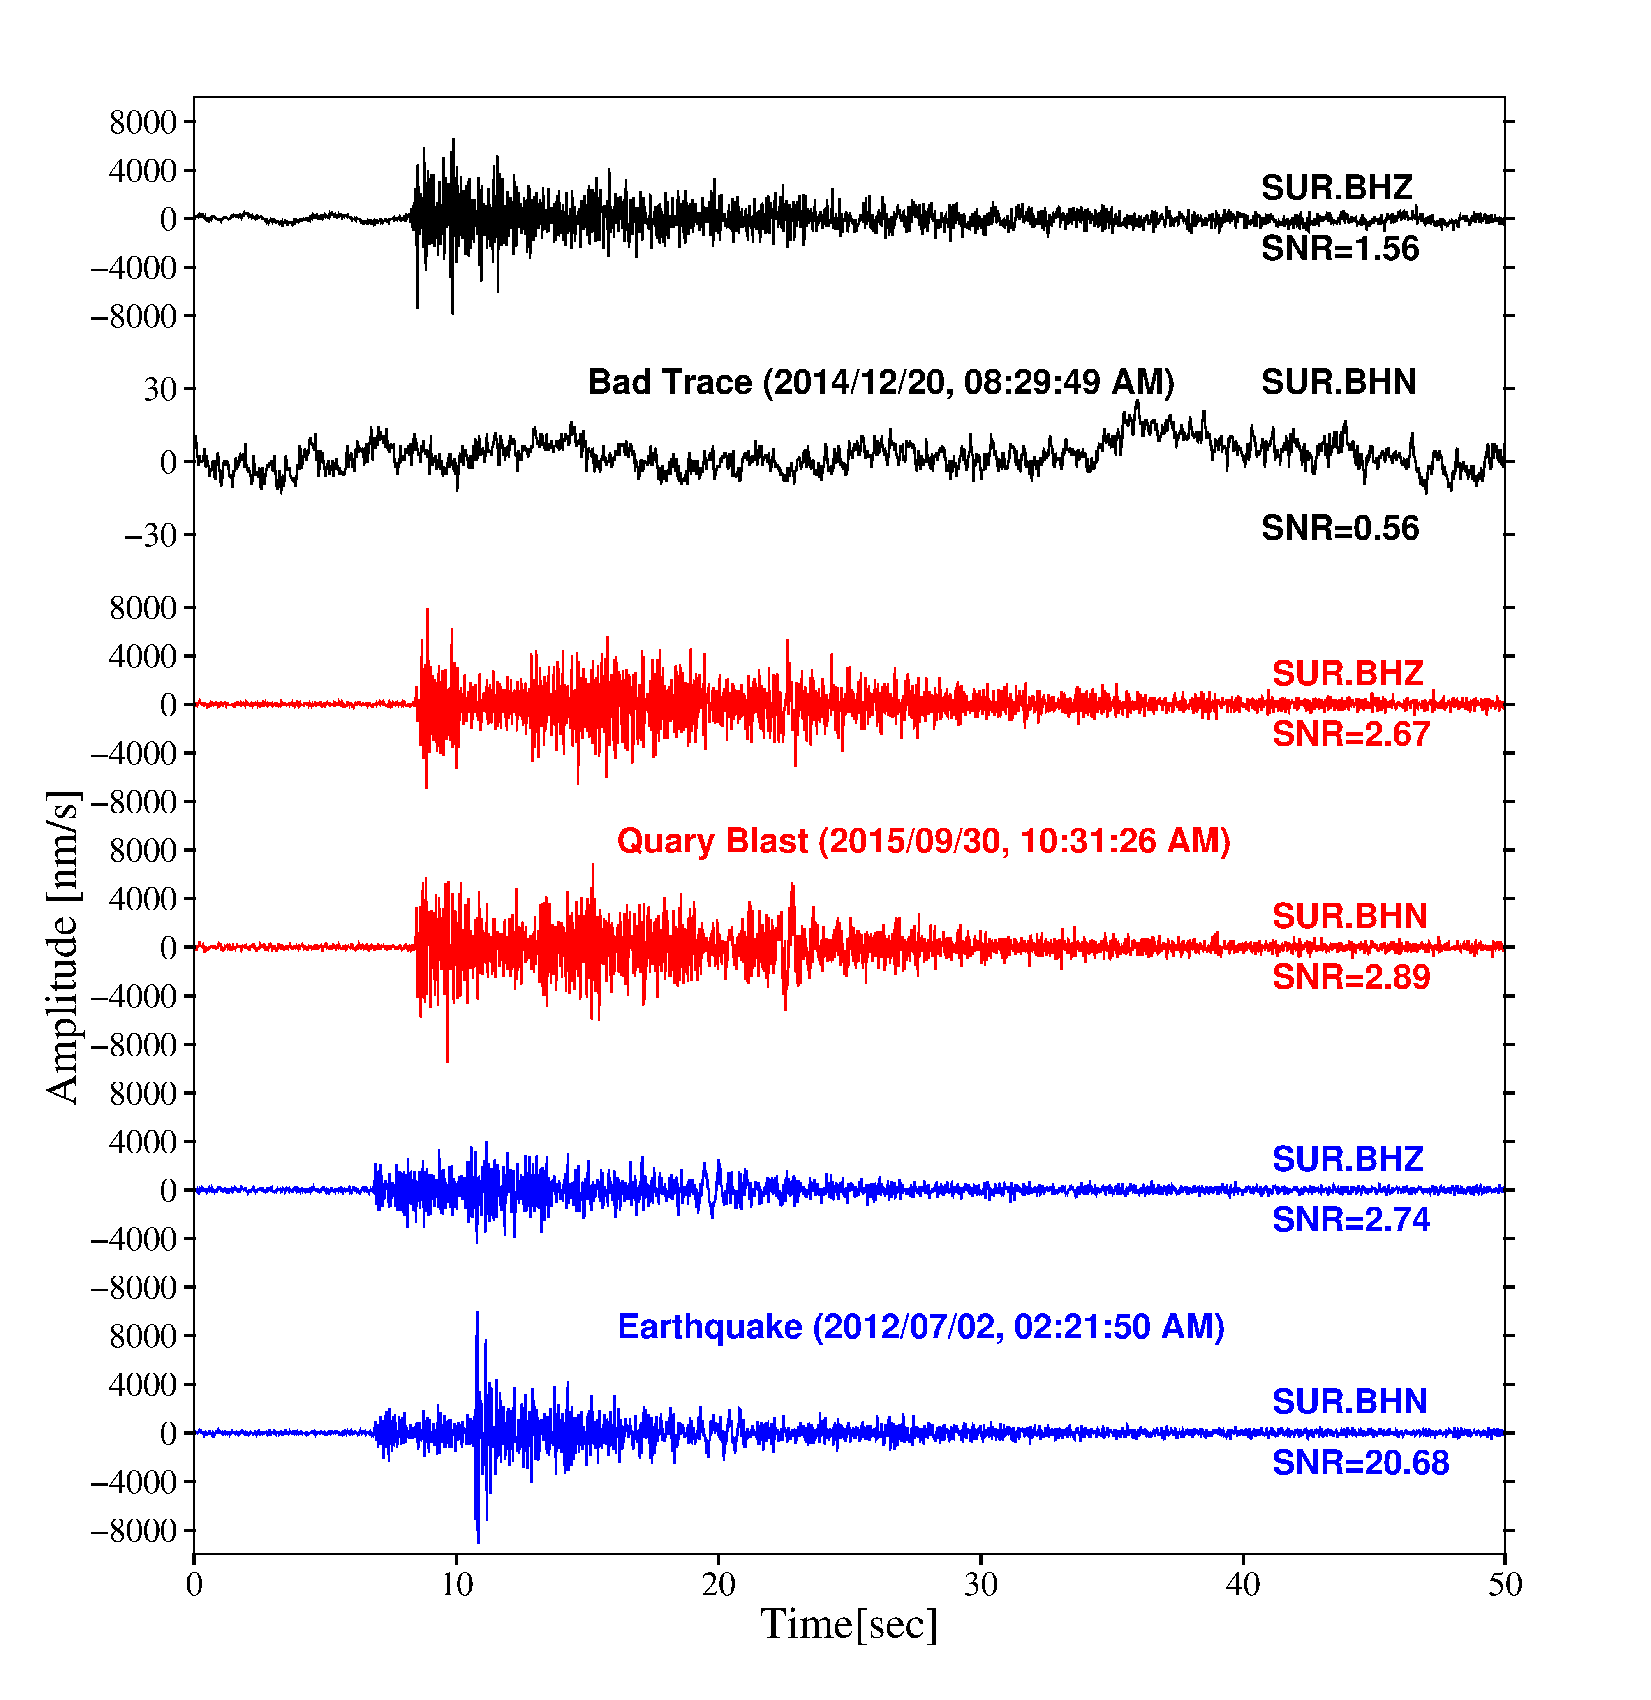

Figure S2: Waveforms with signal to noise ratio (SNR). We rejected those events with SNR lower than 2.0.

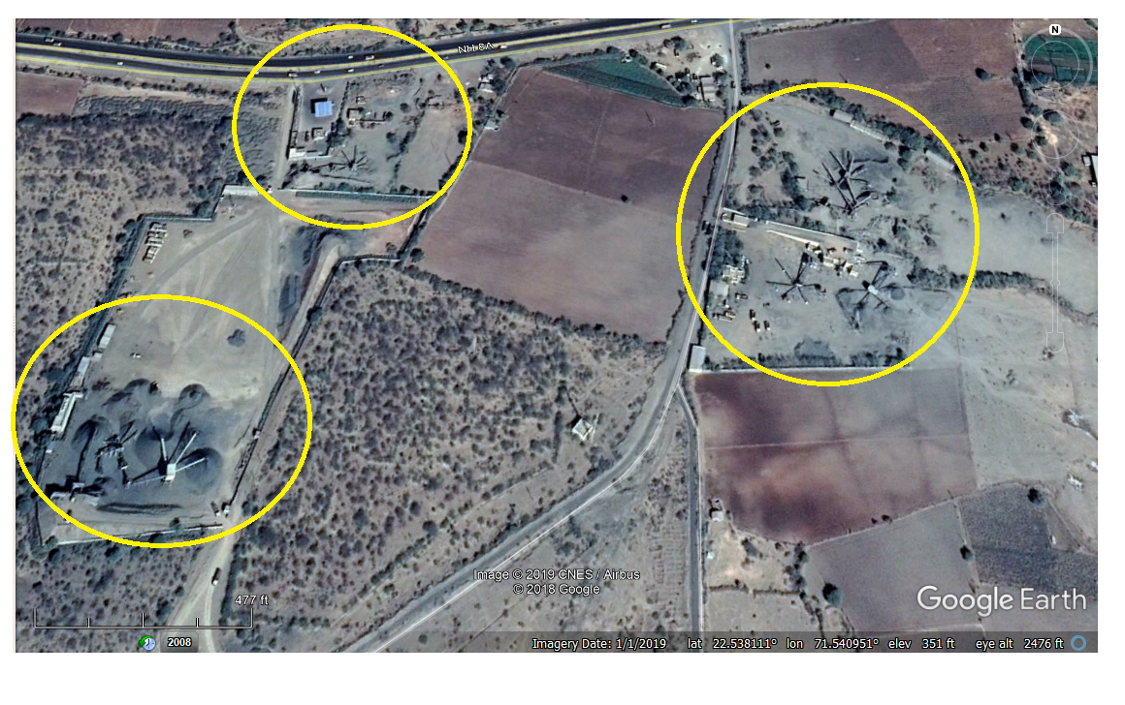
Figure S3: Google Earth view of machines used in Quarry blast in the study area.

