Supporting information

In Situ Size Amplification Strategy Suppresses Lymphatic Clearance for Enhanced Arthritis Therapy

Xianyan Qin¹, Luhan Zhang¹, Yang-Bao Miao¹, Linxi Jiang¹, Liang Zou⁵, Qin Wang^{2*}, Yi Shi^{1,3,4*}

¹ Sichuan Provincial Key Laboratory for Human Disease Gene Study and the Center for Medical Genetics, Department of Laboratory Medicine, Sichuan Academy of Medical Sciences and Sichuan Provincial People's Hospital, University of Electronic Science and Technology of China, Chengdu, 610072, China.
² Institute of Biomedical Engineering, College of Medicine, Southwest Jiaotong University, Chengdu 610031, China
³ Research Unit for Blindness Prevention, Chinese Academy of Medical Sciences (2019RU026), Sichuan Academy of Medical Sciences and Sichuan Provincial People’s Hospital, Chengdu, 610072, China.
⁴ Department of Ophthalmology, Sichuan Provincial People’s Hospital, University of Electronic Science and Technology of China, Chengdu 610072, China.
⁵ School of Food and Biological Engineering, Chengdu University, Chengdu, 610106, Sichuan, China.

*Corresponding authors: Yi Shi and Qin Wang (E-mail: yshi@uestc.edu.cn and wangqin666@swjtu.edu.cn)

Figure S1. The synthesis of Bis-5HT-Glu-NH₂.

Figure S2. The synthesis of PSA-Dex-Bis-5HT.

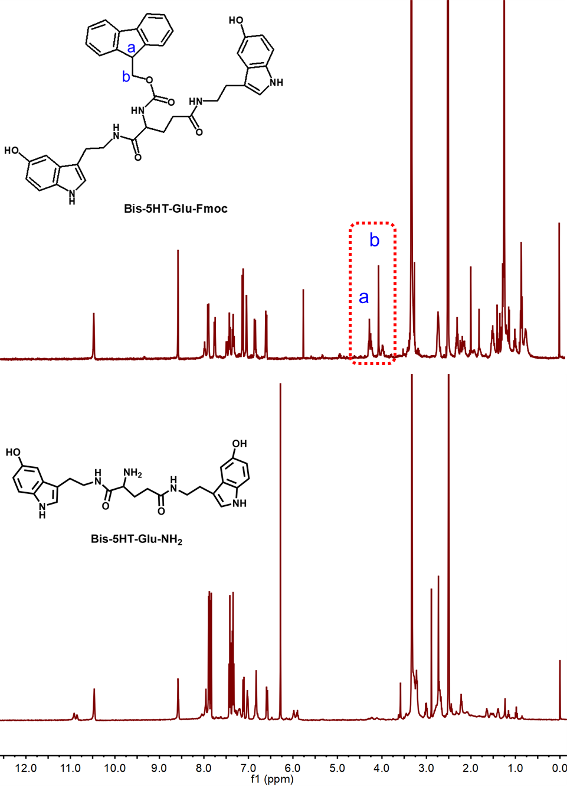
Figure S3. ¹HNMR spectra of Bis-5HT-Glu-Fmoc and Bis-5HT-Glu-NH₂ in DMSO-d6 solution.

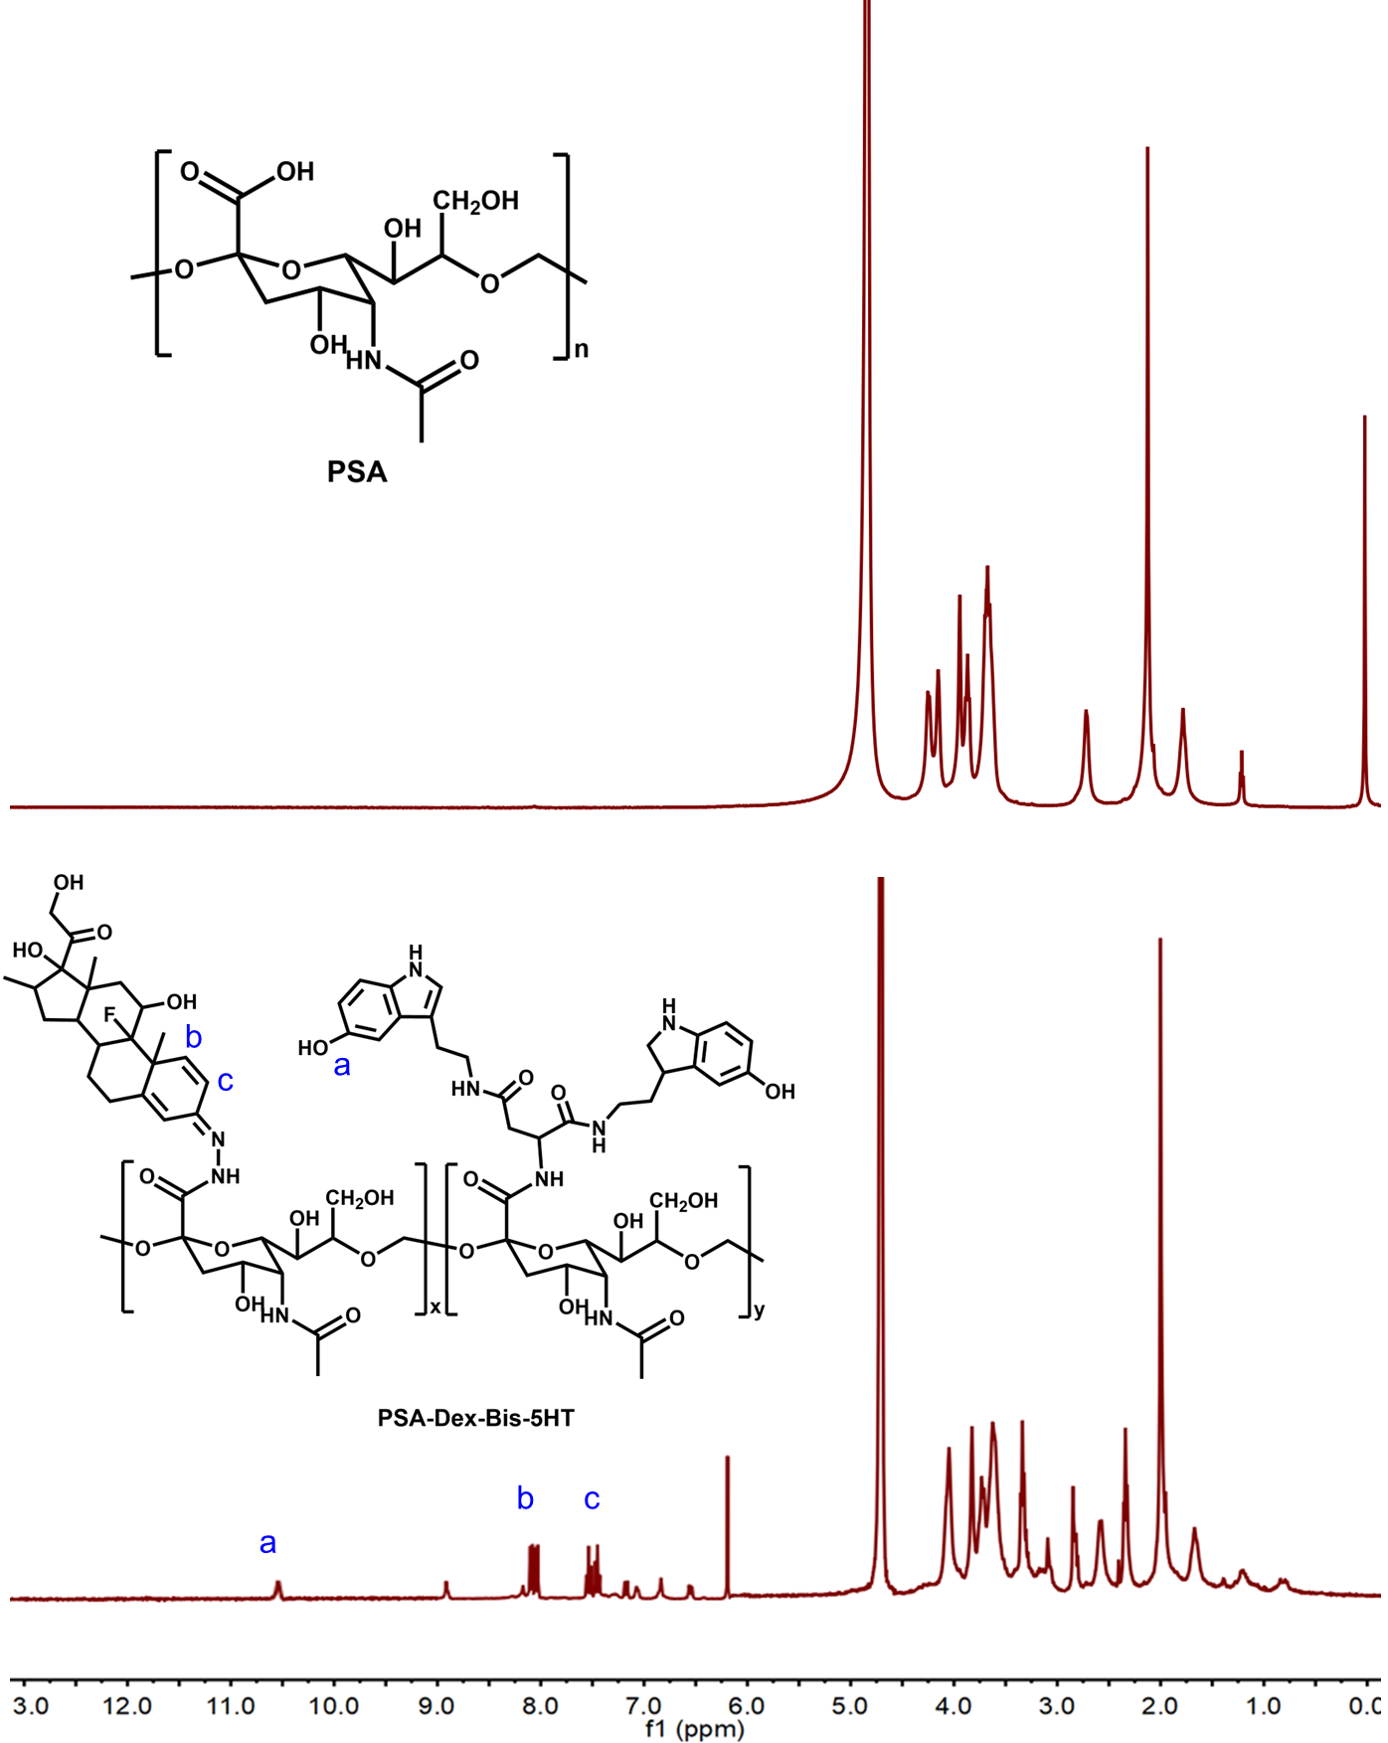
Figure S4. ¹HNMR spectra of PSA and PSA-Dex-Bis-5HT in D₂O-d6 solution.

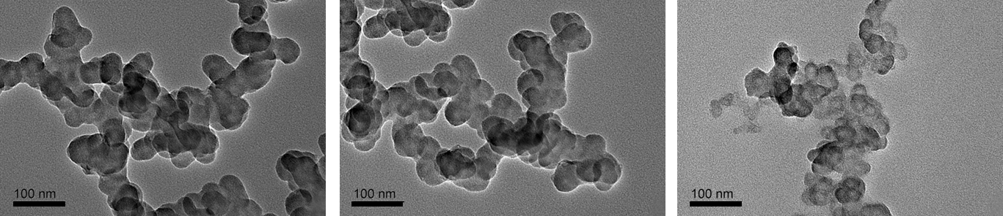
Figure S5. Different zones in TEM fields of PD5NPs incubated with MPO and H2O2 solution at 4 h.

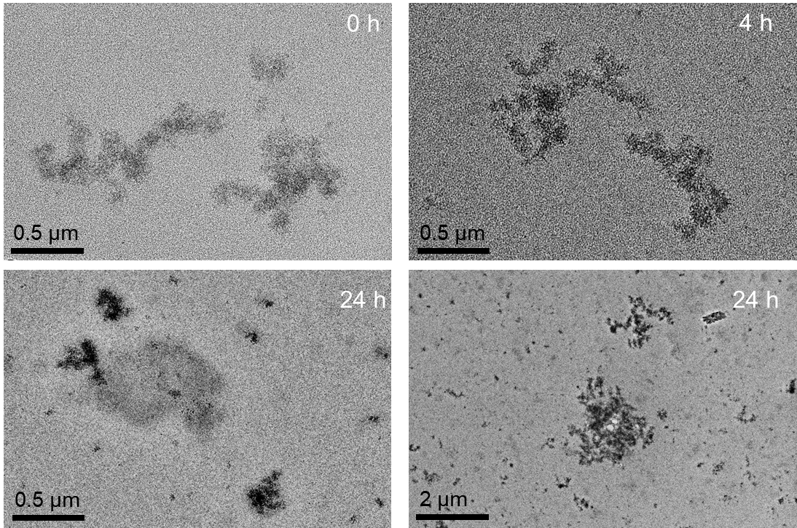
Figure S6. Representative TEM images of PD5NPs aggregates incubated in serum at 0, 4 and 24 h, respectively.

Figure S7. Size distribution of PDNPs at room temperature. Colored lines represented three parallel samples.

Figure S8. Stability of PDNPs after incubation with MPO and hydrogen peroxide for 0 h, 4 h and 24 h.

Figure S9. In vitro release behavior of Dex from aggregetes in PBS buffer with different pH values.

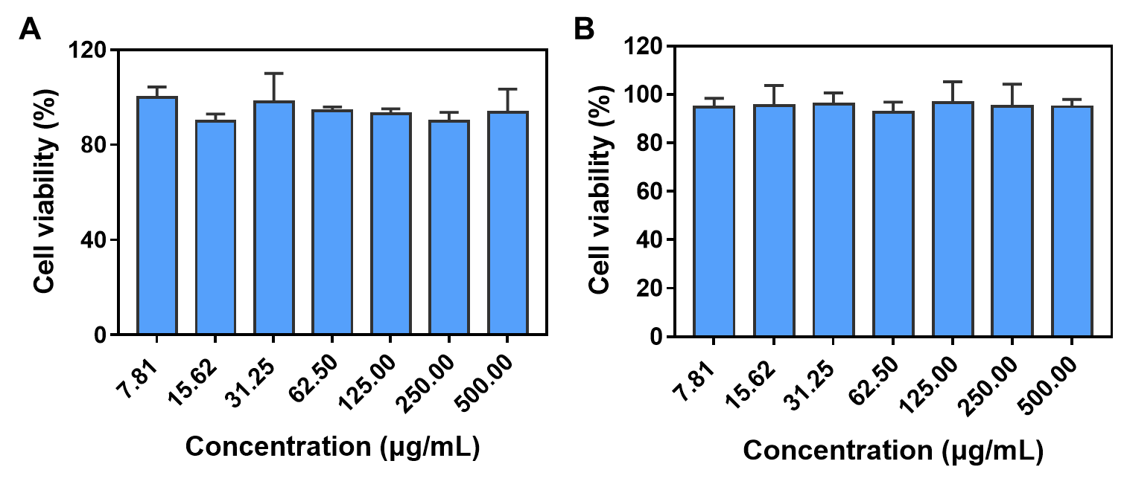
Figure S10. Viability of HUVEC (A) and Raw264.7 (B) cells after 24 h incubation with PD5NPs aggregates at different concentrations. Results were shown as mean ± SD, n=3.
Figure S11. Fluorescence semi-quantitative results in major organs (heart, liver, spleen, lung and kidney) after the intravenous injection of free Cy5.5, Cy5.5-labled PDNPs and Cy5.5-labled PD5NPs at 24 h.

Figure S12. The Pearson’s coefficient of colocalization between Cy5.5 (red) and CD31 (green) after treating with Cy5.5-PDNPs and Cy5.5-PD5NPs at 6 h and 24 h.

Figure S13.Semi-quantification of the fluorescence signal after treating with free Cy5.5, Cy5.5-PDNPs and Cy5.5-PD5NPs at 6 h and 24 h.

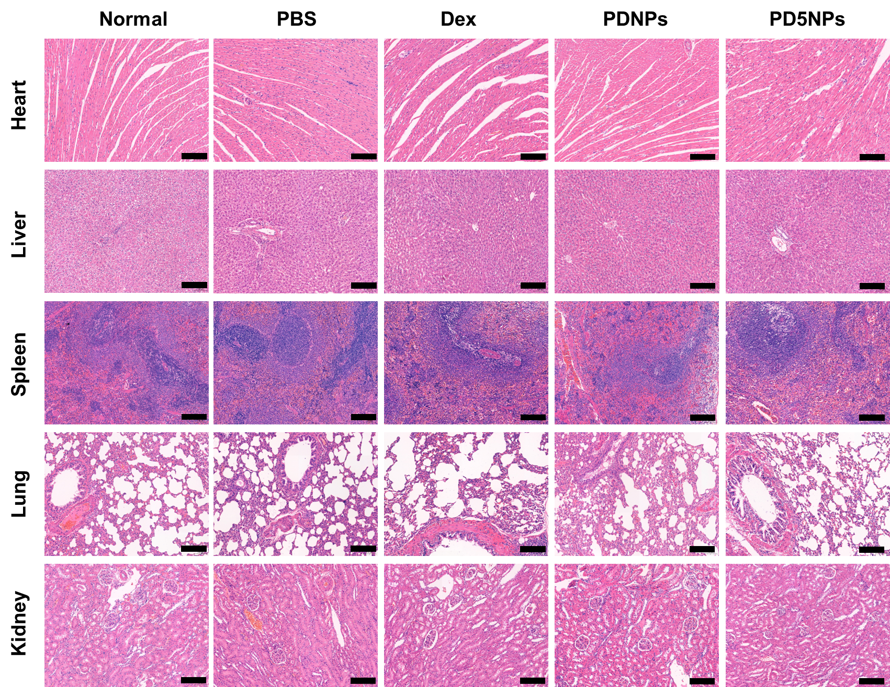
Figure S14. H&E staining of major organs (heart, liver, spleen, lung and kidney) after rats receiving the indicated treatment. Scale bar=200 µm.

