Additional files
Table S1 Primers used for qRT-PCR.
Prmer name | Forward Primer(5'-3') | Reverse Primer(5'-3') | Purpose
PPT2 | TATCCATGGCGTCTGGGACT | CATACTGGCCAGCTTGAGGG | qRT-PCR
ODPB | TGTGTTCCGAGGACCCAATG | GCTGGGCTCTCAACAATCCT | qRT-PCR
KBL | TTGTGGCACTCAGACCATCC | GGTAAGGTCTTGCTCGCTGT | qRT-PCR
ATP5H | ATGGCAGCCCGAAGAGTC | CTCTGCACCCTCCTTGGC | qRT-PCR
G3P | ATGGCGTGTACAAGGGTGAG | TCAACCACGGACACATCAGG | qRT-PCR
SPYA | ATGTGTAACCTGCTGGAGCC | TGGTGGTATTTGCGAGGGAC | qRT-PCR
β-actin | GCCCTTCCTCACGCTATCCT | GCGGCAGTGGTCATCTCCT | qRT-PCR
Genes are abbreviated as follows: Lysosomal thioesterase PPT2 (PPT2); Pyruvate dehydrogenase E1 component subunit beta (ODPB); 2-amino-3-ketobutyrate coenzyme A ligase (KBL); ATP synthase subunit d (ATP5H); Glyceraldehyde-3-phosphate dehydrogenase (G3P); Serine--pyruvate aminotransferase (SPYA).

Table S2 Result statistics of splicing.
Term | All (>300bp) | >=500bp | >=100bp | N50 | Total_length | Max_Length | Min_Length | Average_Length
Unigene | 54537 | 32514 | 17277 | 1876 | 60890086 | 21255 | 301 | 1116.49
All (>300bp): Number of Unigene with length >= 300bp; >=500bp: Number of Unigene with length >=500bp; >=1000bp: Number of Unigene with length >=1000bp; N50: The N50 length is used to determine the assembly continuity, the higher the better. N50 is a weighted median statistic that 50% of the total length is contained in transcripts that are equal to or larger than this value; Total_Length: The read length of Unigenes; Max_Length: the longest length of Unigene; Min_Length: The shortest length of Unigene.

Table S3 Summary for transcriptome sequencing data generated from nine cDNA libraries.
Sample | Raw_reads | Raw_bases | Clean_reads | Clean_bases | Vaid_bases(%) | Q30(%) | GC(%)
CONTROL1 | 55343246 | 8301486900 | 53193490 | 7748273699 | 93.34 | 93.69 | 45.69
CONTROL2 | 50681538 | 7602230700 | 48770678 | 7096588572 | 93.35 | 93.70 | 46.73
CONTROL3 | 49622514 | 7443377100 | 47955458 | 6972528373 | 93.67 | 94.09 | 45.76
HL1 | 57682096 | 8652314400 | 55510188 | 8063552837 | 93.20 | 93.34 | 46.93
HL2 | 54778946 | 8216841900 | 52572856 | 7611407371 | 92.63 | 93.00 | 45.70
HL3 | 56136812 | 8420521800 | 54397854 | 7866049955 | 93.42 | 94.06 | 44.54
LL1 | 53167384 | 7975107600 | 51237134 | 7429856855 | 93.16 | 93.53 | 45.57
LL2 | 50602370 | 7590355500 | 48908268 | 7113470245 | 93.72 | 93.98 | 45.83
LL3 | 56386788 | 8458018200 | 54198790 | 7863446770 | 92.97 | 93.22 | 46.33
Sample: Sample name; RAW_reads: The original reads number; Raw_bases: The raw sequencing quantity, or the number of bases; Clean_reads: The number of clean reads obtained after filtering; Clean_bases: The filtered sequencing quantity, i.e., the number of bases; Valid_bases: valid base percentage; Q30: The percentage of bases whose Phred value is greater than 30 in raw Bases; GC: The percentage of the total number of G and C in clean bases.

Table S4 Summary of annotated genes in different databases.
Annotated Databases | Number of unigenes | Percentage(%)
NR | 16049 | 29.43
Swissprot | 11876 | 21.78
KEGG | 7881 | 14.45
KOG | 10586 | 19.41
eggNOG | 13351 | 24.48
GO | 11204 | 20.54
Pfam | 284 | 0.52
Total unigenes | 54537 | 100

Table S5 Statistical table of SSRs
Unigene Number | Unigene Size | SSRs Number | Unigene Number(SSRs>=1) | Unigene Number(SSR>=2) | Compound SSRs Number
54537 | 60890086 | 54287 | 25540 | 13056 | 11842
Unigene Size: Total base number of Unigene; SSRs Number: Number of predicted SSRs; Unigene Number(SSR>=1): Number of Unigene containing SSRs; Unigene Number(SSR>=2): Number of Unigene containing >=2 SSRs;

Table S6 Sub categorization of the metabolism group.
Major Category | Subcategory | Gene number | Percentage(%)
Metabolism | Amino acid metabolism | 295 | 6.57
 | Biosynthesis of other secondary metabolites | 31 | 0.69
 | Carbohydrate metabolism | 389 | 8.66
 | Energy metabolism | 213 | 4.74
 | Glycan biosynthesis and metabolism | 235 | 5.23
 | Lipid metabolism | 347 | 7.73
 | Metabolism of cofactors and vitamins | 183 | 4.07
 | Metabolism of other amino acids | 121 | 2.69
 | Metabolism of terpenoids and polyketides | 54 | 1.2
 | Nucleotide metabolism | 236 | 5.25
 | Xenobiotics biodegradation and metabolism | 118 | 2.63

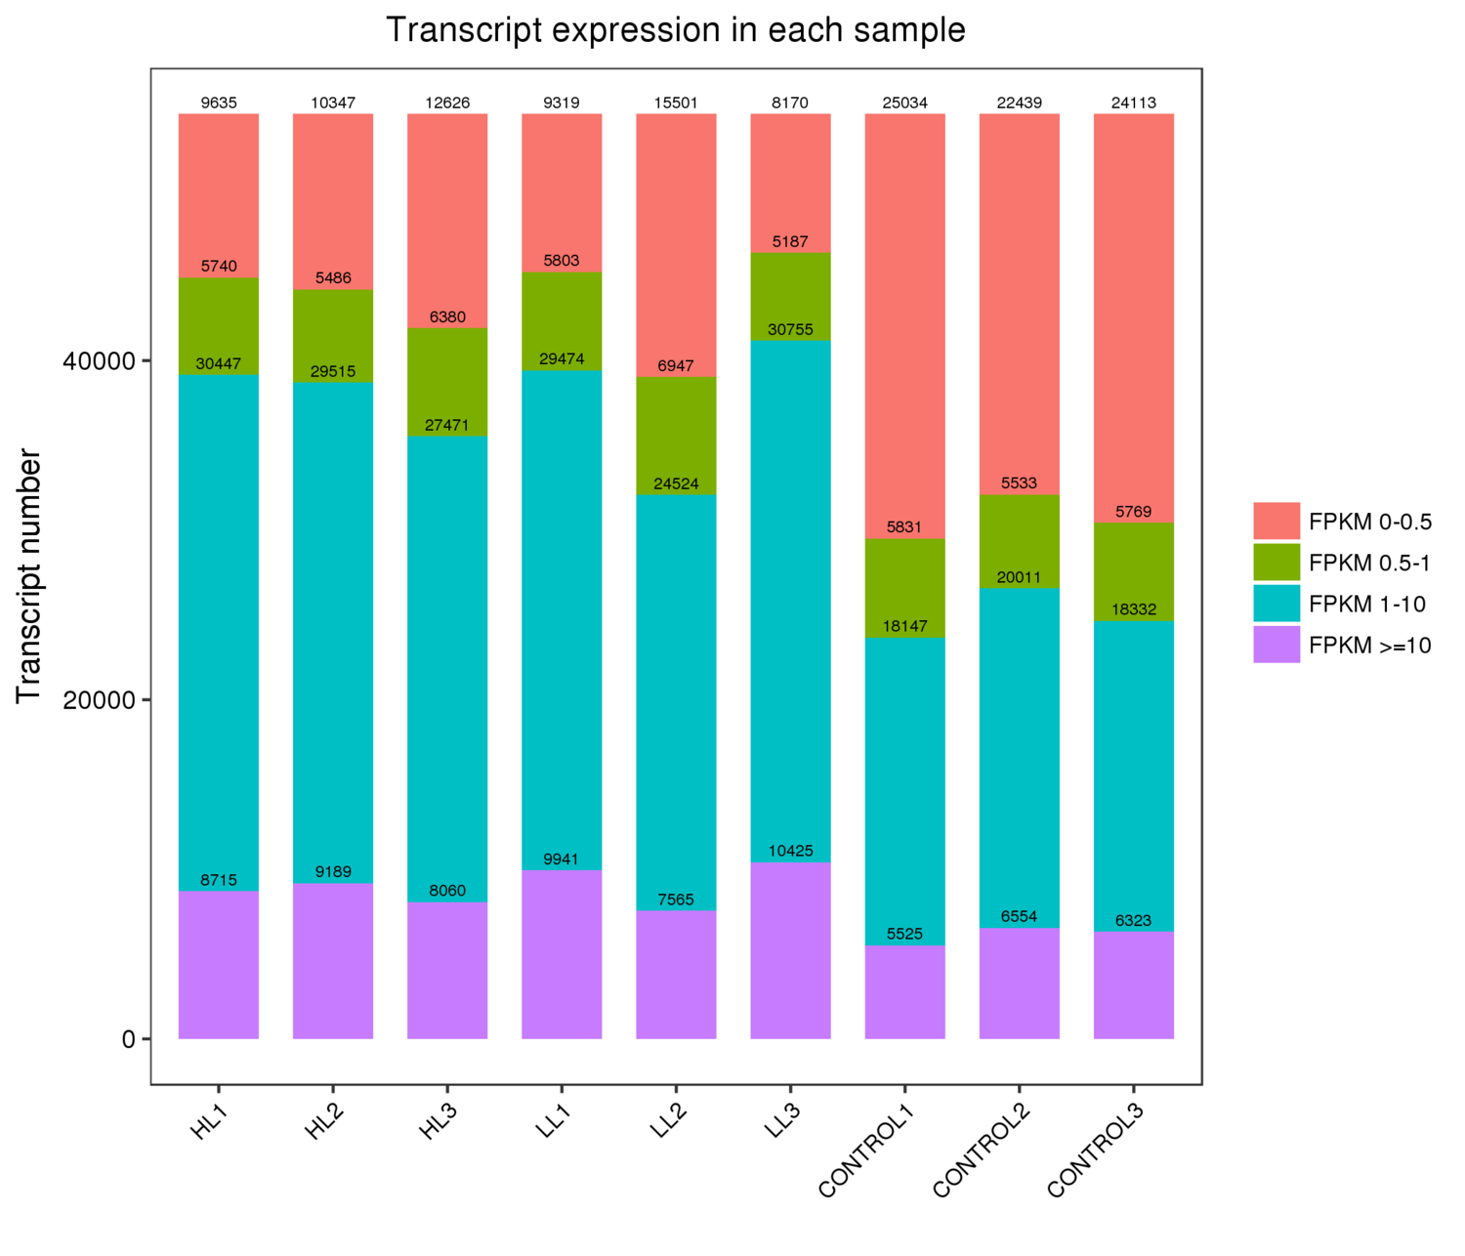
Fig. S1 Distribution of FPKM value in each sample. Different colors represent different range of FPKM values. The abscissa is the sample, and the ordinate is the number of Unigene.

