Additional File 1
Figure 1. Flowchart of the study population.
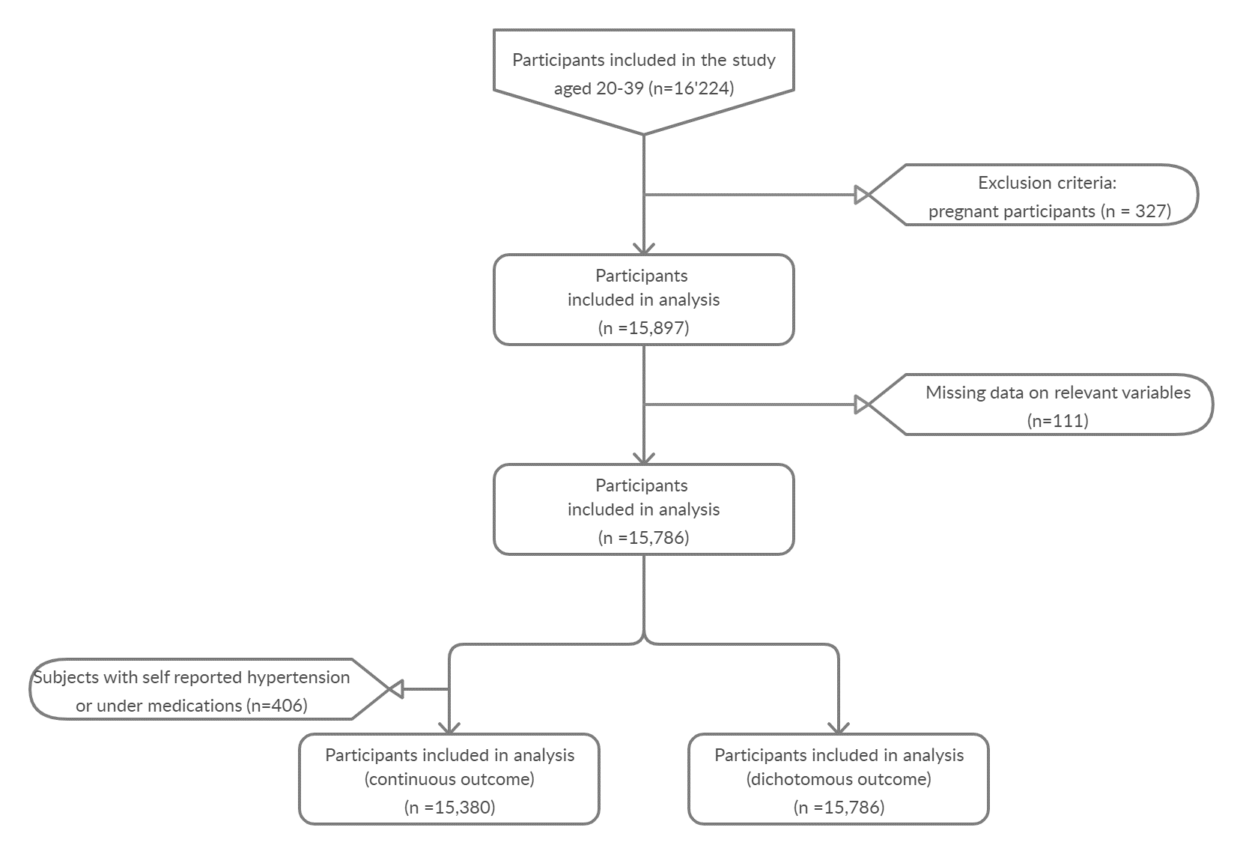

Additional File 4
Figure 2. Exposure–response curves for PFAS exposure and Systolic and Diastolic Blood pressure from GAM models using thin plane splines, with 95% confidence intervals. The predicted levels are based on average characteristics used as covariates in the models.
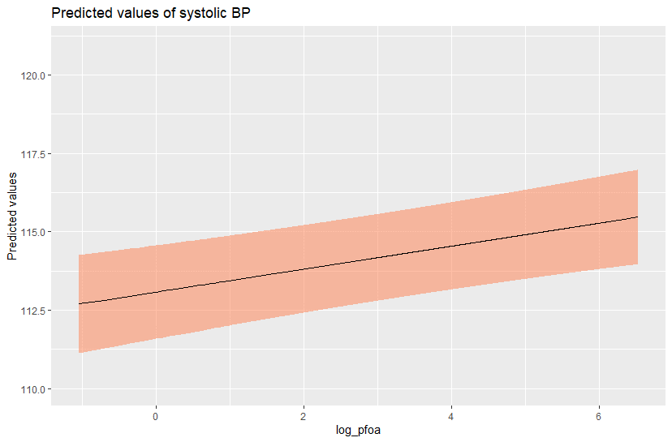 | 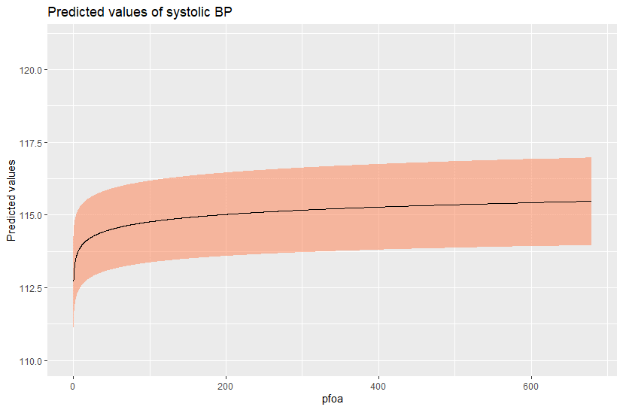
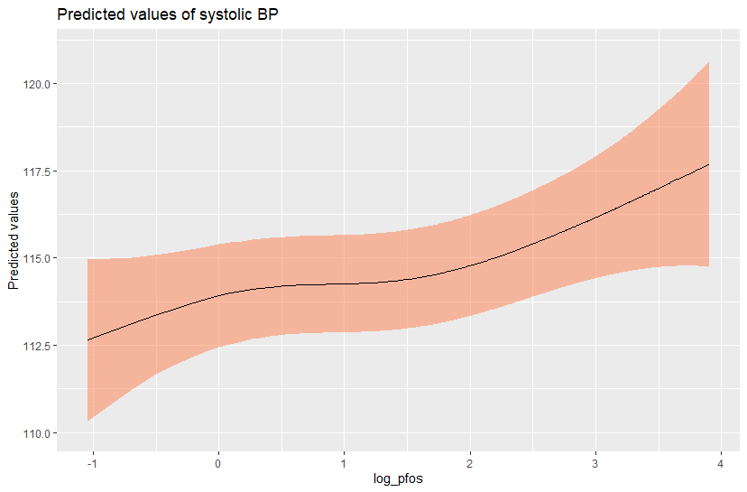 | 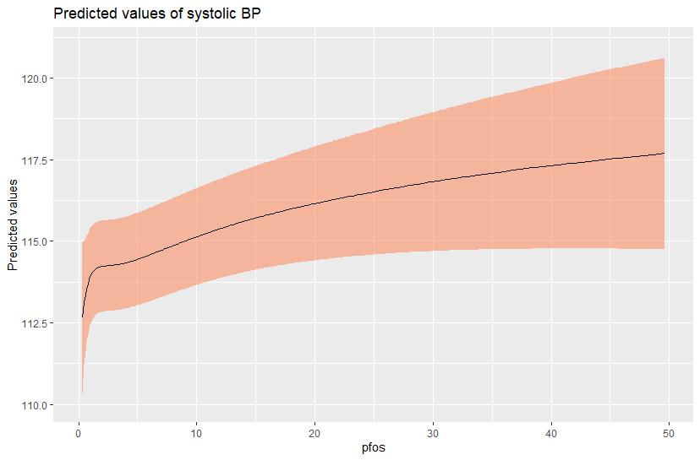
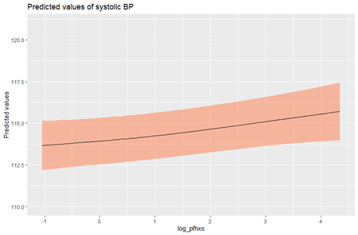 | 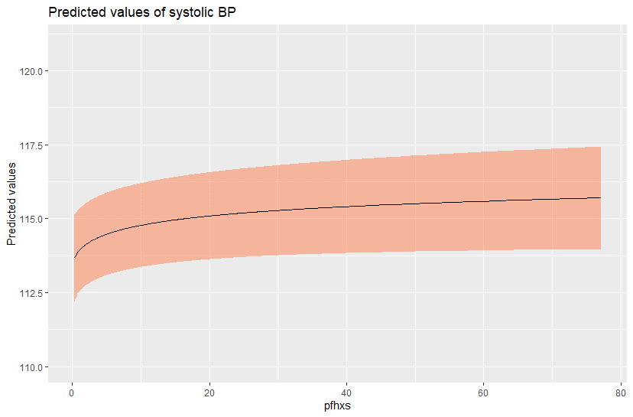
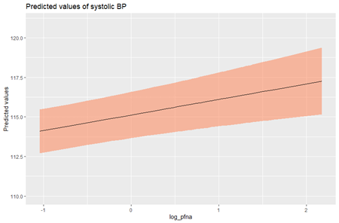 | 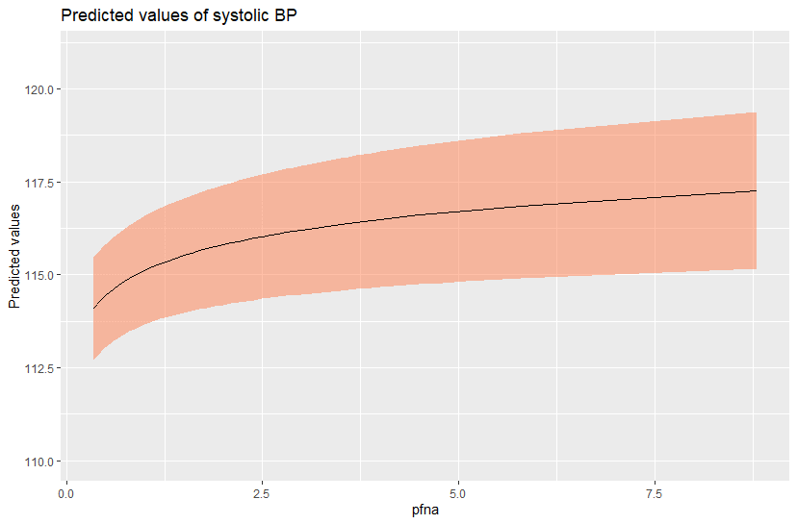
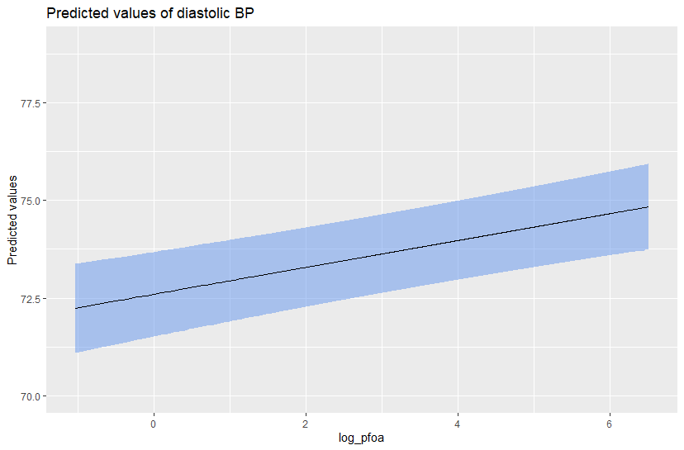 | 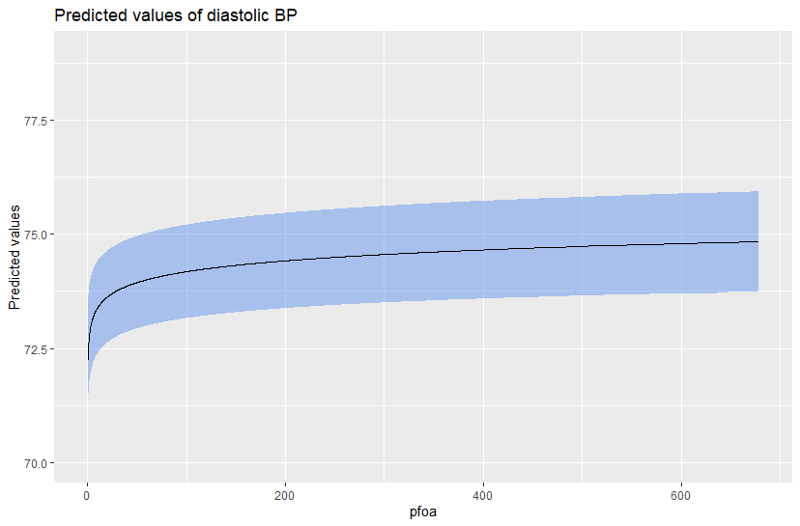
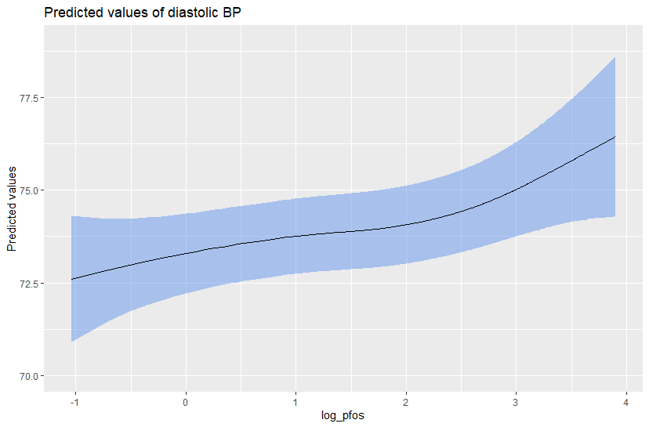 | 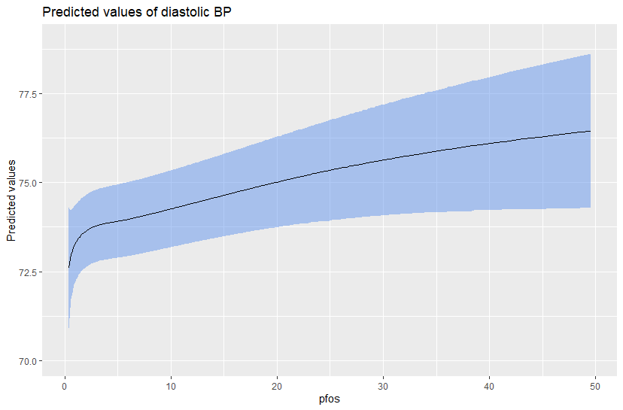
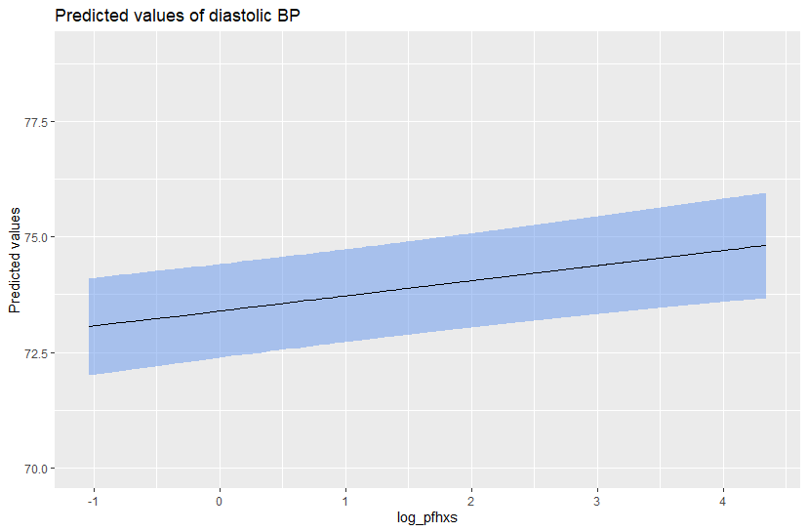 | 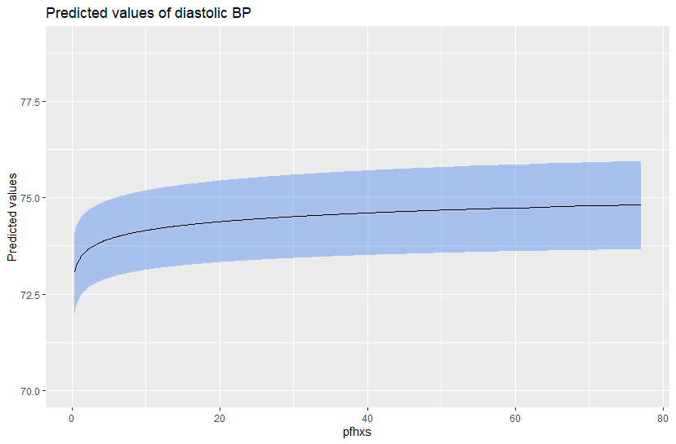
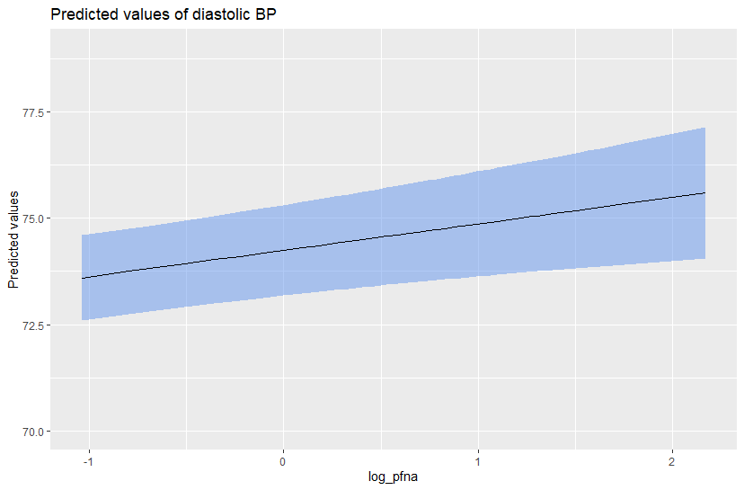 | 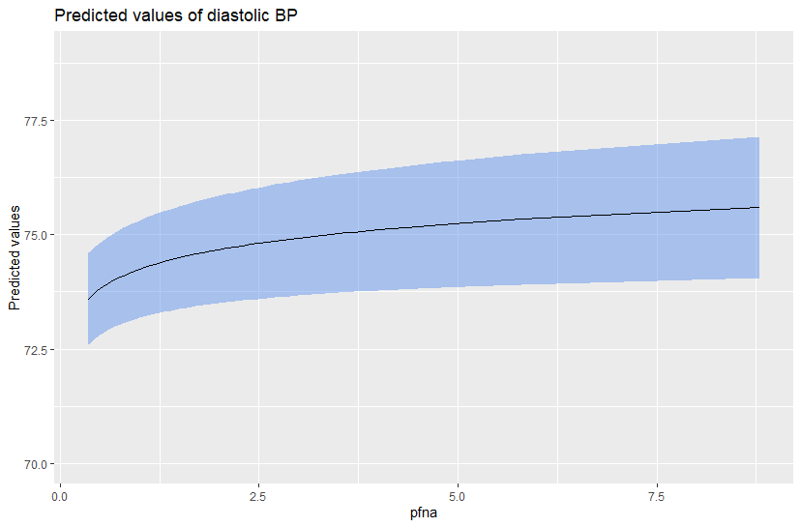

MALES | FEMALES
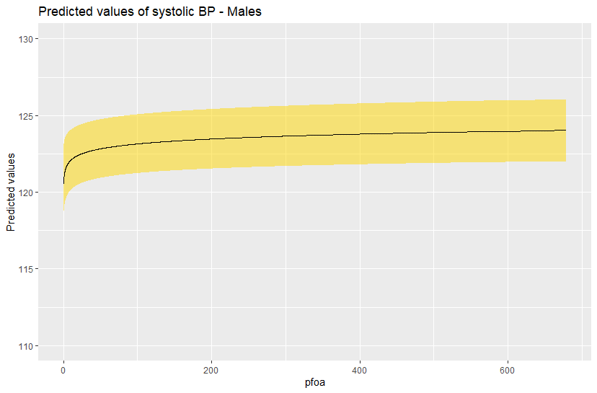 | 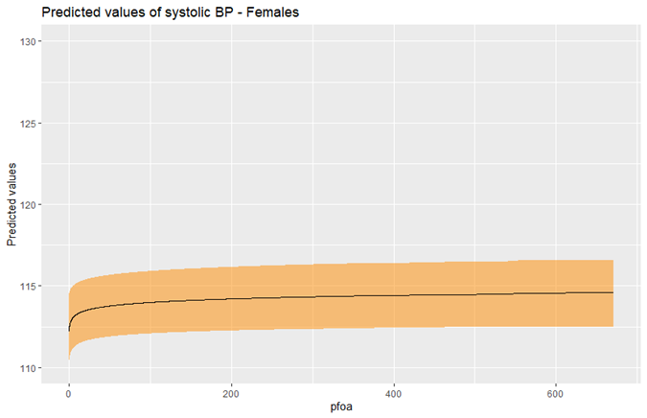
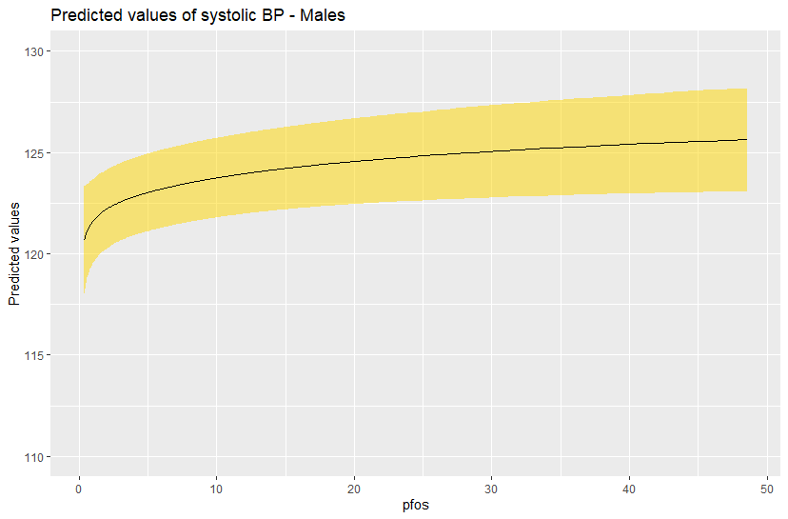 | 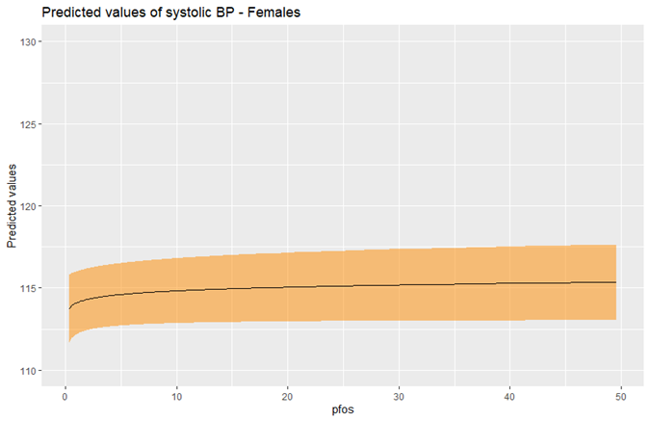
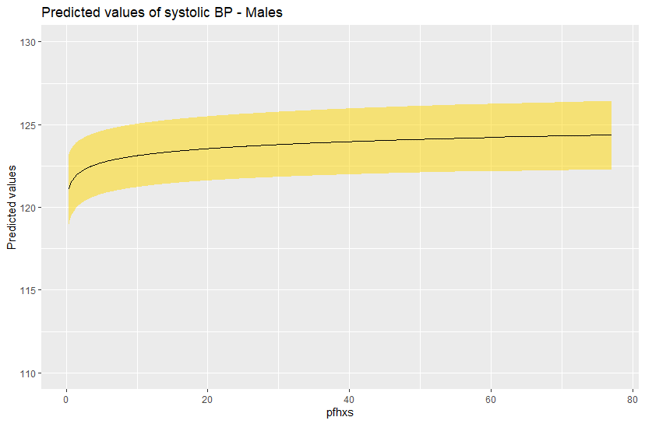 | 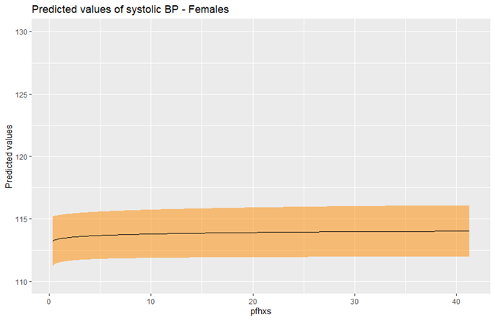
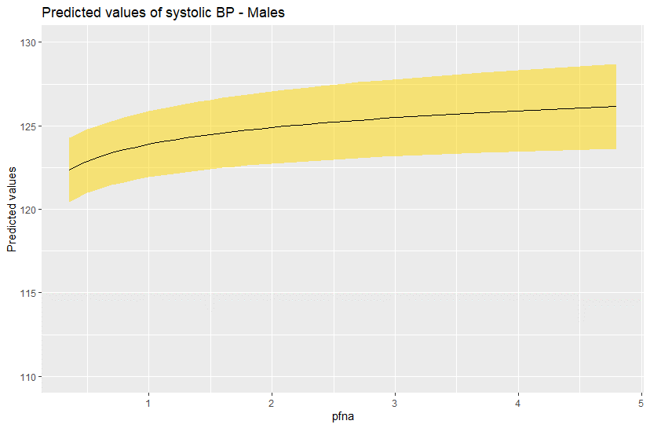 | 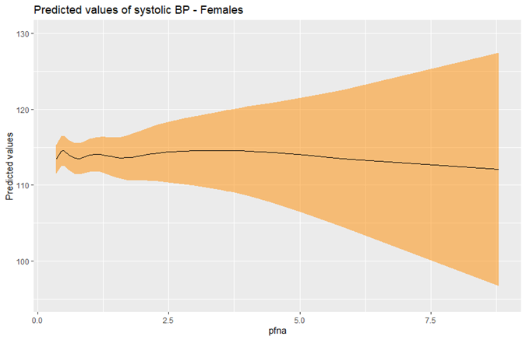

MALES | FEMALES
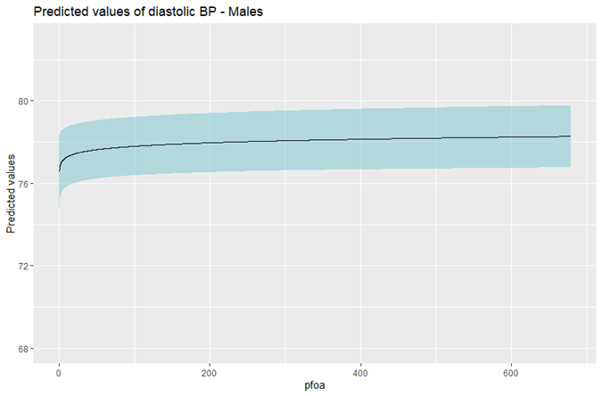 | 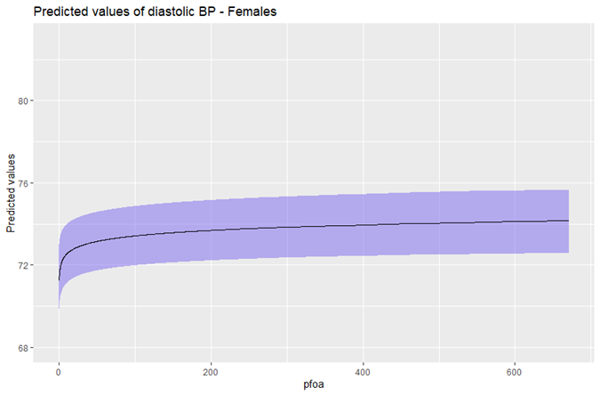
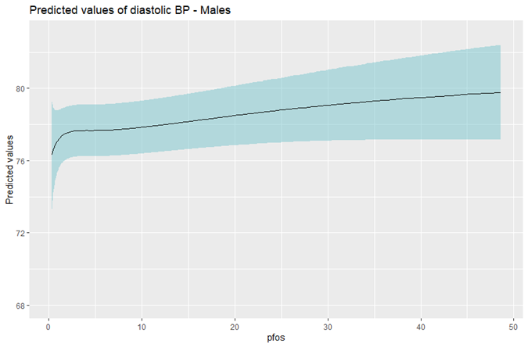 | 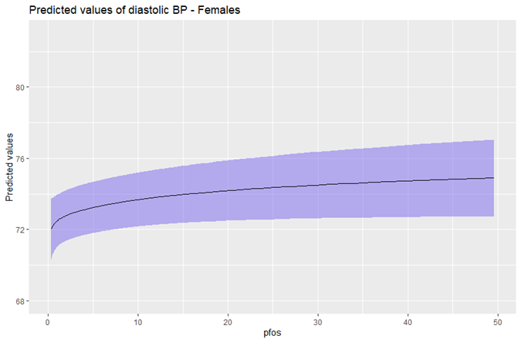
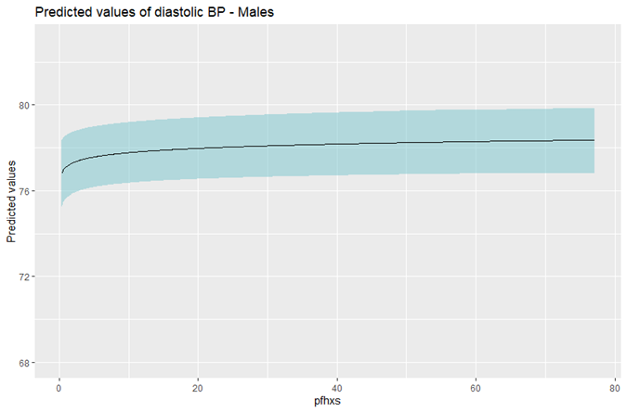 | 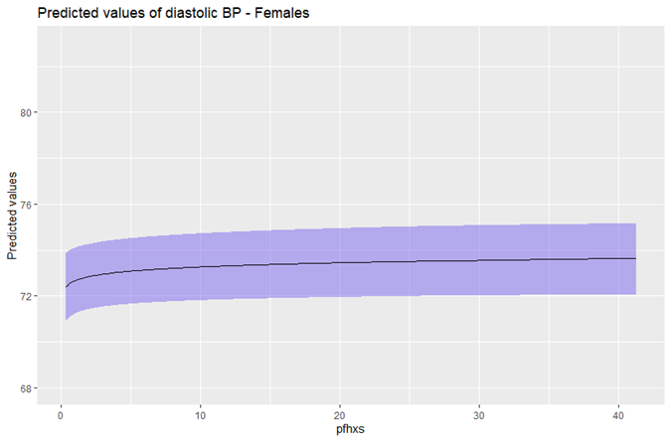
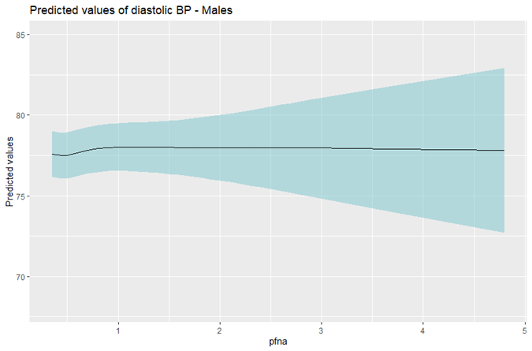 | 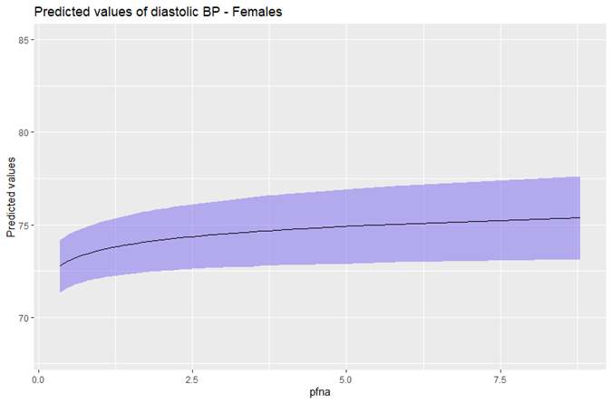

Additional File 6
Figure 3. Predicted values of Systolic and Diastolic Blood Pressure by deciles of PFAS distribution.
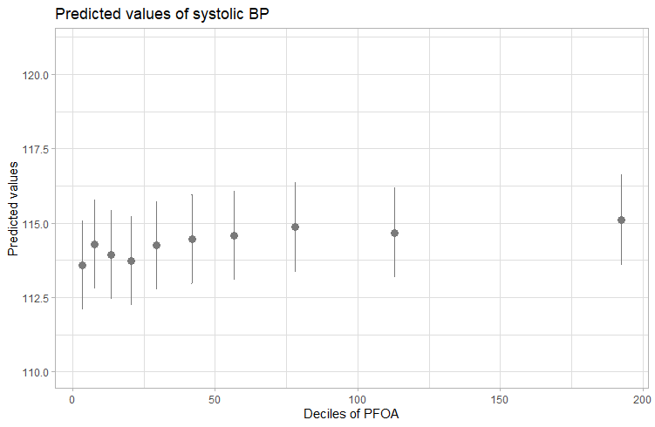 | 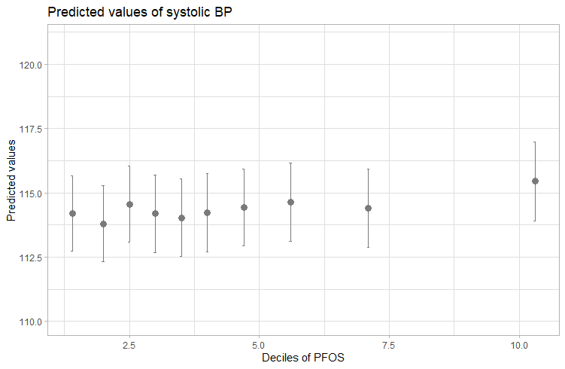
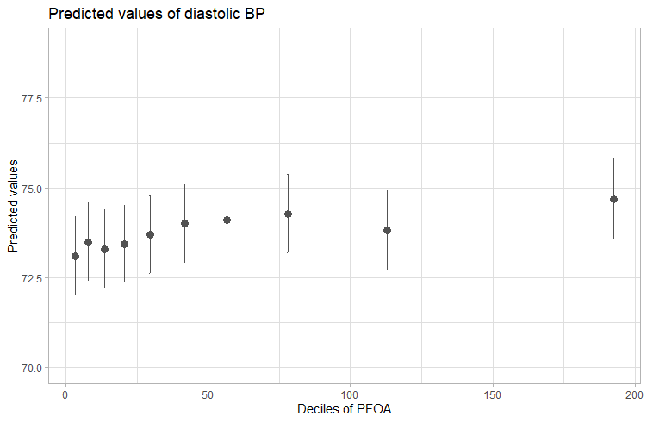 | 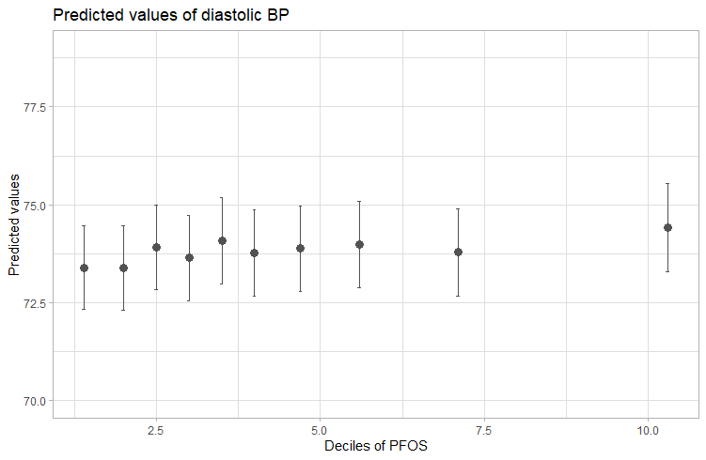

Additional File 2
Table 1. Descriptive statistics of diet and center where Blood Pressure has been measured.
Covariates | Total - n (%) | M - n (%) | F - n (%)
Fruit
I Q | 4180 (26.48) | 2562 (33.42) | 1618 (19.93)
II Q | 5073 (32.14) | 2554 (33.31) | 2519 (31.03)
III Q | 3477 (22.03) | 1407 (18.35) | 2070 (25.5)
IV Q | 3056 (19.36) | 1144 (14.92) | 1912 (23.55)
Milk
I Q | 4824 (30.56) | 2529 (32.99) | 2295 (28.27)
II Q | 3223 (20.42) | 1517 (19.79) | 1706 (21.01)
III Q | 6424 (40.69) | 3003 (39.17) | 3421 (42.14)
IV Q | 1315 (8.33) | 618 (8.06) | 697 (8.58)
Cheese
I Q | 4699 (29.77) | 2041 (26.62) | 2658 (32.74)
II Q | 4042 (25.6) | 1819 (23.73) | 2223 (27.38)
III Q | 4193 (26.56) | 2213 (28.86) | 1980 (24.39)
IV Q | 2852 (18.07) | 1594 (20.79) | 1258 (15.49)
Meat
I Q | 6561 (41.56) | 2438 (31.8) | 4123 (50.78)
II Q | 2717 (17.21) | 1307 (17.05) | 1410 (17.37)
III Q | 5658 (35.84) | 3301 (43.05) | 2357 (29.03)
IV Q | 850 (5.38) | 621 (8.1) | 229 (2.82)
Sweets/Snacks/Sweet beverages
I Q | 5983 (37.9) | 3041 (39.66) | 2942 (36.24)
II Q | 4579 (29.01) | 2067 (26.96) | 2512 (30.94)
III Q | 3653 (23.14) | 1852 (24.16) | 1801 (22.18)
IV Q | 1571 (9.95) | 707 (9.22) | 864 (10.64)
Eggs
I Q | 4532 (28.71) | 2077 (27.09) | 2455 (30.24)
II Q | 6531 (41.37) | 2969 (38.72) | 3562 (43.87)
III Q | 3157 (20) | 1635 (21.33) | 1522 (18.75)
IV Q | 1566 (9.92) | 986 (12.86) | 580 (7.14)
Fish
I Q | 9395 (59.51) | 4591 (59.88) | 4804 (59.17)
II Q | 4184 (26.5) | 2027 (26.44) | 2157 (26.57)
III Q | 2207 (13.98) | 1049 (13.68) | 1158 (14.26)
Bread/Pasta/Cereals
I Q | 7357 (46.6) | 3279 (42.77) | 4078 (50.23)
II Q | 6573 (41.64) | 3431 (44.75) | 3142 (38.7)
III Q | 1856 (11.76) | 957 (12.48) | 899 (11.07)
Salt
Basso | 6650 (42.13) | 2941 (38.36) | 3709 (45.68)
Medio | 8243 (52.22) | 4256 (55.51) | 3987 (49.11)
Elevato | 893 (5.66) | 470 (6.13) | 423 (5.21)
Center
Lonigo | 4067 (25.76) | 1972 (25.72) | 2095 (25.8)
Legnago | 3944 (24.98) | 1907 (24.87) | 2037 (25.09)
San Bonifacio | 4085 (25.88) | 1951 (25.45) | 2134 (26.28)
Noventa Vicentina | 3690 (23.38) | 1837 (23.96) | 1853 (22.82)

Additional File 3
Table 2. Descriptive statistics in subjects with or without hypertension, stratified by gender.
Continuous covariates
 | Total |  |  |  |  | M |  |  |  |  | F
 | Not Hypertensive |  | Hypertensive |  |  | Not Hypertensive |  | Hypertensive |  |  | Not Hypertensive |  | Hypertensive
 | mean | sd | mean | sd | p-value | mean | sd | mean | sd | p-value | mean | sd | mean | sd | p-value
Age | 29.93 | 5.86 | 30.86 | 5.83 | 0.000 | 29.73 | 5.88 | 30.49 | 5.81 | 0.000 | 30.08 | 5.83 | 31.88 | 5.74 | 0.000
Time-lag | 14.72 | 5.48 | 15.10 | 5.23 | 0.004 | 14.65 | 5.57 | 14.88 | 5.26 | 0.150 | 14.78 | 5.41 | 15.71 | 5.12 | 0.000
BMI | 23.49 | 3.96 | 26.87 | 5.29 | 0.000 | 24.28 | 3.40 | 26.81 | 4.73 | 0.000 | 22.84 | 4.25 | 27.02 | 6.62 | 0.000
Categorical covariates
 | NO |  | YES |  |  | NO |  | YES |  |  | NO |  | YES
 | Freq. | % | Freq. | % | p-value | Freq. | % | Freq. | % | p-value | Freq. | % | Freq. | % | p-value
Gender
M | 6,218 | 45.01 | 1,449 | 73.52 | 0.000
F | 7,597 | 54.99 | 522 | 26.48 | 0.000
Smoke
NO | 8,174 | 59 | 1,056 | 53.58 | 0.000 | 3,182 | 51.17 | 713 | 49.21 | 0.370 | 4,992 | 65.71 | 343 | 65.71 | 0.774
YES | 3,738 | 27.06 | 617 | 31.3 | 0.000 | 2,068 | 33.26 | 507 | 34.99 | 0.370 | 1,670 | 21.98 | 110 | 21.07 | 0.774
Ex smoker | 1,903 | 13.77 | 298 | 15.12 | 0.000 | 968 | 15.57 | 229 | 15.8 | 0.370 | 935 | 12.31 | 69 | 13.22 | 0.774
Education
Elementary/Middle school | 2,038 | 14.75 | 371 | 18.82 | 0.000 | 1,063 | 17.1 | 283 | 19.53 | 0.000 | 975 | 12.83 | 88 | 16.86 | 0.000
Highschool | 8,190 | 59.28 | 1,255 | 63.67 | 0.000 | 3,909 | 62.87 | 938 | 64.73 | 0.000 | 4,281 | 56.35 | 317 | 60.73 | 0.000
University | 3,587 | 25.96 | 345 | 17.5 | 0.000 | 1,246 | 20.04 | 228 | 15.73 | 0.000 | 2,341 | 30.81 | 117 | 22.41 | 0.000
Physical activity
Light | 9,374 | 67.85 | 1,264 | 64.13 | 0.003 | 3,843 | 61.8 | 876 | 60.46 | 0.034 | 5,531 | 72.81 | 388 | 74.33 | 0.048
Moderate | 2,056 | 14.88 | 338 | 17.15 | 0.003 | 903 | 14.52 | 249 | 17.18 | 0.034 | 1,153 | 15.18 | 89 | 17.05 | 0.048
Heavy | 2,385 | 17.26 | 369 | 18.72 | 0.003 | 1,472 | 23.67 | 324 | 22.36 | 0.034 | 913 | 12.02 | 45 | 8.62 | 0.048
Country of birth
HDC | ##### | 90.38 | 1,811 | 91.88 | 0.033 | 5,773 | 92.84 | 1,363 | 94.06 | 0.099 | 6,713 | 88.36 | 448 | 85.82 | 0.082
HMPC | 1,329 | 9.62 | 160 | 8.12 | 0.033 | 445 | 7.16 | 86 | 5.94 | 0.099 | 884 | 11.64 | 74 | 14.18 | 0.082
Fruit/Vegetables
1 | 3,608 | 26.12 | 572 | 29.02 | 0.000 | 2,096 | 33.71 | 466 | 32.16 | 0.231 | 1,512 | 19.9 | 106 | 20.31 | 0.148
2 | 4,393 | 31.8 | 680 | 34.5 | 0.000 | 2,050 | 32.97 | 504 | 34.78 | 0.231 | 2,343 | 30.84 | 176 | 33.72 | 0.148
3 | 3,060 | 22.15 | 417 | 21.16 | 0.000 | 1,128 | 18.14 | 279 | 19.25 | 0.231 | 1,932 | 25.43 | 138 | 26.44 | 0.148
4 | 2,754 | 19.93 | 302 | 15.32 | 0.000 | 944 | 15.18 | 200 | 13.8 | 0.231 | 1,810 | 23.83 | 102 | 19.54 | 0.148
Milk/Yogurt
1 | 4,180 | 30.26 | 644 | 32.67 | 0.057 | 2,036 | 32.74 | 493 | 34.02 | 0.580 | 2,144 | 28.22 | 151 | 28.93 | 0.525
2 | 2,808 | 20.33 | 415 | 21.06 | 0.057 | 1,222 | 19.65 | 295 | 20.36 | 0.580 | 1,586 | 20.88 | 120 | 22.99 | 0.525
3 | 5,661 | 40.98 | 763 | 38.71 | 0.057 | 2,452 | 39.43 | 551 | 38.03 | 0.580 | 3,209 | 42.24 | 212 | 40.61 | 0.525
4 | 1,166 | 8.44 | 149 | 7.56 | 0.057 | 508 | 8.17 | 110 | 7.59 | 0.580 | 658 | 8.66 | 39 | 7.47 | 0.525
Cheese
1 | 4,163 | 30.13 | 536 | 27.19 | 0.049 | 1,672 | 26.89 | 369 | 25.47 | 0.729 | 2,491 | 32.79 | 167 | 31.99 | 0.305
2 | 3,528 | 25.54 | 514 | 26.08 | 0.049 | 1,466 | 23.58 | 353 | 24.36 | 0.729 | 2,062 | 27.14 | 161 | 30.84 | 0.305
3 | 3,654 | 26.45 | 539 | 27.35 | 0.049 | 1,791 | 28.8 | 422 | 29.12 | 0.729 | 1,863 | 24.52 | 117 | 22.41 | 0.305
4 | 2,470 | 17.88 | 382 | 19.38 | 0.049 | 1,289 | 20.73 | 305 | 21.05 | 0.729 | 1,181 | 15.55 | 77 | 14.75 | 0.305
Meat
1 | 5,821 | 42.14 | 740 | 37.54 | 0.000 | 1,964 | 31.59 | 474 | 32.71 | 0.177 | 3,857 | 50.77 | 266 | 50.96 | 0.890
2 | 2,387 | 17.28 | 330 | 16.74 | 0.000 | 1,062 | 17.08 | 245 | 16.91 | 0.177 | 1,325 | 17.44 | 85 | 16.28 | 0.890
3 | 4,905 | 35.5 | 753 | 38.2 | 0.000 | 2,705 | 43.5 | 596 | 41.13 | 0.177 | 2,200 | 28.96 | 157 | 30.08 | 0.890
4 | 702 | 5.08 | 148 | 7.51 | 0.000 | 487 | 7.83 | 134 | 9.25 | 0.177 | 215 | 2.83 | 14 | 2.68 | 0.890
Sweets/Snacks/Sweet beverages
1 | 5,186 | 37.54 | 797 | 40.44 | 0.103 | 2,439 | 39.22 | 602 | 41.55 | 0.302 | 2,747 | 36.16 | 195 | 37.36 | 0.843
2 | 4,032 | 29.19 | 547 | 27.75 | 0.103 | 1,685 | 27.1 | 382 | 26.36 | 0.302 | 2,347 | 30.89 | 165 | 31.61 | 0.843
3 | 3,216 | 23.28 | 437 | 22.17 | 0.103 | 1,524 | 24.51 | 328 | 22.64 | 0.302 | 1,692 | 22.27 | 109 | 20.88 | 0.843
4 | 1,381 | 10 | 190 | 9.64 | 0.103 | 570 | 9.17 | 137 | 9.45 | 0.302 | 811 | 10.68 | 53 | 10.15 | 0.843
Eggs
1 | 3,918 | 28.36 | 614 | 31.15 | 0.034 | 1,655 | 26.62 | 422 | 29.12 | 0.049 | 2,263 | 29.79 | 192 | 36.78 | 0.003
2 | 5,734 | 41.51 | 797 | 40.44 | 0.034 | 2,394 | 38.5 | 575 | 39.68 | 0.049 | 3,340 | 43.96 | 222 | 42.53 | 0.003
3 | 2,797 | 20.25 | 360 | 18.26 | 0.034 | 1,351 | 21.73 | 284 | 19.6 | 0.049 | 1,446 | 19.03 | 76 | 14.56 | 0.003
4 | 1,366 | 9.89 | 200 | 10.15 | 0.034 | 818 | 13.16 | 168 | 11.59 | 0.049 | 548 | 7.21 | 32 | 6.13 | 0.003
Fish
1 | 8,219 | 59.49 | 1,176 | 59.67 | 0.554 | 3,733 | 60.04 | 858 | 59.21 | 0.692 | 4,486 | 59.05 | 318 | 60.92 | 0.517
2 | 3,650 | 26.42 | 534 | 27.09 | 0.554 | 1,631 | 26.23 | 396 | 27.33 | 0.692 | 2,019 | 26.58 | 138 | 26.44 | 0.517
3 | 1,946 | 14.09 | 261 | 13.24 | 0.554 | 854 | 13.73 | 195 | 13.46 | 0.692 | 1,092 | 14.37 | 66 | 12.64 | 0.517
Bread/Pasta/Cereals
1 | 6,437 | 46.59 | 920 | 46.68 | 0.753 | 2,634 | 42.36 | 645 | 44.51 | 0.225 | 3,803 | 50.06 | 275 | 52.68 | 0.504
2 | 5,744 | 41.58 | 829 | 42.06 | 0.753 | 2,793 | 44.92 | 638 | 44.03 | 0.225 | 2,951 | 38.84 | 191 | 36.59 | 0.504
3 | 1,634 | 11.83 | 222 | 11.26 | 0.753 | 791 | 12.72 | 166 | 11.46 | 0.225 | 843 | 11.1 | 56 | 10.73 | 0.504
Alcohol consumption
NO | 3,364 | 24.35 | 380 | 19.28 | 0.000 | 831 | 13.36 | 169 | 11.66 | 0.063 | 2,533 | 33.34 | 211 | 40.42 | 0.004
less than e per week | 5,684 | 41.14 | 731 | 37.09 | 0.000 | 2,218 | 35.67 | 509 | 35.13 | 0.063 | 3,466 | 45.62 | 222 | 42.53 | 0.004
3-6 per week | 2,991 | 21.65 | 472 | 23.95 | 0.000 | 1,809 | 29.09 | 412 | 28.43 | 0.063 | 1,182 | 15.56 | 60 | 11.49 | 0.004
more than 7 per week | 1,776 | 12.86 | 388 | 19.69 | 0.000 | 1,360 | 21.87 | 359 | 24.78 | 0.063 | 416 | 5.48 | 29 | 5.56 | 0.004
Salt consumption
Basso | 5,812 | 42.07 | 838 | 42.52 | 0.893 | 2,363 | 38 | 578 | 39.89 | 0.373 | 3,449 | 45.4 | 260 | 49.81 | 0.148
Medio | 7,218 | 52.25 | 1,025 | 52 | 0.893 | 3,468 | 55.77 | 788 | 54.38 | 0.373 | 3,750 | 49.36 | 237 | 45.4 | 0.148
Elevato | 785 | 5.68 | 108 | 5.48 | 0.893 | 387 | 6.22 | 83 | 5.73 | 0.373 | 398 | 5.24 | 25 | 4.79 | 0.148
Center where Blood Pressure have been measured
Lonigo | 3,539 | 25.62 | 528 | 26.79 | 0.000 | 1,575 | 25.33 | 397 | 27.4 | 0.000 | 1,964 | 25.85 | 131 | 25.1 | 0.000
Legnago | 3,368 | 24.38 | 576 | 29.22 | 0.000 | 1,494 | 24.03 | 413 | 28.5 | 0.000 | 1,874 | 24.67 | 163 | 31.23 | 0.000
San Bonifacio | 3,544 | 25.65 | 541 | 27.45 | 0.000 | 1,554 | 24.99 | 397 | 27.4 | 0.000 | 1,990 | 26.19 | 144 | 27.59 | 0.000
Noventa Vicentina | 3,364 | 24.35 | 326 | 16.54 | 0.000 | 1,595 | 25.65 | 242 | 16.7 | 0.000 | 1,769 | 23.29 | 84 | 16.09 | 0.000

Additional File 5
Table 3. GAM model with smoothing splines.
 | Systolic Blood Pressure |  |  |  |  |  | Diastolic Blood Pressure |  |  |  |  |  | Hypertension
PFAS | Total |  | Males |  | Females |  | Total |  | Males |  | Females |  | Total |  | Males |  | Females
PFAS | EDF | P-values | EDF | P-values | EDF | P-values | EDF | P-values | EDF | P-values | EDF | P-values | EDF | P-values | EDF | P-values | EDF | P-values
log_PFOA | 1.00 | 0.000 | 1.00 | 0.001 | 1.00 | 0.010 | 1.00 | 0.000 | 1.10 | 0.023 | 1.00 | 0.000 | 1.99 | 0.020 | 2.41 | 0.018 | 5.02 | 0.247
log_PFOS | 3.06 | 0.003 | 1.34 | 0.001 | 1.00 | 0.159 | 3.12 | 0.004 | 2.76 | 0.228 | 1.47 | 0.011 | 1.00 | 0.016 | 1.00 | 0.005 | 2.82 | 0.424
log_PFHxS | 1.46 | 0.003 | 1.00 | 0.000 | 1.00 | 0.263 | 1.00 | 0.000 | 1.00 | 0.011 | 1.00 | 0.023 | 1.00 | 0.005 | 1.00 | 0.003 | 2.61 | 0.308
log_PFNA | 1.00 | 0.000 | 1.00 | 0.000 | 4.87 | 0.084 | 1.00 | 0.001 | 2.70 | 0.366 | 1.00 | 0.005 | 1.00 | 0.164 | 1.00 | 0.029 | 1.13 | 0.759

Additional File 7
Table 4. GAM models adjusted by eGFR (cut-off 90 ml/min).
PFAS | Systolic Blood Pressure |  |  |  |  |  | Diastolic Blood Pressure
PFAS | Total |  | Males |  | Females |  | Total |  | Males |  | Females
PFAS | β (CI 95%) | p-value | β (CI 95%) | p-value | β (CI 95%) | p-value | β (CI 95%) | p-value | β (CI 95%) | p-value | β (CI 95%) | p-value
ln_PFOA | 0.37 (0.19-0.55) | 0.000 | 0.46 (0.19-0.73) | 0.001 | 0.32 (0.08-0.56) | 0.008 | 0.35 (0.22-0.48) | 0.000 | 0.23 (0.04-0.42) | 0.016 | 0.39 (0.21-0.57) | 0.000
IQ | 113.8 (0-0) |  | 122.11 (0-0) |  | 113.02 (0-0) |  | 73.25 (0-0) |  | 77.39 (0-0) |  | 72.33 (0-0)
II Q | 0.26 (-0.29-0.81) | 0.359 | 0.12 (-0.87-1.1) | 0.818 | 0.47 (-0.19-1.13) | 0.164 | 0.24 (-0.16-0.64) | 0.240 | -0.31 (-1-0.39) | 0.385 | 0.45 (-0.05-0.95) | 0.080
III Q | 0.74 (0.16-1.31) | 0.012 | 0.8 (-0.16-1.75) | 0.101 | 0.81 (0.07-1.54) | 0.031 | 0.78 (0.36-1.2) | 0.000 | 0.4 (-0.27-1.07) | 0.244 | 0.75 (0.19-1.3) | 0.008
IV Q | 1.07 (0.46-1.69) | 0.001 | 1.25 (0.31-2.18) | 0.009 | 0.73 (-0.18-1.64) | 0.115 | 0.98 (0.53-1.43) | 0.000 | 0.49 (-0.17-1.14) | 0.145 | 1.16 (0.47-1.84) | 0.001
ln_PFOS | 0.57 (0.24-0.91) | 0.001 | 0.97 (0.47-1.48) | 0.000 | 0.33 (-0.11-0.78) | 0.145 | 0.44 (0.2-0.69) | 0.000 | 0.29 (-0.07-0.65) | 0.110 | 0.51 (0.18-0.85) | 0.003
IQ | 114.14 (0-0) |  | 122.24 (0-0) |  | 114.26 (0-0) |  | 73.48 (0-0) |  | 77.5 (0-0) |  | 72.63 (0-0)
II Q | -0.01 (-0.56-0.54) | 0.970 | 0.46 (-0.55-1.47) | 0.368 | -0.06 (-0.71-0.59) | 0.851 | 0.32 (-0.08-0.72) | 0.114 | 0.3 (-0.41-1.01) | 0.408 | 0.25 (-0.24-0.74) | 0.317
III Q | 0.28 (-0.29-0.84) | 0.341 | 0.79 (-0.18-1.76) | 0.110 | 0.27 (-0.46-0.99) | 0.474 | 0.3 (-0.11-0.71) | 0.156 | 0.12 (-0.57-0.8) | 0.736 | 0.26 (-0.29-0.81) | 0.348
IV Q | 0.61 (0-1.21) | 0.050 | 1.12 (0.15-2.08) | 0.023 | 0.44 (-0.44-1.31) | 0.327 | 0.58 (0.14-1.02) | 0.010 | 0.19 (-0.49-0.87) | 0.577 | 1.01 (0.35-1.67) | 0.003
ln_PFHxS | 0.37 (0.15-0.58) | 0.001 | 0.61 (0.29-0.92) | 0.000 | 0.18 (-0.12-0.48) | 0.239 | 0.33 (0.17-0.49) | 0.000 | 0.29 (0.07-0.51) | 0.011 | 0.27 (0.04-0.49) | 0.021
IQ | 113.97 (0-0) |  | 121.73 (0-0) |  | 113.33 (0-0) |  | 73.34 (0-0) |  | 77.02 (0-0) |  | 72.61 (0-0)
II Q | -0.01 (-0.55-0.54) | 0.982 | 0.63 (-0.43-1.69) | 0.247 | -0.13 (-0.77-0.51) | 0.687 | 0.21 (-0.19-0.61) | 0.312 | 0.5 (-0.25-1.24) | 0.193 | 0.04 (-0.44-0.53) | 0.863
III Q | 0.61 (0.04-1.18) | 0.036 | 1.16 (0.14-2.17) | 0.025 | 0.58 (-0.13-1.29) | 0.111 | 0.7 (0.29-1.12) | 0.001 | 0.74 (0.03-1.46) | 0.041 | 0.58 (0.04-1.11) | 0.035
IV Q | 0.94 (0.3-1.57) | 0.004 | 1.54 (0.54-2.53) | 0.002 | 0.46 (-0.58-1.49) | 0.387 | 0.79 (0.33-1.25) | 0.001 | 0.75 (0.05-1.45) | 0.036 | 0.76 (-0.02-1.55) | 0.055
ln_PFNA | 0.99 (0.47-1.51) | 0.000 | 1.45 (0.71-2.18) | 0.000 | 0.55 (-0.19-1.29) | 0.147 | 0.63 (0.25-1.01) | 0.001 | 0.36 (-0.15-0.88) | 0.169 | 0.81 (0.25-1.38) | 0.004

Additional File 8
Table 5. GAM models on a restricted population recruited after december 2017 (n=10,656).
PFAS | Systolic Blood Pressure |  |  |  |  |  | Diastolic Blood Pressure
PFAS | Total |  | Males |  | Females |  | Total |  | Males |  | Females
PFAS | β (CI 95%) | p-value | β (CI 95%) | p-value | β (CI 95%) | p-value | β (CI 95%) | p-value | β (CI 95%) | p-value | β (CI 95%) | p-value
ln_PFOA | 0.32 (0.12-0.52) | 0.002 | 0.5 (0.21-0.8) | 0.001 | 0.15 (-0.12-0.42) | 0.271 | 0.3 (0.16-0.45) | 0.000 | 0.21 (0-0.42) | 0.051 | 0.35 (0.14-0.56) | 0.001
ln_PFOS | 0.56 (0.16-0.95) | 0.005 | 0.89 (0.3-1.48) | 0.003 | 0.28 (-0.24-0.81) | 0.292 | 0.39 (0.1-0.68) | 0.008 | 0.27 (-0.15-0.69) | 0.207 | 0.46 (0.05-0.86) | 0.027
ln_PFHxS | 0.36 (0.11-0.6) | 0.004 | 0.67 (0.31-1.02) | 0.000 | 0.01 (-0.34-0.35) | 0.959 | 0.29 (0.11-0.47) | 0.002 | 0.3 (0.05-0.56) | 0.018 | 0.21 (-0.06-0.47) | 0.124
ln_PFNA | 0.79 (0.17-1.4) | 0.013 | 1.28 (0.42-2.14) | 0.004 | 0.17 (-0.74-1.07) | 0.720 | 0.6 (0.14-1.06) | 0.010 | 0.28 (-0.33-0.9) | 0.368 | 0.84 (0.14-1.54) | 0.018

Additional File 9
Table 6. GAM models on a restricted population, excluding subclinical hypertensive (n=13'815).
PFAS | Systolic Blood Pressure |  |  |  |  |  | Diastolic Blood Pressure
PFAS | Total |  | Males |  | Females |  | Total |  | Males |  | Females
PFAS | β (CI 95%) | p-value | β (CI 95%) | p-value | β (CI 95%) | p-value | β (CI 95%) | p-value | β (CI 95%) | p-value | β (CI 95%) | p-value
ln_PFOA | 0.3 (0.14-0.46) | 0.000 | 0.3 (0.06-0.53) | 0.013 | 0.28 (0.05-0.5) | 0.015 | 0.3 (0.18-0.43) | 0.000 | 0.17 (-0.01-0.36) | 0.060 | 0.34 (0.17-0.51) | 0.000
ln_PFOS | 0.42 (0.12-0.72) | 0.006 | 0.52 (0.08-0.96) | 0.022 | 0.33 (-0.08-0.75) | 0.116 | 0.45 (0.22-0.68) | 0.000 | 0.28 (-0.06-0.62) | 0.105 | 0.5 (0.18-0.82) | 0.002
ln_PFHxS | 0.3 (0.1-0.49) | 0.003 | 0.42 (0.14-0.69) | 0.003 | 0.15 (-0.13-0.43) | 0.294 | 0.28 (0.13-0.44) | 0.000 | 0.22 (0.01-0.43) | 0.044 | 0.24 (0.02-0.46) | 0.030
ln_PFNA | 0.77 (0.3-1.24) | 0.001 | 0.79 (0.15-1.43) | 0.016 | 0.7 (0.01-1.39) | 0.046 | 0.66 (0.3-1.03) | 0.000 | 0.3 (-0.19-0.8) | 0.233 | 0.89 (0.36-1.42) | 0.001

Additional File 10
Table 7 .GAM model for the relationship between Systolic BP and PFAS.
Covariates | PFOA |  |  |  | PFOS |  |  |  | PFHxS
Covariates | Estimate | Std. Error | P-values | Significance | Estimate | Std. Error | P-values | Significance | Estimate | Std. Error | P-values | Significance
(Intercept) | 113.65 | 0.57 | <0.0001 | *** | 113.72 | 0.57 | <0.0001 | *** | 113.70 | 0.57 | <0.0001 | ***
center_questLegnago | 6.00 | 0.41 | <0.0001 | *** | 5.91 | 0.41 | <0.0001 | *** | 5.98 | 0.41 | <0.0001 | ***
center_questSanBonifacio | 3.18 | 0.50 | <0.0001 | *** | 3.22 | 0.50 | 0.000 | *** | 3.17 | 0.50 | <0.0001 | ***
center_questNoventaVicentina | -4.62 | 0.31 | <0.0001 | *** | -4.57 | 0.31 | <0.0001 | *** | -4.62 | 0.31 | <0.0001 | ***
sexM | 8.31 | 0.24 | <0.0001 | *** | 8.38 | 0.24 | <0.0001 | *** | 8.27 | 0.25 | <0.0001 | ***
physical_activityModerate | 0.20 | 0.28 | 0.475 |  | 0.22 | 0.28 | 0.429 |  | 0.20 | 0.28 | 0.469
physical_activityHeavy | -0.21 | 0.28 | 0.450 |  | -0.21 | 0.28 | 0.448 |  | -0.21 | 0.28 | 0.454
smokeYES | 0.00 | 0.24 | 0.994 |  | 0.07 | 0.24 | 0.773 |  | 0.00 | 0.24 | 0.994
smokeExsmoker | -1.14 | -3.81 | <0.0001 | *** | -1.11 | 0.30 | <0.0001 | *** | -1.14 | 0.30 | <0.0001 | ***
citizHMPC | -2.00 | 0.37 | <0.0001 | *** | -2.14 | 0.37 | <0.0001 | *** | -2.03 | 0.37 | <0.0001 | ***
fruit_veg2 | 0.40 | 0.26 | 0.121 |  | 0.37 | 0.26 | 0.155 |  | 0.39 | 0.26 | 0.133
fruit_veg3 | 0.59 | 0.29 | 0.044 |  | 0.56 | 0.29 | 0.055 | . | 0.58 | 0.29 | 0.046 | *
fruit_veg4 | 0.30 | 0.31 | 0.342 |  | 0.28 | 0.31 | 0.372 |  | 0.28 | 0.31 | 0.364
milk_yog2 | -0.05 | 0.28 | 0.845 |  | -0.06 | 0.28 | 0.827 |  | -0.06 | 0.28 | 0.837
milk_yog3 | 0.38 | 0.24 | 0.104 |  | 0.38 | 0.24 | 0.111 |  | 0.37 | 0.24 | 0.116
milk_yog4 | 0.42 | 0.39 | 0.278 |  | 0.41 | 0.39 | 0.291 |  | 0.40 | 0.39 | 0.304
cheese2 | 0.11 | 0.26 | 0.685 |  | 0.10 | 0.26 | 0.711 |  | 0.10 | 0.26 | 0.692
cheese3 | -0.10 | 0.27 | 0.709 |  | -0.10 | 0.27 | 0.713 |  | -0.10 | 0.27 | 0.705
cheese4 | -0.27 | 0.30 | 0.359 |  | -0.27 | 0.30 | 0.372 |  | -0.27 | 0.30 | 0.361
meat2 | 0.45 | 0.28 | 0.107 |  | 0.41 | 0.28 | 0.141 |  | 0.44 | 0.28 | 0.113
meat3 | 0.06 | 0.23 | 0.797 |  | 0.02 | 0.23 | 0.926 |  | 0.05 | 0.23 | 0.828
meat4 | 1.56 | 0.46 | 0.001 | *** | 1.50 | 0.46 | 0.001 | ** | 1.54 | 0.46 | 0.001 | ***
sweet_snacks2 | 0.39 | 0.29 | 0.167 |  | 0.40 | 0.29 | 0.163 |  | 0.40 | 0.29 | 0.166
sweet_snacks3 | -0.31 | 0.29 | 0.291 |  | -0.31 | 0.29 | 0.293 |  | -0.31 | 0.29 | 0.293
sweet_snacks4 | 0.29 | 0.42 | 0.494 |  | 0.27 | 0.42 | 0.519 |  | 0.27 | 0.42 | 0.515
eggs2 | -0.24 | 0.24 | 0.319 |  | -0.28 | 0.24 | 0.236 |  | -0.24 | 0.24 | 0.309
eggs3 | -0.01 | 0.29 | 0.974 |  | -0.07 | 0.29 | 0.811 |  | -0.01 | 0.29 | 0.966
eggs4 | 0.07 | 0.37 | 0.844 |  | -0.03 | 0.37 | 0.929 |  | 0.06 | 0.37 | 0.875
fish2 | -0.26 | 0.23 | 0.257 |  | -0.30 | 0.23 | 0.188 |  | -0.27 | 0.23 | 0.243
fish3 | -0.47 | 0.29 | 0.109 |  | -0.51 | 0.30 | 0.082 | . | -0.47 | 0.29 | 0.113
bread_pasta_cereals2 | 0.84 | 0.30 | 0.005 |  | 0.84 | 0.30 | 0.006 | ** | 0.84 | 0.30 | 0.006 | **
bread_pasta_cereals3 | -0.70 | 0.38 | 0.063 |  | -0.69 | 0.38 | 0.067 | . | -0.68 | 0.37 | 0.069 | .
salt_cLow | 0.18 | 0.21 | 0.387 |  | 0.17 | 0.21 | 0.408 |  | 0.17 | 0.21 | 0.407
salt_cHigh | -1.19 | 0.43 | 0.006 | ** | -1.19 | 0.43 | 0.006 | ** | -1.19 | 0.43 | 0.006 | **
alcol_totlessthan3perweek | 0.13 | 0.26 | 0.613 |  | 0.12 | 0.26 | 0.647 |  | 0.16 | 0.26 | 0.549
alcol_tot3-6perweek | 0.81 | 0.31 | 0.010 | * | 0.83 | 0.31 | 0.008 | ** | 0.84 | 0.31 | 0.008 | **
alcol_totmorethan7perweek | 1.37 | 0.37 | <0.0001 | *** | 1.37 | 0.37 | <0.0001 | *** | 1.40 | 0.36 | <0.0001 | ***
educHighschool | 0.03 | 0.30 | 0.925 |  | 0.02 | 0.30 | 0.949 |  | 0.03 | 0.30 | 0.933
educUniversity | 0.14 | 0.35 | 0.691 |  | 0.14 | 0.35 | 0.696 |  | 0.14 | 0.35 | 0.685
 | EDF | p-value | Significance |  | EDF | p-value | Significance |  | EDF | p-value | Significance
s(log_pfas) | 1 | <0.0001 | *** |  | 3.059 | 0.003 | ** |  | 1.464 | 0.003 | **
s(age) | 8.067 | <0.0001 | *** |  | 8.063 | <0.0001 | *** |  | 8.078 | <0.0001 | ***
s(BMI) | 3.34 | <0.0001 | *** |  | 3.391 | <0.0001 | *** |  | 3.324 | <0.0001 | ***
s(mesipassati) | 8.884 | <0.0001 | *** |  | 8.856 | <0.0001 | *** |  | 8.857 | <0.0001 | ***

Additional File 11
Table 8. GAM model for Diastolic Blood Pressure with deciles of the exposure variable.
 | TOTAL |  |  |  | MALES |  |  |  | FEMALES
 | PFOA |  | PFOS |  | PFOA |  | PFOS |  | PFOA |  | PFOS
 | β (CI 95%) | p-value | β (CI 95%) | p-value | β (CI 95%) | p-value | β (CI 95%) | p-value | β (CI 95%) | p-value | β (CI 95%) | p-value
I | Referent |  | Referent |  | Referent |  | Referent |  | Referent |  | Referent
II | 0.39 (-0.23-1.02) | 0.21 | 0 (-0.62-0.61) | 0.99 | -0.75 (-1.98-0.48) | 0.23 | 0.12 (-1.15-1.4) | 0.85 | 0.8 (0.07-1.52) | 0.03 | -0.07 (-0.78-0.64) | 0.84
III | 0.19 (-0.43-0.82) | 0.54 | 0.53 (-0.07-1.12) | 0.08 | 0.28 (-0.92-1.47) | 0.65 | 0.29 (-0.91-1.49) | 0.64 | 0.09 (-0.66-0.84) | 0.81 | 0.57 (-0.13-1.28) | 0.11
IV | 0.33 (-0.3-0.96) | 0.3 | 0.25 (-0.36-0.86) | 0.42 | -0.62 (-1.79-0.56) | 0.3 | 0.1 (-1.09-1.28) | 0.87 | 0.69 (-0.07-1.46) | 0.08 | 0.33 (-0.41-1.07) | 0.38
V | 0.6 (-0.03-1.24) | 0.06 | 0.68 (0.06-1.31) | 0.03 | -0.43 (-1.58-0.71) | 0.46 | 0.89 (-0.27-2.05) | 0.13 | 0.98 (0.19-1.78) | 0.02 | 0.3 (-0.49-1.09) | 0.46
VI | 0.91 (0.27-1.54) | 0.01 | 0.37 (-0.25-0.99) | 0.24 | 0.54 (-0.6-1.67) | 0.36 | -0.12 (-1.25-1.01) | 0.84 | 0.68 (-0.13-1.49) | 0.1 | 0.61 (-0.2-1.42) | 0.14
VII | 1.01 (0.36-1.66) | 0 | 0.49 (-0.13-1.1) | 0.12 | 0.02 (-1.1-1.14) | 0.97 | 0.45 (-0.66-1.56) | 0.43 | 1.36 (0.5-2.21) | 0 | 0.33 (-0.49-1.15) | 0.43
VIII | 1.18 (0.53-1.84) | 0 | 0.59 (-0.04-1.22) | 0.06 | 0.54 (-0.57-1.65) | 0.34 | 0.52 (-0.58-1.63) | 0.35 | 1.05 (0.14-1.95) | 0.02 | 0.38 (-0.51-1.28) | 0.4
IX | 0.72 (0.05-1.38) | 0.03 | 0.39 (-0.24-1.03) | 0.23 | -0.35 (-1.44-0.74) | 0.53 | -0.03 (-1.12-1.06) | 0.95 | 1.54 (0.54-2.54) | 0 | 0.92 (-0.05-1.89) | 0.06
X | 1.6 (0.92-2.27) | 0 | 1.02 (0.37-1.67) | 0 | 0.71 (-0.36-1.79) | 0.19 | 0.69 (-0.4-1.78) | 0.21 | 2.11 (0.85-3.37) | 0 | 1.38 (0.29-2.48) | 0.01

