Highly-sensitive detection of CP-type synthetic cannabinoids from e-cigarettes by novel Zn/Bi bimetallic organic framework-derived ZnO-Bi₂O₃ heterojunctions sensing platform

Haiou Chenª, Ying Heª, Shimeng Duanª, Anyun Xuª, Meng Liª, Yanming Ren^{b,} Ruilin Zhang^{b}, Xiangjun Yangª, Shixiong Wang^{a,}*, Huiping Bai^{a,}*

ª School of Chemical Science and Engineering; School of Material and Energy; Yunnan Key Laboratory of Micro/Nano Materials & Technology; Yunnan University, Kunming 650091, China
^{b} NHC Key Laboratory of Drug Addiction Medicine, School of Forensic Medicine, Kunming Medical University, Kunming 650050, China

* Corresponding author.
E-mail addresses: baihuiping@ynu.edu.cn; wangshixiong@ynu.edu.cn.

Fig S1. N₂ adsorption-desorption isotherms of synthesized ZnBi-BTC (a) and ZnO-Bi₂O₃ (b), the XRD patterns of ZnBi-BTC (c).
According to the literature, the XRD peaks marked with blue pentagrams represent Bi-BTC synthesis,¹ while the XRD peaks of Zn-BTC are represented by green triangles.²

Fig S2. DPV responses on bare SPE with different concentration (a) and the calibration curve (b) of CP47,497; DPV responses with different concentration (c) and the calibration curve (d) of CP55,940 in pH 9 BBS.

Fig S3. SEM images of ZnO-Bi₂O₃ synthesized with different methanol and DMF volume ratio: 1:0 (a,f), 2:1 (b,g), 1:1 (c,h), 1:2 (d,i), 0:1 (e,k).

Fig S4. SEM images of ZnO-Bi₂O₃ at different Zn and Bi molar ratio 1:0 (a,e), 3:1(b,f), 1:1 (c,g) and 0:1(d,h).

Fig S5. SEM images of ZnO-Bi₂O₃ after calcination at 400 ℃ (a,d), 500 ℃ (b,e), 600 ℃ (c,f) for 2 hours.

Fig S6. TGA profile of ZnBi-BTC

Table S1. Overview of CP47,497of the oxidation products observed in the UHPLC-LTQ/Orbitrap HRMS analysis and their corresponding information.
Compound | Retention  time  (min) | Measured  m/z  [M+Na]⁺ | Theoretical  m/z  [M+Na]⁺ | Chemical  formula | Structure
CP47,497 | 1.13 | 341.2451 | 341.2451 | C₂₁H₃₄O₂ | 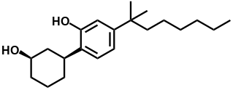
P3 | 1.43 | 338.2300 | 339.2299 | C₂₁H₃₂O₂ | 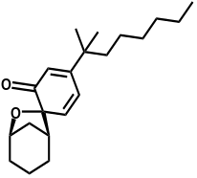
P4 | 1.43 | 338.2300 | 339.2299 | C₂₁H₃₂O₂ | 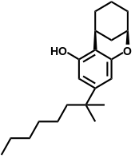
P5 | 1.43 | 338.2300 | 339.2299 | C₂₁H₃₂O₂ | 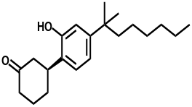

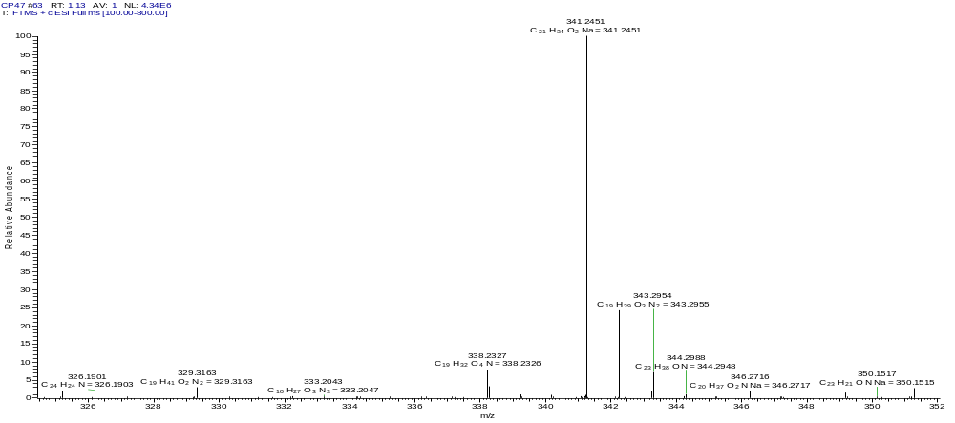

Fig S7. HRMS spectra of CP47,497 (m/z 341.2451, C₂₁H₃₄O₂Na)

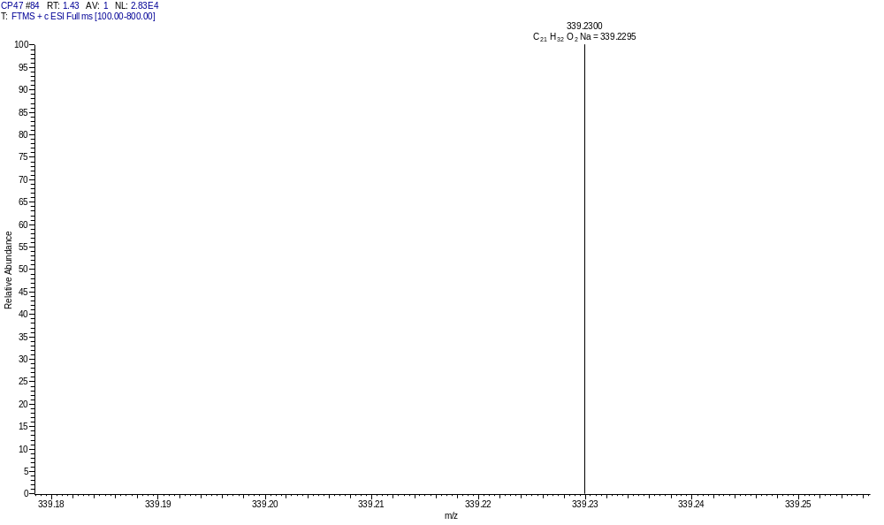
OR
OR

Fig S8. HRMS spectra of P4, P5 and P6 (m/z 339.2300, C₂₁H₃₂O₂Na)

Table S2. Overview of CP55,940 of the oxidation products observed in the UHPLC-LTQ/Orbitrap HRMS analysis and their corresponding information.
Compound | Retention  time  (min) | Measured  m/z  [M+Na]⁺ | Theoretical  m/z  [M+Na]⁺ | Chemical  formula | Structure
CP55,940 | 1.06 | 399.2862 | 399.2870 | C₂₄H₄₀O₃ | 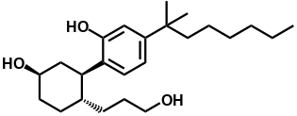
K3 | 1.53 | 397.2715 | 397.2713 | C₂₄H₃₈O₃ | 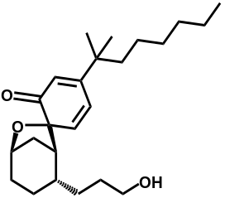
K4 | 1.53 | 397.2715 | 397.2713 | C₂₄H₃₈O₃ | 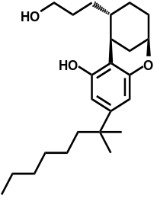
K5 | 1.53 | 397.2715 | 397.2713 | C₂₄H₃₈O₃ | 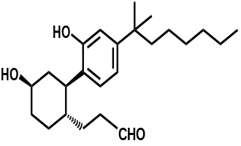
K6 | 1.53 | 397.2715 | 397.2713 | C₂₄H₃₈O₃ | 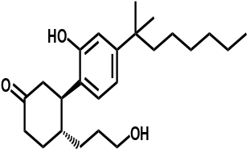

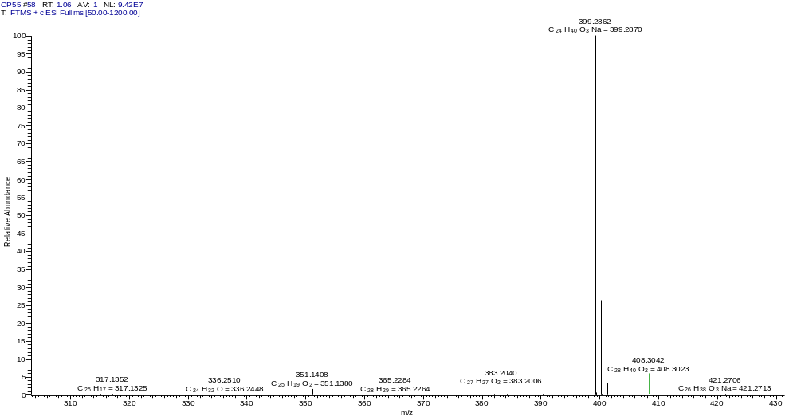
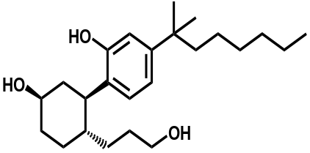

Fig S9. HRMS spectra of CP55,940 (m/z 399.23862, C₂₄H₄₀O₃Na)

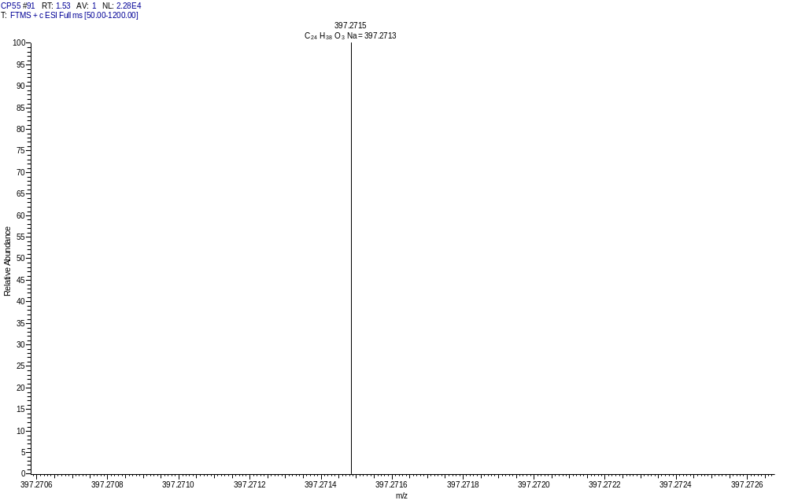

OR

OR

Fig S10. HRMS spectra of K3, K4, K5 and K6 (m/z 397.2715, C₂₄H₃₈O₃Na)
LC-MS/MS detection conditions.
Column conditions: Column: Shimadzu Shim pack Velox PFPP (2.1 mm x 100 mm, 2.7 μm), column temperature 40 ℃, mobile phase A is 10mmol ammonium acetate aqueous solution (containing 5% methanol), and mobile phase B is methanol; Gradient elution, elution procedure: 0-2 min, 20% B, 2-5 min, 20-95% B, 5-7 min, 95% B, 7-7.1 min, 95-20% B, 7.1-10 min, 20% B; The injection volume is 5 μL; The flow rate is 0.3 mL/min.
MS detection conditions: Multi reaction monitoring (MRM) negative ion mode; Atomization gas flow rate: 3 L/min; DL temperature: 250 ℃; Heating block temperature: 400 ℃; Dry gas flow rate: 15 L/min; Converting the voltage of the tanner pole: 6.0 kV; CID gas: 230kPa.
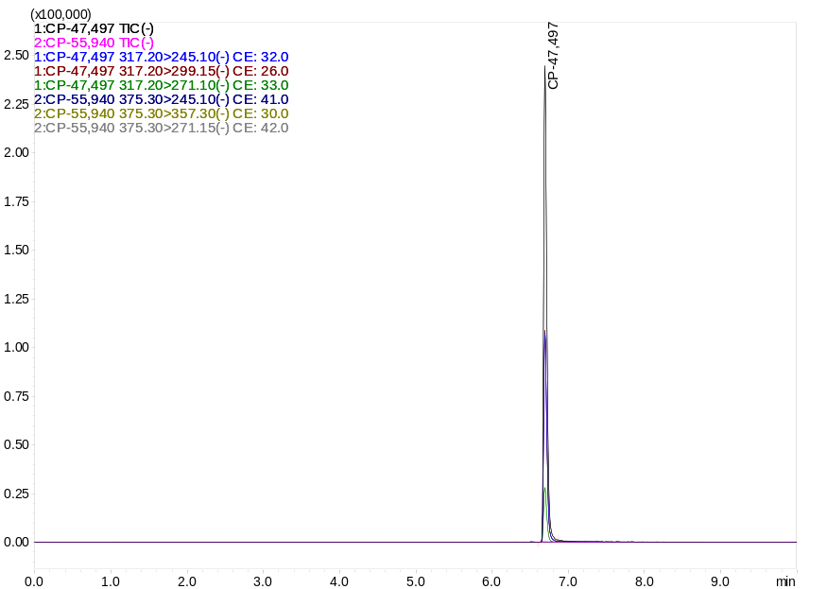

Fig S11. MRM chromatogram of e-cigarettes sample 1 containing CP 47,497

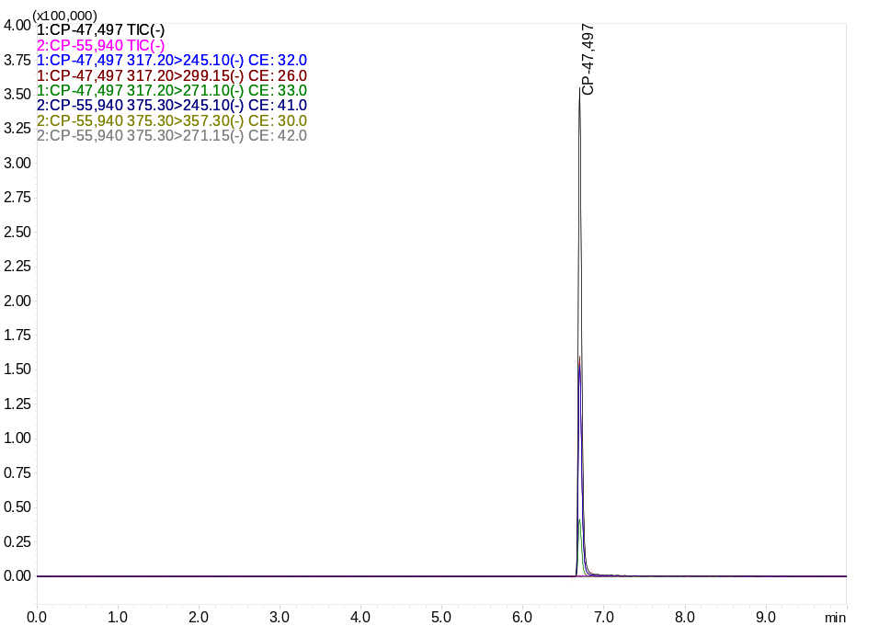

Fig S12. MRM chromatogram of e-cigarettes sample 2 containing CP 47,497

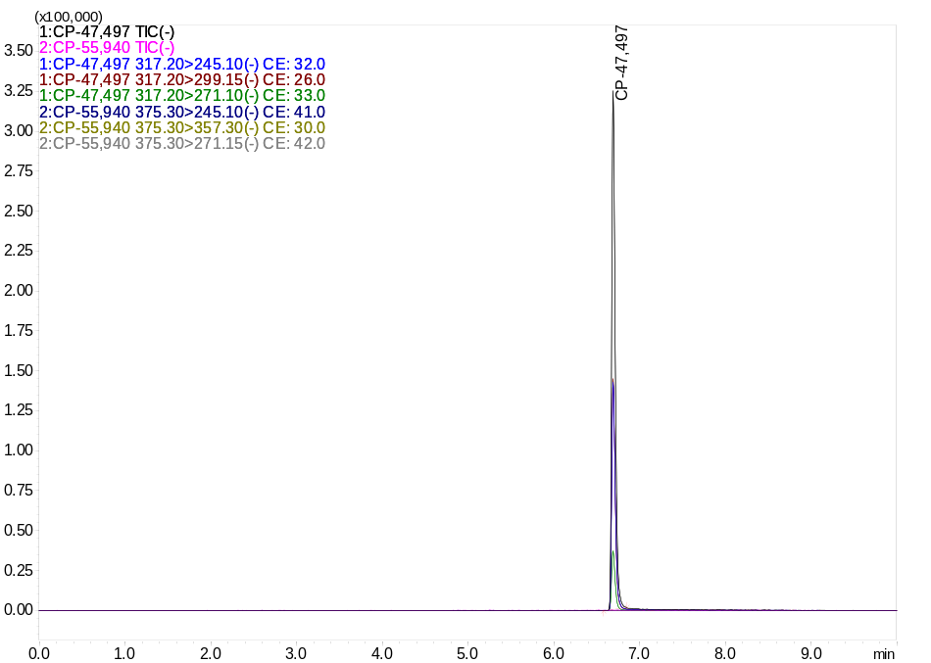
Fig S13. MRM chromatogram of e-cigarettes sample 3 containing CP 47,497

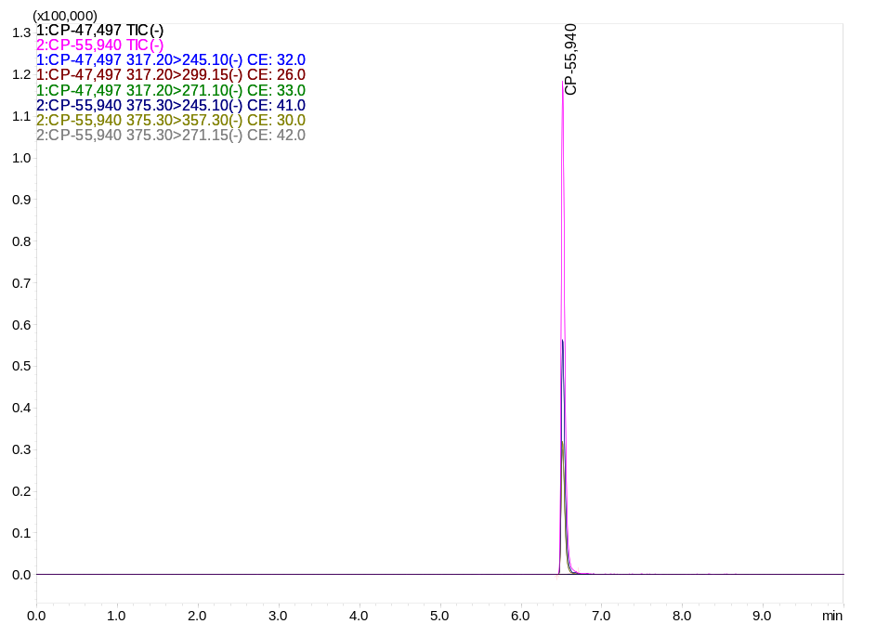
Fig S14. MRM chromatogram of e-cigarettes sample 1 containing CP 55,940

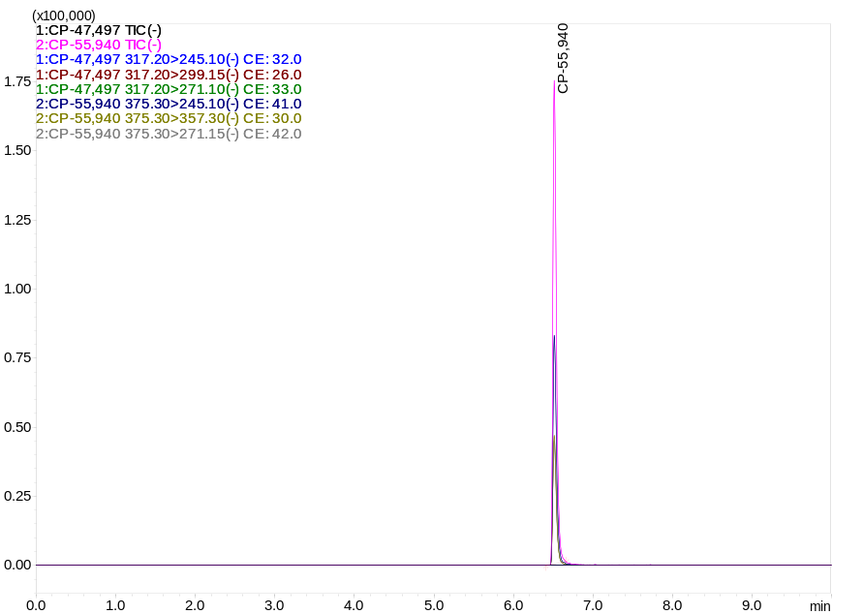
Fig S15. MRM chromatogram of e-cigarettes sample 2 containing CP 55,940

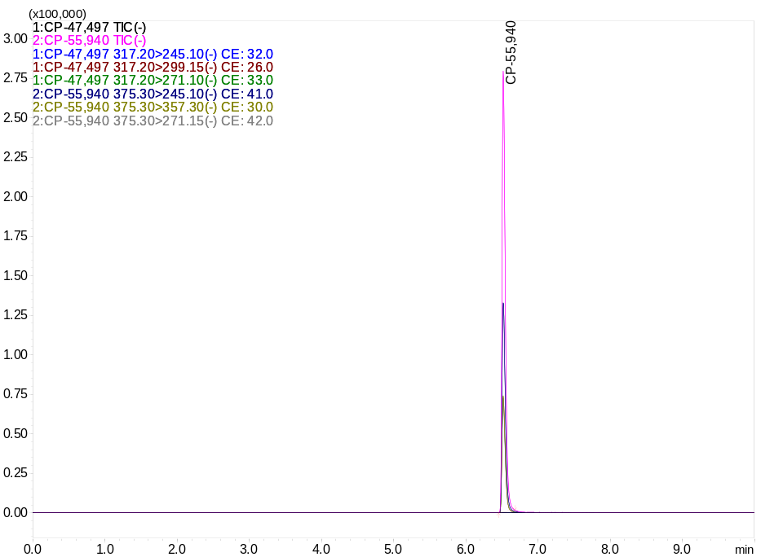
Fig S16. MRM chromatogram of e-cigarettes sample 3 containing CP 55,940

References
1. Nguyen V H, Van Tan L, Lee T D Nguyen (2021) Solvothermal synthesis and photocatalytic activity of metal-organic framework materials based on bismuth and trimesic acid, Sustain. Chem Pharm 20: 100385. https://doi.org/10.1016/j.scp.2021.100385
2. Wang X, Ma X, Wang H, Huang P, Du X, Lu X (2017) A zinc(II) benzenetricarboxylate metal organic framework with unusual adsorption properties, and its application to the preconcentration of pesticides. Microchim Acta 184: 3681-3687. https://doi.org/10.1007/s00604-017-2382-1

