An Ultra-Robust Ultra-Broadband Modified Moiré Varifocal MetaLens for Terahertz Wave
Changlin Sun^{1,2}, Zhiqiang Zeng^{1,3}, Weijun Wang⁴, Lianghui Du^{1,5,7}, Xiaoyin Chen¹, Jin Leng¹, Jiang Li^{1,5}, Zhongquan Wen⁶, Pengfei Qi², Weiwei Liu² and Li-Guo Zhu^{1,2,5,8}
¹Institute of Fluid Physics, China Academy of Engineering Physics, Mianyang 621900, China
²Institute of Modern Optics, Nankai University, Tianjin Key Laboratory of Micro-scale Optical Information Science and Technology, Tianjin 300350, China
³School of Mathematics and Physics, Yibin University, Yibin 644000, China
⁴Institute of Applied Electronics, China Academy of Engineering Physics, Chengdu 610200, China
⁵Microsystem & Terahertz Research Center, China Academy of Engineering Physics, Chengdu 610200, China
⁶Key Laboratory of Optoelectronic Technology and Systems, Ministry of Education, Chongqing University, Chongqing, China
⁷Email: lianghui_du@163.com
⁸Email: zhuliguo@tsinghua.org.cn

Contents

S1. Principle of the Modified Moiré Varifocal MetaLens 1
S2. Calculation of Focusing Efficiency 4
S3. Microstructural Elements of the Modified Moiré Terahertz Varifocal Metalens 5
S4. Processing of Experimental Data 7
S5. Evaluation of Axial Distance on Lens Focusing Performance 8
Reference 11

S1. Principle of the Modified Moiré Varifocal MetaLens
The tunable zoom metalens consists of two identical geometric phase metasurfaces placed "face-to-face." Based on the Moiré effect, the transmission functions of the two geometric phase metasurfaces (MS1 and MS2) that form the composite lens are complex conjugates of each other. In polar coordinates, they can be expressed as¹:
$$\begin{aligned}T_{1}\left(r,θ_{0}\right)=\exp\left(iar^{2}θ_{0}\right)\#\left(S1\right)\end{aligned}$$
$$\begin{aligned}T_{2}\left(r,θ_{0}\right)=\exp\left(-iar^{2}θ_{0}\right)\#\left(S2\right)\end{aligned}$$
where $a$ is a constant, and $r$ and $θ_{0}$ are the polar coordinate parameters measured from the center of the phase plate. When MS2 is rotated by an angle $θ$ around the optical axis relative to MS1, the transmission function $T_{2}$ becomes:
$$\begin{aligned}T_{2,\text{ rot }}\left(r,θ_{0};θ\right)=\exp\left[-iar^{2}\left(θ_{0}+θ\right)\right]\#\left(S3\right)\end{aligned}$$
At this point, the transmission function of the composite metalens formed by combining MS1 and MS2 is:
$$\begin{aligned}T_{c}\left(r,θ_{0};θ\right)=T_{1}\left(r,θ_{0}\right)T_{2,\text{ rot }}\left(r,θ_{0};θ\right)=\exp\left(-iar^{2}θ\right)\#\left(S4\right)\end{aligned}$$
From the equation above, it's evident that when MS1 and MS2 are rotated by a relative angle $θ_{0}$, the transmission function of the composite metalens changes with $θ_{0}$, enabling dynamic tunability.
For a traditional spherical lens with a wavelength $λ_{0}$ and a focal length $f$, the transmission function is given by:
$$\begin{aligned}T_{\text{lens }}=\exp\left(-i\frac{πr^{2}}{λ_{0}f}\right)\#\left(S5\right)\end{aligned}$$
By comparing the equations, the focal length $f$ of the zoom metalens can be expressed as:
$$\begin{aligned}f=\frac{π}{θaλ_{0}}\#\left(S6\right)\end{aligned}$$
Clearly, when the constant $a$ and wavelength $λ_{0}$ are fixed, the focal length $f$ of the composite metalens changes solely with $θ$, meaning $f=f(θ)$. If we set a reference focal length:
$$F_{0}=1/\left(aλ_{0}\right)$$
Then,
$$\begin{aligned}f\left(θ\right)=\frac{π}{θ}F_{0}\#\left(S7\right)\end{aligned}$$
As Equation (S7) shows, after setting a reference focal length, the focal length $f\left(θ\right)$ is inversely proportional to the rotation angle $θ=0$, meaning the focal length can be adjusted by rotating the angle. However, it is important to note that when the relative rotation angle $θ=0$, the focal length $f(θ=0)→∞$ approaches infinity, meaning the composite metalens cannot focus when $θ=0$, and thus cannot continuously adjust the focus around the reference focal length $F_{0}$.
Moreover, due to the periodic nature of the function in Equation (S4), the relative rotation of the two metasurfaces cannot distinguish between clockwise $|θ|$ and counterclockwise rotation angles $-(2π-|θ|)$, resulting in a sector appearing between the radial lines $φ=π$ and $φ=π+θ$ due to phase discontinuity. To avoid this phase discontinuity, the transmission functions of MS1 and MS2 can be modified as follows:
$$\begin{aligned}T_{1}\left(r,θ_{0}\right)=\exp\left[i\text{ round }\left\{ar^{2}\right\}θ_{0}\right]\#\left(S8\right)\end{aligned}$$
$$\begin{aligned}T_{2}\left(r,θ_{0}\right)=\exp\left[-i\text{ round }\left\{ar^{2}\right\}θ_{0}\right]\#\left(S9\right)\end{aligned}$$
where $\text{round}\left\{…\right\}$ is the rounding function, ensuring that the phase shift changes in integer multiples of 2π. This results in the phase distributions of MS1 and MS2 being:
$$\begin{aligned}φ_{1}\left(r,θ_{0}\right)=θ_{0}\operatorname{round}\left\{ar^{2}\right\}\#\left(S10\right)\end{aligned}$$
$$\begin{aligned}φ_{2}\left(r,θ_{0}\right)=-θ_{0}\text{ round }\left\{ar^{2}\right\}\#\left(S11\right)\end{aligned}$$
After rotating MS1 and MS2 by a relative angle $θ$, the total phase distribution $φ$ of the composite metalens becomes:
$$\begin{aligned}φ\left(r,θ\right)=φ_{1}\left(r,θ_{0}\right)+φ_{2}\left(r,θ_{0}+θ\right)=-θ\text{ round }\left\{ar^{2}\right\}\#\left(S12\right)\end{aligned}$$
This equation indicates that the total phase distribution of the composite metalens can be easily adjusted by simply changing the relative rotation angle $θ=0$. It is particularly important to note that, as analyzed in Equations S7, the composite metalens cannot focus when $θ=0$.
To address this, a bias term can be added to allow the composite metalens to focus around a certain offset focal length $F_{\text{offset }}$. A simple and general approach is to distribute the bias factor evenly across the two geometric phase metasurfaces, rewriting the phase distributions $φ_{1}$ and $φ_{2}$ as:
$$\begin{aligned}φ_{1}\left(r,θ_{0}\right)=θ_{0}\text{ round }\left\{\frac{1}{λ_{0}F_{0}}r^{2}\right\}-\frac{π}{2λ_{0}F_{\text{offset }}}r^{2}\#\left(S13\right)\end{aligned}$$
$$\begin{aligned}φ_{2}\left(r,θ_{0}\right)=-θ_{0}\operatorname{round}\left\{\frac{1}{λ_{0}F_{0}}r^{2}\right\}-\frac{π}{2λ_{0}F_{\text{offset }}}r^{2}\#\left(S14\right)\end{aligned}$$
After rotating MS1 and MS2 by a relative angle $θ$, the total phase distribution $φ$ of the composite metalens becomes:
$$\begin{aligned}φ\left(r,θ\right)=φ_{1}\left(r,θ_{0}\right)+φ_{2}\left(r,θ_{0}+θ\right)=-θ\text{ round }\left\{\frac{1}{λ_{0}F_{0}}r^{2}\right\}-\frac{π}{λ_{0}F_{\text{offset }}}r^{2}\#\left(S15\right)\end{aligned}$$
Under paraxial conditions, by comparing the phase distribution of a traditional spherical lens with wavelength $λ_{0}$ and focal length $f$, given by: $φ_{\text{lens }}=-πr^{2}/λ_{0}f$, we obtain:
$$\begin{aligned}\frac{π}{λ_{0}f}=\frac{θ}{λ_{0}F_{0}}+\frac{π}{λ_{0}F_{\text{offset }}}\#\left(S16\right)\end{aligned}$$
Simplifying, we get:
$$\begin{aligned}\frac{1}{f\left(θ\right)}=\frac{1}{F_{0}}\frac{θ}{π}+\frac{1}{F_{\text{offset }}}\#\left(S17\right)\end{aligned}$$
Here, we set $F_{0}=F_{\text{offset }}.$Thus, the tunable focal length of the composite metalens is:
$$\begin{aligned}f\left(θ\right)=\frac{π}{θ+π}F_{\text{offset }}\#\left(S18\right)\end{aligned}$$
where $θ$ is the relative rotation angle between the two geometric phase metasurfaces, and $F_{\text{offset }}$ is the preset offset focal length. Clearly, once the offset focal length $F_{\text{offset }}$ is determined, the tunable focal length $f(θ)$ of the metalens will depend solely on the relative rotation angle $θ$. In other words, the zoom function of the metalens can be easily and conveniently achieved by simply rotating the two metasurfaces relative to each other.

S2. Calculation of Focusing Efficiency
In the first step, we need to obtain the full width at half maximum (FWHM) of the spot by performing a Gaussian fit. Once we have the FWHM, we can calculate the focusing efficiency. The specific method involves defining a square region on the focal plane, centered on the point of maximum intensity, with a side length equal to three times the FWHM. We then sum the electric field intensities within this region to get $E_{A}$. Dividing this by the total intensity $E_{P}$ of the entire focal plane, and multiplying by the transmission efficiency $S$ of the two metasurfaces, gives us the focusing efficiency²:
$$\begin{aligned}η=\frac{E_{\text{A} }}{E_{\text{total} }}=\frac{E_{\text{A} }}{E_{\text{p} }}×\frac{E_{\text{p} }}{E_{\text{total} }}={\left|S\right|}^{2}\frac{E_{\text{A} }}{E_{\text{p} }}\#\left(S19\right)\end{aligned}$$
This approach ensures that the calculation focuses on the most relevant region of the focal spot, while incorporating the metasurface transmission for an accurate representation of focusing efficiency.

S3. Microstructural Elements of the Modified Moiré Terahertz Varifocal Metalens
The metalens is composed of a series of subwavelength microstructural elements arranged in a specific pattern to achieve focusing and imaging functions³. To focus the incident plane wave, each microstructural element of the metalens must impart a spatially and wavelength-dependent phase distribution. According to Fermat's principle, the required phase distribution for the transmitted light to form a spherical wavefront on the metasurface typically adopts a hyperboloidal phase distribution. This ensures that the optical path difference is compensated by the phase gradient of the microstructural elements at different spatial positions. When the wavelength of the incident plane wave is λ, the phase difference corresponding to the optical path difference is:
$$\begin{aligned}dφ=\frac{2π}{λ}\left(\sqrt{r^{2}+f^{2}}-f\right)\#\left(S20\right)\end{aligned}$$
To achieve the necessary hyperboloidal phase distribution, the microstructural elements at specific points on the metalens should compensate for the phase gradient, denoted as $dφ$. Therefore, the phase at any spatial position r on the metalens can be expressed as $φ(r)$.
$$\begin{aligned}φ\left(r\right)=2mπ-\frac{2π}{λ}\left(\sqrt{r^{2}+f^{2}}-f\right)\#\left(S21\right)\end{aligned}$$
However, due to the finite size of the artificial microstructural elements, an ideal continuous phase distribution cannot be practically achieved in a metalens. Typically, when the microstructural elements provide discrete phase values such as 0°, 45°, 90°, 135°, 180°, 225°, 270°, and 315°, the metalens can still achieve good focusing and imaging performance. Thus, by calculating the ideal phase values at arbitrary spatial positions based on the radius and focal length $f$ of the designed metalens, and selecting the closest available phase values, a near-spherical wavefront can be approximated, enabling the metalens to focus and image effectively.
The modified Moiré-based varifocal metalens utilizes the principle of geometric phase control to achieve a 0–2π phase coverage. The microstructural elements consist of rectangular silicon blocks on a silicon substrate, with a 2 µm thick SiO₂ isolation layer embedded between the silicon substrate and the rectangular silicon blocks. The subwavelength microstructural elements forming the metalens are of uniform size, and wavefront control is achieved by varying the azimuthal angle α of the rectangular silicon blocks.
First, for a working wavelength of λ =118.8μm (corresponding to a frequency of 2.52 THz), the geometric parameters of the subwavelength microstructural elements were optimized through simulation software. Under the conditions of achieving high and stable cross-polarized wave amplitude transmittance and 2π phase modulation, while minimizing the coupling effects between adjacent elements, the geometric parameters for the subwavelength microstructural elements were determined as follows: periodicity P = 0.394λ(46.8 µm), length L = 0.326λ (38.7 µm), and width W = 0.09λ (10.7 µm), as shown in Figure S1. Next, the height of the rectangular silicon blocks was optimized to determine the relationship between amplitude transmittance and block height t. As shown in Figure S2, the amplitude transmittance of the cross-polarized wave increases slowly with increasing block height, reaching a maximum value of 0.9 at t 78.1µm. However, a larger block height corresponds to a higher aspect ratio, which can pose significant fabrication challenges for the metalens. Therefore, a balance must be struck between amplitude transmittance and fabrication difficulty. To ensure a relatively low aspect ratio and sufficiently high amplitude transmittance, a block height of t = 0.553λ (65.7 µm) was selected. And the microscopic image of the microstructure unit of the metasurface lens provides a detailed view of the intricate design and arrangement of the subwavelength components that form the lens (refer to Figure S3).

S4. Processing of Experimental Data
For each data point that needs to be measured (e.g., the focal length at a fixed rotation angle), we first use theoretical simulations to derive an approximate range for the accurate value. Within this range, we select multiple points for spot imaging. All captured spot images are then processed, with the main focus being the extraction of the Full Width at Half Maximum (FWHM) of the spots. By analyzing the trend in spot size variation, we identify the precise focal position.
Given that the size of a Gaussian beam near its waist varies quadratically with distance according to the equation:
$$\begin{aligned}{w^{2}\left(z\right)}/{w_{0}^{2}}-{z^{2}}/{z_{0}^{2}}=1,\#\left(S22\right)\end{aligned}$$
we apply a quadratic fitting to determine the FWHM of the spots and the focal position, as illustrated in the process shown in Figure 4b of the main text. Figure S4 shows the raw images of these spots. All parameter extractions in the text are performed using a similar method.

S5. Evaluation of Axial Distance on Lens Focusing Performance
In the modified MML, the phase distributions of the two metasurfaces, MS1 and MS2, remain as shown in Fig. 1(a). However, when there is an axial distance d between MS1 and MS2, the diffraction effect alters the phase distribution. As a result, the phase distribution $φ_{1}$ from MS1, after propagating through the distance d, no longer remains the original $φ_{1}$ but transforms into $φ_{1d}$. This modified phase distribution $φ_{1d}$) combines with the phase distribution $φ_{2}$ on MS2 to yield a total phase $φ_{dc}$.The diffraction effect between MS1 and MS2 is described by the Huygens-Fresnel principle⁴:
$$\begin{aligned}U_{2}\left(x_{2},y_{2}\right)=∬GU_{1}\left(x_{1},y_{1}\right)dx_{1}dy_{1}\#\left(S23\right)\end{aligned}$$
where $G=exp⁡\left(i⋅2πr/λ_{0}\right)/r$ is the diffraction transfer function, $U_{1}=exp⁡\left(iφ_{1}\right)$ represents the complex amplitude of MS1, and $r=\sqrt{{\left(x_{2}-x_{1}\right)}^{2}+{\left(y_{2}-y_{1}\right)}^{2}+d^{2}}$ denotes the distance between any two microstructure units on MS1 and MS2. The phase $φ_{1d}$ is obtained from the phase angle of $arg⁡\left(U_{2}\right)$, allowing the calculation of the combined total phase $φ_{dc}$.
Figure S5 shows that as the axial distance d increases from 5$λ$ to 30$λ$, the phase distributions $φ_{1d}$ and $φ_{dc}$ become increasingly blurred, leading to a deterioration in the focusing performance of the metasurface lens. By calculating the total phase $φ_{dc}$, the light intensity distribution in the x-z propagation plane and the x-y focal plane of the metasurface lens can be simulated. Similarly, the impact of lateral displacement between the two metasurfaces can be evaluated using a similar approach.
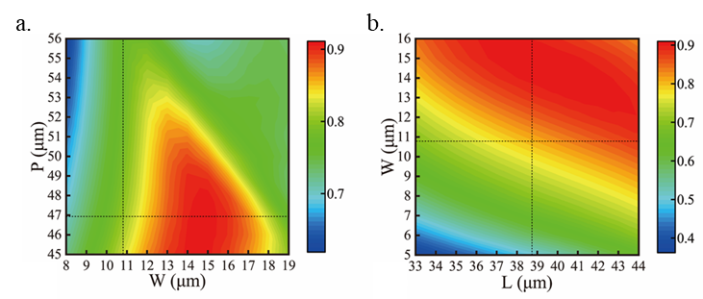
Figure S1. (a) Relationships between transmittance and the period and width of microstructure unit. (b) Relationships between transmittance and the width and length of microstructure unit.
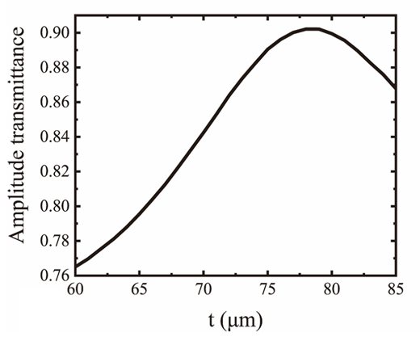
Figure S2. Relationships between transmittance and the height of microstructure unit.
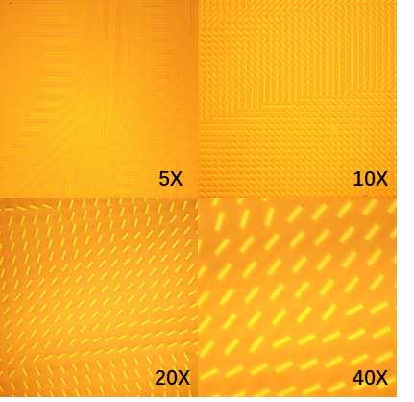
Figure S3. The microscopic image of the microstructure unit of the metalens.

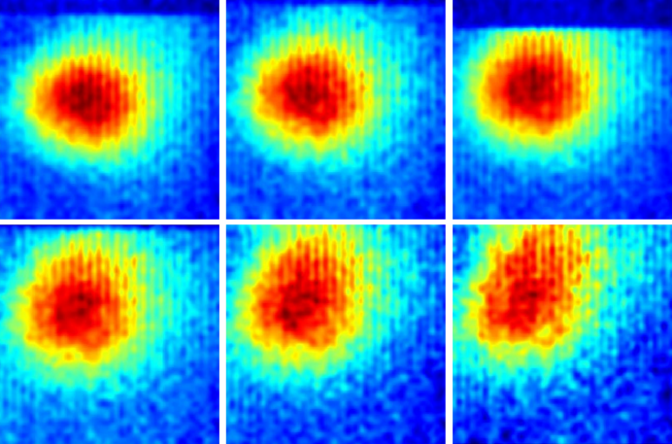
Figure S4. Spot near the focal length at $ω$ = 2.52 THz, θ = -90°.
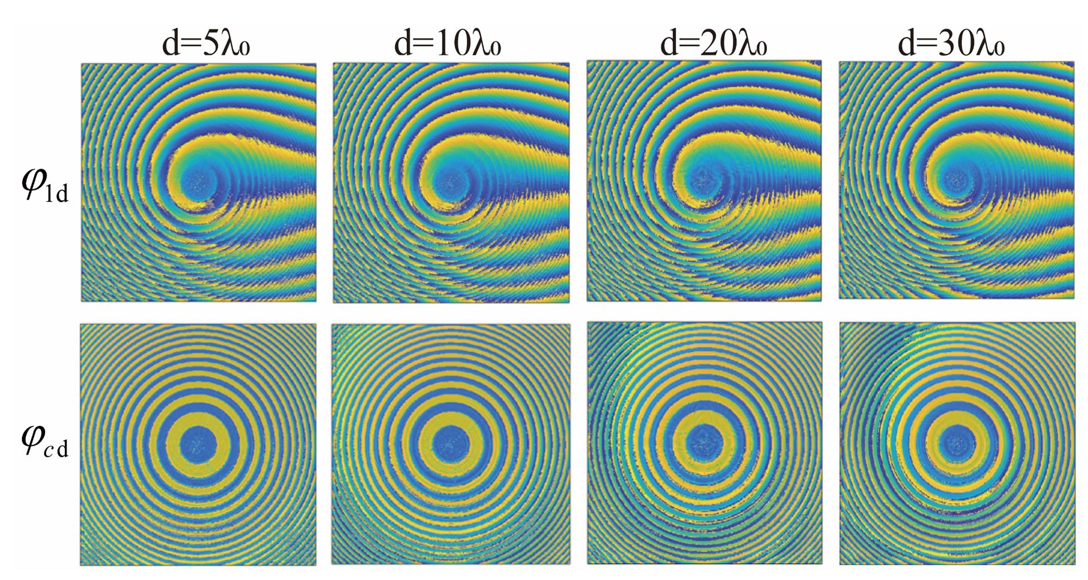
Figure S5. The phase distribution $φ_{1d}$of metasurface MS1 after propagating over an axial distance 𝑑 and the total phase distribution $φ_{cd}$ after combining with the phase
$φ_{2}$ of MS2.

Reference
1. Bernet S, Harm W, Ritsch-Marte M. Demonstration of focus-tunable diffractive Moiré-lenses. Opt Express 21, 6955-6966 (2013).
2. Ji W, Cai T, Xi Z, Urbach P. Highly Efficient and Broadband Achromatic Transmission Metasurface to Refract and Focus in Microwave Region. Laser & Photonics Reviews 16, 2100333 (2022).
3. Berry MV. Quantal phase factors accompanying adiabatic changes. Proceedings of the Royal Society of London A Mathematical and Physical Sciences 392, 45-57 (1984).
4. Qian Y, Hu B, Du Z, Liu J. Reinforced design method for moir&#x00E9; metalens with large spacing. Opt Express 29, 26496-26508 (2021).

