Supplementary material

eTable 1. Baseline characteristics of the participants enrolled in the cross-section study.
Characteristics | Overall | Female | Male
Participants, n | 97735 | 52479 | 45256
Age (years), mean (SD) | 64.51 (2.87) | 64.44 (2.86) | 64.59 (2.88)
White, n (%) | 95971 (98.2) | 51542 (98.2) | 44429 (98.2)
Education =high, n (%) | 30894 (31.6) | 15432 (29.4) | 15462 (34.2)
Smoking status ,n(%)
Current | 7679 (7.9) | 3374 (6.4) | 4305 (9.5)
Never | 49939 (51.1) | 30669 (58.4) | 19270 (42.6)
Previous | 40117 (41.0) | 18436 (35.1) | 21681 (47.9)
Drinking habits ,n(%)
Daily or almost daily | 22749 (23.3) | 9467 (18.0) | 13282 (29.3)
1-4 times a week | 45689 (46.7) | 22943 (43.7) | 22746 (50.3)
One to three times a month | 9733 (10.0) | 6291 (12.0) | 3442 (7.6)
Special occasions only/Never | 19564 (20.0) | 13778 (26.3) | 5786 (12.8)
Fruits&Vegetables ≥ 5 portion, n(%) | 41195 (42.1) | 25552 (48.7) | 15643 (34.6)
Vitamin intake, n(%) | 15982 (16.4) | 9827 (18.7) | 6155 (13.6)
Mineral intake, n(%) | 20324 (20.8) | 12344 (23.5) | 7980 (17.6)
Hypertension, n(%) | 82133 (84.1) | 42134 (80.3) | 39999 (88.4)
Diabetes, n(%) | 21191 (24.4) | 10060 (21.8) | 11131 (27.4)
MET(minutes/week), median (IQR) | 720 (420, 1800) | 720 (480, 1680) | 720 (360, 2040)
WC(cm), median (IQR) | 91 (82.0, 100.0) | 84.0 (77.0, 93.0) | 97.0 (90.0, 104)
Fat percentage, median (IQR) | 32.0 (26.1, 38.40) | 37.6 (33.4, 41.8) | 26.3 (22.6, 29.9)
BMI, median (IQR) | 26.9 (24.5, 29.9) | 26.5 (23.9, 29.8) | 27.4 (25.1, 30.0)
Obesity classified by BMI, n(%) | 24045 (24.6) | 12639 (24.1) | 11406 (25.2)
Obesity classified by WC, n(%) | 64094 (65.6) | 35277 (67.2) | 28817 (63.7)
Obesity classified by fat percentage, n(%) | 29715 (30.4) | 18604 (35.5) | 11111 (24.6)

eTable 2. Spearman's correlation coefficients for obese indicators.
Characteristics | Spearman's rank correlation coefficients | p |  | Spearman's partial correlation coefficients | p
Overall
BMI - BMD | 0.12 | <0.01 |  | 0.11 | <0.01
WC - BMD | 0.19 | <0.01 |  | 0.19 | <0.01
Fat pct - BMD | -0.14 | <0.01 |  | -0.13 | <0.01
Female
BMI - BMD | 0.13 | <0.01 |  | 0.13 | <0.01
WC - BMD | 0.10 | <0.01 |  | 0.11 | <0.01
Fat pct - BMD | 0.13 | <0.01 |  | 0.13 | <0.01
Male
BMI - BMD | 0.07 | <0.01 |  | 0.08 | <0.01
WC - BMD | 0.02 | <0.01 |  | 0.03 | <0.01
Fat pct - BMD | 0.03 | <0.01 |  | 0.04 | <0.01

eTable 3. Association between obesity and the risk of osteoporosis.
Group | Obesity definition | Model 1 |  |  | Model 2
 |  | HR (95%CI) | p |  | HR (95%CI) | p
Having | Yes
diseases | BMI | 0.74 (0.70, 0.78) | < 0.01 |  | 0.71 (0.67, 0.75) | < 0.01
 | Fat percentage | 0.82 (0.79, 0.87) | < 0.01 |  | 0.81 (0.77, 0.85) | < 0.01
 | WC | 0.71 (0.68, 0.74) | < 0.01 |  | 0.70 (0.66, 0.73) | < 0.01
 | No
 | BMI | 0.65 (0.53, 0.81) | < 0.01 |  | 0.63 (0.51, 0.78) | < 0.01
 | Fat percentage | 0.77 (0.67, 0.89) | < 0.01 |  | 0.76 (0.65, 0.88) | < 0.01
 | WC | 0.80 (0.72, 0.89) | < 0.01 |  | 0.79 (0.70, 0.88) | < 0.01
Drinking | Frequent
habits | BMI | 0.72 (0.67, 0.77) | < 0.01 |  | 0.72 (0.66, 0.77) | < 0.01
 | Fat percentage | 0.81 (0.77, 0.86) | < 0.01 |  | 0.81 (0.76, 0.86) | < 0.01
 | WC | 0.72 (0.68, 0.76) | < 0.01 |  | 0.72 (0.68, 0.76) | < 0.01
 | Occasion/never
 | BMI | 0.66 (0.61, 0.72) | < 0.01 |  | 0.66 (0.61, 0.71) | < 0.01
 | Fat percentage | 0.76 (0.71, 0.81) | < 0.01 |  | 0.76 (0.71, 0.81) | < 0.01
 | WC | 0.68 (0.64, 0.73) | < 0.01 |  | 0.68 (0.63, 0.72) | < 0.01
Smoking | Ever-smoker
habits | BMI | 0.74 (0.68, 0.79) | < 0.01 |  | 0.71 (0.66, 0.77) | < 0.01
 | Fat percentage | 0.84 (0.79, 0.90) | < 0.01 |  | 0.83 (0.77, 0.88) | < 0.01
 | WC | 0.76 (0.71, 0.81) | < 0.01 |  | 0.75 (0.71, 0.80) | < 0.01
 | Never-smoker
 | BMI | 0.67 (0.62, 0.73) | < 0.01 |  | 0.66 (0.61, 0.71) | < 0.01
 | Fat percentage | 0.76 (0.71, 0.81) | < 0.01 |  | 0.75 (0.70, 0.80) | < 0.01
 | WC | 0.66 (0.63, 0.70) | < 0.01 |  | 0.66 (0.62, 0.70) | < 0.01
Exercise | High level
 | BMI | 0.73 (0.68, 0.78) | < 0.01 |  | 0.71 (0.66, 0.75) | < 0.01
 | Fat percentage | 0.83 (0.78, 0.87) | < 0.01 |  | 0.81 (0.77, 0.86) | < 0.01
 | WC | 0.72 (0.69, 0.76) | < 0.01 |  | 0.71 (0.68, 0.75) | < 0.01
 | Low level
 | BMI | 0.66 (0.60, 0.73) | < 0.01 |  | 0.64 (0.58, 0.70) | < 0.01
 | Fat percentage | 0.74 (0.69, 0.81) | < 0.01 |  | 0.72 (0.67, 0.78) | < 0.01
 | WC | 0.67 (0.62, 0.73) | < 0.01 |  | 0.65 (0.60, 0.70) | < 0.01
*Obesity definition: BMI: body mass index (≥ 30); Fat percentage (female≥ 40, male ≥30 ); WC: waist circumstance (female ≥80cm, male ≥94cm).

eTable 4. Analysis of BMI and WC/fat percentage in relation to osteoporosis risk.
Group | Characteristic | No (cases), % | HR (95% CI) | p
Overall | BMI + WC
 | Moderate BMI + lower WC | 41738 (2406), 5.8 | reference
 | Lower BMI + lower WC | 40932 (3450), 8.4 | 1.68 (1.59, 1.77) | < 0.01
 | Lower BMI + higher WC | 3465 (104), 3.0 | 1.65 (1.35, 2.02) | < 0.01
 | Moderate BMI + higher WC | 47232 (1344), 2.9 | 1.11 (1.04, 1.19) | < 0.01
 | higher BMI + lower WC | 3480 (203), 5.8 | 0.86 (0.75, 1.00) | 0.04
 | higher BMI + higher WC | 40887 (1491), 3.6 | 0.91 (0.86, 0.95) | < 0.01
Overall | BMI + Fat percentage
 | Moderate BMI + lower Fat pct | 46237 (727), 1.6 | reference
 | Lower BMI + lower Fat pct | 31085 (2172), 7.0 | 1.99 (1.80, 2.19) | < 0.01
 | Lower BMI + higher Fat pct | 13312 (1382), 10.4 | 1.76 (1.57, 1.97) | < 0.01
 | Moderate BMI + higher Fat pct | 42733 (3023), 7.1 | 1.21 (1.09, 1.34) | < 0.01
 | higher BMI + lower Fat pct | 10888 (135), 1.2 | 0.95 (0.79, 1.14) | 0.56
 | higher BMI + higher Fat pct | 33479 (1559), 4.7 | 1.02 (0.92, 1.14) | 0.66
Female | BMI + WC
 | Moderate BMI + lower WC | 26737 (1939), 7.3 | reference
 | Lower BMI + lower WC | 22934 (2611), 11.4 | 1.63 (1.54, 1.73) | < 0.01
 | Lower BMI + higher WC | 807 (114), 14.1 | 2.00 (1.65, 2.41) | < 0.01
 | Moderate BMI + higher WC | 20767 (1590), 7.7 | 1.04 (0.97, 1.11) | 0.29
 | higher BMI + lower WC | 1074 (76), 7.1 | 0.97 (0.82, 1.22) | 0.78
 | higher BMI + higher WC | 22681 (1350), 6.0 | 0.82 (0.77, 0.88) | < 0.01
Female | BMI + Fat percentage
 | Moderate BMI + lower Fat pct | 23290 (1712), 7.4 | reference
 | Lower BMI + lower Fat pct | 22943 (2625), 11.4 | 1.62 (1.52, 1.72) | < 0.01
 | Lower BMI + higher Fat pct | 798(100), 12.5 | 1.72 (1.40, 2.10) | < 0.01
 | Moderate BMI + higher Fat pct | 24214 (1817), 7.5 | 1.00 (0.94, 1.07) | 0.91
 | higher BMI + lower Fat pct | 672 (40), 6.0 | 0.80 (0.59, 1.10) | 0.17
 | higher BMI + higher Fat pct | 23083 (1386), 6.0 | 0.82 (0.76, 0.88) | < 0.01
Male | BMI + WC
 | Moderate BMI + lower WC | 19678 (227), 1.2 | reference
 | Lower BMI + lower WC | 19592 (434), 2.2 | 1.94 (1.65, 2.28) | < 0.01
 | Lower BMI + higher WC | 1051 (28), 2.7 | 2.25 (1.52, 3.33) | < 0.01
 | Moderate BMI + higher WC | 21707 (325), 1.5 | 1.29 (1.09, 1.53) | < 0.01
 | higher BMI + lower WC | 588 (3), 0.5 | 0.46 (0.15, 1.43) | 0.17
 | higher BMI + higher WC | 20118 (301), 1.5 | 1.35 (1.13, 1.60) | < 0.01
Male | BMI + Fat percentage
 | Moderate BMI + lower Fat pct | 20772 (239), 1.2 | reference
 | Lower BMI + lower Fat pct | 18819 (407), 2.2 | 1.87 (1.59, 2.19) | < 0.01
 | Lower BMI + higher Fat pct | 1824 (55), 3.0 | 2.46 (1.83, 3.30) | < 0.01
 | Moderate BMI + higher Fat pct | 20613 (313), 1.5 | 1.26 (1.07, 1.49) | < 0.01
 | higher BMI + lower Fat pct | 1236 (11), 0.9 | 0.81 (0.44, 1.48) | 0.49
 | higher BMI + higher Fat pct | 19470 (293), 1.5 | 1.33 (1.12, 1.58) | < 0.01
eFigure 1. subgroup analysis.
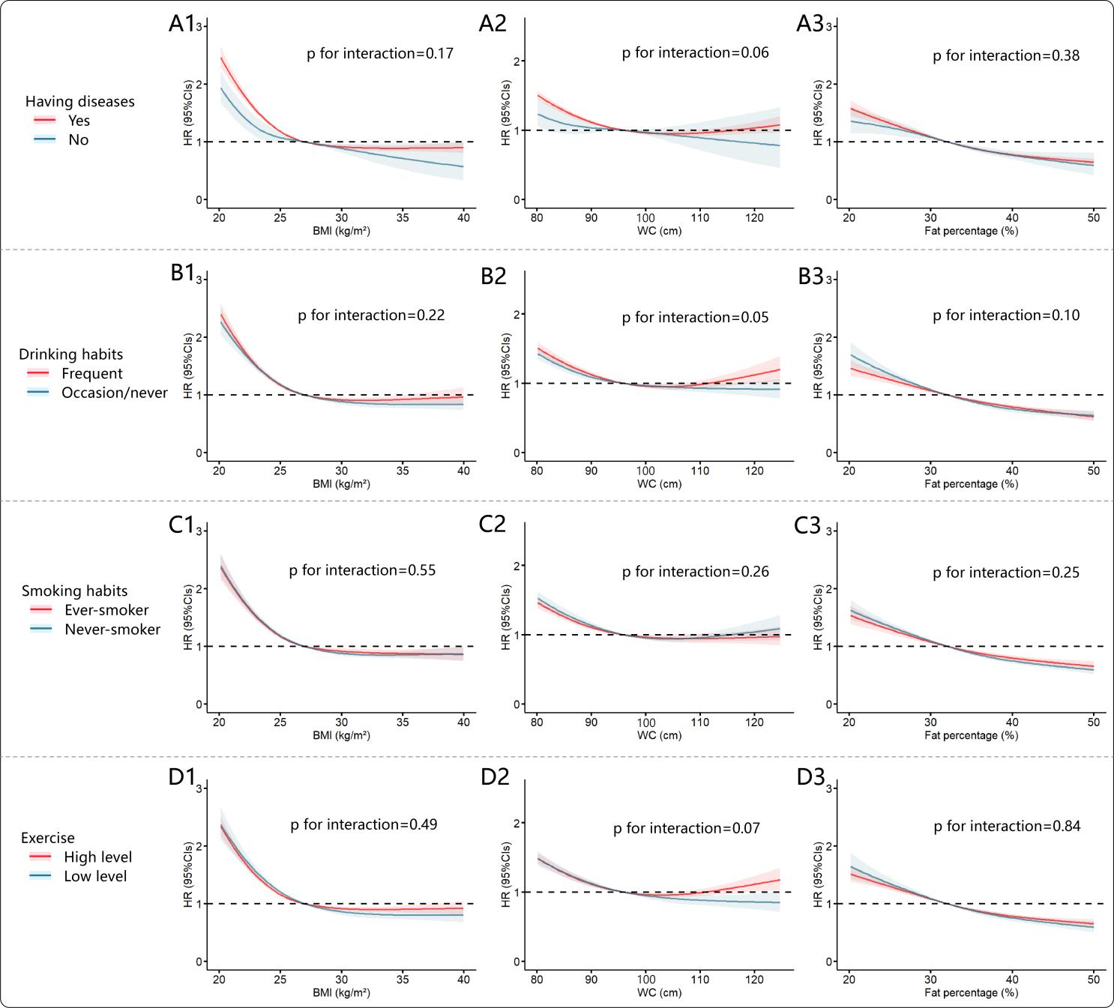

eFigure 2. BMI and WC/fat percentage interaction analysis. WC and fat percentage were classified by median into high and low levels.
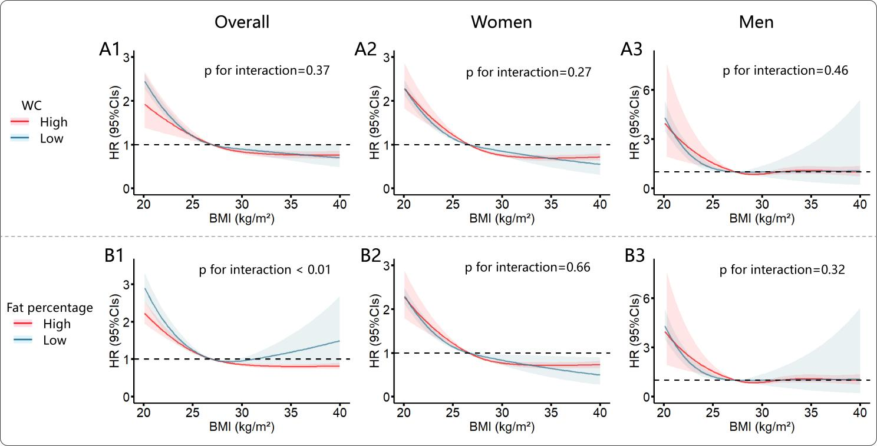

STROBE Statement—checklist of items that should be included in reports of observational studies

 | Item No | Recommendation | Page number
Title and abstract | 1 | (a) Indicate the study’s design with a commonly used term in the title or the abstract | 1
Title and abstract | 1 | (b) Provide in the abstract an informative and balanced summary of what was done and what was found | 2
Introduction
Background/rationale | 2 | Explain the scientific background and rationale for the investigation being reported | 2-3
Objectives | 3 | State specific objectives, including any prespecified hypotheses | 3
Methods
Study design | 4 | Present key elements of study design early in the paper | 4
Setting | 5 | Describe the setting, locations, and relevant dates, including periods of recruitment, exposure, follow-up, and data collection | 4
Participants | 6 | (a) Cohort study—Give the eligibility criteria, and the sources and methods of selection of participants. Describe methods of follow-up  Case-control study—Give the eligibility criteria, and the sources and methods of case ascertainment and control selection. Give the rationale for the choice of cases and controls  Cross-sectional study—Give the eligibility criteria, and the sources and methods of selection of participants | 4
Participants | 6 | (b) Cohort study—For matched studies, give matching criteria and number of exposed and unexposed  Case-control study—For matched studies, give matching criteria and the number of controls per case
Variables | 7 | Clearly define all outcomes, exposures, predictors, potential confounders, and effect modifiers. Give diagnostic criteria, if applicable | 4-5
Data sources/ measurement | 8* | For each variable of interest, give sources of data and details of methods of assessment (measurement). Describe comparability of assessment methods if there is more than one group | 4-5
Bias | 9 | Describe any efforts to address potential sources of bias | 5
Study size | 10 | Explain how the study size was arrived at | 4
Quantitative variables | 11 | Explain how quantitative variables were handled in the analyses. If applicable, describe which groupings were chosen and why
Statistical methods | 12 | (a) Describe all statistical methods, including those used to control for confounding | 5-6
Statistical methods | 12 | (b) Describe any methods used to examine subgroups and interactions | 6
Statistical methods | 12 | (c) Explain how missing data were addressed | 5
Statistical methods | 12 | (d) Cohort study—If applicable, explain how loss to follow-up was addressed  Case-control study—If applicable, explain how matching of cases and controls was addressed  Cross-sectional study—If applicable, describe analytical methods taking account of sampling strategy | 4
Statistical methods | 12 | (e) Describe any sensitivity analyses | 6
Continued on next page
Results
Participants | 13* | (a) Report numbers of individuals at each stage of study—eg numbers potentially eligible, examined for eligibility, confirmed eligible, included in the study, completing follow-up, and analysed | 6
Participants | 13* | (b) Give reasons for non-participation at each stage | 4
Participants | 13* | (c) Consider use of a flow diagram
Descriptive data | 14* | (a) Give characteristics of study participants (eg demographic, clinical, social) and information on exposures and potential confounders | 6
Descriptive data | 14* | (b) Indicate number of participants with missing data for each variable of interest | 6
Descriptive data | 14* | (c) Cohort study—Summarise follow-up time (eg, average and total amount) | 6
Outcome data | 15* | Cohort study—Report numbers of outcome events or summary measures over time | 6
Outcome data | 15* | Case-control study—Report numbers in each exposure category, or summary measures of exposure
Outcome data | 15* | Cross-sectional study—Report numbers of outcome events or summary measures
Main results | 16 | (a) Give unadjusted estimates and, if applicable, confounder-adjusted estimates and their precision (eg, 95% confidence interval). Make clear which confounders were adjusted for and why they were included | 6-7
Main results | 16 | (b) Report category boundaries when continuous variables were categorized | 7
Main results | 16 | (c) If relevant, consider translating estimates of relative risk into absolute risk for a meaningful time period
Other analyses | 17 | Report other analyses done—eg analyses of subgroups and interactions, and sensitivity analyses | 7-8
Discussion
Key results | 18 | Summarise key results with reference to study objectives | 8
Limitations | 19 | Discuss limitations of the study, taking into account sources of potential bias or imprecision. Discuss both direction and magnitude of any potential bias | 10
Interpretation | 20 | Give a cautious overall interpretation of results considering objectives, limitations, multiplicity of analyses, results from similar studies, and other relevant evidence | 11
Generalisability | 21 | Discuss the generalisability (external validity) of the study results | 11
Other information
Funding | 22 | Give the source of funding and the role of the funders for the present study and, if applicable, for the original study on which the present article is based | 11

