Supplementary Information
Unified physio-thermodynamic descriptors via learned CO₂ adsorption properties in metal-organic frameworks
Emily Lin*, Yang Zhong, Gang Chen, Sili Deng*
Massachusetts Institute of Technology, 77 Massachusetts Ave, Cambridge, MA 02139, United States of America

* Corresponding author
Email: elin49@mit.edu, silideng@mit.edu

Appendix A. Data, Methods, and Framework
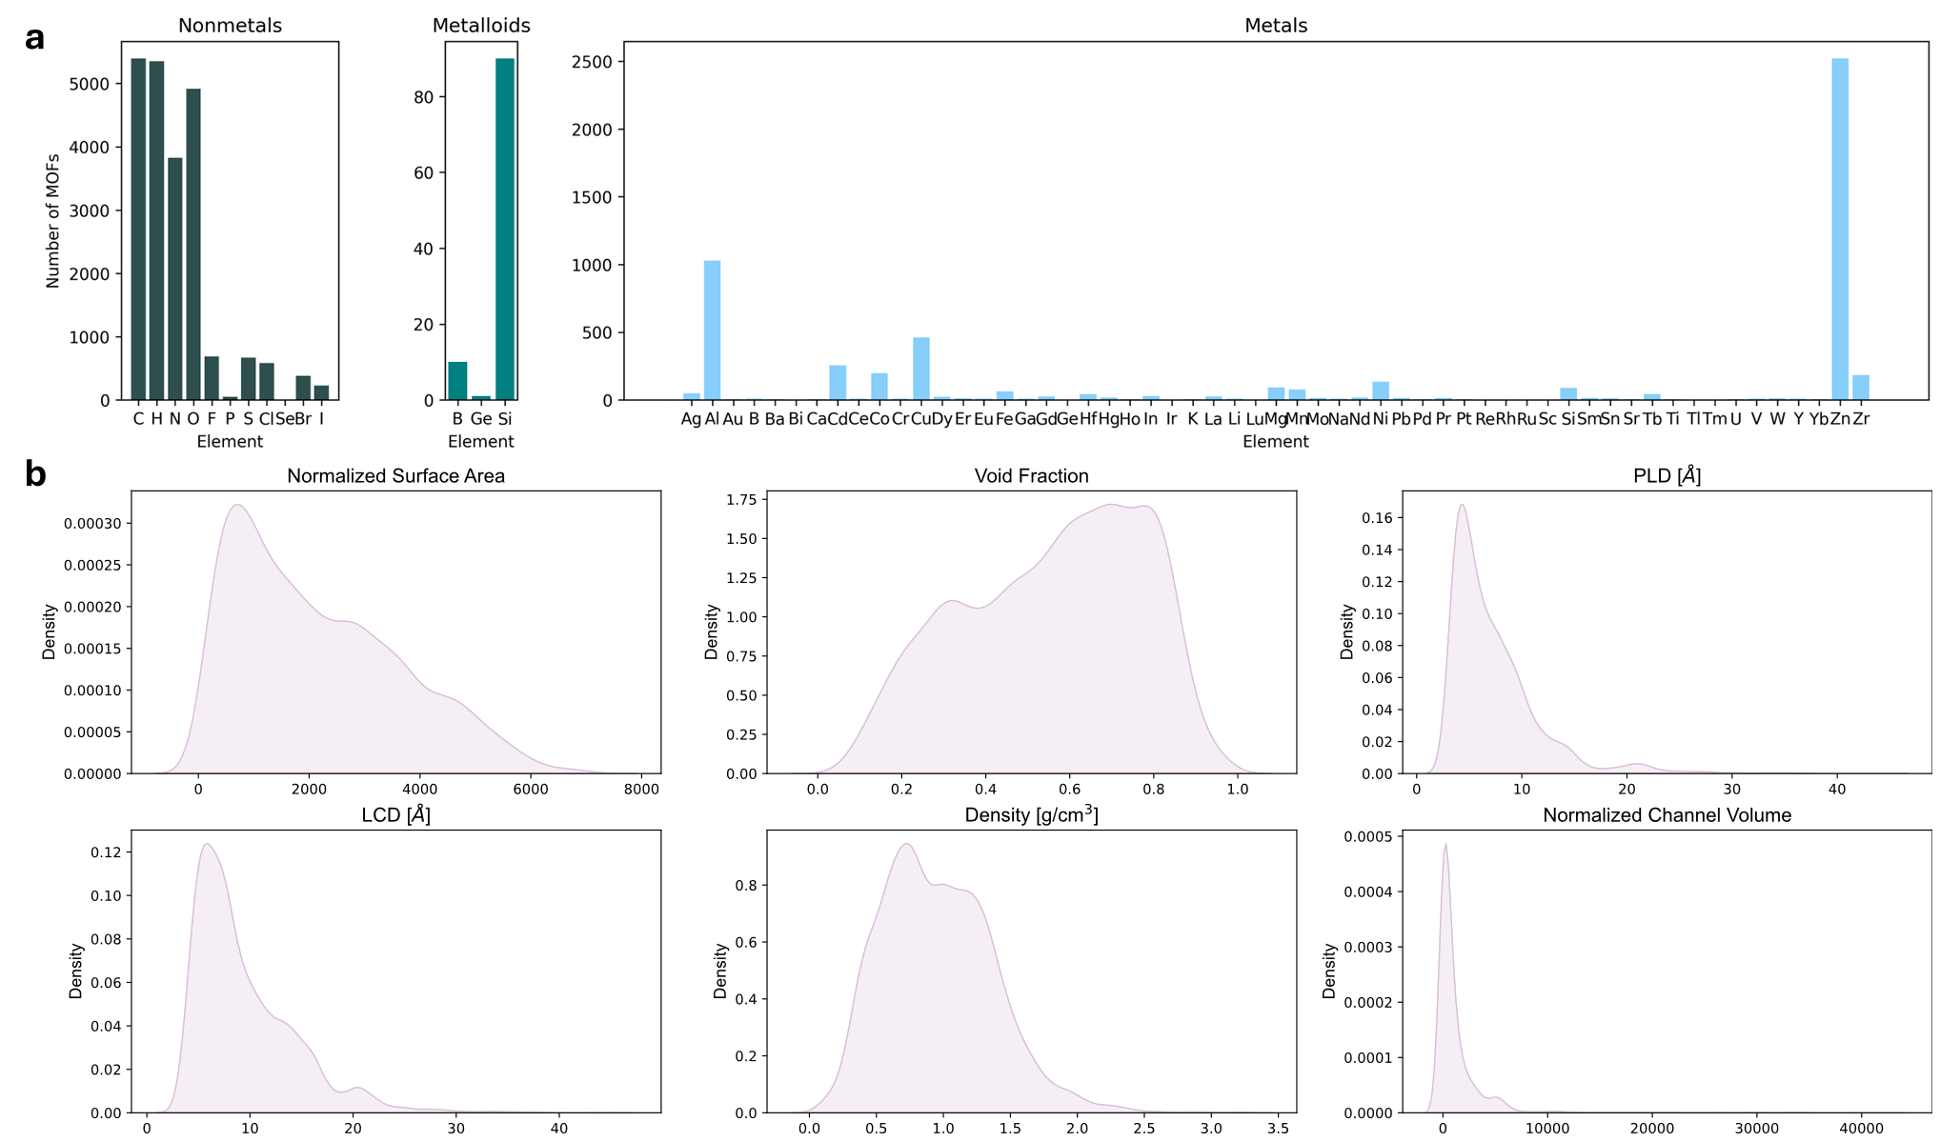
Fig. A.1. The data distribution based on (a) atomic and (b) global textural input features.

Data
Details A.1

This study utilized the Quantum MOF (QMOF) database, which consists of 20,375 MOFs. After post-processing the data, it was determined that 5,394 MOFs were suitable for CO₂ adsorption (limiting condition: pore-limiting diameter [PLD] $≥$ kinetic diameter of CO₂ = 3.3 Å). From the provided relaxed structure files (.cif), local nodal information (element, whether the atom is metallic and resides in a ring, coordination number, electronegativity, and position) and global textural information (pore-limiting diameter [PLD], largest cavity diameter [LCD], gravimetric surface area, void fraction, channel volume, density, and number of channels) were extracted using RDKit and Zeo++, respectively. The bond distances and adjacency matrices were similarly determined. The Lennard-Jones parameters for each element was derived from the Universal Forcefield (UFF) table¹. Additionally, Grand Canonical Monte Carlo (GCMC) simulations were used to compute the $ΔH_{ads}$ for different pressures (0.5-50 bars) using RASPA. The training, validation, and testing datasets are split 80/10/10.

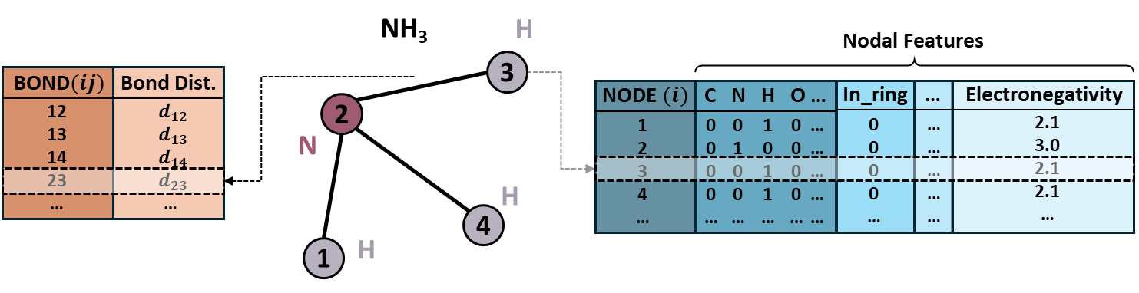

Hyperparameter Optimization
Details A.2

The study will utilize the Adam optimizer due to its ability to handle graphs (sparse matrices) with greater efficiency due to its adaptive nature. The hyperparameters that will be explored for this optimizer are the learning rate (from 1e-5 to 1) and weight decay (from 1e-6 to 1). Additionally, the graph attention mechanism will have tunable hyperparameters, namely the number of attention heads (from 1 to 16) and dropout ratio (from 0 to 0.5). These hyperparameters were fine-tuned using Optuna using the tree-structured parzen estimator (TPE) sampler, which utilizes a Gaussian mixture model (GMM) approach. The parameters were initialized as 1e-3, 1e-5, 0.5, and 4 for learning rate, weight decay, dropout ratio, and number of attention heads. The sampler adaptively tunes the hyperparameters until the lowest loss is achieved during the training/validation loop. Ultimately, it was determined that the optimal learning rate, weight decay, number of attention heads, and dropout ratio were 0.0167, 0.0001033, 12, and 0.3148, respectively. Finally, the number of layers and the size of the CGCNN, GAT, and fully-connected layers were tuned manually (experimenting with layer sizes ranging from 512 to 4). Ultimately, both the CGCNN and GAT will be composed of 2 layers, with the GAT having sizes of [128, 64] and CGCNN having sizes of [64, 32]. The fully-connected layer will have 3 layers, with sizes [16, 8, 4].

Network Architecture
Details A.3

In graph attention networks (GAT), an attention coefficient, $e_{ij}$, is computed based on interactions between a central node (in this case, node 2) and its surrounding nodes (nodes 1, 3, 4, $n$)/itself via a shared attention mechanism. These attention scores will dictate the relative importance of each neighbor node, which will be used to update the nodal representation of the central node. The attention coefficients are then normalized using a softmax function, and the results are aggregated by a non-linear activation function, designated by the sigmoid function. In the case of multi-head attention (as used in this work) to increase model robustness, the process is performed $k$ times, which designates the number of attention heads utilized.
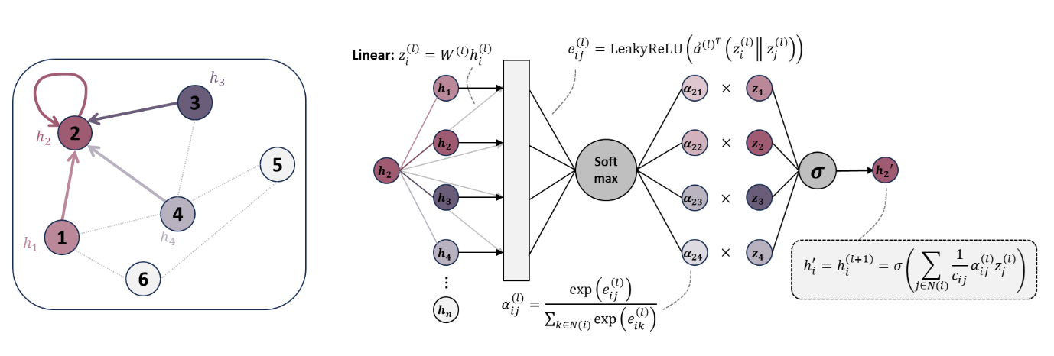
In graph convolution networks (GCN), a central node will update by aggregating information from its neighboring nodes via global pooling, max pooling, or averaging at each layer. The aggregated representation will be passed through a fully-connected linear layer to map to the desired output. The below figure illustrates a central node 2 receiving “messages”, or information, from neighboring nodes 1, 3, and 4. Similarly, a central node 4 is receiving messages from neighboring nodes 2 and $i$. Between layers, there will be message passing, or updates to the central nodal representation.
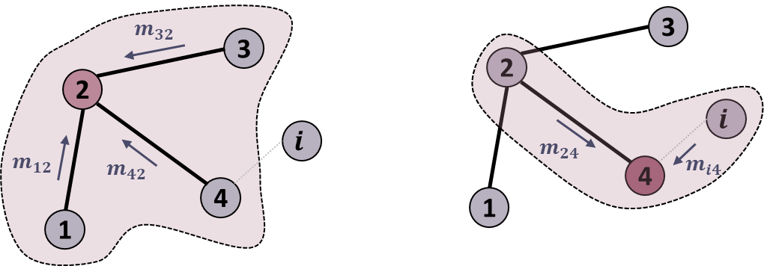
Network Architecture Optimization
Details A.4

For a combined GNN with an unoptimized feature set, in the former case, the MAE was 2.5873 kJ/mol (ref), while the latter case produced a MAE of 3.0522 kJ/mol. Further testing with an optimized feature set (combined GAT-CGCNN ref: 1.7809 kJ/mol) using only CGCNN layers yields a MAE of 5.1862 kJ/mol, and using only GAT layers produces a MAE of 2.3736 kJ/mol. In these studies, the global textural features are concatenated with the local features from the start (before any message passing layers). This reveals that graph attention is better suited for interpreting the local features into more useful learned representations compared to graph convolutions. Thus, GAT was established as the overall model's first message passing layers.

Appendix B. Results
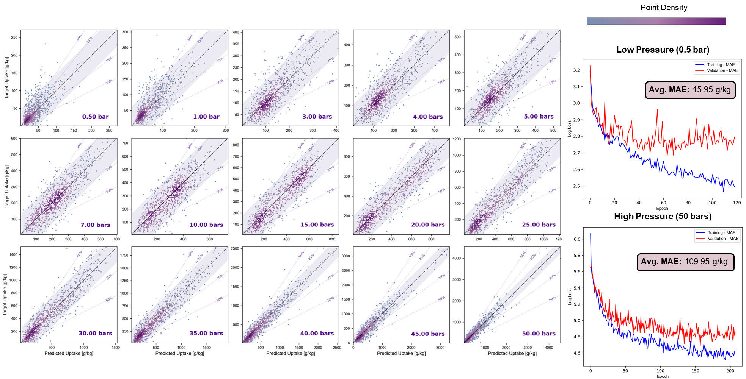
Fig. B.1. The parity (KDE point density) and loss plots for pressures ranging from 0.5 to 50 bars for uptake prediction. The 25th and 50th percentile ranges (dotted lines) and the 95% confidence intervals (shaded band) are marked.

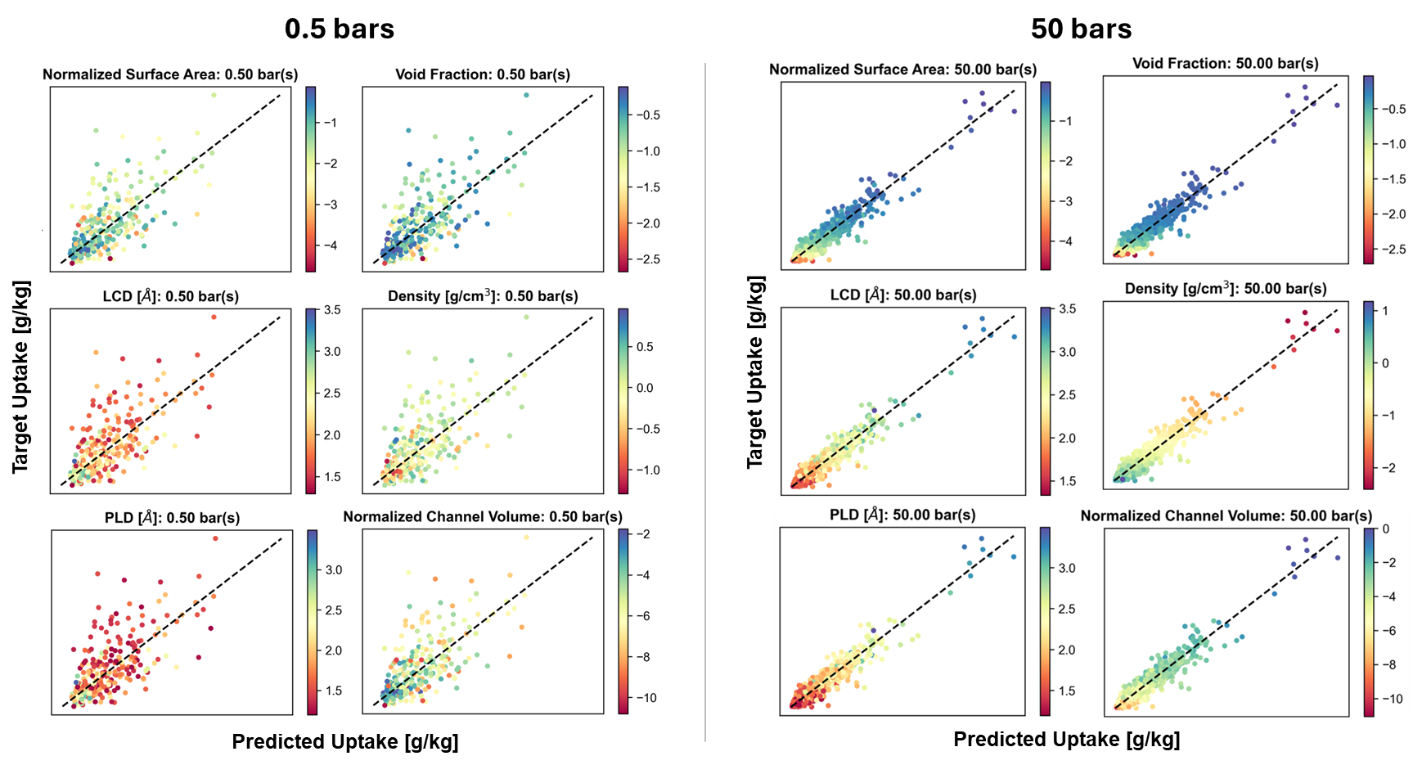
Fig. B.2. The parity plot for uptake prediction as a function of various textural properties (log-scale) at 0.5 bars and 50 bars. A distinct trend is seen at high pressures, not low pressures.

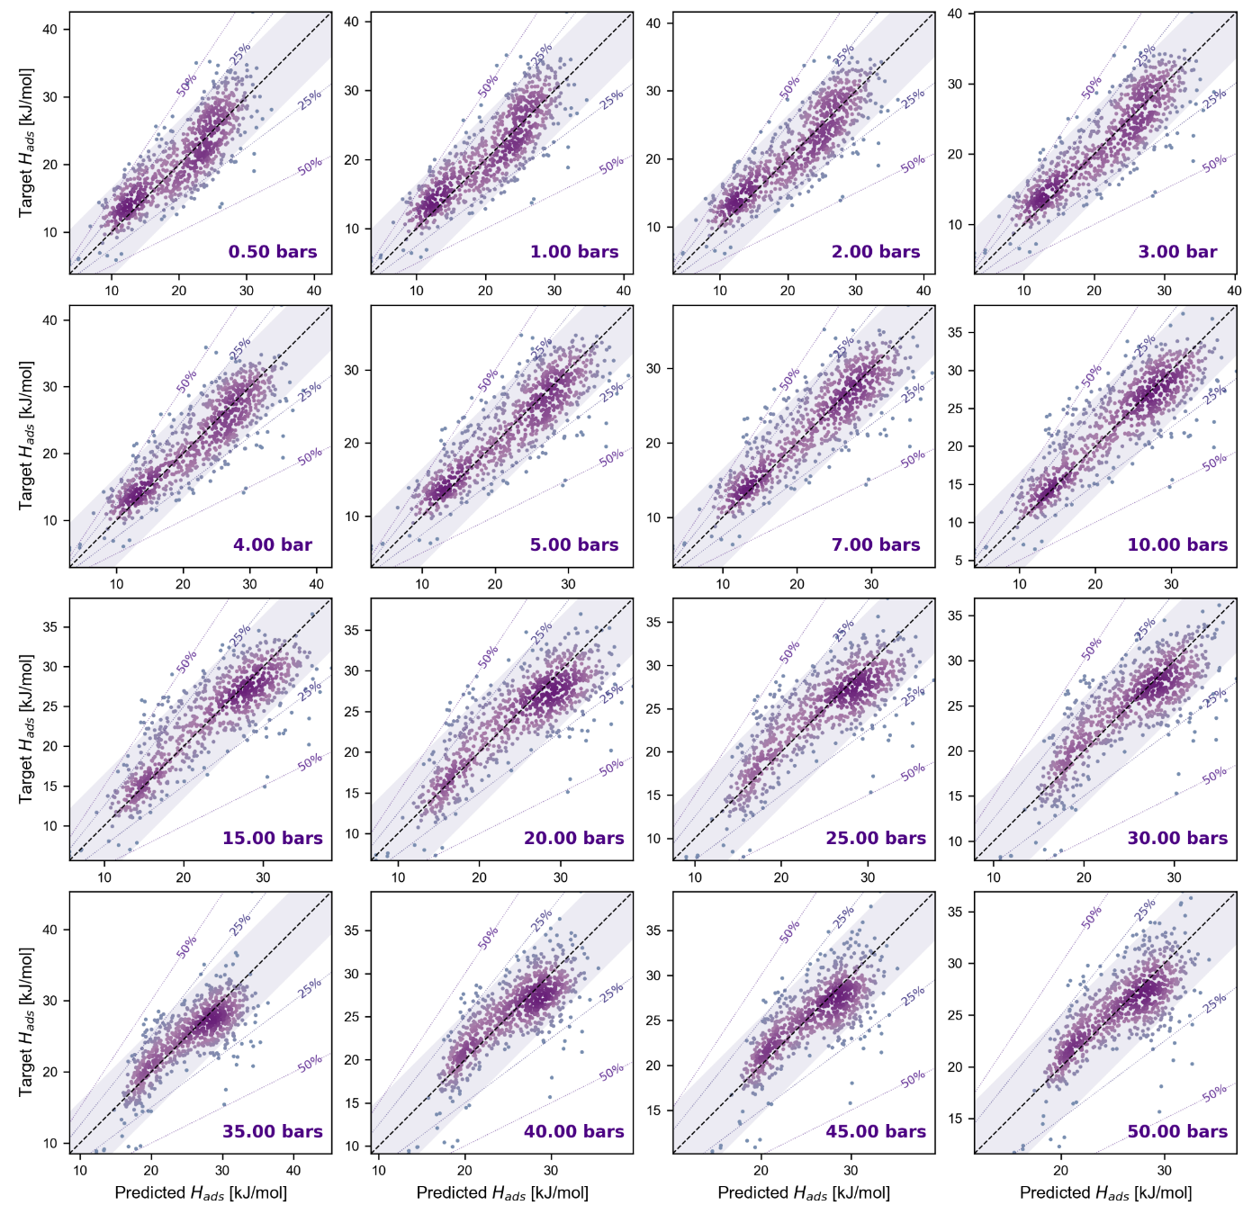
Fig. B.3. The parity (KDE point density) for pressures ranging from 0.5 to 50 bars for heat of adsorption prediction. The 25th and 50th percentile ranges (dotted lines) and the 95% confidence intervals (shaded band) are marked.

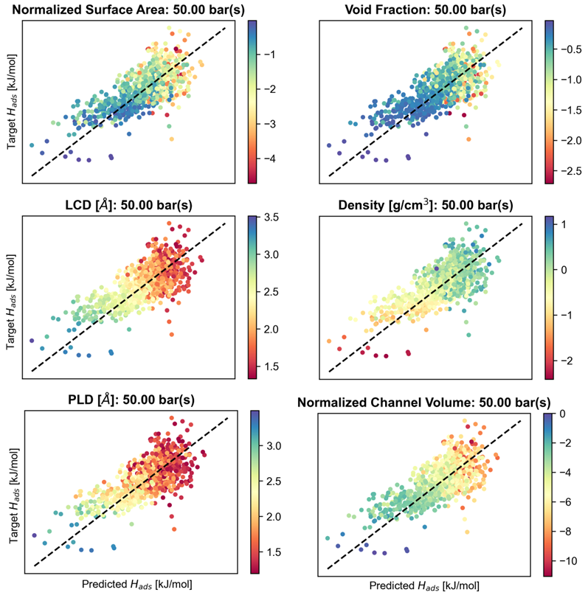
Fig. B.4. The parity plot for heat of adsorption prediction as a function of various textural properties (log-scale) at 50 bars. A distinct (similar) trend is seen at both low and high pressures.

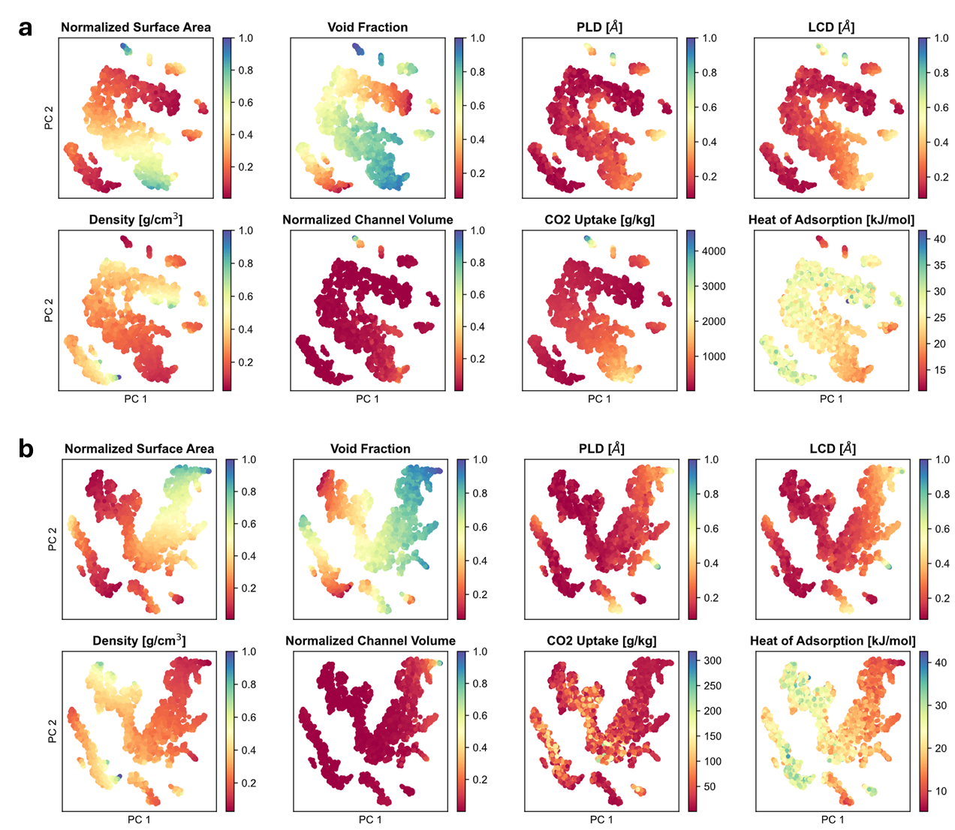
Fig. B.5. The t-distributed stochastic neighbor embedding (t-SNE) plots as a function of various textural properties.

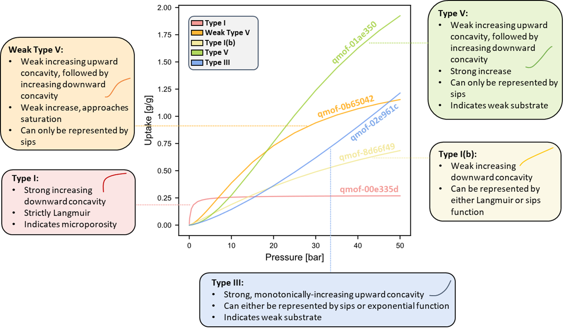
Fig. B.6. A general guide to the observed isotherm shapes in the Quantum MOF (QMOF) database. The typical characteristics for each isotherm type are detailed.

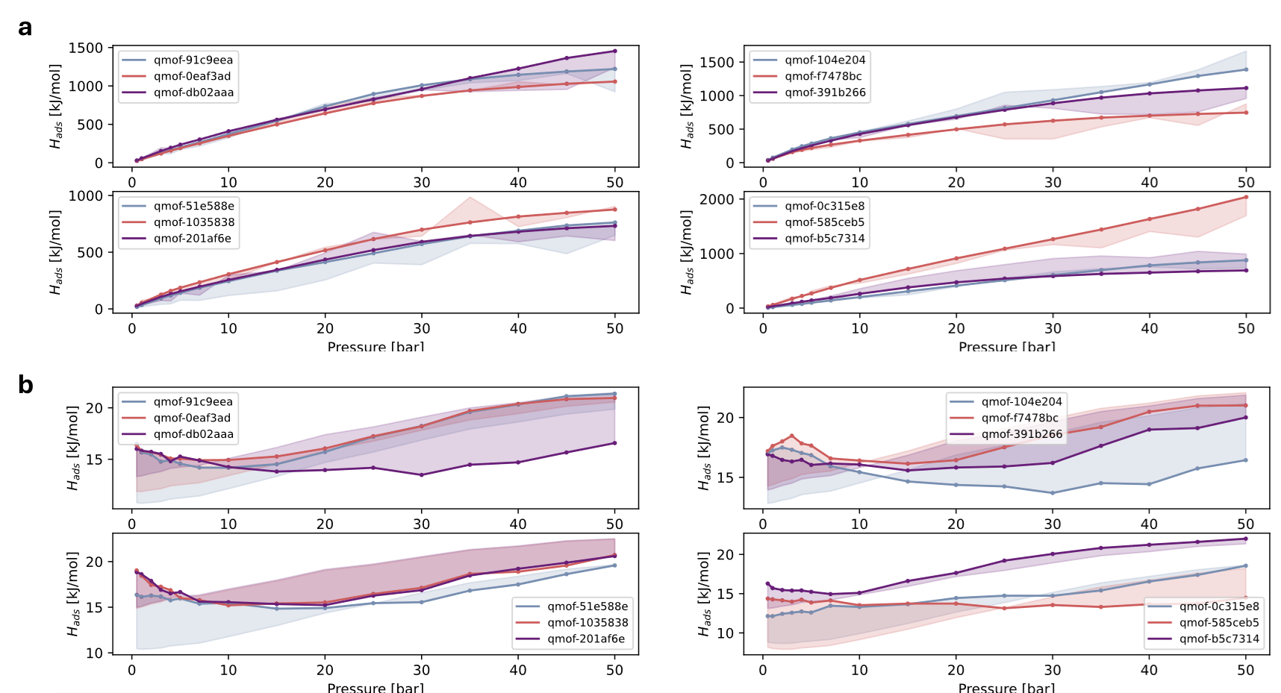
Fig. B.7. Additional Type I(b) plots of predicted (a) uptake showing the model’s tendency for (b) heat of adsorption underestimation for high uptake MOFs.

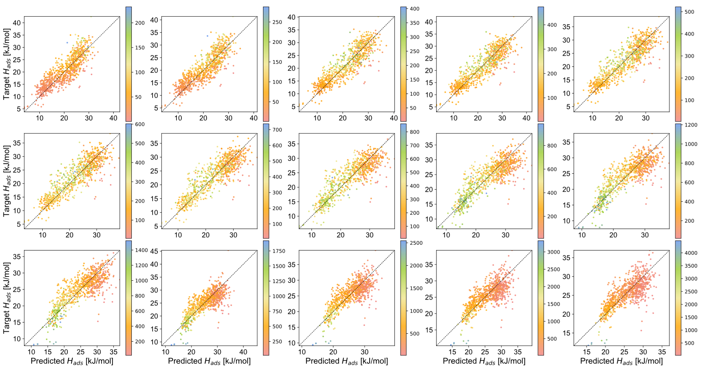
Fig. B.8. Parity plots for heat of adsorption as a function of uptake (colormap).

Table B.1. All descriptor functions as a function of pressure. The $x$ for descriptors 1 and 2 are different (tabulated below).
# | Pressure [bars] | Descriptor Function
1 | 0.5  1  3  4  5  7  10  15  20  25  30  35  40  50 | $$ΔH_{ads}=0.001899x^{3}-0.1345x^{2}+1.8762x+20.7178$$  $$ΔH_{ads}=0.001892x^{3}-0.1371x^{2}+1.9740x+20.8359$$  $$ΔH_{ads}=0.001736x^{3}-0.1342x^{2}+2.0336x+21.9337$$  $$ΔH_{ads}=0.001709x^{3}-0.1342x^{2}+2.0336x+21.9337$$  $$ΔH_{ads}=0.001738x^{3}-0.1369x^{2}+2.1253x+22.2966$$  $$ΔH_{ads}=0.001707x^{3}-0.1352x^{2}+2.1316x+22.0940$$  $$ΔH_{ads}=0.001706x^{3}-0.1343x^{2}+2.1291x+22.5792$$  $$ΔH_{ads}=0.001571x^{3}-0.1248x^{2}+1.9942x+23.3944$$  $$ΔH_{ads}=0.001429x^{3}-0.1248x^{2}+1.8056x+24.8569$$  $$ΔH_{ads}=0.001371x^{3}-0.1076x^{2}+1.7129x+24.5717$$  $$ΔH_{ads}=0.001252x^{3}-0.0975x^{2}+1.5391x+25.1093$$  $$ΔH_{ads}=0.001181x^{3}-0.0917x^{2}+1.4651x+25.2144$$  $$ΔH_{ads}=0.001089x^{3}-0.0841x^{2}+1.3399x+25.3008$$  $${ΔH}_{ads}=0.000980x^{3}-0.0745x^{2}+1.1909x+25.3081$$
2 | 0.5  1  3  4  5  7  10  15  20  25  30  35  40  50 | $${ΔH}_{ads}=0.131043x^{3}-0.2559x^{2}-0.6250x+31.0647$$  $${ΔH}_{ads}=0.040552x^{3}-0.7033x^{2}+0.9407x+29.7681$$  $${ΔH}_{ads}=0.183361x^{3}-2.6504x^{2}+7.3497x+25.3192$$  $${ΔH}_{ads}=0.006881x^{3}-0.1514x^{2}-3.7947x+40.7488$$  $${ΔH}_{ads}=0.260844x^{3}-3.5264x^{2}+9.6153x+24.6302$$  $${ΔH}_{ads}=0.321000x^{3}-4.2027x^{2}+11.4462x+23.4618$$  $${ΔH}_{ads}=0.422810x^{3}-5.3231x^{2}+14.7746x+20.8556$$  $${ΔH}_{ads}=0.507388x^{3}-6.1313x^{2}+16.7382x+20.0114$$  $${ΔH}_{ads}=0.562658x^{3}-6.6390x^{2}+18.0644x+19.6728$$  $${ΔH}_{ads}=0.495428x^{3}-5.9928x^{2}+16.4792x+19.8544$$  $${ΔH}_{ads}=0.587175x^{3}-6.6999x^{2}+18.4029x+18.0208$$  $${ΔH}_{ads}=0.551649x^{3}-6.1690x^{2}+16.4959x+19.7897$$  $${ΔH}_{ads}=0.517788x^{3}-5.8616x^{2}+15.9049x+19.4722$$  $$ΔH_{ads}=0.5017592x^{3}-5.4304x^{2}+14.4098+20.3145$$

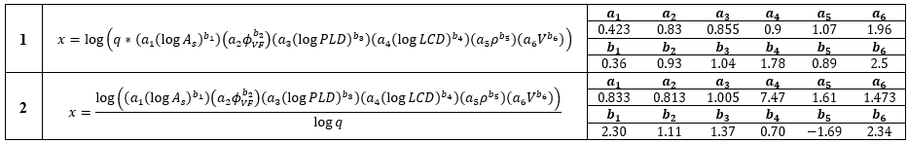

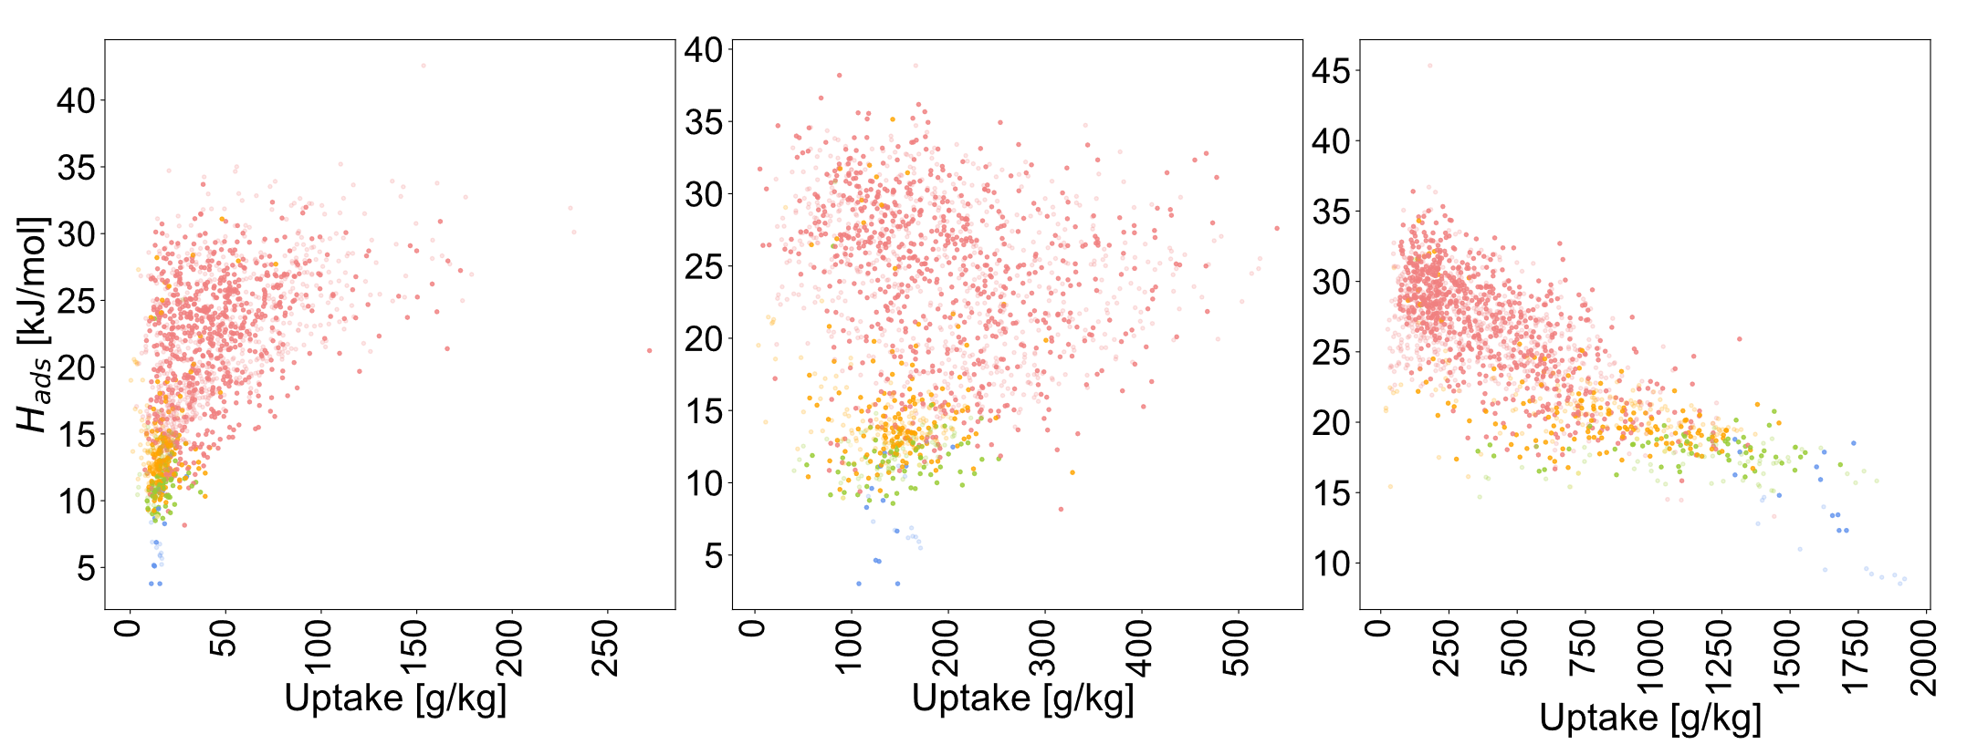
Fig. B.9. The uptake vs. heat of adsorption plots for 1, 25, and 50 bars.

Table B.2. Textural properties of the trialed MOFs (during validation), as calculated using Zeo++.
MOF | Surface Area [m²/g] | Void Fraction [-] | PLD [Å] | LCD [Å] | Density [g/cm³] | Channel Volume [Å³]
UiO-66 | 1224.07 | 0.492274 | 3.97353 | 8.35883 | 1.27955 | 211.203
IRMOF-1 / MOF-5 | 3742.97 | 0.81 | 7.92287 | 15.06472 | 0.593338 | 1917.68
HKUST-1 | 2352.81 | 0.68 | 6.64519 | 13.36950 | 0.883693 | 1370.57
MIL-101 (Cr) | 3181.77 | 0.56242 | 13.85716 | 30.96940 | 0.439743 | 98685.2

Table B.3. The percentage of the CoRE MOF 2019 datapoints within the specified percentiles at 5, 10, 30, and 50 bars.
Descriptor | $$P$$ | 0-10% | 10-25% | $>$ 25%
1 | 5  10  30  50 | 29.19  29.80  41.03  56.17 | 34.47  29.94  40.25  40.10 | 36.34  40.26  18.72  3.73
2 | 5  10  30  50 | 64.59  47.62  45.55  56.33 | 33.23  39.90  42.59  41.23 | 2.18  12.48  11.86  2.44

References
- Rappe, A. K., Casewit, C. J., Colwell, K. S., Goddard, W. A. & Skiff, W. M. UFF, a full periodic table force field for molecular mechanics and molecular dynamics simulations. J. Am. Chem. Soc. 114, 10024–10035 (1992).

