Environmental Impact of Disposable Face Masks: Degradation, Wear, and Cement Mortar Incorporation
Xiluva Maciel Estevão¹; Ana Paula Soares Dias^{2,3}; Inês Flores-Colen⁴; Manuel Francisco Costa Pereira²; Maria Paula Mendes⁵
¹Departamentos de Engenharia Química e de Engenharia Mecânica, Instituto Superior Técnico (IST), Universidade de Lisboa, Av. Rovisco Pais, 1049-001 Lisboa, Portugal
²CERENA—Centro de Estudos em Recursos Naturais e Ambiente, Instituto Superior Técnico, Universidade de Lisboa, 1049-001 Lisboa, Portugal
³VALORIZA—Research Centre for Endogenous Resource Valorization, Polytechnic Institute of Portalegre, 7300-555, Portalegre, Portugal
⁴CERIS- Civil Engineering Research and Innovation for Sustainability, IST, University of Lisbon, Av. António José de Almeida 12, 1049-001, Lisbon, Portugal
⁵CERENA- Civil Engineering Research and Innovation for Sustainability, IST-ID, University of Lisbon, Av, Rovisco Pais 3, 1049-001, Lisbon, Portugal

Supplementary Material
Table 1S. Mortars compositions.
Mixture | Cement  (g) | Sand  (g) | Water  (ml) | Surgical FMs  (g)
REF | 530 | 2687.1 | 397.5
2.5% - CDM | 480 | 2372.76 | 576 | 60.84
REF – Cement reference trace; CDM- Cement with dry mask in the aggregate; % Volume - Percentage of mass replacement of aggregate per mask

Table 2S - Assignment of FTIR Bands for Type IIR Disposable Face Masks and Polypropylene Using Data from the Literature.
FTIR bands (cm⁻¹)
Polypropylene  (Prabowo et al., 2017 | External layer | Middle layer | Inner layer | Thin degraded mascara | Thick degraded mascara | Inner elastic film | Functional groups  (Coates, 2006)
- | - | - | - | - | - | 3570-3100 (broad) | -OH
2950 | 2953 | 2948 | 2952 | 2950 | 2949 | 2947 | CH₃ C-H asymmetrical stretch
2916 | 2919 | 2920 | 2916 | 2919 | 2917 | - | CH₂ C-H asymmetrical stretch
2868 | 2871 | 2872 | 2867 | 2867 | 2866 | - | CH₃ C-H symmetrical stretch
2836 | 2836 | 2837 | 2839 | 2836 | 2838 | - | CH₃ C-H stretch
- | 1706 | 1710 | 1705 | 1710 | 1709 | -
1458 | 1455 | 1455 | 1456 | 1453 | 1453 | - | CH₃ C-H asymmetrical bend / CH₂ C-H bend
1378 | 1377 | 1376 | 1377 | 1376 | 1376 | 1372 | CH₃ C-H symmetrical bend
- | - | - | - | - | - | 1208 | Skeletal C-C vibrations
- | - | - | - | - | - | 1151 | Skeletal C-C vibrations
1170 | 1165 | 1170 | 1167 | 1168 | 1168 | - | Skeletal C-C vibrations
976 | 973 | 972 | 972 | 972 | 973 | - | Skeletal C-C vibrations
844 | 834 | 843 | 840 | 841 | 840 | - | Skeletal C-C vibrations
- | - | - | - | - | - | 636 | Alkyne CH stretch
Prabowo, I., Pratama, J., & Chalid, M. (2017). The effect of modified ijuk fibers to crystallinity of polypropylene composite. IOP Conference Series: Materials Science and Engineering, 223, 12020. https://doi.org/10.1088/1757-899X/223/1/012020;
Coates, J. (2006). Interpretation of Infrared Spectra, A Practical Approach. In Encyclopedia of Analytical Chemistry. https://doi.org/10.1002/9780470027318.a5606

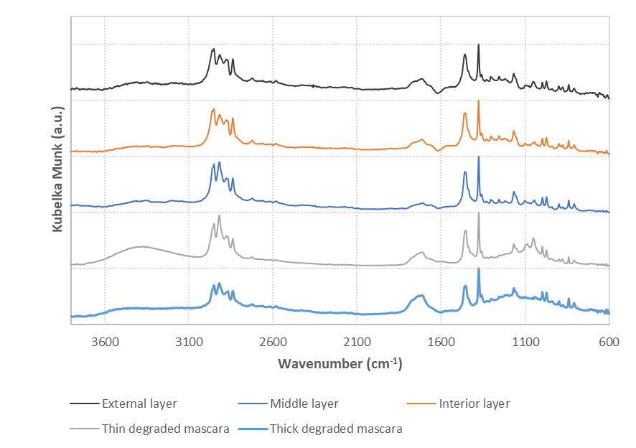
Figure 1S. FTIR spectrum of all three layers of disposable type IIR face mask before and after photodegradation.
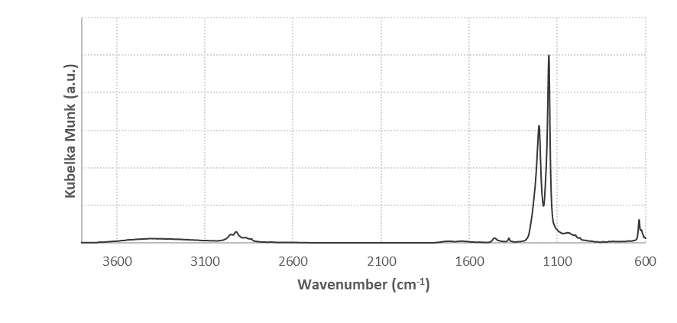
Figure 2S. Inner elastic film FTIR spectrum.

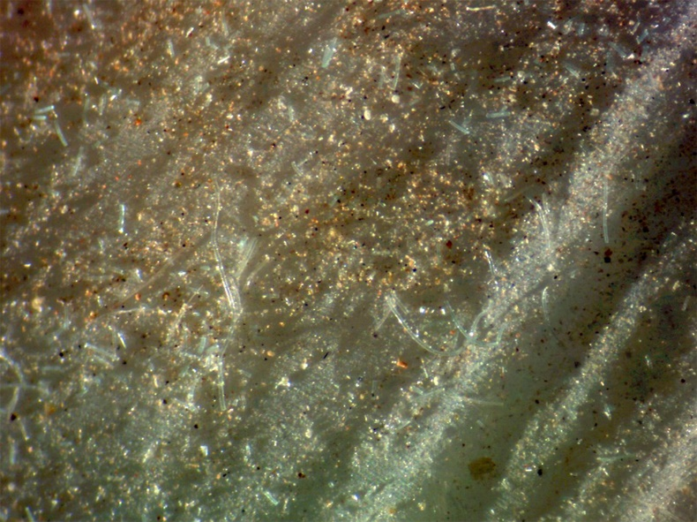
Figure 3S. Binocular magnifying glass image of the inner layer of the surgical mask from BETINATEXTEIS after weathering tests with soil particles.

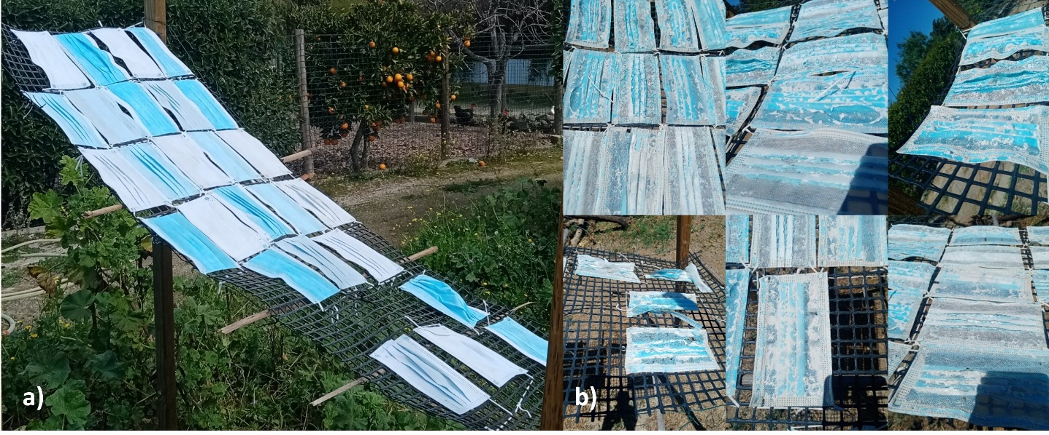
Figure 4S. a) Pristine face masks on March 6th, 2022; b) Face mask details after weathering test on June 26th, 2022.

