Supplementary Materials

Title | Page(s)
Supplementary Table 1. Search strategy of literature review in PubMed [date of search 09th of September, 2024]. | 1
Supplementary Table 2. Design of the ATI studies in the individual data-based meta-analysis. | 2-3
Supplementary Figure 1. Risk factors for time to viremia of 50 and 10,000 copies/mL during 84 days of ATI. | 4-5
Supplementary Figure 2. Time to viremia of 50, 400 and 10,000 copies/mL during 84 days of ATI. | 6
Supplementary Figure 3. Risk factors for time to viremia of 400 copies/mL during 84 days of ATI. | 7
Supplementary Figure 4. Number of participants needed in future trials to achieve prolonged time of at least 14 or 21 days to viremia above 50 or 10,000 copies/mL among ATI participants (not NNRTI-containing regimen) | 8

PubMed
# | Search | Results
1 | "off therapy"[All Fields] OR "ART interruption"[All Fields] OR "treatment interruption"[All Fields] OR "Withholding Treatment"[All Fields] OR "antiretroviral interruption"[All Fields] OR "therapy interruption"[All Fields] OR "Withholding Treatment"[MeSH Terms] | 20,750
2 | "HIV"[Mesh] OR "HIV" | 430,749
3 | "Surveys and Questionnaires"[MeSH Terms] OR "Surveys and Questionnaires"[All Fields] OR "report from"[All Fields] OR "Research Report"[MeSH Terms] OR "Interview"[All Fields] OR "Interview"[Publication Type] OR "Interviews as Topic"[MeSH Terms] OR "case report"[All Fields] OR "Case Reports"[Publication Type] OR "perspective"[All Fields] OR "Review" [Publication Type] | 7,322,522
4 | "Simian Immunodeficiency Virus"[MeSH Terms] OR "Simian Immunodeficiency Virus"[All Fields] OR "Mice"[MeSH Terms] OR "Mice"[All Fields] | 2,022,720
5 | "Child"[MeSH Terms] OR "child*"[All Fields] OR "Infant"[MeSH Terms] OR "Infant"[All Fields] | 3,889,435
6 | "Pregnancy"[All Fields] OR "Pregnancy"[MeSH Terms] OR "postpartum"[All Fields] OR "Postpartum Period"[MeSH Terms] OR "Substance-Related Disorders"[All Fields] OR "Substance-Related Disorders"[MeSH Terms] OR "Transplantation"[All Fields] OR "Transplantation"[MeSH Terms] | 2,395,694
7 | "Treatment Failure"[MeSH Terms] OR "Treatment Failure"[All Fields] OR "Medication Adherence"[MeSH Terms] OR "Medication Adherence"[All Fields] | 98,017
8 | #1 AND #2 | 1,663
9 | #8 NOT #3 | 1,353
10 | #9 NOT #4 | 1,255
11 | #10 NOT #5 | 1,109
12 | #11 NOT #6 | 1,046
13 | #12 NOT #7 | 942
Supplementary Table 1. Search strategy of literature review in PubMed [date of search 09th of September, 2024].

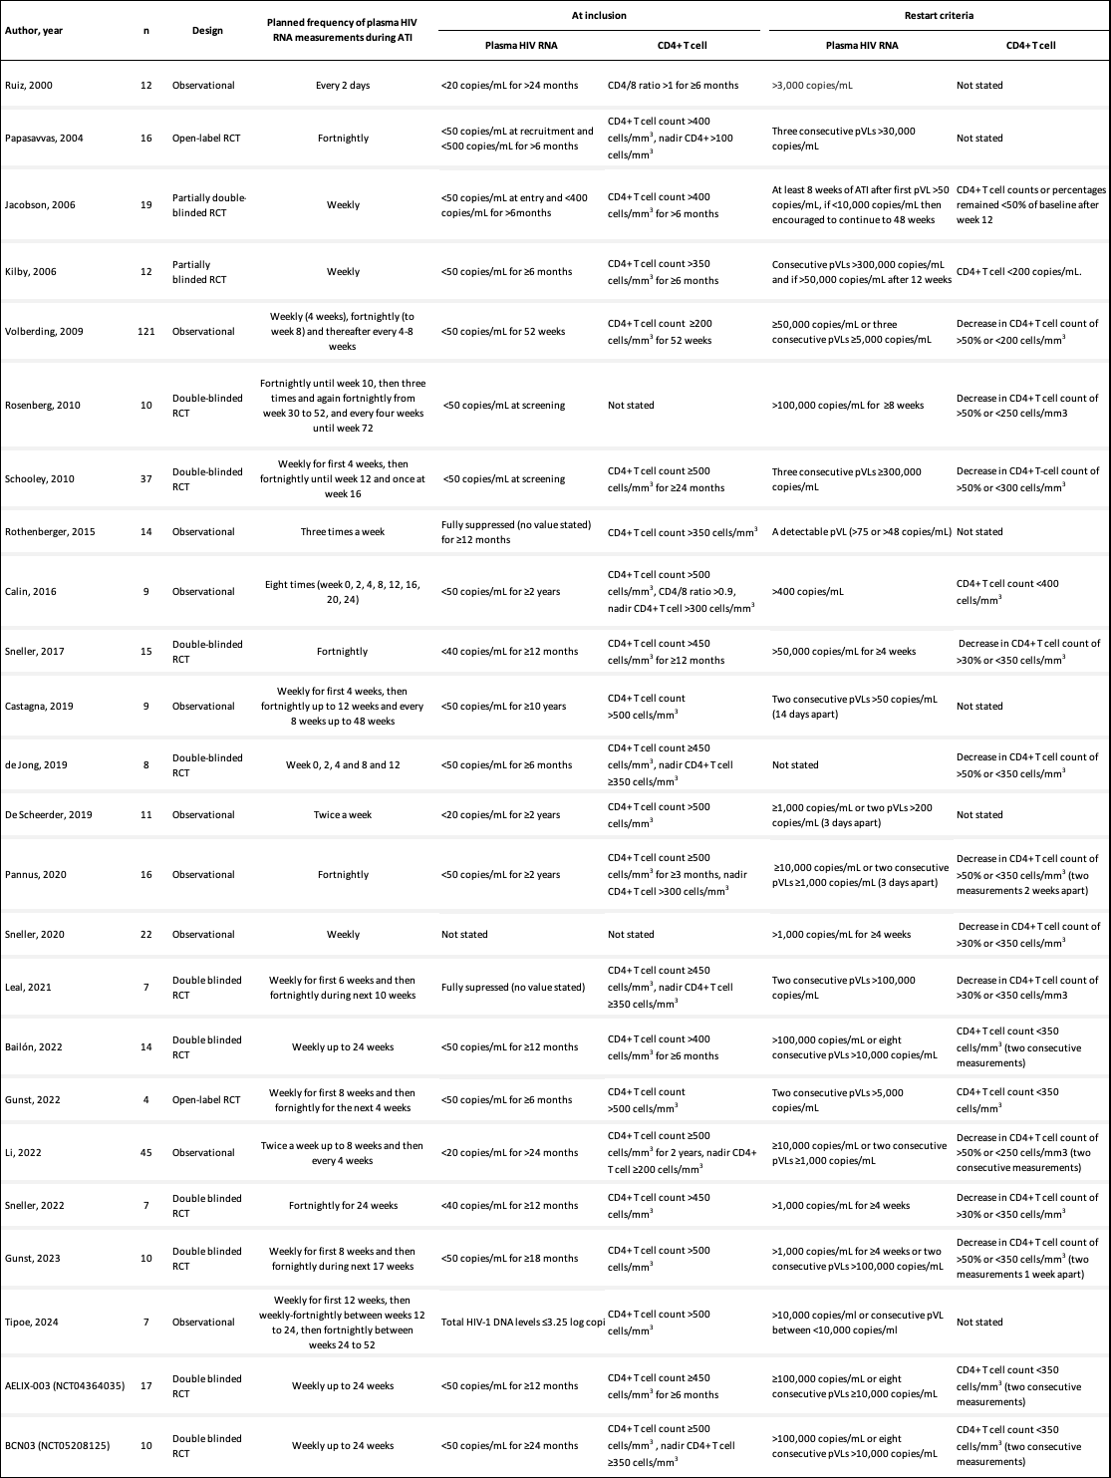
Supplementary Table 2. Design of the ATI studies in the individual data-based meta-analysis.
Abbreviations: pVL, plasma HIV RNA; RCT, randomized controlled trial.
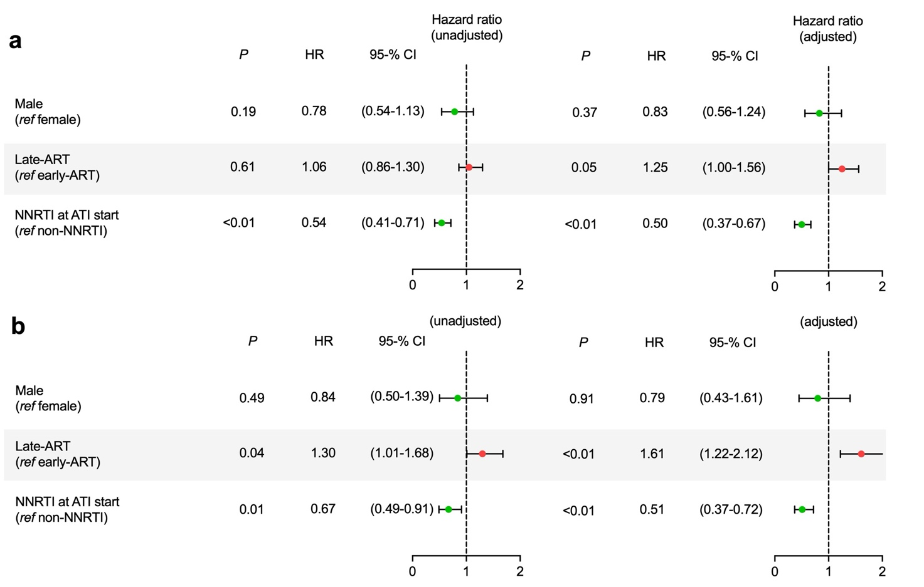
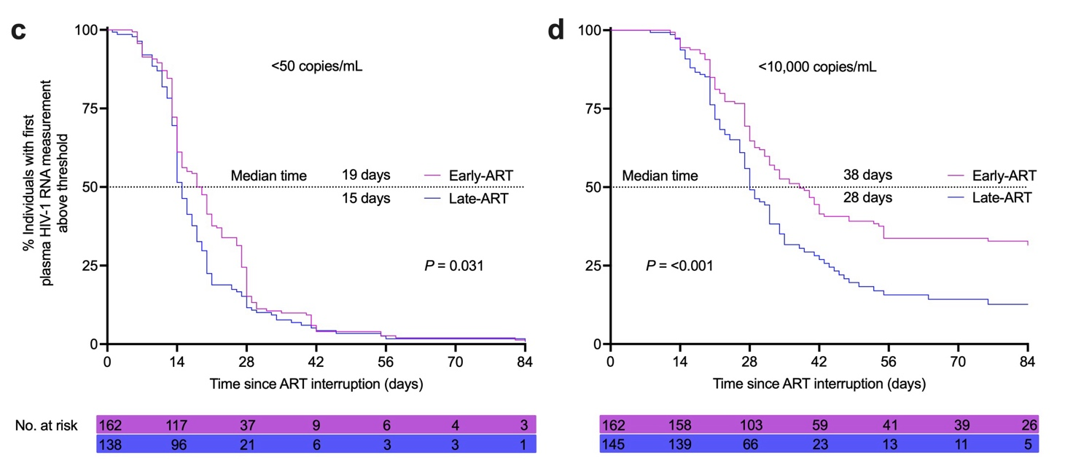Supplementary Figure 1. Risk factors for time to viremia of 50 and 10,000 copies/mL during 84 days of ATI.
a,b, Univariate and multivariate cox proportional hazards models (Hazard ratio, HR) to identify risk factors for time to viremia of 50 and 10,000 copies/mL during 84 days of ATI, respectively. Stage at ART initiation indicated by either early-ART: within 6 months of HIV acquisition, or late-ART: beyond 6 months of HIV acquisition. c,d, Kaplan–Meier curves showing the percentage of individuals on non-NNRTI at ATI start with first plasma HIV RNA measurement below the following two thresholds 50 and 10,000 copies/mL during 84 days of ATI. The dotted lines indicate median times to reach the specified thresholds. Below each Kaplan-Meier curves are noted the number of individuals at risk. P values were calculated using the log-rank test.
ART, antiretroviral therapy; ATI, ART interruption; NNRTI, non-nucleoside reverse transcriptase inhibitor.
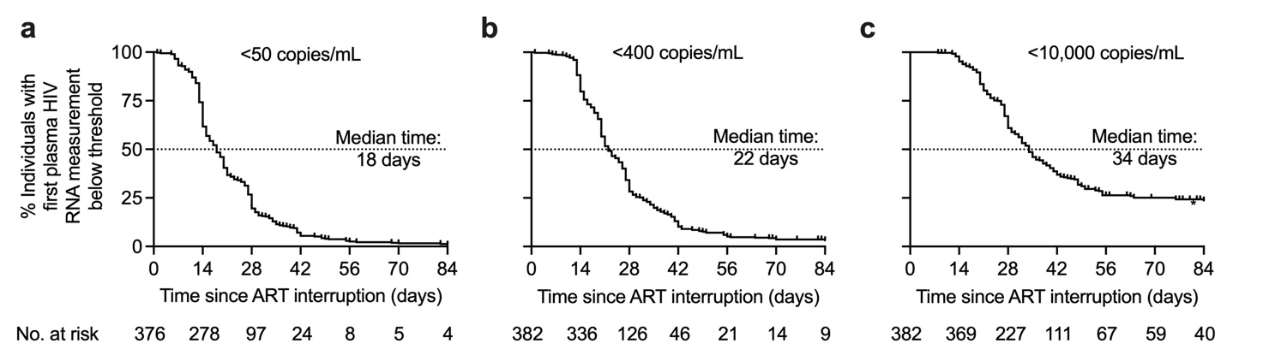Supplementary Figure 2. Time to viremia of 50, 400 and 10,000 copies/mL during 84 days of ATI. a,b,c, Kaplan–Meier curves showing the percentage of individuals (irrespective of ART regimen) with first plasma HIV RNA measurement below the following three thresholds 50, 400 and 10,000 copies/mL during 84 days of ATI. The dotted lines indicate median times to reach the specified thresholds. Below each Kaplan-Meier curves are noted the number of individuals at risk.
ART, antiretroviral therapy; ATI, ART interruption.
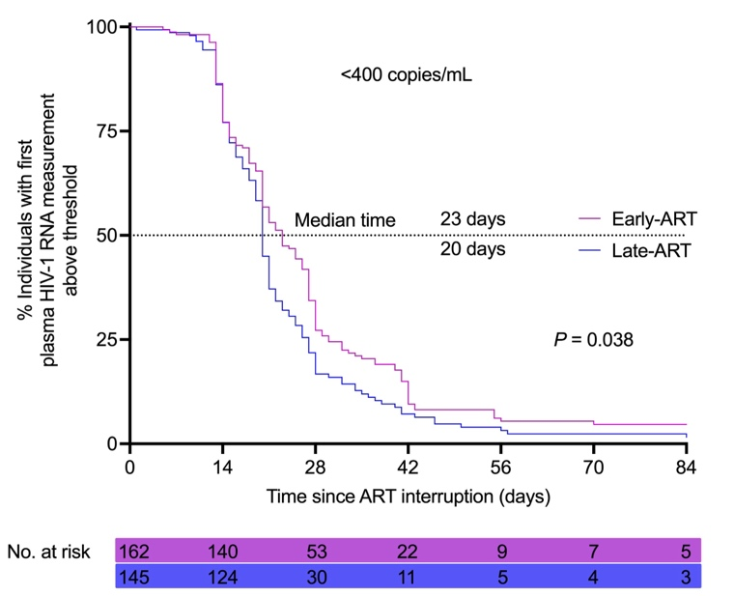
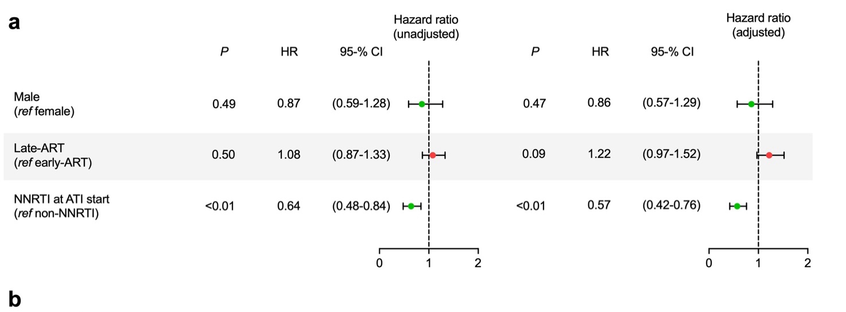
Supplementary Figure 3. Risk factors for time to viremia of 400 copies/mL during 84 days of ATI.
a, Univariate and multivariate cox proportional hazards models (Hazard ratio, HR) to identify risk factors for time to viremia of 400 copies/mL during 84 days of ATI. Stage at ART initiation indicated by either early-ART: within 6 months of HIV acquisition, or late-ART: beyond 6 months of HIV acquisition. b, Kaplan–Meier curve showing the percentage of individuals on non-NNRTI at ATI start with first plasma HIV RNA measurement below 400 copies/mL during 84 days of ATI. The dotted line indicate median time to reach the specified thresholds. Below the Kaplan-Meier curve is noted the number of individuals at risk. P value was calculated using the log-rank test.
ART, antiretroviral therapy; ATI, ART interruption; NNRTI, non-nucleoside reverse transcriptase inhibitor.

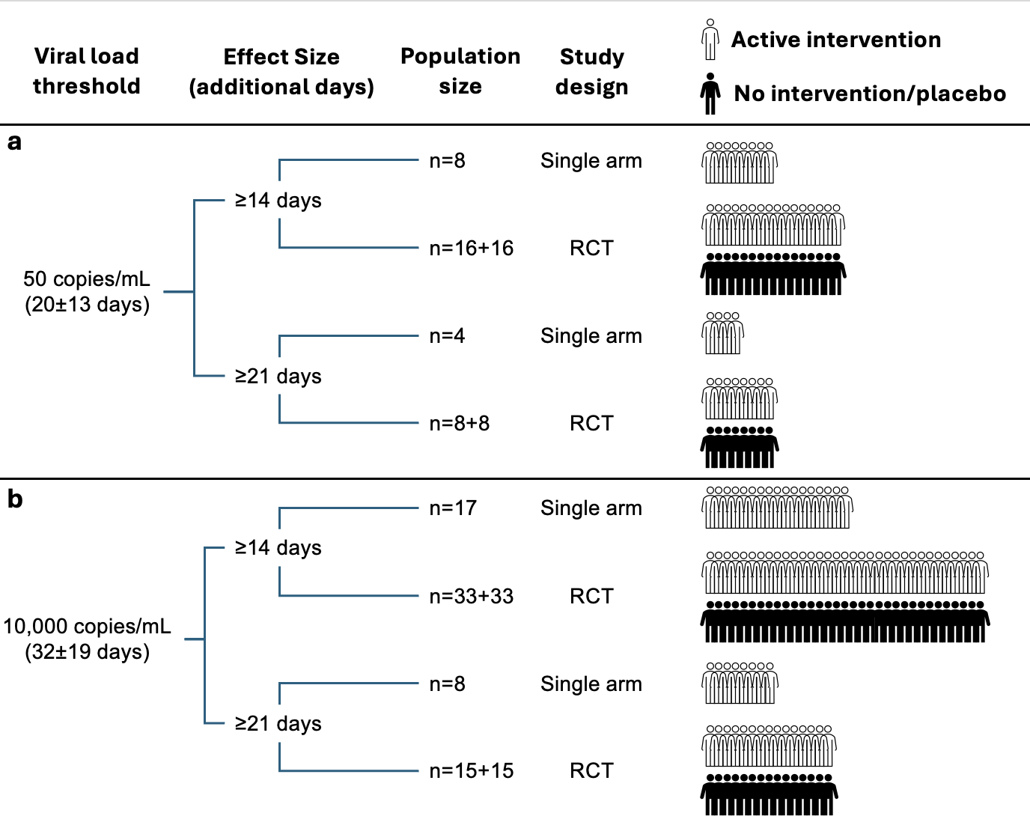
Supplementary Figure 4. Number of participants needed in future trials to achieve prolonged time of at least 14 or 21 days to viremia above 50 or 10,000 copies/mL among ATI participants (not NNRTI-containing regimen)
Power calculations to be use for future study designs on how many participants (irrespectively of stage at ART initiation) would be needed for either single arm or randomized controlled trials (RCTs) with 2 groups based on the assumption that the studies would have a power of 90% to detect the indicated prolonged time to viremia above 50 (a) or 10,000 (b) copies/mL at a 5% significant level, one-sided.
RCT, randomized controlled trial.

