Supplementary Figure 1: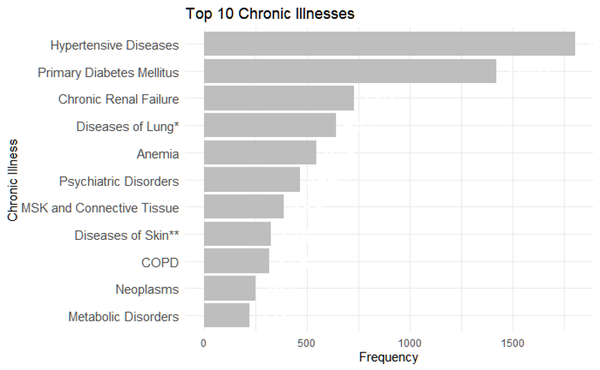

Supplementary Table 1:
List of comorbidities in all the patients.

Comorbidity | Count
Hypertensive Disease | 1801
Primary Diabetes Mellitus | 1419
Acute Renal Failure | 1286
Disorders of Fluid Electrolyte and Acid-Base Balance | 1134
Ischemic Heart Disease | 842
Chronic Renal Failure | 730
Other Diseases of the Lung and Respiratory System | 642
Urethritis and Other Urethral Disorders | 633
Pneumonia and Influenza | 583
Anemia | 546
Other Viral Diseases | 469
Psychiatric Disorders | 466
Arrhythmias | 460
Septicemia | 428
Poisoning | 415
Other Bacterial Diseases | 414
Diseases of MSK and Connective Tissue Autoimmune Conditions | 388
Diseases of Skin and Subcutaneous Tissue | 324
COPD | 318
Purpura and Other Hemorrhagic Conditions | 274
Heart Failure | 271
Neoplasms | 252
Diseases of Male Genital Organs | 234
Metabolic Disorders | 223
Cerebrovascular Diseases Including Stroke | 213
Other CNS Disorders | 208
Mycoses | 192
Pneumoconiosis | 191
Disorders of the Thyroid Gland | 187
Intestinal Infections | 184
Other Accidents | 182
Chronic Liver Disease and Cirrhosis | 159
Empyema and Pleurisy | 156
Other Disorders of Urinary System | 152
Hereditary and Degenerative Diseases of the Central Nervous System | 128
Complications of Surgical and Medical Care Not Elsewhere Classified | 121
Other Disorders of GIT | 118
Pyelonephritis | 117
Accidents Due to Surgical and Medical Care | 109
Valvular Disorders | 104
Hepatobiliary Disorders | 101
Epilepsy | 97
Other Disorders of Urinary System | 92
Cardiomyopathy | 79
Acute Respiratory Infections | 77
Sleep Disorders | 76
Coagulation Defects | 72
Tuberculosis | 69
Venous Embolism and Thrombosis | 69
Injuries Fractures Sprains Dislocations Internal Injuries Wounds Burns Etc | 68
Obesity and Other Hyperalimentation | 66
Disorders of Eye | 66
Other Disorders of Glucose Regulation and Pancreatic Internal Secretion | 64
Vehicle Accidents Not Elsewhere Classifiable | 62
Diseases of MSK and Connective Tissue Including Autoimmune Conditions | 55
Other Heart Diseases | 54
Other Functional Digestive Disorders | 54
Other Disorders of Liver | 54
Calculus of Kidney Ureter or Lower Urinary Tract | 54
Rheumatic Fever Acute Chronic | 52
Gastritis and Duodenitis | 52
Disorders of the Peripheral Nervous System | 50
Diseases of White Blood Cells | 49
Pulmonary Embolism | 48
Pituitary Disorders | 46
Other Infectious Diseases | 46
Other Pulmonary Circulation Diseases | 45
Intestinal Obstruction | 45
Cerebral Hemorrhages | 43
Accidental Falls | 41
Other Infectious and Parasitic Diseases | 38
Breast Female Genital Tract Disorders | 34
Nephritis | 33
Other Inflammatory Diseases of the Central Nervous System | 32
Nutritional Deficiencies | 31
Adrenogenital Disorders and Cushing Syndrome | 30
Noninfective Enteritis and Colitis IBD | 29
Congenital Anomalies | 28
Anorectal Pathologies | 26
Disorder of Ear and Mastoid | 25
Pancreatic Disorders | 25
Cystitis | 25
Other Diseases of Blood and Blood Forming Organs | 22
Paralytic Diseases Hemiplegia Hemiparesis Quadriplegia Etc | 22
Other Diseases of Upper Respiratory Tract | 22
Diseases of Esophagus | 20
Other Peritoneal Diseases | 20
Hereditary and Degenerative Diseases of the Central Nervous | 20
Endocarditis | 19
Arteritis | 19
Pneumothorax | 18
Other Disorders of Stomach and Duodenum | 18
Meningitis | 17
Other Disorders of Arteries and Arterioles | 16
Varicose Veins of Other Sites | 16
Complications of Perinatal Period Pregnancy Childbirth and the Puerperium | 16
Diseases of Oral Soft Tissues and Tongue | 14
Other Renal Diseases | 14
Water Air and Space Transport Accidents | 14
Hernia of Abdominal Cavity | 13
Gastric, Duodenal, Gastrojejunal Ulcers | 12
H. Pylori | 11
Hypotension | 11
Nephrotic Syndrome | 9
Protozoal Diseases | 7
Disorders of the Peripheral Nervous System | 7
Cardiac Tamponade and Other Diseases of Pericardium | 6
Atherosclerosis | 6
Other Disorders of Intestine | 6
Motor Vehicle Road Vehicle Accidents | 6
Parathyroid Disorders | 5
Disorders Involving the Immune Mechanism | 5
Myocarditis | 5
Arterial Embolism Thrombosis and Atheroembolism | 5
Phlebitis and Thrombophlebitis | 5
Appendicitis | 5
Ovarian Endocrine Disorders | 4
Migraine | 4
Disease of Teeth and Jaw TMJ | 4
Vascular Insufficiency of Intestine | 4
Liver Abscess and Sequelae of Chronic Liver Disease | 4
Suicide and Self-inflicted Injury | 4
Other Injuries | 4
Intracranial and Intraspinal Abscess | 3
Other Peripheral Vascular Disease | 3
Diverticula of Intestine | 3
Accidental Poisoning | 3
Secondary Diabetes Mellitus | 2
Headache | 2
Other Circulatory System Disorders | 2
Abscess of Lung and Mediastinum | 2
Helminthiases | 1
Other Endocrine Diseases | 1
Pain | 1
Multiple Sclerosis | 1
Other Demyelinating Diseases of the Central Nervous System | 1
Pericarditis | 1
Aneurysm and Dissections | 1
Varicose Veins of Lower Extremities | 1
Noninfective Disorders of Lymphatic Channels | 1
Diseases of the Salivary Gland | 1
External Causes of Injury - Activity | 1
Paralytic Diseases | 1
Meningococcal | 0
Poliomyelitis | 0
Thymus Disorders | 0
Testicular Endocrine Disorders | 0
Cystic Fibrosis | 0
Pulmonary Hypertension | 0
Diseases of Capillaries | 0
Railway Accidents | 0
Varicose Veins of Lower Extremities | 0
Supplementary Factors Related to Causes of Morbidity Classified Elsewhere | 0
Factors Influencing Health Status and Contact with Health Services | 0
COPD = Chronic Obstructive Pulmonary Disease
TMJ = Temporomandibular Joint
IBD = Inflammatory Bowel Disease

