Supplementary material

Gelatin, a protective agent against iron gall ink corrosion?
Alice Gimat¹, Anne Michelin¹, Pascale Massiani², Véronique Rouchon¹

¹ Sorbonne Université, Muséum National d'Histoire Naturelle, Centre de Recherche sur la Conservation des Collections (CRC, CNRS USR 3224), 36 rue Geoffroy St Hilaire 75005 Paris, France
² Sorbonne Université, Campus UPMC, Laboratoire de Réactivité de Surface, CNRS UMR 7197, 4 place Jussieu, 75005 Paris, France
Corresponding author: alice.gimat@mnhn.fr

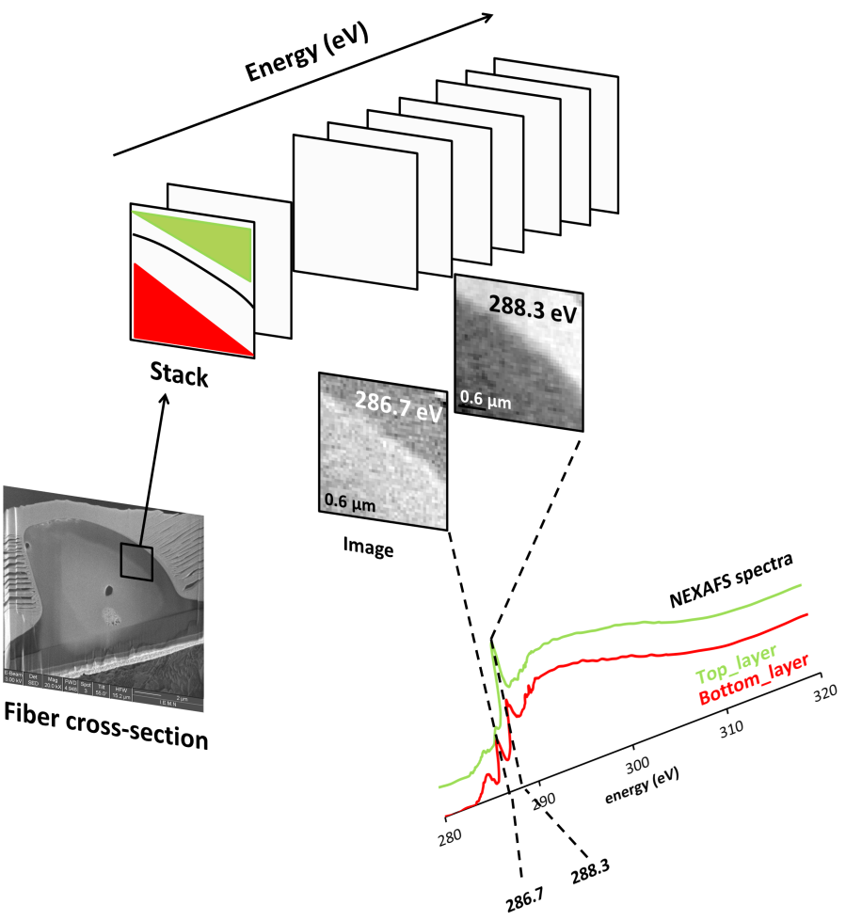
Fig. S1 STXM principle
An area of the fiber cross-section is scanned in x and y (2D map) with each chosen soft X-rays energy to obtain a 3D stack. Each 2D image can then be visualized at each energy and gives a more or less bright area depending on the absorption. For example, at 286.7 eV, the bottom layer (red) is brighter than the top layer (green) as Rag cellulose absorbs more than gelatin at this energy. At 286.3 eV, the trend is reversed. From the stack, a spectrum can also be extracted by selecting a region of interest: the red and green regions give the respective spectra which show specific absorption of the components.
Tab. S1 STXM NEXAFS measurements conditions
C K-edge
Start E (eV) | End E (eV) | Range (eV) | Points | Step (eV) | Dwell time (ms)
270 | 283 | 13 | 15 | 1 | 1
283.2 | 292 | 8.8 | 89 | 0.1 | 1
292.2 | 305 | 12.8 | 27 | 0.492 | 1
305.2 | 325 | 19.8 | 14 | 1.523 | 1

N K-edge
Start E (eV) | End E (eV) | Range (eV) | Points | Step (eV) | Dwell time (ms)
395 | 398 | 3 | 7 | 1 | 1
398.2 | 408 | 9.8 | 66 | 0.1 | 1
408.2 | 415 | 6.8 | 15 | 0.492 | 1
415.5 | 435 | 19.5 | 21 | 1.523 | 1

Fe K-edge
Start E (eV) | End E (eV) | Range (eV) | Points | Step (eV) | Dwell time (ms)
700 | 706 | 6 | 7 | 1 | 1
706.2 | 714 | 7.8 | 40 | 0.2 | 1
714.2 | 720 | 5.8 | 7 | 0.9677 | 1
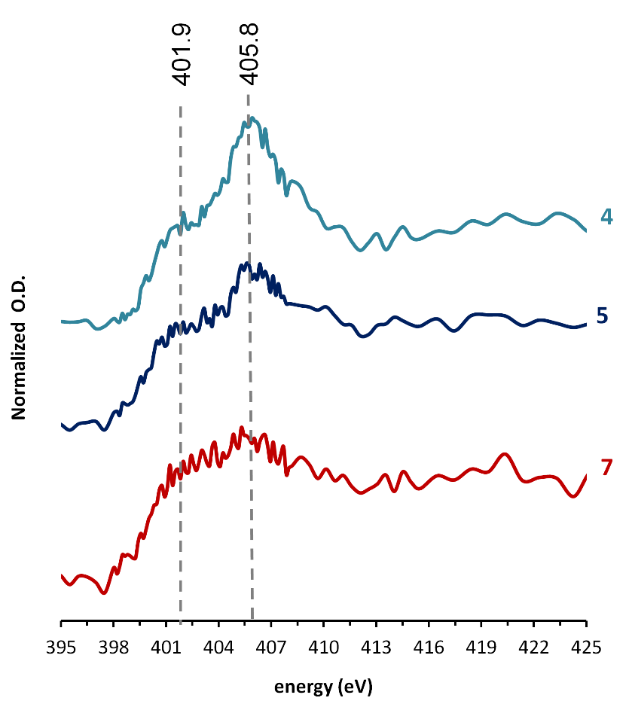
Fig. S2 NEXASF spectra of three different regions of fiber G_I at the N-K edge.

