Supplementary Information
A large-scale solar-driven direct air capture and utilisation process to produce sustainable aviation fuel
Yide Han¹, Olajide Otitoju¹, Ariane D.N. Kamkeng¹, Meihong Wang^{1,*}, Hui Yan², Fisher Millard³, Wenli Du^{4,*}, Feng Qian^{4,*}
¹Department of Chemical and Biological Engineering, The University of Sheffield, Sheffield S1 3JD, UK
²Department of Electrical and Electronic Engineering, University of Manchester, Manchester M13 9PL, UK
³Net Zero Energy, AtkinsRéalis, Edinburgh, EH3 8EG, UK
⁴Key Laboratory of Advanced Control and Optimization for Chemical Process of Ministry of Education, East China University of Science and Technology, 130 Meilong Road, Shanghai 200237, China
*Correspondence: meihong.wang@sheffield.ac.uk

Contents
Note S1: Simulation and comparison of DAC process at commercial scale
Note S2: Modelling, simulation and validation of solar calciner at pilot scale
Note S3: Modelling, simulation and validation of CO₂-FTS at lab scale
Note S4: Scale-up approach of fluidized bed
Note S5: Techno-economic analysis of base case
Note S6: Sensitivity analysis
Supplemental References

Note S1: Simulation and comparison of DAC process at commercial scale
The chemistry of CO₂ absorption with aqueous KOH is described by the set of equilibrium reactions (Table S1) and the kinetic reactions (Table S2).
Table S1: Chemistry settings of equilibrium reactions for rate-based air contactor model
$$lnK=A+B/T+ClnT+DT$$
Equilibrium Reaction | A | B | C | D
$$CO_{2}+2H_{2}O ↔{HCO}_{3}^{-}+H_{3}O^{+}$$ | 231.465 | -12092.1 | -36.7816 | 0
$${HCO}_{3}^{-}+{H_{2}O ↔H}_{3}O^{+}+{CO}_{3}^{2-}$$ | 216.05 | -12431.7 | -35.4819 | 0
$$2H_{2}O ↔{OH}^{-}+H_{3}O^{+}$$ | 132.899 | -13445.9 | -22.4773 | 0

Table S2: Chemistry settings of kinetic reactions for rate-based air contactor model
$$Kinetic factor={KT}^{n}e^{-\frac{E}{RT}}$$
Kinetic Reaction | K | n | E (J/kmol)
$$CO_{2}+{OH}^{-}→{HCO}_{3}^{-}$$ | 4.32e+13 | 0 | 5.54709e+07
$${HCO}_{3}^{-}→CO_{2}+{OH}^{-}$$ | 2.38e+17 | 0 | 1.23305e+08

The simulation approach of one modular unit of air contactor was adopted from Sabatino et al.¹. This model effectively represents the air contactor unit design presented by Keith et al.². Furthermore, we enhanced the rate-based model by incorporating modified built-in packing allowing us to represent the Brentwood XF12560 packing accurately, and to correlate the packing pressure drop based on pilot experiments.
Since the Brentwood XF12560 packing is not a built-in option in Aspen Plus®, we used a modified Sulzer 250Y PVC packing to represent it. The specific information regarding the Brentwood XF12560 packing—such as the specific surface area (SSA), void fraction and liquid holdup—is provided in the table below and was used to modify the default data for the Sulzer 250Y PVC packing.

Table S3: Modified Sulzer 250Y PVC packing setting in Aspen Plus®
Parameter | Settings | Reference
Material | PVC | Holmes (2010)³
SSA | 210 m²/m³ | Holmes (2010)³
Liquid hold up | 35 g/m² | Holmes (2010)³
Void fraction | 0.95 | Cooling Tower Depot® (2023)⁴ and Fair et al. (2000)⁵

Calculation of packing pressure drop:
The pressure drop was estimated using the correlations developed for Brentwood XF12560 packing. This pressure drop correlation provided by Brentwood Industries Inc.⁶ was adapted from the pilot experimental data (air velocity between 1-2 m/s) given in Keith et al.².
$$ΔP=\left(7.4{v_{air}}^{2.14a}+4.3Q_{l}{×v_{air}}^{0.4b}\right){×ATD}^{0.95c}$$
Where $ΔP$ is the pressure drop in Brentwood XF12560 packing (Pa)
$v_{air}$ is the air velocity driven by the air contactor (m/s)
$Q_{l}$ is the average liquid flow rate on the unit packing area (L/m² s)
ATD is the air travel distance (m)
a, b, c are fitting parameters (a=1.06, b=3.31, c=0.79)
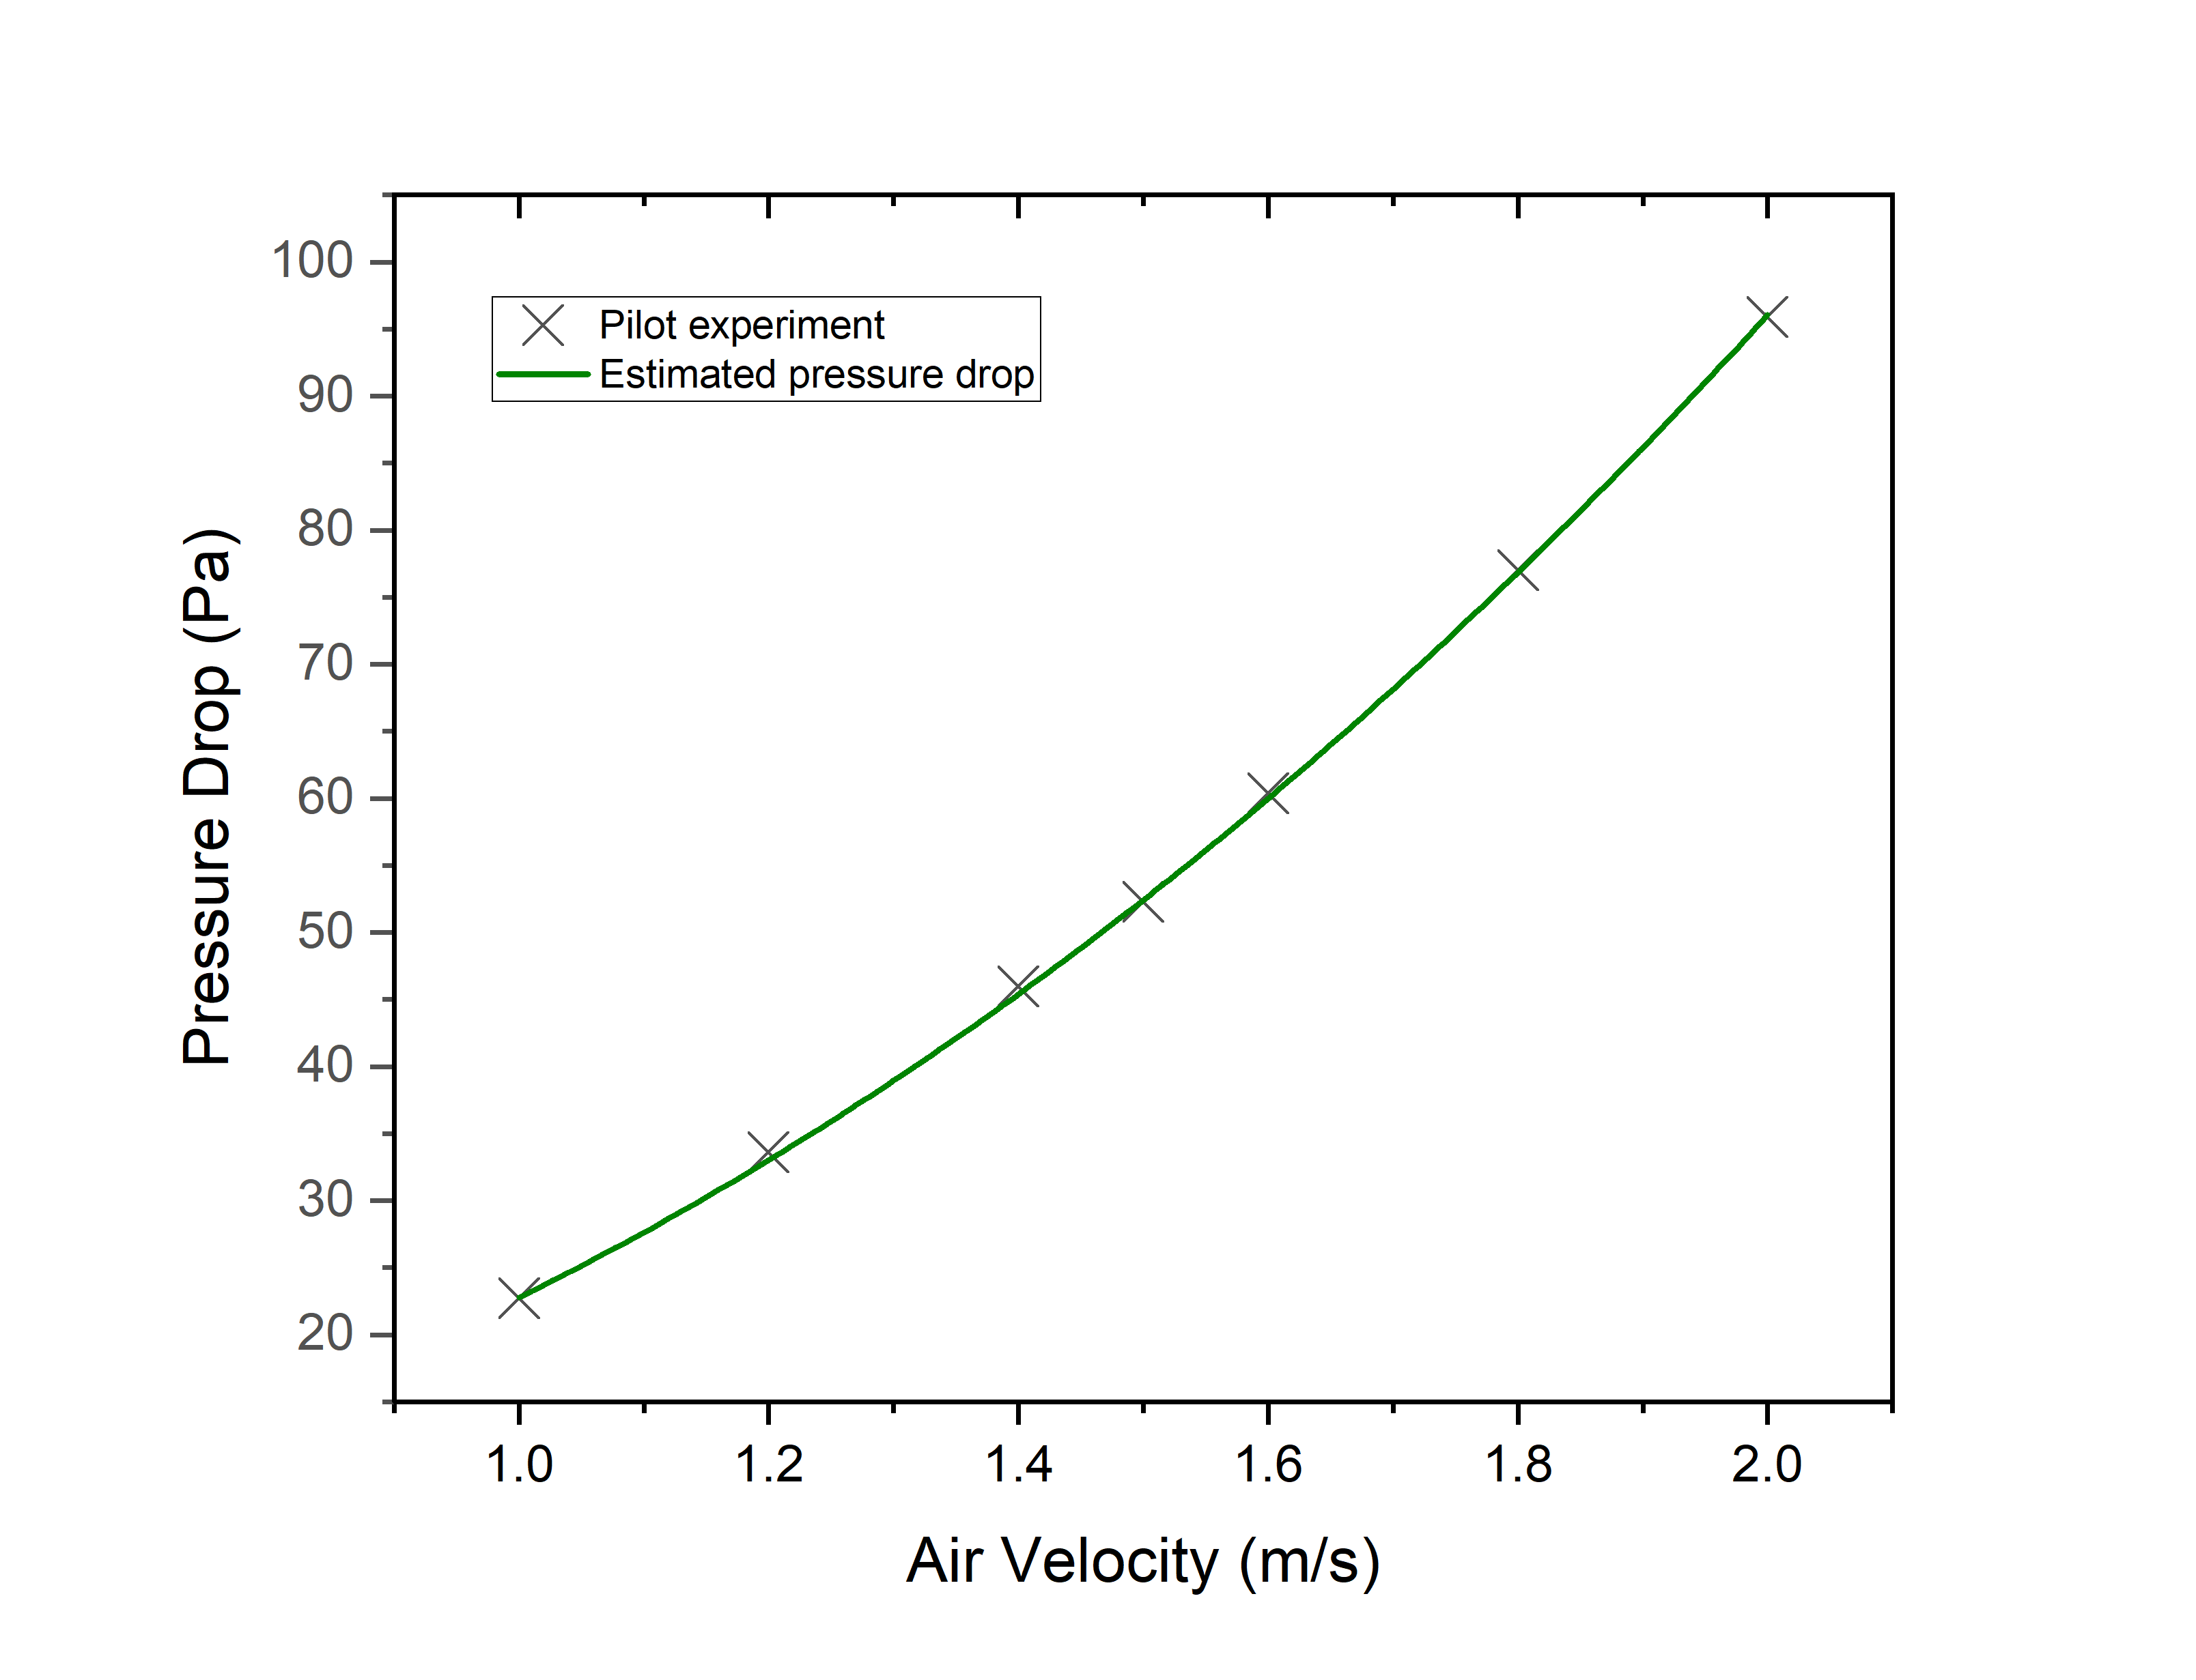
Figure S1: Validation of Brentwood XF12560 packing pressure drop curve under 3 m ATD.
Calculation of fan electricity:
Electricity consumption for the fan is derived from Holmes and Keith⁷:
$$E_{fan}=0.001\frac{{A×ΔP×v}_{air}}{η_{fan}}$$
Where, $E_{fan}$ is the electricity consumption of the fan (kW)
A is the total cross-sectional area of the air contactor (m²) and the value is 40,000 m² for a commercial-scale air contactor.
$η_{fan}$ is the fan energy efficiency (%) and 70% fan efficiency is assumed

Calculation of pumping electricity:
The pumping electricity is determined by loading rate, fluidization velocity and pumping efficiency. Here, we assumed the same fluidization velocity (0.6 L/m²s) and the same pumping efficiency (82%) from Carbon Engineering’s DAC design². Therefore, the difference in pumping electricity consumption is calculated based on different loading rates according to mechanical energy requirements for the pumps⁸.
Table S4: Specifications of unit operations
Parameter | Value | Source
Air Contactor
Number of banks | 10 | Holmes et al. (2013)⁹
Number of air contactor units in each bank | 160 | Holmes et al. (2013)⁹
Number of blocks in each air contactor unit | 6 | Sabatino et al. (2021)¹
Number of stages per block | 20 | Sabatino et al. (2021)¹
Diameter | 5.64 m | Sabatino et al. (2021)¹
Height | 1.16 m | Sabatino et al. (2021)¹
Packing | Modified Sulzer 250Y PVC (representing Brentwood XF12560 packing) | Holmes (2010)³
Solvent recovery rate | 99.93% | Madhu et al. (2021)¹⁰
Operating temperature | 21 ℃ | Sabatino et al. (2021)¹
Operating pressure | 1 bar | Sabatino et al. (2021)¹
Pellet Reactor
Operating temperature | 21 ℃ | Sabatino et al. (2021)¹
Operating pressure | 1 bar | Sabatino et al. (2021)¹
Calcium retention | 90% | Keith et al. (2018)²
Steam Slaker
Pellet water carryover | 11.7 wt% | Adapted from process mass balance
Operating temperature | 300 ℃ | Keith et al. (2018)²
Operating pressure | 1 bar | Keith et al. (2018)²
CaO conversion | 85% | Keith et al. (2018)²
Calciner
Operating temperature | 900 ℃ | Keith et al. (2018)²
Operating pressure | 1 bar | Keith et al. (2018)²
CaCO₃ conversion | 98% | Keith et al. (2018)²
CO₂ Absorber
Diameter | 7.5 m | Keith et al. (2018)²
Height | 12 m | Keith et al. (2018)²
Packing | BERL Ceramic packing | Keith et al. (2018)²

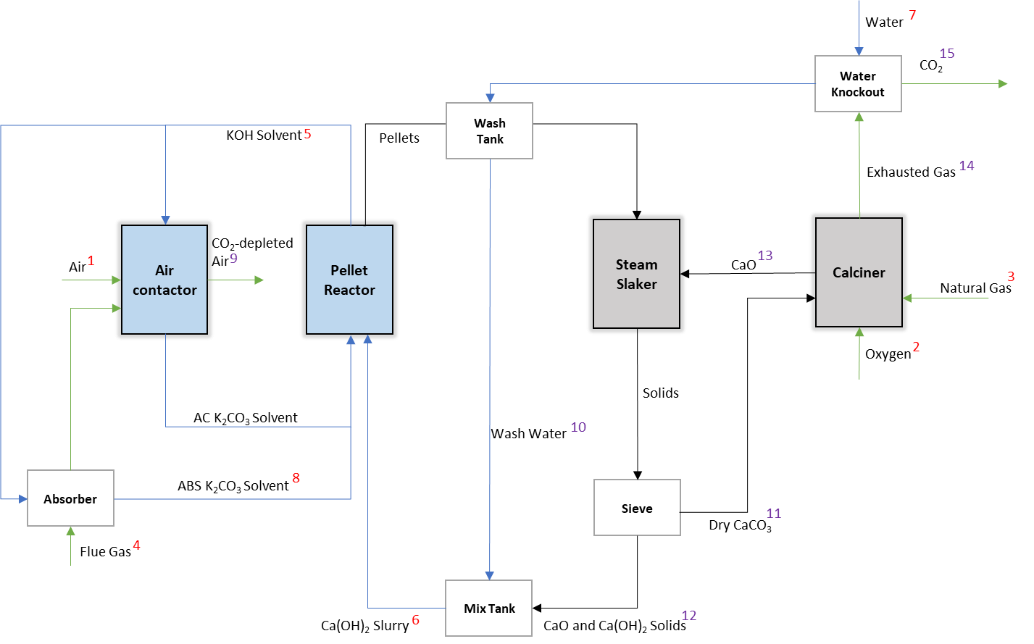

Figure S2: Block flow diagram of Carbon Engineering’s DAC process developed by Keith et al. to which our simulation is compared. The green arrow line lines represent gaseous streams, the blue arrow lines represent liquid streams, and the black arrow lines represent solid streams. The streams numbered 1-8 in red are the input streams, while the streams numbered 9-15 in purple are the outputs from the simulation to which our results are compared.

Table S5: Inputs into the DAC process model
Stream Number | Stream ID | Parameters | Value
1 | Air | Temperature (℃) | 21
1 | Air | Flow rate (kt/hr) | 251
1 | Air | CO₂ (wt%) | 0.06
1 | Air | O₂ (wt%) | 23.00
1 | Air | N₂ (wt%) | 75.96
1 | Air | H₂O (wt%) | 0.98
2 | Oxygen | Temperature (℃) | 21
2 | Oxygen | Flow rate (t/hr) | 58.5
2 | Oxygen | O₂ (wt%) | 95.60
2 | Oxygen | N₂ (wt%) | 4.4
3 | Natural Gas | Temperature (℃) | 21
3 | Natural Gas | Flow rate (kt/hr) | 13.4
4 | Flue Gas | Temperature (℃) | 40
4 | Flue Gas | Flow rate (kt/hr) | 121
4 | Flue Gas | CO₂ (wt%) | 14.43
4 | Flue Gas | O₂ (wt%) | 0.91
4 | Flue Gas | N₂ (wt%) | 72
4 | Flue Gas | H₂O (wt%) | 12.66
5 | KOH Solvent | Temperature (℃) | 21
5 | KOH Solvent | Flow rate (kt/hr) | 35
5 | KOH Solvent | K⁺ (mol/L) | 2
5 | KOH Solvent | OH⁻ (mol/L) | 1.1
5 | KOH Solvent | CO₃²⁻ (mol/L) | 0.45
6 | Ca(OH)₂ Slurry | Temperature (℃) | 21
6 | Ca(OH)₂ Slurry | Flow rate (t/hr) | 777
6 | Ca(OH)₂ Slurry | Ca(OH)₂ (wt%) | 28.7
7 | Water | Temperature (℃) | 21
7 | Water | Flow rate (t/hr) | 531
8 | ABS K₂CO₃ Solvent | Temperature (℃) | 31
8 | ABS K₂CO₃ Solvent | Flow rate (t/hr) | 3200
8 | ABS K₂CO₃ Solvent | K⁺ (mol/L) | 2.01
8 | ABS K₂CO₃ Solvent | OH⁻ (mol/L) | 0.68
8 | ABS K₂CO₃ Solvent | CO₃²⁻ (mol/L) | 0.66

Table S6: Model stream results and comparison with stream results from the Carbon Engineering’s DAC process
Stream ID | Name | Parameters | Carbon Engineering’s DAC process | Simulation results | Relative error (%)
9 | CO₂-depleted Air | Temperature (℃) | 19 | 18.47 | -2.79
9 | CO₂-depleted Air | Flow rate (kt/hr) | 252 | 251.55 | -0.18
9 | CO₂-depleted Air | CO₂ (wt%) | 0.016 | 0.01542 | -3.63
9 | CO₂-depleted Air | O₂ (wt%) | 22.96 | 22.95 | -0.04
9 | CO₂-depleted Air | N₂ (wt%) | 75.83 | 75.8295 | 0
9 | CO₂-depleted Air | H₂O (wt%) | 1.2 | 1.2 | 0
10 | Wash Water | Temperature (℃) | NA | 54 | NA
10 | Wash Water | Flow rate (t/hr) | 567 | 566.998 | 0
10 | Wash Water | K⁺ (kg/hr) | 3089 | 3080 | -0.29
10 | Wash Water | OH⁻ (kg/hr) | 768 | 740 | -3.65
10 | Wash Water | CO₃²⁻ (kg/hr) | 1016 | 1062 | 4.53
11 | Dry CaCO₃ | Temperature (℃) | 300 | 300 | 0
11 | Dry CaCO₃ | Flow rate (t/hr) | 300 | 300.58 | 0.19
12 | CaO and Ca(OH)₂ Solids | Temperature (℃) | 300 | 300 | 0
12 | CaO and Ca(OH)₂ Solids | Flow rate (t/hr) | 211 | 210.11 | -0.42
12 | CaO and Ca(OH)₂ Solids | CaO (t/hr) | 24.7 | 24.76 | 0.24
12 | CaO and Ca(OH)₂ Solids | Ca(OH)₂ (t/hr) | 186 | 185.35 | -0.35
13 | CaO | Temperature (℃) | 674 | 674 | 0
13 | CaO | Flow rate (t/hr) | 165 | 165.04 | 0.02
14 | Exhausted Gas | Temperature (℃) | 454 | 450 | -0.88
14 | Exhausted Gas | Flow rate (t/hr) | 201 | 201.41 | 0.20
14 | Exhausted Gas | CO₂ (wt%) | 82.57 | 82.553 | -0.02
14 | Exhausted Gas | O₂ (wt%) | 1.16 | 1.227 | 5.78
14 | Exhausted Gas | N₂ (wt%) | 1.28 | 1.278 | -0.16
14 | Exhausted Gas | H₂O (wt%) | 14.99 | 14.942 | -0.32
15 | CO₂ | Flow rate (t/hr) | 171 | 171.33 | 0.19
15 | CO₂ | CO₂ (wt%) | 97.12 | 97.046 | -0.08
15 | CO₂ | O₂ (wt%) | 1.36 | 1.442 | 6.03
15 | CO₂ | N₂ (wt%) | 1.51 | 1.502 | -0.53
15 | CO₂ | H₂O (wt%) | 0.01 | 0.0098 | -2.00

Table S7: Model unit performance and comparison with unit performance from Carbon Engineering’s DAC process
Parameter | Carbon Engineering’s DAC process | Simulation results | Relative error (%)
Air Contactor
CO₂ captured level (%) | 74.5 | 74.54ª | 0.05
Pumping energy (kWh/t CO₂) | 21 | 20.9^{b} | 0.13
Fan energy (kWh/t CO₂) | 61 | 61.2^{c} | 0.56
Pellet Reactor
Ca²⁺ to CaCO₃ conversion (%) | 100^{d} | 100 | 0
Discharged pellets (%) | ~90 | 90 | 0
Pumping energy (kWh/t CO₂) | 27 | 26.9^{b} | 0.14
Steam Slaker
CaO conversion (%) | 85 | 85 | 0
Slaking heat (kJ/mol) | 105.2e | 105.03^{f} | -0.16
Calciner
CaCO₃ conversion (%) | 98 | 98 | 0
Thermal energy consumption (GJ/t CO₂) | 5.25 | 5.23^{f} | -0.44
CO₂ absorber
CO₂ absorber capture level (%) | 90 | 89.99ª | -0.01
ªObtained from rate-based absorption model
^{b}Calculated from the liquid flow rate (82% pump efficiency²)
^{c}Calculated from fan energy equation (70% fan efficiency²)
^{d}Ca²⁺ as a limiting reagent mentioned in Keith et al. (2018)²
^{e}Obtained from Carbon Engineering’s patent¹¹
^{f}Aspen Plus® simulation results

Note S2: Modelling, simulation and validation of solar calciner at pilot scale.
This pilot-scale solar reactor is a four-stage fluidized bed fluidized by air from the bottom and particles cross-flow from the first stage to the fourth stage. The solar reactor is 1 m long and contains 4 compartments each 25 cm long, 8 cm wide and separated from each other by 40 cm high baffles. The solar reactor can process 40 kg particles at 0.5 void fraction. The experiments showed the highest conversion at 95.2% which was conducted at 20 kg/h particles and a high air fluidization flow rate of 30 Nm³/h. In this case, the highest thermochemical efficiency (17%) and highest thermal efficiency (29%) were achieved.
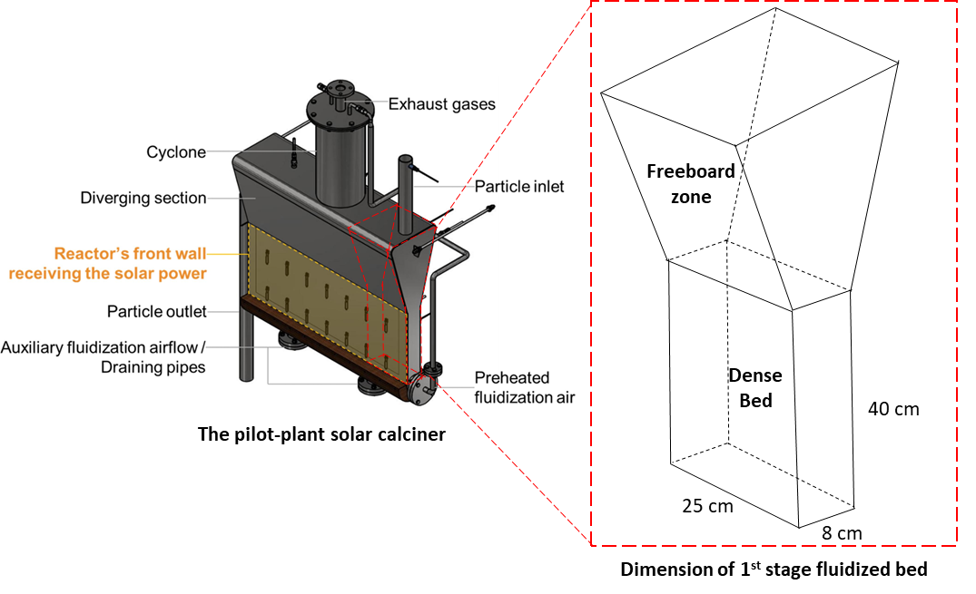
Figure S3: Schematic diagram of the pilot-scale solar reactor and the dimension of 1st stage fluidized bed

Assumptions
- The solar calciner is modelled at steady-state.
- The operating temperature represents the mean reactor temperature.
- The hydrodynamics of the fluidized bed are only considered on the height axis.
Modelling and simulation
To reproduce the four-stage horizontal fluidized bed used for solar calcination, the solar reactor was modelled and simulated in four fluidised beds arranged in series, as represented in the following Figure. The process flowsheet of this new modelling design was conducted in Aspen Plus® V11. Aspen Custom Modeller® (ACM) V11 acted as an additional calculation block in this flowsheet to correct the steam enthalpy and calculate the thermal efficiency.
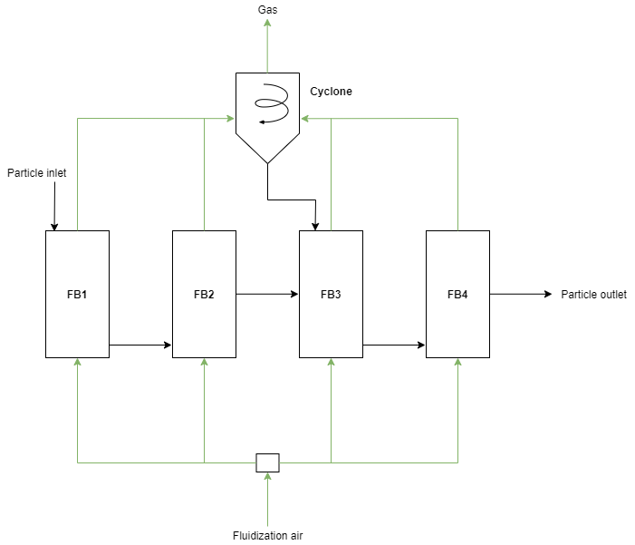
Figure S4: Representation of the approach adopted to model the four-stage horizontal solar fluidized bed (FB: fluidized bed)

Table S8: Specification of fluidized bed
Bed geometry
Bed number | 4
Width | 25 cm
Depth | 8 cm
Height (dense bed height) | 40 cm
1st stage solid discharge location | 5 cm
2nd stage solid discharge location | 30 cm
3rd stage solid discharge location | 5 cm
4th stage solid discharge location | 40 cm
Bed inventory
Voidage at minimum fluidization | 0.5
Geldart classification | Geldart A
Other model settings
Minimum fluidization velocity correlation | Wen & Yu (1966)
Transport disengagement height | Fung and Hamdullahpur (1993)
Elutriation | Tasirin & Geldart (1998)

Table S9: Enthalpy correlation and thermal efficiency calculation
Parameter | Reference
Heat of reaction | Robie and Hemingway, 1995¹²
Enthalpy of CaCO₃ | Robie and Hemingway, 1995¹²
Enthalpy of Air | Hilsenrath et al., 1955¹³
Thermochemical efficiency | Esence et al., 2020¹⁴
Thermal efficiency | Esence et al., 2020¹⁴

Table S10: Process specifications of solar calcination process at pilot scale
Parameter | Case 1:  20 kg/hr low  fluidization flow rate | Case 2:  20 kg/hr high  fluidization flow rate
Mass flow rate of CaCO₃ (kg/hr) | 20 | 20
Air flow rate (Nm³/hr) | 10.1 | 19.3
Auxiliary air (Nm³/hr) | 3 | 4
Global temperature in calcinerª (℃) | 831 | 813
Solar power in (kW) | 67.4 | 57.8
Inlet CaCO₃ purity^{b} (wt%) | 98.5% | 98.5%
ªGlobal temperature represents the reactor temperature in each specific case.
^{b}Other impurities include 0.085% CaO and 0.065% unreactive materials such as SiO, MgO, and MnO.
Table S11: Validation of two representative experimental data of solar calcination
 | Case 1:  20 kg/hr low fluidization flow rate |  |  | Case 2:  20 kg/hr high fluidization flow rate
 | Experimental data | Simulation result | Relative Errors | Experimental data | Simulation result | Relative Errors
Mass balance
CaCO₃ conversion | 88.50% | 88.57% | -0.08% | 95.20% | 95.43% | -0.24%
CaCO₃ weight fraction in solids outlet | 18.60% | 18.26% | 1.80% | 7.62% | 7.68% | -0.75%
CaO weight fraction in solids outlet | 80.65% | 80.92% | -0.34% | 91.24% | 91.22% | 0.03%
Unreactive materials weight fraction in solids outlet | 0.75% | 0.81% | -8.16% | 1.14% | 1.11% | 2.81%
Energy balance
Thermochemical efficiency | 14% | 13.62% | 2.70% | 17% | 17.10% | -0.60%
Thermal efficiency | 23% | 23.42% | -1.85% | 29% | 29.13% | -0.46%

Note S3: Modelling, simulation and validation of CO₂-to-SAF at lab scale
Assumptions
The following assumptions were made for the CO₂ utilisation model using the CO₂-FTS approach.
- This model, which transforms CO₂ into jet fuel, operates at steady-state. Hence, there is no accumulation of heat and mass in the fixed bed reactor.
- Only reaction conversion and specific products are considered based on material balance and stoichiometric reactions.
- Only olefin and paraffin are considered for hydrocarbons in this model (depending on the catalyst nature, the selectivity of oxygenates was neglected in experiments due to it being below 1.0%), and the ratio of olefin to paraffin for each hydrocarbon is obtained from jet fuel experiments^{15,16}.
- The chain growth probability of hydrocarbons is based on the given Anderson-Schulz-Flory (ASF) plot from experiments¹⁵.
- The lumping technique was used for a large number of products from CO₂-FTS reactions. The infinite number of hydrocarbon components is handled by the lump of components from C₁ to C₅₀.
Modelling and simulation of the CO₂-FTS process
A modified ASF model combining ASF theory and kinetic modelling on the Fischer-Tropsch reaction was implemented in ACM to predict the hydrocarbon distribution of converting CO to jet fuel under Fe-Mn-K catalyst in the carbon number range from C₁ to C₅₀.
C₃ compounds do not follow the theoretical ASF distribution and are removed from the modified ASF model. The chain growth probability is calculated separately based on the kinetic values proposed by Kamkeng and Wang¹⁷.
Based on the predicted selectivity of products in ACM, the mass and energy balance of the CO₂-FTS process using the lumping technique was simulated in Aspen Plus® V11.

Table S12: Equations of CO₂-FTS model implemented in ACM
Parameter | Equation | Reference
Chain growth probability of C₃ ($α_{C_{3}}$) | $$α_{C_{3}}=\frac{k_{1}P_{{CO}_{2}}}{k_{1}P_{{CO}_{2}}+k_{5}P_{H_{2}}+k_{6,0}e^{3c}}$$ | Kamkeng and Wang (2023)¹⁷, Todic et al. (2013)¹⁸
Weight fraction of C₃ ($W_{3}$) | $$W_{3}=3×{(1-α_{C_{3}})}^{2}×{α_{C_{3}}}^{2}$$ | Kamkeng and Wang (2023)¹⁷, Todic et al. (2013)¹⁸
Product fraction related to $α_{1}$ ($f_{1}$) | $$f_{1}=λ\frac{1-W_{3}}{\frac{1}{1-α_{1}}-\frac{α_{1}}{1+α_{1}}+\left[\frac{1}{1-α_{2}}-\frac{α_{2}}{1+α_{2}}\right]{(\frac{α_{1}}{α_{2}})}^{b-1}}$$ | Kamkeng and Wang (2023)¹⁷
Product fraction related to $α_{2}$ ($f_{2}$) | $$f_{2}={f_{1}×(\frac{α_{1}}{α_{2}})}^{b-1}$$ | Kamkeng and Wang (2023)¹⁷
Weight fraction of hydrocarbon n ($W_{n}$) | $$W_{n}=f_{1}×{α_{1}}^{n-1}+f_{2}×{α_{2}}^{n-1}$$ | Donnelly et al. (1988)¹⁹
Average molecular weight of hydrocarbons ($\overline{M}$) | $$\frac{1}{\overline{M}}=\sum_{n=1}^{50}{\frac{W_{n}}{M_{n}}}$$ | Kamkeng and Wang (2023)¹⁷
Mole fraction of hydrocarbon n ($x_{n}$) | $$x_{n}=\frac{W_{n}}{M_{n}}×\overline{M}$$ | Kamkeng and Wang (2023)¹⁷
Selectivity of hydrocarbon n ($S_{n}$) | $$S_{n}=\frac{x_{n}×n}{\sum_{n=1}^{50}{x_{n}×n}}$$ | Kamkeng and Wang (2023)¹⁷
Total molar flow rate of hydrocarbons ($N_{HC}$) | $$N_{HC}=n_{{CO}_{2in}}×X_{{CO}_{2}}×X_{CO}$$ | Kamkeng and Wang (2023)¹⁷
Molar flow rate of hydrocarbon n ($n_{HC}$) | $${n_{HC}=N}_{HC}×\frac{S_{n}}{n}$$ | Kamkeng and Wang (2023)¹⁷

Table S13: Products and chemical reactions implemented for the CO₂-FTS model
Carbon range | Product category | Carbon number | Component | Chemical reaction
n=1 | Carbon Monoxide | 1 | $$CO$$ | $${CO}_{2}+H_{2}→ CO+ H_{2}O$$
n=1 | Methane | 1 | $${CH}_{4}$$ | $$CO+{3H}_{2}→ {CH}_{4}+ H_{2}O$$
$$2≤n≤4$$ | Light Hydrocarbon (C₂-C₄) | 2, 3 and 4 | $${C_{2}H}_{6}$$ | $$2CO+{5H}_{2}→ {C_{2}H}_{6}+ {2H}_{2}O$$
$$2≤n≤4$$ | Light Hydrocarbon (C₂-C₄) | 2, 3 and 4 | $${C_{2}H}_{4}$$ | $$2CO+{4H}_{2}→ {C_{2}H}_{4}+ {2H}_{2}O$$
$$2≤n≤4$$ | Light Hydrocarbon (C₂-C₄) | 2, 3 and 4 | $${C_{3}H}_{8}$$ | $$3CO+{7H}_{2}→ {C_{3}H}_{8}+ {3H}_{2}O$$
$$2≤n≤4$$ | Light Hydrocarbon (C₂-C₄) | 2, 3 and 4 | $${C_{3}H}_{6}$$ | $$3CO+{6H}_{2}→ {C_{3}H}_{6}+ {3H}_{2}O$$
$$2≤n≤4$$ | Light Hydrocarbon (C₂-C₄) | 2, 3 and 4 | $${C_{4}H}_{10}$$ | $$4CO+{9H}_{2}→ {C_{4}H}_{10}+ {4H}_{2}O$$
$$2≤n≤4$$ | Light Hydrocarbon (C₂-C₄) | 2, 3 and 4 | $${C_{4}H}_{8}$$ | $$4CO+{8H}_{2}→ {C_{4}H}_{8}+ {4H}_{2}O$$
$$5≤n≤7$$ | Light Naphtha (C₅-C₇) | 5, 6 and 7 | $${C_{5}H}_{12}$$ | $$5CO+{11H}_{2}→{C_{5}H}_{12}+ {5H}_{2}O$$
$$5≤n≤7$$ | Light Naphtha (C₅-C₇) | 5, 6 and 7 | $${C_{5}H}_{10}$$ | $$5CO+{10H}_{2}→{C_{5}H}_{10}+ {5H}_{2}O$$
$$5≤n≤7$$ | Light Naphtha (C₅-C₇) | 5, 6 and 7 | $${C_{6}H}_{14}$$ | $$6CO+{13H}_{2}→ {C_{6}H}_{14}+ {6H}_{2}O$$
$$5≤n≤7$$ | Light Naphtha (C₅-C₇) | 5, 6 and 7 | $${C_{6}H}_{12}$$ | $$6CO+{12H}_{2}→ {C_{6}H}_{12}+ {6H}_{2}O$$
$$5≤n≤7$$ | Light Naphtha (C₅-C₇) | 5, 6 and 7 | $${C_{7}H}_{16}$$ | $$7CO+{15H}_{2}→{C_{7}H}_{16}+ {7H}_{2}O$$
$$5≤n≤7$$ | Light Naphtha (C₅-C₇) | 5, 6 and 7 | $${C_{7}H}_{14}$$ | $$7CO+{14H}_{2}→{C_{7}H}_{14}+ {7H}_{2}O$$
$$8≤n≤16$$ | Jet Fuel (C₈-C₁₆) | 12 | $${C_{12}H}_{26}$$ | $$12CO+{25H}_{2}→ {C_{12}H}_{26}+ {12H}_{2}O$$
$$8≤n≤16$$ | Jet Fuel (C₈-C₁₆) | 12 | $${C_{12}H}_{24}$$ | $$12CO+{24H}_{2}→ {C_{12}H}_{24}+ {12H}_{2}O$$
$$n≥17$$ | Wax (C₁₇₊) | 20 | $${C_{20}H}_{42}$$ | $$20CO+{41H}_{2}→ {C_{20}H}_{42}+ {20H}_{2}O$$

Table S14: Input parameters for CO₂-FTS model validation
Parameter |  | Value | Reference
Reactor type |  | fixed bed | Yao et al. (2020)¹⁵
Reactor diameter (cm) |  | 1 | Yao et al. (2020)¹⁵
Reactor temperature (℃) |  | 300 | Yao et al. (2020)¹⁵
Reactor pressure (MPa) |  | 1 | Yao et al. (2020)¹⁵
H₂/CO₂ ratio |  | 3 | Yao et al. (2020)¹⁵
Flow rate (mL/min) |  | 40 | Yao et al. (2020)¹⁵
CO₂ conversion (%) |  | 38.2 | Yao et al. (2020)¹⁵
Chain growth probability | $$α_{1}$$ | 0.79 | Donnelly et al. (1988)¹⁹, Yao et al. (2020)¹⁵
Chain growth probability | $$α_{2}$$ | 0.572 | Donnelly et al. (1988)¹⁹, Yao et al. (2020)¹⁵
Carbon number at breakpoint |  | 12 | Donnelly et al. (1988)¹⁹, Yao et al. (2020)¹⁵
Kinetic constants | k₁ | 1.66$×$10⁻² | Kamkeng and Wang (2023)¹⁷, Todic et al. (2013)¹⁸
Kinetic constants | k₅ | 6.99 $×$ 10⁻⁵ | Kamkeng and Wang (2023)¹⁷, Todic et al. (2013)¹⁸
Kinetic constants | K_{6,0} | 2.02 $×$ 10⁻² | Kamkeng and Wang (2023)¹⁷, Todic et al. (2013)¹⁸
Constant c |  | -0.26 | Kamkeng and Wang (2023)¹⁷, Todic et al. (2013)¹⁸
Fitting parameter $λ$ | $$n≤7$$ | $$0.15e^{0.35n}$$ | Kamkeng and Wang (2023)¹⁷, Todic et al. (2013)¹⁸
Fitting parameter $λ$ | $$8≤n≤12$$ | $$0.29e^{0.39n}$$ | Kamkeng and Wang (2023)¹⁷, Todic et al. (2013)¹⁸
Fitting parameter $λ$ | $$n≥13$$ | $$2.7e^{36n^{-1}}$$ | Kamkeng and Wang (2023)¹⁷, Todic et al. (2013)¹⁸

Table S15: Model validation results of selectivity for different product categories

Product category | Selectivity (%) |  | Relative error (%)
Product category | Experimental data | Model prediction | Relative error (%)
CO | 5.6 | 5.60 | 0.00
C₁ | 10.4 | 10.14 | -2.51
C₂-C₄ | 27.7 | 27.60 | -0.34
C₅⁺ | 61.9 | 62.26 | 0.58
C₈-C₁₆ | 47.8 | 47.64 | -0.34

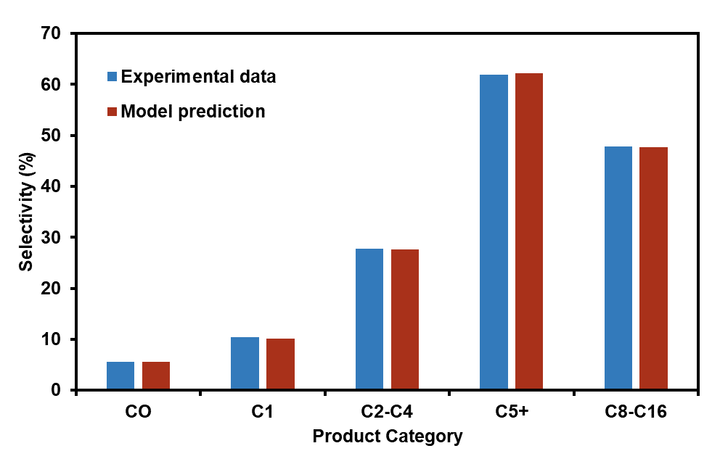
Figure S5: Model predictions and experimental values of CO₂-FTS product selectivity

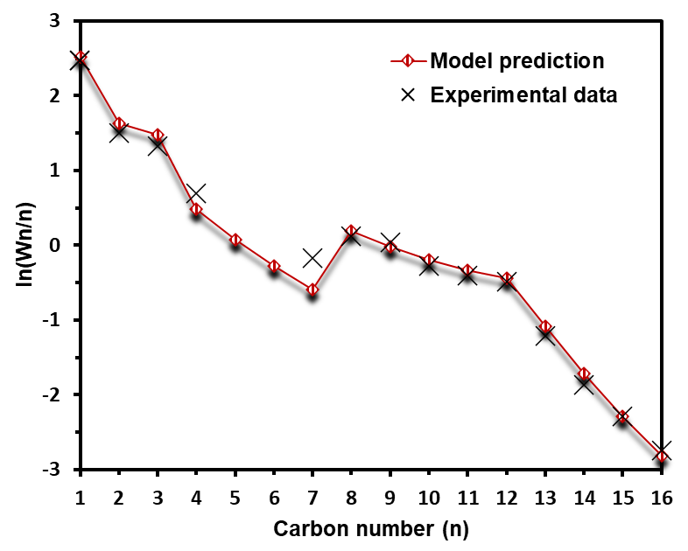
Figure S6: Anderson-Schulz-Flory plots showing the prediction of hydrocarbon distributions

Note S4: Scale-up approach of fluidized bed
Kelkar and Ng studied the scale-up of fluidized beds with the consideration of both hydrodynamic similarity and reaction converion²⁰. Based on the scaling law, the bubble size of the fluidized bed is controlled in a suitable range to achieve the same reaction conversion at a large scale.
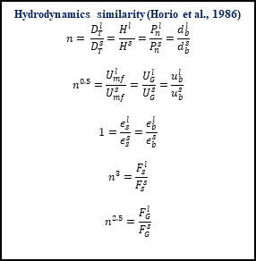
Figure S7: Scale-up principle of solar calciner for achieving hydrodynamic similarity
With the commercial-scale solar calciner, we can achieve the large-scale CSP-driven DAC. The reactor geometry and operation parameters will be based on operating and economic optimisation.
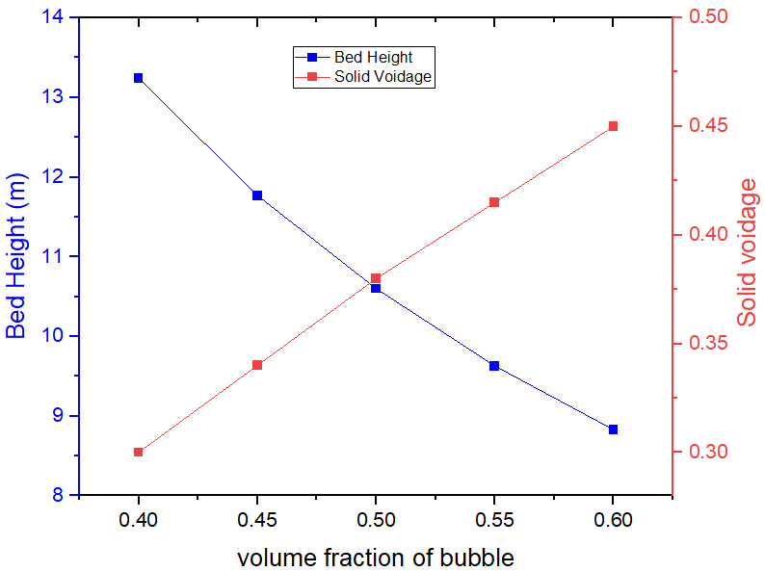
Figure S8: Bed height and solid voidage as a function of bubble volume fraction at large-scale

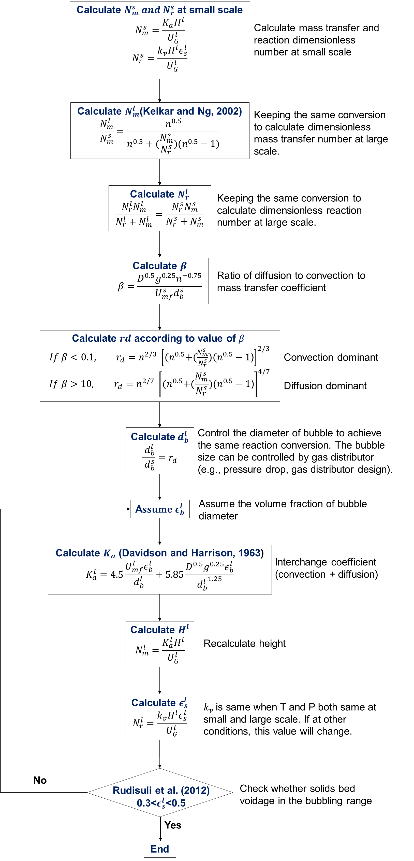
Figure S9: Scale-up principle of solar calciner for achieving the same reaction conversion
Table S16: Example of large-scale hydrogen-based solar calciner through scaling approach
Symbol | Description | Unit | Pilot-scale (Air) | Pilot-scale (H₂) | Commercial-scale (H₂)
n | scaling factor |  | 1 |  | 10
Reactor Geometry and Phase Flows
L | Length | m | 0.08 | 0.08 | 0.8
W | Width | m | 0.25 | 0.25 | 2.5
H | Height | m | 0.8 | 0.8 | 10.73
F_{S} | Solids flow rate | kg/h | 20 | 20 | 20,000
F_{G} | Gas flow rate | kg/h | 30 | 2.077 | 656.8
U_{mf} | Minimum fluidization velocity | mm/s | 4 | 8.1 | 25.5
U_{G} | Superficial fluidization velocity | m/s | 0.4 | 0.404 | 1.28
u_{b} | Bubble velocity | m/s | 0.95 | 0.94 | 2.97
Phase distribution
d_{p} | Mean particle diameter | μm | 100 | 100 | 178
d_{b} | Bubble diameter | m | 0.053 | 0.05 | 0.7
ε_{b} | Volume fraction of bubble | - | 0.415 | 0.42 | 0.5
ε_{s} | Voidage of solids | - | 0.5 | 0.5 | 0.37
Transport attributes
K_{a} | Interchange coefficient | s⁻¹ | 0.64 | 0.01 | 0.69
Dimensionless No. and Reactor Performance
N_{r} | Reaction numbers | - | 1.28 | 1.49 | 4.69
N_{m} | Mass transfer numbers | - | 0.1 | 1.37 | 0.84
X_{CaCO3} | CaCO₃ conversion | - | 0.95 | 0.95 | 0.95

Note S5: Techno-economic assessment at the base case scenario
Table S17: Equipment installed cost breakdown by section (base case)
Equipment type | Installation factor | Scaling exponent | Reference installed cost (US$) | Installed cost (2020 US$) | Source
Direct air captureª
Air contactor | 1.86 | 1 | 212,200,000 | 233,549,271 | ²
Pellet reactor | 1.7 | 0.675 | 130,700,000 | 133,967,959 | ²
Steam slaker | 1.45 | 0.675 | 38,850,000 | 37,606,988 | ²
Steam turbine | NA | 0.7 | 7,510,000 | 8,265,575 | ²
Filter | 1.76 | NA | 30,900,000 | 31,840,017 | ²
Other equipment^{b} | NA | NA | 102,900,000 | 89,045,962 | ^{2,21}
Buildings | NA | 0.61 | 6,700,000 | 6,566,310 | ²
Transformer | NA | 0.7 | 19,800,000 | 19,075,577 | ²
Subtotal |  |  |  | 559,917,659
Solar calcination
Heliostat field^{c} | NA | 1 | NA | 126,688,860 | ²²
Parabolic mirror^{d} | 2.27 | 1 | NA | 38,006,658 | ²²
Solar calciner & solar tower^{e} | 2.27 | 0.48 | NA | 211,679,219 | ²¹
CaCO₃ storage tank^{f} | NA | NA | NA | 1,556,530 | ²¹
CaO storage tank^{f} | NA | NA | NA | 1,006,128 | ²¹
Subtotal |  |  |  | 378,937,395
CO₂-to-SAF
Mixed gas cooler | 3.23 | 0.7 | 4,186,906 | 6,414,481 | ²³
Mixed gas compressor | 2.47 | 0.65 | 11,461,600 | 56,825,619 | ²³
H₂ compressor | 2.47 | 0.6 | 2,547,995 | 1,108,176 | ²³
Preheater | 2.47 | 0.6 | 6,248,204 | 14,770,241 | ²³
CO₂-FTS reactor | 2.75 | 0.8 | 36,681,585 | 262,237,754 | ²³
Syncrude cooler | 1.52 | 0.7 | 50,244 | 1,455,142 | ²³
Three-phase separator | 1.69 | 0.7 | 6,595,713 | 17,995,594 | ²³
Distillation unit^{g} | 2.47 | 0.65 | 2,547,995 | 74,788,647 | ^{23,24}
Subtotal |  |  |  | 435,596,192
ªEquipment of DAC is quoted from CE’s DAC design and updated based on size and cost to 2020
^{b}Other equipment is assumed to be 20% of the cost for the rest of the process equipment, including cyclones, mix tank and auxiliary equipment
^{c}Heilostat field cost is according to US$75/m²
^{d}Parabolic mirror cost is assumed as 30% of the heliostat field cost
^{e}Solar receiver and tower were calculated together
^{f}Cost of storage tanks were calculated according to the reference method²¹
^{g}Distillation unit is assumed as a holistic cost including jet fuel distillation, separator and co-product recovery system (distillation columns, compressors, heaters and coolers)
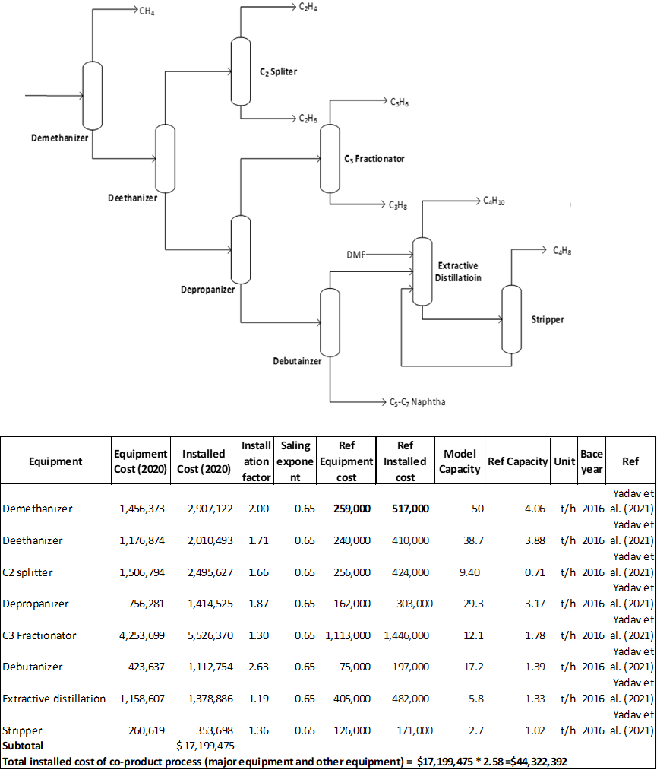
Figure S10: Design and cost of co-product recovery system
While the co-product recovery is illustrated as a single block in Extended Data Fig. 4, for clarity, this unit consists of multiple components, including distillation columns, compressors, heaters and coolers. Specifically, the process handles a stream of 55.8 t/h, which contains 10.1 wt% water, 69.3 wt% C₁-C₄ hydrocarbons and 20.4 wt% C₅⁺ hydrocarbons. After water removal, the remaining hydrocarbons can be separated by conventional petroleum refinery processes—a mature and well-established industrial process. Here, the same separation process was adopted from previous study²⁴ to recover high-purity (>99.5 wt%) fractions of CH₄, C₂H₄, C₂H₆, C₃H₆, C₃H₈, C₄H₈, C₄H₁₀ and C₅-C₇ naphtha (see Figure S10). The total installed cost of the co-product recovery system is $44.3 million, which is around 59.3% of the distillation unit cost.
Table S18: CAPEX summary of 1 Mt_{CO2}/yr solar-driven DACCU plant by section (base case)
Parameter | Item | Calculation | Cost (2020 US$M)
Parameter | Item | method | Cost (2020 US$M)
Direct air capture
Total direct field costs (TDFC) |  | Sum of the installed cost | 559.9
Indirect field costs (IFC) |  | 12.7% of TDFC | 71.1
Total field costs (TFC) |  | TDFC + IFC | 631.0
Non-field costs (NFC) | Engineering | 12% of TPC | 108.4
Non-field costs (NFC) | Contingency | 6% of TFC | 126.2
Non-field costs (NFC) | Other project costs | 20% of TFC | 37.9
Total non-field costs (TNFC) |  | Sum of non-field costs | 272.5
Total project costs (TPC) |  | TFC + TNFC | 903.5
Solar calcination
TDFC |  | Sum of the installed cost | 378.9
Contingency |  | 10% TDFC | 37.9
Direct cost |  | TDFC + Contingency | 416.8
Indirect cost |  | 9% TDFC | 34.1
Total capital investment of CSP |  | Direct cost + Indirect cost | 450.9
CO₂-to-SAF
TDFC |  | Sum of the installed cost | 435.6
IFC |  | 12.7% of TDFC | 55.3
TFC |  | TDFC + IFC | 490.9
NFC | Engineering | 12% of TPC | 84.3
NFC | Contingency | 6% of TFC | 98.2
NFC | Other project costs | 20% of TFC | 29.5
TNFC |  | Sum of non-field costs | 212.0
TPC |  | TFC + TNFC | 702.9
Land cost |  | Average land cost | 21.1
Total CAPEX |  | 2,078.5

Table S19: Annual operational expenditure breakdown (base case)
Operating Parameters
Parameter | Value | Units
Annual operating hours | 8,000 | hr/yr
CO₂ concentration in the air | 420 | ppm
Air velocity | 1.4 | m/s
Air travel distance | 7 | m
CO₂ capture rate | 74.5 | %
Annual CO₂ capture productivity | 0.96 | Mt/yr
Annual SAF productivity | 0.12 | Mt/yr
Variable Operating Costs
Raw material/Utility | Mass flow (kg/hr) or  Energy flow (kW) | Cost (US$/yr)
KOH makeup | 907.7 | 5,446,008.0
CaCO₃ makeup | 2,717.0 | 4,347,200.0
Water makeup | 516,110.0 | 4,128,880.0
Fan electricity | 6,858.8 | 1,646,112.0
Pumping electricity | 5,028.8 | 1,206,912.0
Hydrogen for fluidization | 8,110.0 | 141,438,616.3
Additional hydrogen | 8,300.5 | 144,760,503.7
Hydrogen makeup | 912.7 | 15,917,413.0
Catalyst makeupª | NA | 7,960,000.0
Electricity | 30,283.9 | 7,268,124.8
Heating utility | 58,849.6 | 14,123,896.0
Cooling utility | 248,632.6 | 1,551,467.6
Potential Co-Products and Credits
Co-products | Mass flow (kg/hr) | Cost (US$/yr)
NG | 3,768.9 | 7,839,382.5
Ethane | 1,405.9 | 1,912,089.9
Ethylene | 1,738.1 | 8,064,569.1
Propane | 1,617.9 | 4,271,330.4
Propylene | 2,399.7 | 15,934,192.2
Butane | 1,044.0 | 3,006,589.9
Butene | 913.8 | 9,284,373.8
Light Naphtha | 3,573.2 | 10,862,405.1
Subtotal |  | 61,174,933.0
Fixed operating costs
Section | Calculation method | Cost (US$M/yr)
DAC | 3% of CAPEX | 27.11
CO₂-to-SAF | 3% of CAPEX | 21.09
Solar calcination | 3% of CAPEX | 13.53
ªCatalyst consumption is assumed as 2 t/yr²⁵

Table S20: Summary of annual operational expenditure (base case)
Process Section | Cost category (US$M/yr)
Process Section | Fixed cost | Sorbent | Water | Catalyst | Utility | Hydrogen | Co-products | Subtotal
DAC | 27.11 | 9.79 | 4.13 | - | 2.85 | - | - | 43.88
Solar calcination | 13.53 | - | - | - | - | 141.44 | - | 154.97
CO₂-to-SAF | 21.09 | - | - | 7.96 | 22.94 | 160.68 | -61.17 | 151.49
Subtotal | 61.72 | 9.79 | 4.13 | 7.96 | 25.80 | 302.12 | -61.17 | 350.34

Table S21: MSP of SAF at base case
Process Section | Cost category (US$/kg SAF)
Process Section | Fixed cost | Sorbent | Water | Catalyst | Utility | Hydrogen | Co-products | Capital charge | Land cost | Subtotal
DAC | 0.22 | 0.08 | 0.03 | - | 0.02 | - | - | 0.78 | - | 1.13
Solar calcination | 0.11 | - | - | - | - | 1.15 | - | 0.39 | - | 1.64
CO₂-to-SAF | 0.17 | - | - | 0.06 | 0.19 | 1.30 | -0.50 | 0.60 | - | 1.83
Subtotal | 0.50 | 0.08 | 0.03 | 0.06 | 0.21 | 2.45 | -0.50 | 1.77 | 0.02 | 4.62

Table S22: LCOD at base case
Process Section | Cost category (US$/t CO₂)
Process Section | Fixed cost | Sorbent | Water | Catalyst | Utility | Hydrogen | Co-products | Capital charge | Land cost | SAF avenue | Subtotal
DAC | 28.37 | 10.25 | 4.32 | - | 2.99 | - | - | 100.31 | - | - | 146.24
Solar calcination | 14.61 | - | - | - | - | 148.04 | - | 50.07 | - | - | 212.26
CO₂-to-SAF | 22.07 | - | - | 8.33 | 24.01 | 168.17 | -64.03 | 78.04 | - | -314.84 | -78.24
Subtotal | 64.60 | 10.25 | 4.32 | 8.33 | 27.00 | 316.21 | -64.03 | 228.42 | 2.35 | -314.84 | 282.61

Table S23: Application and price of co-products²⁴
Co-products | Applications | Price (US$/kg)
Natural gas | Fuel | 0.26
Ethane | Refrigerant | 0.17
Ethylene | Plastics | 0.58
Propane | Fuel | 0.33
Propylene | Plastics | 0.83
Butane | Fuel | 0.36
Butene | Plastics | 1.27
Light naphtha (C₅-C₇) | Fuel | 0.38

Table S24: Historical price of jet fuel and sustainable aviation fuel²⁶
Price Year | Jet Fuel (US$/t) | SAF (US$/t)
2019 | 628 | NA
2020 | 365 | 1412
2021 | 613 | 2140
2022 | 1094 | 2437

Table S25: Technical parameters of CSP
Parameters | Value | Units | Comments
Average CaCO₃ flow rate to the solar calciner | 285.3 | t_{CaCO3}/hr | Calculated from the process model
Solar power | 712.97 | MW_{th} | Calculated from the process model
Single heliostat geometry | 12.2 x 12.2 | m | Adopt design from the CSP plant
Size of the single solar calciner | 39.61 | MW_{th} | Calculated from the process model
Scaling factor of the solar calciner | 13.35 | NA | Determined from solar calciner scaling
Hydrogen fluidisation flow rate in a single solar calciner | 1.35 | t_{H2}/hr | Determined from solar calciner scaling
Number of solar CSP plants | 18 | NA | Determined from solar calciner scaling and process model
Total solar field area | 98.79 | acres | Calculated from SAM
Non-solar field land area | 45 | acres | Obtained from SAM
DNI | 2516.2 | kWh/m²/yr | Obtained from Global Solar Atlas
Solar multiple | 2.4 | NA | Calculated from the process model
Thermal efficiency of solar calciner | 60 | % | Assumed based on literature²⁷

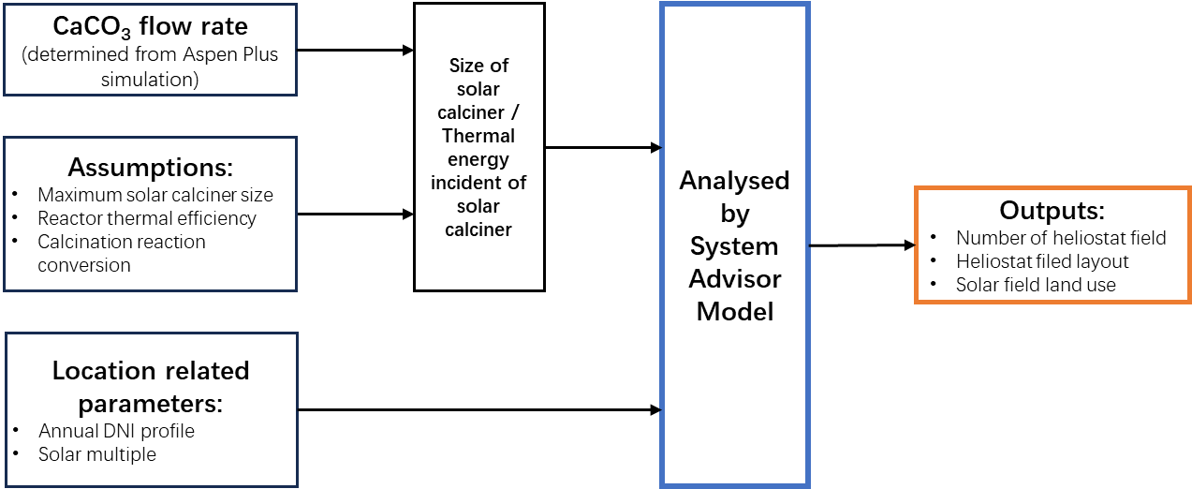
Figure S11: Principle of SAM analysis

The System Advisor Model (SAM) is a tool for designing and optimizing heliostat fields for solar towers based on an annual performance calculation. Based on the selected locations²⁹, the SAM is used to calculate the requirement of heliostat field area and land area. The imported weather conditions (e.g., annual DNI and wind speed) are from NREL’s National Solar Radiation Database (NSRD)²⁸.

Figure S12: Energy flow diagram of solar calcination

Solar-to-thermal energy efficiency ($η_{sloar-th}$), which is defined as the ratio of the solar calciner’s thermal energy input to the solar beam irradiation in the solar field. This value is automatically calculated by SAM.
Thermal efficiency ($η_{th}$), which is defined as the ratio of calcination reaction enthalpy to the solar calciner’s thermal energy input. This value is assumed as 60% referring to the literature²⁷.

Table S26: Five selected CSP project locations²⁸ used for geographical analysis
Project | Country | Longitude (deg) | Latitude (deg) | Averaged T (℃) | Relative Humidity (%) | Capacity | Technology | SM | Status
Crescent Dunes | USA | 39.17 | -119.78 | 12.5 | 42.7 | 110 MW | Solar power tower | 3 | Operational since 2015
Cerro Dominador | Chile | -22.46 | -68.93 | 15.7 | 17.6 | 110 MW | Solar power tower | 2.4 | Operational since 2021
Planta Solar 20 | Spain | 37.45 | -6.26 | 19.1 | 58.9 | 20 MW | Solar power tower | 3 | Operational since 2009
Redstone CSP Project | South Africa | -28.31 | 23.38 | 18.2 | 28.8 | 100 MW | Solar power tower | 2.7 | Operational since 2023
Shouhang Dunhuang Phase II | China | 40.05 | 94.42 | 12.0 | 22.5 | 100 MW | Solar power tower | 3 | Operational since 2018

Table S27: Regional hydrogen cost²⁹⁻³¹, PV cost³² and WACC³³
Country | Hydrogen production technology and cost (US$/kg) |  |  |  | PV electricity price (US$/MWh) | WACC (%)
Country | AE | PEM | SOEC | SMR with CCS | PV electricity price (US$/MWh) | WACC (%)
USA | 2.5 - 4.0 | 3.0 - 5.0 | 4.5 - 6.5 | 1.5 - 2.0 | 41 | 5.10
Chile | 1.8 - 3.2 | 2.5 - 4.0 | 3.8 - 5.8 | 1.2 - 1.7 | 32 | 9.20
Spain | 2.2 - 3.7 | 2.8 - 4.3 | 4.0 - 6.0 | 1.4 - 1.9 | 36 | 4.20
South Africa | 2.3 - 3.8 | 2.9 - 4.4 | 4.2 - 6.2 | 1.3 - 1.8 | 42 | 11.80
China | 2.0 - 3.5 | 2.7 - 4.2 | 3.9 - 5.9 | 1.1 - 1.6 | 23 | 6.60

Note S6: Sensitivity analysis
All process analyses of air contactors are under the same liquid solvent composition (2 M K⁺, 1.1 M OH⁻, 0.45 M CO₃²⁻) because the rate-based model was specifically developed under this circumstance. The process analysis was carried out for CO₂ concentration in the air, air velocity (V_{air}), air travel distance (ATD) and the ratio of the mass flow rate of liquid solvent over the mass flow rate of air (L/G ratio).
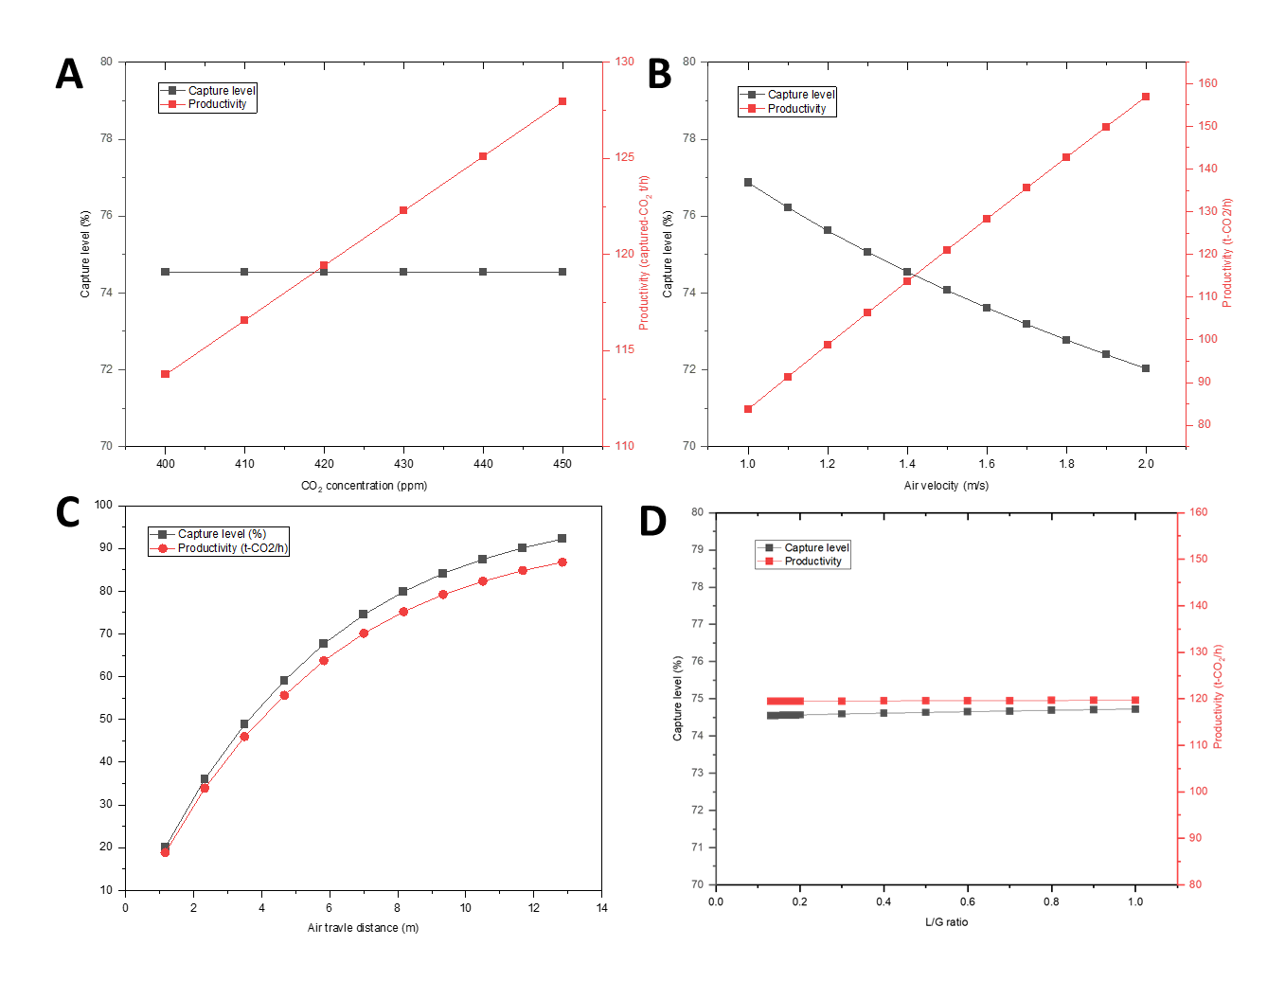
Figure S13: Impact of operating and design variables on capture level and productivity. Variables are (A) CO₂ concentration in the air, (B) air velocity, (C) air travel distance and (D) L/G ratio.
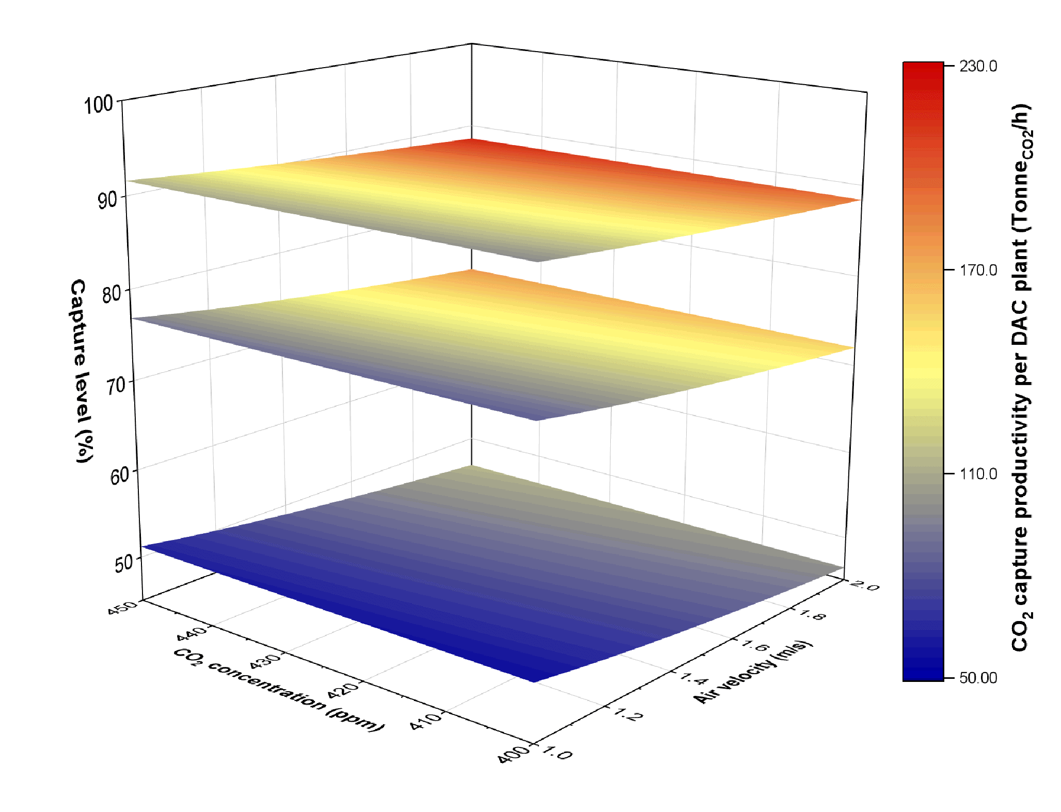
Figure S14: Map of DAC CO₂ capture productivity. CO₂ productivity as a function of CO₂ concentration in the air, air velocity, and air travel distance (ATD). Three coloured layers represent capture level at around 50%, 75% and 90% with 3 segments (3.5 m ATD), 6 segments (7 m ATD) and 10 segments (11.7 m ATD) Brentwood XF12560 packing, respectively.

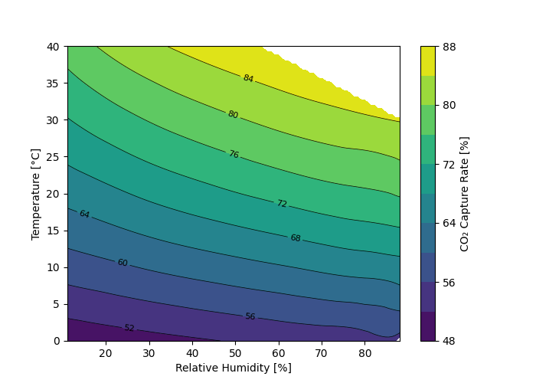
Figure S15: CO₂ capture rate at different relative humidity and temperature ranges (White-coloured area represents unreachable air conditions).

Table S28: Sensitivity analysis of parameters for DAC—material requirement and electricity consumption under different operating conditions
Parameter | Pr | conc | V_{air} | ATD | CL | F_{air} | F_{KOH} | Re_{KOH} | F_{Ca(OH)2} | F_{water} | Fan $ΔP$ | E_{fan} | E_{pump} | E_{DAC} | F_{CaCO3}
Unit | t-CO₂/h | ppm | m/s | m | % | kt/h | kt/h | % | t/h | t | Pa | kWh/t-CO₂ | kWh/t-CO₂ | kWh/t-CO₂ | t/h
Base case | 119.4 | 420 | 1.4 | 7 | 74.5 | 251.0 | 32.6 | 99.7 | 716.5 | 516.1 | 85.7 | 57.4 | 42.1 | 99.5 | 238.7
400 ppm | 113.7 | 400 | 1.4 | 7 | 74.5 | 251.0 | 32.6 | 99.7 | 682.4 | 489.7 | 85.7 | 60.3 | 44.2 | 104.5 | 271.7
450 ppm | 128.0 | 450 | 1.4 | 7 | 72.0 | 251.0 | 32.6 | 99.7 | 767.7 | 555.8 | 85.7 | 53.6 | 39.3 | 92.9 | 305.7
1m/s V_{air} | 88.0 | 420 | 1 | 7 | 76.9 | 179.3 | 23.3 | 99.7 | 527.7 | 369.8 | 43.0 | 27.9 | 40.9 | 68.8 | 210.1
2m/s V_{air} | 164.9 | 420 | 2 | 7 | 74.5 | 358.6 | 46.6 | 99.7 | 989.1 | 727.4 | 181.4 | 125.8 | 43.6 | 169.4 | 393.8
3.5m ATD | 78.3 | 420 | 1.4 | 3.5 | 48.9 | 251.0 | 16.3 | 99.7 | 469.6 | 324.7 | 51.0 | 52.1 | 32.1 | 84.2 | 187.0
11.7m ATD | 144.4 | 420 | 1.4 | 11.7 | 90.1 | 251.0 | 54.5 | 99.7 | 866.4 | 632.3 | 126.1 | 69.8 | 58.2 | 128.1 | 345.0

Under different operating conditions, the L/G ratio and packing wetting condition were maintained the same. The airflow rate was based on CO₂ concentration in the air (conc) and air velocity (V_{air}). Thereby, the KOH solvent flow rate (F_{KOH}) was determined by the inlet air flow rate (F_{air}). The mass flow rate of Ca(OH)₂ slurry (F_{Ca(OH)2}) depends on how much CO₂ is captured by the air contactor for subsequent decomposition in the pellet reactor with calcium ions. The water flow rate (F_{water}) is based on the mass balance of the process model.
Electricity demand for DAC is influenced by a combination of parameters (V_{air,} ATD and conc). In the optimistic scenario, higher V_{air} increases the volume of air processed and thus requires higher solvent flow rates and greater fan and pump power. Longer ATD requires more liquid to wet the packing column, increasing pump energy. Higher conc reduces electricity demand due to improved capture productivity (Pr). Conversely, in the pessimistic scenarios, lower V_{air} and shorter ATD result in reduced airflow and solvent use, which decreases fan and pump electricity demand. While for the lower conc case, the system requires more electricity.
Figure S16: Potential heat integration in the CO₂-to-SAF section at base case scenario. Using a heat recovery strategy and pinch analysis, the heat from 450°C mixed gas (Stream 209) and 300°C syncrude (Stream 307) can be recovered to preheat the 40°C gas (Stream 305). This heat recovery results in the savings of 176.55 MW for heating in the CO₂-to-SAF section.
Table S29: Sensitivity analysis summary of MSP, related to Fig. 4d
Sensitivity parameter | Sensitivity parameter ranges |  |  |  | MSP (US$/kg) |  | %MSP difference (from base case) |  | Justification and parameter range
Sensitivity parameter | Unit | Optimistic case | Base case | Pessimistic case | Optimistic MSP | Pessimistic MSP | Optimistic% | Pessimistic% | Justification and parameter range
CO₂ concentration | ppm | 450 | 420 | 400 | 4.58 | 4.65 | -0.9 | 0.6 | Ranges of CO₂ concentration in the air³⁴. 450 ppm represents the global warming 2℃ target.
Air velocity | m/s | 2 | 1.4 | 1 | 4.42 | 4.79 | -4.5 | 3.6 | Carbon Engineering’s pilot plant operation condition²
Air travel distance | m | 11.7 | 7 | 3.5 | 4.51 | 4.85 | -2.5 | 4.8 | Based on the process model, controlling the air travel distance, the CO₂ capture rate was modelled at around 50%, 75% and 90%
Temperature | ℃ | 30 | 21 | 0 | 4.57 | 4.85 | -1.2 | 5.0 | Based on process model and ref³⁵
Relative humidity | % | 80 | 64 | 20 | 4.62 | 4.70 | -0.1 | 1.6 | Based on process model and ref³⁵
Thermal efficiency of solar calciner | % | 80% | 60% | 40% | 4.50 | 4.86 | -2.7 | 5.1 | Referring to CSP plant^{27,36}
Solar multiple | NA | 2.5 | 3 | 3.5 | 4.45 | 4.78 | -3.8 | 3.3 | Referring to the CSP plant^{28,37}
CAPEX of CSP | US$M | 189.5 | 378.9 | 568.4 | 4.38 | 4.87 | -5.4 | 5.4 | $±$50% based on process model
Gas recovery ratio | % | 99 | 90 | 80 | 3.96 | 5.37 | -14.4 | 16.1 | Based on process model
Hydrogen production cost | US$/kg | 1 | 2 | 3 | 3.50 | 5.75 | -24.3 | 24.3 | Baseline is at US$2/kg which is the short-term USA target³⁸. US$1/kg is the long-term target. Sensitivity analysis investigates $±$50% of hydrogen production cost.
Plant lifetime | year | 40 | 30 | 20 | 4.56 | 4.82 | -1.4 | 4.1 | Baseline is at 30 years, and sensitivity analysis investigates $±$10 years of plant lifetime³⁹
WACC | % | 5 | 10 | 15 | 3.93 | 5.40 | -14.9 | 16.8 | Baseline is at 10%⁴⁰, and sensitivity analysis investigates $±$50% of WACC³³.
PV electricity price | US$/MWh | 10 | 30 | 60 | 4.49 | 4.82 | -2.8 | 4.2 | PV cost based on ref³²
Land cost | US$/m² | 1.24 | 2.47 | 49.42 | 4.62 | 4.97 | -0.2 | 7.5 | Baseline land cost is based on ref²². The optimistic case uses -50% cost while the pessimistic cost is based on ref⁴¹.
Table S30: Sensitivity analysis summary of LCOD, related to Fig. 4e
Sensitivity parameter | Sensitivity parameter ranges |  |  |  | LCOD (US$/t CO₂) |  | %LCOD difference (from base case) |  | Justification and parameter range
Sensitivity parameter | Unit | Optimistic case | Base case | Pessimistic case | Optimistic LCOD | Pessimistic LCOD | Optimistic% | Pessimistic% | Justification and parameter range
CO₂ concentration | ppm | 450 | 420 | 400 | 277.0 | 286.2 | -2.0 | 1.3 | Ranges of CO₂ concentration in the air³⁴. 450 ppm represents the global warming 2℃ target.
Air velocity | m/s | 2 | 1.4 | 1 | 255.8 | 303.9 | -9.5 | 7.6 | Carbon Engineering’s pilot plant operation condition²
Air travel distance | m | 11.7 | 7 | 3.5 | 267.4 | 311.5 | -5.4 | 10.2 | Based on the process model, controlling the air travel distance, the CO₂ capture rate was modelled at around 50%, 75% and 90%
Temperature | ℃ | 30 | 21 | 0 | 275.4 | 313.3 | -2.5 | 10.5 | Based on process model and ref³⁵
Relative humidity | % | 80 | 64 | 20 | 281.8 | 292.4 | -0.3 | 3.5 | Based on process model and ref³⁵
Thermal efficiency of solar calciner | % | 80% | 60% | 40% | 266.3 | 313.3 | -5.8 | 10.9 | Referring to CSP plant^{27,36}
Solar multiple | NA | 2.5 | 3 | 3.5 | 260.1 | 302.4 | -8.0 | 7.0 | Referring to the CSP plant^{28,37}
CAPEX of CSP | US$M | 189.5 | 378.9 | 568.4 | 250.5 | 314.7 | -11.4 | 11.4 | $±$50% based on process model
Gas recovery ratio | % | 99 | 90 | 80 | 226.2 | 330.8 | -20.0 | 17.0 | Based on process model
SAF market price | US$/kg | 1.24 | 2.47 | 3.71 | 125.2 | 440.0 | -55.7 | 55.7 | Baseline SAF market price uses 2022 data²⁶. Sensitivity analysis investigates $±$50% of SAF market price.
Hydrogen production cost | US$/kg | 1 | 2 | 3 | 137.6 | 427.7 | -51.3 | 51.3 | Baseline is at US$2/kg which is the short-term USA target³⁸. US$1/kg is the long-term target. Sensitivity analysis investigates $±$50% of hydrogen production cost.
Plant lifetime | Year | 40 | 30 | 20 | 274.3 | 307.4 | -2.9 | 8.8 | Baseline is at 30 years, and sensitivity analysis investigates $±$10 years of plant lifetime³⁹
WACC | % | 5 | 10 | 15 | 193.4 | 383.2 | -31.6 | 35.6 | Baseline is at 10%⁴⁰, and sensitivity analysis investigates $±$50% of WACC³³.
PV electricity price | US$/MWh | 10 | 30 | 60 | 265.4 | 308.0 | -6.0 | 9.0 | PV cost based on ref³²
Land cost | US$/m² | 1.24 | 2.47 | 49.42 | 281.4 | 327.2 | -0.4 | 15.8 | Baseline land cost is based on ref²². The optimistic case uses -50% cost while the pessimistic cost is based on ref⁴¹.

Supplemental References
1 Sabatino, F. et al. A comparative energy and costs assessment and optimization for direct air capture technologies. Joule 5, 2047-2076 (2021).
2 Keith, D. W., Holmes, G., Angelo, D. S. & Heidel, K. A process for capturing CO₂ from the atmosphere. Joule 2, 1573-1594 (2018).
3 Holmes, G. J. A carbon dioxide absorption performance evaluation for capture from ambient air, University of Calgary, (2010).
4 CoolingTowerDepot®. The depot of all cooling towers, <http://www.coolingtowerdepot.com/content/cooling-towers> (2023).
5 Fair, J. R., Seibert, A. F., Behrens, M., Saraber, P. & Olujic, Z. Structured packing performance experimental evaluation of two predictive models. Industrial & Engineering Chemistry Research 39, 1788-1796 (2000).
6 Heidel, K., Keith, D., Singh, A. & Holmes, G. Process design and costing of an air-contactor for air-capture. Energy Procedia 4, 2861-2868 (2011).
7 Holmes, G. & Keith, D. W. An air–liquid contactor for large-scale capture of CO₂ from air. Philosophical Transactions of the Royal Society A: Mathematical, Physical and Engineering Sciences 370, 4380-4403 (2012).
8 de Jonge, M. M., Daemen, J., Loriaux, J. M., Steinmann, Z. J. & Huijbregts, M. A. Life cycle carbon efficiency of Direct Air Capture systems with strong hydroxide sorbents. International Journal of Greenhouse Gas Control 80, 25-31 (2019).
9 Holmes, G. et al. Outdoor prototype results for direct atmospheric capture of carbon dioxide. Energy Procedia 37, 6079-6095 (2013).
10 Madhu, K., Pauliuk, S., Dhathri, S. & Creutzig, F. Understanding environmental trade-offs and resource demand of direct air capture technologies through comparative life-cycle assessment. Nature Energy 6, 1035-1044 (2021).
11 Heidel, K. & Rossi, R. United States Patent application: 0170327421. High Temperature Hydrator (A1). Filed May 10 (2017).
12 Robie, R. A. & Hemingway, B. S. Thermodynamic properties of minerals and related substances at 298.15 K and 1 bar (105 Pascals) pressure and at higher temperatures. Vol. 2131 (US Government Printing Office, 1995).
13 Hilsenrath, J. Tables of thermal properties of gases: comprising tables of thermodynamic and transport properties of air, argon, carbon dioxide, carbon monoxide, hydrogen, nitrogen, oxygen, and steam. Vol. 564 (US Department of Commerce, National Bureau of Standards, 1955).
14 Esence, T., Guillot, E., Tessonneaud, M., Sans, J.-L. & Flamant, G. Solar calcination at pilot scale in a continuous flow multistage horizontal fluidized bed. Solar Energy 207, 367-378 (2020).
15 Yao, B. et al. Transforming carbon dioxide into jet fuel using an organic combustion-synthesized Fe-Mn-K catalyst. Nature Communications 11, 6395 (2020).
16 Zhang, L. et al. Direct conversion of CO₂ to a jet fuel over CoFe alloy catalysts. The Innovation 2, 100170 (2021).
17 Kamkeng, A. D. & Wang, M. Technical analysis of the modified Fischer-Tropsch synthesis process for direct CO₂ conversion into gasoline fuel: Performance improvement via ex-situ water removal. Chemical Engineering Journal 462, 142048 (2023).
18 Todic, B. et al. Kinetic model of Fischer–Tropsch synthesis in a slurry reactor on Co–Re/Al₂O₃ catalyst. Industrial & Engineering Chemistry Research 52, 669-679 (2013).
19 Donnelly, T. J., Yates, I. C. & Satterfield, C. N. Analysis and prediction of product distributions of the Fischer-Tropsch synthesis. Energy & Fuels 2, 734-739 (1988).
20 Kelkar, V. V. & Ng, K. M. Development of fluidized catalytic reactors: Screening and scale‐up. AIChE journal 48, 1498-1518 (2002).
21 Prats-Salvado, E., Jagtap, N., Monnerie, N. & Sattler, C. Solar-Powered Direct Air Capture: Techno-Economic and Environmental Assessment. Environmental Science & Technology 58, 2282-2292 (2024).
22 Buck, R. & Sment, J. Techno-economic analysis of multi-tower solar particle power plants. Solar Energy 254, 112-122 (2023).
23 Zang, G., Sun, P., Elgowainy, A. A., Bafana, A. & Wang, M. Performance and cost analysis of liquid fuel production from H₂ and CO₂ based on the Fischer-Tropsch process. Journal of CO₂ Utilization 46, 101459 (2021).
24 Yadav, G. et al. Techno-economic analysis and life cycle assessment for catalytic fast pyrolysis of mixed plastic waste. Energy & Environmental Science 16, 3638-3653 (2023).
25 Liu, C. M., Sandhu, N. K., McCoy, S. T. & Bergerson, J. A. A life cycle assessment of greenhouse gas emissions from direct air capture and Fischer–Tropsch fuel production. Sustainable Energy & Fuels 4, 3129-3142 (2020).
26 IATA. IATA Economics, < https://www.iata.org/en/publications/economics/> (2024).
27 Bellos, E. Progress in beam-down solar concentrating systems. Progress in Energy and Combustion Science 97, 101085 (2023).
28 NREL. Power Tower Projects, <https://solarpaces.nrel.gov/by-technology/power-tower> (2024).
29 IEA. Global Hydrogen Review 2023 – Analysis. (2023).
30 McKinsey & Company. Global Energy Perspective 2023: Hydrogen outlook, <https://www.mckinsey.com/industries/oil-and-gas/our-insights/global-energy-perspective-2023-hydrogen-outlook> (2024).
31 Hydrogen Council. Hydrogen Insights 2023, <https://hydrogencouncil.com/en/hydrogen-insights-2023/> (2024).
32 IEA. Global Hydrogen Review 2023: Assumptions Annex. (2023).
33 Ameli, N. et al. Higher cost of finance exacerbates a climate investment trap in developing economies. Nature Communications 12, 1-12 (2021).
34 NASA. Carbon dioxide concentration, <https://climate.nasa.gov/vital-signs/carbon-dioxide/?intent=121> (2024).
35 An, K., Farooqui, A. & McCoy, S. T. The impact of climate on solvent-based direct air capture systems. Applied Energy 325, 119895 (2022).
36 Zhao, J. et al. Particle-based high-temperature thermochemical energy storage reactors. Progress in Energy and Combustion Science 102, 101143 (2024).
37 NREL. NSRDB: National Solar Radiation Database, <https://nsrdb.nrel.gov/data-viewer> (2024).
38 Department of Energy. U.S. National Clean Hydrogen Strategy and Roadmap. (2023).
39 Fasihi, M., Efimova, O. & Breyer, C. Techno-economic assessment of CO₂ direct air capture plants. Journal of Cleaner Production 224, 957-980 (2019).
40 IEAGHG. Global Assessment of Direct Air Capture Costs. (2021).
41 landsearch. Price of Land per Acre by State - LandSearch, <https://www.landsearch.com/price> (2024).

