Supplementary materials
eMethods
Data collection
At the time of 3D T1-weighted image (isotropic spatial voxel size ≤ 1mm) collection, a total of 16,828 scans including 12,946 scans of healthy controls (HCs, age mean ± standard deviation [SD] = 36.0 ± 17.9 years; Female/Male=7441/7458) and 271 scans with mild cognitive impairment (MCI, age = 63.0 ± 9.8 years; Female/Male=165/106), 608 scans with Alzheimer's disease (AD, age = 66.7 ± 11.6 years; Female/Male=356/250), 1,470 scans with Parkinson's disease (PD, age = 61.5 ± 11.1 years; Female/Male=646/820), 539 scans with cerebral small vessel disease (CSVD, age = 59.6 ± 11.8 years; Female/Male=216/321), 641 scans with multiple sclerosis (MS, age = 36.3 ± 12.3 years; Female/Male=415/223) and 353 scans with aquaporin-4 antibody seropositivity neuromyelitis optica spectrum disorder (NMOSD, age = 42.6 ± 14.1 years; Female/Male=303/28) participated in this cross-sectional study.

Inclusion and exclusion criteria are as follows: HCs were defined as individuals with no history of clinically-diagnosed CNS disorders aged 0 to 100 years; clinically-diagnosed AD was defined as patients meeting the criteria of the National Institute on Aging and Alzheimer’s Association clinical criteria¹; clinically-diagnosed idiopathic PD was defined according to the clinical criteria for PD by the International Parkinson and Movement Disorder Society²; clinically-diagnosed CSVD was defined according to the STandards for ReportIng Vascular changes on nEuroimaging criteria³; and clinically-diagnosed MS was determined as relapsing-remitting MS according to the 2017 McDonald criteria with both myelin oligodendrocyte glycoprotein and aquaporin 4 antibody seronegative⁴; AQP4+ NMOSD was determined according to antibody status (AQP4 antibody detected by cell-based immunofluorescence assay [CBA])⁵. Exclusion criteria were: (1) a history of other neurological or neuropsychological diseases (e.g., stroke or tumor); (2) incomplete MRI acquisition, poor image quality or insufficient image segmentation. For the cross-sectional analysis, we also excluded the follow-up scans from the main analysis. According to the exclusion criteria 886 HCs, 59 MCI, 141 AD, 207 PD, 41 CSVD, 141 MS and 45 NMOSD were excluded from the normative model fitting and disease comparison analysis (details see eFigure 1). Finally, 12,060 HCs and those with neurological diseases including 212 MCI, 467 AD, 1,263 PD, 498 CSVD, 497 MS and 308 NMOSD participated in this cross-sectional study. The age distribution of the included cases in HCs and disease groups across the 44 sites were shown in eFigure 2.

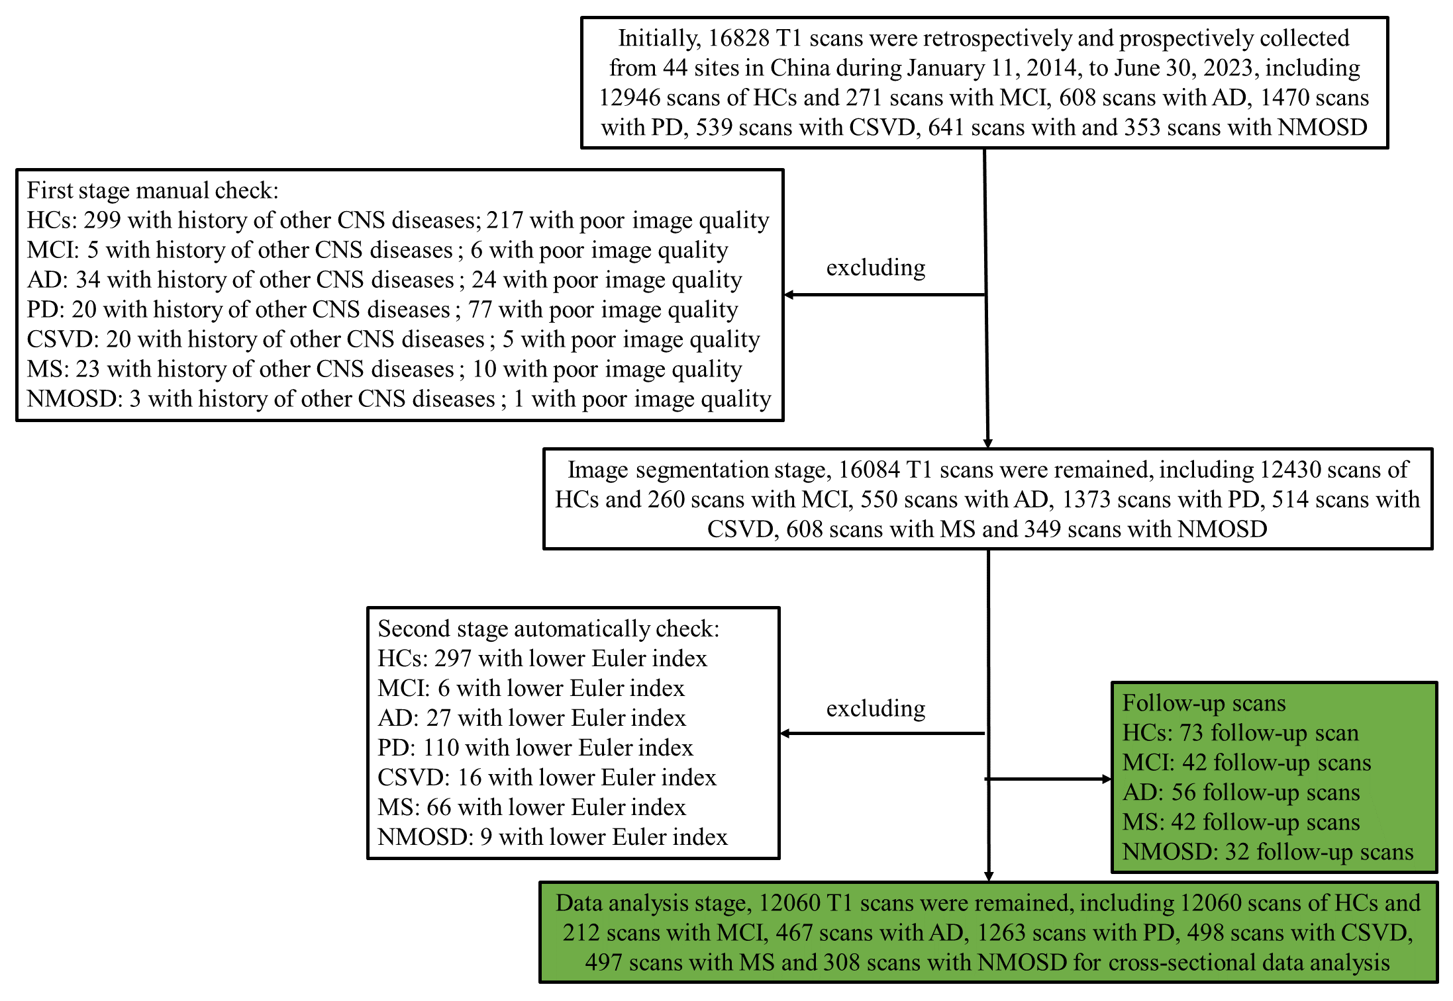
eFigure 1. A flowchart of the included participants in this study. Note: HC, Healthy Control; AD, Alzheimer's disease; PD, Parkinson's disease; CSVD, cerebral small vessel disease; MS, multiple sclerosis; NMOSD, neuromyelitis optica spectrum disorder
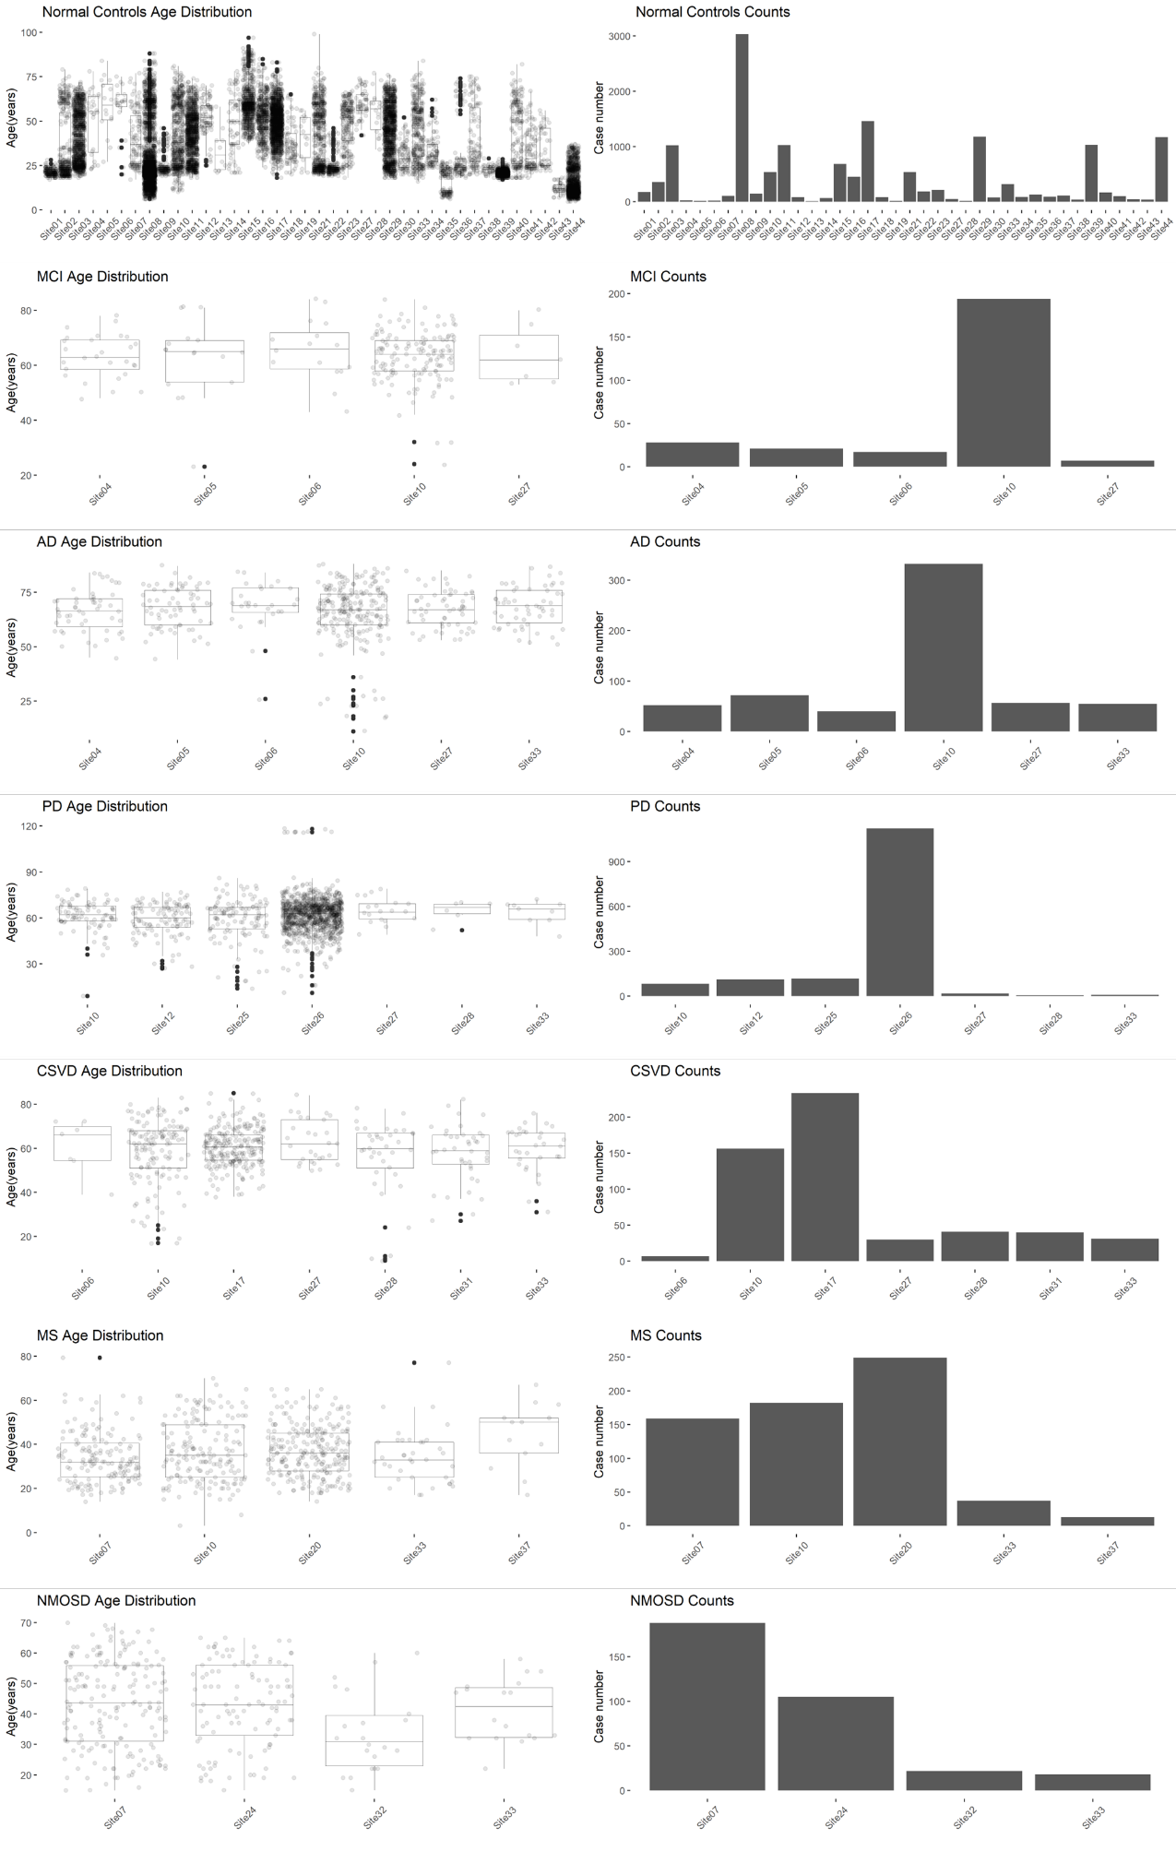

eFigure 2. The distribution of age and case count of included participants collected from 44 sites in China. Note: HC, healthy control; AD, Alzheimer's disease; PD, Parkinson's disease; CSVD, cerebral small vessel disease; MS, multiple sclerosis; NMOSD, neuromyelitis optica spectrum disorder.

Data processing
T1-wighted images were processed and segmented using FreeSurfer Software Suite, version 7.0 (Laboratory for Computational Neuroimaging at the Athinoula A. Martinos Center for Biomedical Imaging). Briefly, the first processing stage of recon-all includes: non-uniformity correction, projection to Talairach space, intensity normalisation, skull-stripping, automatic tissue and subcortical segmentation. Subsequently, surface interpolation, tessellation and registration are done at the second and third stages of the recon-all pipeline. All six brain tissue volumes were extracted from the aseg.stats files output by the recon-all process: “Total cortical gray matter volume” for GMV; “Total cerebral white matter volume” for WMV; “Subcortical gray matter volume” for sGMV (inclusive of thalamus, caudate nucleus, putamen, pallidum, hippocampus, amygdala, and nucleus accumbens area; https://freesurfer.net/fswiki/SubcorticalSegmentation); the difference between “BrainSegVol” and “BrainSegVolNotVent' for Ventricular volume; “Total cerebellar gray and white matter volume” for cerebellum volume; “Total brain-stem volume” for brainstem volume. Regional volume, cortical thickness and surface area were estimated for each of 34 cortical regions defined by the Desikan-Killiany parcellation atlas following the final stages of the recon-all pipeline and using the hemisphere-specific aparc.stats files generated by FreeSurfer. In addition, the mean cortical thickness and total surface area at the whole cortical level were also extracted.

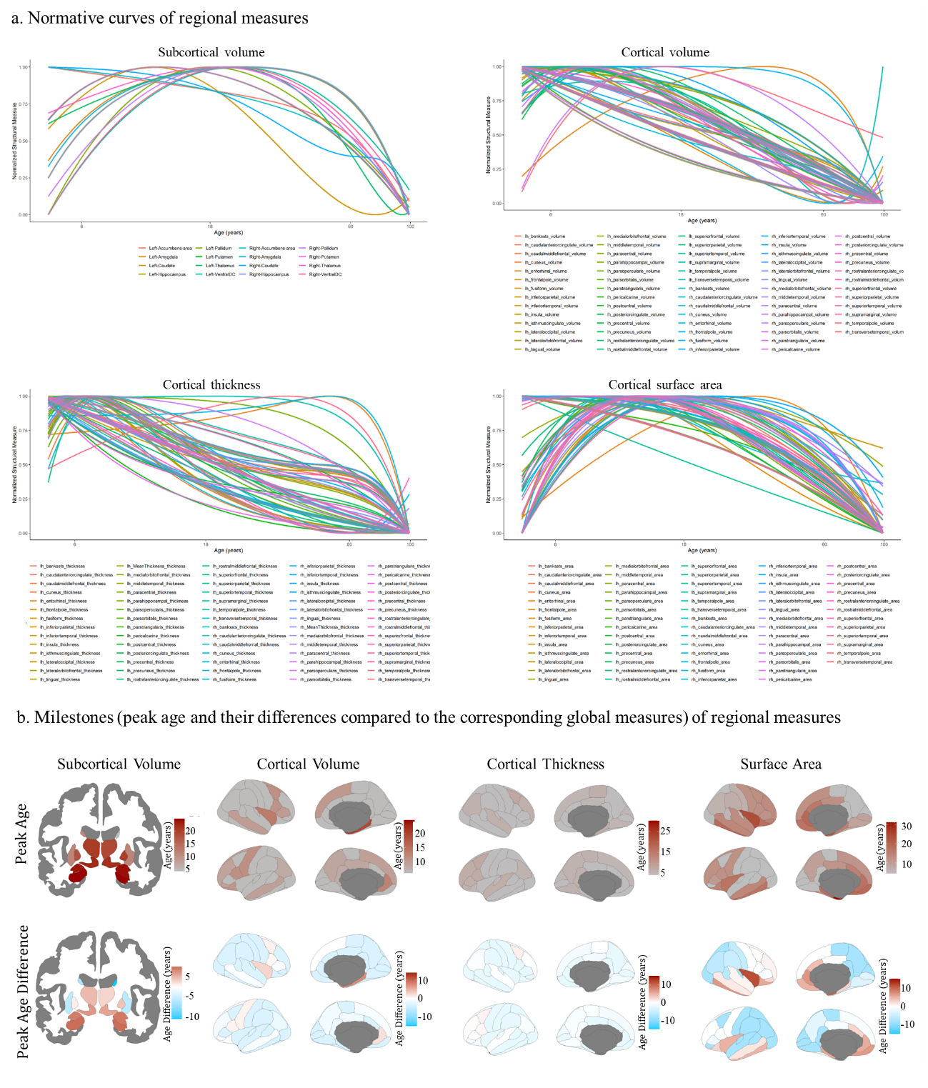
eFigure 3. The normalized curves of the brain regional MRI measures and peak age maps of regional structural measures. Note: lh, left hemisphere; rh, right hemisphere.

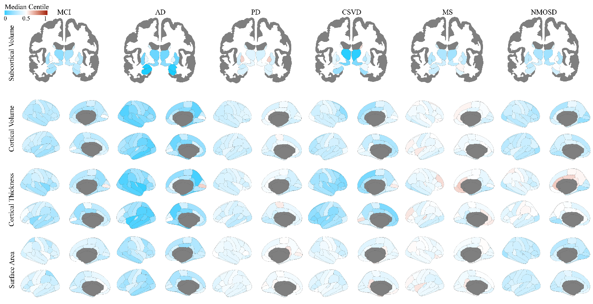
eFigure 4. the median regional deviation scores in neurological diseases were mapped on the subcortical and cortical regions. Note: MCI, mild cognitive impairment; AD, Alzheimer's disease; PD, Parkinson's disease; CSVD, cerebral small vessel disease; MS, multiple sclerosis; NMOSD, neuromyelitis optica spectrum disorder.

eResults
eResults 1. Effective size and distribution overlap between HC and disease groups
The group differences of deviation scores were evaluated using Cohen’s d via Monte Carlo Test. This comparison was conducted between disease groups (comprising 3,245 patients with a mean age of 56 ± 16 years; 1,780 female patients [54.9%], see Table 1) and age-, sex-, and site-matched (if available; otherwise, unmatched) HCs. To emphasize the most sensitive deviation scores associated with disease pathology, we highlighted the deviation scores exhibiting the largest effect sizes (largest Cohen’s d) between HCs and each disease group. Furthermore, to assess the dissimilarity of the deviation score distribution of the most sensitive measures between diseases and HCs, we additionally calculated the overlapping coefficient, which was defined as the overlapped percentage of the distribution of deviation scores between groups. To estimate univariate predictive ability of the most sensitive deviation scores for clinical diagnosis, we conducted univariate logistic regression for the most sensitive deviation scores, which was evaluated by accuracy and area under the curve (AUC).

For deviation scores in neurological diseases, we reported the global and regional deviation scores that display the largest effect sizes in each disease group compared with HCs. For global deviation scores, MCI (Cohen’s D = 0.64 [95% CI 0.44-0.83], false discovery rate corrected p [pFDR] < 0.001), AD (Cohen’s D = 0.82 [95% CI 0.69-0.96], pFDR < 0.001) and CSVD (Cohen’s D = 0.74 [95% CI 0.61-0.87], pFDR < 0.001) showed the largest effect sizes in cortical thickness. PD (Cohen’s D = 0.39 [95% CI 0.31-0.47], pFDR< 0.001) and NMOSD (Cohen’s D = 0.50 [95% CI 0.34-0.66], pFDR < 0.001) showed the largest effect size in GMV. MS (Cohen’s D = 0.73 [95% CI 0.60-0.86], pFDR < 0.001) showed the largest effect size in sGMV. For regional deviation scores, MCI showed the largest effect size in right isthmus cingulate thickness (Cohen’s D = 0.83 [95% CI 0.63-1.02], pFDR < 0.001). AD showed the largest effect size in left hippocampus volume (Cohen’s D = 1.16 [95% CI 1.02-1.30], pFDR < 0.001). PD showed the largest effect size in right lateral occipital thickness (Cohen’s D = 0.42 [95% CI 0.34-0.50], pFDR < 0.001). CSVD showed the largest effect size in right thalamus volume (Cohen’s D = 1.16 [95% CI 0.97-1.36], pFDR < 0.001). MS showed the largest effect size in left nucleus accumben volume (Cohen’s D = 0.79 [95% CI 0.66-0.92], pFDR < 0.001). NMOSD showed the largest effect size in right lingual volume (Cohen’s D = 0.63 [95% CI 0.47-0.79], pFDR < 0.001).

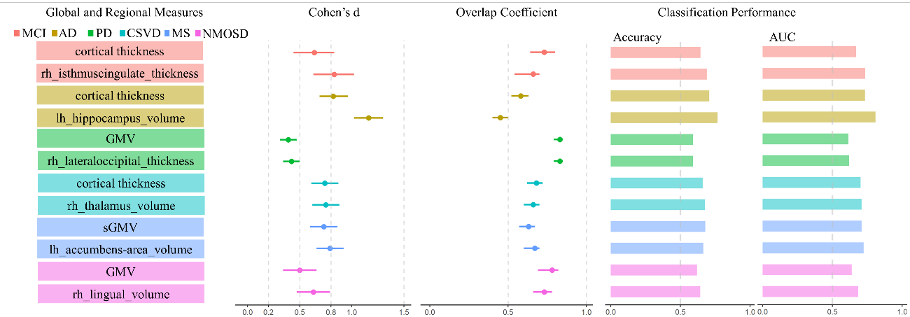
eFigure 5. Univariate analyses of the deviation scores with largest effect size. Note: MCI, mild cognitive impairment; AD, Alzheimer's disease; PD, Parkinson's disease; CSVD, cerebral small vessel disease; MS, multiple sclerosis; NMOSD, neuromyelitis optica spectrum disorder; AUC, area under the curve; GMV, gray matter volume; sGMV, subcortical gray matter volume.

We also calculated the effective size and distribution overlap between disease pairs to investigate the difference and similarity between the deviation scores of diseases (eFigure 6). This may give clues to clinicians that which diseases have distinct brain alterations and which diseases have similar brain changes even though distinct pathologies were found in these diseases. While for neurological diseases, some common pathologies were presented including the blood brain barrier damages, oxidative stress, neuronal and axonal loss, which may pave a common target for these diseases. These findings would have indications that which diseases may be managed with a common strategy.
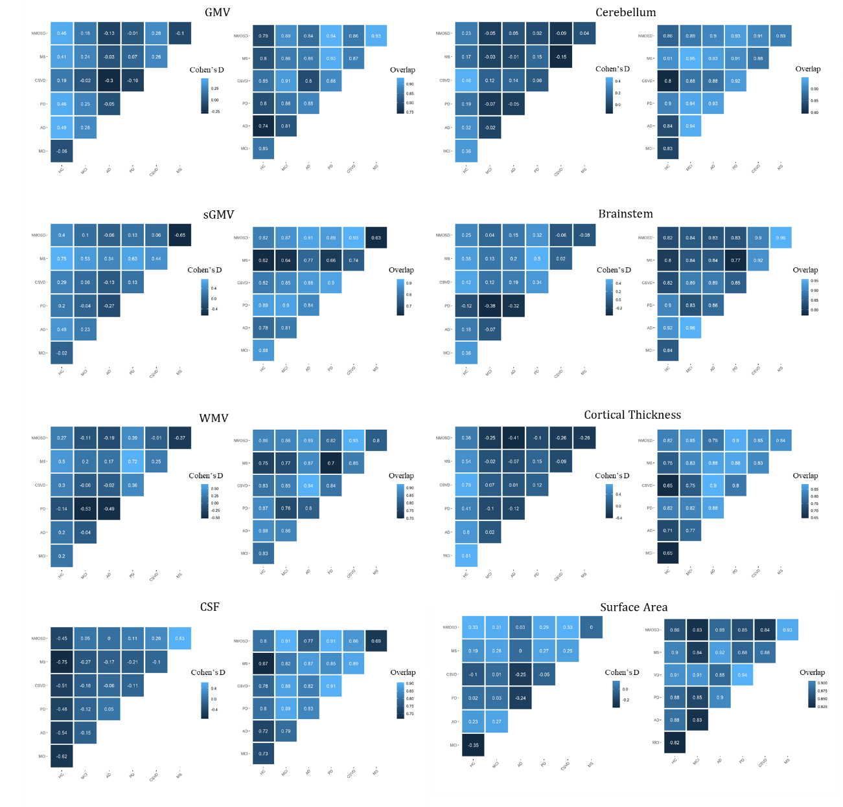
eFigure 6. Cohen’s d and distribution overlap between disease groups for global deviation scores. Note: GMV, gray matter volume; sGMV, subcortical gray matter volume; WMV, white matter volume; CSF, cerebrospinal fluid; HC, healthy control; AD, Alzheimer's disease; PD, Parkinson's disease; CSVD, cerebral small vessel disease; MS, multiple sclerosis; NMOSD, neuromyelitis optica spectrum disorder.

For details of the effective size and distribution overlap on local deviation scores (eFigure 7-10), we additionally mapped the Cohen’s d and overlap coefficient onto the subcortical and cortical regions. Based on these maps, we observed distinct effective size and distribution overlap on subcortical volume, cortical volume, cortical thickness and cortical surface area. These distinct local alterations may give indications that which region may be the first target or which region was the most sensitive to the disease-specific pathology. These findings may also give individual maps by using the normative references that help the clinician to decide the changes underlying the individual brain, which would help the clinical diagnosis and individualized targeted therapy.
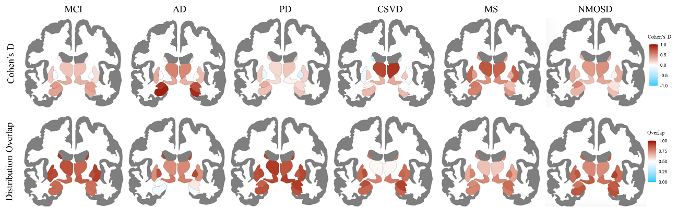
eFigure 7. Cohen’s d and distribution overlap between disease groups for regional subcortical volumes. Note: MCI, mild cognitive impairment; AD, Alzheimer's disease; PD, Parkinson's disease; CSVD, cerebral small vessel disease; MS, multiple sclerosis; NMOSD, neuromyelitis optica spectrum disorder.

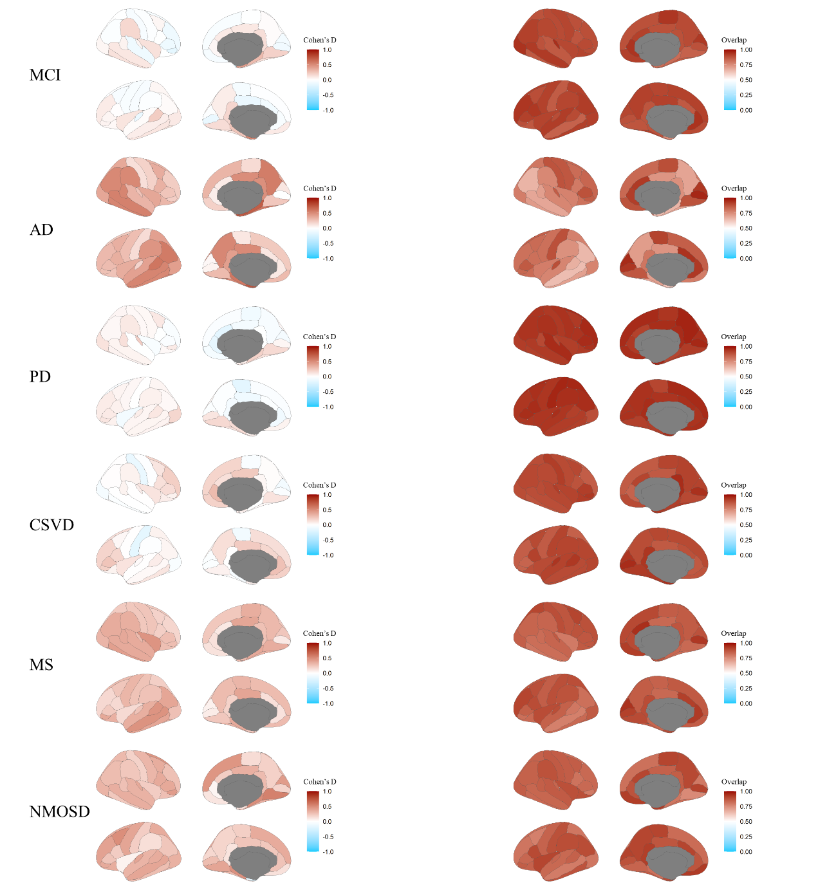
eFigure 8. Cohen’s d and distribution overlap between disease groups for regional cortical volumes. Note: MCI, mild cognitive impairment; AD, Alzheimer's disease; PD, Parkinson's disease; CSVD, cerebral small vessel disease; MS, multiple sclerosis; NMOSD, neuromyelitis optica spectrum disorder.

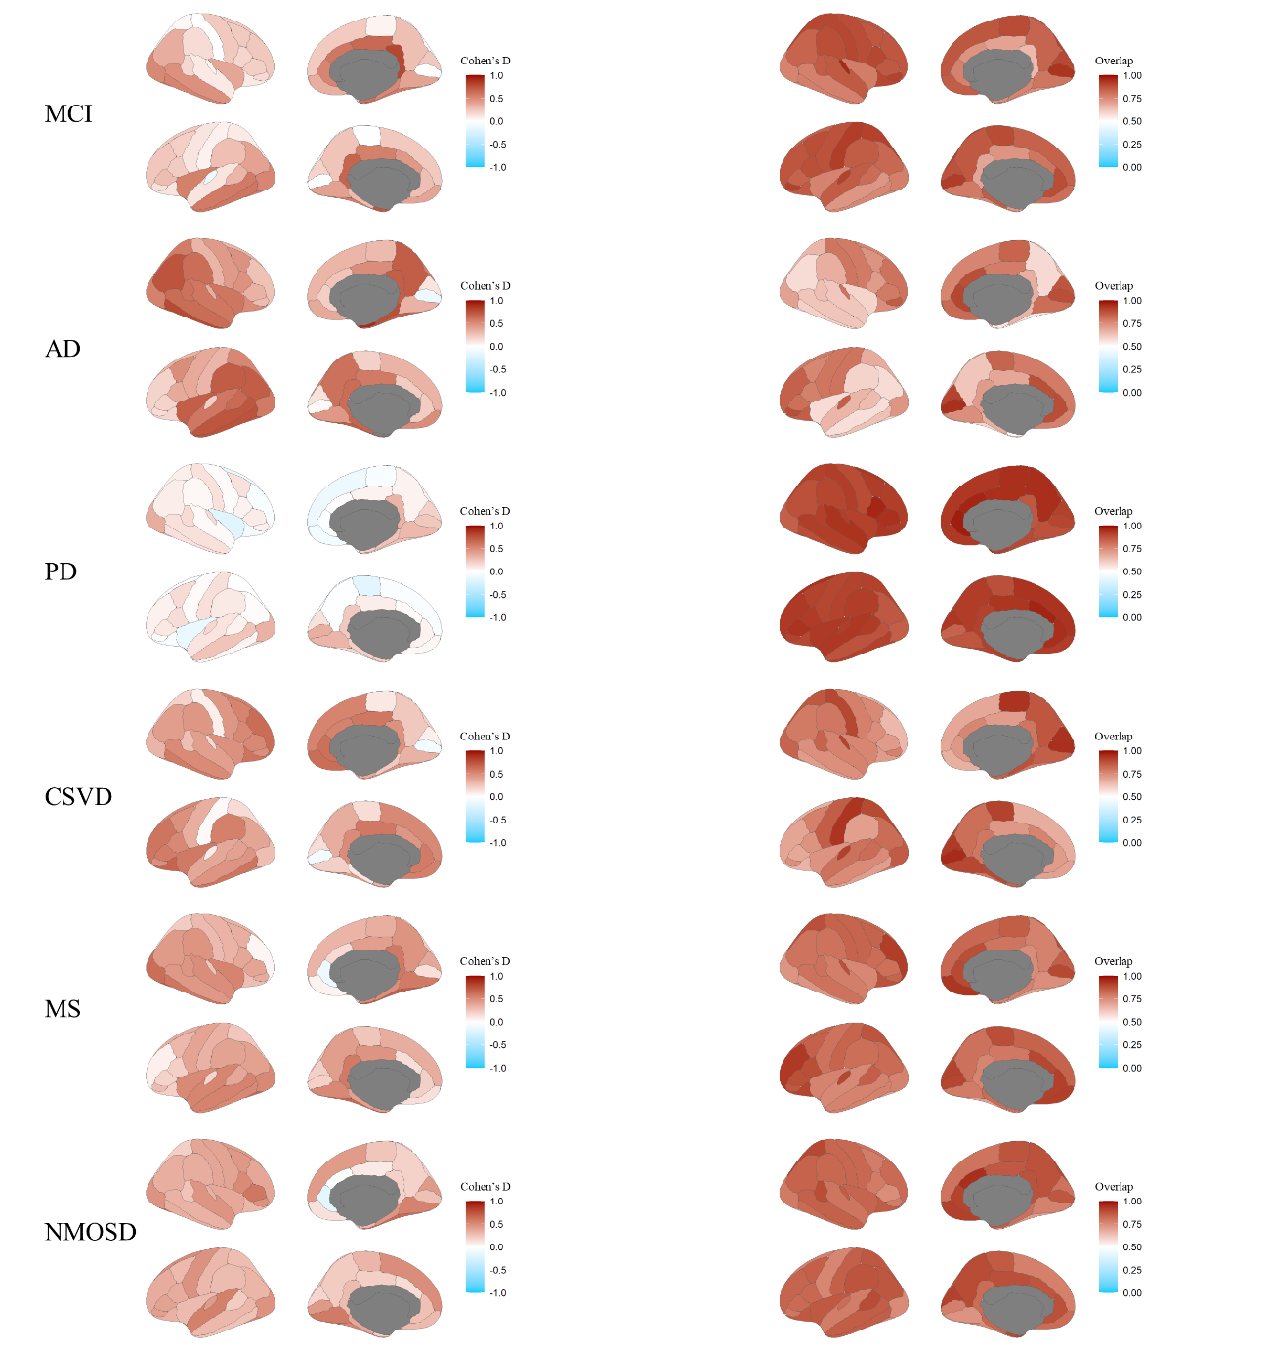
eFigure 9. Cohen’s d and distribution overlap between disease groups for regional cortical thickness. Note: MCI, mild cognitive impairment; AD, Alzheimer's disease; PD, Parkinson's disease; CSVD, cerebral small vessel disease; MS, multiple sclerosis; NMOSD, neuromyelitis optica spectrum disorder.
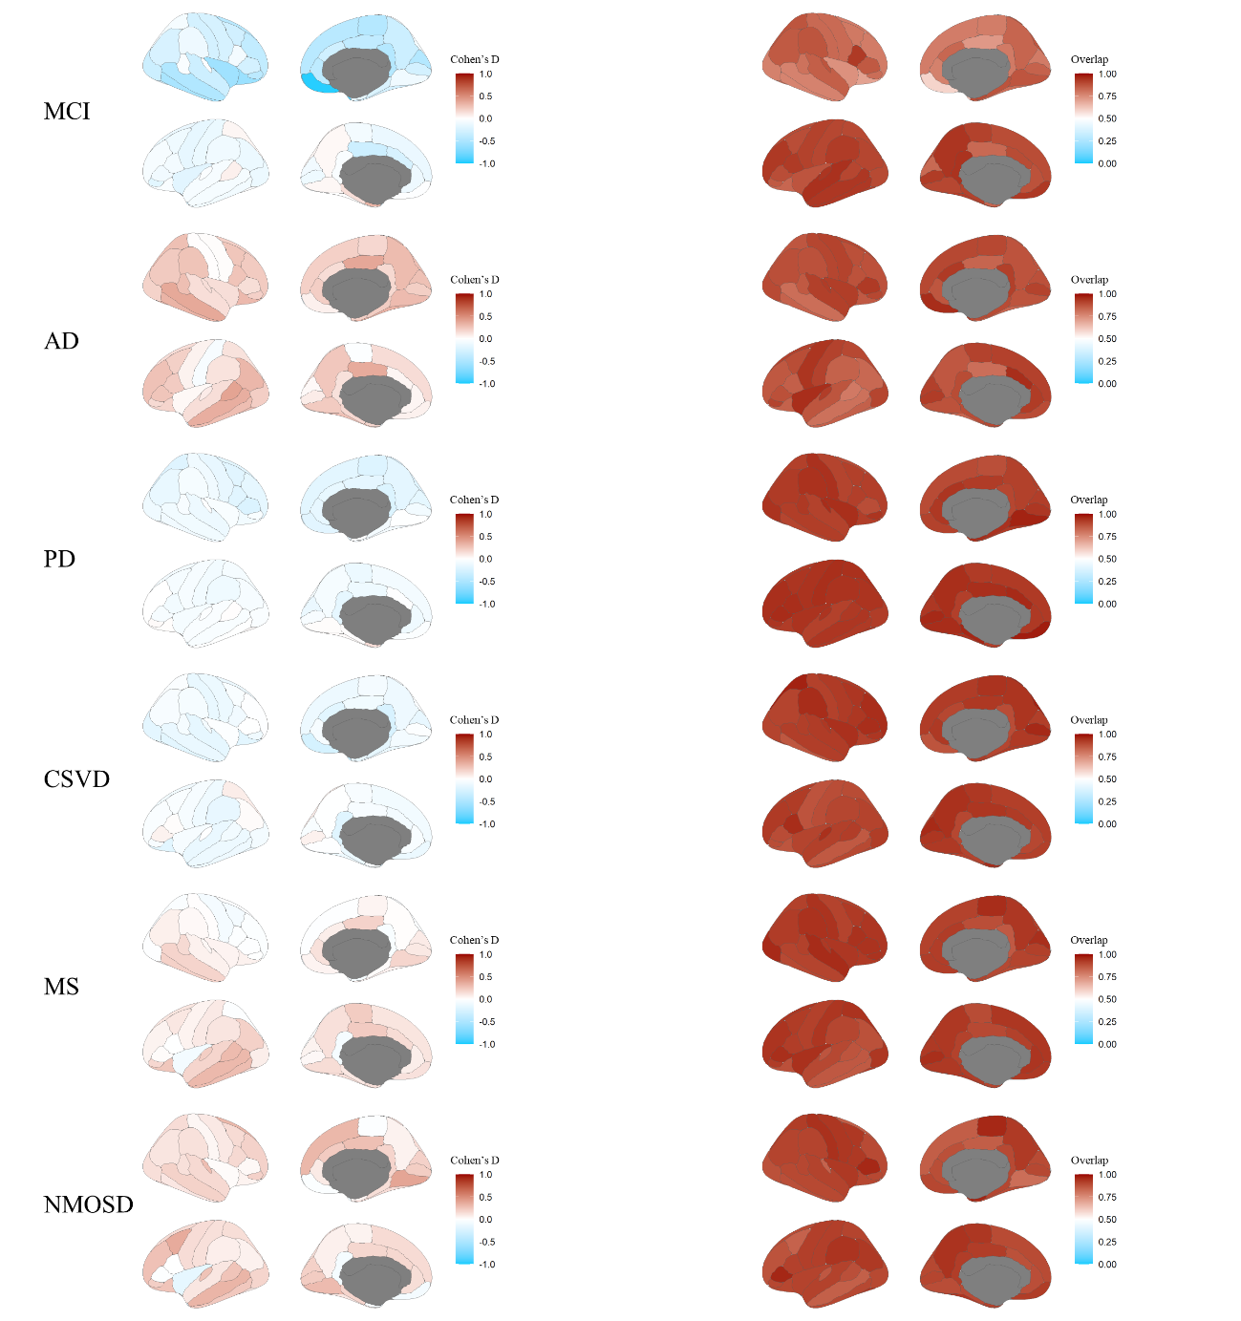
eFigure 10. Cohen’s d and distribution overlap between disease groups for regional cortical surface areas. Note: MCI, mild cognitive impairment; AD, Alzheimer's disease; PD, Parkinson's disease; CSVD, cerebral small vessel disease; MS, multiple sclerosis; NMOSD, neuromyelitis optica spectrum disorder.

Using word clouds, we summarized the significant altered regional structural features (eFigure 11). The MCI mostly involves the cingulate and entorhinal gyrus, which are significant markers for cognitive decline and hubs of the brain network. The dysfunction of these regions may account for the cognitive network disruptions that leads to the cognitive impairment in MCI. While for AD, which is next disease stage of MCI, in addition to the entorhinal atrophy, we observed the largest altered region locating at hippocampus, which is the key area for memory impairment. These findings may also indicate during the disease duration or at the different stage of this kind of disease, the mostly associated brain pathology may be varied along the disease course. It is surprised that we found the regions that showed most sensitive to the PD pathology is dominated by the visual associated areas, which is a common clinical non-motor manifestation in PD patients. Less motor related regions were showed statistical significance, this seemed contrary to previous studies that showed the motor associated regions (e.g., precentral and postcentral gyrus). While, previous studies also found significant involvement of occipital gyrus especially for cases with dementia, but pay little attention on them. Maybe, the occipital pathology is an early marker in PD patients with dementia that should be paid more attention. Thalamus involvement is an evidenced finding in CSVD, as the pathology mostly involved periventricular vessels that had close relation with thalamus. A widespread subcortical region involvement is a disease feature of MS, while the visual associated regions and cognitive associated regions were also involved. These findings indicated that the subcortical areas may be the first target and then the inflammation spreading the whole brain. This was not different from the CSVD, as the CSVD only related the thalamus and then spreading the whole brain, this may indicate different pathology of CSVD and MS, even the MS is also regarded as a disease of vascular origin. As one of clinical challenges is the differential diagnosis of MS and NMOSD, we can observe distinct MR phenotypes even they are both involve the subcortical and visual associated areas. However, we can observe more predominating alterations of visual associated areas in NMOSD compared to MS, this may give a clue that visual dysfunction is more predominating in NMOSD and may be a featured MR biomarker in NMOSD in addition to the spinal cord pathology.
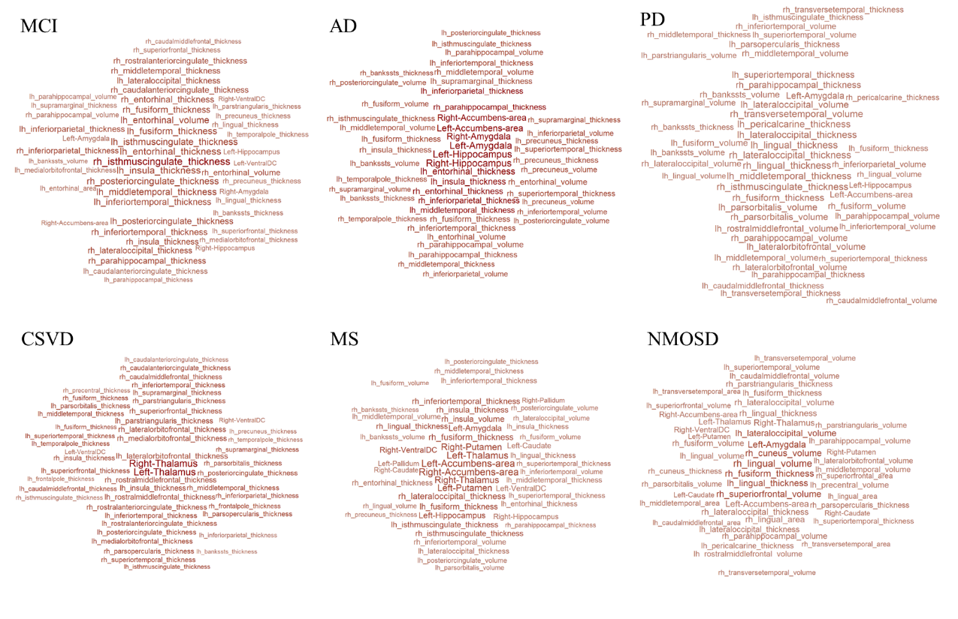 eFigure 11. Word clouds to summarize the regional deviation scores that show differences between diseases and HCs. The larger word size, the more significant difference of disease compared to age-, sex- and site- matched HCs. Note: HC, healthy control; MCI, mild cognitive impairment; AD, Alzheimer's disease; PD, Parkinson's disease; CSVD, cerebral small vessel disease; MS, multiple sclerosis; NMOSD, neuromyelitis optica spectrum disorder.

eResults 2. Longitudinal assessment of the MR scans across diseases
We assessed the longitudinal scans of HCs, MCI, AD, MS and NMOSD. The interquartile range (IQR) of the differences of the centiles between the follow-up and baseline scans for each case. The IQR ranged from 0 to 0.61 with a median IQR of 0.09, indicating a stability of deviation scores across the follow-ups and baseline. More cases with high IQR seemed predominate in younger and older populations while stable in middle aged population, indicating the variation of the brain alterations may be more sensitive with age-specific population.

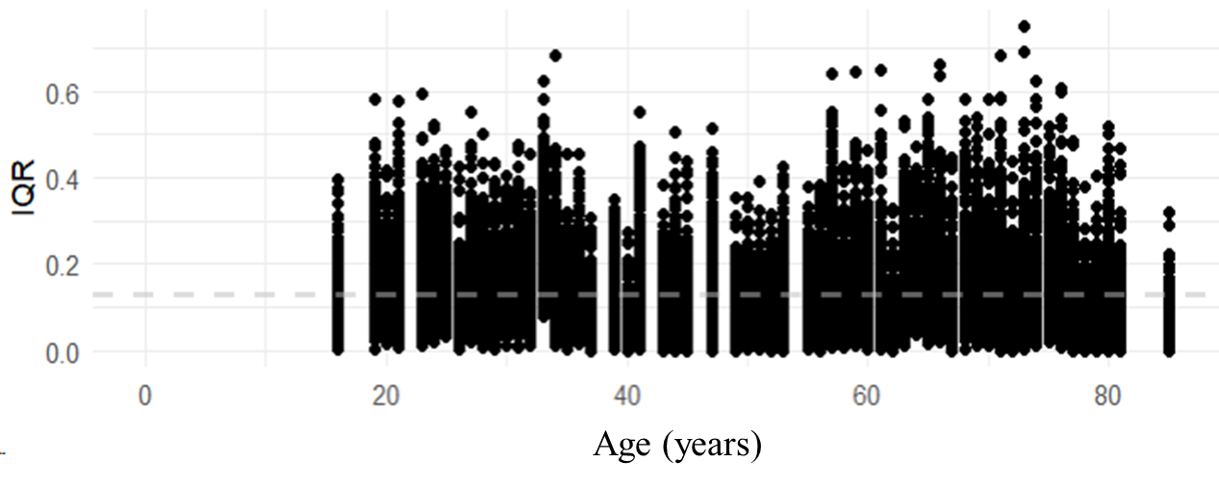
eFigure 12. The IQR distribution of longitudinal assessment of the MR scans across diseases. The grey line indicates the mean IQR across the individuals. Note: IQR, interquartile range.

eResults 3. Comparisons between our normative models and international models
To investigate whether there are some discrepancies between our normative model based on Chinese population and the international model largely based on European and North-American populations. We used Peason’s correlation and mean absolute scaled error (MASE) to explore the similarity and difference between these models. Here we only compared the models on global MRI features as local MR features defined in this study are different from the previous study. We observed that the international models seemed well fit our data except for cortical thickness displaying a large shift from our data distribution, even we calibrated the international model for site effects. The calibrated international model is still insufficient to fit our data especially for cortical thickness. Lager differences on median values of WMV and cortical thickness were observed between our model and the raw and calibrated international models, as indicated by the lower Pearson’s correlations and larger MASEs. These findings indicated the population-specific normative references is necessary especially for the different populations. Even the calibrated international model seemed having a better fitting for different populations with site-effect corrected, the discrepancies still presented, implying the importance of using population-specific normative references for clinical applications.
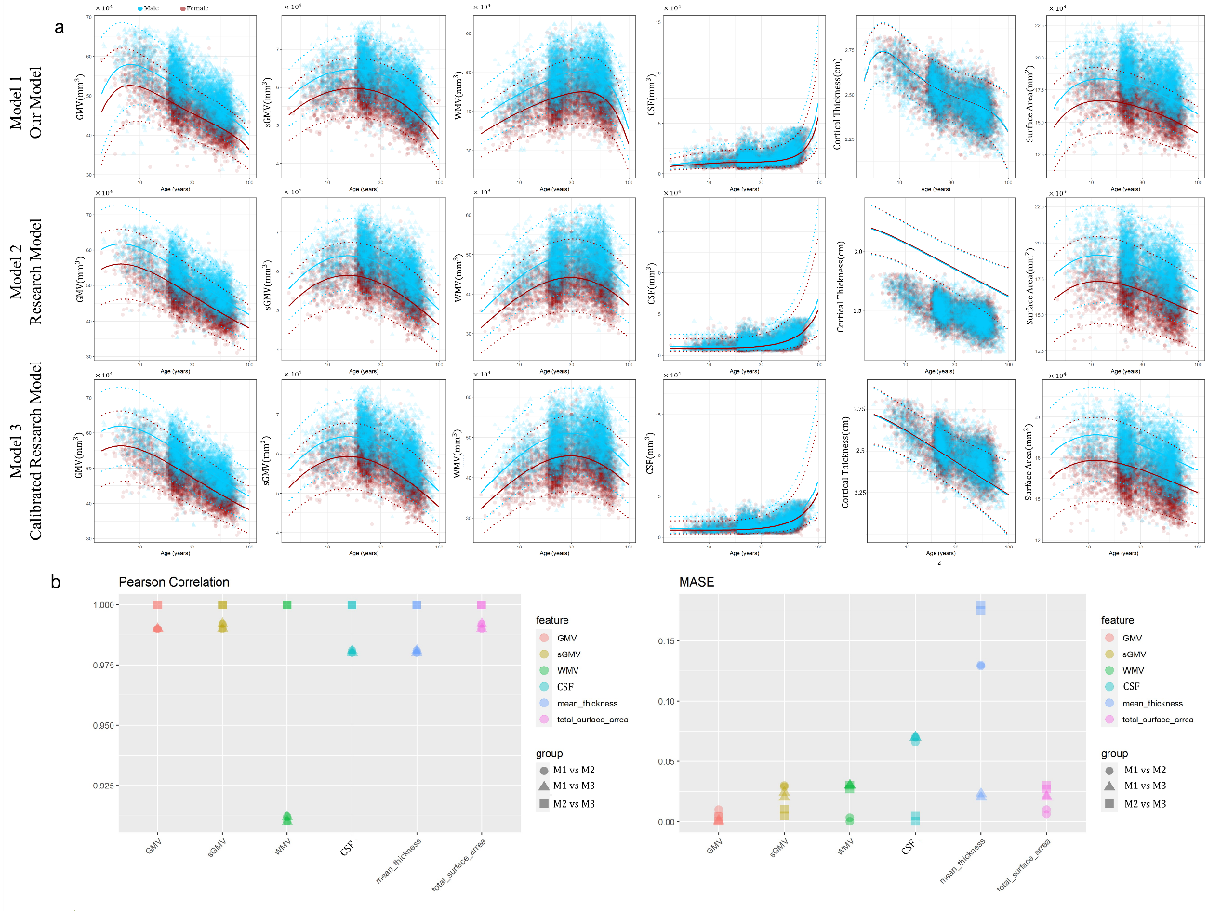
eFigure 13. Model comparisons between our normative models using Asian population and pre-trained international models largely based on European and North American populations. Note: MASE, mean absolute scaled error; GMV, gray matter volume, sGMV, subcortical gray matter volume; WMV, white matter volume; CSF, cerebrospinal fluid; M1, our normative model; M2, international model; M3, calibrated international model for site effect.

eResults 4. Normative references and clinical tasks stratified by sex
We observed that the fitted normative references stratified by sex were comparable to that in the main text. While the male had larger gray matter and white matter volumes, larger ventricle volume and total surface area than female.
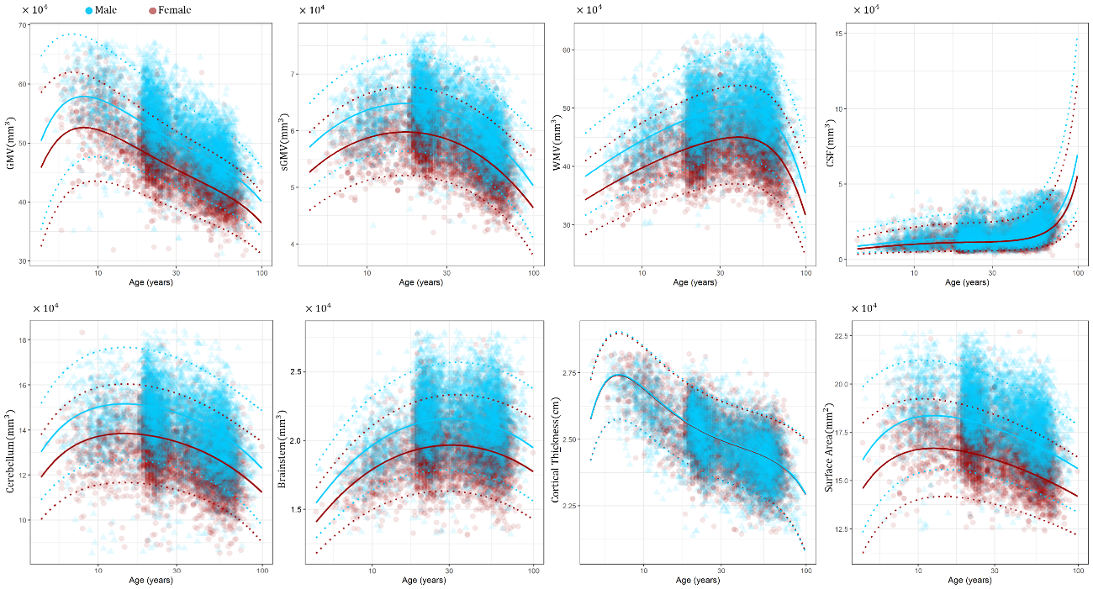
eFigure 14. Normative references stratified by sex. Note: GMV, gray matter volume, sGMV, subcortical gray matter volume; WMV, white matter volume; CSF, cerebrospinal fluid.

The centile distribution in patients with female and male stratified are similar for these diseases except for MCI, MS and NMOSD that showed severe brain atrophy in female patients, indicating a different pathology-sensitivity of male and female patients in these diseases.
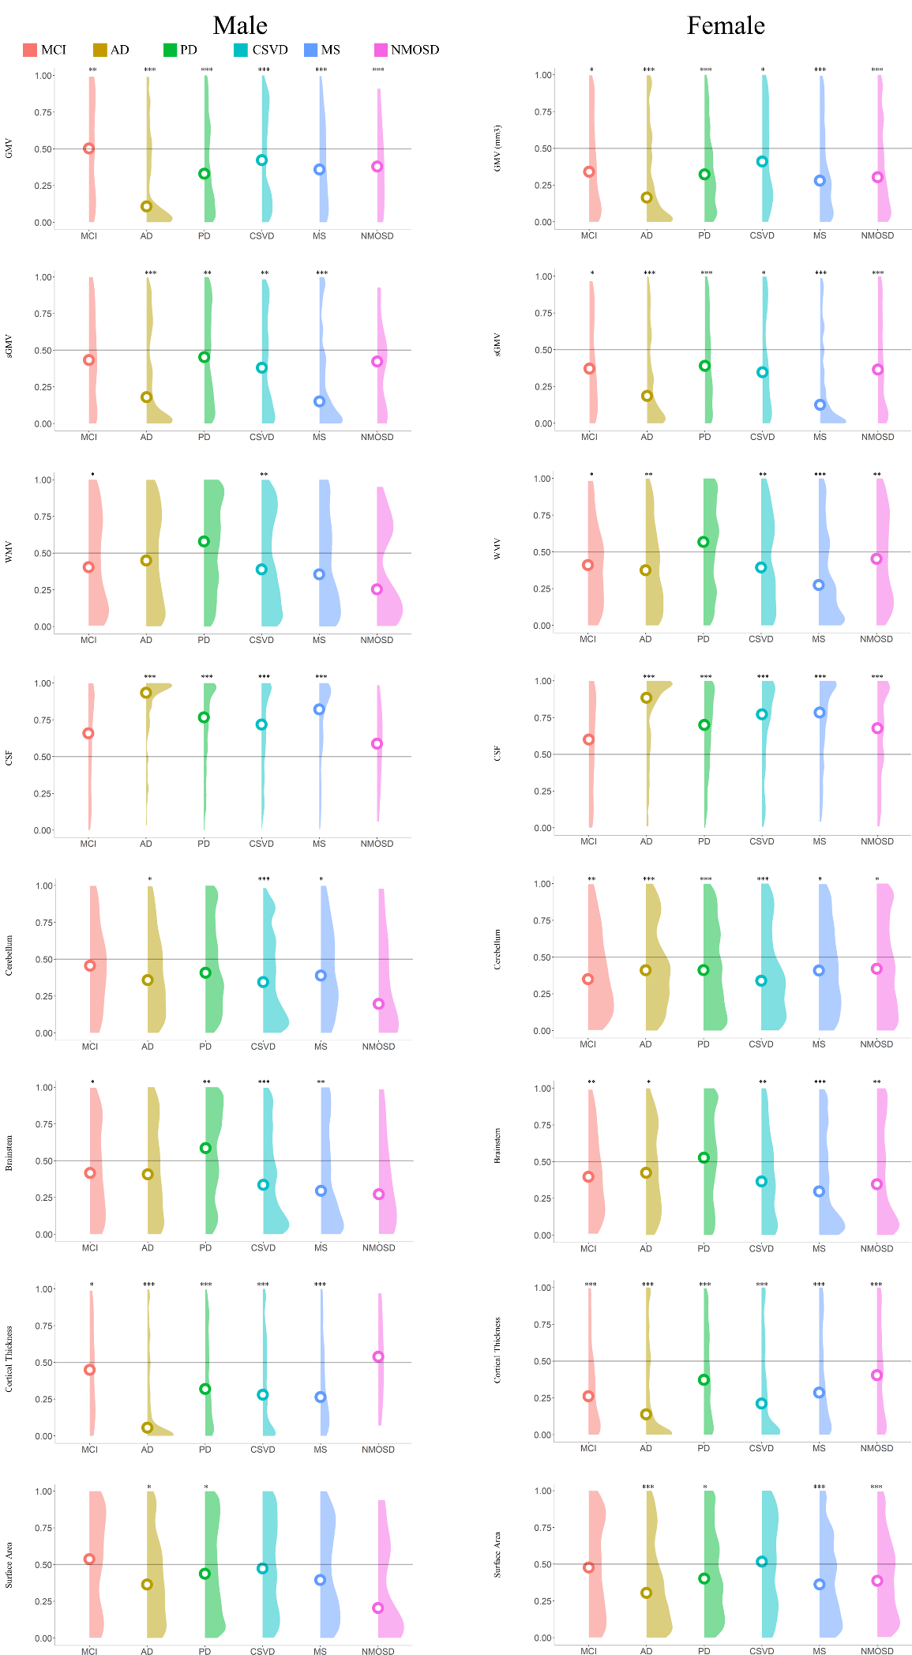
eFigure 15. The comparison between female and male in disease groups compared to age-matched HCs by raincloud plots. Note: GMV, gray matter volume, sGMV, subcortical gray matter volume; WMV, white matter volume; CSF, cerebrospinal fluid; HC, healthy control; MCI, mild cognitive impairment; AD, Alzheimer's disease; PD, Parkinson's disease; CSVD, cerebral small vessel disease; MS, multiple sclerosis; NMOSD, neuromyelitis optica spectrum disorder. * pFDR<0.05, ** pFDR<0.005, *** pFDR<0.001.

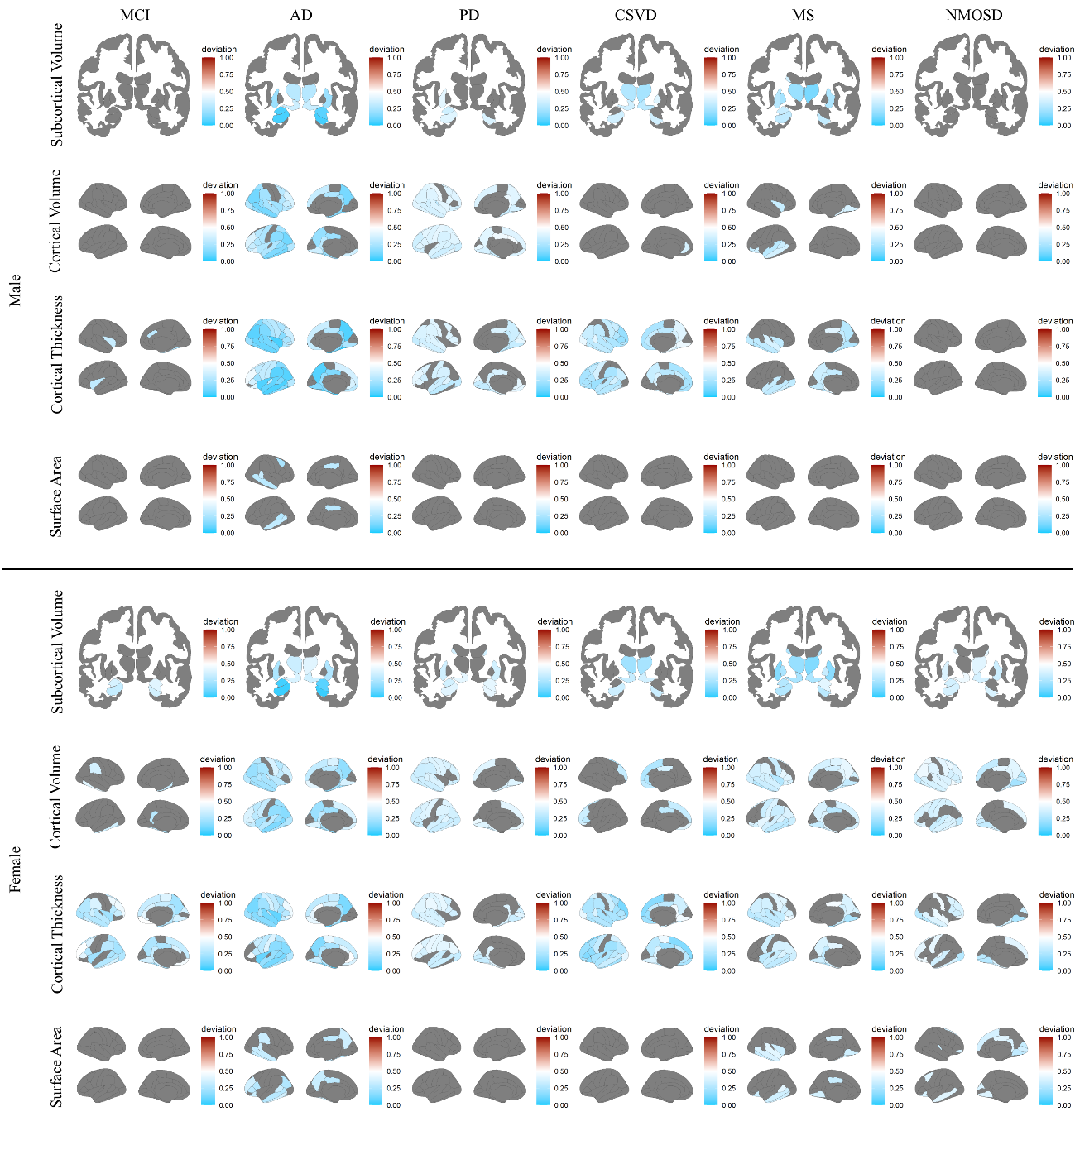
eFigure 16. Deviation scores of regional structural measures in neurological diseases for female and male cases. Statistical significances were presented for each disease group compared to age- sex- and site-matched HCs. Note: HC, healthy control; MCI, mild cognitive impairment; AD, Alzheimer's disease; PD, Parkinson's disease; CSVD, cerebral small vessel disease; MS, multiple sclerosis; NMOSD, neuromyelitis optica spectrum disorder.

In eFigure 17, we also observed distinct global and local deviation scores that display largest difference between diseases and HCs for female and male patients especially for MCI and NMOSD. As the NMOSD is a female predominated disease, a small sample size of male patients displayed a larger confidence interval for effect size and overlap coefficient. These differences on sex may support previous findings on the sex-specific alterations of patients. These also give clues which disease has a sex-specific alteration and which disease did not. These findings may be important for clinical management for patients according to the sex-specific pathology.

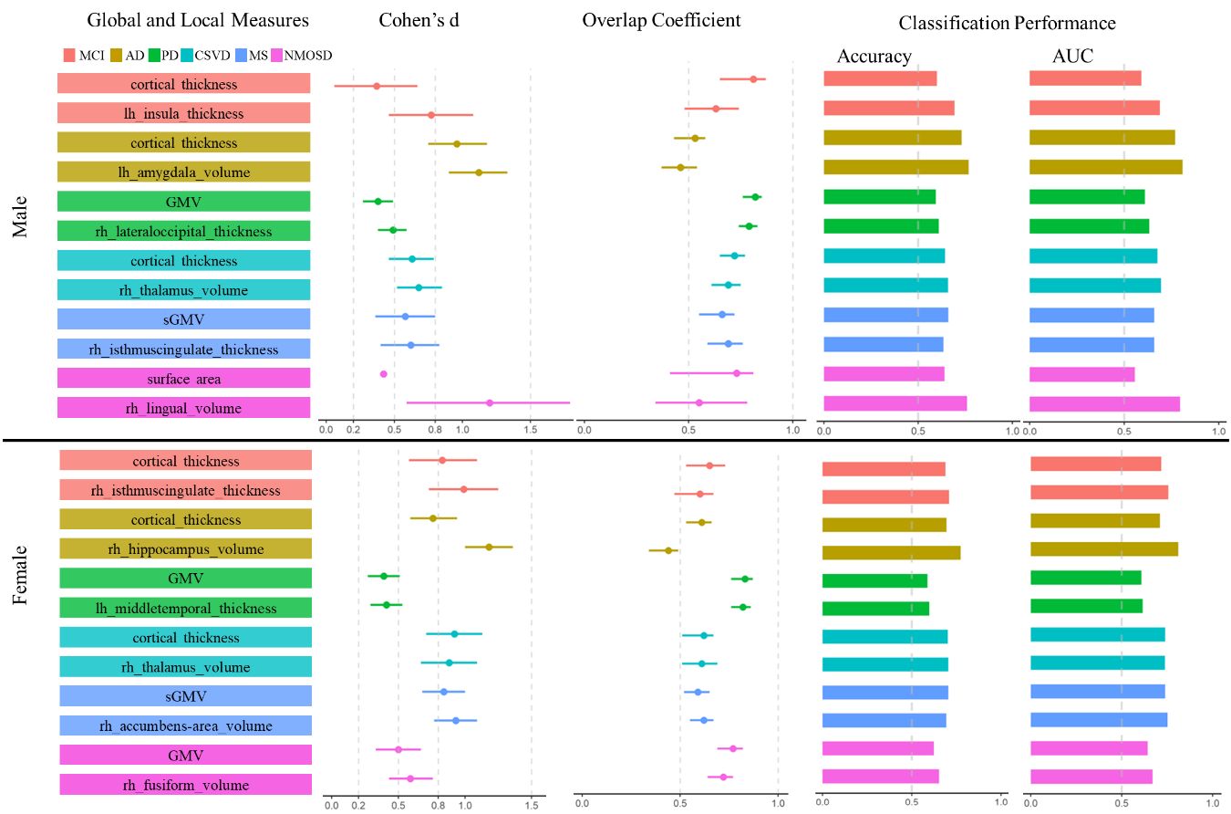
eFigure 17. The comparison on global and local deviation scores displaying largest difference between diseases and HCs for female and male separately. Note: GMV, gray matter volume, sGMV, subcortical gray matter volume; MCI, mild cognitive impairment; AD, Alzheimer's disease; PD, Parkinson's disease; CSVD, cerebral small vessel disease; MS, multiple sclerosis; NMOSD, neuromyelitis optica spectrum disorder; AUC, area under the curve.

eResults 5. Comparison of clinical tasks using centile score, Z-score and raw MR measures
Both the Z-scores and raw MR measures of diseases displayed normative data distribution which is different from the centiles displaying a non-normative distribution. We observed comparable effect size, overlap distribution and classification performance among centile score, Z-score and raw MR measures in classical case-control methods. However, different regional deviation with largest effect sizes were observed in PD, MS and NMOSD, indicating the detection of pathology-related structural MRI features may link with the used quantitative methods. However, we currently cannot determine whether the deviation scores are superior to raw measures in the detection of disease-pathology as previous findings were mainly based on raw measures in classical case-control designs. Additional analyses showed that these methods have comparable abilities for detection of feature numbers that showed statistical significances between disease groups and HCs. More than 60% detected features were overlapped, implied a combination of these methods may provide the robust structural alterations in neurological diseases.

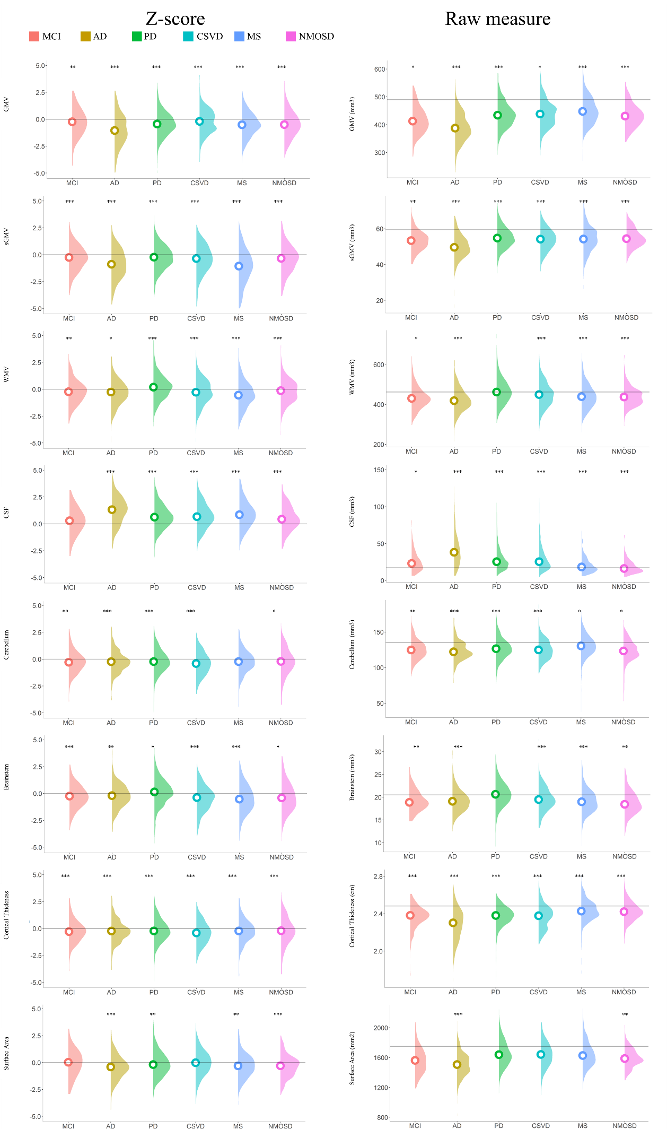
eFigure 18. Comparisons of clinical unitality for detecting the alterations of global phenotypes in disease groups using Z-score and conventional case-control methods. Note: GMV, gray matter volume, sGMV, subcortical gray matter volume; WMV, white matter volume; CSF, cerebrospinal fluid; HC, healthy control; MCI, mild cognitive impairment; AD, Alzheimer's disease; PD, Parkinson's disease; CSVD, cerebral small vessel disease; MS, multiple sclerosis; NMOSD, neuromyelitis optica spectrum disorder. * pFDR<0.05, ** pFDR<0.005, *** pFDR<0.001.

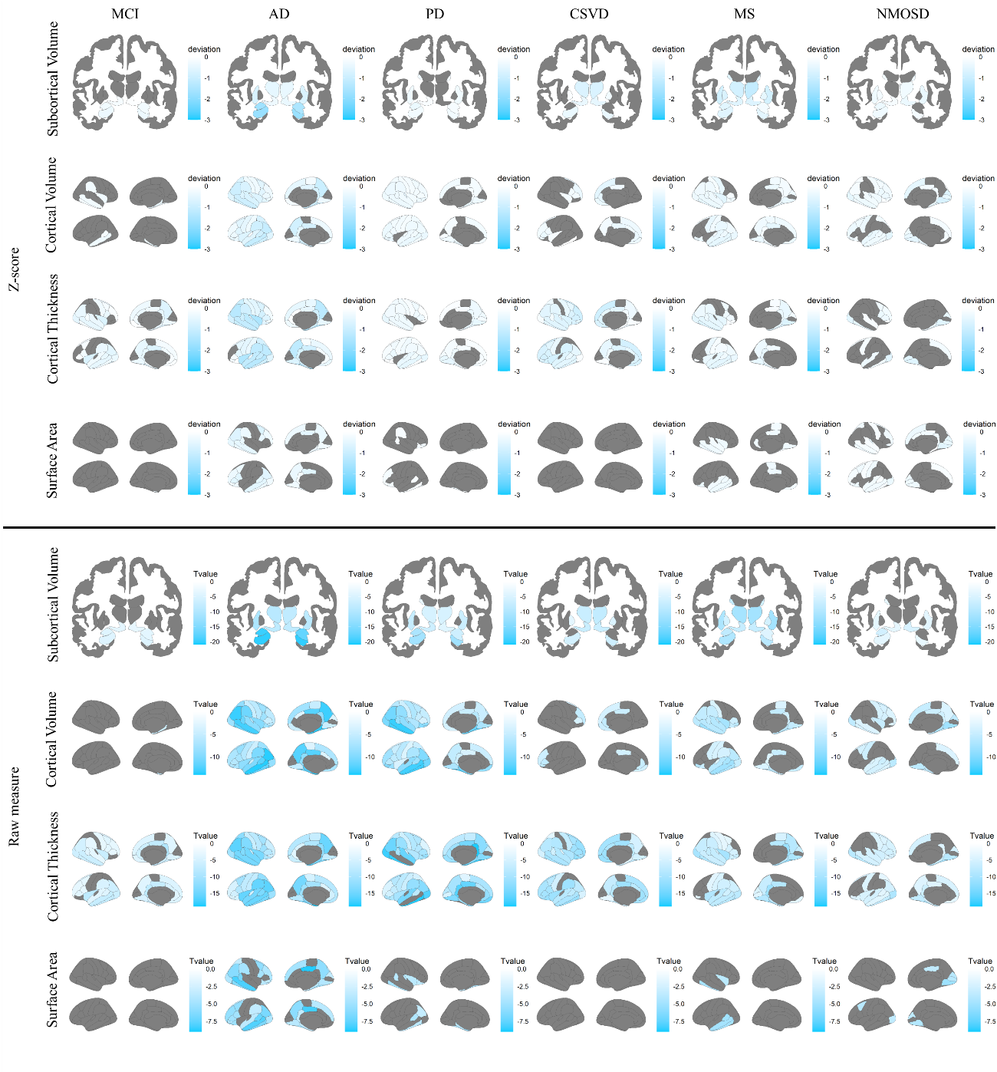
eFigure 19. Z-score of regional structural measures and raw measures (T values between diseases and HCs were mapped) in neurological diseases. Statistical significances were presented for each disease group compared to age- sex- and site-matched HCs. Note: HC, healthy control; MCI, mild cognitive impairment; AD, Alzheimer's disease; PD, Parkinson's disease; CSVD, cerebral small vessel disease; MS, multiple sclerosis; NMOSD, neuromyelitis optica spectrum disorder.

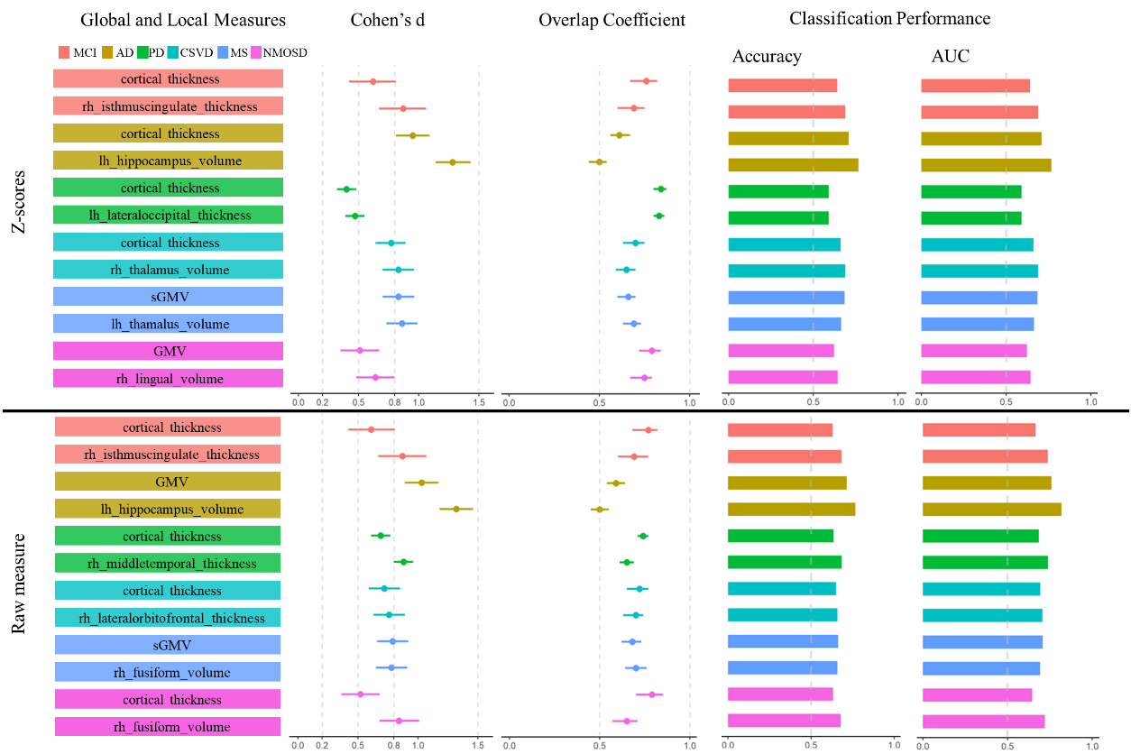
eFigure 20. Comparisons of clinical values for detecting the largest difference of single variable in disease groups using Z-score and classical case-control methods. Note: GMV, gray matter volume, sGMV, subcortical gray matter volume; MCI, mild cognitive impairment; AD, Alzheimer's disease; PD, Parkinson's disease; CSVD, cerebral small vessel disease; MS, multiple sclerosis; NMOSD, neuromyelitis optica spectrum disorder; AUC, area under the curve.
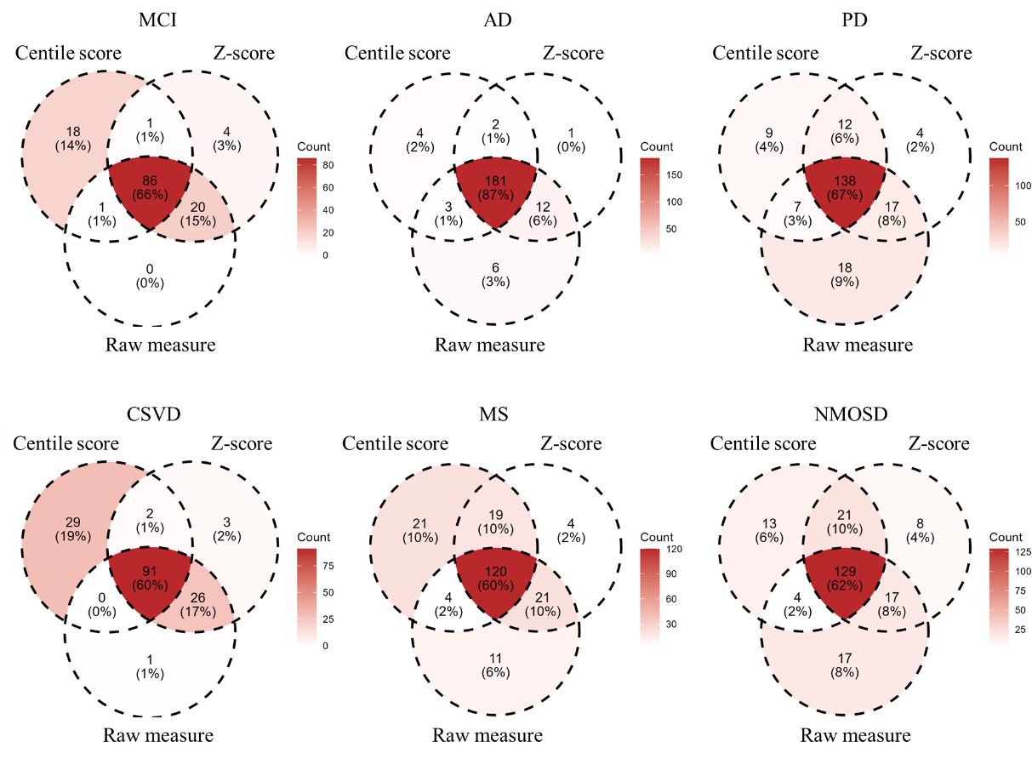
eFigure 21. Overlaps of brain structural measures with statistical significance (pFDR < 0.05) between centile score, Z-score and raw measure. Note: MCI, mild cognitive impairment; AD, Alzheimer's disease; PD, Parkinson's disease; CSVD, cerebral small vessel disease; MS, multiple sclerosis; NMOSD, neuromyelitis optica spectrum disorder.

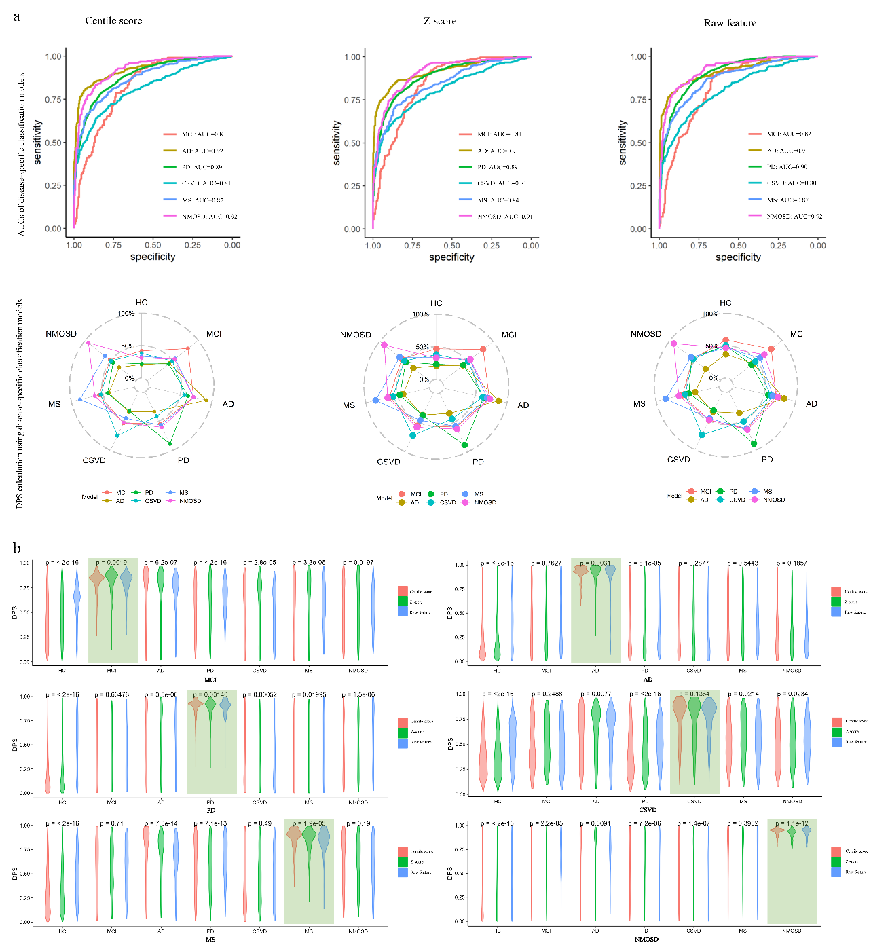
eFigure 22. Comparisons of clinical utility of deviation score for DPS estimation using centile score, Z-score and raw measure. a, the disease-specific model performance for classification of disease and HCs, and predicted DPS for HCs and diseases using different disease-specific models. b, the distribution of the predicted DPS for targeted disease and other groups. The disease-specific model should have high DPS for targeted diseases and low DPS for other groups. The targeted diseases using the corresponding disease-specific models were highlighted. Note: AUC, area under the curve; DPS, disease propensity score; HC, healthy control; MCI, mild cognitive impairment; AD, Alzheimer's disease; PD, Parkinson's disease; CSVD, cerebral small vessel disease; MS, multiple sclerosis; NMOSD, neuromyelitis optica spectrum disorder.

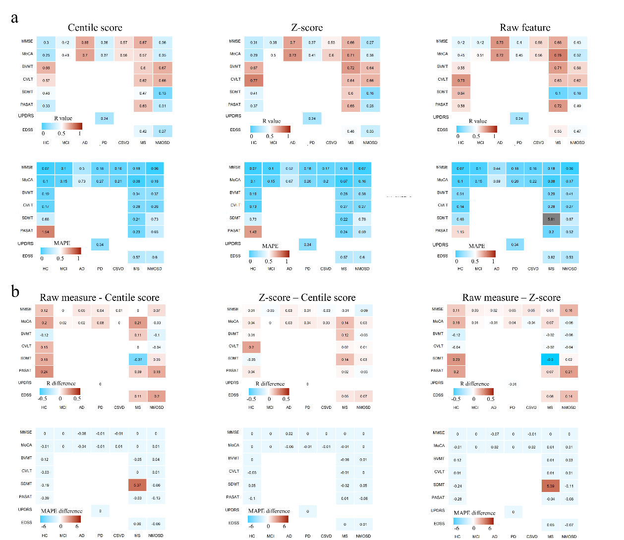
eFigure 23. Comparisons of clinical utility for the prediction of clinical variables for HCs and diseases involving cognitive and physical scores using centile score, Z-score and raw measures. a, The Pearson’s correlation between predicted and actual clinical measures and the MAPE of predictive models were presented. a, The difference of Pearson’s correlation and the MAPE of between centile score, Z-score and raw measures were presented. Note: HC, healthy control; MCI, mild cognitive impairment; AD, Alzheimer's disease; PD, Parkinson's disease; CSVD, cerebral small vessel disease; MS, multiple sclerosis; NMOSD, neuromyelitis optica spectrum disorder; MMSE, Mini-Mental State Examination; MoCA, Montreal Cognitive Assessment; BVMT, Brief Visuospatial Memory Test; CVLT, California Verbal Learning Test; SDMT, Symbol Digit Modalities Test; PASAT, Paced Auditory Serial Addition Test; UPDRS, Unified Parkinson's Disease Rating Scale; EDSS, expanded disability status scale; MAPE, mean absolute percentage error.

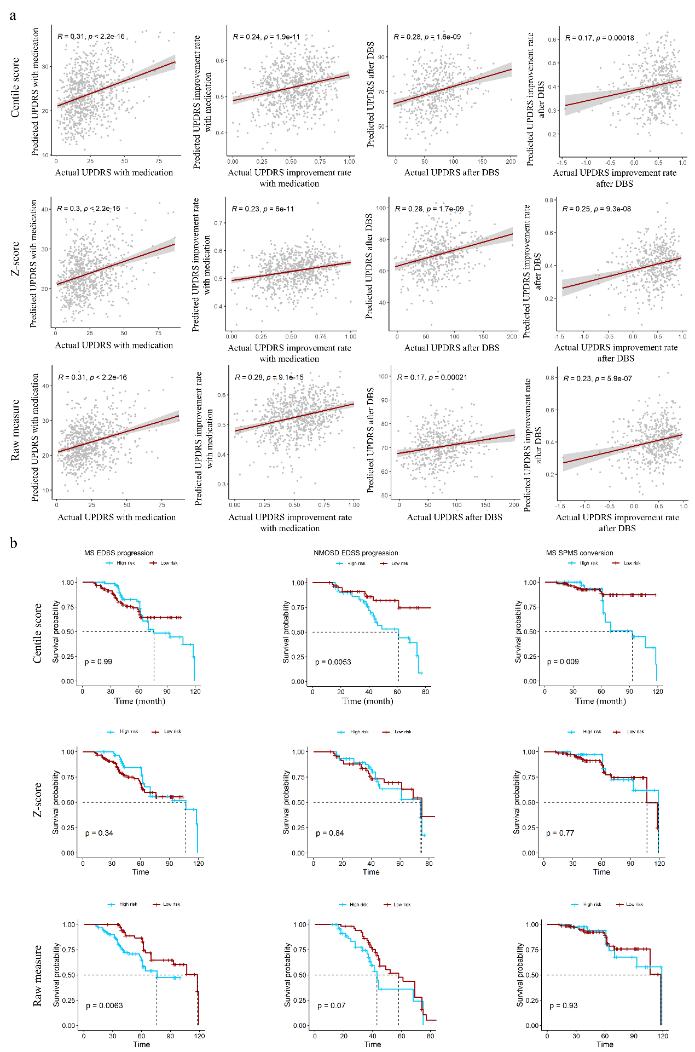
eFigure 24. Comparisons of clinical utility for the prognosis of PD subgroups of MS and NMOSD patients stratified by predicted relative hazards using centile score, Z-score and raw measure. The Pearson’s correlation between predicted and actual clinical measures were presented. Note: PD, Parkinson's disease, MS, multiple sclerosis; NMOSD, neuromyelitis optica spectrum disorder; EDSS, expanded disability status scale; SPMS, secondary progressive multiple sclerosis; UPDRS, Unified Parkinson's Disease Rating Scale; DBS, deep brain stimulation.

eTable 1. A summary of hazard ratios of features that showed the statistical significances in univariate and multivariate Cox proportional hazards regressions
 | HR (univariate) | HR (multivariate)
MS EDSS progression
rh_frontalpole_area | 0.12 (0.05-0.31, p<.001) | 0.14 (0.03-0.61, p=.009)
rh_lingual_thickness | 9.30 (2.82-30.65, p<.001) | 14.30 (2.13-95.96, p=.006)
rh_medialorbitofrontal_volume | 0.19 (0.07-0.51, p=.001) | 0.14 (0.03-0.59, p=.007)
lh_frontalpole_area | 0.25 (0.11-0.58, p=.001) | 3.33 (0.73-15.20, p=.120)
lh_frontalpole_volume | 0.25 (0.10-0.64, p=.004) | 0.23 (0.05-1.14, p=.072)
rh_frontalpole_volume | 0.31 (0.13-0.74, p=.008) | 3.35 (0.79-14.29, p=.102)
rh_insula_volume | 3.46 (1.29-9.28, p=.014) | 7.33 (1.78-30.24, p=.006)
rh_cuneus_thickness | 3.26 (1.20-8.88, p=.021) | 0.32 (0.07-1.39, p=.127)
lh_superiortemporal_volume | 0.37 (0.16-0.86, p=.021) | 0.30 (0.10-0.89, p=.030)
rh_supramarginal_area | 3.50 (1.20-10.17, p=.022) | 2.67 (0.69-10.35, p=.154)
rh_parahippocampal_thickness | 2.72 (1.10-6.74, p=.031) | 2.33 (0.84-6.45, p=.104)
MS SPMS conversion
rh_supramarginal_area | 15.58 (2.74-88.60, p=.002) | 472.03 (2.86-77876.35, p=.018)
rh_insula_volume | 15.78 (2.65-94.15, p=.002) | 44.26 (1.23-1594.31, p=.038)
rh_supramarginal_volume | 11.99 (2.32-61.86, p=.003) | 0.03 (0.00-2.40, p=.114)
rh_frontalpole_area | 0.15 (0.04-0.57, p=.005) | 0.10 (0.01-0.68, p=.019)
rh_middletemporal_thickness | 6.20 (1.62-23.77, p=.008) | 6.84 (0.94-49.91, p=.058)
lh_paracentral_area | 7.31 (1.64-32.51, p=.009) | 10.94 (0.41-291.30, p=.153)
rh_cuneus_thickness | 6.51 (1.41-29.97, p=.016) | 6.64 (0.71-62.28, p=.097)
rh_superiorparietal_area | 6.44 (1.37-30.14, p=.018) | 994.59 (11.27-87764.35, p=.003)
lh_parstriangularis_area | 7.46 (1.39-40.01, p=.019) | 4.59 (0.52-40.20, p=.169)
lh_paracentral_volume | 6.40 (1.35-30.39, p=.019) | 0.02 (0.00-0.67, p=.029)
rh_precuneus_thickness | 5.08 (1.29-19.93, p=.020) | 22.93 (1.94-271.25, p=.013)
rh_pericalcarine_area | 0.25 (0.07-0.92, p=.037) | 0.06 (0.01-0.37, p=.003)
lh_insula_volume | 4.31 (1.04-17.93, p=.044) | 0.10 (0.01-1.36, p=.085)
lh_superiortemporal_volume | 0.29 (0.09-0.98, p=.047) | 0.17 (0.03-0.80, p=.025)
rh_superiorparietal_volume | 4.53 (1.01-20.33, p=.049) | 0.00 (0.00-0.23, p=.009)
NMOSD EDSS progression
lh_entorhinal_area | 6.58 (2.19-19.80, p<.001) | 20835.13 (441.51-983216.46, p<.001)
rh_entorhinal_volume | 9.16 (2.44-34.38, p=.001) | 14.67 (1.60-134.35, p=.017)
lh_frontalpole_thickness | 7.01 (2.15-22.82, p=.001) | 29.89 (4.47-199.71, p<.001)
rh_rostralanteriorcingulate_volume | 4.93 (1.54-15.81, p=.007) | 0.01 (0.00-0.57, p=.025)
lh_frontalpole_area | 0.20 (0.06-0.68, p=.010) | 0.03 (0.00-0.21, p<.001)
lh_precuneus_thickness | 4.52 (1.41-14.46, p=.011) | 7.44 (0.98-56.68, p=.053)
rh_lateraloccipital_area | 4.54 (1.38-14.92, p=.013) | 69.14 (7.74-617.51, p<.001)
rh_fusiform_thickness | 4.23 (1.32-13.53, p=.015) | 42.88 (3.34-551.30, p=.004)
rh_rostralanteriorcingulate_area | 4.12 (1.29-13.15, p=.017) | 392.59 (7.55-20418.36, p=.003)
lh_inferiortemporal_thickness | 3.80 (1.22-11.88, p=.022) | 100.23 (12.90-778.62, p<.001)
lh_rostralmiddlefrontal_thickness | 3.28 (1.17-9.21, p=.024) | 28.80 (3.57-232.37, p=.002)
lh_fusiform_thickness | 3.65 (1.12-11.93, p=.032) | 0.03 (0.00-0.37, p=.006)
rh_frontalpole_area | 0.26 (0.07-0.91, p=.034) | 0.16 (0.02-1.42, p=.100)
lh_superiorfrontal_thickness | 3.03 (1.03-8.94, p=.044) | 0.03 (0.00-0.59, p=.021)
rh_inferiorparietal_volume | 2.92 (1.03-8.28, p=.044) | 0.22 (0.03-1.49, p=.121)
lh_parstriangularis_volume | 3.31 (1.01-10.81, p=.048) | 17.52 (3.55-86.55, p<.001)
rh_superiortemporal_volume | 0.33 (0.11-0.99, p=.048) | 0.01 (0.00-0.07, p<.001)
lh_entorhinal_volume | 3.51 (1.01-12.24, p=.048) | 0.00 (0.00-0.02, p<.001)
lh_posteriorcingulate_volume | 3.40 (1.00-11.51, p=.049) | 5.49 (1.02-29.51, p=.047)
Note: MS, multiple sclerosis; NMOSD, neuromyelitis optica spectrum disorder; EDSS, expanded disability status scale; SPMS, secondary progressive multiple sclerosis; HR, hazard ratio; rh, right hemisphere; lh, left hemisphere.

eReferences
1. McKhann GM, Knopman DS, Chertkow H, et al. The diagnosis of dementia due to Alzheimer's disease: recommendations from the National Institute on Aging-Alzheimer's Association workgroups on diagnostic guidelines for Alzheimer's disease. Alzheimers Dement. May 2011;7(3):263-9. doi:10.1016/j.jalz.2011.03.005
2. Postuma RB, Berg D, Stern M, et al. MDS clinical diagnostic criteria for Parkinson's disease. Mov Disord. Oct 2015;30(12):1591-601. doi:10.1002/mds.26424
3. Wardlaw JM, Smith EE, Biessels GJ, et al. Neuroimaging standards for research into small vessel disease and its contribution to ageing and neurodegeneration. Lancet Neurol. Aug 2013;12(8):822-38. doi:10.1016/S1474-4422(13)70124-8
4. Thompson AJ, Banwell BL, Barkhof F, et al. Diagnosis of multiple sclerosis: 2017 revisions of the McDonald criteria. Lancet Neurol. Feb 2018;17(2):162-173. doi:10.1016/S1474-4422(17)30470-2
5. Takahashi T, Fujihara K, Nakashima I, et al. Establishment of a new sensitive assay for anti-human aquaporin-4 antibody in neuromyelitis optica. Tohoku J Exp Med. Dec 2006;210(4):307-13. doi:10.1620/tjem.210.307

