Supplementary material
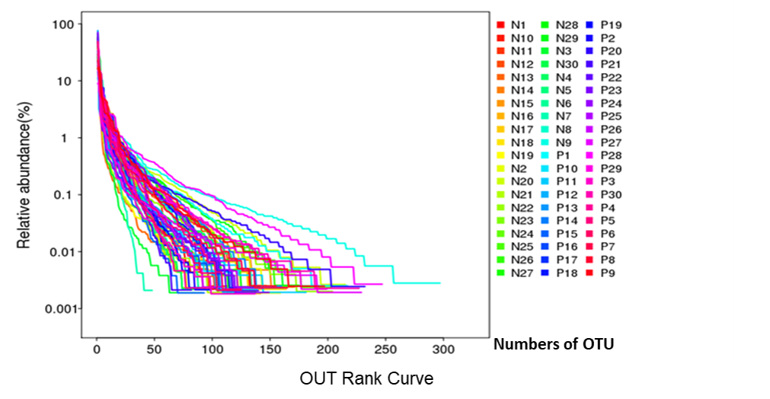
Supplement 1. The horizontal axis is the rank of OTU in decreasing order of abundance, while the vertical axis is the relative abundance of OTU. Each line represents one sample.

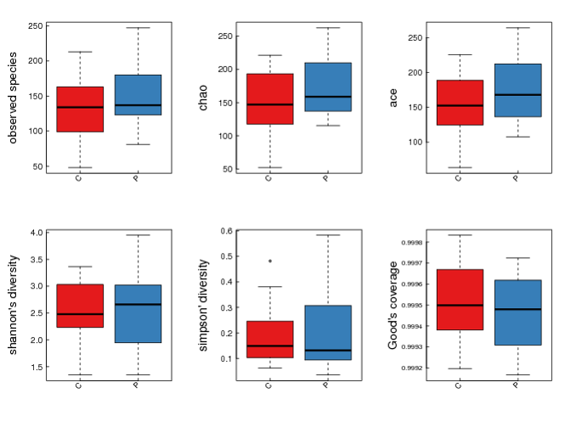
Supplement 2. Boxplot of alpha diversity. The figure shows the alpha diversity among groups. For all boxplots, black center lines represent the median and box edges are the first and third quartiles. The horizontal axis is group information and the vertical axis is the value of index. The red box represented healthy control group (C) and the blue box represented psoriasis patients group (P).

#Alpha | mean(C) | SD(C) | mean(P) | SD(P) | p-vaule
sobs | 140 | 50.82356 | 150.1 | 45.88317 | 0.34398
chao | 162.9168 | 56.13711 | 176.7536 | 45.51086 | 0.20784
ace | 162.5852 | 53.8374 | 176.2936 | 45.81328 | 0.27289
shannon | 2.54986 | 0.62968 | 2.56003 | 0.64969 | 0.92402
simpson | 0.18491 | 0.11516 | 0.19554 | 0.1451 | 0.80868
coverage | 0.99949 | 0.00021 | 0.99946 | 0.00017 | 0.33654
Supplement 3. Table 2.healthy control group (C) - psoriasis patients group (P) .Alpha diversity test result. The exact figures showed in boxplot of alpha diversity.

Supplement 4. Clinical indices of psoriasis patients
 | WBC | ALT | AST | TC | TG | HDL | LDL | FBG | IgA | IgE | C3 | hsCRP | IL2R | IL6 | IL8
P1 | 6.61 | 46 | 31 | 4.59 | 2.43 | 0.79 | 3.66 | 5.34 | 2.65 | 252 | 0.84 | 3.23 | 624 | 3.82 | 13.9
P2 | 7.05 | 73 | 44 | 4.83 | 1.31 | 1.02 | 3.54 | 4.43 | 2.82 | 12.5 | 1.1 | 3.23 | 386 | 4.76 | 5
P4 | 10.71 | 21 | 26 | 3.66 | 1.02 | 0.94 | 2.39 | 4.34 | 1.42 | 382 | 0.85 | 21.30 | 1971 | 11.8 | 23.6
P5 | 5.62 | 17 | 14 | 4.19 | 2.55 | 1.19 | 2.74 | 3.87 | 1.46 | 188 | 1.07 | 3.23 | 246 | 3.81 | 7.27
P7 | 10.96 | 16 | 15 | 3.99 | 1.26 | 0.85 | 2.75 | 4.68 | 1.57 | 8.61 | 0.95 | 3.23 | 501 | 9.77 | 11.3
P9 | 10.36 | 6 | 11 | 2.45 | 0.65 | 0.65 | 1.54 | 4.54 | 1.92 | 181 | 1.15 | 105 | 1846 | 104 | 15.6
P10 | 5.73 | 68 | 40 | 4.06 | 1.27 | 1.01 | 2.82 | 4.91 | 3.38 | 40.9 | 1.02 | 3.23 | 476 | 4.87 | 7.68
P11 | 6.97 | 27 | 20 | 4.42 | 1.93 | 1.01 | 3.25 | 5.2 | 1.26 | 146 | 1.04 | 3.27 | 486 | 3.76 | 8.31
P13 | 5.51 | 7 | 14 | 2.6 | 0.58 | 0.79 | 1.76 | 4.13 | 2.29 | 75.7 | 1.26 | 17.3 | 1399 | 8.18 | 22.6
P14 | 8.69 | 15 | 15 | 4.1 | 1.99 | 0.77 | 3.08 | 5.27 | 3.55 | 205 | 1.18 | 21.6 | 526 | 4.81 | 8.08
P15 | 11.46 | 26 | 20 | 4.29 | 1.23 | 1.16 | 3.02 | 7.36 | 2.53 | 19.2 | 1.07 | 7.91 | 390 | 5.45 | 9.37
P17 | 13.5 | 22 | 25 | 3.76 | 1.12 | 0.74 | 2.68 | 4.71 | 5.31 | 968 | 0.98 | 27.3 | 1173 | 29.2 | 18.5
P19 | 5.15 | 10 | 19 | 3.89 | 1.98 | 1.02 | 2.58 | 4.53 | 5.4 | 1310 | 1.07 | 3.23 | 1017 | 4.87 | 22
P20 | 6.34 | 21 | 14 | 3.1 | 2.1 | 0.59 | 2.07 | 5.25 | 2.61 | 1230 | 1.01 | 3.23 | 789 | 2.48 | 5
P21 | 6.05 | 28 | 29 | 4.67 | 2.76 | 1.18 | 3.03 | 4.62 | 1.49 | 49.9 | 1.09 | 3.23 | 375 | 4.66 | 6.07
P22 | 7.69 | 11 | 12 | 3.47 | 1.1 | 1.55 | 1.72 | 4.61 | 4.58 | 908 | 1 | 3.23 | 353 | 3.76 | 8.25
P23 | 7.22 | 8 | 13 | 3.72 | 0.81 | 1.34 | 2.25 | 4.99 | 2.31 | 567 | 1.28 | 3.23 | 351 | 8.06 | 5
P25 | 6.36 | 12 | 14 | 2.87 | 0.58 | 1.05 | 1.61 | 4.69 | 1.21 | 34.7 | 0.91 | 3.23 | 258 | 4.31 | 707
P27 | 8.37 | 13 | 20 | 3.69 | 3.02 | 0.77 | 2.27 | 3.92 | 1.94 | 12.2 | 1.21 | 3.23 | 481 | 6.71 | 39.4
P28 | 7.13 | 10 | 15 | 5.54 | 1.02 | 1.42 | 3.73 | 4.8 | 1.68 | 18 | 1.26 | 7.9 | 241 | 2.5 | 23
P29 | 4.29 | 15 | 15 | 4.11 | 1.11 | 1.31 | 2.69 | 5.14 | 1.67 | 8.14 | 1.14 | 3.23 | 370 | 4.73 | 7.51
P30 | 4.4 | 11 | 18 | 5.87 | 3.9 | 1.21 | 3.9 | 6.06 | 2.8 | 13.9 | 1.44 | 7.88 | 670 | 3.77 | 17.2
Reference values and unit: White blood cell (WBC) 3.50-9.50 10^{^9}/L; Alanine transaminase (ALT) 9-50 IU/L; Aspartate transaminase (AST) 15-40 IU/L; Total Cholesterol (TC) 3.3-5.8 mmol/L; Triglyceride (TG) 0.5-1.7 mmol/L; High-density lipoprotein (HDL) 0.8-1.8 mmol/L; Low-density lipoprotein (LDL) 2.3-3.3 mmol/L; Fasting blood-glucose (FBG) 3.3-6.0 mmol/L; IgA 0.70-4.00 g/L; IgE <100 IU/ml; C3 0.90-1.80 g/L; High sensitivity C reactive protein (hsCRP) 0-3.5 mg/L; Interleukin-2 Receptor (IL2R) 223-710 U/ml; Interleukin-6 (IL6) 0-3.4 pg/ml; Interleukin-8 (IL8) 0-14 pg/ml.

