Supplementary material
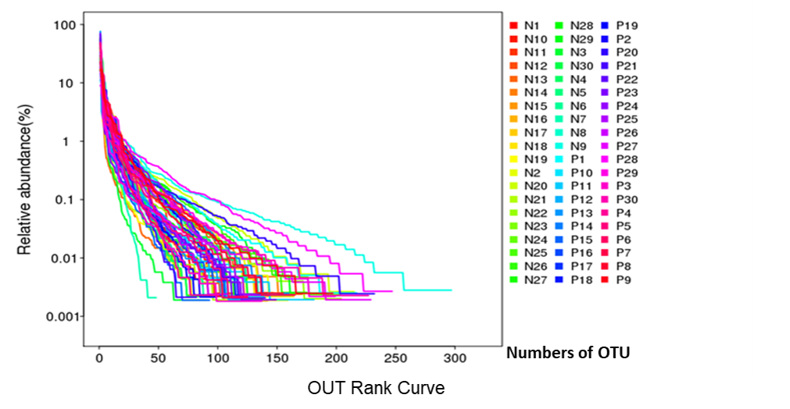
Supplement 1. The horizontal axis is the rank of OTU in decreasing order of abundance, while the vertical axis is the relative abundance of OTU. Each line represents one sample.

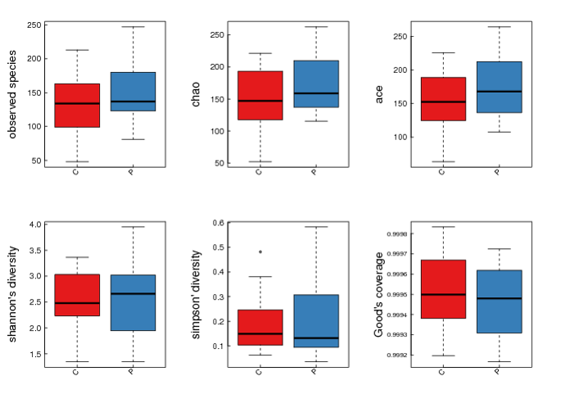
Supplement 2. Boxplot of alpha diversity. The figure shows the alpha diversity among groups. For all boxplots, black center lines represent the median and box edges are the first and third quartiles. The horizontal axis is group information and the vertical axis is the value of index. The red box represented healthy control group (C) and the blue box represented psoriasis patients group (P).

#Alpha | mean(C) | SD(C) | mean(P) | SD(P) | p-vaule
sobs | 140 | 50.82356 | 150.1 | 45.88317 | 0.34398
chao | 162.9168 | 56.13711 | 176.7536 | 45.51086 | 0.20784
ace | 162.5852 | 53.8374 | 176.2936 | 45.81328 | 0.27289
shannon | 2.54986 | 0.62968 | 2.56003 | 0.64969 | 0.92402
simpson | 0.18491 | 0.11516 | 0.19554 | 0.1451 | 0.80868
coverage | 0.99949 | 0.00021 | 0.99946 | 0.00017 | 0.33654
Supplement 3. Table 2.healthy control group (C) - psoriasis patients group (P) .Alpha diversity test result. The exact figures showed in boxplot of alpha diversity.

Supplement 4.Blood sample collection and serum measurement of clinical indices
Peripheral blood samples were collected from patients and ELISA assays were performed to determine serum concentrations of clinical indices. The data are presented as the mean ± SD. Statistical dependence between continuous variables was determined using a Spearman's rank correlation. Analyses were performed using the GraphPad Prism 7.

Supplement 5. Clinical indices of psoriasis patients
 | WBC | ALT | AST | TC | TG | HDL | LDL | FBG | IgA | IgE | C3 | hsCRP | IL2R | IL6 | IL8
P1 | 0.82 | 1.66 | 1.49 | 0.66 | 0.39 | -0.10 | 0.56 | 0.73 | 0.42 | 2.40 | -0.08 | 0.51 | 2.80 | 0.58 | 1.14
P2 | 0.85 | 1.86 | 1.64 | 0.68 | 0.12 | 0.01 | 0.55 | 0.65 | 0.45 | 1.10 | 0.04 | 0.51 | 2.59 | 0.68 | 0.70
P3 | 1.03 | 1.32 | 1.41 | 0.56 | 0.01 | -0.03 | 0.38 | 0.64 | 0.15 | 2.58 | -0.07 | 1.33 | 3.29 | 1.07 | 1.37
P4 | 0.75 | 1.23 | 1.15 | 0.62 | 0.41 | 0.08 | 0.44 | 0.59 | 0.16 | 2.27 | 0.03 | 0.51 | 2.39 | 0.58 | 0.86
P5 | 1.04 | 1.20 | 1.18 | 0.60 | 0.10 | -0.07 | 0.44 | 0.67 | 0.20 | 0.94 | -0.02 | 0.51 | 2.70 | 0.99 | 1.05
P6 | 1.02 | 0.78 | 1.04 | 0.39 | -0.19 | -0.19 | 0.19 | 0.66 | 0.28 | 2.26 | 0.06 | 2.02 | 3.27 | 2.02 | 1.19
P7 | 0.76 | 1.83 | 1.60 | 0.61 | 0.10 | 0.00 | 0.45 | 0.69 | 0.53 | 1.61 | 0.01 | 0.51 | 2.68 | 0.69 | 0.89
P8 | 0.84 | 1.43 | 1.30 | 0.65 | 0.29 | 0.00 | 0.51 | 0.72 | 0.10 | 2.16 | 0.02 | 0.51 | 2.69 | 0.58 | 0.92
P9 | 0.74 | 0.85 | 1.15 | 0.41 | -0.24 | -0.10 | 0.25 | 0.62 | 0.36 | 1.88 | 0.10 | 1.24 | 3.15 | 0.91 | 1.35
P10 | 0.94 | 1.18 | 1.18 | 0.61 | 0.30 | -0.11 | 0.49 | 0.72 | 0.55 | 2.31 | 0.07 | 1.33 | 2.72 | 0.68 | 0.91
P11 | 1.06 | 1.41 | 1.30 | 0.63 | 0.09 | 0.06 | 0.48 | 0.87 | 0.40 | 1.28 | 0.03 | 0.90 | 2.59 | 0.74 | 0.97
P12 | 1.13 | 1.34 | 1.40 | 0.58 | 0.05 | -0.13 | 0.43 | 0.67 | 0.73 | 2.99 | -0.01 | 1.44 | 3.07 | 1.47 | 1.27
P13 | 0.71 | 1.00 | 1.28 | 0.59 | 0.30 | 0.01 | 0.41 | 0.66 | 0.73 | 3.12 | 0.03 | 0.51 | 3.01 | 0.69 | 1.34
P14 | 0.80 | 1.32 | 1.15 | 0.49 | 0.32 | -0.23 | 0.32 | 0.72 | 0.42 | 3.09 | 0.00 | 0.51 | 2.90 | 0.39 | 0.70
P15 | 0.78 | 1.45 | 1.46 | 0.67 | 0.44 | 0.07 | 0.48 | 0.66 | 0.17 | 1.70 | 0.04 | 0.51 | 2.57 | 0.67 | 0.78
P16 | 0.89 | 1.04 | 1.08 | 0.54 | 0.04 | 0.19 | 0.24 | 0.66 | 0.66 | 2.96 | 0.00 | 0.51 | 2.55 | 0.58 | 0.92
P17 | 0.86 | 0.90 | 1.11 | 0.57 | -0.09 | 0.13 | 0.35 | 0.70 | 0.36 | 2.75 | 0.11 | 0.51 | 2.55 | 0.91 | 0.70
P18 | 0.80 | 1.08 | 1.15 | 0.46 | -0.24 | 0.02 | 0.21 | 0.67 | 0.08 | 1.54 | -0.04 | 0.51 | 2.41 | 0.63 | 2.85
P19 | 0.92 | 1.11 | 1.30 | 0.57 | 0.48 | -0.11 | 0.36 | 0.59 | 0.29 | 1.09 | 0.08 | 0.51 | 2.68 | 0.83 | 1.60
P20 | 0.85 | 1.00 | 1.18 | 0.74 | 0.01 | 0.15 | 0.57 | 0.68 | 0.23 | 1.26 | 0.10 | 0.90 | 2.38 | 0.40 | 1.36
P21 | 0.63 | 1.18 | 1.18 | 0.61 | 0.05 | 0.12 | 0.43 | 0.71 | 0.22 | 0.91 | 0.06 | 0.51 | 2.57 | 0.67 | 0.88
P22 | 0.64 | 1.04 | 1.26 | 0.77 | 0.59 | 0.08 | 0.59 | 0.78 | 0.45 | 1.14 | 0.16 | 0.90 | 2.83 | 0.58 | 1.24
P23 | 0.82 | 1.66 | 1.49 | 0.66 | 0.39 | -0.10 | 0.56 | 0.73 | 0.42 | 2.40 | -0.08 | 0.51 | 2.80 | 0.58 | 1.14
P24 | 0.85 | 1.86 | 1.64 | 0.68 | 0.12 | 0.01 | 0.55 | 0.65 | 0.45 | 1.10 | 0.04 | 0.51 | 2.59 | 0.68 | 0.70
P25 | 1.03 | 1.32 | 1.41 | 0.56 | 0.01 | -0.03 | 0.38 | 0.64 | 0.15 | 2.58 | -0.07 | 1.33 | 3.29 | 1.07 | 1.37
P26 | 0.75 | 1.23 | 1.15 | 0.62 | 0.41 | 0.08 | 0.44 | 0.59 | 0.16 | 2.27 | 0.03 | 0.51 | 2.39 | 0.58 | 0.86
P27 | 1.04 | 1.20 | 1.18 | 0.60 | 0.10 | -0.07 | 0.44 | 0.67 | 0.20 | 0.94 | -0.02 | 0.51 | 2.70 | 0.99 | 1.05
P28 | 1.02 | 0.78 | 1.04 | 0.39 | -0.19 | -0.19 | 0.19 | 0.66 | 0.28 | 2.26 | 0.06 | 2.02 | 3.27 | 2.02 | 1.19
P29 | 0.76 | 1.83 | 1.60 | 0.61 | 0.10 | 0.00 | 0.45 | 0.69 | 0.53 | 1.61 | 0.01 | 0.51 | 2.68 | 0.69 | 0.89
P30 | 0.84 | 1.43 | 1.30 | 0.65 | 0.29 | 0.00 | 0.51 | 0.72 | 0.10 | 2.16 | 0.02 | 0.51 | 2.69 | 0.58 | 0.92

