Supporting information

Determination of the activation energies of phase transition for calcium orthophosphates based on powder X-ray diffraction data

Kateryna Vasylenko¹, Yuriy Sakhno^{2*}; Deb Jaisi²; and Mykola Nikolenko^{1*}

¹Faculty of Chemical Technologies and Ecology, Ukrainian State University of Chemical Technology, Dnipro, Ukraine, 49005
²Department of Plant and Soil Sciences, University of Delaware, Newark, Delaware, 19716

Corresponding author:
Mykola Nikolenko: n_nikolenko@ukr.net,

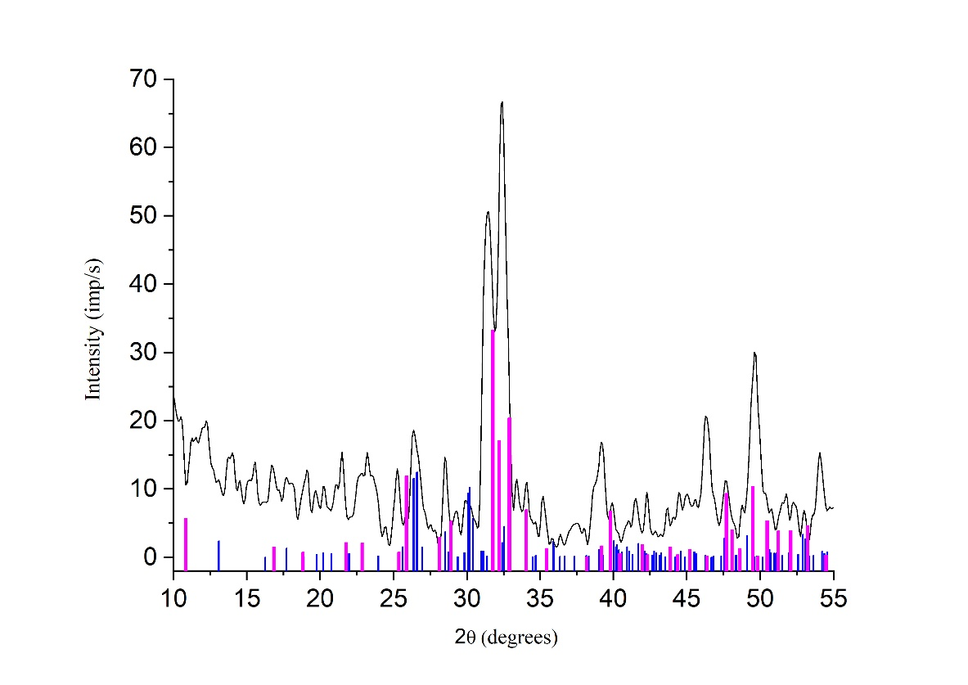

Fig. SI 1. The X-ray diffraction pattern of calcium orthophosphate precipitated at pH 9, temperature 20 °C and initial ratio Ca/P = 1.5. Aging conditions in mother solution: 24 hours at temperature 20 °C with initial heat treatment during 6 hours at 250 ⁰С in a high-pressure reactor. The figure shows dicalcium phosphate anhydrous (PCPDFWIN No. 77-0128) with the blue lines and hydroxyapatite (PCPDFWIN No. 74-0566) with the magenta lines.
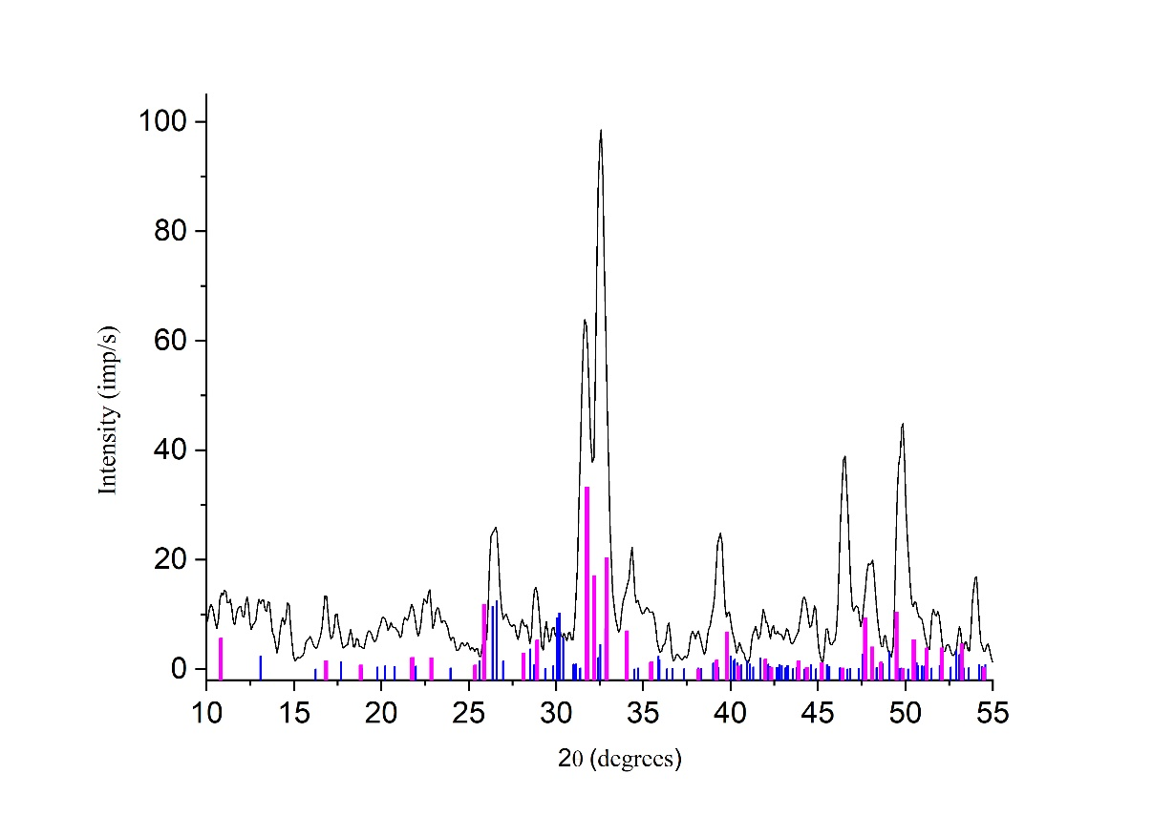
Fig. SI 2. The X-ray diffraction pattern of calcium orthophosphate precipitated at pH 10, temperature 20 °C and initial ratio Ca/P = 1.5. Aging conditions in mother solution: 24 hours at temperature 20 °C with initial heat treatment during 6 hours at 250 ⁰С in a high-pressure reactor. The figure shows dicalcium phosphate anhydrous (PCPDFWIN No. 77-0128) with the blue lines and hydroxyapatite (PCPDFWIN No. 74-0566) with the magenta lines.
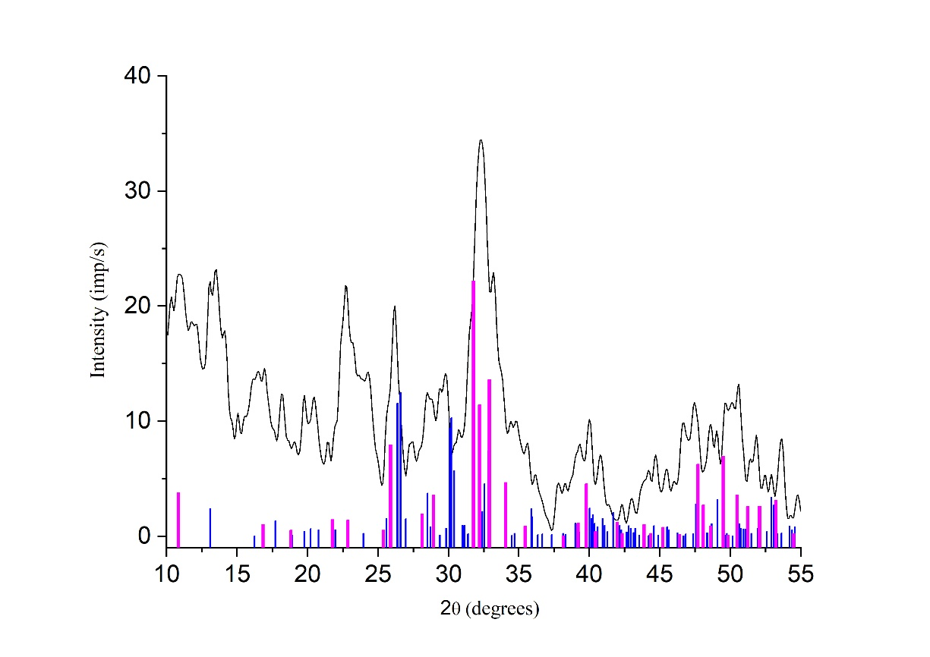
Fig. SI 3. The X-ray diffraction pattern of calcium orthophosphate precipitated at pH 11, temperature 20 °C and initial ratio Ca/P = 0.5. Aging conditions in mother solution: 24 hours at temperature 20 °C. The figure shows dicalcium phosphate anhydrous (PCPDFWIN No. 77-0128) with the blue lines and hydroxyapatite (PCPDFWIN No. 74-0566) with
the magenta lines.

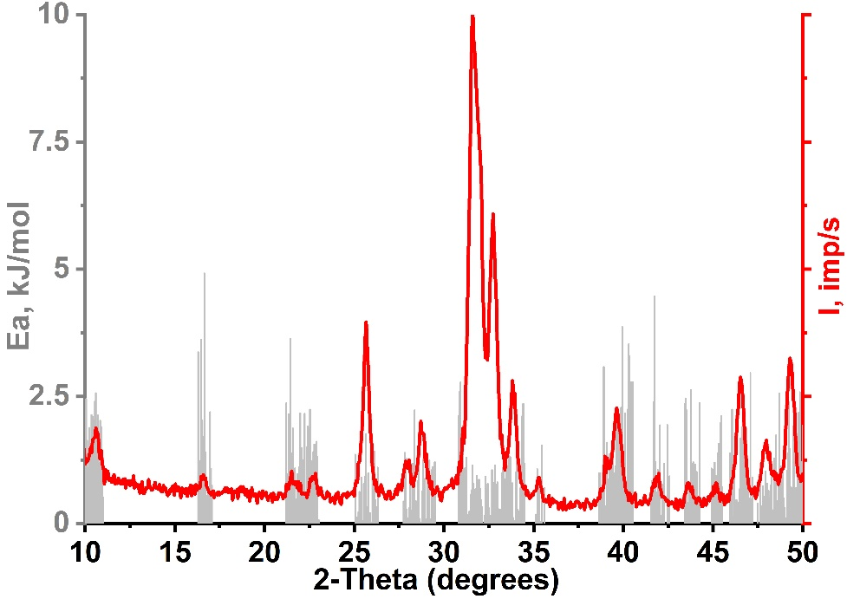
Fig. SI 4. Red curve is diffractogram of pure HA maturated at 50°С. Grey bars show the results of the calculation of activation energies for this sample.

