Supplemental Materials

From –20 to 200 °C: Fuel Cells with Broad Operational Flexibility Enabled by Intrinsically Ultramicroporous Membranes

Hongying Tang^{1,2#}, Kang Geng^{1#}, Lei Wu¹, Junjie Liu³, Zhiquan Chen³, Wei You^{4,**}, Feng Yan^{5,}, Michael D. Guiver,^{6,7,***} Nanwen. Li^{1,8,*}

¹State Key Laboratory of Coal Conversion, Institute of Coal Chemistry, Chinese Academy of Sciences. Taiyuan, China

²Tianjin Key Laboratory of Water Resources and Environment, Tianjin Normal University, Tianjin, China

³Hubei Nuclear Solid Physics Key Laboratory, Department of Physics, Wuhan University, Wuhan, China

⁴Beijing National Laboratory for Molecular Sciences (BNLMS), CAS Key Laboratory of Engineering Plastics, Institute of Chemistry, Chinese Academy of Sciences, Beijing, China

⁵College of Chemistry, Chemical Engineering and Materials Science, Soochow University, No. 199 Renai Road, Suzhou, China

⁶State Key Laboratory of Engines, Tianjin University, Tianjin, China

⁷Collaborative Innovation Center of Chemical Science and Engineering (Tianjin), Tianjin, China

⁸Lead Contact

*Correspondence: linanwen@sxicc.ac.cn

**Correspondence: weiyou@iccas.ac.cn

***Correspondence: guiver@tju.edu.cn
# equal contribution

Figure S1. Polymer structures and backbone geometry.
Table S1. Molecular weight parameters and N wt%.
Figure S2. Normalized positron annihilation lifetime spectra (PALS) of TB membranes.
Table S2. Cavity size characterization and FFV of TB membranes measured by PALS.
Figure S3. N₂ adsorption/desorption isotherms of the PA-undoped (a) and doped (b) TB membranes at 77 K.
Figure S4. Structure of PIM-1 and pore size distribution.
Figure S5. Calculated Mulliken and natural population analysis (NPA) charges of N atoms for TB units.
Tables S3–S6. Calculated Cartesian coordinates.
Figure S6. Solid ³¹P NMR spectra of PA-doped TB membranes, Chemical shift refered to (NH₄)₂HPO₄, 1.00 ppm.
Figure S76. Through-plane proton conductivity of PA-doped PEMs without external humidification.
Table S7. Summary and comparison of representative PEMFC performance.
Figure S87. i-V curves and power density of m-PBI/PA MEAs as a function of operating temperature.
Figure S98. Photographs of pH indicators with the generated liquid in the flow field plates after the durability tests.
Figure S10. i-V curves of m-PBI MEAs in the AST cycling tests at 40 °C.
Figure S11. i-V curves of DMBP-TB MEAs in the AST cycling tests at 40 °C.
Figure S12. i-V curves of DMBP-TB MEAs in the AST cycling tests at –20 °C.
References (1–58)

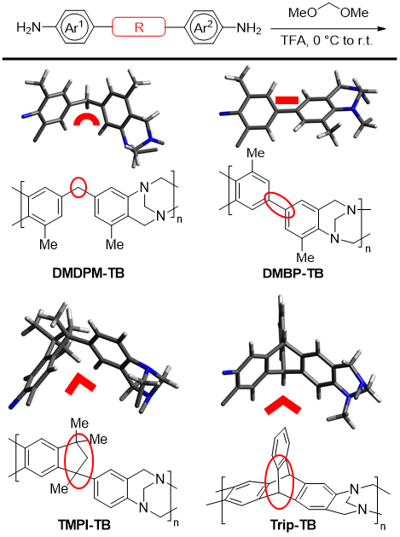
Figure S1. Synthesis, structures, and estimated backbone geometries of four different TB polymers.

Table S1. Molecular weight distribution and nitrogen weight percentage of TB-based membranes.

Membranes | M_{n} [kDa]ª | M_{w} [kDa]ª | Đª | N wt%^{c}
m-PBI | N.A. | 55^{b} | N.A. | 18.2
DMDPM-TB | 40 | 89 | 2.2 | 10.7
DMBP-TB | 40 | 99 | 2.5 | 11.3
TMPI-TB | 39 | 58 | 1.5 | 9.3
Trip-TB | 41 | 90 | 2.2 | 8.7
a) Measured by gel-permeation chromatography (GPC) against polystyrene standards except for m-PBI; b) Estimated from the inherent viscosity; c) Weight percentage of nitrogen atoms per repeating unit.

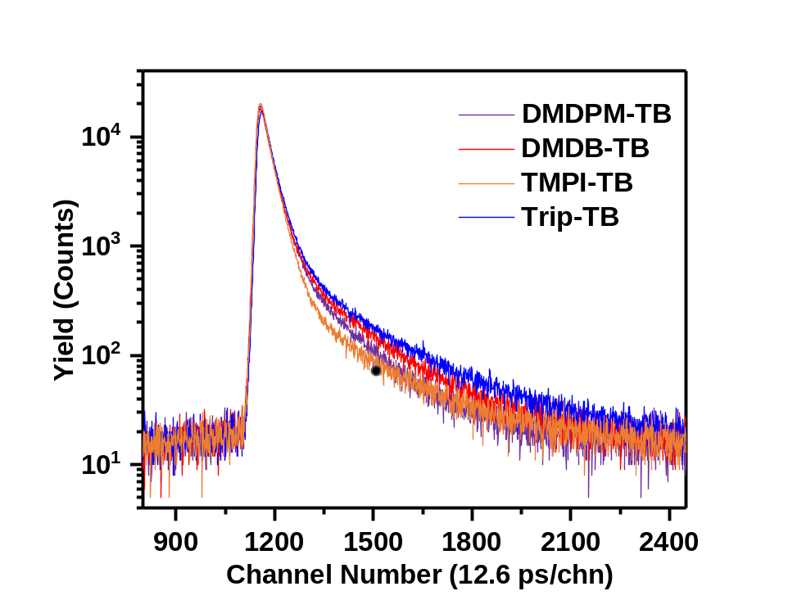
Figure S2. Normalized positron annihilation lifetime spectra (PALS) of TB films.

Table S2. Cavity size characterization and FFV of TB ﬁlms (undoped PA) measured by PALS.
Membrane | τ₁ (ps) | τ₂ (ns) | τ₃ (ns) | τ₄ (ns) | I₃ (%) | I₄ (%) | R₃ (Å) | R₄ (Å) | FFV₃  (%) | FFV₄  (%)
DMDPM-TB | 157.3 | 0.41 | 1.94 | N.A. | 17.62 | N.A. | 2.8 | N.A. | 29 | N.A.
DMBP-TB | 264.0 | 0.49 | 2.51 | N.A. | 19.24 | N.A. | 3.3 | N.A. | 52 | N.A.
TMPI-TB | 208.3 | 0.42 | 2.70 | N.A. | 10.01 | N.A. | 3.4 | N.A. | 30 | N.A.
Trip-TB | 145.7 | 0.41 | 1.95 | 4.33 | 15.65 | 9.16 | 2.8 | 4.4 | 26 | 59

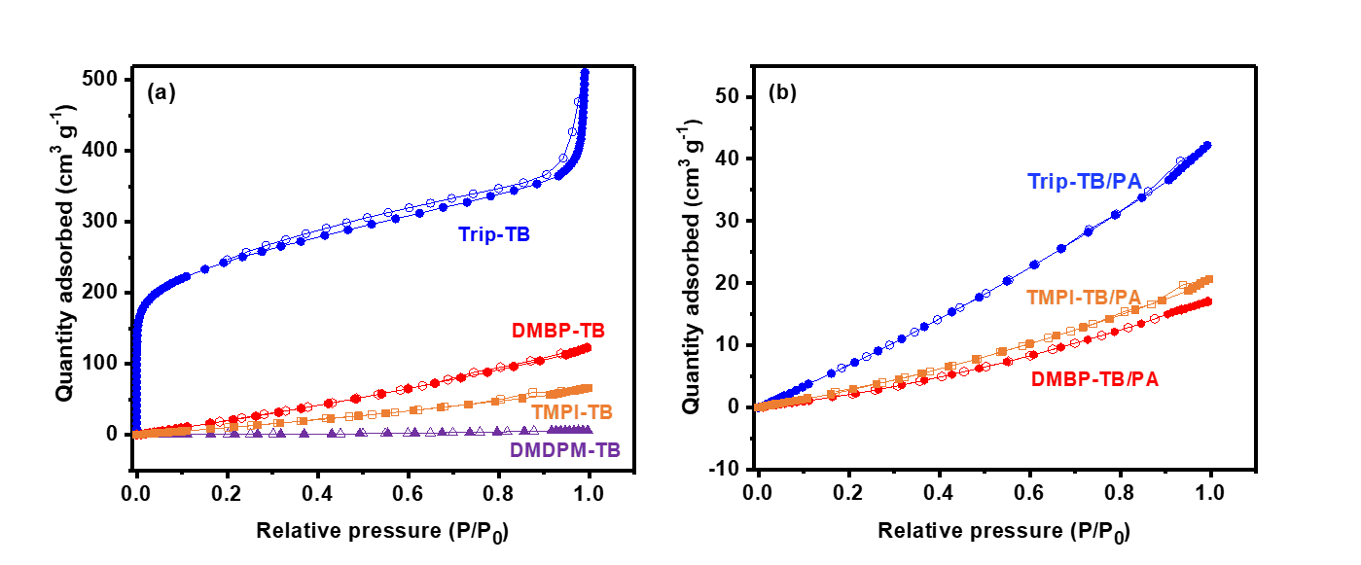
Figure S3. N₂ adsorption/desorption isotherms of the PA-undoped (a) and doped (b) TB membranes at 77 K.

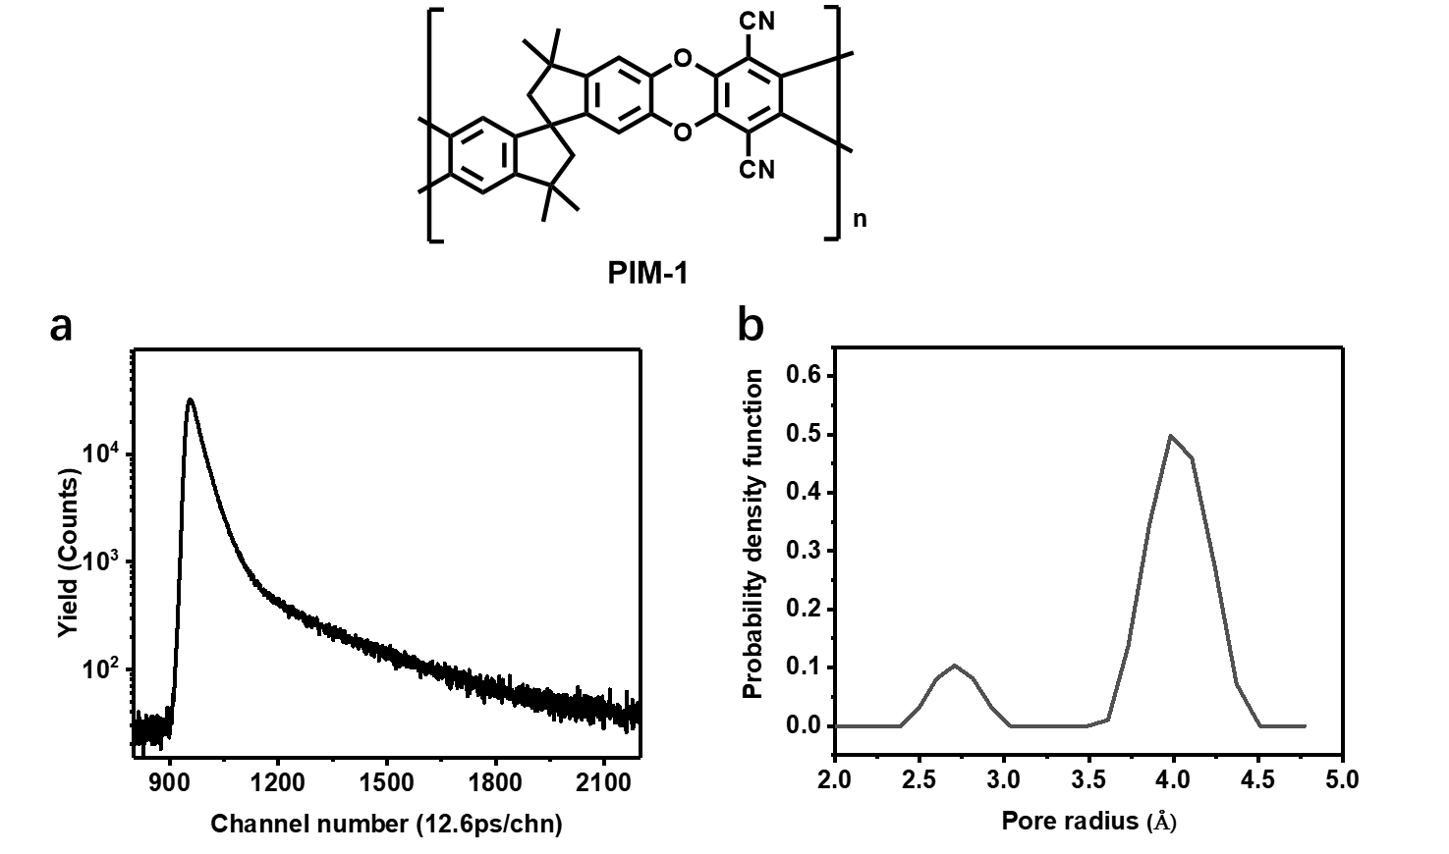
Figure S4. Structure of PIM-1. (a) Normalized positron annihilation lifetime spectra (PALS) of PIM-1 film, and (b) Pore size distribution results obtained via CONTIN analysis from PALS.

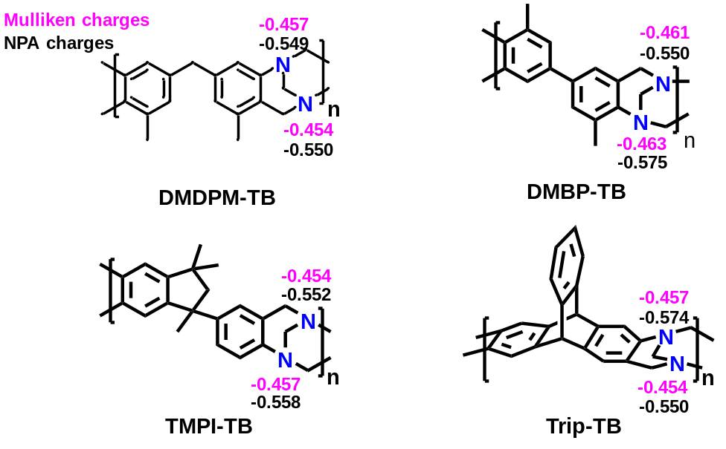
Figure S5. Calculated Mulliken and natural population analysis (NPA) charges of N atoms for TB units.
Geometry optimizations, vibrational frequencies, and thermal energy corrections were performed with the B3LYP-D3 functional in conjunction with a mixed basis set of 6-31G(d) for all atoms in the gas phase. The universal solvation model (SMD) was employed to account for the effects of water solution.⁵ All the optimized structures were confirmed by frequency calculations to be either minima or transition states at the same level of theory. To obtain more accurate electronic energies, single-point energy calculations were performed at the (SMD) B3LYP-D3/6-311+g** levels with the B3LYP-D3/6-31g(d) optimized structures. Structures were generated using CYLview.⁶ All calculations were carried out with Gaussian 09 packages.⁷ The detailed calculated cartesian coordinates for the four TB-based units are included in Tables S3-S6.

Table S3. DMBP-TB calculated Cartesian coordinates.
C | 0 | -1.4725487361 | 1.0547744644 |  | 0.1489939332
C | 0 | -0.0965061567 | 1.1573613437 |  | 0.064240476
C | 0 | 0.5178155818 | 2.402704266 |  | 0.2204655878
C | 0 | -0.2442583684 | 3.5818481099 |  | 0.1492240573
C | 0 | -1.6370156793 | 3.4894859706 |  | -0.0331975824
C | 0 | -2.2296025301 | 2.2372548647 |  | -0.1829662055
H | 0 | 0.5216278594 | 0.2660198065 |  | 0.1096585145
H  C  H  H  H  C  H  H  C  C  C  C  H  C  H  C  H  H  H  C  H  H  N  N  C  C  C  C  C  H  C  H  H  C  H  H  C  H  H  H | 0  0  0  0  0  0  0  0  0  0  0  0  0  0  0  0  0  0  0  0  0  0  0  0  0  0  0  0  0  0  0  0  0  0  0  0  0  0  0  0 | -3.307441064  -2.483109636  -3.543761817  -2.361700004  -2.212177939  2.342459839  1.906930246  3.43241676  -2.120559577  -1.685956927  -3.185132026  -2.293188632  -0.882096429  -3.79443112  -3.518143522  -3.350842883  -1.945635692  -4.611660719  -3.825238379  0.441275107  0.085992819  0.198990523  1.932112869  1.90623084  2.361156955  2.802925904  2.371211256  3.296445051  2.83150526  2.038500416  3.302383869  2.844832586  3.677582856  2.725856168  2.279215731  3.731785427  3.789791579  4.589640985  2.987616619  4.180158602 | 2.174275822  4.738890168  4.490353338  5.350153096  5.375724455  3.731952273  3.869038356  3.743929484  -0.26770908  -1.382041087  -0.439340316  -2.625801353  -1.262723905  -1.682287211  0.405070675  -2.781837885  -3.472983631  -1.794104215  -3.751199921  4.934689897  5.598976792  5.427179247  2.438754736  4.831073472  4.648127267  3.395737976  5.755826526  3.272876247  5.624545865  6.715505915  4.390195532  6.486888395  4.291535899  2.182060161  1.335717202  1.862841103  1.939073999  1.532947608  1.189488043  2.027227717 |  | -0.303083912  -0.084452217  -0.180489089  0.818609739  -0.936819738  0.995996187  1.989574765  1.082025263  -0.314004665  0.421256569  -1.213132954  0.261398318  1.141613499  -1.372144922  -1.809356684  -0.635894531  0.846392323  -2.0795227  -0.759844719  0.245623139  -0.547291378  1.198409105  0.455140903  0.13946938  -1.208687076  -1.671129195  -2.065015933  -2.984345556  -3.368770915  -1.680300469  -3.821369593  -4.029456896  -4.836746346  -0.758395402  -1.287684634  -0.45025734  -3.491443732  -2.859485872  -3.507290363  -4.509282876
Zero-point correction=  Thermal correction to Energy=  Thermal correction to Enthalpy=  Thermal correction to Gibbs Free Energy=  Sum of electronic and zero-point Energies=  Sum of electronic and thermal Energies=  Sum of electronic and thermal Enthalpies=  Sum of electronic and thermal Free Energies= |  |  |  | 0.397215 (Hartree/Particle)  0.416864  0.417808  0.349191  -998.925732  -998.906083  -998.905139  -998.973757

C  C  C  C  C  C  H  H  C  H  H  H  C  H  H  C  C  C  C  H  C  H  C  H  H  H  C  H  H  N  C  C  C  C  C  H  C  H  H  C  H  H  C  H  H  H  H  N | 0  0  0  0  0  0  0  0  0  0  0  0  0  0  0  0  0  0  0  0  0  0  0  0  0  0  0  0  0  0  0  0  0  0  0  0  0  0  0  0  0  0  0  0  0  0  0  0 | -1.480828136  -0.104950647  0.495388444  -0.260039719  -1.651445326  -2.232304552  0.513395228  -3.306928461  -2.499507223  -3.553997654  -2.41562322  -2.212918585  2.335832171  1.855947486  3.421968916  -2.128093695  -1.692770209  -3.188854294  -2.302138581  -0.89567001  -3.79511564  -3.520743909  -3.354316242  -1.961854432  -4.60800838  -3.829064614  0.377020218  0.06607107  0.148483649  1.921165437  2.411626834  2.788810407  2.494457639  3.287042717  2.978855147  2.192922427  3.368571908  3.058002581  3.746810971  2.705429418  2.242497836  3.711719274  3.720000655  4.50217148  2.883089601  4.113839359  2.273492595  1.889523458 | 1.019487075  1.127327232  2.376775032  3.552102881  3.464509335  2.20505231  0.238776723  2.138093346  4.709644901  4.454124792  5.326395663  5.340091645  3.629498324  3.774049657  3.689088687  -0.304213678  -1.397303648  -0.491328722  -2.642806431  -1.262760321  -1.738229373  0.336255612  -2.817502259  -3.475190612  -1.868847054  -3.788572105  4.912397816  5.588818596  5.393613248  2.438373016  4.671785764  3.412308977  5.826897881  3.319549097  5.721584486  6.790035403  4.476197703  6.606561829  4.399226026  2.187502858  1.354777234  1.858568905  1.986378628  1.52617315  1.278209035  2.094412256  5.69122582  4.821875645 | -0.147604756  0.078609151  0.207999747  0.103818216  -0.102282774  -0.22621294  0.150520643  -0.361302184  -0.187735513  -0.312596206  0.716171223  -1.040056379  1.039635068  2.008945774  1.124758778  -0.283573944  0.482203263  -1.18380199  0.351461728  1.207632627  -1.316447447  -1.803819556  -0.548974046  0.960028969  -2.024339472  -0.650685635  0.228173106  -0.571058518  1.187011823  0.408773221  -1.231906138  -1.700831684  -2.004153954  -3.016557413  -3.30311551  -1.599688726  -3.796871861  -3.925258834  -4.81164688  -0.811924305  -1.344135014  -0.520989498  -3.571612181  -2.956138027  -3.613545765  -4.584538756  0.535949163  0.153836146

Zero-point correction=  Thermal correction to Energy=  Thermal correction to Enthalpy=  Thermal correction to Gibbs Free Energy=  Sum of electronic and zero-point Energies=  Sum of electronic and thermal Energies=  Sum of electronic and thermal Enthalpies=  Sum of electronic and thermal Free Energies= | 0.411434 (Hartree/Particle)  0.431329  0.432273  0.363085  -999.300464  -999.280569  -999.279625  -999.348813

Table S4. DMBP-TB calculated Cartesian coordinates.
C  C  C  C  C  C  H  H  C  H  H  H  C  C  C  C  H  C  H  C  H  H  H  C  C  C  C  C  H  C  H  H  C  H  H  H  C  H  H  C  H  H  C  H  H  N  N | 0  0  0  0  0  0  0  0  0  0  0  0  0  0  0  0  0  0  0  0  0  0  0  0  0  0  0  0  0  0  0  0  0  0  0  0  0  0  0  0  0  0  0  0  0  0  0 | -1.807755093  -0.436329506  0.255658564  -0.428460166  -1.809835528  -2.471240385  0.108327101  -3.539080533  -2.557464339  -3.451838574  -2.888424089  -1.916146462  -2.536581988  -2.223876798  -3.557990029  -2.906528575  -1.455967885  -4.243343574  -3.796921139  -3.920381905  -2.652749949  -5.025253675  -4.453905323  0.946832198  1.987913643  0.718870742  2.793945248  1.502534667  -0.089014841  2.531172995  1.318591667  3.156192572  3.934935091  3.603723349  4.396485036  4.693723906  0.080391718  0.312382602  -0.973180686  1.748154685  1.964992506  2.302056275  1.706104736  2.198725474  1.891320667  0.268703416  2.266900224 | 0.736666413  0.773028692  1.979732353  3.191600803  3.182779659  1.958263307  -0.159450104  1.954118779  4.469973513  4.293614333  4.934643942  5.195906369  -0.550134002  -1.615363926  -0.73844146  -2.82708083  -1.479683107  -1.948762137  0.06439395  -2.999533863  -3.635161806  -2.074551833  -3.94359556  4.622710338  3.718600264  5.028651707  3.217727199  4.535870881  5.727266636  3.635977757  4.851854413  3.260922517  2.275793607  1.229947769  2.51684016  2.331981301  5.166913757  6.226565008  5.117718424  1.978284389  1.297166964  1.605454621  4.259955101  5.229926068  3.879296842  4.443801556  3.315948606 |  | -0.008936023  0.263683111  0.355032061  0.15682235  -0.126196296  -0.199856024  0.393805306  -0.401224224  -0.364700239  -0.970064641  0.573787706  -0.873426023  -0.096961587  0.762793087  -1.04185187  0.679646265  1.518774987  -1.123926314  -1.733123025  -0.263961569  1.360365873  -1.867949244  -0.328271444  2.601970109  2.326276083  3.919078498  3.369936719  4.957160034  4.127755697  4.676033743  5.980048014  5.48279962  3.080851406  3.025687855  2.118583979  3.867477003  1.477130425  1.300905629  1.762200681  0.646185622  1.472334213  -0.226610332  0.012685638  0.122544435  -0.995496848  0.207937719  0.977108495
Zero-point correction=  Thermal correction to Energy=  Thermal correction to Enthalpy=  Thermal correction to Gibbs Free Energy=  Sum of electronic and zero-point Energies=  Sum of electronic and thermal Energies=  Sum of electronic and thermal Enthalpies=  Sum of electronic and thermal Free Energies= |  |  |  | 0.397355 (Hartree/Particle)  0.416990  0.417934  0.349495  -998.926196  -998.906561  -998.905617  -998.974056

C  C  C  C  C  C  H  H  C  H  H  H  C  C  C  C  H  C  H  C  H  H  H  C  C  C  C  C  H  C  H  H  C  H  H  H  C  H  H  C  H  H  C  H  H  N  H  N | 0  0  0  0  0  0  0  0  0  0  0  0  0  0  0  0  0  0  0  0  0  0  0  0  0  0  0  0  0  0  0  0  0  0  0  0  0  0  0  0  0  0  0  0  0  0  0  0 | -1.823750441  -0.463065797  0.236288072  -0.461288761  -1.817407347  -2.474401791  0.071206923  -3.529934281  -2.550523677  -3.569645189  -2.626790908  -2.07630778  -2.553622693  -2.267625098  -3.543408371  -2.955308455  -1.527593981  -4.226442397  -3.755980151  -3.935498234  -2.731767875  -4.980821733  -4.470081372  0.954999637  2.017233786  0.729245314  2.864874731  1.556774215  -0.093237458  2.611783261  1.384432191  3.263485031  4.017400053  3.706763203  4.446904665  4.80069563  0.057154311  0.266479949  -0.99600964  1.727694797  1.962693352  2.267670926  1.780108338  2.232386129  1.915338091  2.240432251  -0.109160393  0.252594565 | 0.73996987  0.777593067  1.979867198  3.163274547  3.183349023  1.956993  -0.152915398  1.948005939  4.466078644  4.248123961  5.139294083  5.026961577  -0.543716627  -1.580547055  -0.748807013  -2.78942941  -1.427268366  -1.960236453  0.030386709  -2.983185866  -3.577618228  -2.108544256  -3.926448998  4.587545107  3.725583595  4.971365924  3.235215  4.491460098  5.640890381  3.633742612  4.788041004  3.273608434  2.319676961  1.266675842  2.554232557  2.405884549  5.158042744  6.218702553  5.055318653  1.979457254  1.311065855  1.604183137  4.269165109  5.251134871  3.922474201  3.32267342  5.083632358  4.460845434 | -0.031103468  0.300184426  0.38958568  0.136643559  -0.222813586  -0.296502072  0.467098937  -0.54717306  -0.539966022  -0.86544884  0.322412966  -1.358518779  -0.106457785  0.795940221  -1.080799847  0.726859016  1.576027818  -1.152014978  -1.806863037  -0.247909629  1.439232487  -1.918538968  -0.30257013  2.654138615  2.349838367  3.978675235  3.359680157  4.98767315  4.216717521  4.674743131  6.01706189  5.465358595  3.037056282  3.016099581  2.059177671  3.794566897  1.583070086  1.403110592  1.847852498  0.664829097  1.493942056  -0.213738626  0.04522939  0.193309506  -0.980485986  0.985123436  -0.478877556  0.249478574

Zero-point correction=  Thermal correction to Energy=  Thermal correction to Enthalpy=  Thermal correction to Gibbs Free Energy=  Sum of electronic and zero-point Energies=  Sum of electronic and thermal Energies=  Sum of electronic and thermal Enthalpies=  Sum of electronic and thermal Free Energies= | 0.411541 (Hartree/Particle)  0.431487  0.432431  0.363185  -999.300584  -999.280638  -999.279694  -999.348939

Table S5. TMPI-TB calculated Cartesian coordinates.
C  C  C  C  C  C  H  H  C  C  C  C  C  H  C  H  H  C  H  H  C  H  H  C  H  H  N  N  H  H  C  C  C  C  C  C  C  H  H  H  H  H  H  C  C  C  H  H  H  C  H  H  H  C  H  H  H | 0  0  0  0  0  0  0  0  0  0  0  0  0  0  0  0  0  0  0  0  0  0  0  0  0  0  0  0  0  0  0  0  0  0  0  0  0  0  0  0  0  0  0  0  0  0  0  0  0  0  0  0  0  0  0  0  0 | -2.478140982  -1.203825062  -0.543155074  -1.185489285  -2.456677464  -3.091214921  -0.703922461  -4.080036161  1.280751471  1.970492074  1.805519439  3.14604018  2.976753197  1.271509546  3.643986588  3.365143581  4.55963862  -0.027377334  0.113564862  -0.773287525  0.858767554  1.484954164  0.83281336  0.531078149  1.029923005  0.133967255  1.499743795  -0.568227711  -2.952787574  3.6694654  -2.967517119  -2.480130114  -2.315356325  -2.638388551  -3.122971249  -3.289823651  -2.338443508  -1.933708931  -2.507230093  -3.365669615  -3.650196219  -2.828803909  -1.33876187  -3.11713824  -2.209421456  -0.803948701  -0.600670886  -0.700757477  -0.036895155  -3.257251667  -3.195294749  -3.090729024  -4.275312727  -4.612135519  -4.758052367  -5.168563506  -5.048765138 | 1.321109475  1.647412919  2.817763124  3.724204311  3.411616377  2.22687387  0.957688105  2.024158979  4.159224275  3.806461914  3.7718614  3.049814146  3.024252759  4.045564032  2.654843715  2.726459883  2.07257547  4.930004901  5.967490856  4.481119736  3.112369138  2.219268511  3.393422081  5.299468071  6.194940189  5.51196903  4.20886076  4.959764007  4.121622368  2.797322441  -0.244863397  -1.523871784  -1.940776929  -1.065275798  0.21672391  0.632693229  -1.223705088  -2.934194142  -1.379387417  0.893063998  1.633270162  -1.606281313  -0.894356569  -0.002705536  -2.316026924  -2.938370224  -3.429278038  -3.692733563  -2.173231903  -3.434458305  -4.151745637  -3.980457993  -3.033669002  -0.072422519  -0.044074703  0.758195061  -1.003067456 | 0.116933018  -0.362912842  0.005345193  0.869579836  1.356440218  0.991381541  -1.04018488  1.386667053  2.710496056  1.536289574  3.947530924  1.623176928  4.031830699  4.855625845  2.860043956  5.001492043  2.912744051  2.625611296  2.958448844  3.287590524  -0.503924866  -0.425857583  -1.56546322  0.352335189  0.732797832  -0.643914792  0.243497106  1.255570018  2.012345121  0.705322115  -1.804475271  -2.080799427  -3.401774724  -4.440924044  -4.160475954  -2.838198685  0.295750256  -3.624518354  -5.472844751  -4.975532284  -2.61402805  1.197287124  0.593435224  -0.305911443  -0.810574593  -0.808181395  0.151135206  -1.596878886  -0.970024793  -0.641631168  -1.468117085  0.294802744  -0.626205981  0.063458061  1.148725135  -0.383514083  -0.308201206

Zero-point correction=  Thermal correction to Energy=  Thermal correction to Enthalpy=  Thermal correction to Gibbs Free Energy=  Sum of electronic and zero-point Energies=  Sum of electronic and thermal Energies=  Sum of electronic and thermal Enthalpies=  Sum of electronic and thermal Free Energies= | 0.490020 (Hartree/Particle)  0.513167  0.514112  0.437788  -1154.896575  -1154.873428  -1154.872483  -1154.948807

C  C  C  C  C  C  H  H  C  C  C  C  C  H  C  H  H  C  H  H  C  H  H  C  H  H  N  H  N  H  H  C  C  C  C  C  C  C  H  H  H  H  H  H  C  C  C  H  H  H  C  H  H  H  C  H  H  H | 0  0  0  0  0  0  0  0  0  0  0  0  0  0  0  0  0  0  0  0  0  0  0  0  0  0  0  0  0  0  0  0  0  0  0  0  0  0  0  0  0  0  0  0  0  0  0  0  0  0  0  0  0  0  0  0  0  0 | -2.512759676  -1.221621277  -0.547907452  -1.213966715  -2.494999577  -3.140511651  -0.729662146  -4.141848172  1.352200915  2.025823655  1.907883902  3.2302422  3.108837298  1.390339996  3.768035185  3.529586931  4.707342565  0.051365572  0.187518907  -0.693780929  0.831748287  1.477441401  0.769809483  0.600240833  1.090276406  0.132138095  1.472734852  -1.249614663  -0.547466251  -2.995958321  3.740639184  -2.927426121  -2.413445001  -2.170859327  -2.443875729  -2.960142393  -3.206055309  -2.416183298  -1.772426953  -2.255092398  -3.171954748  -3.604971899  -2.964533522  -1.434045798  -3.158839136  -2.224058663  -0.825675494  -0.687414144  -0.679493274  -0.042437196  -3.289841742  -3.179003766  -3.187751666  -4.304232673  -4.668310245  -4.867464042  -5.194126066  -5.097817754 | 1.326410797  1.62585519  2.790758817  3.682509476  3.428007135  2.252900886  0.925325542  2.0689585  4.105457068  3.813383135  3.698161802  3.106010506  2.997131829  3.92433322  2.696274201  2.683812047  2.153225677  4.870394389  5.907951073  4.399470625  3.101215359  2.223484832  3.384015926  5.311314065  6.188852679  5.546178098  4.205706508  5.686601894  4.940717926  4.138225766  2.900205258  -0.267836169  -1.548129234  -1.993452645  -1.146144779  0.135549923  0.581130328  -1.198757397  -2.988608263  -1.484759099  0.784594594  1.57780459  -1.558604318  -0.869404529  0.007692323  -2.313686274  -2.94241091  -3.413948579  -3.714669748  -2.187091694  -3.420788938  -4.15731138  -3.944985204  -3.015220153  -0.025651261  0.024934819  0.797842283  -0.95878132 | 0.068280661  -0.390207158  -0.030401321  0.815399639  1.289219778  0.911789747  -1.05908939  1.27996637  2.625535075  1.431611498  3.843685254  1.459808427  3.871162345  4.772486738  2.675081718  4.820789412  2.692555017  2.634797717  2.960569859  3.279239669  -0.575792293  -0.51414705  -1.633818302  0.262731262  0.687678008  -0.694160009  0.162740976  1.240252211  1.243590889  1.943448211  0.524133216  -1.833713863  -2.047424687  -3.347115197  -4.423040285  -4.20405877  -2.904068106  0.327296646  -3.525063557  -5.437474026  -5.048664892  -2.730928541  1.20349006  0.681240239  -0.35073062  -0.747654392  -0.641113142  0.338649093  -1.403998519  -0.772295154  -0.619460886  -1.422426279  0.337730537  -0.68123545  -0.045718295  1.030475828  -0.540770831  -0.416158303

Zero-point correction=  Thermal correction to Energy=  Thermal correction to Enthalpy=  Thermal correction to Gibbs Free Energy=  Sum of electronic and zero-point Energies=  Sum of electronic and thermal Energies=  Sum of electronic and thermal Enthalpies=  Sum of electronic and thermal Free Energies= | 0.504268 (Hartree/Particle)  0.527658  0.528602  0.451623  -1155.271560  -1155.248170  -1155.247226  -1155.324205

Table S6. Trip-TB calculated Cartesian coordinates.
C  C  C  C  C  C  H  C  H  H  C  H  H  N  N  C  C  C  C  C  H  C  H  H  C  H  H  C  H  H  H  H  C  H  C  H  C  C  C  C  C  C  H  H  H  H  C  C  C  C  C  C  H  H  H  H | 0  0  0  0  0  0  0  0  0  0  0  0  0  0  0  0  0  0  0  0  0  0  0  0  0  0  0  0  0  0  0  0  0  0  0  0  0  0  0  0  0  0  0  0  0  0  0  0  0  0  0  0  0  0  0  0 | -1.349850965  0.031094405  0.681392008  -0.071344481  -1.473348619  -2.1095637  0.631265191  2.610716807  2.329271889  3.701362584  0.629525664  0.158066632  0.543127423  2.1149696  2.060580664  2.305724663  2.664376297  2.19475115  2.954267483  2.453358569  1.929666439  2.842562666  2.373061298  3.060297821  2.717248266  2.191411129  3.75597647  3.356065747  4.236416596  2.553336102  3.593386987  -2.058068388  -2.213858555  -1.624895035  -3.615384053  -4.205604615  -3.241065604  -3.122243742  -3.881303972  -4.757474223  -4.878263378  -4.125600578  -2.65337351  -5.343668161  -5.562274669  -4.22374582  -3.257379184  -3.130762659  -3.890020974  -4.774361102  -4.903167771  -4.150116787  -2.668914781  -5.361044694  -5.593814458  -4.254198622 | 1.003279566  1.057829449  2.295775981  3.474902536  3.398940679  2.17926567  0.155117958  3.571177286  3.636220462  3.580432779  4.819821898  5.544022727  5.222753234  2.316706503  4.72847447  4.641821826  3.426517757  5.806862189  3.398313673  5.769338096  6.735795314  4.571623581  6.675957143  4.545908502  2.151101926  1.342304145  1.815346594  2.105305339  1.656025498  1.357668693  2.26709643  4.312672989  -0.248011009  -1.161678049  1.923113766  2.836062947  -0.76109403  0.019846085  1.194727542  1.585540068  0.797702669  -0.367231919  -1.669625773  2.494633939  1.098154806  -0.974123555  -1.301174304  -0.271631341  0.903109319  1.045237377  0.006129242  -1.158637379  -2.208813857  1.954379935  0.110848307  -1.960804387 | 0.073566445  0.093480015  0.242892323  0.363066224  0.36319926  0.216204333  0.015775544  0.834422519  1.888939171  0.75696693  0.467626778  -0.202842446  1.48621189  0.271939415  0.132266246  -1.278299864  -1.88835892  -2.046897049  -3.266205761  -3.41083309  -1.550447584  -4.014309059  -4.004039903  -5.07893269  -1.062112759  -1.57745287  -0.931100568  -3.934209963  -3.457518952  -3.885586831  -4.989526388  0.456862082  -0.07673503  -0.18456613  0.179571744  0.287453597  -2.41703705  -1.276239956  -1.137354361  -2.139852374  -3.292416442  -3.430023947  -2.522544765  -2.031235648  -4.081113336  -4.325709402  2.067163636  1.145500674  1.283982887  2.343852494  3.275090758  3.137793785  1.958791283  2.449563959  4.107106954  3.86295935

Zero-point correction=  Thermal correction to Energy=  Thermal correction to Enthalpy=  Thermal correction to Gibbs Free Energy=  Sum of electronic and zero-point Energies=  Sum of electronic and thermal Energies=  Sum of electronic and thermal Enthalpies=  Sum of electronic and thermal Free Energies= | 0.464525 (Hartree/Particle)  0.486946  0.487891  0.413383  -1266.842151  -1266.819730  -1266.818786  -1266.893293

C  C  C  C  C  C  H  C  H  H  C  H  H  N  C  C  C  C  C  H  C  H  H  C  H  H  C  H  H  H  H  C  H  C  H  C  C  C  C  C  C  H  H  H  H  C  C  C  C  C  C  H  H  H  H  H  N | 0  0  0  0  0  0  0  0  0  0  0  0  0  0  0  0  0  0  0  0  0  0  0  0  0  0  0  0  0  0  0  0  0  0  0  0  0  0  0  0  0  0  0  0  0  0  0  0  0  0  0  0  0  0  0  0  0 | -1.386407315  -0.004625505  0.622338924  -0.082768243  -1.486240567  -2.130172955  0.582245825  2.646719669  2.36019933  3.731645091  0.630063011  0.190373085  0.529893534  2.065865192  2.35594517  2.661672531  2.305315119  2.950293611  2.569303206  2.080332548  2.895515062  2.539025006  3.11329434  2.708931625  2.144431156  3.735914661  3.298273823  4.173730093  2.469894979  3.526553584  -2.06357355  -2.262573428  -1.684424199  -3.635279921  -4.209920506  -3.276543233  -3.154308274  -3.89428554  -4.758452076  -4.886138654  -4.15159692  -2.707745479  -5.333575492  -5.564375637  -4.259913273  -3.326956725  -3.181444824  -3.921792578  -4.809451775  -4.960404511  -4.225525663  -2.757334021  -5.384803219  -5.656535668  -4.351211208  2.432753053  2.109452184 | 0.941891729  0.98801767  2.234271643  3.430152989  3.357529807  2.138292208  0.074976534  3.558270583  3.53729867  3.529434488  4.757583332  5.512468142  5.123423236  4.649229185  4.647109812  3.452057356  5.85539658  3.467357386  5.869920579  6.76876707  4.685515785  6.80665977  4.705965756  2.13395494  1.356258434  1.77467641  2.194898321  1.696458473  1.474193029  2.399957659  4.27513279  -0.298872657  -1.22194994  1.902148255  2.826920558  -0.857314714  -0.04436279  1.14419693  1.524000627  0.703167314  -0.477934026  -1.780330788  2.442463557  0.988353701  -1.110285898  -1.273848321  -0.269754956  0.918469602  1.107005911  0.093534341  -1.087223095  -2.19574475  2.025601831  0.228951303  -1.868858091  1.448432047  2.250286474 | 0.076556657  0.08869055  0.210458196  0.314592572  0.302230488  0.181906704  0.009397775  0.840806005  1.893192568  0.726560527  0.475623552  -0.178942856  1.505198906  0.159290139  -1.250526766  -1.916687668  -1.947553412  -3.296175138  -3.311529866  -1.406292597  -3.975078097  -3.858571983  -5.038468113  -1.183269385  -1.701931108  -1.046134421  -4.028323361  -3.592923608  -4.009622294  -5.076534674  0.382238381  -0.045135504  -0.124337702  0.143114309  0.222163268  -2.379910515  -1.261609956  -1.160123353  -2.177681116  -3.305349772  -3.405614893  -2.455189843  -2.097650934  -4.103715672  -4.281516459  2.124468337  1.177368091  1.278978267  2.329220147  3.284067448  3.18249631  2.04256249  2.406076008  4.106108988  3.925449366  0.753321275  0.203886805

Zero-point correction=  Thermal correction to Energy=  Thermal correction to Enthalpy=  Thermal correction to Gibbs Free Energy=  Sum of electronic and zero-point Energies=  Sum of electronic and thermal Energies=  Sum of electronic and thermal Enthalpies=  Sum of electronic and thermal Free Energies= | 0.478887 (Hartree/Particle)  0.501522  0.502466  0.427470  -1267.219189  -1267.196554  -1267.195609  -1267.270605

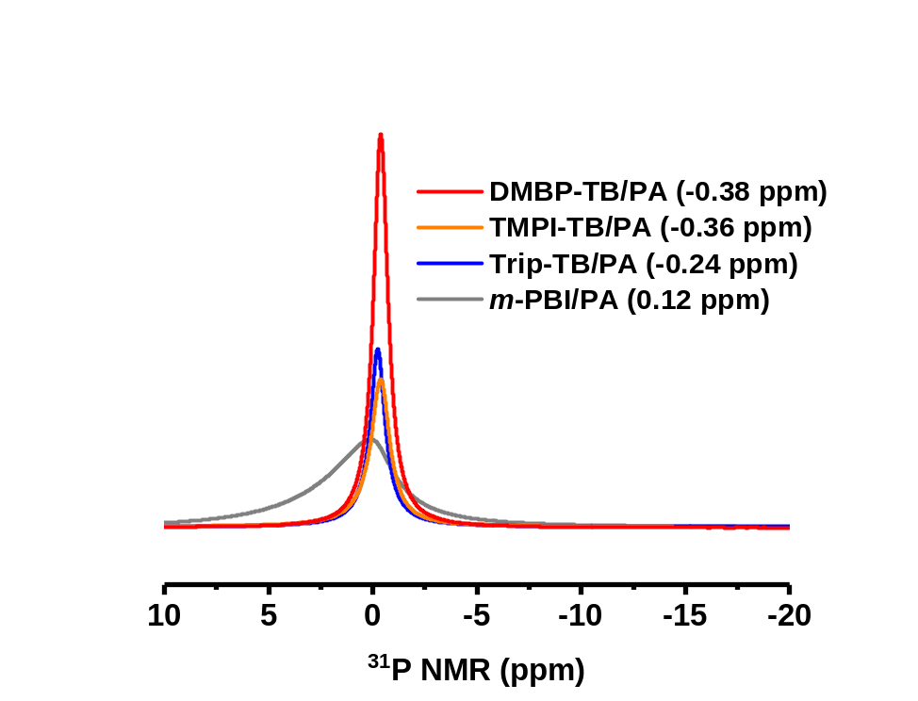
Figure S6. Solid ³¹P NMR spectra of PA-doped TB membranes, Chemical shift refered to (NH₄)₂HPO₄, 1.00 ppm.

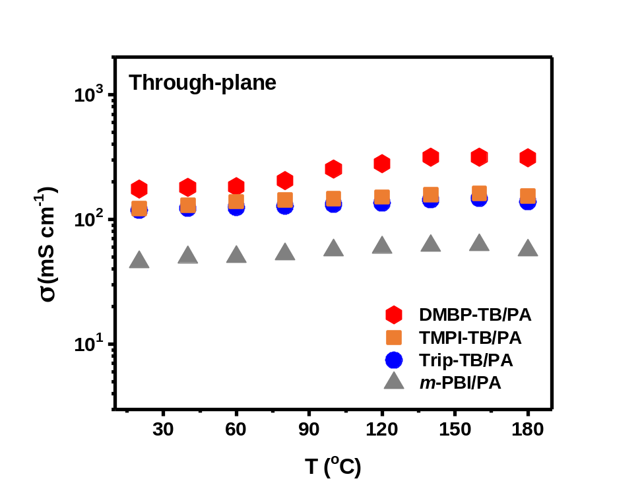
Figure S7. Through-plane proton conductivity of PA-doped PEMs without additional humidification.

Table S6. Summary and comparison of representative PEMFC performance.

Membrane (PA doped) | Binder | Pt (mg cm⁻²) Anode (+), Cathode (-) | Temperature range (ºC) | Power density (mW cm⁻²) | Reference
DMBP-TB | PTFE | 0.5 | –20–200 | 815 (160 °C) | This work
mPBI | PBI or PTFE | N.A. | 140–200 | 1000 (3 atm, 200 °C) | (8)
para-PBI (pPBI) sol-gel membranes | BASF GDE | 1.0 | 140–160 | 750 (160 °C) | (9, 10)
AB-PBI | PTFE | 1.2 | 140–160 | 300 (H₂/air） | (11)
Poly (aryl sulfone benzimidazole) | HCOOH, PA and mPBI | 0.7 | 120–180 | 346 (180 °C) | (12)
mPBI–78 kDa | HCOOH, PA and mPBI | 0.6 | 140–180 | 430 (160 °C) | (13)
Thermoset mPBI | mPBI | 0.58 (+), 0.29 (-) | 140–180 | 350 (160 °C) | (14)
So-gel PBI (BASF) | BASF GDE | 0.7 (+), 1.0 (-) | 140–180 | 350 (180 °C) | (15)
PBI & PBI-O-PhT + Zr (Acac)₄ composite | BASF GDE | 1.0 | 140–160 | 300 (160 °C) | (16)
OPBI | Nafion (5%) | 1.5 | 140–180 | 350 (160 °C) | (17)
ABPBI | PTFE | 1.0 | 120–180 | 400 (160 °C) | (18)
PyPBI | BASF GDE | 1.0 | 120–180 | N.A. | (19)
Cross Linked-6FPBI | HCOOH, PA and mPBI | 0.6 | 120–180 | 360 | (20)
F₆PBI | N.A. | 1.0 | 120–160 | 420 (160 °C) | (21, 22)
PFCB–PBI | N.A. | 1.0 | 100–140 | 210 (140 °C) | (23)
2OHPBI | BASF GDE | 1.0 |  | 130 (160 °C) | (24)
Sulfonated PBI | BASF GDE | 1.0 | 120–180 | 600 (180 °C) | (25)
F₆PBI, SO₂PBI and blends | HCOOH, PA and mPBI | 0.6 | 120–200 | 450 (200 °C) | (26)
Crosslinked NH₂PBI | N.A. | N.A. | 75–160 | 120 (100 °C) | (27, 28)
Hyperbranched PBI | N.A. | N.A. | 75–160 | 60 (160 °C) | (29, 30)
Asymmetric 6FPBI | PBI | 1.0 | 120–170 | 280 (170 °C) | (31)
Branched pPBI-b-F6-PBI | N.A. | N.A. | 160 | 713 (160 °C) | (32)
Bipy-PBI | N.A. | N.A. | 120 | 779 (120 °C) | (33)
PIM-1 reinforced PBI alloy membranes | HCOOH, PA and OPBI | 0.6 | 120–160 | 438 (160 °C) | (34)
Imidazole-riched crosslinked Networks | N.A. | 0.6 | 150–165 | 533 (160 °C) | (35)
m/p PBI copolymer | BASF GDE | 1.0 | 160–200 | 600 (180 °C) | (36)
Polysulfonated PBI | N.A. | 0.5 | 110–150 | 318 (150 °C, 1 bar) | (37)
Polysulfonated Fluoro-oxyPBI | N.A. | 0.5 | 110–150 | 360/290 (150 °C, 1 bar) | (38)
SiO₂/imidazole-cPBI | PA/ PBI | 0.6 | 160 | 497 (160 °C) | (39)
Arylether-type benzimidazolyl-OPBI | N.A. | 0.6 | 160 | 443 (160 °C) | (40)
Ether-linked bulky pendant- OPBI | N.A. | N.A. | 160 | 320 (160 °C, H₂/air) | (41)
Cross-linked triazole- XTPPO | N.A. | N.A. | 100–180 | 220 (150 °C) | (42)
Phosphonated-PPFS  /PBI composites | GDE (Johnson Matthey) | 0.4 | 70 | 780 (70 °C, 100% RH) | (43)
PTFE/Quaternized PVBzCl⁻ | qPVB/Cl⁻ and 5% PVDF | 0.5 | 105–180 | 360 (175 °C) | (44)
Tz-poly(arylene ether) | PTFE | 1.03 | 120–160 | 287 (160 °C, H₂/air) | (45)
QA-biphosphate ion pairs | 5 wt% QASOH | 0.6(+),  0.4 Pt-Ru (-) | 80–180 | 800 (180 °C) | (46, 47)
QA-biphosphate ion pairs | Phosphonated PPSF | N.A. | 120–200 | 1130/1740 (160 /240 °C, H₂O₂, 147.1 kPa) | (48)
Polycation−Polybenzimidazole Blends | QPPSf | 0.5 | 120–220 | 680 (220 °C) | (49)
Poly(arylene piperidine)s | PTFE | 1.2 | 120–180 | 1220.2 (180 °C, 0.15 MPa) | (50)
PES-PVP blends | PVP | 1.1/0.5 | 120–180 | 800/850 (160/180 °C) | (51, 52)
PES/PVP-HPW hybrid membrane | N.A. | 0.4 |  | 618 (50 °C) | (53)
PVDF-PVP blends | PVP | 0.5 | 110–180 | 530 (180 °C) | (54)
PBI/SiO₂ | N.A. | 1.0 | 200–250 | 283 (240 °C) | (55)
Self-crosslinked PEI-PSF | N.A. | N.A. | 120–150 | 200 (150 °C) | (56)
PSF-QA | PTFE | 0.55 | 100–160 | >400 (160 °C) | (57)
mPBI | Phosphonated PPSU | 0.5 | 100–160 | 242 (160 °C) | (58)

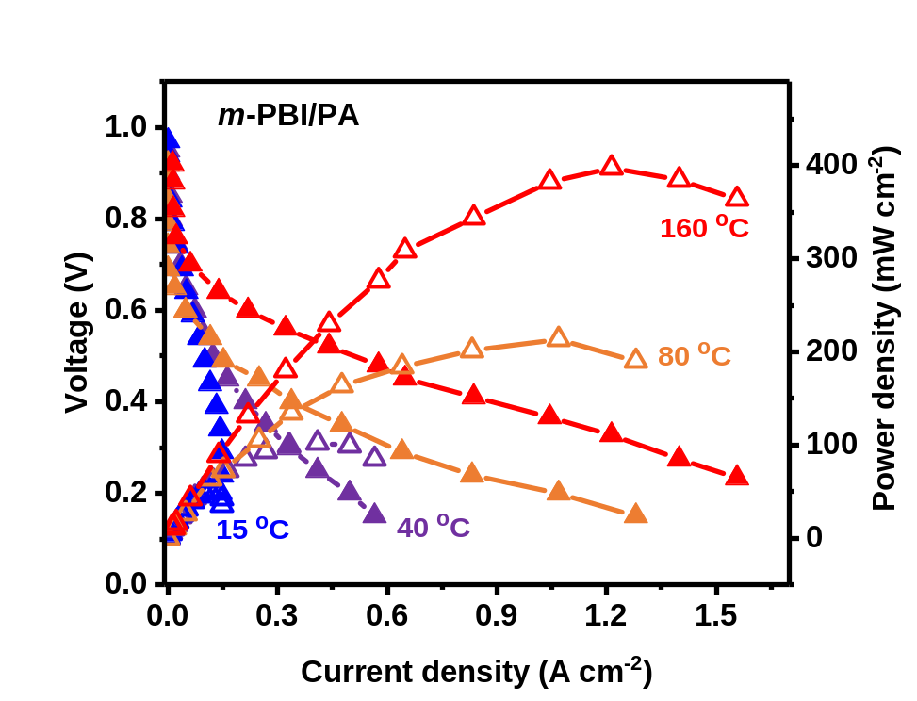
Figure S8. i-V curves, and power density of these m-PBI/PA MEAs as a function of operating temperature with no backpressure, without external humidification. Tested conditions: Anode/Cathode: Pt/C (0.50 mg Pt cm⁻²), PTFE binder (20 wt%), H₂/O₂ flow: 200 sccm. Data represented by the filled symbols refer to the voltage and the hollow symbols refer to the power density. PEM thickness: m-PBI/PA membrane 100 µm.

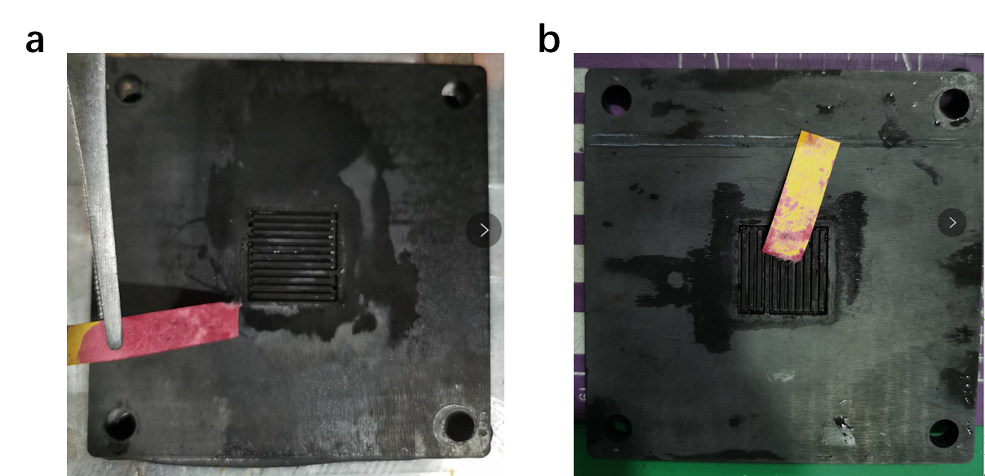
Figure S9. Photographs of pH indicators with the generated liquid in the flow field plates after the durability tests. The pH indicators show the extent of acid leaching after the MEA durability tests at 40 °C and H₂/O₂ conditions without external humidification. (a) m-PBI/PA (high acid leaching) and (b) DMBP-TB/PA (low acid leaching).

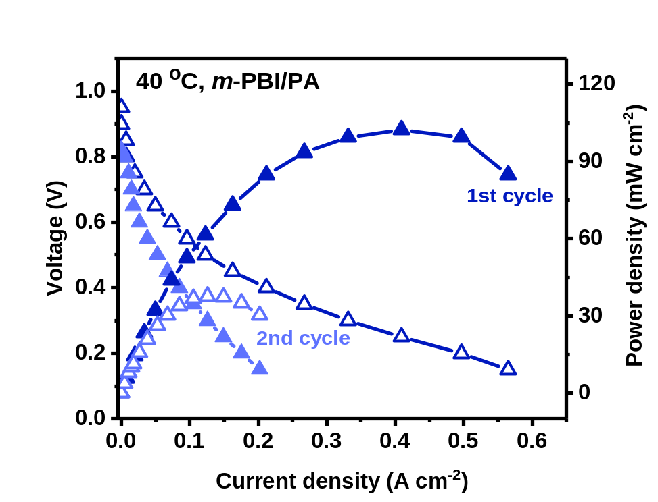
Figure S10. i-V curves of m-PBI/PA MEAs in the AST cycling tests at 40 °C, which failed after 2 cycles. Tested conditions: Anode/Cathode: Pt/C (0.50 mg Pt cm⁻²), PTFE binder (20 wt%), H₂/O₂ flow: 200 sccm. Data represented by the filled symbols refer to the voltage and the hollow symbols refer to the power density. PA-doped PEM thickness: m-PBI/PA membrane 100 µm.

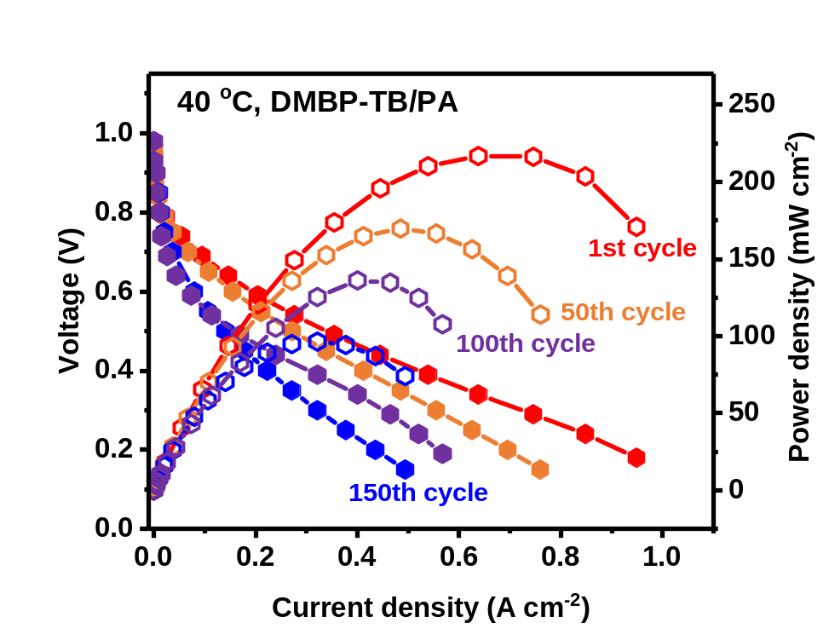
Figure S11. i-V curves of DMBP-TB/PA MEAs in the AST cycling tests at 40 °C. Tested conditions: Anode/Cathode: Pt/C (0.50 mg Pt cm⁻²), PTFE binder (20 wt%), H₂/O₂ flow: 200 sccm. Data represented by the filled symbols refer to the voltage and the hollow symbols refer to the power density. PA-doped PEM thickness: DMBP-TB /PA membrane 160 µm.

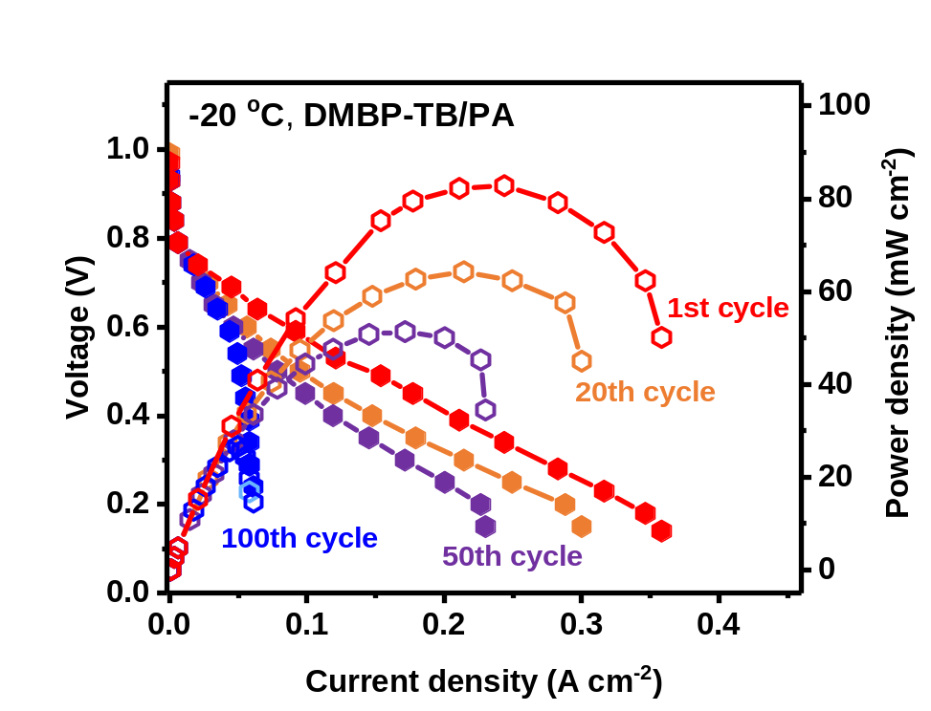
Figure S12. i-V curves of DMBP-TB/PA MEAs in the AST cycling tests at –20 °C. Tested conditions: Anode/Cathode: Pt/C (0.50 mg Pt cm⁻²), PTFE binder (20 wt%), H₂/O₂ flow: 200 sccm. Data represented by the filled symbols refer to the voltage and the hollow symbols refer to the power density, PA-doped PEM thickness: DMBP-TB /PA membrane 160 µm.

References:
1 Lee, A. S., Choe, Y.-K., Matanovic, I. & Kim, Y. S. The energetics of phosphoric acid interactions reveals a new acid loss mechanism. J. Mater. Chem. A 7, 9867–9876, doi:10.1039/c9ta01756a (2019).
2 Aihara, Y., Sonai, A., Hattori, M. & Hayamizu, K. Ion conduction mechanisms and thermal properties of hydrated and anhydrous phosphoric acids studied with ¹H, ²H, and ³¹P NMR. J. Phys. Chem. B 110, 24999–25006, doi:10.1021/jp064452v (2006).
3 Xu, Z., Shi, J. L., Chen, X. & Jiang, X. K. ³¹P NMR Study on some phosphorus-containing compounds. Chinese Chem. Lett. 11, 1057–1060 (2000).
4 Guo, S.-Y., Guo, Q.-H., Tong, S. & Wang, M.-X. Synthesis of electron-deficient corona[5]arenes and their selective complexation with dihydrogen phosphate: cooperative effects of anion-pi interactions. Angew. Chem. Int. Ed. 132, 8155–8160, doi:10.1002/anie.201915839 (2020).
5 Marenich, A. V., Cramer, C. J. & Truhlar, D. G. Universal solvation model based on solute electron density and on a continuum model of the solvent defined by the bulk dielectric constant and atomic surface tensions. J. Phys. Chem. B 113, 6378–6396, doi:10.1021/jp810292n (2009).
6 Legault, C. Y. CYLview, <http://www.cylview.org/> (2020).
7 Gaussian 09 Rev. B.01 (Wallingford, CT, 2009).
8 Li, Q., He, R., Jensen, J. O. & Bjerrum, N. J. PBI‐Based polymer membranes for high temperature fuel cells – preparation, characterization and fuel cell demonstration. Fuel cells 4, 147–158, doi:10.1002/fuce.200400020 (2004).
9 Yu, S., Xiao, L. & Benicewicz, B. C. Durability studies of PBI‐based high temperature PEMFCs. Fuel Cells 8, 165–174, doi:10.1002/fuce.200800024 (2008).
10 Xiao, L. et al. High-temperature polybenzimidazole fuel cell membranes via a sol-gel process. Chem. Mater. 17, 5328–5333, doi:10.1021/cm050831 (2005).
11 Wannek, C., Kohnen, B., Oetjen, H. F., Lippert, H. & Mergel, J. Durability of ABPBI-based MEAs for high temperature PEMFCs at different operating conditions. Fuel Cells 8, 87–95, doi:10.1002/fuce.200700059 (2008).
12 Yang, J. et al. Synthesis and properties of poly(aryl sulfone benzimidazole) and its copolymers for high temperature membrane electrolytes for fuel cells. J. Mater. Chem. 22, 11185–11195, doi:10.1039/c2jm30217a (2012).
13 Yang, J. S. et al. High molecular weight polybenzimidazole membranes for high temperature PEMFC. Fuel Cells 14, 7–15, doi:10.1002/fuce.201300070 (2014).
14 Aili, D. et al. Thermal curing of PBI membranes for high temperature PEM fuel cells. J. Mater. Chem. 22, 5444–5453, doi:10.1039/c2jm14774b (2012).
15 Galbiati, S., Baricci, A., Casalegno, A. & Marchesi, R. Degradation in phosphoric acid doped polymer fuel cells: A 6000 h parametric investigation. Int. J. Hydrogen Energy 38, 6469–6480, doi:10.1016/j.ijhydene.2013.03.012 (2013).
16 Kondratenko, M. S. et al. Novel composite Zr/PBI-O-PhT membranes for HT-PEFC applications. Beilstein J Nanotechnol 4, 481–492, doi:10.3762/bjnano.4.57 (2013).
17 Modestov, A. D., Tarasevich, M. R., Filimonov, V. Y. & Zagudaeva, N. M. Degradation of high temperature MEA with PBI-H₃PO₄ membrane in a life test. Electrochim. Acta 54, 7121–7127, doi:10.1016/j.electacta.2009.07.031 (2009).
18 Liu, F., Kvesić, M., Wippermann, K., Reimer, U. & Lehnert, W. Effect of spiral flow field design on performance and durability of HT-PEFCs. J. Electrochem. Soc. 160, F892–F897, doi:10.1149/2.116308jes (2013).
19 Molleo, M. A., Chen, X., Ploehn, H. J., Fishel, K. J. & Benicewicz, B. C. High polymer content 3,5-pyridine-polybenzimidazole copolymer membranes with improved compressive properties. Fuel Cells 14, 16–25, doi:10.1002/fuce.201300202 (2014).
20 Yang, J. et al. Crosslinked hexafluoropropylidene polybenzimidazole membranes with chloromethyl polysulfone for fuel cell applications. Adv. Energy Mater. 3, 622–630, doi:10.1002/aenm.201200710 (2013).
21 Chuang, S.-W. & Hsu, S. L.-C. Synthesis and properties of a new fluorine-containing polybenzimidazole for high-temperature fuel-cell applications. J. Polym. Sci. A Polym. Chem. 44, 4508–4513, doi:10.1002/pola.21555 (2006).
22 Qian, G. & Benicewicz, B. C. Synthesis and characterization of high molecular weight hexafluoroisopropylidene-containing polybenzimidazole for high-temperature polymer electrolyte membrane fuel cells. J. Polym. Sci. A Polym. Chem. 47, 4064–4073, doi:10.1002/pola.23467 (2009).
23 Qian, G., Smith, D. W. & Benicewicz, B. C. Synthesis and characterization of high molecular weight perfluorocyclobutyl-containing polybenzimidazoles (PFCB–PBI) for high temperature polymer electrolyte membrane fuel cells. Polymer 50, 3911–3916, doi:10.1016/j.polymer.2009.06.024 (2009).
24 Yu, S. & Benicewicz, B. C. Synthesis and properties of functionalized polybenzimidazoles for high-temperature PEMFCs. Macromolecules 42, 8640–8648, doi:10.1021/ma9015664 (2009).
25 Mader, J. A. & Benicewicz, B. C. Sulfonated polybenzimidazoles for high temperature PEM fuel cells. Macromolecules 43, 6706–6715, doi:10.1021/ma1009098 (2010).
26 Li, Q. F. et al. Properties, degradation and high temperature fuel cell test of different types of PBI and PBI blend membranes. J. Membr. Sci. 347, 260–270, doi:10.1016/j.memsci.2009.10.032 (2010).
27 Xu, N., Guo, X., Fang, J., Xu, H. & Yin, J. Synthesis of novel polybenzimidazoles with pendant amino groups and the formation of their crosslinked membranes for medium temperature fuel cell applications. J. Polym. Sci. A Polym. Chem. 47, 6992–7002, doi:10.1002/pola.23738 (2009).
28 Bhadra, S., Kim, N. H. & Lee, J. H. A new self-cross-linked, net-structured, proton conducting polymer membrane for high temperature proton exchange membrane fuel cells. J. Membr. Sci. 349, 304–311, doi:10.1016/j.memsci.2009.11.061 (2010).
29 Xu, H., Chen, K., Guo, X., Fang, J. & Yin, J. Synthesis of hyperbranched polybenzimidazoles and their membrane formation. J. Membr. Sci. 288, 255–260, doi:10.1016/j.memsci.2006.11.022 (2007).
30 Bhadra, S., Kim, N. H., Choi, J. S., Rhee, K. Y. & Lee, J. H. Hyperbranched poly(benzimidazole-co-benzene) with honeycomb structure as a membrane for high-temperature proton-exchange membrane fuel cells. J. Power Sources 195, 2470–2477, doi:10.1016/j.jpowsour.2009.11.083 (2010).
31 Jheng, L.-C., Hsu, S. L.-C., Tsai, T.-Y. & Chang, W. J.-Y. A novel asymmetric polybenzimidazole membrane for high temperature proton exchange membrane fuel cells. J. Mater. Chem. A 2, 4225–4233, doi:10.1039/c3ta14631f (2014).
32 Wang, L. et al. Synthesis and preparation of branched block polybenzimidazole membranes with high proton conductivity and single-cell performance for use in high temperature proton exchange membrane fuel cells. J. Membr. Sci. 602, 117981|1–8, doi:10.1016/j.memsci.2020.117981 (2020).
33 Berber, M. R. & Nakashima, N. Bipyridine-based polybenzimidazole membranes with outstanding hydrogen fuel cell performance at high temperature and non-humidifying conditions. J. Membr. Sci. 591, 117354|1–10, doi:10.1016/j.memsci.2019.117354 (2019).
34 Wang, P. et al. Toward enhanced conductivity of high-temperature proton exchange membranes: development of novel PIM-1 reinforced PBI alloy membranes. Chem. Commun. 55, 6491–6494, doi:10.1039/c9cc02102g (2019).
35 Li, X. et al. Highly conductive and mechanically stable imidazole-rich cross-linked networks for high-temperature proton exchange membrane fuel cells. Chem. Mater. 32, 1182–1191, doi:10.1021/acs.chemmater.9b04321 (2020).
36 Pingitore, A. T., Huang, F., Qian, G. & Benicewicz, B. C. Durable high polymer content m/p-polybenzimidazole membranes for extended lifetime electrochemical devices. ACS Appl. Energy Mater. 2, 1720–1726, doi:10.1021/acsaem.8b01820 (2019).
37 Angioni, S. et al. Polysulfonation of PBI-based membranes for HT-PEMFCs: a possible way to maintain high proton transport at a low H₃PO₄ doping level. J. Mater. Chem. A 2, 663–671, doi:10.1039/c3ta12200j (2014).
38 Villa, D. C., Angioni, S., Barco, S. D., Mustarelli, P. & Quartarone, E. Polysulfonated Fluoro-oxyPBI membranes for PEMFCs: an efficient strategy to achieve good fuel cell performances with low H₃PO₄ doping levels. Adv. Energy Mater. 4, 1301949|1–8, doi:10.1002/aenm.201301949 (2014).
39 Li, X. et al. Construction of high-performance, high-temperature proton exchange membranes through incorporating SiO₂ nanoparticles into novel cross-linked polybenzimidazole networks. ACS Appl. Mater. Interfaces 11, 30735–30746, doi:10.1021/acsami.9b06808 (2019).
40 Li, X. et al. Arylether-type polybenzimidazoles bearing benzimidazolyl pendants for high-temperature proton exchange membrane fuel cells. J. Power Sources 393, 99–107, doi:10.1016/j.jpowsour.2018.05.011 (2018).
41 Li, X. et al. Dimensionally-stable phosphoric acid–doped polybenzimidazoles for high-temperature proton exchange membrane fuel cells. J. Power Sources 336, 391–400, doi:10.1016/j.jpowsour.2016.11.013 (2016).
42 Jang, J. et al. Phosphoric acid doped triazole-containing cross-linked polymer electrolytes with enhanced stability for high-temperature proton exchange membrane fuel cells. J. Membr. Sci. 595, 117508|1–9, doi:10.1016/j.memsci.2019.117508 (2020).
43 Atanasov, V., Oleynikov, A., Xia, J., Lyonnard, S. & Kerres, J. Phosphonic acid functionalized poly(pentafluorostyrene) as polyelectrolyte membrane for fuel cell application. J. Power Sources 343, 364–372, doi:10.1016/j.jpowsour.2017.01.085 (2017).
44 Cao, Y.-C., Xu, C., Zou, L., Scott, K. & Liu, J. A polytetrafluoroethylene porous membrane and dimethylhexadecylamine quaternized poly (vinyl benzyl chloride) composite membrane for intermediate temperature fuel cells. J. Power Sources 294, 691–695, doi:10.1016/j.jpowsour.2015.06.113 (2015).
45 Henkensmeier, D. et al. Tetrazole substituted polymers for high temperature polymer electrolyte fuel cells. J. Mater. Chem. A 3, 14389–14400, doi:10.1039/c5ta01936b (2015).
46 Lee, K.-S., Spendelow, J. S., Choe, Y.-K., Fujimoto, C. & Kim, Y. S. An operationally flexible fuel cell based on quaternary ammonium-biphosphate ion pairs. Nat. Energy 1, 16120|1–7, doi:10.1038/nenergy.2016.120 (2016).
47 Lee, K.-S. et al. Intermediate temperature fuel cells via an ion-pair coordinated polymer electrolyte. Energy Environ. Sci. 11, 979–987, doi:10.1039/C7EE03595K (2018).
48 Atanasov, V. et al. Synergistically integrated phosphonated poly(pentafluorostyrene) for fuel cells. Nat. Mater., doi:10.1038/s41563-020-00841-z.
49 Venugopalan, G. et al. Stable and highly conductive polycation–polybenzimidazole membrane blends for intermediate temperature polymer electrolyte membrane fuel cells. ACS Appl. Energy Mater. 3, 573–585, doi:10.1021/acsaem.9b01802 (2020).
50 Bai, H. et al. Poly(arylene piperidine)s with phosphoric acid doping as high temperature polymer electrolyte membrane for durable, high-performance fuel cells. J. Power Sources 443, 227219|1–9, doi:10.1016/j.jpowsour.2019.227219 (2019).
51 Zhang, S. et al. Unusual influence of binder composition and phosphoric acid leaching on oxygen mass transport in catalyst layers of high-temperature proton exchange membrane fuel cells. J. Power Sources 473, 228616|1–7, doi:10.1016/j.jpowsour.2020.228616 (2020).
52 Xu, X. et al. A novel phosphoric acid doped poly(ethersulphone)-poly(vinyl pyrrolidone) blend membrane for high-temperature proton exchange membrane fuel cells. J. Power Sources 286, 458–463, doi:10.1016/j.jpowsour.2015.04.028 (2015).
53 Lu, S. et al. A self-anchored phosphotungstic acid hybrid proton exchange membrane achieved via one-step synthesis. Adv. Energy Mater. 4, 1400842|1–5, doi:10.1002/aenm.201400842 (2014).
54 Guo, Z., Xu, X., Xiang, Y., Lu, S. & Jiang, S. P. New anhydrous proton exchange membranes for high-temperature fuel cells based on PVDF–PVP blended polymers. J. Mater. Chem. A 3, 148–155, doi:10.1039/c4ta04952g (2015).
55 Cheng, Y. et al. High CO tolerance of new SiO₂ doped phosphoric acid/polybenzimidazole polymer electrolyte membrane fuel cells at high temperatures of 200–250 °C. Int. J. Hydrogen Energy 43, 22487–22499, doi:10.1016/j.ijhydene.2018.10.036 (2018).
56 Zhao, W. et al. Self-crosslinked polyethyleneimine-polysulfone membrane for high temperature proton exchange membrane. Acta Chimica Sinica 78, 69–75, doi:10.6023/a19090329 (2020).
57 Tang, H. et al. Properties and stability of quaternary ammonium-biphosphate ion-pair poly(sulfone)s high temperature proton exchange membranes for H₂/O₂ fuel cells. J. Power Sources 475, 228521|1–9, doi:10.1016/j.jpowsour.2020.228521 (2020).
58 Tang, H., Geng, K., Hu, Y. & Li, N. Synthesis and properties of phosphonated polysulfones for durable high-temperature proton exchange membranes fuel cell. J. Membr. Sci. 605, 118107|1–9, doi:10.1016/j.memsci.2020.118107 (2020).

