Additional file 1
H₂-driven xylitol production in Cupriavidus necator H16
Tytti Jämsä^{1,*}, Nico J. Claassens², Laura Salusjärvi¹, Antti Nyyssölä¹
¹ VTT Technical Research Centre of Finland Ltd., Tekniikantie 21, 02150 Espoo, Finland
² Laboratory of Microbiology, Wageningen University, Stippeneng 4, 6708WE Wageningen, the Netherlands
*Correspondence to Tytti Jämsä: tytti.jamsa@vtt.fi

Table S1. Oligonucleotide primers used in the study.
Primer | 5’ to 3’ sequence | Details
oXR1 | CCCAAGCTTTTAAAAGGGGAGGTATTTCTATGCCGTCGATCAAGCTGAA | PCR of synthesized S. stipitis XR for cloning
oXR2 | CTAGACTAGTACCCCTTCCTTACACGAAGA | PCR of synthesized S. stipitis XR for cloning
oSEVA_F | TCTAGGGCGGCGGAT | Colony PCR
oSEVA_R | CTGGATTCTCACCAATAAAAAACG | Colony PCR

Table S2. Synthesized xylose reductase gene used in this study originating from Scheffersomyces stipitis. Codon-optimized for C. necator (957 bp). The original sequence is associated with GeneID 4839234.
Name | Nucleotide sequence
XRsti | ATGCCGTCGATCAAGCTGAACTCGGGCTACGACATGCCGGCCGTGGGCTTCGGCTGCTGG  AAGGTGGACGTGGACACCTGCTCGGAACAGATCTACCGCGCCATCAAGACCGGCTACCGC  CTGTTCGACGGCGCCGAGGACTACGCCAACGAAAAGCTGGTGGGCGCCGGCGTGAAGAAG  GCCATCGACGAGGGCATCGTGAAGCGCGAAGACCTGTTCCTGACCTCGAAGCTGTGGAAC  AACTACCACCACCCGGACAACGTGGAGAAGGCCCTGAACCGCACCCTGAGCGACCTGCAG  GTGGACTACGTGGACCTGTTCCTGATCCACTTCCCGGTGACCTTCAAGTTCGTGCCGCTG  GAGGAAAAGTACCCGCCGGGCTTCTACTGCGGCAAGGGCGACAACTTCGACTACGAGGAC  GTGCCGATCCTGGAAACCTGGAAGGCCCTGGAGAAGCTGGTGAAGGCCGGCAAGATCCGC  TCGATCGGCGTGTCGAACTTCCCCGGCGCCCTGCTGCTGGACCTGCTGCGCGGCGCAACC  ATCAAGCCGTCGGTGCTGCAGGTGGAACACCACCCGTACCTGCAGCAGCCGCGCCTGATC  GAGTTCGCCCAGAGCCGCGGCATCGCCGTGACCGCCTACTCGAGCTTCGGCCCGCAGTCG  TTCGTGGAGCTGAACCAGGGCCGCGCCCTGAACACCAGCCCGCTGTTCGAGAACGAAACC  ATCAAGGCCATCGCCGCCAAGCACGGCAAGAGCCCGGCCCAGGTGCTGCTGCGCTGGTCG  AGCCAGCGCGGCATCGCCATCATCCCGAAGTCGAACACCGTGCCGCGCCTGCTGGAAAAC  AAGGACGTGAACAGCTTCGACCTGGACGAGCAGGACTTCGCCGACATCGCCAAGCTGGAC  ATCAACCTGCGCTTCAACGACCCGTGGGACTGGGACAAGATCCCGATCTTCGTGTAA

Table S3. Upstream and downstream regions of A0006 used to create C. necator H16 △A0006.
Description | 5’ to 3’ sequence
Upstream of A0006 | CAAAGCTGGGCCGGATGCTGTGCGTGCTGCTGAAGGCGAAACGATACTGCTGTGGGACGG  TTCGAACGCTGGGGAATTCTTCAGGTCCAAGGTCGGGTTGGTTGCTTCGACGATGACGAA  GATTTCTCCGAGCAGTGTTTTTCGTCCGGCATACTTTTTTCATGTCGCCAAGCAAGCTGA  GCGATTCCTGAAGGCTCAAACCAATGGCACTGGCATTCCACACGTTGACCGAGAGCTTCT  CGAGGGGATAAAGGTCTTTTGTCCTGGCTCTACGGAGCAGCAATTACTTGCGGAAATCCT  CGACACTCTCGACACCGCCATCTACGAAACTGAAGCGATCATCGCCAAGCTCAAGGCGGT  CAAGCAAGGCCTGCTGCATGACCTCTTGACGCGCGGCATCGACGCCAACGGCGAATTGCG  CCCACCTCAGGCCGAGGCACCGCATCTCTACGAGTCGTCACCGTTGGGTTGGATTCCGAA  TGAGTGGGGTCTTGCTCCTACAGCAACTCGCTGCCATCTGATAACCAAAGGCACTACCCC  TGCGGCTAATGAGATGTGGCAGGGTGGCGCGGGAATTAGGTTTCTGCGAGTCGATAATCT  TTCTTTCGATGGACAACTGGATCTAGATGCAAGCACGTTTCGAGTTAGCCTTGCCACGCA  CAAAGGTTTTCTGGCTCGTTCAAGATGCCTTGAAGGTGATGTGCTGACGAACATCGTTGG  CCCACCTCTAGGGAAACTGGGGCTTGTTACCAAAGAAATTGGTGAGGTCAATATTAATCA  AGCAATTGCGTTATTTCGACCAACCGAACAACTACTGCCAAAGTTCCTATTAATCTGGCT  TAGTAGCTCAATCTCGCAGTCTTGGCTGAGGAACCGAGCCAAGCAGACGTCGGGACAAGT  GAATCTGACCCTCGCTCTATGCCAGGAGCTTCCTCTACCTCGGATGACGATCAATGAGCA  ACAGGCAATCGTTGACCGAGTTGATGCCGCGCAGGAACAAATCTGGTGTGAGGAGGAACT  GATCCGAAAGATGCGACTTGAGAAATCTGGCCTTATGGATGACCTCCTCACCGGCCGCGT  CCGCGTCAAGCCGCAGCTGGCGGAAACCAAACAAGCAGGGAGCGCCTGATG
Downstream of A0006 | GCGCCTGATGCACGACAAGCTGATGCAGGTGTGATTCGATGCCTTCGCCGGTGAAATTGC  CAAGCCTTCAGATCGGTGACCTCCGGTTCACGCTCCAGCGGAGCGCGCGCCGCAGAACTA  TGCAGATCACCGTGGAGCGCAGTGGCGACTTGATGCTCTGCGCACCGCCGGAGGTGGACG  AGGCCGCGCTGCGAGCATTCGTGCTGGAGAAGCGCTTCTGGATCTACACCAAGCTGGCCG  AGAAGGACCGCTTGCAGCGCCAGGTTCCGCGCAAGGAATTCGTCGGAGGCGAGGGATTCT  TGTATCTCGGCCGCAGCCATCGGCTGAAGGTGGTCGATGAACAGAATGTGCCACTGAAGT  TGAATGGAGGCCGCTTTTGTCTGCGCCGTGACGCCCTACCCGCCGCGCGCGAGCATTTCA  TCCGCTGGTACGGCGAGCGTGCCAAGGCCTGGCTTTCGGGGCGTGTAGCTGACTACCAGT  CGCGAATGGAGGTGACGCCTGCCGGCGTCAAGGTGCAGGACCTTGGATATCGCTGGGGTT  CGTGTGGCAAGGGCGACTGGCTGTACTTCCACTGGAAGGCAATCCTGCTGCCGGCGCGCA  TCGCTGAGTATGTCGTGGTGCATGAGATTGCCCATCTGCATGAGCCGCACCACACGCCTG  CGTTCTGGCTTCGAGTGGAGCGTGCCATGCCGGACTATGCGCAACGCAAGGCCTGGCTGG  CCGAGCATGGAATCGATGTTGAAGGAATCTAAAGAACGATGGCTGACTATTTCACCAGTG  ACTACTTCAAGCTGCTGAACAAGTGGAAGGGGCAGAAGCGTGACGAGTCCAACCCCGAGC  AGAACCGCGCTTATGAAGATCTGAAGAAGGCCTACGAGGTGACGGAGGCGTGGGCGGACA  AGGTTAAGGCCGAGTTGTTCCCTGTCGGGCGCGTCGAGATTCGTAAGCGCCCGACCAACC  AGGGCAACAACTTTGCCAGCTACAACTGGGCCAAAATCTACCCTTCATCTGAGGCGCCGA  AAGAGTTGGCTTACACAGTTGGCATCGGCGCCGATGACGGCTTCGTAGTCAAGATCGATA  CCGTTGGGCTCGACGAATTGGACGCGACGAGAAAGGCCTAT

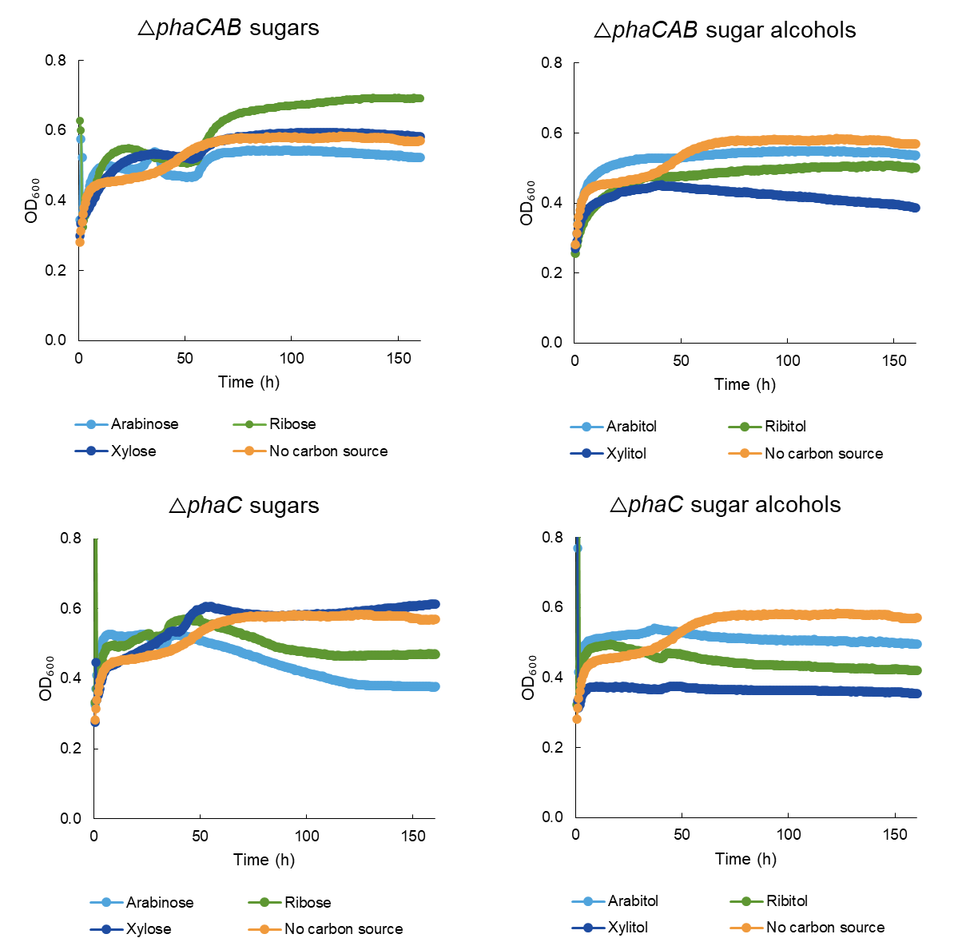
Figure S1. The growth of C. necator strains △phaCAB and △phaC on different sugars and sugar alcohols (100 mM). Precultures were grown in TSB. Cells were cultivated in 96-well plate at an initial OD₆₀₀ of 0.05 in 130 μl of AUT media supplemented with the carbon sources. The cultures were topped with 50 μl of mineral oil to avoid evaporation. The negative control was cultivated in AUT media without any carbon source. The 96-well plate was incubated at 30°C using a double shake orbital at 282 rpm. All conditions had three replicates.
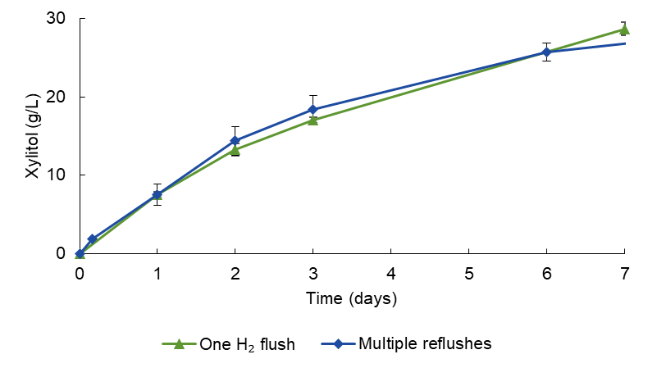
Figure S2. Comparison of bioconversion with a single H₂ flush at the start and H₂ flush after every sampling. The initial concentration of D-xylose was 34 g/L (one H₂ flush) and 30 g/L (multiple reflushes) in 100 mM sodium phosphate buffer (pH 7). The cell concentrations were OD₆₀₀ of 13 (one H₂ flush) and OD₆₀₀ of 17 (multiple reflushes).

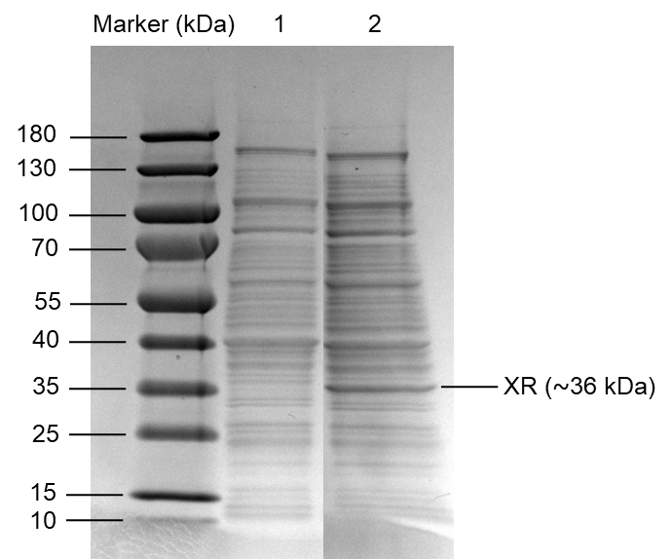
Figure S3. SDS-PAGE analysis of soluble extracts by C. necator H16 strains. Lane 1, wild type C. necator H16. Lane 2, △phaCAB_xr (△phaCAB with XRsti under Pj5 promoter).

