Supplementary Information
NaYS₂:Er³⁺ - a highly efficient NIR II response multi-photon up-conversion phosphor

Xiumei Yin^{1†}, Wen Xu^{1,2†}, Ge Zhu¹, Yanan Ji¹, Qi Xiao¹, Xinyao Dong¹, Ming He¹, Baosheng Cao¹, Na Zhou¹, Xixian Luo¹*, Lin Guo ²*, Bin Dong ¹*
¹Key Laboratory of New Energy and Rare Earth Resource Utilization of State Ethnic Affairs Commission, Key Laboratory of Photosensitive Materials & Devices of Liaoning Province, School of Physics and Materials Engineering, Dalian Minzu University, 18 Liaohe West Road, Dalian 116600, P. R. China.
²School of Chemistry and Environment, Beijing University of Aeronautics & Astronautics, 37 Xueyuan Road, Beijing 100191, PR China.
†These authors contributed equally to this work.
Corresponding authors: Prof. Xixian Luo (luoxx@dlmu.edu.cn); Prof. Lin Guo (guolin@buaa.edu.cn); Prof. Bin Dong (dong@dlnu.edu.cn).

I. Supplementary Methods
1. Materials and Synthesis route
Lanthanide oxide (Y₂O₃, Lu₂O₃, La₂O₃, Gd₂O₃, or Er₂O₃; 99.99%), and alkaline metal carbonate (Na₂CO₃, K₂CO₃, or Li₂CO_{3;} A.R.) were used as the primary materials. Carbon disulfide (CS₂, aladdin, ≥99%) was employed as the sulfur source.
MLnS₂:Er³⁺ (M=Li, Na, or K; Ln=Y, Lu, La, or Gd) phosphors were fabricated by the high temperature solid reaction method [S1]. In the typical synthesis process, the Ln₂O₃ and M₂CO₃ were mixed and thoroughly ground in an agate mortar for 30 min according to the 1:1.1 ratio, and the doping concentrations of Er³⁺ ions were 2, 5, 10, and 15 mol%, respectively. The mixture was transferred to the quartz boat and placed into the tube furnace. The samples were heated to 773 K under argon (Ar) atmosphere, and then saturated vapor of CS₂ (40 kPa) was flowed in Ar at a flow rate of 50 mL/min. The final products were obtained after calcining the mixture at 1073, 1173, 1273, or 1373 K for two hours and washing by water and ethanol for several times.
2. Characterization
The X-ray diffraction (XRD) patterns were characterized by the Shimadzu XRD-6000 X-ray diffractometer with a Cu Kα (λ=0.1541 nm). Scanning electron microscopic (SEM) images were performed by the Hitachi S-4800 scanning electron microscope. Transmission electron microscopic (TEM) and high resolution transmission electron microscopic (HRTEM) images were measured by using a JEM-2100F transmission electron microscope. The UC luminescence spectra were measured by a Jobin Yvon iHR550 monochromator equipped with 808, 980 and 1532 nm laser diode (LD) (maximum power: 2.0 W). The absorption spectra of the samples were recorded on a Lambda 750 UV–Vis-NIR spectrophotometer (Perkin-Elmer, USA). The photo-luminescent decay curves were obtained by an Andor SR500 monochromator equipped with an R928 photomultiplier tube from Hamamatsu with 980 and 1532 nm excitation wavelength from a pulsed work Horizon OPO laser. The decay profiles were collected using a Tektronix DPO 5104 digital oscilloscope. The Up-conversion quantum yield (UCQY) was measured by the Edinburgh FLS1000 Steady/Transient State Fluorescence Spectrometer, equipped with the detector of electric cooling ultraviolet visible PMT R298 and liquid nitrogen cooling near infrared PMT R5509. The underwater optical communication test was performed by a self-designed system, the signal transmitter was composed of a signal generator and 1532 nm laser diode (LD), Jobin Yvon iHR550 monochromator and oscilloscope constitute the signal receiver.
Note 1 Transition rate equation for green emission in MnLnS₂:Er³⁺
In order to understand qualitatively the UC luminescence mechanism in Er³⁺, a set of rate equations were established based on the well-known UC process:
$\frac{dN_{1}}{dt}={R'}_{21}N_{2}+W_{1}N_{1}^{2}+σ_{01}ρN_{0}-σ_{13}ρN_{1}-R_{1}N_{1}$ (S1)
$\frac{dN_{2}}{dt}={R'}_{32}N_{3}-σ_{24}ρN_{2}-{R'}_{21}N_{2}-R_{2}N_{2}$ (S2)
$\frac{dN_{3}}{dt}={R'}_{43}N_{3}+σ_{13}ρN_{1}-σ_{35}ρN_{3}-{R'}_{32}N_{3}-R_{3}N_{3}$ (S3)
$\frac{dN_{4}}{dt}={R'}_{54}N_{5}+σ_{24}ρN_{2}-{R'}_{43}N_{4}-R_{4}N_{4}$ (S4)
$\frac{dN_{5}}{dt}=σ_{35}ρN_{3}-{R'}_{54}N_{5}-R_{5}N_{5}$ (S5)
$N_{Er=}N_{0}{+N}_{1}+N_{2}+N_{3}+N_{4}+N_{5}$ (S6)
where N₀, N₁, N₂, N₃, N₄, and N₅ denote the population densities of ⁴I_{15/2}, ⁴I_{13/2}, ⁴I_{11/2}, ⁴I_{9/2}, ⁴F_{9/2}, and (²H_{11/2}+⁴S_{3/2}) levels of Er³⁺, respectively. N_{Er} is the nominal ion density corresponding to Er³⁺ doping concentration. R₁, R₂, R₃, R₄, and R₅ are the radiative rates of ⁴I_{13/2}, ⁴I_{11/2}, ⁴I_{9/2}, ⁴F_{9/2} and (²H_{11/2}+⁴S_{3/2}) levels of Er³⁺, respectively. R'_{ij} is non-radiative rate from level i to level j. W is the rate of the energy transfer process between Er³⁺ ions. ρ is the laser photon number density. σ_{ij} denotes the absorption cross-section between level i and j of Er³⁺. Taking into account that the excited state populations (<10¹⁶ ions/cm³) are a small fraction of all the Er³⁺ ions (N_{Er}>10²⁰ ions/cm³), it can be assumed that N₀≈N_{Er}. At steady state (dN_{i}/dt=0), the rate equations can be simplified as:
$W_{1}N_{1}^{2}+σ_{01}ρN_{0}-σ_{13}ρN_{1}=0$ (S7)
${R'}_{32}N_{3}-σ_{24}ρN_{2}-R_{2}N_{2}=0$ (S8)
$σ_{24}ρN_{2}-R_{4}N_{4}=0$ (S9)
$N_{Er=}N_{0}$ (S10)
The intensities of green emissions (I_{green}) can be given according to the population densities of N₅:
${I_{green}=N}_{5}R_{5}=\frac{σ_{13}^{2}σ_{35}ρ^{3}}{W_{1}(R_{3}+{R'}_{32}+σ_{35}ρ)}$ (11)
Note 2. Principle of UCQY determination
The upconversion quantum yield (UCQY) is defined as the ratio of the number of emitted upconverted photons to the number of absorbed NIR photons, which can be described as the following formula [Ref. S2, ACS Nano, 5, 4981-4986],
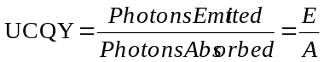 (S11)
The UCQY of NaYS₂:Er³⁺ excited by 980 nm are measured and used as a reference. The UCQY of the samples to be measured and referenced can be describe as the following equations (S12) and (S13):
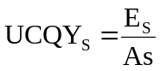 (S12)
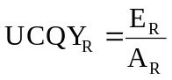 (S13)
where the UCQY_{S} and UCQY_{R} are the UCQY of the sample to be determined and reference sample, respectively. E_{S} and E_{R} are the numbers of the emitted photons for measured sample and reference sample; and A_{S} and A_{R} are the numbers of the photons absorbed by measured sample and referenced sample, respectively. According to equations (S12) and (S13), the UCQY_{S} of the sample can be determined:
 (S14)
The UCQY of the measured sample can be calculated by the luminescence intensities and the absorption values of the measured sample and the reference sample.
Note 3. Measurement of UCQY
The UCQY of NaYS₂:Er³⁺ phosphor under 980 nm excitation is measured by the Edinburgh FLS1000 Steady/Transient State Fluorescence Spectrometer, equipped with detector of electric cooling ultraviolet visible PMT R298 and liquid nitrogen cooling near infrared PMT R5509. The measured UCQY of NaYS₂:Er³⁺ phosphor excited by 980 nm excitation is 0.45%.
Note 4. Determination of PDs’s performance
Three representative parameters to characterize the performance of the PDs including photo-responsivity (R), detectivity (D*) and external quantum efficiency (EQE). R represents the photocurrent (I_{ph}) generated per unit of incident power, D* is the ability of detecting weak signal from a noisy environment, and EQE presents the number of carriers produced in the external circuit for each absorbed incident photon, respectively. They are defined by the following equations:
$R=\frac{I_{light}-I_{dark}}{PS}$ , (S15)
$\text{D}\text{*}=\frac{R}{{\left(2eI_{dark}/S\right)}^{\frac{1}{2}}}$ , (S16)
$EQE=R\frac{hc}{λe}$ , (S17)
where I_{light} and I_{dark} are the photocurrents of PDs separately under the light illumination and in the dark; P is the input light power intensity, S is the effective illuminated area; h, c, $λ$, and e represents the Planck’s constant, the velocity of light, the wavelength of incident light, and the elementary charge, respectively.

II. Supplementary Figures

Figure S1 XRD patterns of NaYS₂:Er³⁺ prepared at 1073, 1173, 1273, and 1373 K. The samples prepared at 1073 and 1173 K are hexagonal phase NaYS₂, while there are two phases of Y₂O₂S and NaYS₂ while the synthesis temperature of 1273, and 1373 K.

Figure S2 UC luminescence spectra of NaYS₂:Er³⁺ phosphor prepared at 1073, 1173, 1273, and 1373 K under the excitation source is 1532 nm (inset: integral intensity of NaYS₂:Er³⁺ varies with synthesis temperature). The luminescence intensity of the samples present a tendency to increase first and then decrease with the temperature rises.

Figure S3 SEM images of LiYS₂, NaYS₂, KYS₂, NaLaS₂, NaGdS₂, and NaLuS₂ phosphors.

Figure S4 Dependence of the green, red and NIR integral UC emission intensities of NaYS₂:Er³⁺ on the excitation power of 1532 nm.

Figure S5 Decay profiles of 564 nm (corresponding to the ⁴S_{3/2}→⁴I_{15/2} transition) under the excitation with 1532 nm for NaYS₂ doping with 2, 5, 10, 15 mol% Er³⁺. The lifetime values increase rapidly from 0.87 ms to 3.37 ms when Er³⁺ concentration increases from 2 to 5 mol%, and then decrease as the concentration continues increasing to 15 mol%, which might illustrates that a concentration quenching effect occurs while the Er³⁺ concentration higher than 5 mol%.

Figure S6 Decay profiles of 660 nm (corresponding to the ⁴F_{9/2}→⁴I_{15/2} transition) under the excitation with 1532 nm for NaYS₂ doping with 2, 5, 10, 15 mol% Er³⁺, the lifetimes of the ⁴F_{9/2} state are evaluated to be 0.28-0.56 ms.

Figure S7 Decay profiles of 800 nm (corresponding to the ⁴I_{9/2}→⁴I_{15/2} transition) under the excitation with 1532 nm for NaYS₂ doping with 2, 5, 10, 15 mol% Er³⁺. And the lifetimes of the ⁴I_{9/2} state are evaluated to be 4.8-10.28 ms.

Figure S8 Decay profiles of 1000 nm (corresponding to the ⁴I_{11/2}→⁴I_{15/2} transition) under the excitation with 1532 nm for NaYS₂ doping with 2, 5, 10, 15 mol% Er³⁺.

Figure S9 Decay profiles of 1500 nm (corresponding to the ⁴I_{13/2}→⁴I_{15/2} transition) under the excitation with 980 nm for NaYS₂ doping with 2, 5, 10, 15 mol% Er³⁺. NaYS₂:Er³⁺ phosphors have ultra-long lifetimes of 9.44 to 33.04 ms, respectively.

Figure S10 Decays curves of ⁴I_{9/2} level to ⁴I_{13/2} level transition of Er³⁺ in MLnS₂ (M=Li, K; Ln=La, Y, Lu, Gd).

Figure S11 Decays curves of ⁴I_{11/2} level to ⁴I_{13/2} level transition of Er³⁺ in MLnS₂ (M=Li, K; Ln=La, Y, Lu, Gd).

Figure S12 Integral intensity of NaYS₂:Er³⁺ excited by 1532 nm and NaYF₄:Er³⁺ excited by 980 nm with various excitation power density (W/cm²).
Figure S13 Absorption spectrum of NaYS₂:Er³⁺. The peaks value at 980 nm and 1532 nm are used to determine the parameter of A_{R}/A_{S} in the equation (S4), which is calculated to be about 0.47.

Figure S14 UC luminescence spectra of NaYS₂:5%Er³⁺ excited by 980 and 1532 nm under the same power density (4.8 W/cm²). The excitation at 980 nm and 1532 nm are from the same tunable optical parametric oscillator. The emission intensity of NaYS₂:5%Er³⁺ excited by 1532 nm are found to be about 28.9 times of 980 nm. According to equation (S4), the UCQY of NaYS₂:5%Er³⁺ under 1532 nm excitation is 6.13%

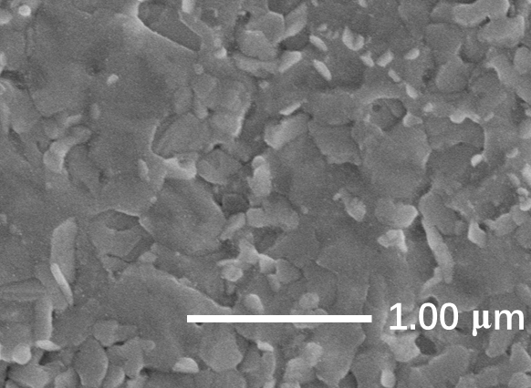
Figure S15 Top view SEM image of the NaYS₂:Er³⁺/MAPbI₃ hybrid.

Figure S16 Absorption spectrum of MAPbI₃ films as well as emission spectra of NaYS₂:Er³⁺ phosphor from ²H_{9/2}, ²H_{11/2}, ⁴S_{3/2}, ⁴F_{9/2}→⁴I_{15/2} transitions under 808 nm, 980 nm, and 1532 nm excitation, respectively.
Figure S17 EQE of the NaYS₂: Er³⁺/MAPbI₃ PD.

Figure S18 On-off switching currents at the lowest detectable excitation power density of NaYS₂:Er³⁺/MAPbI₃ device under 808, 980, and 1532 nm, respectively.

III. Supplementary Tables
Table S1 Decay time constants τ (ms) of ⁴S_{3/2} (564 nm), ⁴F_{9/2} (650 nm), ⁴I_{9/2} (800 nm), ⁴I_{11/2} (1000 nm), and ⁴I_{13/2} (1500 nm) levels in NaYS₂:xEr³⁺ (x=2, 5, 10, 15 mol%).
Samples | ⁴S_{3/2} | ⁴F_{9/2} | ⁴I_{9/2} | ⁴I_{11/2} | ⁴I_{13/2}
NaYS₂:2%Er³⁺ | 0.87 | 0.28 | 10.28 | 2.33 | 33.04
NaYS₂:5%Er³⁺ | 3.37 | 0.56 | 9.24 | 2.18 | 30.27
NaYS₂:10%Er³⁺ | 3.25 | 0.50 | 6.18 | 1.94 | 19.18
NaYS₂:15%Er³⁺ | 2.24 | 0.42 | 4.80 | 1.67 | 9.44
\

Table S2 Calculated decay time constants (τ; ms) of different transitions for Er³⁺ ions in MLnS₂:5%Er³⁺ under 1532 nm excitation and NaYF₄:Yb³⁺,Er³⁺ under 980 nm excitation.
Samples | ⁴S_{3/2} | ⁴F_{9/2} | ⁴I_{9/2} | ⁴I_{11/2} | ⁴I_{13/2}
α-LiYS₂ | 1.26 | 0.83 | 2.40 | 2.83 | 4.69
β-KYS₂ | 2.37 | 0.98 | 7.45 | 2.54 | 13.12
α-NaLaS₂ | 1.77 | 0.79 | 2.84 | 2.52 | 7.08
β-NaYS₂ | 3.37 | 0.56 | 9.24 | 2.18 | 30.27
β-NaLuS₂ | 2.47 | 0.82 | 9.03 | 1.97 | 29.28
β-NaGdS₂ | 1.64 | 0.57 | 7.78 | 1.41 | 18.77
β-NaYF₄ | 4.83 | 0.82 | 0.98 | -- | 9.92

Table S3 Performance of several NIR photodetectors
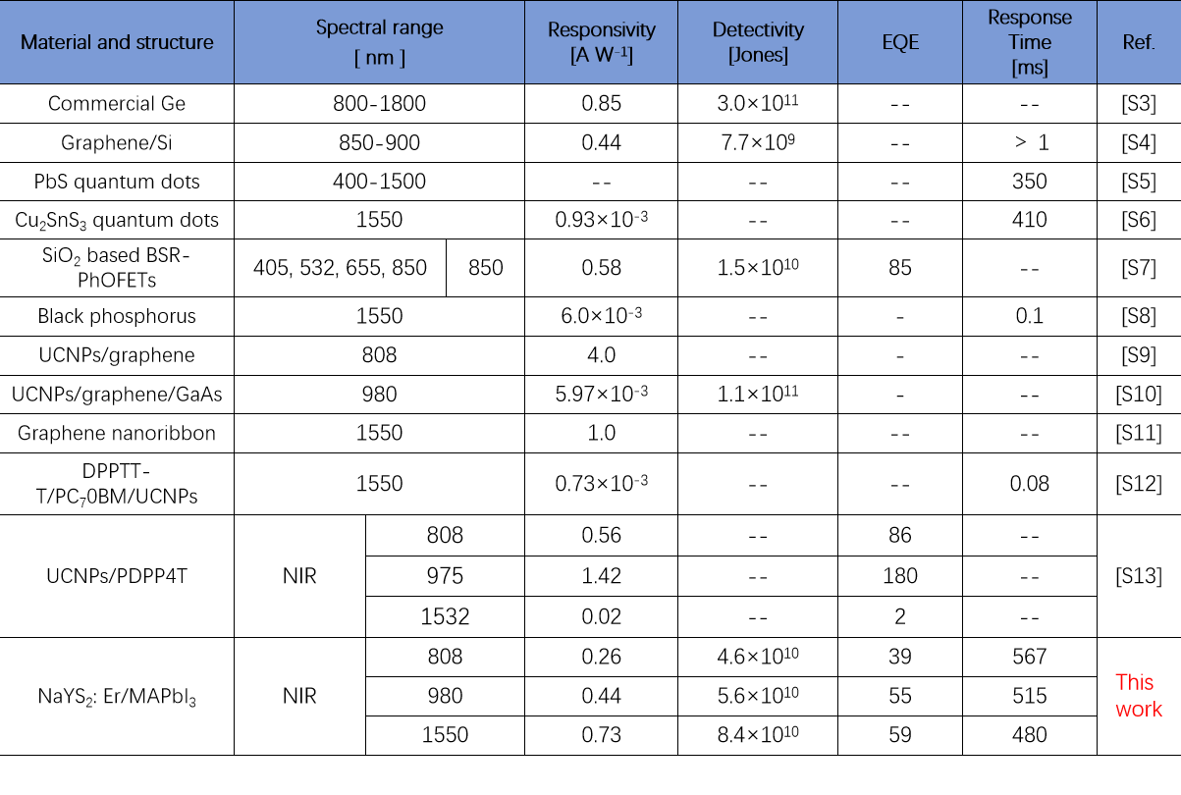
Supplementary References
[S1] Masuda, H. Fujino, T. Sato, N. & Yamada K. Electrical properties of Na₂US₃, NaGdS₂ and NaLaS₂. Mater. Res. Bull. 34, 1291-1300 (1999).
[S2] Chen, G. Ohulchanskyy, T. Y. Kachynski, A. Ågren, H. & Prasad, P. N. Intense visible and near-Infrared upconversion photoluminescence in colloidal LiYF₄:Er³⁺ nanocrystals under laser excitation of 1490 nm. ACS Nano 5, 4981-4986 (2011).
[S3] Saran, R. & Curry, R. J. Lead sulphide nanocrystal photodetector technologies. Nat. Photonics 10, 81-92 (2016).
[S4] An, X. Liu, F. Jung, Y. J. & Kar, S. Tunable graphene-silicon heterojunctions for ultrasensitive photodetection. Nano Lett. 13, 909-916 (2013).
[S5] Ageno, W. Eikelboom, J. & Lip. G. Y. H. Dabigatran in clinical practice: contemporary overview of the evidence. Int. J. Cardiol. 220, 417-428 (2016).
[S6] Dias, S. Kumawat, K. Biswas, S. & Krupanidhi, S. B. Solvothermal synthesis of Cu₂SnS₃ quantum dots and their application in near-infrared photodetectors. Inorg. Chem. 56, 2198-2203 (2017).
[S7] Huang, F. et al. Towards high performance broad spectral response fullerene based photosensitive organic field-effect transistors with tricomponent bulk heterojunctions. Carbon 118, 666-674 (2017).
[S8] Na, J. Park, K. Kim, J. T. Choi, W. K. & Song, Y. W. Air-stable few-layer black phosphorus phototransistor for near-infrared detection. Nanotechnology 28, 085201 (2017).
[S9] Kataria, M. et al. Transparent, wearable, broad band, and highly sensitive upconversion nanoparticles and graphene based hybrid photodetectors. ACS Photonics 5, 2336-2347 (2018).
[S10] Wu, J. et al. Enhanced performance of a graphene/GaAs self-driven near-infrared photodetector with upconversion nanoparticles. Nanoscale 10, 8023-8030 (2018).
[S11] Chitara, B. Panchakarla, L. S. Krupanidhi, S. B. & Rao, C. N. R. Infrared photodetectors based on reduced graphene oxide and graphene nanoribbons. Adv. Mater. 23, 5419-5424 (2011).
[S12] Xiang, H. et al. Heavy-metal-free flexible hybrid polymer-nanocrystal photodetectors sensitive to 1.5 μm wavelength. ACS Appl. Mater. Inter. 11, 42571-42579 (2019).
[S13] Zhao, X. Song, L. Zhao, R. & Tan, M. C. High-performance and flexible Shortwave infrared photodetectors using composites of rare earth-doped nanoparticles. ACS Appl. Mater. Inter. 11, 2344-2351 (2019).

