Supplement to: The Burden of Adolescent Depression and the Impact of COVID-19 Across 204 Countries and Regions from 1990 to 2021: Results from the 2021 Global Burden of Disease Study

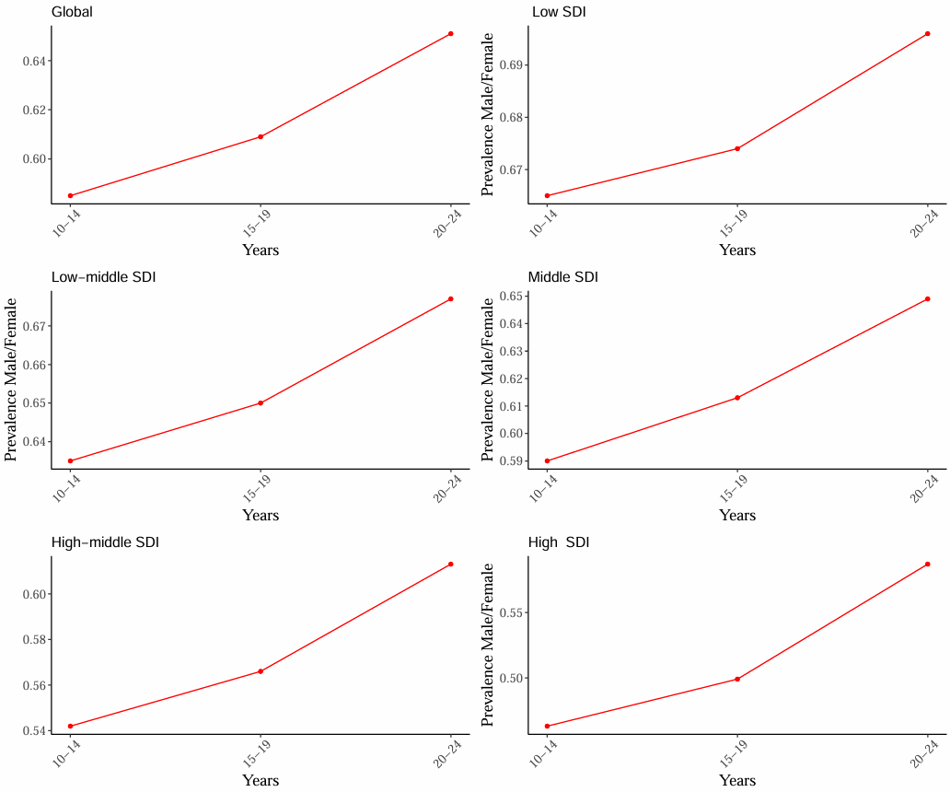

Supplementary Figure 1 Line chart of prevalence by age group and gender ratio

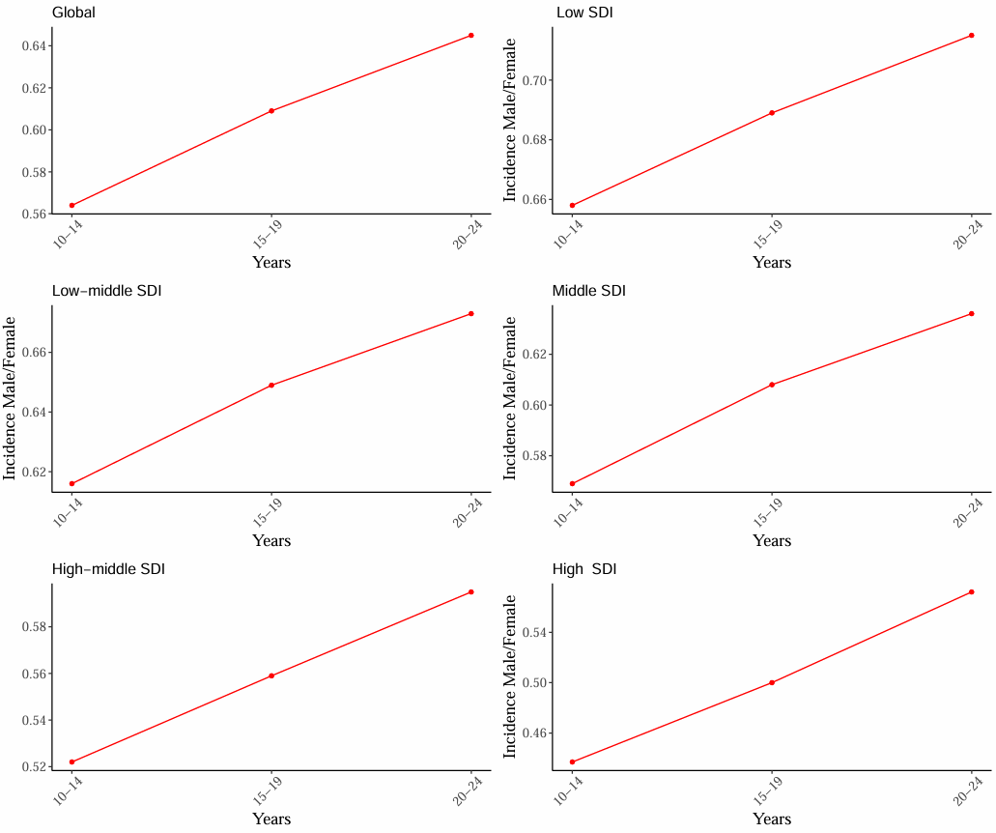

Supplementary Figure 2 Line chart of incidence by age group and gender ratio

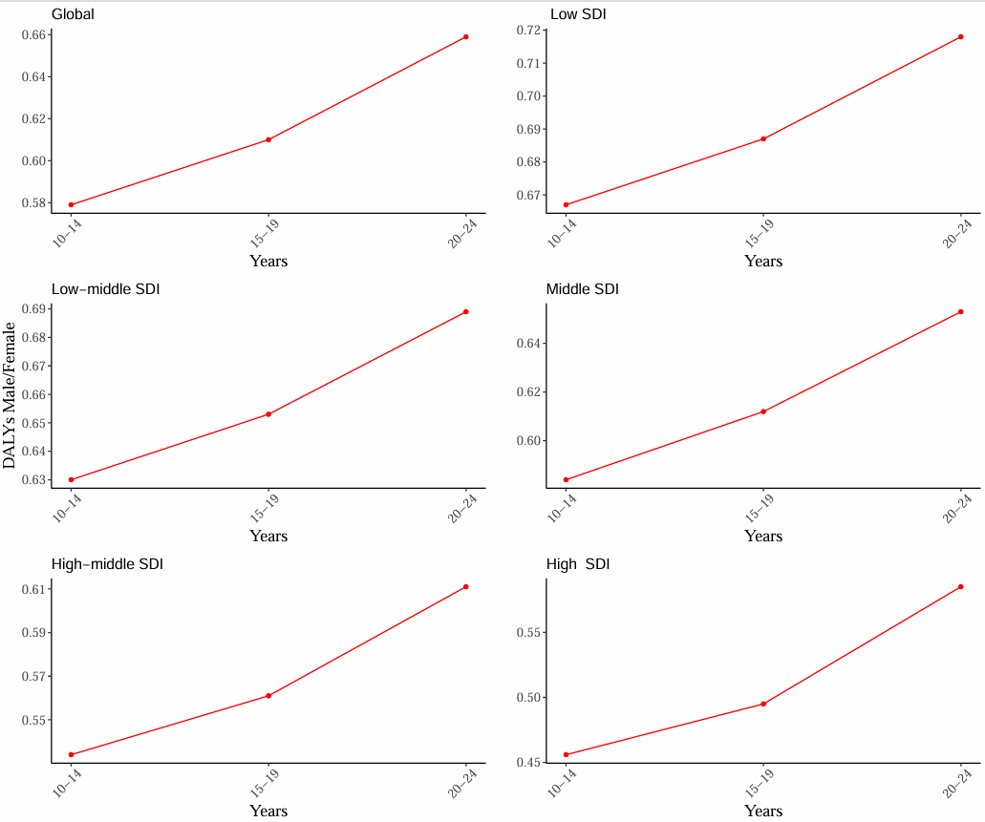

Supplementary Figure 3 Line chart of DALYs by age group and gender ratio

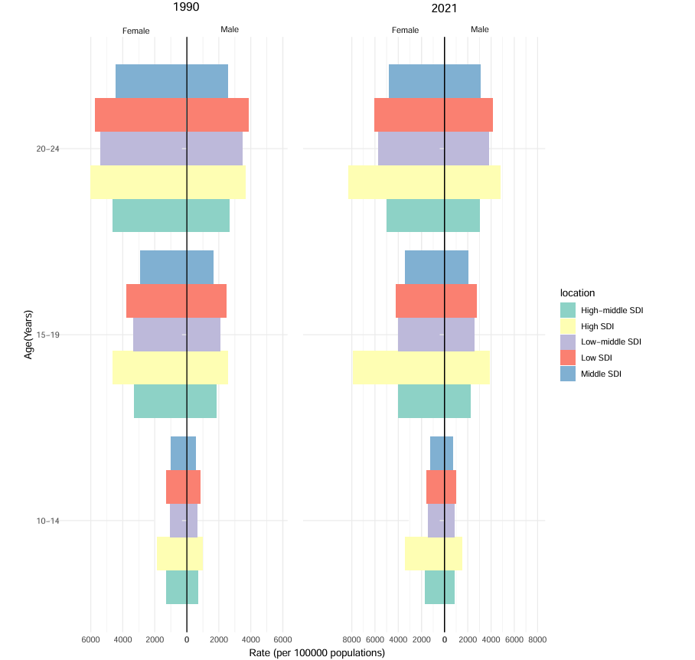

Supplementary Figure 4 Comparison of adolescent depression prevalence by gender across different regions and age groups in 1990 and 2021.

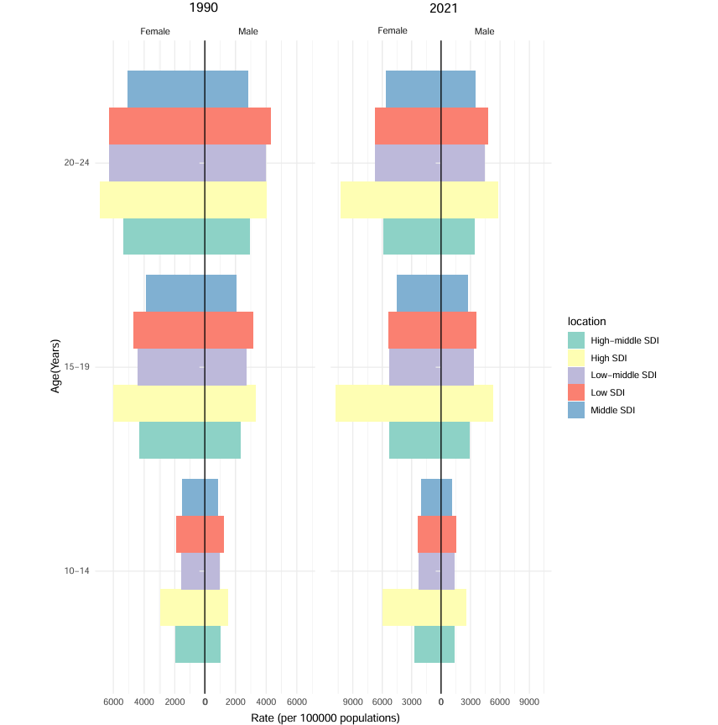

Supplementary Figure 5 Comparison of adolescent depression incidence by gender across different regions and age groups in 1990 and 2021.

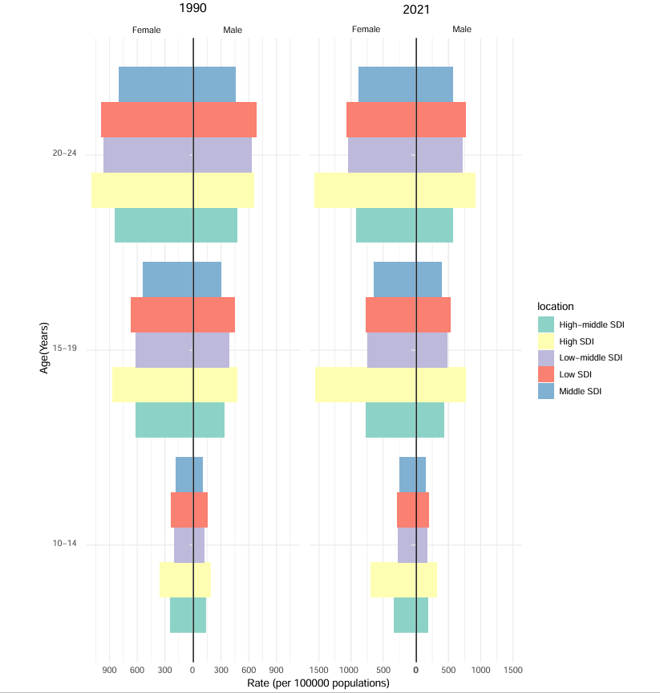

Supplementary Figure 6 Comparison of adolescent depression DALYs by gender across different regions and age groups in 1990 and 2021.
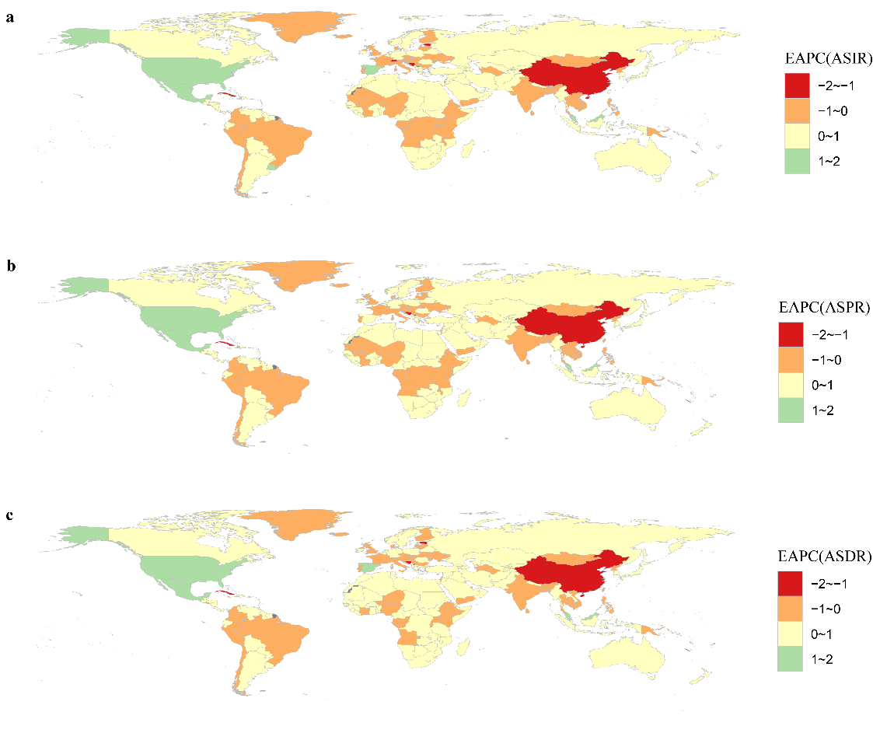
Supplementary Figure 7 EAPC of ASR for adolescent depression all sex from 1990 to 2021.

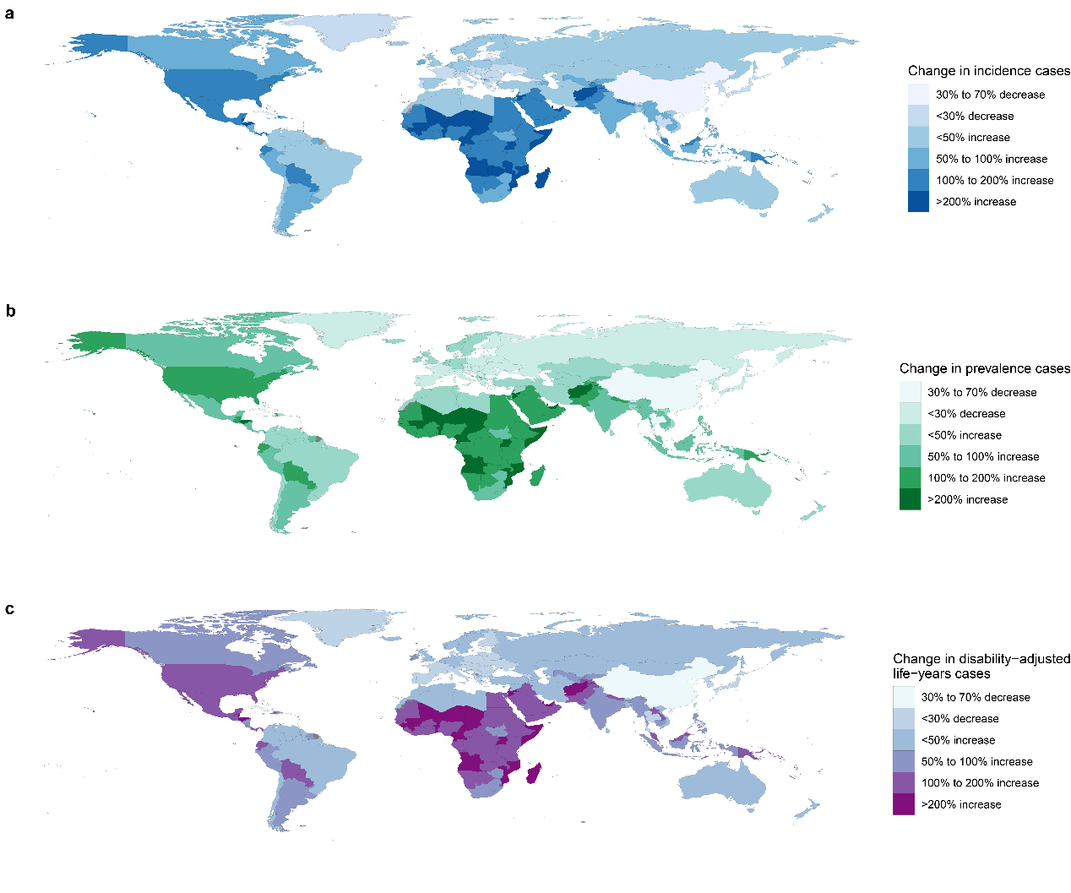

Supplementary Figure 8 Change in cases of depression among adolescents aged 10–24 years for both genders, in 204 countries and territories. (a). Change in incidence cases (b) Change in prevalence cases. (c) Change in disability-adjusted life-years cases.

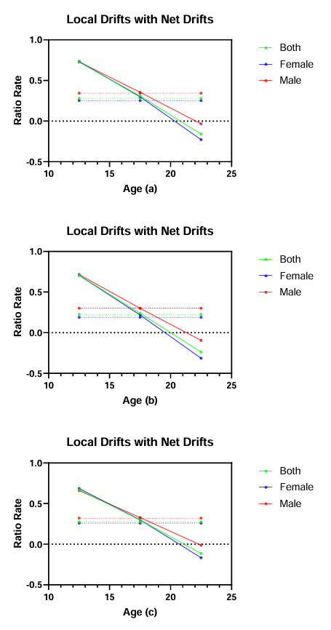

Supplementary Figure 9 Localized and net drift curves for age-standardized prevalence (a), incidence (b), and DALYs (c) of adolescent depression from 1990 to 2021.

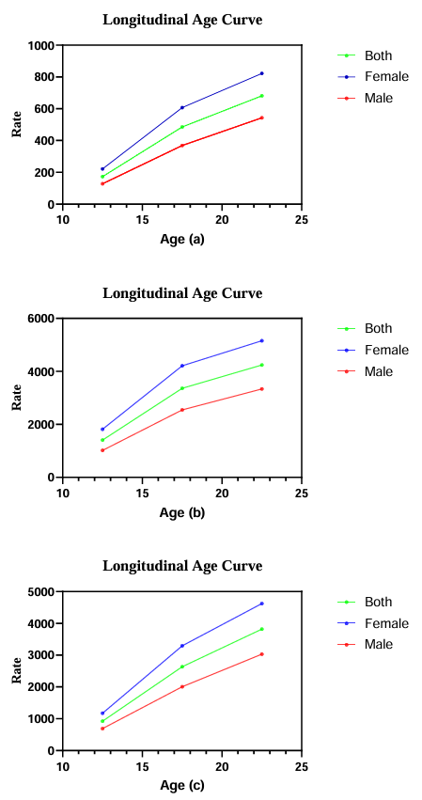

Supplementary Figure 10 Longitudinal age curves of age-standardized prevalence (a), incidence (b), and DALYs (c) for adolescent depression from 1990 to 2021.

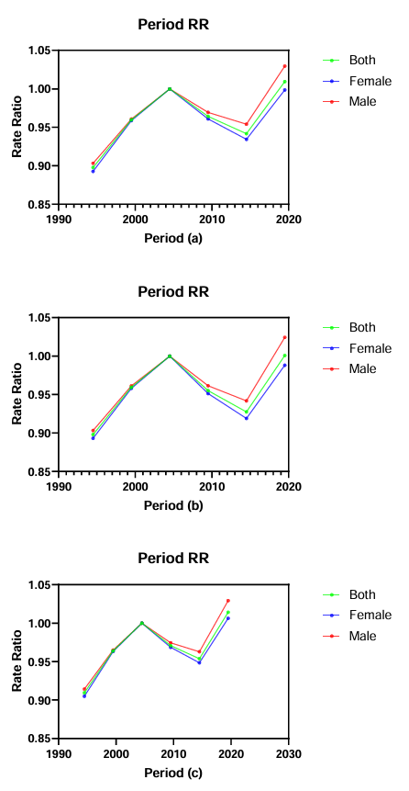

Supplementary Figure 11 Period RR curves of age-standardized prevalence (a), incidence (b), and DALYs (c) for adolescent depression from 1990 to 2021.

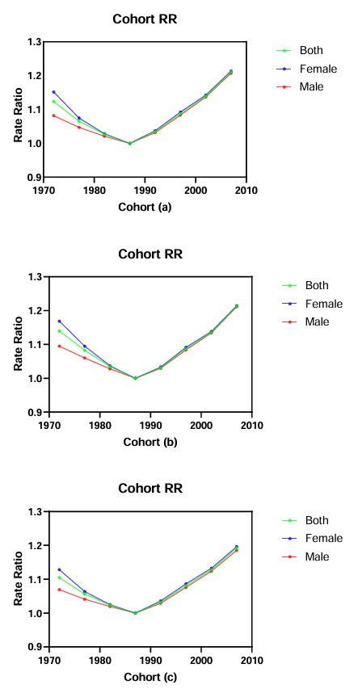

Supplementary Figure 12 Cohort RR curves of age-standardized prevalence (a), incidence (b), and DALYs (c) for adolescent depression from 1990 to 2021.

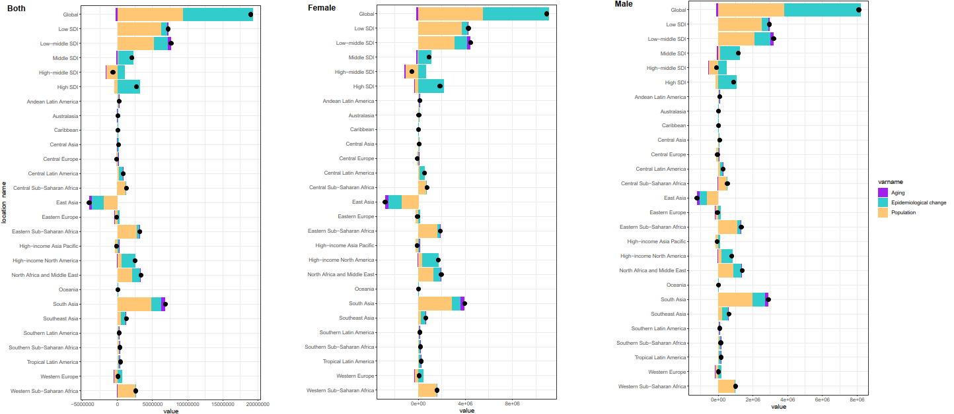

Supplementary Figure 13 Changes in prevalence for adolescent depression among 10-24 year-olds from 1990 to 2021 across global, five Socio-Demographic Index (SDI) regions, 21 regions, and by gender, based on population-level determinants of growth, aging, and epidemiological shifts. Black dots represent the overall change due to the combined contributions of all three components. For each component, positive values prevalence an increase in adolescent depression incidence, while negative values indicate a decrease. SDI: Socio-Demographic Index.

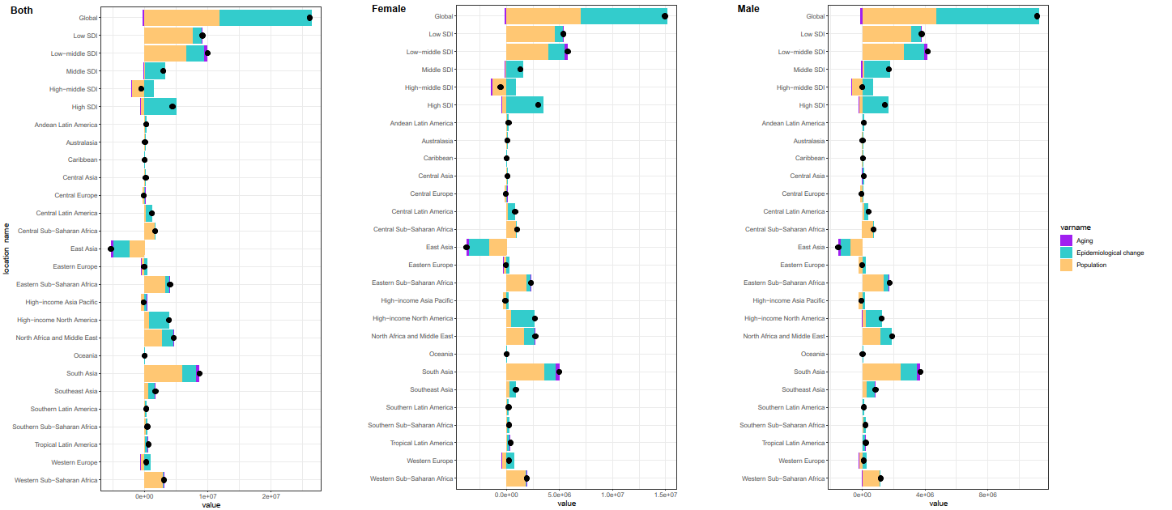

Supplementary Figure 14 Changes in incidence for adolescent depression among 10-24 year-olds from 1990 to 2021 across global, five Socio-Demographic Index (SDI) regions, 21 regions, and by gender, based on population-level determinants of growth, aging, and epidemiological shifts. Black dots represent the overall change due to the combined contributions of all three components. For each component, positive values indicate an increase in adolescent depression incidence, while negative values indicate a decrease. SDI: Socio-Demographic Index.

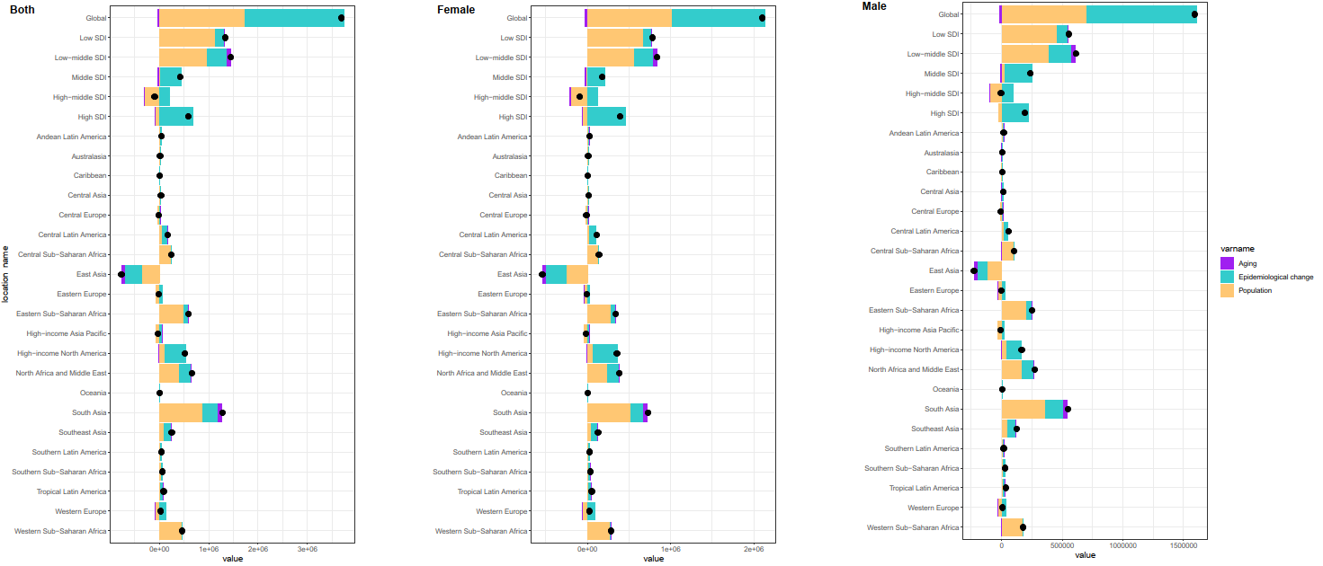

Supplementary Figure 15 Changes in DALYs for adolescent depression among 10-24 year-olds from 1990 to 2021 across global, five Socio-Demographic Index (SDI) regions, 21 regions, and by gender, based on population-level determinants of growth, aging, and epidemiological shifts. Black dots represent the overall change due to the combined contributions of all three components. For each component, positive values indicate an increase in adolescent depression DALYs, while negative values indicate a decrease. SDI: Socio-Demographic Index; DALYs: Disability-Adjusted Life Years.

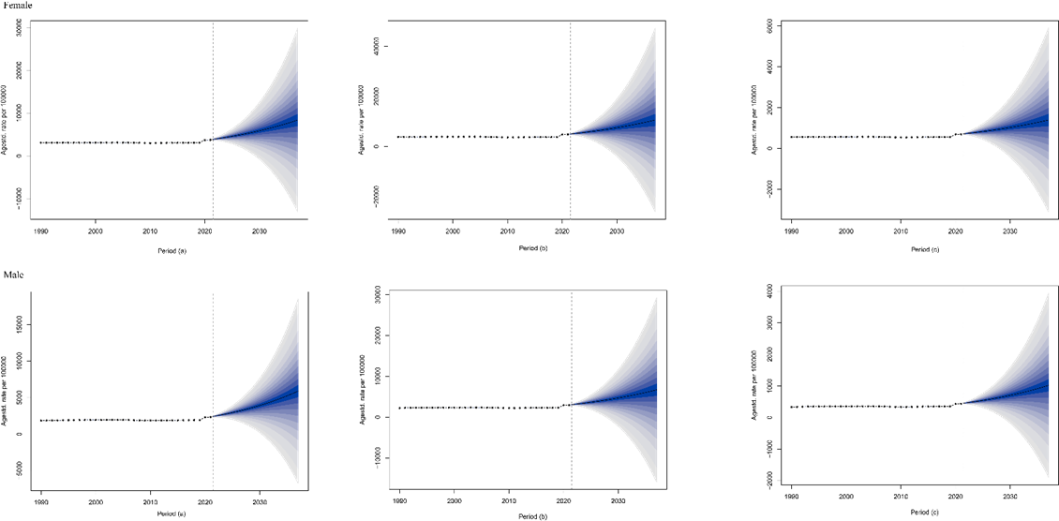

Supplementary Figure 16 Projected trends in prevalence (a), incidence (b), and DALYs for females and males from 2020 to 2035 using the Bayesian Age-Period-Cohort (BAPC) model for global data.

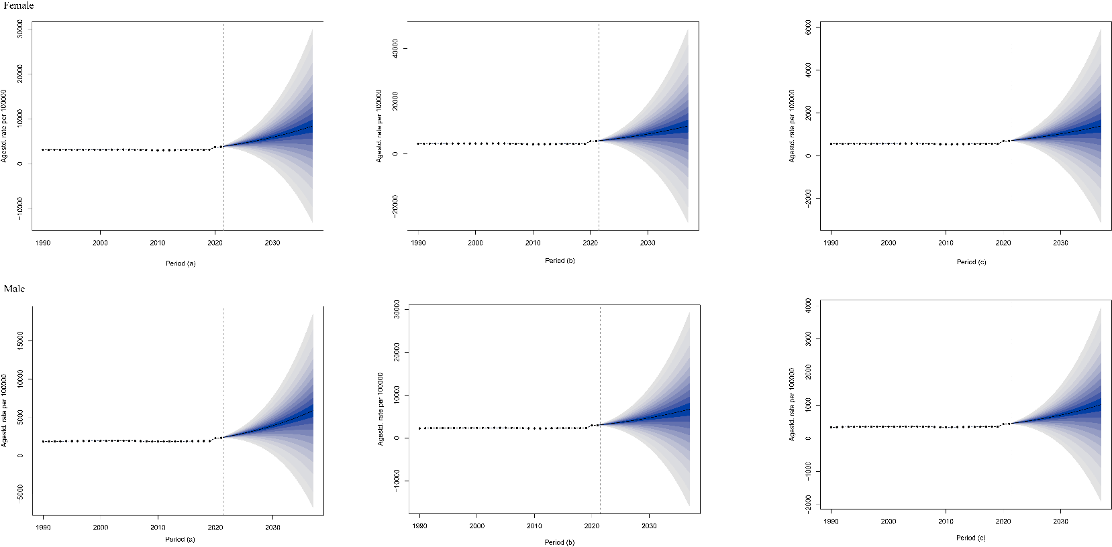

Supplementary Figure 17 Projected trends in prevalence (a), incidence (b), and DALYs for females and males from 2022 to 2037 using the Bayesian Age-Period-Cohort (BAPC) model for global data.

Supplementary Table 1 The number and age-standardised rate of incidence, prevalence, DALYs of depression at the national levels in 1990 and 2021
Type | 1990 |  | 2021 |  | EAPC (95% CI)
Type | Number  (95% UI) | ASR per 10⁵  (95% UI) | Number  (95% UI) | ASR per 10⁵  (95% UI) | EAPC (95% CI)
Prevalence
Afghanistan | 134775 (95193-181863) | 4186.44 (2835.69,5989.98) | 530132 (365541-752387) | 5105.86 (3332.78,7480.78) | 0.15 (-0.03-0.34)
Albania | 17442 (13463-23269) | 1773.14 (1270.08,2407.57) | 13705 (9838-19221) | 2411.13 (1627.29,3554.32) | 0.21 (-0.02-0.44)
Algeria | 302018 (217095-405995) | 3636.62 (2475.23,5188.46) | 404961 (275508-585524) | 4086.17 (2656.29,6218.73) | 0.12 (-0.05-0.3)
American Samoa | 287 (215-380) | 1906.92 (1345.01,2612.64) | 275 (196-380) | 2097.6 (1428.9,3032.96) | -0.05 (-0.16-0.06)
Andorra | 453 (331-615) | 3549.85 (2455.27,4984.51) | 601 (420-852) | 4509.08 (2906.95,6668.06) | 0.19 (-0.09-0.46)
Angola | 137739 (98782-189737) | 4559.64 (3128.31,6513.39) | 486839 (334721-691414) | 5015.2 (3341.52,7460.4) | -0.07 (-0.21-0.07)
Antigua and Barbuda | 353 (263-482) | 2002.83 (1368.3,2869.06) | 531 (376-769) | 2570.57 (1704.73,3856.42) | 0.2 (-0.01-0.42)
Argentina | 231764 (168410-300431) | 2734.64 (1900.98,3760.85) | 411442 (305043-535557) | 3769.63 (2661.15,5177.79) | 0.35 (0.09-0.6)
Armenia | 16897 (12670-22141) | 1934.71 (1349.55,2658.91) | 15466 (10802-21174) | 2905.2 (1921.34,4176.23) | 0.71 (0.45-0.98)
Australia | 206670 (159560-256311) | 5038.61 (3688.22,6595.33) | 264207 (188711-357554) | 5507.19 (3792.51,7862.49) | 0.21 (0.09-0.33)
Austria | 57665 (43405-74270) | 3255.27 (2338.76,4372.55) | 52026 (36854-71392) | 3532.23 (2366.71,5085.35) | -0.39 (-0.62--0.16)
Azerbaijan | 40940 (31090-54683) | 1902.21 (1331.34,2636.72) | 55708 (39862-75725) | 2532.84 (1702.82,3661.25) | 0.31 (0.06-0.55)
Bahamas | 1684 (1239-2255) | 2045.03 (1412.67,2884.72) | 2699 (1865-3888) | 2705.52 (1792.08,4016.25) | 0.29 (0.03-0.54)
Bahrain | 5925 (4245-8060) | 4505.49 (3038.32,6322.26) | 17650 (11848-25054) | 4997.76 (3209.48,7447.59) | -0.36 (-0.56--0.15)
Bangladesh | 1130463 (844494-1509890) | 3392.51 (2415.2,4725.89) | 1553984 (1083430-2126097) | 3369.1 (2275.66,4793.23) | -0.56 (-0.77--0.35)
Barbados | 1453 (1098-1936) | 2082.37 (1462.48,2897.19) | 1717 (1197-2489) | 2892.75 (1901.8,4275.53) | 0.37 (0.16-0.59)
Belarus | 55790 (41970-72566) | 2496.66 (1778.24,3400.65) | 51697 (36420-72342) | 3695.47 (2467.37,5390) | 0.05 (-0.26-0.37)
Belgium | 66953 (56728-80980) | 3178.93 (2503.84,4013.47) | 81712 (57355-112860) | 4108.98 (2736.97,5926.9) | 0.46 (0.24-0.69)
Belize | 1301 (937-1782) | 2186.98 (1532.41,3094.62) | 3838 (2620-5361) | 2860.47 (1906.99,4173.06) | 0.36 (0.16-0.56)
Benin | 36872 (27387-49009) | 2749.36 (1911.48,3834.98) | 125845 (89086-177728) | 2999.39 (2003.92,4356.79) | 0.07 (-0.01-0.15)
Bermuda | 342 (256-454) | 2554.26 (1803.99,3541.31) | 272 (184-391) | 2925.08 (1900.07,4335.01) | -0.28 (-0.5--0.06)
Bhutan | 5131 (3816-6905) | 2284.15 (1612.78,3208.84) | 4786 (3386-6625) | 2239.73 (1538.02,3208.14) | -0.1 (-0.22-0.02)
Bolivia (Plurinational State of) | 43073 (31914-58521) | 2285.44 (1614.93,3202.83) | 102089 (69626-145798) | 3117.17 (2078.87,4584.68) | 0.05 (-0.36-0.46)
Bosnia and Herzegovina | 30613 (22961-40553) | 2572.37 (1857.82,3510.58) | 14769 (10579-20360) | 2619.81 (1766.54,3772.35) | -1.02 (-1.34--0.71)
Botswana | 11800 (8812-15742) | 2783.21 (1957.01,3834.88) | 24560 (17507-34325) | 3751.95 (2470.1,5414.72) | 0.19 (0-0.37)
Brazil | 1227964 (958890-1581828) | 2702.78 (2013.25,3594.05) | 1615336 (1238140-2114539) | 3162.12 (2346.1,4264.89) | -0.4 (-0.88-0.08)
Brunei Darussalam | 1347 (1006-1795) | 1743.39 (1219.13,2405.52) | 2249 (1619-3145) | 2018.41 (1364.63,2980.38) | 0.12 (-0.04-0.29)
Bulgaria | 37964 (28978-48946) | 2051.05 (1495.06,2788.56) | 26556 (18958-36206) | 2749.93 (1856.2,3925.39) | -0.25 (-0.61-0.1)
Burkina Faso | 74581 (54623-100337) | 2794.34 (1984.83,3926.01) | 197608 (142941-275475) | 2863.58 (1949.68,4205.31) | 0.26 (0.13-0.39)
Burundi | 55029 (41177-74316) | 3477.37 (2451.43,4839.91) | 148755 (102193-208162) | 3645.87 (2420.06,5260.79) | -0.37 (-0.53--0.2)
Cabo Verde | 3214 (2394-4248) | 2930.32 (2039.52,4051.57) | 5819 (4125-8164) | 3810.48 (2524.1,5574.23) | 0.33 (0.15-0.51)
Cambodia | 76265 (56057-100617) | 2508 (1727.64,3548.26) | 129994 (90191-181668) | 2814.73 (1874.59,4145.14) | -0.44 (-0.64--0.24)
Cameroon | 86207 (63755-115663) | 2824.47 (1979.34,3919.59) | 304706 (217476-418459) | 3069.48 (2038.71,4434.12) | 0.06 (-0.01-0.13)
Canada | 205967 (163094-259119) | 3427.9 (2556.27,4522.15) | 316604 (221344-435441) | 4800.61 (3215.84,6951.81) | 0.32 (0.07-0.56)
Central African Republic | 36773 (26482-51029) | 4539.45 (3141.51,6458.19) | 84004 (57008-120923) | 4838.53 (3139.04,7241.31) | 0.03 (-0.1-0.15)
Chad | 55019 (40051-74992) | 3216.26 (2217.63,4539.93) | 181617 (126327-258137) | 3344.39 (2203.12,4959.59) | 0.06 (-0.04-0.16)
Chile | 187327 (156886-225052) | 4843.77 (3800.99,6185.51) | 223779 (150305-309009) | 5543.64 (3557.09,8145.46) | -0.29 (-0.59-0.01)
China | 6967371 (5532091-8874797) | 1783.82 (1345.96,2307.37) | 2961493 (2373048-3701057) | 1280.99 (967.98,1666.09) | -1.17 (-1.28--1.07)
Colombia | 172065 (129841-226945) | 1683.14 (1195.58,2326.6) | 238223 (170425-329682) | 1881.66 (1290.78,2630.76) | -0.42 (-0.74--0.1)
Comoros | 4141 (3091-5378) | 2845.72 (2013.8,3890.53) | 7118 (5057-9945) | 3245.75 (2220.11,4757.84) | 0.01 (-0.14-0.16)
Congo | 34630 (24848-47208) | 4466.24 (3087.77,6330.66) | 76870 (51907-112653) | 4813.3 (3101.16,7145.73) | -0.19 (-0.38-0)
Cook Islands | 128 (92-177) | 2205.59 (1462.65,3207.49) | 105 (71-154) | 2571.53 (1631.19,3908.34) | 0.14 (0.05-0.24)
Costa Rica | 18416 (13617-24584) | 2024.72 (1424.77,2830.64) | 31453 (22326-45872) | 2771.59 (1870.71,4129.28) | 0.44 (0.25-0.63)
Croatia | 24548 (18646-31801) | 2323.93 (1657.65,3153.03) | 17542 (12420-24297) | 2555.12 (1716.11,3649.5) | -0.42 (-0.66--0.19)
Cuba | 119842 (90776-155073) | 3475.15 (2519.01,4660.99) | 62315 (44825-88831) | 3035.54 (2017.84,4542.81) | -1.41 (-1.76--1.06)
Cyprus | 6009 (4453-8029) | 3128.93 (2161.46,4410.55) | 8448 (5941-12059) | 3807.52 (2483.32,5577) | 0.2 (0-0.39)
Czechia | 50011 (38550-64846) | 2160.39 (1549.52,2930.37) | 39613 (27849-53496) | 2606.28 (1742.23,3743.76) | -0.19 (-0.43-0.04)
Côte d'Ivoire | 91593 (68831-120395) | 2483.64 (1749.64,3420.29) | 210069 (150616-285278) | 2537.41 (1733.94,3589.24) | -0.03 (-0.09-0.04)
Democratic People's Republic of Korea | 90041 (68049-116964) | 1571.95 (1105.61,2165.7) | 83617 (61779-110466) | 1466.43 (1001.31,2057.92) | -0.45 (-0.55--0.36)
Democratic Republic of the Congo | 487958 (348604-664619) | 4278.05 (2937.62,6035.6) | 1277265 (885070-1799024) | 4507.56 (2962.6,6627.56) | -0.03 (-0.15-0.09)
Denmark | 42066 (31408-55414) | 3635.14 (2580.23,5023.13) | 41657 (29040-57820) | 3856.37 (2529.17,5612.04) | -0.38 (-0.62--0.14)
Djibouti | 4225 (3154-5585) | 2928.03 (2069.44,4044.73) | 11846 (8401-16020) | 3351.94 (2275.55,4856.36) | 0.1 (-0.04-0.23)
Dominica | 456 (339-610) | 2015.4 (1424.47,2824.08) | 451 (317-636) | 2700.45 (1800.91,3974.51) | 0.34 (0.13-0.56)
Dominican Republic | 59429 (43108-82316) | 2497.39 (1720.14,3580.16) | 87680 (59968-126399) | 2971.58 (1938.22,4367) | 0.15 (-0.07-0.36)
Ecuador | 77795 (57811-103907) | 2465.05 (1743.82,3401.47) | 164515 (114894-228588) | 3346.69 (2189.64,4822.9) | 0.31 (-0.03-0.66)
Egypt | 545353 (400486-743653) | 3247.61 (2214.14,4660.8) | 1206509 (842876-1713833) | 4119.29 (2662.4,6118.92) | 0.33 (0.15-0.52)
El Salvador | 50074 (37907-66673) | 2972.45 (2093.4,4116.67) | 55210 (38744-79054) | 3070.65 (2053.3,4539.37) | -0.48 (-0.72--0.25)
Equatorial Guinea | 5656 (4046-7687) | 4621.01 (3195.83,6664.87) | 25359 (17800-37009) | 4717.57 (3146.96,7029.21) | -0.19 (-0.33--0.06)
Eritrea | 33919 (25369-44885) | 3187.42 (2238,4424.59) | 70642 (50011-96974) | 3438.78 (2304.71,5024.7) | -0.05 (-0.15-0.06)
Estonia | 10076 (7729-13286) | 3047.31 (2183.46,4128.28) | 6464 (4430-9045) | 3263.4 (2164.09,4755.6) | -0.94 (-1.23--0.64)
Eswatini | 7306 (5424-9642) | 2842.14 (1993.52,3943.06) | 16697 (11495-23910) | 4598.56 (3045.24,6647.23) | 0.56 (0.26-0.86)
Ethiopia | 468381 (372495-613587) | 3151.69 (2354.57,4211.8) | 1208077 (944542-1586955) | 3279.65 (2403.54,4458.84) | -0.28 (-0.5--0.06)
Fiji | 4788 (3614-6307) | 2065.84 (1472.52,2844.85) | 6138 (4385-8374) | 2607.69 (1750.6,3731.78) | 0.18 (0.02-0.33)
Finland | 52067 (39485-66597) | 5210.23 (3688.32,7033.3) | 51979 (36421-70875) | 5594.48 (3737.44,7966.26) | -0.26 (-0.42--0.1)
France | 563444 (481695-659678) | 4282.37 (3438.62,5309.65) | 551283 (391160-760188) | 4473.24 (2938.58,6536.3) | -0.56 (-0.87--0.26)
Gabon | 12990 (9269-17888) | 4391.39 (3018,6356.18) | 27907 (19063-39445) | 5048.28 (3275.46,7384.68) | -0.02 (-0.17-0.12)
Gambia | 10716 (7753-14296) | 3579.02 (2475.56,5051.06) | 31059 (21387-43592) | 3921.61 (2554.67,5825.85) | 0.03 (-0.11-0.16)
Georgia | 28020 (21099-36945) | 2159.76 (1523.4,2968.6) | 18830 (12994-25620) | 3058.95 (1982.14,4410.29) | 0.43 (0.19-0.68)
Germany | 490935 (401634-603358) | 3059.15 (2347.31,3931.12) | 555334 (390709-764415) | 4225.43 (2761.14,6150.09) | 0.64 (0.44-0.84)
Ghana | 125726 (93615-169239) | 2797.73 (1959.57,3892.93) | 317873 (226095-446627) | 3078.56 (2069.13,4511.39) | 0.05 (-0.11-0.2)
Greece | 112613 (79959-157394) | 4702.61 (3144.43,6807.87) | 97492 (68204-139704) | 6247.33 (3981.64,9343.06) | 0.19 (-0.12-0.5)
Greenland | 1238 (911-1668) | 8045.55 (5686.87,11070.03) | 1179 (820-1637) | 10252.85 (6790.05,14704.25) | -0.04 (-0.29-0.21)
Grenada | 547 (400-741) | 2169.77 (1524.65,3057.6) | 766 (537-1088) | 2845.96 (1862.88,4169.07) | 0.27 (0.09-0.45)
Guam | 1021 (764-1353) | 2438.7 (1731.35,3346.84) | 1169 (826-1617) | 3196.19 (2137.72,4590.26) | 0.37 (0.19-0.55)
Guatemala | 54142 (39479-74054) | 2251.19 (1565.76,3174.49) | 150056 (102735-222703) | 2972.89 (1917.64,4521.99) | 0.24 (0.01-0.47)
Guinea | 42381 (31207-56424) | 2709.15 (1892.06,3787.89) | 125157 (88143-171318) | 3062.07 (2042.48,4428.03) | 0.15 (0.05-0.25)
Guinea-Bissau | 8222 (6023-10946) | 2721.67 (1900.25,3786.97) | 19490 (13766-26793) | 3032.39 (2020.59,4378.62) | 0.14 (0.03-0.24)
Guyana | 8631 (6299-11622) | 3350.42 (2347.67,4598.56) | 11083 (7652-15778) | 5069.46 (3366.49,7435.2) | 0.61 (0.39-0.83)
Haiti | 47066 (34087-63401) | 2565.23 (1771.47,3639.9) | 112375 (77732-164349) | 3030.7 (2008.82,4487.64) | 0 (-0.18-0.17)
Honduras | 25910 (19091-35396) | 1847.7 (1285.97,2630.41) | 83026 (56397-116923) | 2578.38 (1668.28,3832.13) | 0.4 (0.13-0.66)
Hungary | 49024 (37945-62042) | 2182.65 (1599.02,2903.05) | 34653 (24691-47363) | 2322.24 (1594.06,3270.16) | -0.53 (-0.75--0.32)
Iceland | 2044 (1527-2657) | 3163.49 (2213.67,4345.98) | 2277 (1618-3040) | 3309.1 (2216.31,4762.21) | -0.16 (-0.32-0)
India | 5741995 (4552405-7378885) | 2294.76 (1733.62,3031.11) | 10939519 (8600946-14044761) | 2690.15 (2001.95,3625.03) | -0.2 (-0.42-0.01)
Indonesia | 939320 (744385-1230370) | 1617.37 (1191.55,2145.45) | 1502450 (1157973-1942641) | 2123.12 (1529.76,2870.18) | 0.23 (0-0.46)
Iran (Islamic Republic of) | 717741 (544579-955078) | 4099.32 (2913.96,5706.65) | 896016 (668821-1182812) | 5154.67 (3602.63,7224.87) | 0.63 (0.42-0.84)
Iraq | 199881 (145795-260540) | 3370.01 (2338.2,4729.23) | 465524 (329149-643706) | 3753.1 (2493.94,5447.82) | 0.24 (0-0.48)
Ireland | 37730 (28637-48271) | 3950.57 (2823.56,5375.39) | 55833 (38274-77729) | 5746.54 (3811.79,8403.85) | 0.41 (0.13-0.69)
Israel | 56880 (41571-73564) | 4250.27 (2961,5889.6) | 107899 (75942-151405) | 4826.39 (3167.89,7098.42) | -0.12 (-0.31-0.08)
Italy | 459533 (358141-595735) | 3451.81 (2511.56,4662.64) | 392562 (302225-511752) | 4416.04 (3160.6,6042.41) | -0.04 (-0.36-0.29)
Jamaica | 15357 (11412-20892) | 2029.18 (1398.2,2875.01) | 20365 (14020-29055) | 2722.56 (1797.37,4050.47) | 0.29 (0.06-0.52)
Japan | 604283 (481350-755826) | 2080.08 (1590.92,2671.91) | 518787 (408076-658199) | 2821.31 (2141.18,3668.71) | 0.55 (0.38-0.72)
Jordan | 49289 (35839-66337) | 3673.62 (2515.56,5321.96) | 154855 (107127-221190) | 4081.57 (2655.45,5967.65) | 0.02 (-0.11-0.14)
Kazakhstan | 108631 (83897-139223) | 2528.75 (1843.73,3406.19) | 120577 (86462-167867) | 3101.08 (2115.09,4367.08) | 0.28 (0.12-0.44)
Kenya | 219112 (175482-274614) | 2958.03 (2242.44,3882.71) | 539658 (432249-681929) | 3228.76 (2427.15,4266.63) | -0.03 (-0.16-0.11)
Kiribati | 535 (395-706) | 2376.75 (1682.33,3237.74) | 834 (588-1164) | 2431.43 (1636.11,3546.81) | -0.29 (-0.42--0.17)
Kuwait | 16732 (12168-22984) | 3584.3 (2447.86,5133.67) | 31689 (21482-45013) | 3742.17 (2417.79,5594.58) | 0.12 (0.01-0.24)
Kyrgyzstan | 31634 (23950-41141) | 2516.68 (1801.19,3458.09) | 53485 (38045-72518) | 3101.4 (2095.9,4463.32) | 0.03 (-0.2-0.27)
Lao People's Democratic Republic | 27535 (20394-36394) | 2276.13 (1580.64,3193.27) | 54336 (37548-76003) | 2569 (1694.24,3752.16) | 0 (-0.18-0.18)
Latvia | 14500 (10912-19025) | 2590.79 (1822.68,3581.52) | 8745 (6051-12177) | 3284.95 (2165.98,4829.34) | -0.39 (-0.69--0.08)
Lebanon | 31827 (23635-42040) | 3707.36 (2611.2,5204) | 69429 (46350-97808) | 5899.37 (3756.53,8884.84) | 0.36 (0.09-0.62)
Lesotho | 17240 (12560-23069) | 3974.87 (2747.11,5551.65) | 34344 (23203-47314) | 5613.2 (3731.12,8054.44) | 0.42 (0.15-0.69)
Liberia | 20520 (15146-27361) | 2965.68 (2074.76,4119.01) | 52952 (36325-72583) | 3065.58 (2046.14,4392.59) | 0.29 (0.07-0.52)
Libya | 53568 (38120-72464) | 3783.4 (2580.22,5410.51) | 78801 (54920-111118) | 4424.88 (2889.38,6516.38) | 0.21 (0.05-0.36)
Lithuania | 22954 (17381-29887) | 2706.22 (1947.07,3691.36) | 16665 (11839-23321) | 3865.1 (2645.33,5619.14) | -0.1 (-0.42-0.23)
Luxembourg | 2861 (2164-3705) | 3698.78 (2627.62,5000.83) | 4230 (2970-5814) | 3833.13 (2510.14,5502.71) | -0.44 (-0.69--0.18)
Madagascar | 114875 (86157-152332) | 3169.16 (2248.4,4392.65) | 337187 (238214-474913) | 3629.49 (2470.63,5200.61) | 0.05 (-0.09-0.19)
Malawi | 86759 (64769-113760) | 2840.98 (2027.59,3870.99) | 224459 (160632-309637) | 3279.41 (2240.18,4697.96) | -0.06 (-0.22-0.11)
Malaysia | 123258 (89643-163661) | 2330.64 (1600.94,3291.68) | 245910 (170509-344117) | 2950.61 (1937.3,4327.95) | 1.79 (1.31-2.27)
Maldives | 1968 (1442-2568) | 2881.73 (2013.15,4057.78) | 2776 (1918-3803) | 2712.4 (1769.65,3961.54) | -0.92 (-1.13--0.71)
Mali | 56130 (42421-74753) | 2357.9 (1661.42,3265.31) | 186849 (135172-255868) | 2466.18 (1679.05,3548.22) | 0 (-0.14-0.13)
Malta | 2555 (1897-3440) | 3163.21 (2174.65,4448.6) | 2445 (1689-3463) | 3746.72 (2451.28,5430.29) | 0.18 (-0.02-0.38)
Marshall Islands | 302 (221-398) | 2192.98 (1540.56,3046.2) | 390 (277-540) | 2375.86 (1607.18,3469.53) | -0.16 (-0.26--0.06)
Mauritania | 14587 (11006-19339) | 2401.54 (1682.74,3319.21) | 35260 (25081-48418) | 2576.43 (1731.86,3717.4) | 0 (-0.16-0.16)
Mauritius | 11702 (8514-15334) | 3616.13 (2478.31,5052.1) | 11729 (7930-16457) | 4318.3 (2744.98,6312.73) | -0.22 (-0.46-0.03)
Mexico | 531453 (423519-669497) | 1884.1 (1430.88,2484.17) | 1060141 (824318-1385945) | 3142.75 (2320.95,4223.27) | 1.17 (0.89-1.44)
Micronesia (Federated States of) | 701 (514-931) | 2246.07 (1574.61,3126.43) | 737 (537-1025) | 2354.73 (1600.56,3424.44) | -0.22 (-0.33--0.11)
Monaco | 179 (128-249) | 3796.33 (2501.46,5534.17) | 271 (182-390) | 4998.86 (3159.93,7553.09) | 0.28 (0.08-0.48)
Mongolia | 20886 (15381-27900) | 3050.83 (2168.94,4247.89) | 22513 (16093-31362) | 3101.96 (2108.93,4436.27) | -0.18 (-0.23--0.14)
Montenegro | 3190 (2401-4163) | 1987.69 (1416.08,2709.97) | 3262 (2314-4491) | 2696.11 (1788.33,3851.35) | 0.12 (-0.14-0.38)
Morocco | 335308 (234249-454187) | 4217.91 (2854.13,5949.78) | 485584 (326505-685939) | 5175.53 (3284.05,7761.24) | 0.17 (-0.07-0.41)
Mozambique | 121085 (89876-162733) | 3190.45 (2242.23,4452.89) | 389329 (266494-540789) | 3873.64 (2536.72,5621.51) | 0.14 (0-0.28)
Myanmar | 188307 (140892-247369) | 1459.66 (1016.28,1997.65) | 308698 (217331-431011) | 2007.2 (1341.23,2911.31) | 0.24 (-0.04-0.53)
Namibia | 11685 (8794-15316) | 2549.4 (1798.2,3494.5) | 26489 (18590-36923) | 3592.96 (2419.05,5177.28) | 0.15 (-0.13-0.43)
Nauru | 64 (47-89) | 2197.57 (1467.95,3209.18) | 86 (59-123) | 2542.18 (1615.49,3898.11) | 0.12 (0.03-0.21)
Nepal | 149496 (109764-196752) | 2649.8 (1886.99,3647.68) | 346020 (237572-495191) | 3566.25 (2337.04,5295.49) | 0.36 (0.13-0.59)
Netherlands | 113716 (96167-136163) | 3189.75 (2530.95,3999.21) | 135114 (91946-187403) | 4344.05 (2824.16,6289.18) | 0.49 (0.26-0.72)
New Zealand | 34756 (26012-45999) | 3984.93 (2844.49,5492.54) | 49989 (36633-67874) | 4807.38 (3372.4,6629.99) | 0.66 (0.63-0.69)
Nicaragua | 29256 (21532-38525) | 2401.49 (1704.84,3341.37) | 56537 (39336-76489) | 2979.02 (1998.97,4272.19) | 0.08 (-0.14-0.3)
Niger | 61223 (45675-81799) | 2695.57 (1885.29,3782.4) | 209086 (148037-284433) | 2659.14 (1759.11,3779.69) | -0.04 (-0.1-0.01)
Nigeria | 669604 (527552-874055) | 2473.13 (1848.1,3279.21) | 1761059 (1399735-2267225) | 2384.97 (1780.78,3147.81) | -0.26 (-0.45--0.06)
Niue | 13 (9-18) | 2175.39 (1441.61,3116.79) | 10 (7-14) | 2520.8 (1624.23,3768.21) | 0.12 (0.03-0.21)
North Macedonia | 9435 (7121-12542) | 1836.95 (1305.77,2487.6) | 10245 (7440-13921) | 2633.85 (1781.28,3814.14) | 0.21 (-0.11-0.54)
Northern Mariana Islands | 272 (206-367) | 1987.08 (1414.14,2733.85) | 300 (213-426) | 2690.68 (1807.93,3941.83) | 0.36 (0.17-0.55)
Norway | 34423 (26765-44809) | 3536.62 (2599.57,4750.87) | 42934 (32887-57547) | 4247.12 (3028.8,5829.3) | 0.32 (0.17-0.46)
Oman | 18013 (13026-23850) | 3488.01 (2393.69,4952.25) | 40368 (26874-56550) | 4413.78 (2777.02,6548.79) | 0.3 (0.1-0.49)
Pakistan | 747638 (582011-984693) | 2241.5 (1656.69,3005.22) | 1750438 (1328763-2354693) | 2458.39 (1780.51,3382.03) | 0.05 (-0.13-0.23)
Palau | 104 (75-147) | 2187.35 (1444.99,3154.81) | 89 (61-131) | 2531.57 (1616.74,3839.35) | 0.09 (0-0.19)
Palestine | 35547 (24802-48469) | 5402.11 (3600.27,7849.72) | 108695 (75112-156143) | 6674.45 (4324.35,9990.88) | 0.25 (0.05-0.45)
Panama | 14499 (10853-19902) | 1926.26 (1371.34,2698.26) | 28472 (19728-40856) | 2545.04 (1664.6,3825.59) | 0.36 (0.1-0.61)
Papua New Guinea | 30992 (22727-42996) | 2443.35 (1711.4,3424.38) | 74072 (53062-104626) | 2454.15 (1652.52,3557.27) | -0.22 (-0.27--0.17)
Paraguay | 27899 (20214-37100) | 2378.67 (1671.19,3329.2) | 70599 (50296-99369) | 3501.12 (2321.3,5125.85) | 0.55 (0.34-0.76)
Peru | 110433 (82944-139807) | 1608.44 (1159.88,2175.31) | 197961 (137985-274475) | 2098.43 (1399.54,3035.43) | -0.03 (-0.39-0.34)
Philippines | 438228 (339319-572558) | 2200.35 (1599.83,2958.12) | 846822 (653539-1119545) | 2597.46 (1870.13,3559.82) | -0.06 (-0.44-0.33)
Poland | 123645 (97200-158625) | 1499.65 (1128.26,1948.17) | 114601 (88739-150837) | 1949.89 (1437.12,2606.82) | 0.06 (-0.21-0.32)
Portugal | 123253 (88689-161555) | 4889.36 (3373.46,6703.71) | 94449 (65104-132976) | 5574.46 (3646.03,8192.3) | -0.37 (-0.65--0.09)
Puerto Rico | 18713 (14175-24349) | 1924.57 (1380.73,2632.69) | 14587 (10192-20591) | 2277.54 (1523.17,3334.12) | -0.08 (-0.31-0.14)
Qatar | 3624 (2643-4926) | 3612.18 (2471.64,5134.78) | 18525 (12765-27303) | 3994.92 (2579.9,6109.28) | -0.05 (-0.21-0.1)
Republic of Korea | 278319 (224470-347698) | 2034.38 (1549.01,2666.48) | 209838 (153967-281767) | 2563.31 (1782.07,3537.07) | 0.68 (0.46-0.91)
Republic of Moldova | 23054 (17424-30057) | 2308.38 (1662.89,3153.71) | 14970 (10844-21214) | 2699.74 (1789.96,3906.01) | -0.27 (-0.56-0.03)
Romania | 107395 (81554-140127) | 1806.35 (1287.84,2444.19) | 78393 (56845-108428) | 2522.18 (1719.4,3620.2) | 0.33 (0.07-0.6)
Russian Federation | 657373 (507593-860943) | 2089.38 (1547.87,2799.86) | 645233 (492927-846801) | 2830.33 (2056.84,3865.73) | 0.06 (-0.18-0.31)
Rwanda | 76089 (55678-101520) | 3567.66 (2488.2,5013.75) | 164760 (116827-229291) | 3875.62 (2629.5,5677.24) | -0.53 (-0.73--0.32)
Saint Kitts and Nevis | 300 (215-427) | 2401.48 (1590.93,3542.07) | 394 (259-608) | 3015.1 (1873.94,4718.12) | 0.23 (0.06-0.4)
Saint Lucia | 999 (735-1323) | 2247.01 (1582.18,3174.83) | 1234 (861-1757) | 3205.48 (2129.78,4702.9) | 0.34 (0.11-0.58)
Saint Vincent and the Grenadines | 796 (589-1065) | 2195.56 (1542.37,3061.13) | 830 (589-1183) | 3073.83 (2046.54,4551.58) | 0.46 (0.26-0.65)
Samoa | 1226 (899-1619) | 2187.01 (1543.76,3014.84) | 1399 (983-1953) | 2324.42 (1555.65,3368.47) | -0.23 (-0.34--0.11)
San Marino | 227 (164-315) | 3849.35 (2568.82,5655.87) | 283 (189-416) | 5101.17 (3179.04,7820.95) | 0.3 (0.04-0.56)
Sao Tome and Principe | 953 (711-1281) | 2537.7 (1740.73,3543.35) | 1870 (1316-2613) | 2733.73 (1820.94,3910.34) | 0.1 (-0.01-0.21)
Saudi Arabia | 175492 (128819-235349) | 3542.62 (2416.64,5007.52) | 354029 (259172-492682) | 4114.9 (2782.56,6022.14) | 0.4 (0.25-0.56)
Senegal | 57303 (42856-76297) | 2510.91 (1769.27,3462.93) | 149418 (107028-208793) | 2944.04 (2001.42,4229.98) | 0.09 (-0.07-0.26)
Serbia | 45004 (34081-58776) | 2052.3 (1469.07,2791.44) | 38147 (27937-52509) | 2315.05 (1613.79,3285.6) | -0.31 (-0.54--0.07)
Seychelles | 455 (342-590) | 2031.96 (1416.81,2806.97) | 583 (400-812) | 2653.96 (1709.41,3843.83) | 0.09 (-0.14-0.33)
Sierra Leone | 32138 (24089-42575) | 2701.75 (1883.73,3742.21) | 80192 (57281-110672) | 2790.88 (1858.11,4005.81) | 0.13 (0.05-0.2)
Singapore | 27636 (22771-34669) | 3038.35 (2374.9,3932.99) | 19813 (14721-26706) | 2627.2 (1824.26,3710.02) | -0.89 (-1.13--0.64)
Slovakia | 23484 (18099-30682) | 1895.81 (1360.2,2564.45) | 21198 (15479-29520) | 2503.65 (1698.87,3590.3) | -0.01 (-0.28-0.26)
Slovenia | 11754 (9044-15046) | 2593.25 (1886.57,3500.63) | 7742 (5608-10532) | 2626.25 (1806.77,3767.38) | -0.71 (-0.96--0.47)
Solomon Islands | 2476 (1826-3287) | 2280.58 (1594.55,3207.31) | 5008 (3548-7053) | 2448.46 (1625.94,3576.46) | -0.15 (-0.25--0.05)
Somalia | 70624 (53133-93131) | 3071.59 (2163.53,4278.82) | 273510 (191621-375440) | 3915.24 (2619.01,5715.45) | 0.17 (-0.01-0.34)
South Africa | 327465 (261456-405571) | 2801.75 (2131.58,3615.37) | 551613 (424748-712800) | 3849.72 (2855.96,5085.26) | 0.54 (0.29-0.8)
South Sudan | 58411 (43572-77088) | 3052.66 (2176.96,4214.86) | 106334 (76969-145197) | 3345.81 (2263.08,4751.78) | 0.13 (0.02-0.23)
Spain | 413766 (357680-477782) | 4189.08 (3469.32,5058.25) | 393280 (280146-538666) | 5614.01 (3759.15,8097.78) | 0.9 (0.51-1.3)
Sri Lanka | 146196 (112106-187356) | 2849.29 (2066.92,3852.92) | 162364 (115459-220898) | 3100.4 (2115.73,4384.86) | -0.66 (-0.98--0.33)
Sudan | 245883 (178971-334181) | 3957.34 (2679.18,5679.21) | 638867 (430740-904673) | 4538.56 (2915.23,6733.47) | 0.01 (-0.18-0.19)
Suriname | 4119 (3029-5358) | 3305.47 (2316.23,4595.02) | 7368 (5211-10469) | 5168.05 (3453.3,7513.01) | 0.49 (0.23-0.75)
Sweden | 67731 (52718-84962) | 3868.25 (2876.22,5017.51) | 86463 (63631-113343) | 4875.58 (3388.57,6648.88) | 0.27 (0.09-0.45)
Switzerland | 61847 (45581-81145) | 4289.26 (3054.57,5777.16) | 58694 (41482-81073) | 4186.41 (2795.48,5996.12) | -0.84 (-1.17--0.5)
Syrian Arab Republic | 149037 (107716-202869) | 3599.79 (2450.61,5147.89) | 203764 (137908-285128) | 4409.45 (2831.88,6507.4) | 0.25 (0.06-0.45)
Taiwan (Province of China) | 73148 (56121-94737) | 1270.57 (900.36,1739.81) | 52211 (38061-71594) | 1368.89 (934.31,1934.12) | -0.01 (-0.08-0.07)
Tajikistan | 33451 (25033-43633) | 2074.77 (1467.14,2869.59) | 69135 (49212-93681) | 2520.78 (1694.76,3602.77) | 0.01 (-0.22-0.23)
Thailand | 395104 (291036-505612) | 2167.76 (1523.01,2965.57) | 277062 (191494-380685) | 2269.23 (1500.37,3314.94) | -0.42 (-0.56--0.28)
Timor-Leste | 5453 (3981-7250) | 2369.7 (1636.71,3294.57) | 11937 (8198-16575) | 2528.76 (1655.77,3707.71) | -0.45 (-0.66--0.24)
Togo | 30803 (22866-41192) | 2736.75 (1898.08,3819.98) | 73478 (50983-99698) | 2916.48 (1938.61,4217.19) | 0.06 (-0.01-0.14)
Tokelau | 10 (7-13) | 2191.02 (1459.08,3186.43) | 9 (6-13) | 2532.41 (1574.97,3831.69) | 0.11 (0.01-0.2)
Tonga | 623 (461-807) | 1962.35 (1388.49,2690.38) | 666 (473-939) | 2208.55 (1491.4,3176.65) | 0.04 (-0.06-0.14)
Trinidad and Tobago | 10172 (7656-13395) | 3028.79 (2177.54,4184.72) | 11269 (7830-15872) | 4121.41 (2757.69,6079.29) | -0.01 (-0.3-0.28)
Tunisia | 115296 (81281-156795) | 4368.65 (2922.63,6230.35) | 161521 (110875-230242) | 6471.51 (4124.8,9657.19) | 0.46 (0.17-0.75)
Turkey | 654170 (539242-793235) | 3623.23 (2784.39,4690.4) | 946063 (649205-1335780) | 4849.56 (3072.63,7149.68) | 0.37 (0.18-0.57)
Turkmenistan | 26247 (19723-34256) | 2345.3 (1654.76,3219.22) | 36832 (26671-51839) | 2752.42 (1872.34,3964.3) | -0.05 (-0.24-0.13)
Tuvalu | 54 (39-76) | 2197.65 (1467.91,3215.28) | 88 (59-129) | 2512.94 (1624.5,3819.83) | 0.1 (0-0.19)
Uganda | 236961 (171962-313092) | 4398.92 (3062.05,6120.56) | 738337 (490010-1010780) | 5097.44 (3323.05,7419.51) | -0.76 (-1.19--0.33)
Ukraine | 274329 (211545-362614) | 2509.45 (1848.61,3407) | 206145 (148242-279459) | 3208.39 (2191.48,4510.8) | -0.1 (-0.34-0.14)
United Arab Emirates | 14653 (10735-19877) | 3411.65 (2350.02,4901.65) | 45100 (30624-63861) | 4098.37 (2604.35,6110.48) | 0.05 (-0.18-0.29)
United Kingdom | 560835 (431443-740673) | 4432.57 (3227.94,6049.83) | 595703 (459069-783615) | 4846.51 (3477.72,6665.45) | -0.29 (-0.62-0.04)
United Republic of Tanzania | 254963 (190990-339236) | 3167.06 (2246.5,4382.02) | 649472 (462731-884896) | 3493.68 (2384.36,4999.55) | -0.02 (-0.15-0.1)
United States of America | 2316330 (1846199-2846097) | 4043.7 (3072.66,5221.19) | 4697726 (3788851-5719112) | 7104.85 (5505.74,9097.35) | 1.09 (0.81-1.36)
United States Virgin Islands | 598 (438-797) | 2219.14 (1561.77,3118.37) | 396 (281-552) | 2879.94 (1938.24,4146.49) | 0.32 (0.14-0.5)
Uruguay | 21102 (15511-27559) | 2774.94 (1938.45,3885.13) | 31479 (21810-44250) | 4223.31 (2768.22,6253.1) | 0.84 (0.59-1.09)
Uzbekistan | 145849 (109154-189602) | 2339.7 (1668.27,3174.64) | 219256 (158439-307752) | 2737.17 (1861.21,3965.03) | 0.09 (-0.08-0.25)
Vanuatu | 1039 (762-1384) | 2316.72 (1629.79,3212.58) | 2322 (1628-3247) | 2526.07 (1666.7,3695.48) | -0.14 (-0.25--0.04)
Venezuela (Bolivarian Republic of) | 118947 (88152-159699) | 2032.71 (1440.31,2816.96) | 137533 (96762-195123) | 2436.44 (1613.87,3486.02) | 0.28 (0.17-0.38)
Viet Nam | 372169 (274633-485558) | 1764.92 (1229.55,2420.03) | 423101 (294668-579088) | 2023.78 (1343.31,2941.27) | -0.16 (-0.36-0.04)
Yemen | 161675 (114307-215121) | 4252.64 (2867.38,6085.17) | 443939 (306804-623394) | 4250.79 (2776.98,6323.26) | -0.07 (-0.13--0.01)
Zambia | 73602 (54630-96121) | 2782.77 (1971.92,3793.53) | 211375 (150095-289917) | 3319.48 (2279.51,4749.15) | 0.04 (-0.11-0.18)
Zimbabwe | 70759 (53257-94054) | 2096.44 (1465.42,2901.69) | 125012 (91057-172488) | 2542.11 (1742.03,3696.94) | 0.19 (0.03-0.36)
Incidence
Afghanistan | 180433 (119761-252070) | 5540.7 (3490.98,8287.92) | 731678 (476874-1078109) | 7008.79 (4317.7,10781.29) | 0.18 (-0.04-0.4)
Albania | 18909 (13331-26481) | 1923 (1276.87,2799.99) | 16385 (10810-25156) | 2934.1 (1824.54,4671.17) | 0.29 (-0.03-0.62)
Algeria | 390244 (263035-545369) | 4669.49 (2926.53,7037) | 535391 (339098-807660) | 5370.1 (3153.04,8569.69) | 0.14 (-0.06-0.35)
American Samoa | 344 (238-481) | 2284.24 (1515.21,3312.9) | 345 (226-502) | 2590.1 (1607.05,3939.57) | -0.07 (-0.21-0.07)
Andorra | 561 (385-793) | 4451 (2903.7,6543.91) | 788 (495-1177) | 5951.7 (3566.89,9259.81) | 0.23 (-0.11-0.56)
Angola | 187486 (126360-267767) | 6159.49 (4022.48,9130.85) | 675903 (434157-1002046) | 6882.47 (4227.83,10683.37) | -0.09 (-0.26-0.08)
Antigua and Barbuda | 428 (287-616) | 2434.35 (1546.27,3705.47) | 684 (444-1049) | 3339.68 (2000.19,5333.51) | 0.26 (-0.02-0.54)
Argentina | 302142 (206071-413194) | 3541.63 (2321.77,5094.18) | 559798 (396772-762117) | 5156.07 (3460.95,7330.37) | 0.45 (0.16-0.74)
Armenia | 18982 (13105-26038) | 2176.04 (1408.52,3154.89) | 19811 (12827-28215) | 3715.45 (2232.42,5667.76) | 0.97 (0.62-1.31)
Australia | 278144 (208007-354646) | 6817.64 (4815.66,9180.43) | 361155 (243648-505075) | 7562.74 (4847.15,11081.5) | 0.23 (0.1-0.37)
Austria | 69532 (49226-92550) | 4002.01 (2667.98,5537.08) | 64435 (42301-93886) | 4432.04 (2733.63,6791.14) | -0.52 (-0.82--0.22)
Azerbaijan | 45483 (31390-64128) | 2123.33 (1379.07,3138.4) | 68666 (44772-98860) | 3125.71 (1910.8,4734) | 0.42 (0.09-0.76)
Bahamas | 2054 (1388-2922) | 2501.55 (1605.73,3768.2) | 3544 (2297-5328) | 3552.75 (2148.53,5563.91) | 0.36 (0.04-0.68)
Bahrain | 7908 (5440-11123) | 6051.08 (3868.45,8993.01) | 23879 (15119-34541) | 6847.81 (4104.51,10508.82) | -0.41 (-0.65--0.16)
Bangladesh | 1483446 (1044336-2073351) | 4426.08 (2999.49,6475.38) | 2027774 (1341025-2893675) | 4400.26 (2767.22,6625.54) | -0.69 (-0.95--0.43)
Barbados | 1775 (1224-2503) | 2559.51 (1648.36,3803.5) | 2267 (1456-3397) | 3845.79 (2330.43,5986.03) | 0.47 (0.2-0.74)
Belarus | 68780 (48735-93415) | 3082.33 (2077.26,4432.86) | 70282 (47120-100531) | 5016.43 (3155.77,7647.4) | 0.07 (-0.32-0.46)
Belgium | 82116 (67109-99198) | 3945.3 (3027.94,5126.46) | 107055 (70828-153506) | 5403.13 (3325.09,8196.59) | 0.55 (0.28-0.83)
Belize | 1637 (1124-2336) | 2726.25 (1762.74,4115.53) | 5085 (3358-7376) | 3794.05 (2354.36,5835.48) | 0.45 (0.2-0.7)
Benin | 43805 (29965-60923) | 3216.9 (2089.77,4799.53) | 153763 (101068-226331) | 3629.75 (2178.59,5671.43) | 0.11 (0-0.21)
Bermuda | 436 (311-612) | 3298.6 (2217.47,4798.13) | 361 (228-535) | 3890.97 (2313.71,6034.59) | -0.35 (-0.62--0.08)
Bhutan | 6070 (4133-8717) | 2693.88 (1757.75,4020.25) | 5527 (3575-8107) | 2608.55 (1586.32,4017.49) | -0.15 (-0.32-0.01)
Bolivia (Plurinational State of) | 54988 (37682-77533) | 2897.01 (1929.39,4288.04) | 138335 (89704-206592) | 4232.33 (2637.76,6562.68) | 0.04 (-0.46-0.55)
Bosnia and Herzegovina | 37618 (27121-51865) | 3178.05 (2151.48,4566.63) | 18192 (11725-26648) | 3260.98 (1997.33,4952.86) | -1.35 (-1.77--0.93)
Botswana | 14102 (9595-19541) | 3282.16 (2138.41,4846.51) | 31673 (20701-46640) | 4838.02 (2975.09,7481.06) | 0.25 (0.02-0.49)
Brazil | 1646064 (1235485-2187012) | 3612.57 (2579.52,4979) | 2211111 (1657486-2973748) | 4358.45 (3110.38,6017.09) | -0.46 (-1.01-0.09)
Brunei Darussalam | 1549 (1060-2164) | 2016.38 (1298.59,2969.62) | 2686 (1765-3989) | 2450.05 (1477.59,3840.38) | 0.17 (-0.06-0.4)
Bulgaria | 43740 (31215-58545) | 2362.45 (1597.99,3380.86) | 33583 (21833-47811) | 3474.24 (2161.38,5329.14) | -0.37 (-0.85-0.11)
Burkina Faso | 89754 (60812-124410) | 3292.27 (2142.75,4898.91) | 237701 (153058-350227) | 3399.47 (2110.46,5322.48) | 0.36 (0.19-0.53)
Burundi | 67055 (45651-95809) | 4194.57 (2719.41,6223.22) | 184266 (116318-272266) | 4457.29 (2715.98,6941.38) | -0.5 (-0.73--0.28)
Cabo Verde | 3895 (2674-5366) | 3523.42 (2291.45,5229.71) | 7511 (4927-11097) | 4935.34 (3010.58,7684.84) | 0.43 (0.2-0.66)
Cambodia | 98457 (66803-136385) | 3202.28 (2067.75,4768.05) | 170357 (112116-248005) | 3687.52 (2284.66,5676.96) | -0.54 (-0.79--0.3)
Cameroon | 103263 (70543-143939) | 3343.43 (2166.61,4958.88) | 375497 (242076-562380) | 3744.93 (2259.52,5960.12) | 0.09 (0-0.19)
Canada | 257709 (194795-334987) | 4322.82 (3076.34,5953.01) | 424261 (280315-598928) | 6475.2 (4047,9817.57) | 0.38 (0.08-0.68)
Central African Republic | 49831 (34133-71549) | 6123.7 (3970.39,9083.71) | 115340 (74451-174090) | 6599.35 (4031,10337.6) | 0.03 (-0.12-0.18)
Chad | 68678 (45824-98841) | 3957.59 (2505.11,6009.33) | 229888 (144259-341373) | 4166.88 (2512.95,6538.55) | 0.08 (-0.04-0.2)
Chile | 261770 (213428-320217) | 6798.09 (5210.23,8823.57) | 316450 (207658-448724) | 7903.18 (4873.64,11952.14) | -0.33 (-0.66-0.01)
China | 8490152 (6428751-11231688) | 2194.88 (1580.33,3018.51) | 3247037 (2439645-4217916) | 1402.27 (994.6,1932.08) | -1.6 (-1.73--1.47)
Colombia | 205998 (144501-278941) | 2014.47 (1351.98,2895.39) | 292074 (193379-422565) | 2330.48 (1470.17,3508.47) | -0.53 (-0.93--0.13)
Comoros | 4714 (3211-6657) | 3194.69 (2059.16,4759.69) | 8427 (5429-12642) | 3836.64 (2318.39,6050.91) | 0 (-0.21-0.22)
Congo | 46926 (32225-65414) | 6008.45 (3920.24,8922.3) | 105486 (65668-158732) | 6559.96 (3942.82,10242.69) | -0.23 (-0.45--0.01)
Cook Islands | 161 (106-239) | 2772.2 (1675.45,4367.49) | 137 (83-212) | 3337.23 (1901.44,5398.51) | 0.16 (0.05-0.28)
Costa Rica | 22947 (16197-31555) | 2520.6 (1658.04,3694.23) | 41861 (27600-63134) | 3710.86 (2310.7,5720.51) | 0.55 (0.32-0.79)
Croatia | 29426 (20934-40931) | 2797.07 (1900.26,4079.13) | 21472 (14111-31144) | 3158.82 (1968.35,4833.39) | -0.58 (-0.9--0.26)
Cuba | 163074 (118395-217604) | 4763.82 (3314.33,6586.73) | 83028 (55405-122519) | 4082.95 (2575.69,6402.02) | -1.69 (-2.12--1.27)
Cyprus | 7210 (4935-10142) | 3770.18 (2373.7,5632.42) | 10597 (6834-15829) | 4826.69 (2845.29,7503.62) | 0.25 (0-0.49)
Czechia | 59296 (41591-81015) | 2542.2 (1714.16,3656.43) | 49580 (32525-72010) | 3244.84 (2009.84,4947.09) | -0.28 (-0.59-0.03)
Côte d'Ivoire | 104596 (71457-143314) | 2814.22 (1819.2,4153.66) | 243183 (157256-359881) | 2909.4 (1777.48,4526.08) | -0.04 (-0.13-0.05)
Democratic People's Republic of Korea | 102840 (72770-143137) | 1811.34 (1204.52,2643.08) | 93834 (63465-136814) | 1665.3 (1052.71,2526.66) | -0.58 (-0.71--0.46)
Democratic Republic of the Congo | 655306 (438122-931322) | 5704.47 (3688.51,8397.21) | 1733225 (1132067-2566867) | 6069.06 (3757.77,9334.8) | -0.04 (-0.19-0.1)
Denmark | 52755 (37721-72530) | 4606.83 (3056.75,6603.78) | 52754 (34630-77135) | 4926.64 (2988.32,7458.06) | -0.52 (-0.83--0.21)
Djibouti | 4849 (3309-6796) | 3342.03 (2161.81,4963.61) | 14282 (9099-20894) | 4036.44 (2423.65,6260.76) | 0.15 (-0.03-0.34)
Dominica | 557 (379-776) | 2455.94 (1569.55,3672.66) | 592 (385-879) | 3547.88 (2148.43,5468.83) | 0.44 (0.17-0.71)
Dominican Republic | 76550 (50920-111877) | 3213.83 (2033.65,4887.83) | 116613 (75558-174642) | 3972.67 (2394.64,6237.48) | 0.18 (-0.08-0.44)
Ecuador | 99964 (70088-137314) | 3149.26 (2106.96,4585.85) | 222585 (144734-322134) | 4543.69 (2773.55,6854.87) | 0.36 (-0.05-0.78)
Egypt | 687448 (461874-967010) | 4064.96 (2544.51,6121.59) | 1596816 (1037790-2371948) | 5428.65 (3237.28,8500.9) | 0.41 (0.18-0.63)
El Salvador | 67825 (48621-91295) | 3995.37 (2708.16,5720.92) | 74725 (49251-109704) | 4175 (2630.88,6427.42) | -0.55 (-0.84--0.27)
Equatorial Guinea | 7712 (5261-10983) | 6248.81 (4083.33,9291.42) | 34761 (22726-52370) | 6444.66 (4057.26,10030.42) | -0.2 (-0.37--0.04)
Eritrea | 40329 (27012-56660) | 3742.52 (2398.66,5603.73) | 85564 (55217-127347) | 4150.79 (2534.17,6495.2) | -0.06 (-0.19-0.08)
Estonia | 13032 (9349-17722) | 3946.06 (2691.43,5686.28) | 8531 (5402-12487) | 4293.94 (2631.93,6667.91) | -1.18 (-1.55--0.82)
Eswatini | 8792 (5909-12130) | 3371.76 (2193.93,4942.11) | 22547 (14271-32925) | 6192.59 (3775.27,9439.72) | 0.73 (0.35-1.11)
Ethiopia | 565220 (420392-761679) | 3750.57 (2584.26,5312.23) | 1484429 (1078333-2048962) | 4007.66 (2694.38,5770.73) | -0.34 (-0.63--0.04)
Fiji | 5917 (4182-8206) | 2541.55 (1701.84,3764.67) | 8027 (5398-11584) | 3400.58 (2145.11,5139.7) | 0.22 (0.03-0.41)
Finland | 68141 (48712-89110) | 6863.69 (4616.22,9471.07) | 69819 (44379-99748) | 7536.02 (4781,11368.14) | -0.29 (-0.47--0.1)
France | 728637 (613884-862163) | 5583.22 (4362.89,6994.29) | 722425 (474194-1038924) | 5873.14 (3626.24,8900.93) | -0.7 (-1.07--0.33)
Gabon | 17469 (11840-24793) | 5876.3 (3812.98,8847.09) | 38379 (25372-56673) | 6918.97 (4231.47,10618.09) | -0.04 (-0.21-0.13)
Gambia | 13668 (9297-19159) | 4524.73 (2877.31,6721.77) | 40428 (25920-59657) | 5070.42 (3073.8,7901.9) | 0.02 (-0.15-0.19)
Georgia | 32779 (22731-46112) | 2531.8 (1657.86,3705.48) | 24365 (15527-35211) | 3955.78 (2379.09,5987.95) | 0.57 (0.25-0.88)
Germany | 576113 (455169-725055) | 3677.29 (2699.34,4874.11) | 722395 (463397-1042097) | 5565.9 (3344.28,8596.24) | 0.88 (0.62-1.14)
Ghana | 150158 (102683-211374) | 3306.13 (2115.73,4887.75) | 388907 (251444-594977) | 3752.01 (2298.46,5991.03) | 0.06 (-0.15-0.26)
Greece | 148003 (99643-212985) | 6211.81 (3874.22,9374.65) | 134129 (88745-201372) | 8619.81 (5165.18,13364.81) | 0.22 (-0.14-0.58)
Greenland | 1737 (1276-2368) | 11571.83 (8012.15,16336.81) | 1720 (1158-2396) | 15032.63 (9725.34,22117.91) | -0.05 (-0.32-0.22)
Grenada | 686 (470-967) | 2700.42 (1751.82,4037.05) | 1006 (652-1508) | 3780.19 (2317.09,5917.8) | 0.34 (0.12-0.56)
Guam | 1300 (927-1757) | 3143.64 (2126.76,4457.08) | 1578 (1041-2287) | 4326.32 (2718.31,6630.91) | 0.44 (0.22-0.66)
Guatemala | 70314 (47300-100272) | 2883.68 (1876.99,4347.06) | 202413 (129702-306430) | 4019.8 (2422.63,6369.06) | 0.27 (-0.01-0.55)
Guinea | 50154 (33061-69725) | 3157.29 (2017.34,4749.42) | 154219 (99258-226555) | 3722.64 (2221.49,5815.31) | 0.2 (0.07-0.33)
Guinea-Bissau | 9780 (6512-13568) | 3187.85 (2018.15,4765.58) | 23942 (15408-35083) | 3687.76 (2239.76,5735.84) | 0.18 (0.05-0.32)
Guyana | 11777 (8321-16171) | 4563.46 (3084.23,6555.05) | 15845 (10483-23555) | 7300.58 (4661.86,11304.71) | 0.7 (0.45-0.95)
Haiti | 61542 (41509-87483) | 3328.27 (2151.1,4985.18) | 151225 (97886-226876) | 4070.75 (2497.19,6303.44) | 0 (-0.21-0.21)
Honduras | 31868 (21805-44686) | 2241.2 (1444.72,3353.19) | 109591 (70366-160214) | 3407.64 (2022.54,5322.86) | 0.5 (0.17-0.84)
Hungary | 58348 (42626-78915) | 2585.5 (1770.77,3635.45) | 41464 (26935-59374) | 2795.25 (1723.71,4213.92) | -0.76 (-1.06--0.46)
Iceland | 2468 (1690-3313) | 3841.89 (2521.27,5472.55) | 2783 (1808-3981) | 4061.04 (2464.28,6240.54) | -0.22 (-0.43--0.01)
India | 7028771 (5250700-9341724) | 2802.03 (2015.75,3889.94) | 13633078 (10084023-18360052) | 3364.17 (2366.92,4704.46) | -0.43 (-0.73--0.12)
Indonesia | 1078978 (798532-1449738) | 1843.7 (1252.56,2613.91) | 1857210 (1339496-2515232) | 2643.44 (1765.86,3797.76) | 0.31 (0.01-0.62)
Iran (Islamic Republic of) | 970037 (693728-1347796) | 5491.44 (3621,8032.77) | 1245961 (884413-1703221) | 7147.06 (4776.89,10415.89) | 0.71 (0.46-0.96)
Iraq | 255461 (170895-345490) | 4274.21 (2771.92,6223.19) | 606244 (398147-894357) | 4876.6 (2992.74,7446.46) | 0.29 (-0.03-0.61)
Ireland | 49155 (35031-64962) | 5115.26 (3479.1,7167.48) | 77297 (50442-113005) | 7937.42 (5041.47,12023.69) | 0.48 (0.15-0.81)
Israel | 73402 (50505-98450) | 5452.26 (3550.11,7804.85) | 142526 (92088-207491) | 6361.11 (3804.78,9895.42) | -0.15 (-0.38-0.08)
Italy | 579997 (423589-786748) | 4416.39 (3001.09,6244.47) | 522798 (379260-697223) | 5917.09 (3974.17,8390.16) | -0.08 (-0.47-0.32)
Jamaica | 18779 (12733-26905) | 2475.58 (1575.54,3760.63) | 26498 (16529-40424) | 3579.77 (2146.92,5653.43) | 0.37 (0.08-0.66)
Japan | 750323 (564331-983087) | 2585.83 (1873.65,3465.69) | 686290 (517738-903070) | 3758.76 (2708.32,5136.17) | 0.74 (0.53-0.94)
Jordan | 63880 (43192-89590) | 4745.83 (2963.91,7170.32) | 203910 (132667-298498) | 5373.82 (3276.22,8298.25) | 0.01 (-0.15-0.16)
Kazakhstan | 134273 (95811-180993) | 3114.82 (2115.65,4462.46) | 157965 (105509-227785) | 4027.53 (2546.45,6182.75) | 0.36 (0.16-0.56)
Kenya | 260326 (195476-342648) | 3470.76 (2461.09,4813.87) | 657252 (488653-870997) | 3903.76 (2765.01,5449.99) | -0.05 (-0.23-0.14)
Kiribati | 680 (483-933) | 3030.15 (2041.11,4343.25) | 1075 (717-1588) | 3119.19 (1971.66,4824.78) | -0.36 (-0.52--0.21)
Kuwait | 21290 (14380-30294) | 4588.89 (2889.01,6904.74) | 40689 (25416-61099) | 4833.66 (2833.58,7551.99) | 0.14 (0.01-0.28)
Kyrgyzstan | 39113 (27332-53054) | 3091.69 (2074.19,4451.42) | 69612 (45900-99529) | 4020.3 (2494.77,6081.86) | 0.04 (-0.26-0.34)
Lao People's Democratic Republic | 34949 (24239-48650) | 2846.08 (1852.01,4252.06) | 69627 (46009-103759) | 3303.24 (2012.08,5207.47) | -0.01 (-0.24-0.22)
Latvia | 18033 (12981-24840) | 3238.09 (2186.05,4706.35) | 11635 (7519-17081) | 4354.1 (2623.5,6688.2) | -0.5 (-0.88--0.12)
Lebanon | 41206 (29073-57428) | 4786.07 (3177.77,6940.89) | 97140 (62804-143310) | 8240.47 (4878.96,12930.47) | 0.42 (0.11-0.73)
Lesotho | 22664 (15616-31250) | 5129.76 (3323.74,7626.72) | 47586 (30767-68424) | 7770.79 (4843.42,11838.88) | 0.52 (0.2-0.84)
Liberia | 24936 (16740-35029) | 3566.05 (2276.27,5279.8) | 65161 (41006-95435) | 3734.99 (2205.75,5863.81) | 0.39 (0.11-0.67)
Libya | 70111 (47569-99427) | 4901.88 (3125.76,7311.81) | 104733 (69253-154778) | 5908.11 (3592.47,9133.43) | 0.25 (0.07-0.44)
Lithuania | 28804 (20601-38622) | 3412.59 (2300.68,4846.63) | 22534 (14965-32663) | 5273.1 (3305.84,8067.43) | -0.12 (-0.52-0.28)
Luxembourg | 3565 (2518-4845) | 4685 (3123.71,6622.22) | 5332 (3534-7647) | 4882.87 (3008.19,7380.8) | -0.57 (-0.89--0.25)
Madagascar | 135844 (91588-189509) | 3701.64 (2396.4,5508.73) | 415310 (268681-626529) | 4434.41 (2678.1,6937.02) | 0.06 (-0.13-0.25)
Malawi | 97838 (67272-133107) | 3179.94 (2071.49,4664.63) | 268578 (172039-393396) | 3879.78 (2348.36,5953.19) | -0.09 (-0.32-0.14)
Malaysia | 155005 (104564-212059) | 2917.15 (1869.79,4315.49) | 320863 (206278-469630) | 3889.63 (2309.28,5998.04) | 2.07 (1.52-2.62)
Maldives | 2611 (1825-3569) | 3788.84 (2508.25,5532.53) | 3592 (2274-5094) | 3547.54 (2152.58,5400.58) | -1.09 (-1.35--0.84)
Mali | 63153 (43378-87776) | 2609.99 (1673.66,3921.82) | 214445 (140960-313096) | 2789.06 (1705.07,4340.41) | -0.01 (-0.21-0.19)
Malta | 3103 (2124-4355) | 3821.5 (2428.33,5648.58) | 3055 (1968-4524) | 4730.3 (2827.24,7363.65) | 0.23 (-0.03-0.48)
Marshall Islands | 384 (266-529) | 2742.79 (1831.91,3996.77) | 499 (328-735) | 3034.48 (1887.36,4664.51) | -0.2 (-0.32--0.07)
Mauritania | 16493 (11343-22871) | 2683.28 (1720.22,3972.16) | 41023 (26145-62449) | 2957.13 (1777.88,4761.24) | -0.01 (-0.24-0.22)
Mauritius | 15832 (10989-21337) | 4899.47 (3215.98,7082.4) | 16058 (10507-23275) | 5985.19 (3686.5,9100.23) | -0.25 (-0.54-0.03)
Mexico | 650694 (494471-851263) | 2294.77 (1652.11,3125.55) | 1454916 (1087613-1947353) | 4320.37 (3068.2,5997.16) | 1.48 (1.15-1.81)
Micronesia (Federated States of) | 898 (629-1273) | 2824.84 (1881.06,4186.86) | 941 (636-1391) | 3001.05 (1890.19,4562.9) | -0.27 (-0.41--0.13)
Monaco | 223 (146-333) | 4828.59 (2944.48,7455.32) | 362 (224-539) | 6721.07 (3945.64,10636.01) | 0.34 (0.09-0.58)
Mongolia | 27128 (19229-37918) | 3939.04 (2667.71,5699.2) | 29342 (19898-42139) | 4027.92 (2596.35,6005.36) | -0.22 (-0.28--0.16)
Montenegro | 3630 (2589-4905) | 2266.31 (1520.7,3239.93) | 4074 (2608-5903) | 3389.14 (2045.66,5156.82) | 0.15 (-0.2-0.5)
Morocco | 446029 (295086-624201) | 5589.45 (3591.29,8281.1) | 665343 (430639-966371) | 7096.47 (4222.15,10929.03) | 0.19 (-0.09-0.48)
Mozambique | 143473 (97287-204021) | 3707.36 (2388.71,5528.85) | 489237 (312888-722587) | 4813.44 (2853.39,7630.63) | 0.2 (0.02-0.38)
Myanmar | 203779 (140398-278755) | 1571.41 (1010.52,2330.51) | 372596 (236099-564213) | 2429.17 (1448.68,3818.08) | 0.33 (-0.07-0.74)
Namibia | 13493 (9268-18520) | 2918.91 (1909.49,4235.3) | 33924 (21930-48701) | 4590.09 (2777.27,6991.82) | 0.19 (-0.19-0.57)
Nauru | 81 (53-121) | 2757.85 (1668.17,4310.54) | 112 (68-169) | 3307.03 (1929.18,5430.05) | 0.15 (0.04-0.27)
Nepal | 184720 (125941-253247) | 3246.65 (2152.18,4705.27) | 456396 (290879-688159) | 4720.51 (2862.96,7359.41) | 0.45 (0.16-0.74)
Netherlands | 141944 (116437-176535) | 4025.75 (3106.56,5189.67) | 176755 (116314-255280) | 5732.73 (3493.23,8681.66) | 0.5 (0.21-0.78)
New Zealand | 45404 (32059-63472) | 5216.99 (3449.23,7501.7) | 67552 (48138-95309) | 6545.4 (4358.42,9622.39) | 0.77 (0.73-0.8)
Nicaragua | 38153 (26647-51879) | 3098.18 (2089.2,4486.57) | 76201 (50302-108662) | 4021.09 (2511.09,6001.04) | 0.1 (-0.17-0.36)
Niger | 72534 (49380-101603) | 3138.54 (2016.31,4712.57) | 247109 (157367-364195) | 3087.56 (1836.78,4725.76) | -0.05 (-0.12-0.03)
Nigeria | 781783 (577517-1068220) | 2863.42 (1956.41,4071.34) | 2022833 (1503034-2737341) | 2701.01 (1859.81,3794.21) | -0.39 (-0.66--0.11)
Niue | 17 (11-25) | 2734.32 (1680.77,4190.65) | 13 (8-20) | 3278.89 (1905.64,5242.63) | 0.15 (0.04-0.26)
North Macedonia | 10404 (7436-14515) | 2027.56 (1361.29,2955.82) | 12617 (8461-18348) | 3288.03 (2012.27,5033.58) | 0.28 (-0.17-0.72)
Northern Mariana Islands | 323 (225-460) | 2399.66 (1577.62,3566.06) | 396 (264-568) | 3529.45 (2211.65,5352.37) | 0.5 (0.26-0.74)
Norway | 43257 (31933-58749) | 4504.09 (3094.58,6344.89) | 56679 (41254-77941) | 5639.92 (3805.08,8103.1) | 0.41 (0.24-0.58)
Oman | 23319 (15696-32811) | 4458.36 (2770.02,6594.97) | 54009 (33425-78778) | 5897.17 (3420.17,9177.83) | 0.36 (0.13-0.59)
Pakistan | 901915 (659838-1237445) | 2678.2 (1813.53,3873.27) | 2158315 (1516398-2993646) | 3022.96 (2007.57,4482.69) | 0.06 (-0.18-0.29)
Palau | 131 (85-195) | 2749.32 (1674.99,4259.33) | 116 (73-179) | 3304.45 (1875.44,5267.77) | 0.13 (0.01-0.25)
Palestine | 49088 (32730-68204) | 7407.92 (4646.96,11050.57) | 153516 (100667-224739) | 9395.96 (5801.65,14638.93) | 0.28 (0.05-0.51)
Panama | 17824 (12343-25017) | 2365.78 (1557.6,3499.94) | 37368 (24100-56410) | 3350.76 (2076.47,5266.18) | 0.44 (0.12-0.76)
Papua New Guinea | 40097 (27865-56829) | 3146.35 (2092.42,4675.65) | 95700 (61806-139479) | 3168.27 (1972.87,4872.03) | -0.27 (-0.33--0.2)
Paraguay | 35576 (24642-49743) | 3010.12 (1972.92,4456.79) | 96542 (64717-140584) | 4796.47 (3046.39,7335.56) | 0.67 (0.42-0.92)
Peru | 125262 (88085-168353) | 1815.77 (1222.45,2597.68) | 243650 (163510-362122) | 2599.63 (1588.98,4026.09) | -0.07 (-0.57-0.43)
Philippines | 556514 (405884-757713) | 2776.35 (1878.89,3918.45) | 1106253 (808225-1506470) | 3395.58 (2280.9,4821.85) | -0.09 (-0.58-0.41)
Poland | 128993 (95843-174272) | 1551.4 (1065.94,2166.46) | 132496 (96205-182676) | 2264.41 (1533.7,3238.13) | 0.05 (-0.34-0.45)
Portugal | 164022 (111649-220157) | 6513.85 (4247.34,9263.81) | 127330 (82200-183741) | 7583.34 (4675.57,11648.1) | -0.44 (-0.77--0.11)
Puerto Rico | 22582 (16313-30635) | 2315.44 (1555.34,3364.84) | 18271 (12087-27044) | 2875.19 (1757.76,4459.2) | -0.11 (-0.4-0.19)
Qatar | 4670 (3167-6632) | 4688.65 (2941.86,6945.24) | 24020 (15420-36212) | 5279.26 (3102.98,8491.24) | -0.05 (-0.23-0.13)
Republic of Korea | 331117 (253624-424740) | 2436.01 (1758.89,3332.56) | 261194 (177731-364897) | 3248.19 (2076.45,4765.32) | 0.85 (0.58-1.13)
Republic of Moldova | 27918 (19620-37922) | 2778.53 (1880.3,3972.21) | 18796 (12313-27392) | 3405.48 (2100.19,5254.85) | -0.37 (-0.76-0.02)
Romania | 117494 (83311-158979) | 1980.35 (1320.63,2810.42) | 96655 (63789-139558) | 3110.54 (1908.87,4762.46) | 0.45 (0.09-0.81)
Russian Federation | 786053 (572690-1058450) | 2497.8 (1690.38,3530.38) | 846027 (610370-1150105) | 3693.03 (2470.07,5249.39) | 0.08 (-0.24-0.41)
Rwanda | 93490 (63226-130511) | 4331.58 (2808.16,6435.2) | 205941 (133564-305732) | 4823.29 (2981.17,7509.59) | -0.68 (-0.94--0.41)
Saint Kitts and Nevis | 386 (255-583) | 3080.24 (1872.59,4853.69) | 526 (317-837) | 4058.84 (2323.77,6707.39) | 0.28 (0.07-0.48)
Saint Lucia | 1259 (867-1750) | 2819.06 (1849.05,4084.37) | 1656 (1089-2485) | 4344.6 (2702.22,6643.91) | 0.42 (0.13-0.71)
Saint Vincent and the Grenadines | 1000 (673-1408) | 2739.97 (1763.94,4050.35) | 1114 (734-1646) | 4136.11 (2551.63,6429.29) | 0.56 (0.32-0.8)
Samoa | 1557 (1076-2104) | 2744.86 (1815.93,3949.46) | 1793 (1158-2666) | 2952.34 (1795.03,4600.65) | -0.3 (-0.45--0.15)
San Marino | 285 (189-424) | 4909.16 (3008.39,7599.09) | 380 (238-585) | 6881.9 (3895.17,11042.74) | 0.37 (0.06-0.68)
Sao Tome and Principe | 1110 (756-1560) | 2893.58 (1830.76,4315.4) | 2212 (1403-3257) | 3203.38 (1922.16,4944.12) | 0.13 (-0.02-0.28)
Saudi Arabia | 222702 (150145-312110) | 4473.62 (2819.2,6747.07) | 458417 (313688-670402) | 5398.24 (3362.78,8251.3) | 0.46 (0.26-0.67)
Senegal | 65995 (45581-90987) | 2847.31 (1845.02,4219.54) | 181800 (119967-269238) | 3552.46 (2185.52,5542.14) | 0.14 (-0.08-0.37)
Serbia | 52061 (37228-70041) | 2374.11 (1602.18,3379.81) | 45832 (30049-67799) | 2791.36 (1721.77,4287.28) | -0.44 (-0.76--0.11)
Seychelles | 551 (388-752) | 2458.89 (1609.07,3581.2) | 754 (480-1107) | 3434.41 (2026.27,5246.2) | 0.12 (-0.17-0.42)
Sierra Leone | 37599 (25471-52418) | 3145.83 (1996.33,4688.27) | 95052 (61217-139865) | 3297.39 (1998.47,5127.75) | 0.19 (0.09-0.29)
Singapore | 36786 (29066-47563) | 4101.62 (3089.47,5471.69) | 25890 (17846-35565) | 3464.32 (2259.05,5055.61) | -1.04 (-1.32--0.76)
Slovakia | 26490 (18681-36143) | 2124.47 (1419.35,3052.25) | 26024 (17146-38026) | 3087.69 (1924.2,4775.33) | -0.03 (-0.41-0.35)
Slovenia | 14528 (10406-19917) | 3219.53 (2202.95,4608.2) | 9649 (6347-14037) | 3277.49 (2061.39,5004.35) | -0.93 (-1.25--0.61)
Solomon Islands | 3170 (2205-4414) | 2886.57 (1912.94,4250.52) | 6491 (4230-9735) | 3153.92 (1935.79,4916.83) | -0.19 (-0.32--0.06)
Somalia | 84244 (57420-116462) | 3581.3 (2285.86,5308.44) | 346916 (216472-505894) | 4917.75 (2931.93,7596.44) | 0.22 (-0.02-0.45)
South Africa | 398514 (306353-521521) | 3400.93 (2465.16,4629.07) | 729139 (543887-954395) | 5089.4 (3565.24,7028.84) | 0.71 (0.39-1.04)
South Sudan | 68244 (46436-94123) | 3535.36 (2266.87,5196.35) | 128937 (82715-186787) | 3987.35 (2461.34,6172.61) | 0.16 (0.02-0.3)
Spain | 508838 (432685-596317) | 5171.61 (4155.63,6427.39) | 526846 (367537-747221) | 7522.59 (4746.5,11334.34) | 1.11 (0.66-1.58)
Sri Lanka | 192728 (140368-255126) | 3750.2 (2586.34,5261.83) | 217064 (146385-309493) | 4138.54 (2633.36,6220.18) | -0.81 (-1.21--0.41)
Sudan | 324641 (219506-452363) | 5180.87 (3310.84,7701.64) | 862581 (548405-1269925) | 6099.42 (3666.15,9481.26) | 0.01 (-0.21-0.22)
Suriname | 5569 (3969-7724) | 4481.56 (3001.53,6390.66) | 10593 (7137-15593) | 7436.39 (4813.99,11330.13) | 0.55 (0.26-0.85)
Sweden | 86306 (63553-112208) | 4980.07 (3537.44,6730.62) | 116955 (81451-159892) | 6591.59 (4339.54,9355.99) | 0.34 (0.13-0.55)
Switzerland | 78790 (55064-106548) | 5552.89 (3708.15,7840.97) | 74712 (49414-107363) | 5377.39 (3367.68,8080.81) | -1.08 (-1.51--0.65)
Syrian Arab Republic | 193179 (129753-274492) | 4608.59 (2920.65,6907.71) | 271495 (169119-401455) | 5858.23 (3470.77,9130.25) | 0.29 (0.05-0.52)
Taiwan (Province of China) | 77899 (54876-106037) | 1358.38 (898.33,1978.93) | 56437 (36940-82647) | 1518.33 (931.84,2338.12) | 0.02 (-0.09-0.12)
Tajikistan | 38950 (26675-54397) | 2398.59 (1571.95,3521.84) | 85331 (56525-122716) | 3105.81 (1896.07,4743.97) | 0 (-0.3-0.3)
Thailand | 484152 (337878-661004) | 2670.24 (1749.57,3861.4) | 341513 (216090-484930) | 2832.68 (1739.23,4237.76) | -0.54 (-0.72--0.36)
Timor-Leste | 6884 (4740-9357) | 2994.81 (1963.59,4397.67) | 15325 (9739-22298) | 3236.3 (1976.38,4957.31) | -0.59 (-0.85--0.32)
Togo | 36640 (24735-52023) | 3211.88 (2070.82,4822.97) | 89185 (56969-128070) | 3508.68 (2102.79,5420.89) | 0.09 (-0.01-0.19)
Tokelau | 12 (8-18) | 2751.09 (1672.88,4268.93) | 12 (7-18) | 3295.77 (1878.19,5362.72) | 0.14 (0.03-0.26)
Tonga | 765 (539-1049) | 2375.63 (1589.45,3466.46) | 840 (557-1250) | 2761.72 (1722.28,4324.21) | 0.04 (-0.09-0.17)
Trinidad and Tobago | 13644 (9637-19009) | 4050.28 (2755.42,5909.43) | 15835 (10503-23275) | 5786.62 (3643.96,8873.46) | -0.02 (-0.36-0.32)
Tunisia | 153497 (103526-215332) | 5796.88 (3617.99,8624.95) | 225508 (149068-330326) | 9021.19 (5567.15,14077.6) | 0.5 (0.16-0.83)
Turkey | 852548 (672565-1059333) | 4697.96 (3466.78,6285.93) | 1275523 (797985-1826805) | 6570.46 (3865.31,10038.89) | 0.36 (0.12-0.6)
Turkmenistan | 31743 (22352-43404) | 2819.66 (1881.71,4064.25) | 46408 (30462-69310) | 3471.85 (2160.97,5386.69) | -0.07 (-0.3-0.17)
Tuvalu | 68 (45-101) | 2754.62 (1687.89,4345.29) | 114 (72-177) | 3267.77 (1900.08,5281.14) | 0.14 (0.02-0.25)
Uganda | 304659 (207837-427245) | 5602.87 (3640.25,8243.7) | 984574 (609946-1443648) | 6730.25 (4032.43,10355.74) | -0.87 (-1.36--0.38)
Ukraine | 346280 (251364-474471) | 3168.9 (2154.12,4554.56) | 276623 (188847-386568) | 4292.65 (2683.26,6311.01) | -0.14 (-0.44-0.17)
United Arab Emirates | 18539 (12623-26293) | 4351.95 (2755.53,6548.09) | 59577 (38427-88233) | 5396.7 (3233.31,8400.14) | 0.04 (-0.23-0.32)
United Kingdom | 740374 (543384-1002345) | 5925.36 (4052.16,8348.34) | 805280 (591799-1082694) | 6578.5 (4485.05,9367.21) | -0.35 (-0.75-0.05)
United Republic of Tanzania | 300150 (206253-418132) | 3678.18 (2368.09,5496.15) | 789205 (512461-1124548) | 4206.23 (2518.99,6461.45) | -0.03 (-0.21-0.14)
United States of America | 2877782 (2203849-3692725) | 5079.49 (3693.19,6792.8) | 6619419 (5198807-8357606) | 10083.53 (7533.61,13201.86) | 1.36 (1.01-1.72)
United States Virgin Islands | 754 (517-1041) | 2771.51 (1810.58,4105.31) | 528 (348-769) | 3824.01 (2369.73,5911.82) | 0.4 (0.18-0.62)
Uruguay | 27473 (19249-37589) | 3603.71 (2341.32,5280.95) | 43593 (28523-62519) | 5888.51 (3679.55,9012.24) | 1.01 (0.72-1.3)
Uzbekistan | 176549 (122709-239164) | 2817.13 (1875.23,4035.4) | 275436 (182677-416394) | 3445.1 (2172.31,5251.32) | 0.11 (-0.11-0.32)
Vanuatu | 1328 (929-1864) | 2937.1 (1948.61,4250.13) | 3018 (1913-4448) | 3270.28 (1987.03,5048.52) | -0.18 (-0.32--0.05)
Venezuela (Bolivarian Republic of) | 148738 (103930-209321) | 2532.9 (1663.05,3713.41) | 180844 (119669-263873) | 3172.96 (1998.01,4842.67) | 0.35 (0.21-0.48)
Viet Nam | 435090 (302996-583388) | 2049.89 (1342.03,2924.5) | 517357 (335840-758852) | 2463.32 (1488.53,3812.62) | -0.22 (-0.48-0.05)
Yemen | 219127 (147822-307243) | 5652.35 (3559.5,8485.99) | 596660 (380525-863106) | 5650.52 (3369.25,8877.52) | -0.09 (-0.16--0.01)
Zambia | 82590 (55583-115293) | 3083.55 (1983.75,4547.73) | 253542 (159539-370845) | 3946.19 (2435.56,6125.22) | 0.05 (-0.15-0.26)
Zimbabwe | 75578 (51718-105488) | 2201.74 (1425.83,3247.4) | 144732 (92464-213403) | 2915.04 (1757.11,4631.51) | 0.28 (0.04-0.53)
DALYs (Disability-Adjusted Life Years)
Afghanistan | 25348 (15187-38244) | 784.78 (444.94,1226.28) | 102514 (58502-163205) | 986.16 (545.22,1594.85) | 0.21 (0.01-0.41)
Albania | 2964 (1854-4398) | 301.35 (182.16,460.51) | 2478 (1461-3859) | 437.58 (248,718) | 0.27 (-0.01-0.55)
Algeria | 56956 (34104-85457) | 684.91 (391.06,1087.12) | 77766 (43764-125398) | 783.95 (420.96,1329.03) | 0.15 (-0.04-0.34)
American Samoa | 52 (32-77) | 344.6 (204.42,533.96) | 51 (30-77) | 384.77 (219.96,607.14) | -0.06 (-0.18-0.07)
Andorra | 84 (50-124) | 660.46 (386.13,1023.67) | 115 (66-177) | 861.51 (475.24,1401.64) | 0.21 (-0.1-0.52)
Angola | 26113 (15636-40138) | 863.97 (505.62,1351.48) | 93883 (51937-145550) | 966.11 (530.04,1550.19) | -0.05 (-0.2-0.11)
Antigua and Barbuda | 64 (38-98) | 361.4 (207.28,571.87) | 100 (57-160) | 482.19 (265.94,799.09) | 0.24 (-0.01-0.5)
Argentina | 43769 (27043-64769) | 515.83 (302.12,803.2) | 79974 (48318-118228) | 733.38 (432.47,1135.16) | 0.42 (0.14-0.69)
Armenia | 2949 (1813-4401) | 337.76 (197.03,522.01) | 2900 (1740-4553) | 544.7 (299.88,890.99) | 0.87 (0.56-1.18)
Australia | 39718 (25405-57923) | 969.25 (614.89,1443.77) | 51271 (32203-77081) | 1069.6 (639.37,1699.54) | 0.23 (0.1-0.37)
Austria | 10516 (6473-15537) | 595.94 (354.16,911.74) | 9609 (5712-15298) | 654.69 (363.47,1059.18) | -0.46 (-0.73--0.19)
Azerbaijan | 7091 (4311-10478) | 329.83 (196.09,511.5) | 10219 (6048-16246) | 464.9 (259.72,768.35) | 0.39 (0.09-0.68)
Bahamas | 305 (184-467) | 370.72 (215.95,582.79) | 509 (291-828) | 510.68 (274.72,843.46) | 0.32 (0.03-0.61)
Bahrain | 1143 (702-1683) | 870 (510.4,1364.95) | 3442 (1939-5430) | 976.85 (536.36,1587.78) | -0.37 (-0.6--0.15)
Bangladesh | 211400 (131525-316071) | 634.34 (388.38,967.32) | 291643 (169759-448661) | 632.34 (357.23,1008.93) | -0.61 (-0.85--0.38)
Barbados | 264 (163-408) | 378.34 (223.65,596.36) | 326 (193-523) | 548.94 (306.27,928.97) | 0.43 (0.18-0.67)
Belarus | 10199 (6340-15352) | 456.52 (273.2,704.58) | 9949 (5752-14535) | 711.08 (399.74,1109.26) | 0.06 (-0.29-0.42)
Belgium | 12329 (8407-17626) | 587.01 (380.47,852.81) | 15532 (9026-24353) | 781.72 (431.35,1248.76) | 0.5 (0.25-0.76)
Belize | 238 (147-360) | 399.86 (235.3,632.02) | 726 (429-1116) | 541.31 (302.81,861.59) | 0.42 (0.19-0.64)
Benin | 6479 (3846-9817) | 481.69 (277.79,757.64) | 22695 (13416-35823) | 539.86 (304.57,879.19) | 0.11 (0.02-0.21)
Bermuda | 64 (40-94) | 478.95 (282.8,738.05) | 52 (29-82) | 558.54 (305.65,923.09) | -0.32 (-0.57--0.07)
Bhutan | 909 (543-1348) | 404.36 (240.29,618.32) | 846 (477-1348) | 396.53 (222.13,657.68) | -0.11 (-0.25-0.04)
Bolivia (Plurinational State of) | 7922 (4749-11918) | 420.42 (244.8,648.58) | 19547 (11168-31475) | 596.94 (329.1,980.02) | 0.06 (-0.4-0.52)
Bosnia and Herzegovina | 5621 (3486-8277) | 472.56 (286.57,724.13) | 2712 (1554-4210) | 482.13 (267.77,781.96) | -1.2 (-1.56--0.83)
Botswana | 2095 (1276-3167) | 492.94 (289.42,769.58) | 4588 (2615-7057) | 700.85 (384.43,1116.23) | 0.25 (0.04-0.47)
Brazil | 231111 (148337-335858) | 508.66 (324.73,759.45) | 308438 (198130-457129) | 604.03 (381.92,912.65) | -0.44 (-0.96-0.09)
Brunei Darussalam | 239 (148-371) | 310.27 (181.59,486.61) | 410 (240-646) | 369.43 (202.27,606.93) | 0.15 (-0.05-0.35)
Bulgaria | 6700 (4158-9877) | 361.93 (221.2,554.09) | 4917 (2836-7520) | 509.06 (285.29,815.75) | -0.32 (-0.74-0.1)
Burkina Faso | 13201 (7992-20011) | 492.38 (294.6,762.66) | 35406 (19985-55054) | 511.58 (282.4,829.62) | 0.36 (0.2-0.51)
Burundi | 9900 (5922-14770) | 624.71 (369.7,962.92) | 27139 (15099-42120) | 663.46 (359.25,1087.61) | -0.41 (-0.61--0.21)
Cabo Verde | 581 (350-870) | 528.63 (304.85,815.01) | 1096 (620-1719) | 717.91 (396.09,1164.5) | 0.39 (0.19-0.6)
Cambodia | 14191 (8488-21275) | 465.79 (267.38,735.53) | 24880 (14438-39786) | 538.73 (301.12,877.26) | -0.45 (-0.67--0.22)
Cameroon | 15259 (8873-22803) | 498.69 (286.1,777.95) | 55242 (31430-85926) | 555.4 (306.36,903.2) | 0.11 (0.03-0.2)
Canada | 38090 (24217-55117) | 634.94 (399.98,946.72) | 60888 (36027-95389) | 924.53 (528.53,1501.25) | 0.35 (0.08-0.63)
Central African Republic | 6916 (4298-10520) | 853.58 (506.08,1352.12) | 16052 (9324-25215) | 924.08 (520.96,1508.85) | 0.06 (-0.07-0.2)
Chad | 9984 (5803-15160) | 581.87 (336.64,925.97) | 33343 (19708-52738) | 612.15 (349.77,1008.39) | 0.09 (-0.02-0.2)
Chile | 37122 (25164-52884) | 960.25 (629.77,1420.94) | 44589 (25751-67487) | 1105.84 (606.95,1733.18) | -0.31 (-0.63-0.01)
China | 1275500 (813918-1850998) | 326.84 (209.26,485.7) | 511265 (330116-741228) | 221.12 (138.7,329.07) | -1.37 (-1.49--1.26)
Colombia | 30750 (19375-46750) | 300.78 (177.56,467.75) | 43517 (25572-66886) | 344.25 (193.39,538.16) | -0.46 (-0.82--0.1)
Comoros | 719 (442-1081) | 492.53 (292.3,771.28) | 1272 (726-2021) | 580.03 (314.11,958) | 0.03 (-0.15-0.21)
Congo | 6555 (3899-9850) | 845.03 (494.98,1317.89) | 14751 (8478-23259) | 923.06 (507.87,1513.97) | -0.19 (-0.4-0.01)
Cook Islands | 24 (14-36) | 409.61 (225.69,666.14) | 20 (11-33) | 485.7 (259.07,836.5) | 0.16 (0.05-0.26)
Costa Rica | 3377 (2118-5055) | 371.24 (221.25,579.97) | 5999 (3425-9598) | 528.83 (293.05,862.74) | 0.5 (0.29-0.72)
Croatia | 4438 (2763-6538) | 420.34 (253.66,639.11) | 3220 (1905-5044) | 470.01 (262.03,752.8) | -0.5 (-0.78--0.22)
Cuba | 23152 (14634-34524) | 671.12 (410.56,1026.83) | 11892 (7213-18063) | 579.86 (335.85,955.32) | -1.57 (-1.96--1.18)
Cyprus | 1097 (648-1649) | 571.94 (326.74,902.82) | 1580 (925-2470) | 714.52 (395.02,1161.5) | 0.22 (0-0.44)
Czechia | 8901 (5532-12977) | 383.94 (229.73,586.93) | 7304 (4132-11225) | 480.05 (267.91,766.77) | -0.23 (-0.5-0.05)
Côte d'Ivoire | 15733 (9615-23480) | 425.93 (253.76,660.11) | 36751 (21826-57517) | 442.92 (250.55,705.19) | 0 (-0.08-0.08)
Democratic People's Republic of Korea | 16008 (10073-23713) | 279.98 (166.13,435.8) | 14715 (8777-22912) | 258.83 (151.5,409.51) | -0.53 (-0.64--0.42)
Democratic Republic of the Congo | 90953 (54814-136120) | 797.07 (466.93,1258.86) | 241566 (139313-373374) | 851.84 (478.07,1373.88) | 0 (-0.13-0.14)
Denmark | 7827 (4916-11463) | 677.64 (407.7,1046.71) | 7784 (4548-12017) | 722.27 (407.35,1165.98) | -0.44 (-0.71--0.16)
Djibouti | 741 (451-1116) | 513 (298.59,797.18) | 2143 (1264-3385) | 606.18 (334.43,985.41) | 0.15 (-0.01-0.31)
Dominica | 82 (50-126) | 363.82 (212.96,568.69) | 85 (47-133) | 509.12 (281.85,840.76) | 0.4 (0.16-0.64)
Dominican Republic | 11067 (6507-17127) | 464.97 (266.44,739.13) | 16685 (9446-26422) | 565.84 (310.71,928.08) | 0.17 (-0.07-0.41)
Ecuador | 14530 (9222-22121) | 460.25 (275.1,721.01) | 31762 (18312-50847) | 646.36 (360.11,1055.51) | 0.35 (-0.03-0.74)
Egypt | 101304 (60149-156103) | 602.22 (340.79,958.45) | 230766 (136056-370049) | 787.26 (428.33,1294.28) | 0.39 (0.19-0.6)
El Salvador | 9503 (5871-14372) | 563.96 (349.04,865.84) | 10629 (6144-16888) | 591.32 (332.53,965.81) | -0.5 (-0.76--0.24)
Equatorial Guinea | 1064 (645-1633) | 869.27 (509.79,1366.98) | 4891 (2917-7936) | 909.61 (517.72,1533.43) | -0.14 (-0.28-0.01)
Eritrea | 5931 (3603-8851) | 555.63 (324.37,876.85) | 12777 (7552-19507) | 621.57 (340.27,985.31) | 0.02 (-0.1-0.13)
Estonia | 1899 (1170-2784) | 574.38 (348.51,895.25) | 1228 (748-1886) | 619.74 (357.42,990.42) | -1.08 (-1.41--0.74)
Eswatini | 1307 (779-1923) | 507.07 (290.71,794.46) | 3198 (1818-5059) | 880.38 (483.55,1448.9) | 0.65 (0.31-1)
Ethiopia | 83240 (53329-121737) | 558.88 (350.38,841.15) | 218851 (140214-323000) | 593.5 (367.65,912.79) | -0.28 (-0.54--0.02)
Fiji | 875 (547-1288) | 377.2 (226.27,581.54) | 1163 (702-1892) | 494.09 (284.23,810.46) | 0.22 (0.04-0.39)
Finland | 10008 (6459-14884) | 1002.57 (619.59,1523.22) | 10048 (6153-15477) | 1081.92 (634.67,1709.28) | -0.3 (-0.48--0.12)
France | 106665 (72504-149969) | 811.96 (528.79,1172.46) | 104799 (60063-162651) | 850.73 (473.31,1363.48) | -0.64 (-0.98--0.3)
Gabon | 2452 (1429-3760) | 828.91 (471.9,1318.58) | 5360 (3105-8517) | 969.25 (523.51,1619.61) | -0.01 (-0.17-0.15)
Gambia | 1982 (1157-3024) | 660.81 (374.99,1052.5) | 5822 (3292-9121) | 733.98 (397.59,1206.07) | 0.04 (-0.12-0.19)
Georgia | 4999 (3024-7551) | 385.47 (229.42,598.95) | 3556 (2024-5595) | 577.81 (329.34,931.4) | 0.51 (0.23-0.8)
Germany | 88436 (58285-124833) | 554.42 (355.47,810.97) | 105431 (64333-167111) | 804.47 (453.65,1295.72) | 0.76 (0.52-1)
Ghana | 22333 (13556-33505) | 495.83 (296.75,777.75) | 57693 (33547-91743) | 558.3 (312.67,915.9) | 0.07 (-0.11-0.26)
Greece | 21626 (12604-32816) | 904.05 (508.15,1438.85) | 19131 (11042-30279) | 1226.67 (660.89,2005.88) | 0.2 (-0.13-0.53)
Greenland | 246 (154-374) | 1604.15 (989.85,2471.42) | 238 (145-368) | 2071.79 (1196.95,3299.58) | -0.03 (-0.29-0.23)
Grenada | 100 (61-151) | 395.47 (233.17,623.9) | 145 (84-230) | 538.9 (296.42,873.72) | 0.32 (0.12-0.52)
Guam | 192 (119-283) | 459.84 (274.04,712.17) | 227 (130-358) | 620.22 (351.7,1002.33) | 0.41 (0.21-0.62)
Guatemala | 9922 (5914-14878) | 411.98 (237.34,650.22) | 28604 (16572-45561) | 566.81 (314.6,931.57) | 0.29 (0.04-0.55)
Guinea | 7460 (4442-10994) | 475.28 (276.25,737.59) | 22649 (12875-35042) | 552.59 (305.98,912.84) | 0.2 (0.08-0.31)
Guinea-Bissau | 1449 (869-2210) | 478.24 (280.35,749.47) | 3524 (2051-5669) | 547.19 (304.36,897.48) | 0.19 (0.07-0.31)
Guyana | 1651 (1007-2468) | 640.9 (388.58,1003.69) | 2189 (1267-3501) | 1001.47 (565.92,1631.81) | 0.67 (0.44-0.91)
Haiti | 8658 (5289-13276) | 471.56 (277.25,752.11) | 21131 (12133-33343) | 569.81 (317.95,926.92) | 0.01 (-0.18-0.2)
Honduras | 4668 (2808-7226) | 332.34 (193.37,527.99) | 15656 (8586-24968) | 486.28 (262.64,799.25) | 0.46 (0.16-0.76)
Hungary | 8759 (5517-12911) | 389.74 (237.91,594.45) | 6262 (3569-9700) | 420.1 (234.19,666.1) | -0.64 (-0.9--0.38)
Iceland | 372 (234-561) | 576.99 (339.07,887.98) | 417 (244-644) | 607.18 (334.95,968.59) | -0.19 (-0.38-0)
India | 1019385 (648754-1502832) | 407.46 (258.17,612.68) | 1995395 (1255760-2917188) | 490.92 (306.52,742.7) | -0.26 (-0.52-0)
Indonesia | 165582 (107834-242112) | 284.54 (175.94,425.03) | 278133 (175749-406350) | 393.72 (241.56,601.13) | 0.29 (0.02-0.56)
Iran (Islamic Republic of) | 136838 (85630-200932) | 780.67 (473.92,1202.16) | 174505 (110041-261884) | 1003.58 (609.43,1562.1) | 0.68 (0.45-0.91)
Iraq | 37072 (22316-55518) | 623.89 (360.54,976.4) | 87696 (53167-137177) | 706.67 (402.57,1170) | 0.28 (0.01-0.54)
Ireland | 7135 (4491-10625) | 746.14 (459.71,1129.38) | 10881 (6708-16801) | 1119.47 (642.36,1799.58) | 0.43 (0.12-0.75)
Israel | 10787 (6576-16145) | 804.99 (476.2,1252.39) | 20703 (12380-32440) | 925.6 (518.12,1505.17) | -0.13 (-0.35-0.08)
Italy | 85677 (54697-126159) | 645.35 (397.63,982.02) | 75270 (47770-111686) | 847.92 (515.74,1292.36) | -0.05 (-0.41-0.31)
Jamaica | 2779 (1667-4185) | 367.1 (212.57,579.93) | 3835 (2218-6241) | 513.39 (285.84,862.61) | 0.34 (0.08-0.61)
Japan | 111556 (71659-163198) | 383.95 (248.05,568.61) | 99570 (63068-146438) | 541.63 (342.92,799.54) | 0.66 (0.48-0.85)
Jordan | 9316 (5520-14321) | 693.78 (392.45,1098.48) | 29569 (17564-46691) | 779.2 (438.98,1297.54) | 0.02 (-0.12-0.16)
Kazakhstan | 19917 (12139-29029) | 463.36 (282.36,700.79) | 22804 (13825-35636) | 585.81 (344.29,944.97) | 0.33 (0.15-0.51)
Kenya | 38767 (24964-56011) | 522.28 (328.35,779.62) | 97277 (62946-141387) | 581.17 (366.59,868.51) | -0.01 (-0.18-0.15)
Kiribati | 99 (61-146) | 441.2 (266.14,678.79) | 156 (92-245) | 454.1 (260.6,744.45) | -0.32 (-0.46--0.18)
Kuwait | 3151 (1869-4803) | 676.4 (382.08,1075.3) | 6004 (3348-9602) | 710.3 (386.69,1176.32) | 0.14 (0.02-0.26)
Kyrgyzstan | 5800 (3577-8574) | 460.93 (275.88,712.05) | 10107 (5535-16101) | 585.83 (316.15,963.82) | 0.05 (-0.22-0.32)
Lao People's Democratic Republic | 5086 (3095-7587) | 419.43 (253.37,653.52) | 10258 (6029-16243) | 485.26 (272.73,790.38) | 0.03 (-0.18-0.24)
Latvia | 2668 (1652-3997) | 476.96 (283.49,738.01) | 1662 (969-2576) | 623.9 (351.04,1003.55) | -0.44 (-0.78--0.1)
Lebanon | 5969 (3731-8866) | 694.8 (415.57,1089.65) | 13633 (7601-21415) | 1158.05 (636.98,1896.94) | 0.41 (0.12-0.7)
Lesotho | 3236 (2017-4846) | 743.81 (435.54,1167.37) | 6658 (3809-10085) | 1087.97 (608.63,1712.62) | 0.48 (0.18-0.77)
Liberia | 3605 (2159-5403) | 519.8 (300.64,806.12) | 9439 (5447-14793) | 545.27 (303.45,905.02) | 0.39 (0.13-0.65)
Libya | 10165 (6099-15120) | 716.42 (407.68,1143.33) | 15095 (9092-23781) | 848.31 (477.35,1398.44) | 0.23 (0.06-0.4)
Lithuania | 4258 (2660-6406) | 502.24 (304.68,779.37) | 3226 (1925-5171) | 749.35 (432.82,1230.01) | -0.11 (-0.47-0.26)
Luxembourg | 531 (332-789) | 688.96 (411.02,1054.15) | 789 (452-1211) | 716.85 (404.06,1137.09) | -0.5 (-0.79--0.21)
Madagascar | 20205 (12423-30798) | 556.17 (324.46,865.97) | 61129 (34269-98703) | 657.01 (357.28,1081.68) | 0.09 (-0.08-0.26)
Malawi | 14772 (8945-22001) | 483 (285.38,751.03) | 40037 (23865-61164) | 583.41 (337.28,926.48) | 0 (-0.19-0.2)
Malaysia | 22976 (13989-35278) | 434.02 (249.77,686.5) | 47241 (26480-73790) | 568.15 (307.28,948.09) | 2.01 (1.48-2.55)
Maldives | 375 (229-557) | 548.4 (325.78,847.06) | 528 (313-812) | 516.95 (288.71,834.63) | -1 (-1.23--0.77)
Mali | 9581 (5854-14540) | 401.11 (236.62,615.25) | 32409 (18994-50749) | 426.33 (240.83,708.76) | 0.02 (-0.15-0.2)
Malta | 467 (289-711) | 577.63 (333.13,906.85) | 455 (267-715) | 700.1 (390.25,1147) | 0.2 (-0.02-0.43)
Marshall Islands | 56 (35-84) | 404.29 (244.76,629.24) | 73 (43-113) | 442.96 (253.17,723.21) | -0.18 (-0.29--0.06)
Mauritania | 2519 (1515-3781) | 413.69 (240.7,644.37) | 6221 (3478-9865) | 453.07 (249.36,752.89) | 0.01 (-0.19-0.21)
Mauritius | 2283 (1402-3373) | 705.91 (421.35,1098.78) | 2316 (1320-3764) | 854.19 (473.96,1421.73) | -0.24 (-0.51-0.03)
Mexico | 95910 (61870-139290) | 339.84 (212.47,509.19) | 204469 (133469-302434) | 606.19 (381.8,924.58) | 1.33 (1.03-1.63)
Micronesia (Federated States of) | 130 (79-195) | 415.88 (245.08,652.03) | 138 (83-223) | 440.6 (249.12,721.94) | -0.25 (-0.38--0.12)
Monaco | 33 (20-51) | 710.84 (400.05,1160.7) | 52 (28-83) | 963.71 (499.05,1634.54) | 0.31 (0.08-0.53)
Mongolia | 3929 (2425-5912) | 573.53 (341.29,905.76) | 4254 (2470-6837) | 586.11 (337.3,941.65) | -0.19 (-0.25--0.14)
Montenegro | 560 (355-822) | 349.31 (209.86,527.06) | 601 (343-916) | 497.44 (274.93,786.45) | 0.14 (-0.17-0.44)
Morocco | 64198 (38707-98782) | 807.12 (463.17,1264.69) | 94781 (54314-153308) | 1010.29 (560.87,1679.32) | 0.19 (-0.07-0.45)
Mozambique | 21100 (12697-31916) | 553.76 (319.93,867.99) | 70425 (39950-112309) | 699.14 (382.33,1144.96) | 0.19 (0.04-0.35)
Myanmar | 31946 (19589-47546) | 247.24 (143.98,382.49) | 56300 (33146-90798) | 366.25 (200.38,594.66) | 0.32 (-0.03-0.67)
Namibia | 2037 (1271-3067) | 443.76 (263.38,684.74) | 4932 (2840-7630) | 668.65 (365.96,1073.43) | 0.2 (-0.14-0.54)
Nauru | 12 (7-19) | 406.55 (226.3,659.4) | 16 (9-27) | 479.78 (255.9,833.77) | 0.14 (0.04-0.25)
Nepal | 26824 (16392-39782) | 474.88 (284.07,729.11) | 65220 (38114-102717) | 672.48 (374.88,1098.53) | 0.45 (0.18-0.71)
Netherlands | 21057 (14170-29628) | 591.5 (384.18,853.39) | 25843 (15281-41452) | 832.64 (461.2,1365.69) | 0.53 (0.27-0.79)
New Zealand | 6474 (4045-9589) | 742.33 (449.38,1145.91) | 9622 (5990-14264) | 926.66 (558.5,1437.75) | 0.77 (0.73-0.81)
Nicaragua | 5429 (3389-8319) | 445 (267.38,695.91) | 10862 (6525-16786) | 572.41 (332.8,911.11) | 0.11 (-0.13-0.36)
Niger | 10791 (6587-16451) | 473.28 (276.86,746.72) | 36999 (21195-57600) | 468.66 (263.65,756.38) | -0.02 (-0.08-0.05)
Nigeria | 116077 (73861-169339) | 428.1 (267.78,644.53) | 305758 (197870-445896) | 412.78 (258.95,620.85) | -0.27 (-0.51--0.03)
Niue | 2 (1-4) | 403.6 (225.44,648.41) | 2 (1-3) | 475.64 (254.15,776.26) | 0.13 (0.03-0.23)
North Macedonia | 1624 (1030-2415) | 316.21 (190.58,485.34) | 1881 (1086-2936) | 485.08 (270.44,789.68) | 0.26 (-0.13-0.65)
Northern Mariana Islands | 49 (30-73) | 360.71 (212.47,557.17) | 57 (34-89) | 512.89 (289.56,825.85) | 0.43 (0.22-0.65)
Norway | 6421 (4109-9326) | 661.35 (408.49,995.83) | 8193 (5193-12050) | 811.36 (491.05,1239.23) | 0.37 (0.21-0.54)
Oman | 3401 (2033-5193) | 657.09 (374.38,1043.72) | 7796 (4205-12323) | 852.68 (453.63,1404.77) | 0.34 (0.13-0.55)
Pakistan | 132347 (83615-195575) | 396.34 (246.22,605.05) | 315581 (198905-471578) | 443.07 (266.91,692.99) | 0.07 (-0.14-0.28)
Palau | 19 (11-30) | 406.09 (223.06,656.07) | 17 (9-28) | 479.11 (263.23,815.85) | 0.11 (0-0.22)
Palestine | 6959 (4150-10558) | 1056.3 (608.28,1683.01) | 21669 (12645-34396) | 1329.94 (746.99,2207.09) | 0.28 (0.07-0.49)
Panama | 2634 (1620-3970) | 349.89 (207.23,550.12) | 5374 (3056-8344) | 480.53 (264.17,796.56) | 0.41 (0.12-0.7)
Papua New Guinea | 5771 (3584-8881) | 454.86 (274.1,715.53) | 13861 (7902-21967) | 459.21 (253.79,744.17) | -0.23 (-0.28--0.17)
Paraguay | 5137 (3101-7770) | 437.67 (257.18,684.45) | 13551 (7974-21468) | 672.1 (382.63,1097.8) | 0.62 (0.4-0.85)
Peru | 19078 (11646-28154) | 277.72 (161.73,434.16) | 35955 (21687-55988) | 381.62 (220,618.06) | -0.04 (-0.48-0.4)
Philippines | 81196 (51856-118958) | 407.21 (250.11,616.53) | 160776 (102958-237124) | 493.21 (300.01,759.78) | -0.05 (-0.5-0.39)
Poland | 20486 (13317-29813) | 248.08 (156.41,371.15) | 20201 (13080-29243) | 344.03 (212.63,521.65) | 0.07 (-0.27-0.4)
Portugal | 23658 (14567-35288) | 938.73 (560.22,1466.04) | 18300 (10175-28640) | 1082.5 (589.38,1747.48) | -0.4 (-0.71--0.09)
Puerto Rico | 3350 (2091-5052) | 344.38 (205.92,531.15) | 2690 (1548-4198) | 420.36 (233.58,673.46) | -0.09 (-0.35-0.17)
Qatar | 686 (408-1046) | 684.81 (395.8,1093.76) | 3552 (1985-5847) | 769.53 (412.5,1295.19) | -0.03 (-0.2-0.14)
Republic of Korea | 50222 (32843-71762) | 367.39 (229.06,547.64) | 39177 (24169-60351) | 480.26 (280.99,764.58) | 0.81 (0.55-1.07)
Republic of Moldova | 4172 (2604-6165) | 417.23 (248.65,647.26) | 2771 (1651-4408) | 500.31 (281.07,824.13) | -0.32 (-0.67-0.03)
Romania | 18394 (11790-27654) | 309.53 (185.65,479.58) | 14328 (8696-22151) | 461 (267.52,745.18) | 0.41 (0.09-0.73)
Russian Federation | 117391 (75681-170182) | 373.09 (231.54,567.25) | 121096 (77524-180250) | 530.8 (327.68,807.31) | 0.09 (-0.2-0.38)
Rwanda | 13738 (8260-21020) | 643.08 (377.95,1016.3) | 30421 (17797-49216) | 714.86 (404.27,1177.53) | -0.56 (-0.79--0.33)
Saint Kitts and Nevis | 56 (32-88) | 444.81 (248.18,728.33) | 75 (42-121) | 574.95 (307.14,963) | 0.27 (0.08-0.46)
Saint Lucia | 183 (115-272) | 411.53 (242.56,644.23) | 236 (135-375) | 614.64 (341.08,1010.93) | 0.4 (0.14-0.66)
Saint Vincent and the Grenadines | 146 (88-220) | 402.07 (237.26,628.02) | 159 (94-250) | 587.85 (323.89,950.54) | 0.52 (0.31-0.74)
Samoa | 227 (141-340) | 404.94 (242.6,620.12) | 261 (153-419) | 433.66 (248.08,714.63) | -0.27 (-0.41--0.14)
San Marino | 42 (25-66) | 722.7 (401.91,1180.05) | 55 (30-87) | 986.43 (513.07,1609.05) | 0.33 (0.05-0.62)
Sao Tome and Principe | 167 (98-251) | 443.8 (253.15,686.05) | 334 (194-528) | 487.32 (272.05,787.83) | 0.13 (-0.01-0.26)
Saudi Arabia | 32768 (19914-50309) | 660.74 (382.41,1025.02) | 67555 (39755-105703) | 787.46 (446.38,1267.93) | 0.45 (0.27-0.63)
Senegal | 9908 (5945-14991) | 432.63 (258.33,668.39) | 26834 (15490-42494) | 527.61 (289.92,864.43) | 0.15 (-0.04-0.35)
Serbia | 7943 (5012-11722) | 362.21 (220.56,557.94) | 6897 (4066-10834) | 418.85 (236.74,681.18) | -0.37 (-0.66--0.09)
Seychelles | 83 (52-125) | 371.16 (219.43,576.59) | 111 (61-174) | 504.65 (269.19,825.39) | 0.12 (-0.15-0.38)
Sierra Leone | 5630 (3368-8441) | 472.86 (272.41,742) | 14276 (8131-23083) | 496.48 (278.46,817.67) | 0.19 (0.11-0.28)
Singapore | 5375 (3546-7747) | 591.17 (373.31,870.72) | 3798 (2293-5772) | 504.01 (292.51,800.21) | -0.97 (-1.24--0.7)
Slovakia | 4087 (2549-6116) | 329.55 (193.41,505.12) | 3871 (2297-6100) | 457.67 (260.9,739.18) | -0.02 (-0.35-0.31)
Slovenia | 2162 (1364-3207) | 477.16 (289.64,738.69) | 1424 (832-2194) | 483.07 (278.76,784.3) | -0.84 (-1.13--0.55)
Solomon Islands | 459 (287-694) | 422.58 (248.81,667.44) | 940 (555-1444) | 459.06 (261.43,733.21) | -0.16 (-0.28--0.05)
Somalia | 12440 (7463-18474) | 538.62 (319.21,840.37) | 50256 (28586-76549) | 717.99 (394.81,1155.35) | 0.22 (0.02-0.42)
South Africa | 58690 (37455-84882) | 501.96 (320.8,743.5) | 103594 (64693-150778) | 723 (450.44,1084.92) | 0.64 (0.35-0.94)
South Sudan | 10233 (6052-15400) | 533.86 (308.81,842.76) | 18960 (10958-29639) | 594.48 (333.94,966.73) | 0.16 (0.03-0.28)
Spain | 77326 (53658-106296) | 784.06 (525.66,1109.24) | 76325 (46532-120682) | 1089.63 (627.9,1804.99) | 1.03 (0.6-1.46)
Sri Lanka | 27907 (17798-41647) | 543.81 (333.92,833.85) | 31340 (19541-50032) | 598.21 (349.74,987) | -0.73 (-1.1--0.37)
Sudan | 46568 (27563-71108) | 748.5 (432.98,1187.75) | 123123 (69998-188554) | 873.92 (487.4,1436.18) | 0.02 (-0.18-0.22)
Suriname | 790 (498-1191) | 634.39 (384.89,980.4) | 1461 (881-2380) | 1024.74 (598.83,1683.98) | 0.53 (0.26-0.81)
Sweden | 12691 (8001-18544) | 725.89 (455.96,1097.4) | 16646 (10212-25614) | 938.59 (558.94,1461.52) | 0.3 (0.11-0.5)
Switzerland | 11613 (7341-17052) | 807.47 (494.69,1228.05) | 11002 (6602-16673) | 786.51 (452.34,1230.63) | -0.95 (-1.34--0.57)
Syrian Arab Republic | 28065 (16497-42989) | 676.04 (386.53,1072.28) | 38873 (22041-62234) | 839.69 (465.07,1396.62) | 0.25 (0.03-0.46)
Taiwan (Province of China) | 12466 (7413-18649) | 216.87 (129.17,336.09) | 9029 (5158-14052) | 238.55 (130.45,389.12) | 0 (-0.1-0.09)
Tajikistan | 5909 (3618-8821) | 365.88 (213.2,565.63) | 12678 (7478-20113) | 462.21 (262.87,758.55) | 0.02 (-0.24-0.29)
Thailand | 72665 (44223-108784) | 399.13 (232.83,617.73) | 51441 (29065-81548) | 422.62 (231.3,688.11) | -0.48 (-0.64--0.32)
Timor-Leste | 1009 (607-1497) | 438.85 (255.98,677.5) | 2260 (1303-3542) | 478.35 (264.61,788.87) | -0.47 (-0.71--0.23)
Togo | 5435 (3134-8100) | 481.68 (274.7,748.91) | 13199 (7588-20407) | 523.06 (284.52,843.01) | 0.1 (0.02-0.19)
Tokelau | 2 (1-3) | 405.31 (228.21,663.73) | 2 (1-3) | 479.46 (251.25,799.87) | 0.13 (0.03-0.24)
Tonga | 114 (69-169) | 356.89 (209.79,553.62) | 123 (74-192) | 408.51 (236.55,662.4) | 0.04 (-0.08-0.15)
Trinidad and Tobago | 1936 (1227-2892) | 576.43 (355.21,888.96) | 2205 (1295-3538) | 806.46 (452.88,1322.16) | -0.01 (-0.32-0.31)
Tunisia | 22225 (12948-33942) | 841.62 (468.51,1322.57) | 32075 (18478-51379) | 1284.74 (717.67,2155.98) | 0.5 (0.19-0.81)
Turkey | 124136 (82074-176803) | 686.75 (434,1007.45) | 184709 (104181-293824) | 948.04 (513.13,1530.99) | 0.4 (0.18-0.62)
Turkmenistan | 4749 (2992-7015) | 423.84 (258.53,653.39) | 6843 (4007-10432) | 511.53 (293.47,830.19) | -0.05 (-0.26-0.16)
Tuvalu | 10 (6-15) | 406.44 (224.57,660.22) | 17 (9-27) | 475.04 (255.87,807.95) | 0.14 (0.03-0.24)
Uganda | 43715 (25497-66321) | 810.27 (468.1,1274.33) | 140644 (79843-219094) | 969.4 (537.91,1565.51) | -0.8 (-1.27--0.33)
Ukraine | 50586 (31930-74575) | 462.75 (282.38,694.91) | 39299 (23828-60655) | 611.38 (358.48,981.06) | -0.11 (-0.39-0.16)
United Arab Emirates | 2740 (1661-4205) | 639.43 (373.98,1023.16) | 8630 (4881-14065) | 783.78 (428.15,1304.62) | 0.06 (-0.2-0.31)
United Kingdom | 106916 (69300-157224) | 846.85 (524.48,1280.04) | 114653 (73924-170276) | 933.73 (575.68,1427.67) | -0.33 (-0.7-0.04)
United Republic of Tanzania | 44293 (27002-65867) | 548.74 (327.93,846.13) | 116650 (67500-183788) | 626.29 (355.8,1001.65) | 0.04 (-0.11-0.18)
United States of America | 428855 (282936-618979) | 750.63 (482.92,1115.63) | 927649 (628050-1341592) | 1404.83 (923.49,2068.39) | 1.25 (0.94-1.56)
United States Virgin Islands | 110 (68-166) | 407.86 (241.45,642.7) | 75 (43-114) | 547.34 (306.62,875.34) | 0.37 (0.17-0.57)
Uruguay | 3989 (2467-5919) | 524.34 (310.86,819.83) | 6177 (3683-9982) | 829.44 (469.16,1370.36) | 0.93 (0.66-1.2)
Uzbekistan | 26282 (16319-38904) | 421.22 (255.93,641.36) | 40647 (24627-62058) | 507.67 (292.56,816.16) | 0.12 (-0.08-0.31)
Vanuatu | 193 (118-292) | 430.52 (255.37,670.07) | 436 (250-681) | 474.33 (264.45,763.72) | -0.16 (-0.28--0.04)
Venezuela (Bolivarian Republic of) | 21714 (13494-32422) | 370.98 (221.97,576.46) | 25829 (15211-39435) | 457.24 (254.76,735.23) | 0.32 (0.2-0.45)
Viet Nam | 66259 (40701-99513) | 313.71 (185.26,488.98) | 77538 (44026-122057) | 370.51 (201.59,607.97) | -0.17 (-0.41-0.06)
Yemen | 30699 (18195-46905) | 804.98 (458.71,1274.71) | 84318 (47940-136303) | 805.68 (437.81,1364.37) | -0.07 (-0.13-0)
Zambia | 12528 (7654-18644) | 472.39 (281.51,736.24) | 37636 (21935-60230) | 589.97 (334.52,964.17) | 0.09 (-0.09-0.26)
Zimbabwe | 11804 (7052-17488) | 348.2 (204.12,541.63) | 21918 (13027-34666) | 444.68 (257.31,717.76) | 0.26 (0.06-0.47)
EAPC, estimated annual percentage change; ASR, age-standardised rate; SDI, Sociodemographic Index.

Supplementary Table 2 Annual percentage change for depression incidence overall (net drift) by sex from 1990 to 2021
measure | sex | Net Drift (%/year) | 95%CI_low | 95%CI_high
Prevalence | Both | 0.276 | 0.2392 | 0.3128
Prevalence | Female | 0.2591 | 0.2167 | 0.3016
Prevalence | Male | 0.3202 | 0.2925 | 0.348
Incidence | Both | 0.2255 | 0.1479 | 0.3032
Incidence | Female | 0.189 | 0.1002 | 0.2779
Incidence | Male | 0.3022 | 0.2429 | 0.3616
DALYs | Both | 0.282 | 0.2416 | 0.3224
DALYs | Female | 0.2534 | 0.2077 | 0.299
DALYs | Male | 0.3446 | 0.3132 | 0.3761

Supplementary Table 3 Annual percentage change for bipolar disorder incidence in each age group (Local drift) by sex from 1990 to 2021
label | measure | sex | Percent per Year | 95%CI_low | 95%CI_high
10 to 14 | Prevalence | Both | 0.6708 | 0.5967 | 0.745
15 to 19 | Prevalence | Both | 0.2998 | 0.2571 | 0.3424
20 to 24 | Prevalence | Both | -0.114 | -0.1577 | -0.0703
10 to 14 | Prevalence | Female | 0.6853 | 0.5999 | 0.7707
15 to 19 | Prevalence | Female | 0.2994 | 0.2502 | 0.3486
20 to 24 | Prevalence | Female | -0.1665 | -0.2172 | -0.1159
10 to 14 | Prevalence | Male | 0.6589 | 0.603 | 0.7148
15 to 19 | Prevalence | Male | 0.3287 | 0.2966 | 0.3609
20 to 24 | Prevalence | Male | -0.0121 | -0.0448 | 0.0206
10 to 14 | Incidence | Both | 0.7064 | 0.5554 | 0.8576
15 to 19 | Incidence | Both | 0.2389 | 0.1477 | 0.3302
20 to 24 | Incidence | Both | -0.2376 | -0.3385 | -0.1366
10 to 14 | Incidence | Female | 0.7073 | 0.5351 | 0.8799
15 to 19 | Incidence | Female | 0.2183 | 0.1139 | 0.3229
20 to 24 | Incidence | Female | -0.315 | -0.4312 | -0.1986
10 to 14 | Incidence | Male | 0.7169 | 0.601 | 0.8329
15 to 19 | Incidence | Male | 0.3007 | 0.2311 | 0.3703
20 to 24 | Incidence | Male | -0.0948 | -0.1711 | -0.0185
10 to 14 | DALYs | Both | 0.7279 | 0.6469 | 0.809
15 to 19 | DALYs | Both | 0.3099 | 0.263 | 0.3569
20 to 24 | DALYs | Both | -0.159 | -0.2078 | -0.1102
10 to 14 | DALYs | Female | 0.7344 | 0.643 | 0.8259
15 to 19 | DALYs | Female | 0.2994 | 0.2463 | 0.3524
20 to 24 | DALYs | Female | -0.2276 | -0.2831 | -0.1721
10 to 14 | DALYs | Male | 0.7296 | 0.6664 | 0.7929
15 to 19 | DALYs | Male | 0.355 | 0.3185 | 0.3916
20 to 24 | DALYs | Male | -0.0332 | -0.0707 | 0.0043

Supplementary Table 4 Fitted longitudinal age effects of depression rates (per 100 000 person-years) and the corresponding 95% CIs
label | measure | sex | Rate | 95%CI_low | 95%CI_high
10 to 14 | Prevalence | Both | 922.7689 | 912.117 | 933.5452
15 to 19 | Prevalence | Both | 2635.5918 | 2612.0455 | 2659.3503
20 to 24 | Prevalence | Both | 3819.441 | 3786.3858 | 3852.7847
10 to 14 | Prevalence | Female | 1171.2665 | 1155.6943 | 1187.0484
15 to 19 | Prevalence | Female | 3292.6006 | 3258.6699 | 3326.8846
20 to 24 | Prevalence | Female | 4622.209 | 4575.8989 | 4668.9878
10 to 14 | Prevalence | Male | 689.2451 | 683.2406 | 695.3023
15 to 19 | Prevalence | Male | 2006.6596 | 1993.1617 | 2020.2489
20 to 24 | Prevalence | Male | 3030.49 | 3010.8528 | 3050.2551
10 to 14 | Incidence | Both | 1405.2743 | 1371.8234 | 1439.5409
15 to 19 | Incidence | Both | 3360.0665 | 3295.4531 | 3425.9467
20 to 24 | Incidence | Both | 4241.3403 | 4160.1864 | 4324.0774
10 to 14 | Incidence | Female | 1816.8017 | 1767.5061 | 1867.4721
15 to 19 | Incidence | Female | 4210.0919 | 4117.4232 | 4304.8462
20 to 24 | Incidence | Female | 5159.9211 | 5046.4521 | 5275.9413
10 to 14 | Incidence | Male | 1018.4963 | 999.8674 | 1037.4723
15 to 19 | Incidence | Male | 2546.3988 | 2509.03 | 2584.3243
20 to 24 | Incidence | Male | 3338.5549 | 3290.1128 | 3387.7102
10 to 14 | DALYs | Both | 172.9296 | 170.7383 | 175.149
15 to 19 | DALYs | Both | 485.0272 | 480.249 | 489.8531
20 to 24 | DALYs | Both | 681.6269 | 675.0806 | 688.2366
10 to 14 | DALYs | Female | 220.9784 | 217.8209 | 224.1816
15 to 19 | DALYs | Female | 606.8726 | 600.113 | 613.7083
20 to 24 | DALYs | Female | 822.4975 | 813.5252 | 831.5688
10 to 14 | DALYs | Male | 127.7602 | 126.4965 | 129.0365
15 to 19 | DALYs | Male | 368.3493 | 365.5289 | 371.1914
20 to 24 | DALYs | Male | 543.1717 | 539.146 | 547.2275

Supplementary Table 5 Relative risk for depression prevalence rate, incidence rate and DALYs rate of each period compared with the reference (2002–2006)
label | measure | sex | Rate Ratio | 95%CI_low | 95%CI_high
1992 to 1996 | Prevalence | Both | 0.9095 | 0.8968 | 0.9224
1997 to 2001 | Prevalence | Both | 0.964 | 0.9535 | 0.9747
2002 to 2006 | Prevalence | Both | 1 | 1 | 1
2007 to 2011 | Prevalence | Both | 0.9708 | 0.9609 | 0.9809
2012 to 2016 | Prevalence | Both | 0.9537 | 0.9432 | 0.9644
2017 to 2021 | Prevalence | Both | 1.0141 | 1.0027 | 1.0256
1992 to 1996 | Prevalence | Female | 0.905 | 0.8905 | 0.9198
1997 to 2001 | Prevalence | Female | 0.9631 | 0.9509 | 0.9753
2002 to 2006 | Prevalence | Female | 1 | 1 | 1
2007 to 2011 | Prevalence | Female | 0.9686 | 0.9571 | 0.9802
2012 to 2016 | Prevalence | Female | 0.9484 | 0.9363 | 0.9607
2017 to 2021 | Prevalence | Female | 1.0063 | 0.9933 | 1.0196
1992 to 1996 | Prevalence | Male | 0.9143 | 0.9047 | 0.924
1997 to 2001 | Prevalence | Male | 0.965 | 0.9571 | 0.973
2002 to 2006 | Prevalence | Male | 1 | 1 | 1
2007 to 2011 | Prevalence | Male | 0.9744 | 0.9669 | 0.982
2012 to 2016 | Prevalence | Male | 0.9628 | 0.9548 | 0.9709
2017 to 2021 | Prevalence | Male | 1.0293 | 1.0207 | 1.0381
1992 to 1996 | Incidence | Both | 0.8979 | 0.8715 | 0.9252
1997 to 2001 | Incidence | Both | 0.9595 | 0.9369 | 0.9826
2002 to 2006 | Incidence | Both | 1 | 1 | 1
2007 to 2011 | Incidence | Both | 0.9551 | 0.9338 | 0.9769
2012 to 2016 | Incidence | Both | 0.9274 | 0.9051 | 0.9501
2017 to 2021 | Incidence | Both | 1.0008 | 0.9762 | 1.026
1992 to 1996 | Incidence | Female | 0.8931 | 0.8631 | 0.9242
1997 to 2001 | Incidence | Female | 0.9581 | 0.9323 | 0.9845
2002 to 2006 | Incidence | Female | 1 | 1 | 1
2007 to 2011 | Incidence | Female | 0.9512 | 0.9269 | 0.9762
2012 to 2016 | Incidence | Female | 0.9189 | 0.8936 | 0.9448
2017 to 2021 | Incidence | Female | 0.9881 | 0.9602 | 1.0168
1992 to 1996 | Incidence | Male | 0.9032 | 0.8828 | 0.9241
1997 to 2001 | Incidence | Male | 0.9612 | 0.9439 | 0.9787
2002 to 2006 | Incidence | Male | 1 | 1 | 1
2007 to 2011 | Incidence | Male | 0.9614 | 0.9451 | 0.9781
2012 to 2016 | Incidence | Male | 0.9418 | 0.9246 | 0.9593
2017 to 2021 | Incidence | Male | 1.0242 | 1.0051 | 1.0437
1992 to 1996 | DALYs | Both | 0.8978 | 0.884 | 0.9118
1997 to 2001 | DALYs | Both | 0.9598 | 0.9482 | 0.9715
2002 to 2006 | DALYs | Both | 1 | 1 | 1
2007 to 2011 | DALYs | Both | 0.9643 | 0.9533 | 0.9753
2012 to 2016 | DALYs | Both | 0.9418 | 0.9302 | 0.9534
2017 to 2021 | DALYs | Both | 1.0094 | 0.9968 | 1.0221
1992 to 1996 | DALYs | Female | 0.8928 | 0.8773 | 0.9085
1997 to 2001 | DALYs | Female | 0.9587 | 0.9457 | 0.972
2002 to 2006 | DALYs | Female | 1 | 1 | 1
2007 to 2011 | DALYs | Female | 0.961 | 0.9486 | 0.9735
2012 to 2016 | DALYs | Female | 0.9345 | 0.9215 | 0.9476
2017 to 2021 | DALYs | Female | 0.9985 | 0.9844 | 1.0128
1992 to 1996 | DALYs | Male | 0.9032 | 0.8924 | 0.9141
1997 to 2001 | DALYs | Male | 0.9608 | 0.9518 | 0.9699
2002 to 2006 | DALYs | Male | 1 | 1 | 1
2007 to 2011 | DALYs | Male | 0.9695 | 0.9609 | 0.9781
2012 to 2016 | DALYs | Male | 0.9541 | 0.945 | 0.9632
2017 to 2021 | DALYs | Male | 1.0295 | 1.0196 | 1.0395

Supplementary Table 6 Relative risk for depression incidence rate，prevalence rate and DALYs rate of each birth cohort compared with the reference (cohort 1985-1989)
Cohort | measure | sex | Rate Ratio | 95%CI_low | 95%CI_high
1970 to 1974 | Prevalence | Both | 1.1046 | 1.0867 | 1.1228
1975 to 1979 | Prevalence | Both | 1.0563 | 1.0433 | 1.0695
1980 to 1984 | Prevalence | Both | 1.0235 | 1.0129 | 1.0343
1985 to 1989 | Prevalence | Both | 1 | 1 | 1
1990 to 1994 | Prevalence | Both | 1.0323 | 1.0217 | 1.043
1995 to 1999 | Prevalence | Both | 1.0812 | 1.0689 | 1.0937
2000 to 2004 | Prevalence | Both | 1.1279 | 1.1116 | 1.1443
2005 to 2009 | Prevalence | Both | 1.1922 | 1.1657 | 1.2193
1970 to 1974 | Prevalence | Female | 1.1281 | 1.107 | 1.1496
1975 to 1979 | Prevalence | Female | 1.0635 | 1.0484 | 1.0789
1980 to 1984 | Prevalence | Female | 1.0247 | 1.0124 | 1.0371
1985 to 1989 | Prevalence | Female | 1 | 1 | 1
1990 to 1994 | Prevalence | Female | 1.0358 | 1.0235 | 1.0482
1995 to 1999 | Prevalence | Female | 1.0865 | 1.0722 | 1.1011
2000 to 2004 | Prevalence | Female | 1.1321 | 1.1133 | 1.1512
2005 to 2009 | Prevalence | Female | 1.1965 | 1.166 | 1.2279
1970 to 1974 | Prevalence | Male | 1.0691 | 1.0561 | 1.0823
1975 to 1979 | Prevalence | Male | 1.041 | 1.0313 | 1.0507
1980 to 1984 | Prevalence | Male | 1.0195 | 1.0115 | 1.0275
1985 to 1989 | Prevalence | Male | 1 | 1 | 1
1990 to 1994 | Prevalence | Male | 1.0289 | 1.021 | 1.0369
1995 to 1999 | Prevalence | Male | 1.0762 | 1.0669 | 1.0855
2000 to 2004 | Prevalence | Male | 1.1239 | 1.1117 | 1.1363
2005 to 2009 | Prevalence | Male | 1.1854 | 1.1655 | 1.2056
1970 to 1974 | Incidence | Both | 1.1396 | 1.0986 | 1.1821
1975 to 1979 | Incidence | Both | 1.0829 | 1.0537 | 1.1128
1980 to 1984 | Incidence | Both | 1.0343 | 1.0109 | 1.0582
1985 to 1989 | Incidence | Both | 1 | 1 | 1
1990 to 1994 | Incidence | Both | 1.0309 | 1.0079 | 1.0544
1995 to 1999 | Incidence | Both | 1.0873 | 1.0606 | 1.1146
2000 to 2004 | Incidence | Both | 1.1355 | 1.1011 | 1.1709
2005 to 2009 | Incidence | Both | 1.2131 | 1.1589 | 1.2698
1970 to 1974 | Incidence | Female | 1.1688 | 1.1206 | 1.219
1975 to 1979 | Incidence | Female | 1.0947 | 1.0609 | 1.1295
1980 to 1984 | Incidence | Female | 1.037 | 1.0101 | 1.0645
1985 to 1989 | Incidence | Female | 1 | 1 | 1
1990 to 1994 | Incidence | Female | 1.0331 | 1.0067 | 1.0602
1995 to 1999 | Incidence | Female | 1.0915 | 1.0608 | 1.123
2000 to 2004 | Incidence | Female | 1.1383 | 1.0989 | 1.1791
2005 to 2009 | Incidence | Female | 1.2144 | 1.1527 | 1.2794
1970 to 1974 | Incidence | Male | 1.095 | 1.065 | 1.1259
1975 to 1979 | Incidence | Male | 1.0599 | 1.0381 | 1.0821
1980 to 1984 | Incidence | Male | 1.0278 | 1.0101 | 1.0458
1985 to 1989 | Incidence | Male | 1 | 1 | 1
1990 to 1994 | Incidence | Male | 1.0294 | 1.0119 | 1.0471
1995 to 1999 | Incidence | Male | 1.0839 | 1.0636 | 1.1045
2000 to 2004 | Incidence | Male | 1.1338 | 1.1075 | 1.1607
2005 to 2009 | Incidence | Male | 1.2114 | 1.1697 | 1.2546
1970 to 1974 | DALYs | Both | 1.1236 | 1.1034 | 1.1442
1975 to 1979 | DALYs | Both | 1.0656 | 1.0511 | 1.0803
1980 to 1984 | DALYs | Both | 1.0265 | 1.0148 | 1.0385
1985 to 1989 | DALYs | Both | 1 | 1 | 1
1990 to 1994 | DALYs | Both | 1.0341 | 1.0224 | 1.0459
1995 to 1999 | DALYs | Both | 1.0878 | 1.074 | 1.1017
2000 to 2004 | DALYs | Both | 1.1393 | 1.1213 | 1.1576
2005 to 2009 | DALYs | Both | 1.2113 | 1.1819 | 1.2414
1970 to 1974 | DALYs | Female | 1.1517 | 1.1282 | 1.1757
1975 to 1979 | DALYs | Female | 1.0749 | 1.0583 | 1.0917
1980 to 1984 | DALYs | Female | 1.0285 | 1.0152 | 1.0421
1985 to 1989 | DALYs | Female | 1 | 1 | 1
1990 to 1994 | DALYs | Female | 1.0372 | 1.0239 | 1.0506
1995 to 1999 | DALYs | Female | 1.0926 | 1.077 | 1.1084
2000 to 2004 | DALYs | Female | 1.1426 | 1.1222 | 1.1634
2005 to 2009 | DALYs | Female | 1.2139 | 1.1808 | 1.248
1970 to 1974 | DALYs | Male | 1.0817 | 1.0666 | 1.0969
1975 to 1979 | DALYs | Male | 1.0471 | 1.036 | 1.0583
1980 to 1984 | DALYs | Male | 1.0213 | 1.0122 | 1.0305
1985 to 1989 | DALYs | Male | 1 | 1 | 1
1990 to 1994 | DALYs | Male | 1.0314 | 1.0223 | 1.0405
1995 to 1999 | DALYs | Male | 1.0835 | 1.0729 | 1.0942
2000 to 2004 | DALYs | Male | 1.137 | 1.123 | 1.1512
2005 to 2009 | DALYs | Male | 1.2075 | 1.1847 | 1.2309

