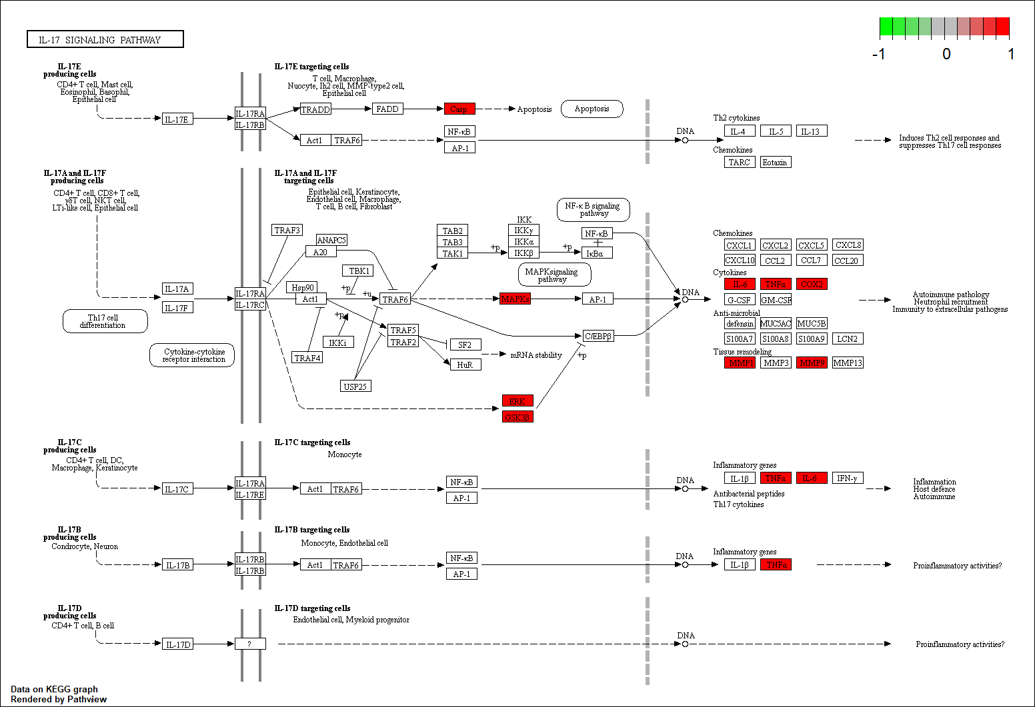
Additional file 5. IL-17 signaling pathway in KEGG pathway analysis

