Supplementary Materials for
Variable Stiffness Electronics by Chemically Sinterable Phase-Change Metal Ink with Versatile Solution Processes

Simok Lee, Gun-Hee Lee et al.
*Corresponding authors: St.P. (stevepark@kaist.ac.kr) Se.P. (seongjunpark@snu.ac.kr) J.-W.J. (jjeong1@kaist.ac.kr)

The PDF file includes:
Table S1
Note S1
Figs. S1 to S27
Legends for videos S1 and S2

Other Supplementary Materials for this manuscript include the following:
Supplementary videos S1 and S2

Supplementary Table. 1 | Comparison of commercial PCB and STAR ink-based T-PCB

 | Rigid PCB (Standard) | Flexible PCB | STAR ink-based T-PCB  (This work)
Minimum line width | 0.0762 mm | 0.06 mm | 0.05 mm
Minimum spacing | 0.0762 mm | 0.06 mm | 0.05 mm
Minimum hole size | 0.15 mm | 0.15 mm | 0.05 mm
Circuit material | Copper | Copper | STAR ink  (Gallium, Hydrophilic polymer)
Circuit conductivity | 5.96×10⁷ S/m at 20 °C | 5.96×10⁷ S/m at 20 °C | 2.27×10⁶ S/m at 15 °C  1.78×10⁶ S/m at 35 °C
Multilayering capability | O | O | O
Stiffness tunability | X | X | O

Supplementary Note. 1 | Arduino codes loaded in microcontrollers
Microcontroller (Atmega328Pau)
#include <Wire.h> // Include Wire library for I2C communication
#include <Adafruit_GFX.h> // Include Adafruit Graphics library for drawing shapes, text, etc.
#include <Adafruit_SSD1306.h> // Include Adafruit SSD1306 library to control the OLED display
#include <Keypad.h> // Include Keypad library for interfacing with the keypad
#define SCREEN_WIDTH 128 // Define OLED display width in pixels
#define SCREEN_HEIGHT 64 // Define OLED display height in pixels

// Define pins for OLED display
#define OLED_MOSI 9
#define OLED_CLK 10
#define OLED_DC 11
#define OLED_CS 12
#define OLED_RESET 13
// Initialize Adafruit SSD1306 display
Adafruit_SSD1306 display(SCREEN_WIDTH, SCREEN_HEIGHT,
OLED_MOSI, OLED_CLK, OLED_DC, OLED_RESET, OLED_CS);
// Define keypad layout and pins
const byte ROWS = 4;
const byte COLS = 4;
char keys[ROWS][COLS] = {
{ '1', '2', '3', '+' },
{ '4', '5', '6', '-' },
{ '7', '8', '9', '*' },
{ 'C', '0', '=', '/' }
};
byte rowPins[ROWS] = { A1, A3, 4, 6 };
byte colPins[COLS] = { A0, A2, 3, 5 };
Keypad keypad = Keypad(makeKeymap(keys), rowPins, colPins, ROWS, COLS);

// Variables for calculator funtionality
float num1 = 0;
float num2 = 0;
float result = 0;
char op = '?';
bool calculationDone = false;
bool flag_num12 = true; // True if inputting first number, false for second
char step = '1'; // Current step in calculation (1 = num1, 2 = op, 3 = num2)
char mode = '0'; // Current mode ( 0 = mode selection, 1 = calculator, 2 = PPG)

// Variables for PPG (Photoplethysmogram) functionality
unsigned long lastBeatTime = 0; // Time of last detected heart beat
int peakThreshold = 500; // Threshold for detecting a beat
bool isPeakDetected = false;
int bpm = 0; // bpm = Beats per minute
unsigned long measurementStartTime = 0; // Start time for BPM measurement
const unsigned long measurementInterval = 6000; // Measurement interval (6 seconds)
bool measuring = false; // True if currently measuring BPM

void setup() {
// Initialization code for display and serial communication
display.begin(SSD1306_SWITCHCAPVCC);
display.clearDisplay();
display.setTextColor(WHITE);
display.setTextSize(1);
display.setCursor(0, 0);
display.println("Calculator & PPG");
display.println("Version 3.0");
display.println(" ");
display.println("Developed by");
display.println(" Simok Lee");
display.display();
delay(3000);
display.begin(SSD1306_SWITCHCAPVCC);
display.clearDisplay();
display.setTextColor(WHITE);
display.setTextSize(1);
display.setCursor(0, 0);
display.println("Select Mode:");
display.println("1: Calculator");
display.println("2: PPG");
display.display();
Serial.begin(9600);
}

void loop() {
// Main program loop handling mode selection, calculator functionality, and PPG functionality
char key = keypad.getKey();
// Resets to mode selection if ‘C’ is pressed
if (key == 'C') {
// Resets variables and displays mode selection screen
mode = '0';
num1 = num2 = result = 0;
op = '?';
calculationDone = false;
flag_num12 = true;
step = '1';
display.clearDisplay();
display.setTextSize(1);
display.setCursor(0, 0);
display.println("Select Mode:");
display.println("1: Calculator");
display.println("2: PPG");
display.display();
return; // Exits current iteration of loop
}

// Mode selection logic (1 = Calculator mode, 2 = PPG mode)
if (mode == '0') {
if (key == '1') {
mode = '1';
display.clearDisplay();
} else if (key == '2') {
mode = '2';
display.clearDisplay();
}
} else if (mode == '1') { // Calculator Mode
display.setTextSize(2);
if (!calculationDone) {
if (step == '1') {
display.clearDisplay();
display.setCursor(0, 0);
display.print(num1, 1);
} else if (step == '2') {
display.clearDisplay();
display.setCursor(0, 0);
display.print(num1, 1);
display.print(op);
} else if (step == '3') {
display.clearDisplay();
display.setCursor(0, 0);
display.print(num1, 1);
display.print(op);
display.print(num2, 1);
}
display.display();

// Handles numeric and operator input
if (key != NO_KEY) {
// If ‘C’ is pressed, resets to mode selection
if (key == 'C') {
num1 = num2 = result = 0; // Reset all numbers
op = '?'; // Reset operator
flag_num12 = true; // Set flag to true to start with num1 again
step = '1'; // Reset step to 1
mode = '0'; // Back to mode selection
display.clearDisplay();
display.setTextSize(2);
display.setCursor(0, 0);
display.println("Select Mode:");
display.println("1: Calculator");
display.println("2: PPG");
display.display();
} else if (key == '+' || key == '-' || key == '*' || key == '/') {
op = key; // Stores the operator selected by the user and prepares for the second number input.
flag_num12 = false;
step = '2';
} else if (key == '=') {
calculateResult(); // Calculate the result based on num1, num2 and operator.
calculationDone = true;
flag_num12 = true;
op = '?';
step = '1';
} else if (isdigit(key)) {
// If digit is pressed, append it to the current number (num1 or num2)
if (flag_num12 == true) {
num1 = num1 * 10 + (key - '0'); // Adds the digit to num1
step = '1';
} else {
num2 = num2 * 10 + (key - '0'); // Adds the digit to num2
step = '3'; // Move to step 3
}
}
}
} else {
// If calculation is done, display the result
display.clearDisplay();
display.setCursor(0, 0);
display.print(result, 1); // Display result with 1 decimal place
display.display();
// If ‘C’ is pressed after displaying result, reset to mode selection
if (key == 'C') {
calculationDone = false;
num1 = num2 = result = 0;
op = '?';
flag_num12 = true;
step = '1';
mode = '0'; // Back to mode selection
display.clearDisplay();
display.setTextSize(1);
display.setCursor(0, 0);
display.println("Select Mode:");
display.println("1: Calculator");
display.println("2: PPG");
display.display();
}
}
} else if (mode == '2') { // PPG Mode
if (!measuring) {
measuring = true;
measurementStartTime = millis(); // Record the start time
display.clearDisplay();
display.setCursor(0, 0);
display.setTextSize(2);
display.print("Measuring BPM...");
display.display();
} else {
// Read PPG signal
int sensorValue = analogRead(A5); // Read sensing value from analog pin A5
Serial.println(sensorValue); // Print sensor value to serial monitor

// Detect peak in PPG signal
if (sensorValue > peakThreshold && !isPeakDetected) {
isPeakDetected = true;
unsigned long currentTime = millis();
unsigned long beatInterval = currentTime - lastBeatTime;
lastBeatTime = currentTime;

// Check if beatInterval is above a minimum to avoid noise
if (beatInterval > 250) { // Minimum beat interval (250 ms)
bpm = 60000 / beatInterval; // Calculate BPM
Serial.print("BPM: ");
Serial.println(bpm);
}
} else if (sensorValue < peakThreshold) {
isPeakDetected = false;
}

// Display BPM after the measurement period
if (millis() - measurementStartTime > measurementInterval) {
measuring = false;
display.clearDisplay();
display.setCursor(0, 0);
display.setTextSize(2);
display.print("BPM: ");
display.println(bpm);
display.display();
delay (3000);
}
}
}
}

void calculateResult() {
// Function to perform calculation based on operator
switch (op) {
case '+':
result = num1 + num2;
break;
case '-':
result = num1 - num2;
break;
case '*':
result = num1 * num2;
break;
case '/':
if (num2 != 0) {
result = num1 / num2;
} else {
display.setTextSize(1);
display.clearDisplay();
display.setCursor(0, 0);
display.print("Error: Div by 0");
display.display();
delay(2000);
}
break;
}
num1 = result;
num2 = 0;
}

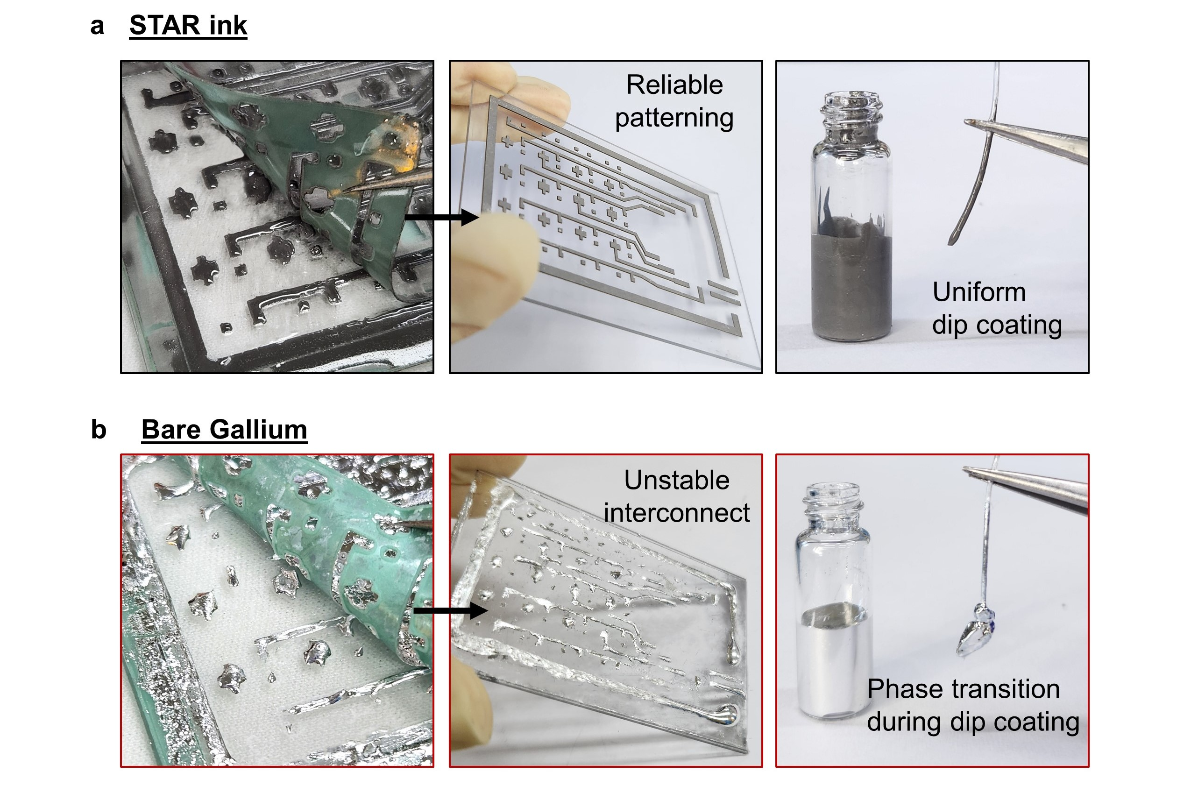

Supplementary Fig. 1 | Photograph of solution process with STAR ink and bare gallium. The low surface tension, good wettability, and tunable viscosity of STAR ink enable various solution processes including screen printing and dip coating, unlike bulk gallium.
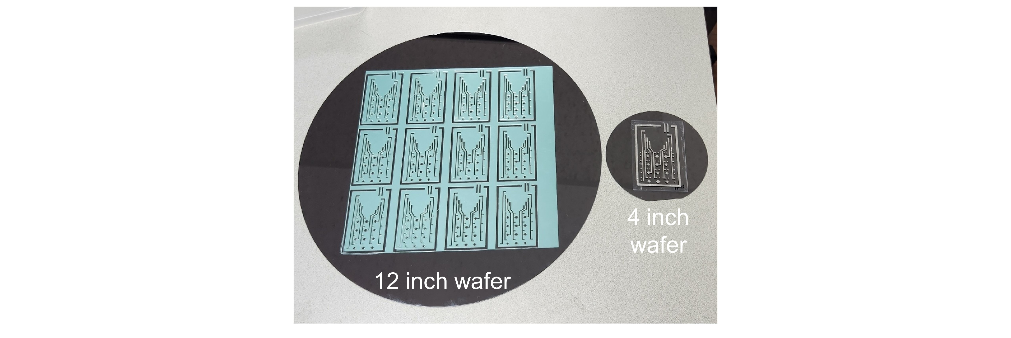

Supplementary Fig. 2 | Mask for large-scale TES fabrication through solution process of STAR ink.
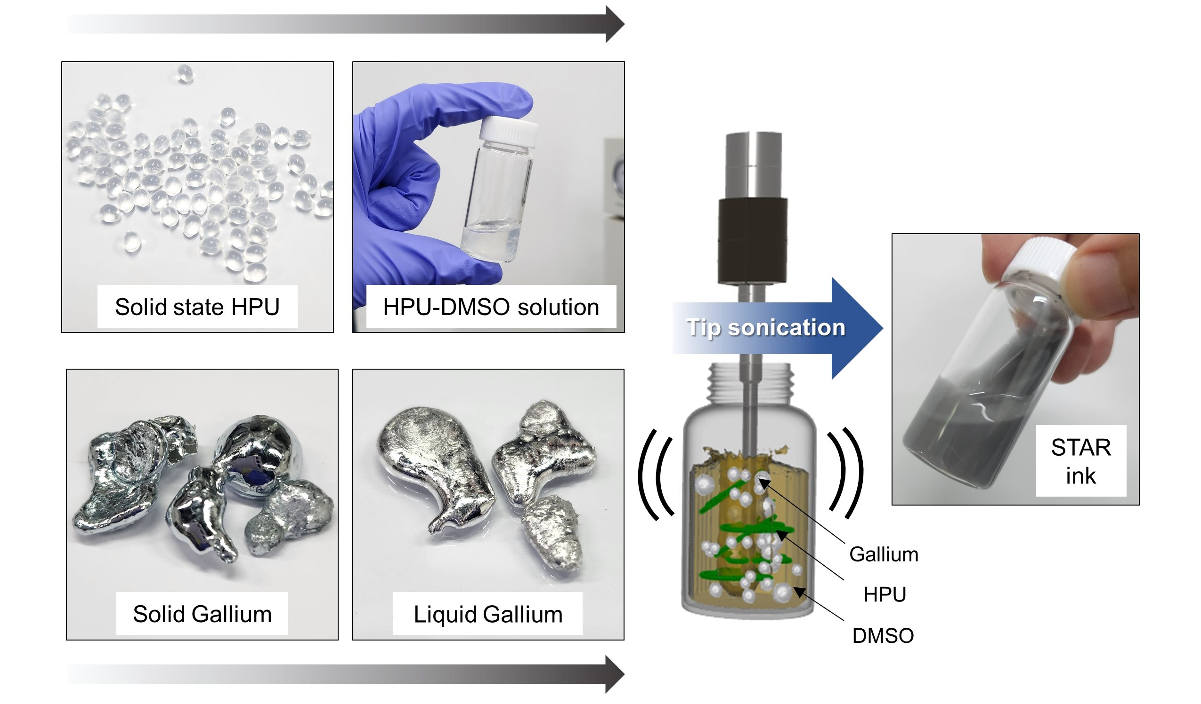
Supplementary Fig. 3 | Schematic illustration of STAR ink fabrication process.
To fabricate STAR ink, hydrophilic polyurethane (HPU) dissolved in dimethyl sulfoxide (DMSO) and liquid-state gallium is tip sonicated.

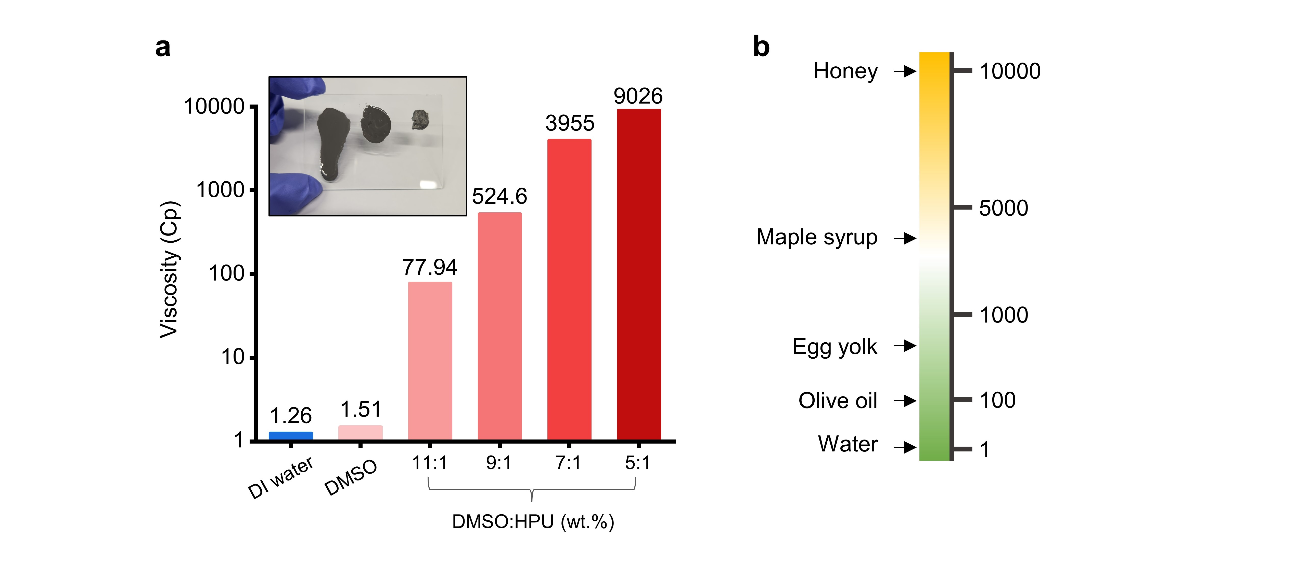
Supplementary Fig. 4 | Viscosity comparison of various solutions. a, Viscosity measurements of DMSO-HPU solutions with varying DMSO solvent ratios using a Lamy Rheology RM 100 CP2000 PLUS instrument. Measurements were conducted at 70°C for 40 seconds at 600 rpm using a cp 6010 cone. Inset: Photograph showing a visual comparison of inks with different viscosities on a tilted glass substrate, demonstrating the flow behavior of various DMSO-HPU solutions. b, Comparison of viscosities of common materials encountered in daily life, measured at room temperature (20-24°C).
The results demonstrate that pure DMSO exhibits viscosity similar to water, while increasing the HPU ratio in the solution leads to viscosities comparable to honey. This range of viscosities allows for tuning of the STAR ink properties for various applications.

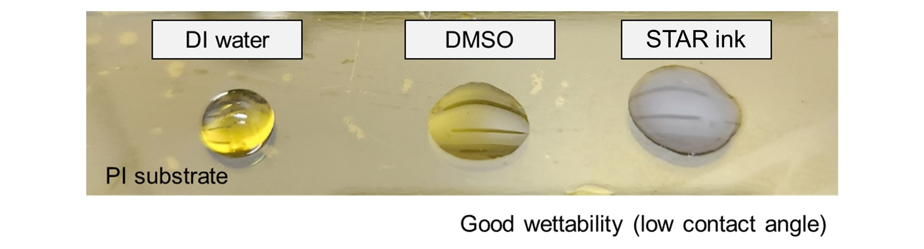
Supplementary Fig. 5 | Wettability of STAR ink.
The good wettability of STAR ink is evidenced by its low contact angle, even on hydrophobic polyimide (PI) surfaces. DMSO, the solvent used in STAR ink, exhibits a low contact angle of 12°, surpassing that of water (76°). This low contact angle of DMSO contributes to the excellent wettability of STAR ink, which shows a similarly low contact angle of 13°. The enhanced wettability of STAR ink, inherited from its DMSO solvent, is crucial for various solution-based fabrication processes, including screen printing, nozzle printing, and dip coating.

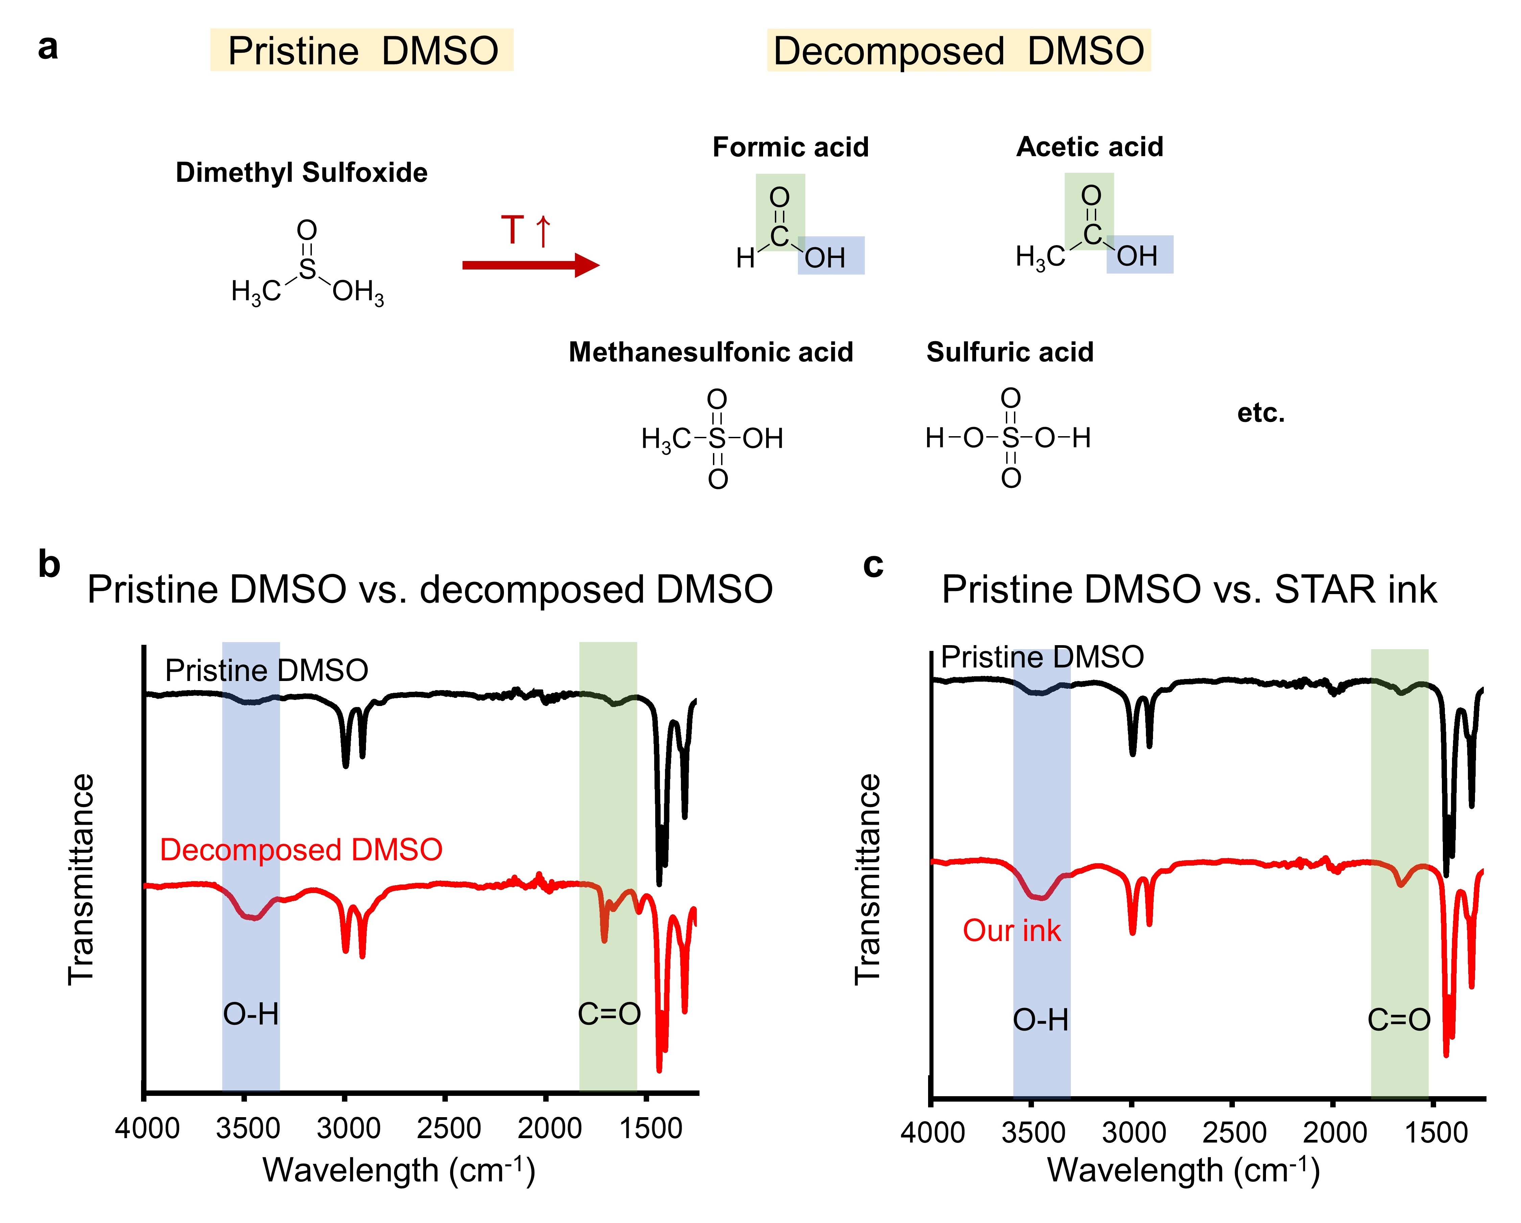
Supplementary Fig. 6 | Decomposition of DMSO. a, Decomposition of DMSO b, FTIR spectra of pure DMSO and decomposed DMSO. c, FTIR spectra of DMSO and STAR ink
DMSO undergoes chemical decomposition under thermal and mechanical stimuli, resulting in the formation of acidic components and converting it into an acidic solvent. The decomposition of DMSO leads to the presence of OH groups, as observed in the FTIR data. This phenomenon is also evident in our STAR ink, confirming the decomposition of DMSO during the fabrication process of STAR ink.

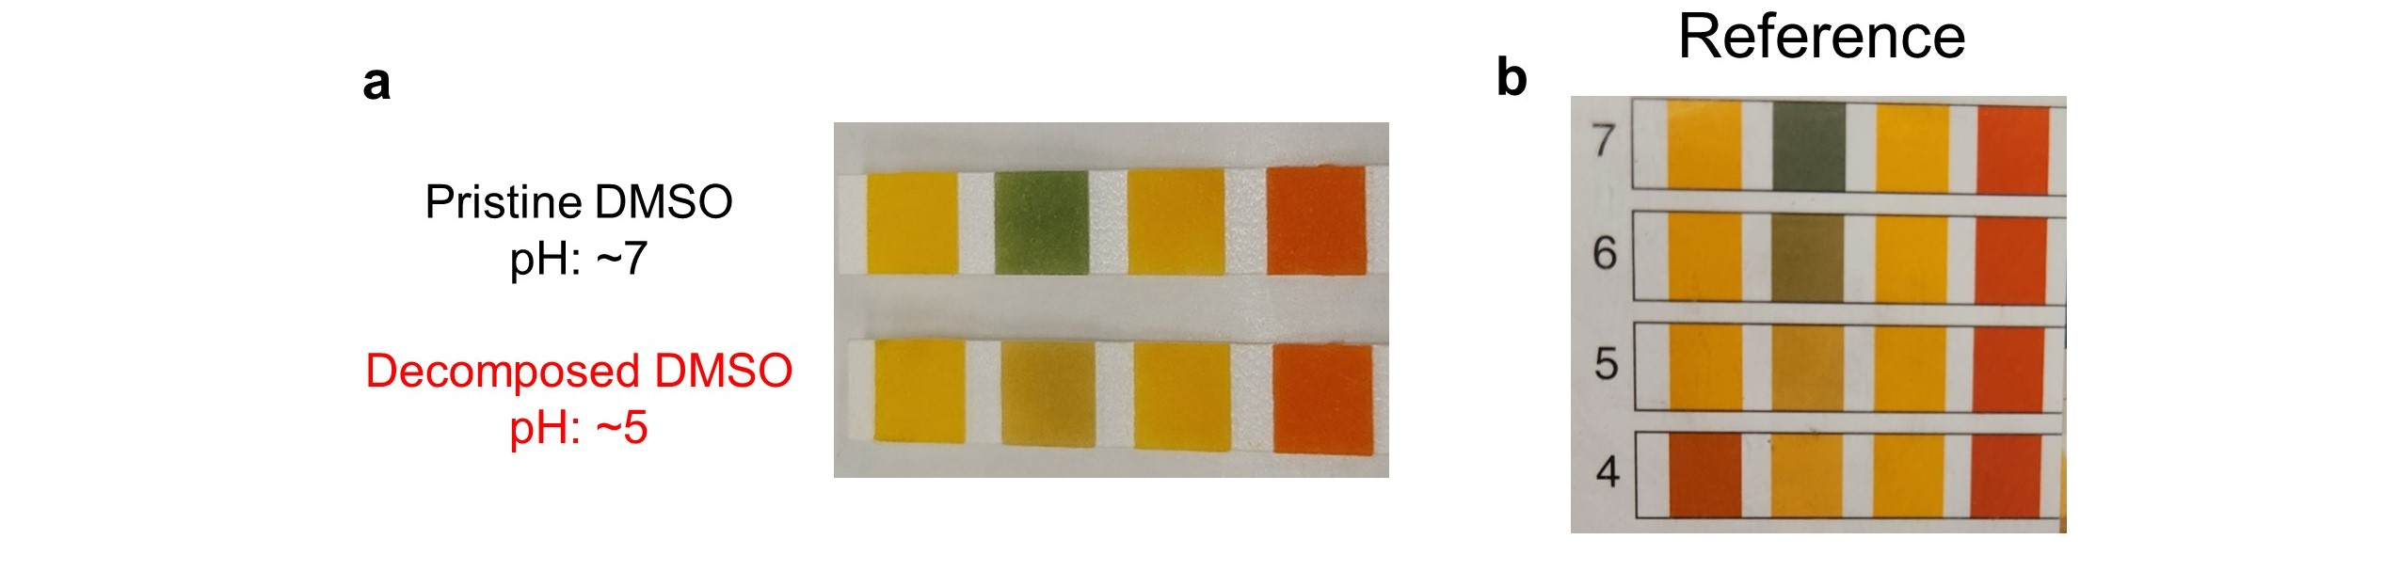

Supplementary Fig. 7 | Acidity of decomposed DMSO. a, pH of pristine DMSO and decomposed DMSO at room temperature 26.5°C b, pH reference.
The decomposition of DMSO converts it into an acidic solvent.

Supplementary Fig. 8 | Gallium composite fabrication with acid. a, Photograph of ink with acid. b, Photograph of film fabricated with acid.
If we were to fabricate STAR ink with acetic acid instead of DMSO, reduction of gallium particles would occur, hindering the dispersion of particles. Additionally, the acidic nature of acetic acid could damage the hydrophilic PU, resulting in the formation of several voids.

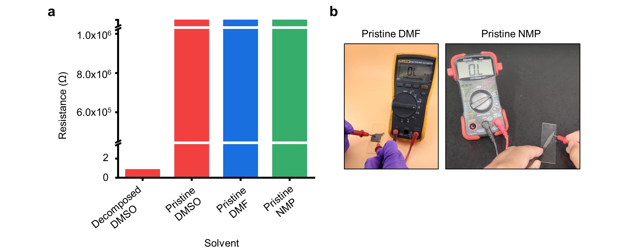

Supplementary Fig. 9 | Electrical properties of STAR ink created with various solvents. a, Resistance measurements of STAR ink prepared using DMSO, DMF, and NMP. b, Photographs of films fabricated with pristine DMF and NMP, demonstrating their non-conductive nature.
DMSO-based STAR ink shows high conductivity due to acid generation during sonication, while samples prepared with DMSO in an ice bath exhibit no conductivity. STAR ink created with “pristine” DMF or NMP (which do not produce acids at high temperatures) remain non-conductive, highlighting the crucial role of in-situ acid generation in the chemical sintering process.

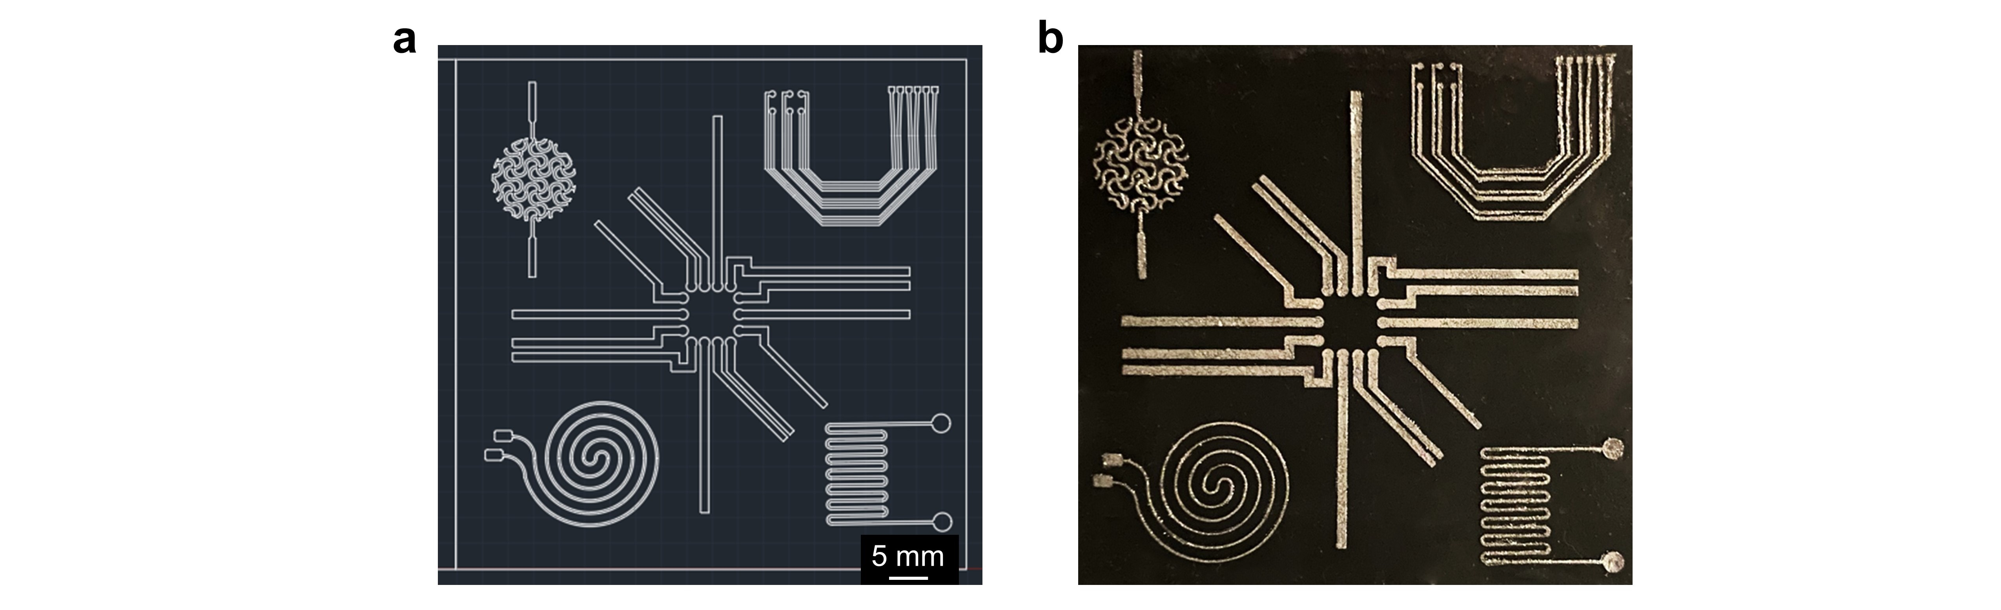

Supplementary Fig. 10 | High-resolution pattering of STAR ink. a, Mask design used for screen printing. b, Photograph of fabricated pattern using the mask.
The good wettability and low surface tension of STAR ink, coupled with its tunable viscosity, enable the creation of high-resolution and complex pattern.



Supplementary Fig. 11 | OM image of bottom interface of sonicated gallium particles with different types of solvent.
To see the gallium particle behavior, we sonicated gallium particles using different types of solvent and compared the bottom interface of samples. Only the decomposed DMSO, which exhibits acidity, facilitates the sintering of gallium particles.

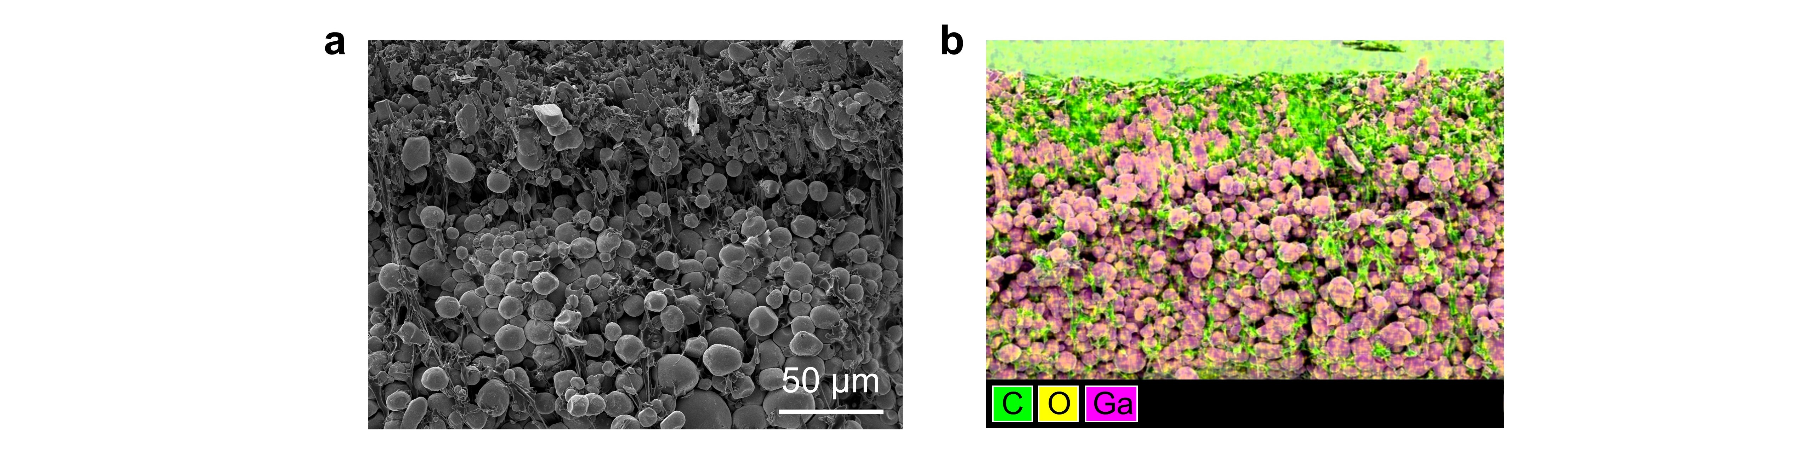

Supplementary Fig. 12 | Side view of STAR ink fabricated with inactivated DMSO.
The lack of acidity in inactivated DMSO prevents the sintering of the STAR ink, resulting in the microparticle morphology of the STAR ink without sintering.

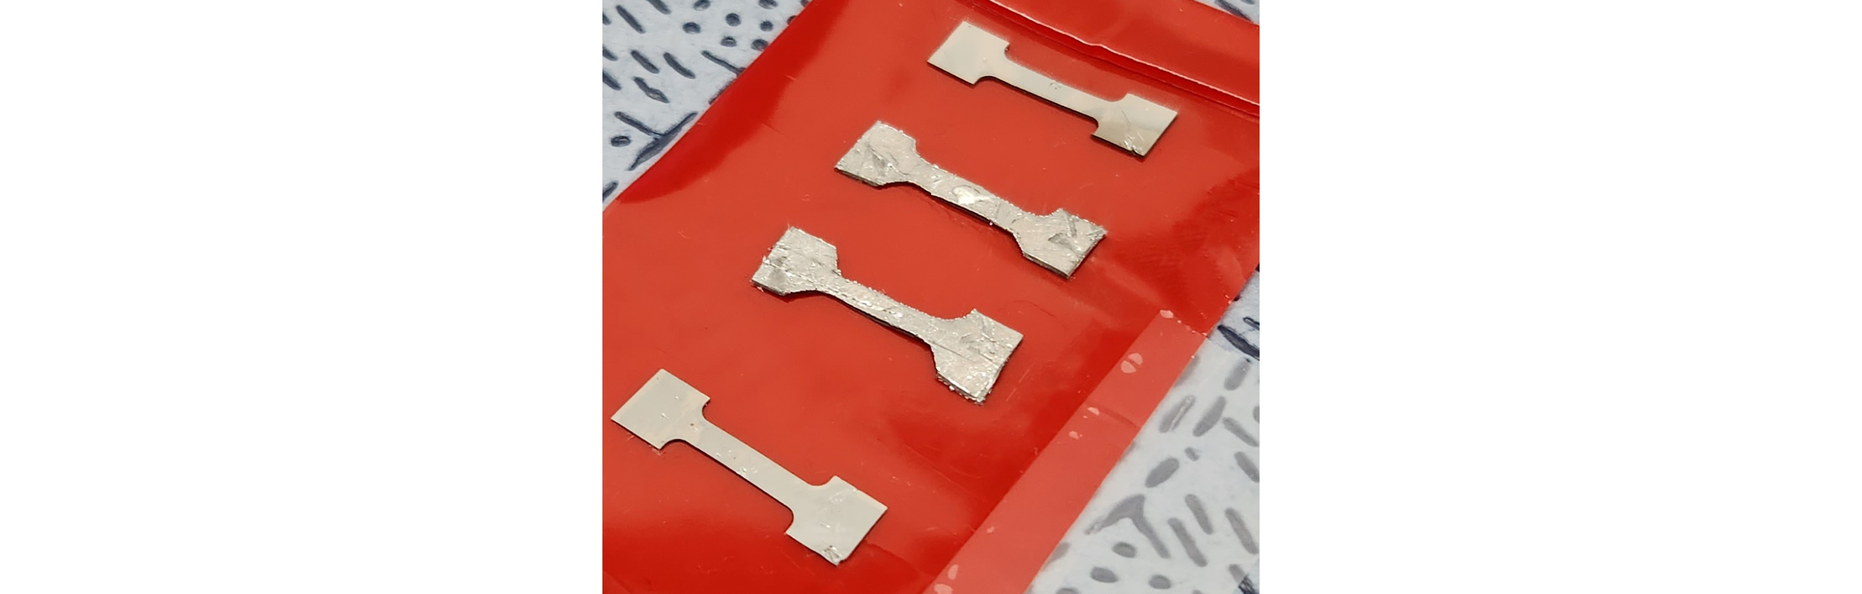

Supplementary Fig. 13 | Dog-bone shaped STAR ink-based TES.
The STAR ink-based TES is printed on dog-bone shape to measure its mechanical property.

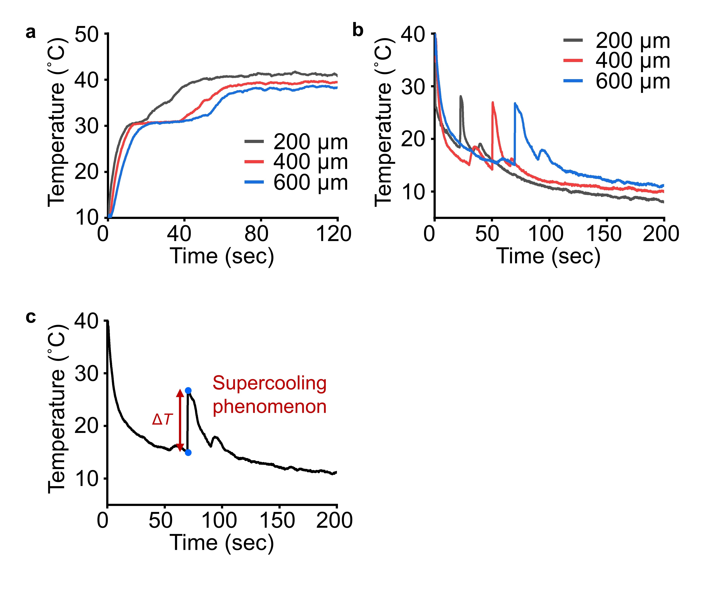
Supplementary Fig. 14 | Plot illustrating phase transition of STAR ink-based TES with different thicknesses. a, Solid-to-liquid phase transition. b, Liquid-to-solid phase transition. c, Supercooling phenomenon during liquid-to-solid phase transition.

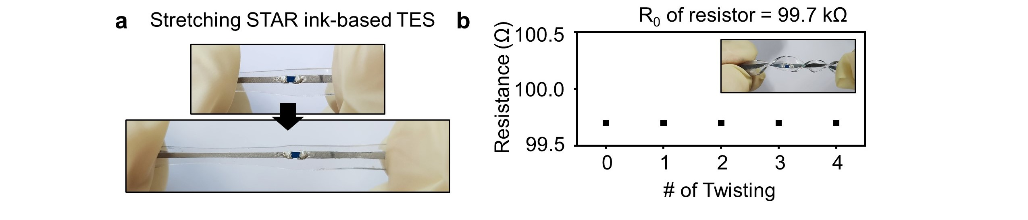

Supplementary Fig. 15 | Robust integration of resistor with STAR ink-based TES. a, Photographs showing a resistor integrated on TES using STAR ink, undergoing stretching. b, Resistance values of resistors integrated on STAR ink-based TES subjected to varying number of twisting.

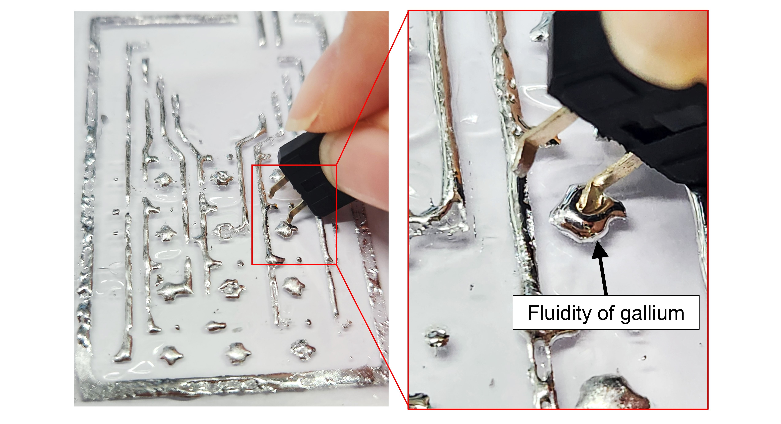

Supplementary Fig. 16 | Challenges of integrating electronic component with bare gallium
Due to the fluidity of bare gallium, integrating electronic component with gallium-based electrodes is impractical.

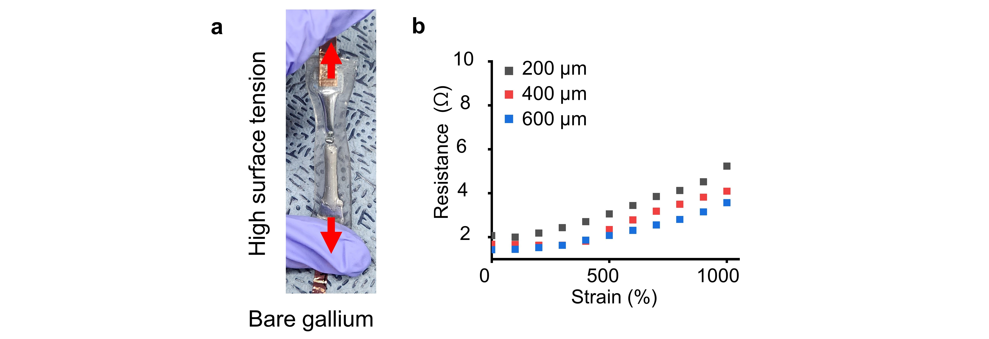

Supplementary Fig. 17 | Stretchability of bare gallium and STAR ink-based TES. a, Photograph of bare gallium under stretching. b, Resistance variation in STAR ink-based TES of different thicknesses during stretching.
Due to its high surface tension, bare gallium tends to merging during stretching, limiting its stretchability. In contrast, STAR ink is covered with an elastomer matrix, allowing for enhanced stretchability.
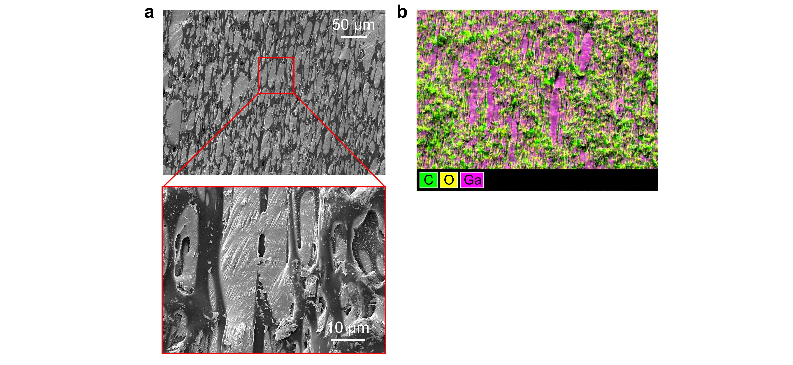

Supplementary Fig. 18 | SEM image of stretched STAR ink. a, SEM image of STAR ink under strain. b, EDS image of STAR ink.
The elastomer matrix covering the gallium imparts mechanical stability, enabling longer elongation of the liquid-phase gallium.



Supplementary Fig. 19 | Resistance variation of STAR ink-based TES during repeated stretching cycles.
The elastomer matrix covering the gallium imparts mechanical stability, enabling stable operation under repeated mechanical stimuli. The inset shows magnified views of the graphs in the red boxed parts.

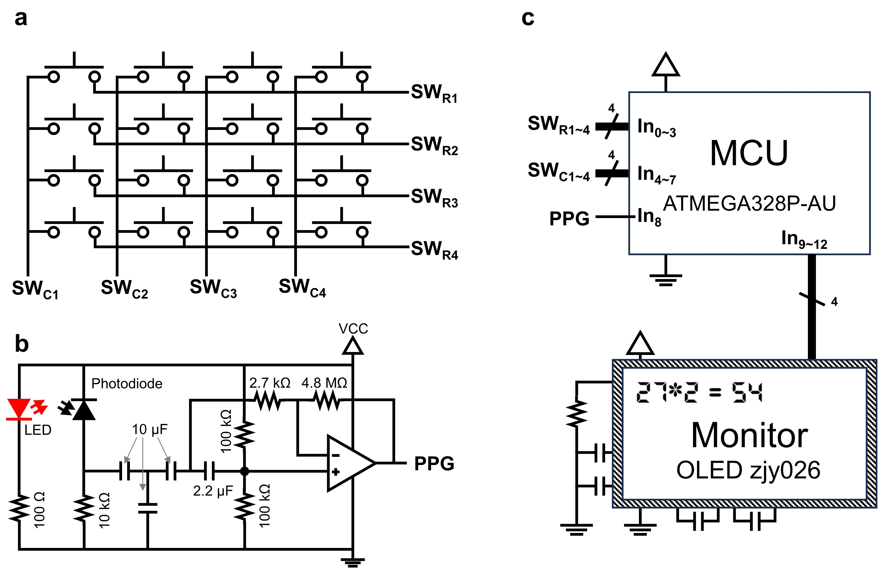

Supplementary Fig. 20 | Circuit diagram and design rationale for a multifunctional transformative PCB (t-PCB) integrating a PPG sensor and computing machine. a, Circuit diagram for the computing machine part. b, Circuit diagram for the PPG sensor part. c, Design rationale for the entire t-PCB, which integrates two functions: PPG sensor and computing machine.
This circuit features a dual-mode operation: a desktop electronic calculator in its rigid mode for numerical tasks and a wearable PPG sensor in its soft mode for health monitoring. It includes an integrated OLED display for real-time monitoring of either calculation process or heartbeat from PPG data. The calculator part operates through inputs from a 4 x 4 push-button switch array (detailed in Supplementary Note 1), which includes 10 numeric buttons (0-9) and 6 function buttons (+, -, X, %, =, and mode selection button), feeding into 8 inputs of the microcontroller (Atmega328Pau, Mouser). The PPG sensor part analyze the raw PPG signals using the microcontroller to compute heart rate. Results from both the calculator and PPG sensor are displayed on a 0.96-inch OLED screen (zjy026, ICBANQ). Further details on the operating principles are available in the Methods section.

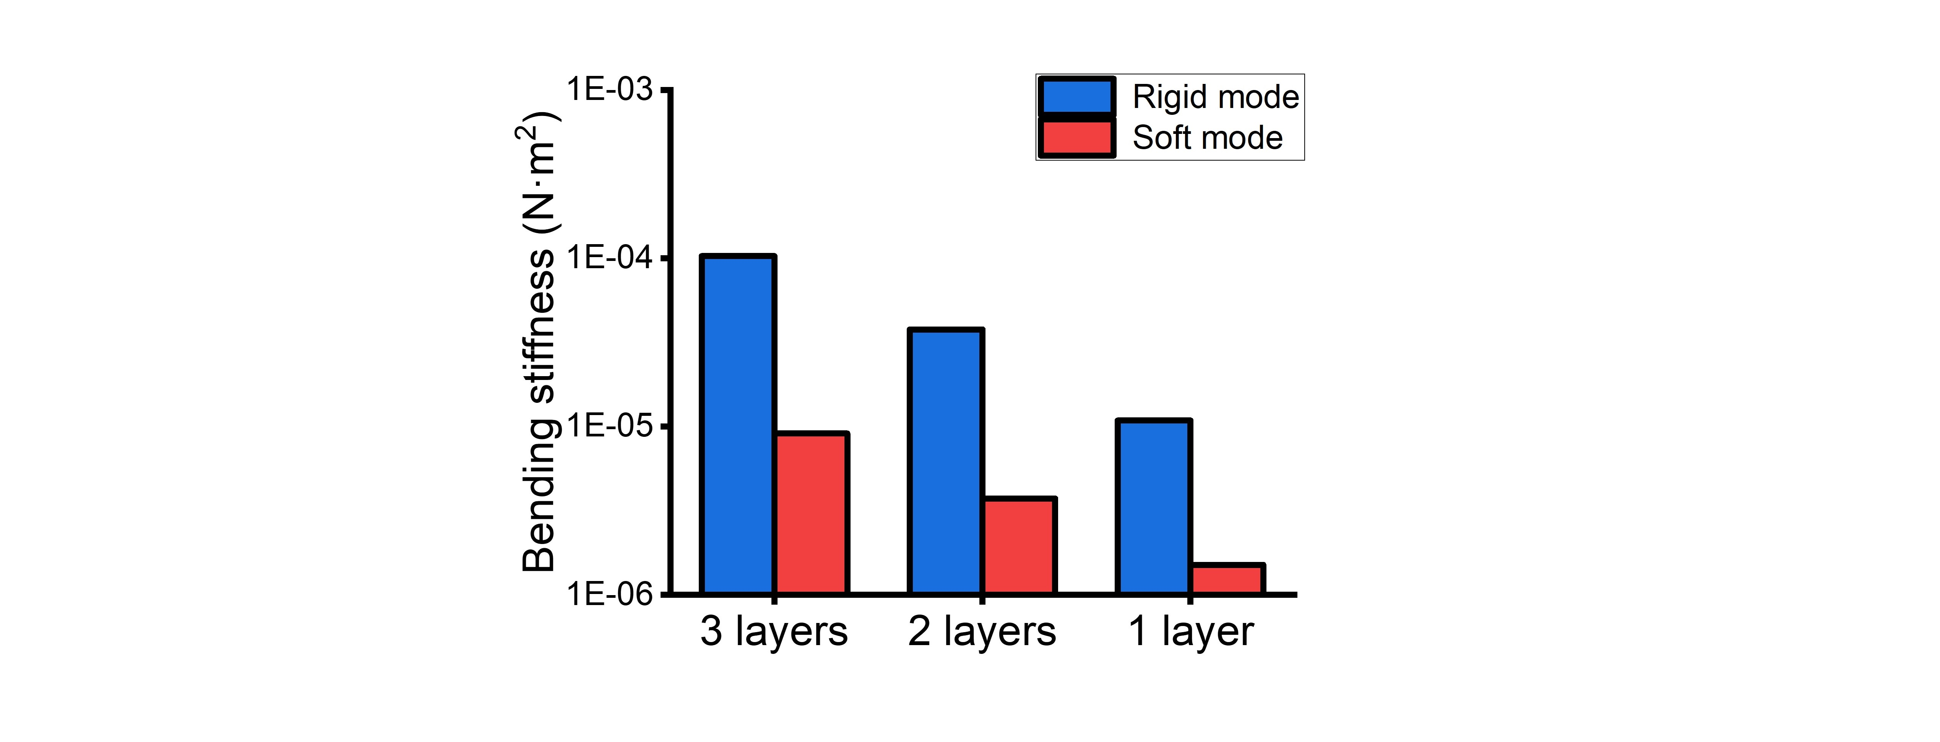
Supplementary Fig. 21 | Bending stiffness of T-PCB with various number of layer.
Each layer, measuring 5 mm in width, 10 mm in length, and 500 μm in thickness, was printed onto a 65 μm-thick PDMS substrate.

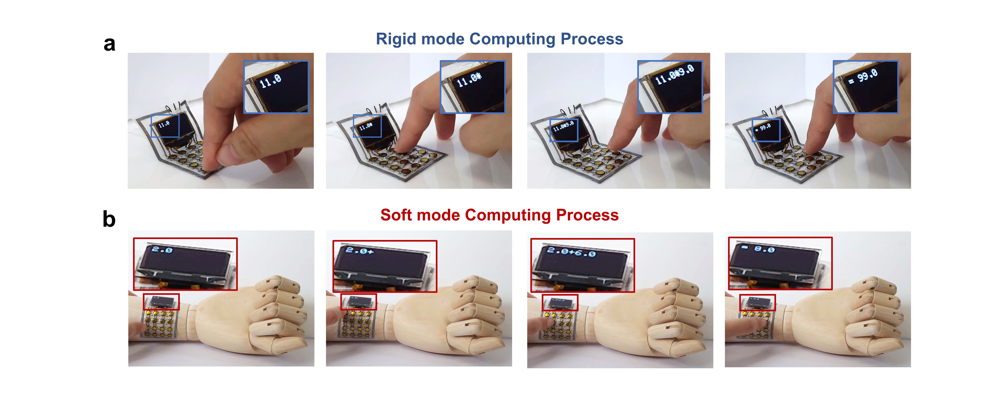
Supplementary Fig. 22 | Computing process uisng T-PCB. a, In a soft mode, T-PCB flexibly atttaches to the arm, facilitating mobile computing. b, In rigid mode, the T-PCB enables computing process while folded, simiolar to a desktop setup.
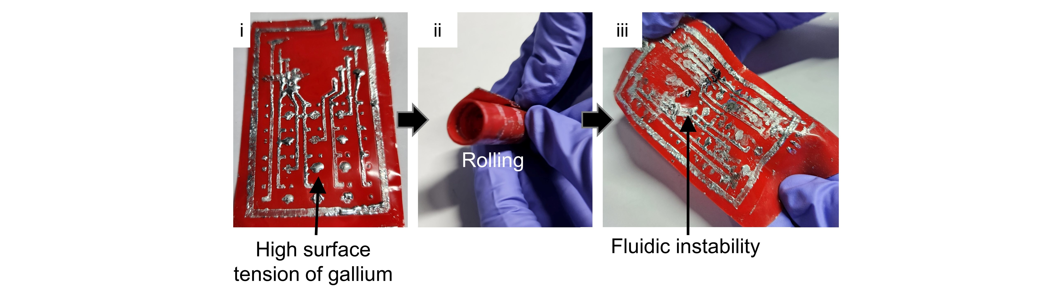

Supplementary Fig. 23 | Challenges of bare gallium in circuit fabrication and storage.
The high surface tension of bare gallium impedes fine patterning, and its fluidic instability prevents stable rolling of the circuit, a necessary feature for compact storage.

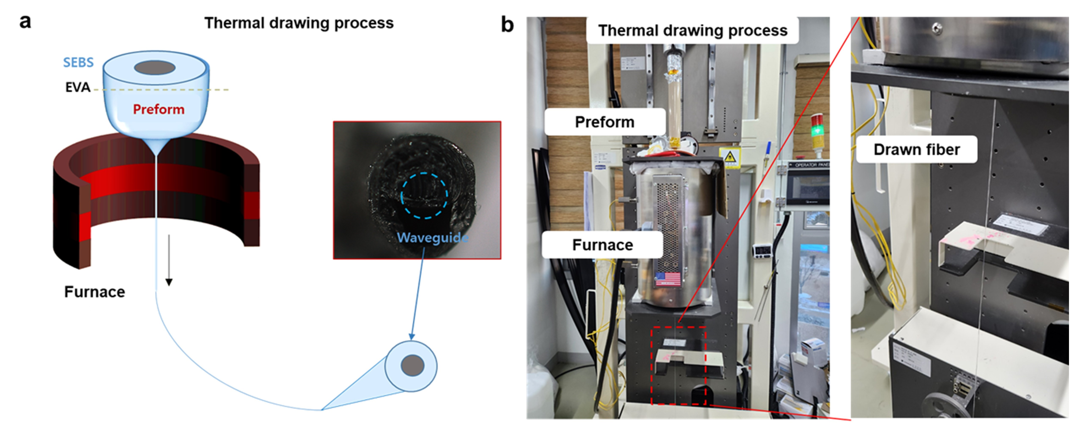

Supplementary Fig. 24 | Fabrication of soft optical fiber. a, Schematic illustrations of thermal drawing process (TDP) of soft optical fiber. b, Photograph of TDP of soft optical fiber
For optogenetic applications with STAR ink, all soft fibers are fabricated through the TDP process using soft Styrene-Ethylene-Butylene-Styrene (SEBS) and Ethylene-vinyl acetate (EVA) elastomer.

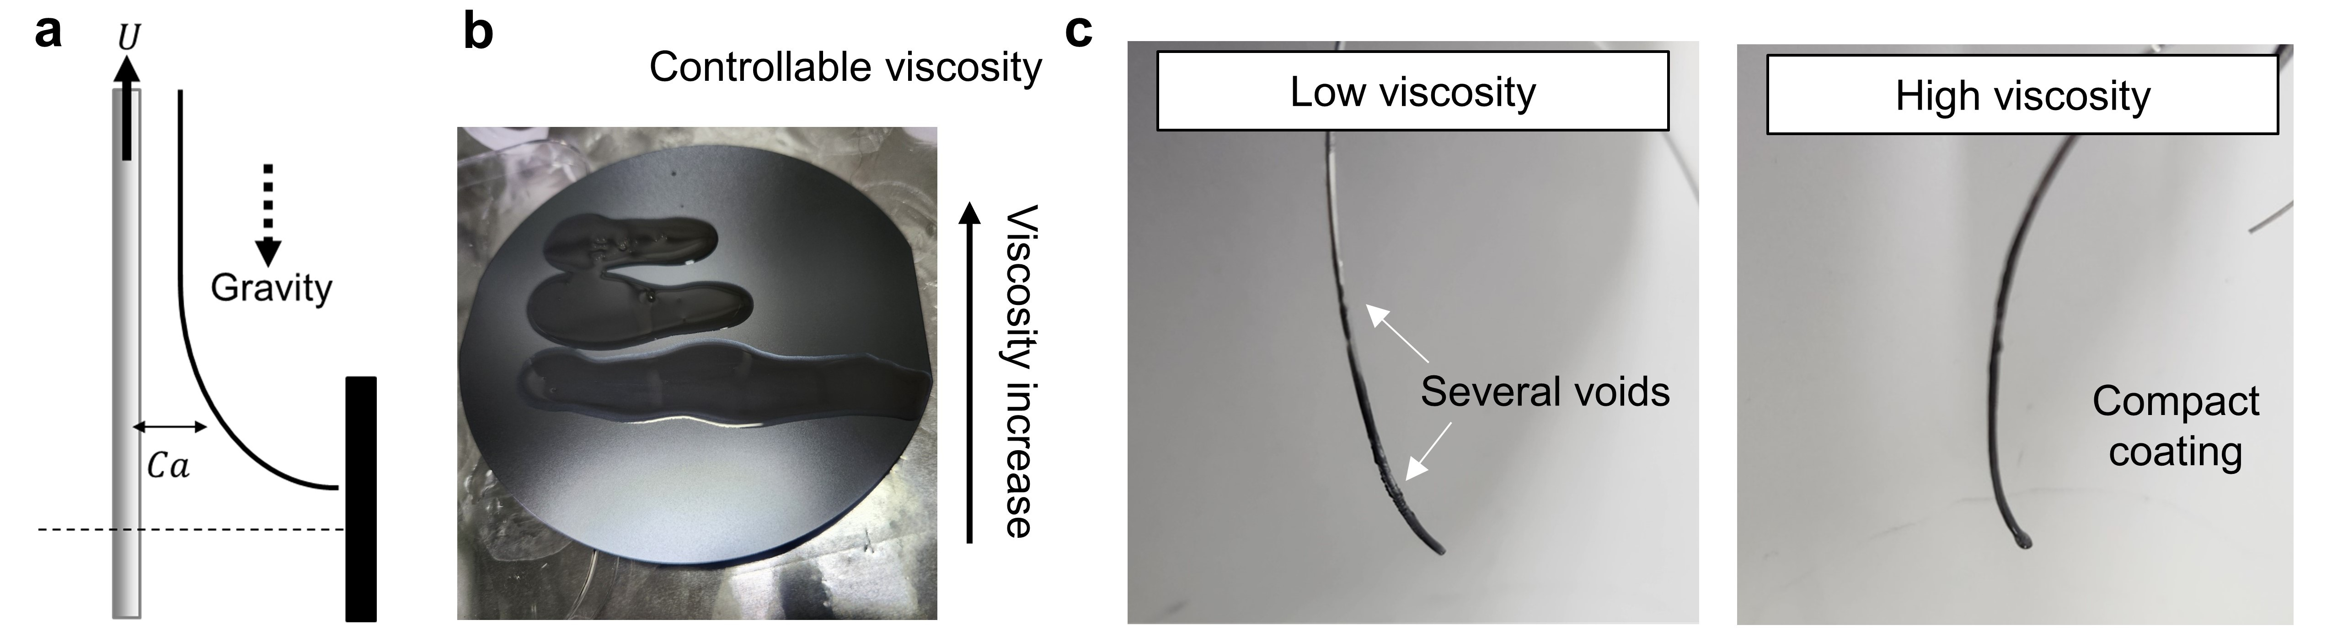

Supplementary Fig. 25 | Dip-coating of STAR ink on fiber. a, Schematic illustration of dip-coating on fiber. b, Photograph of STAR ink with various viscosity. c, Photograph of dip-coated fiber. STAR ink with high viscosity results in a compact coating on the fiber through STAR ink.
In the context of dip-coating, the capillary number (Ca) plays a crucial role in determining the initial thickness of the solution coating. If the Ca value is too low, it means that the force due to viscosity is insufficient to lift the particles upward along the moving fiber. The capillary number (Ca) is calculated using the formula Ca=μU/σ, where μ represents the viscosity and σ denotes the surface tension of the solvent. Therefore, having a high viscosity of the STAR ink is advantageous as it enables a compact coating. The viscosity of the STAR ink, which includes the polymer, can be easily adjusted by adding more polymer. This high viscosity of the STAR ink facilitates the formation of a dense and thick coating on the fiber during the dip-coating process.

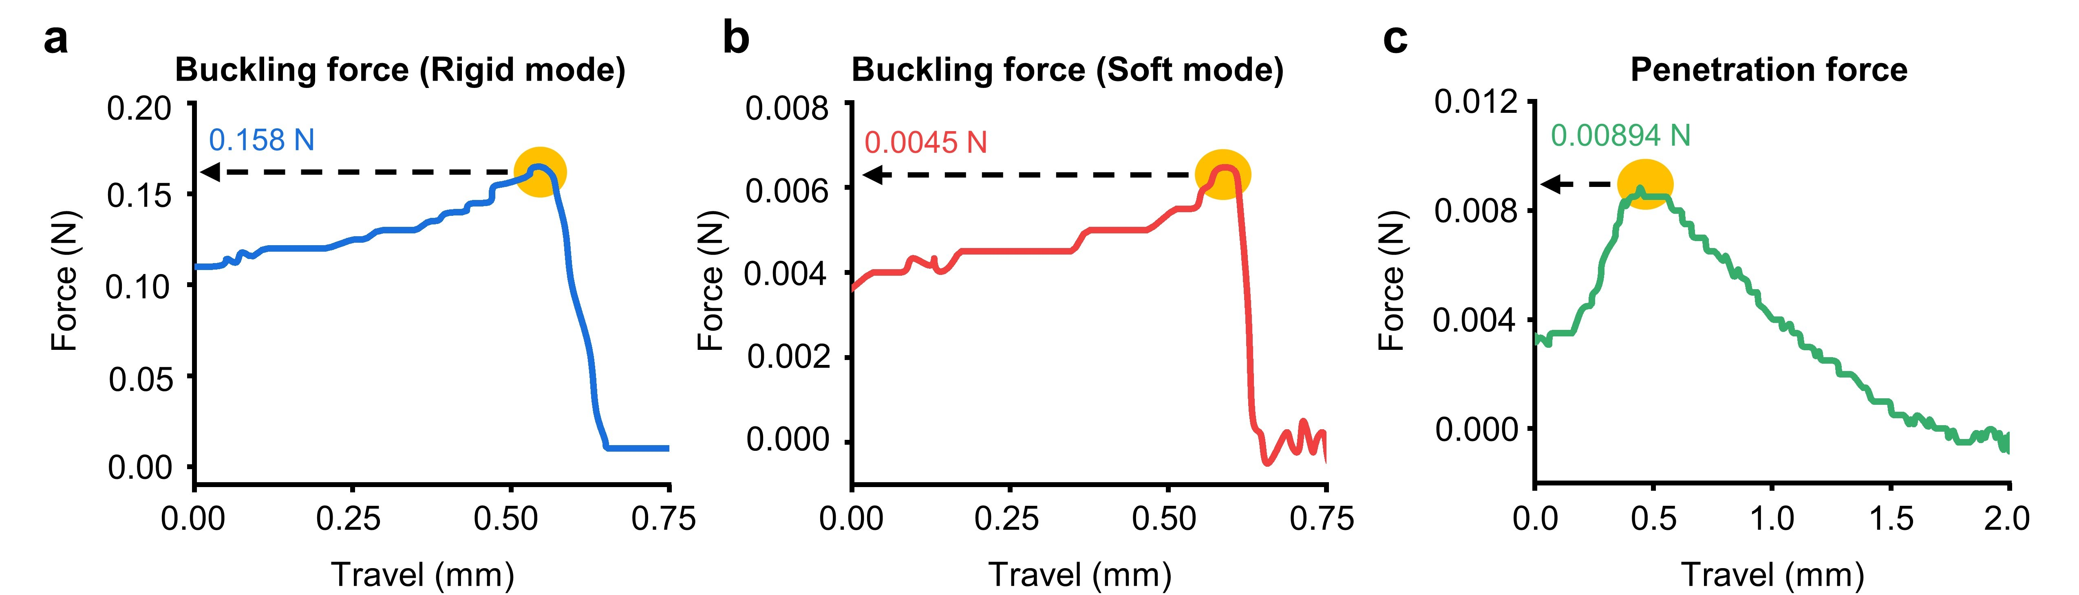

Supplementary Fig. 26 | Insertion test of the STAR probe. a, b, Force profile during compression of the STAR probe in the rigid mode (a) and soft mode (b) to analyze the buckling force. c, Force profile during insertion of the rigid STAR probe in a brain mimicking 0.6 wt.% agarose gel to calculate the penetration force.
Buckling force represents the maximum force a sample can withstand before bending, whereas penetration force is the minimum force required to penetrate a sample. Given that the penetration force falls between the buckling forces for the probe in soft and rigid modes, only rigid state STAR probe is capable of penetrating the brain, while the soft state probe bends before achieving penetration.

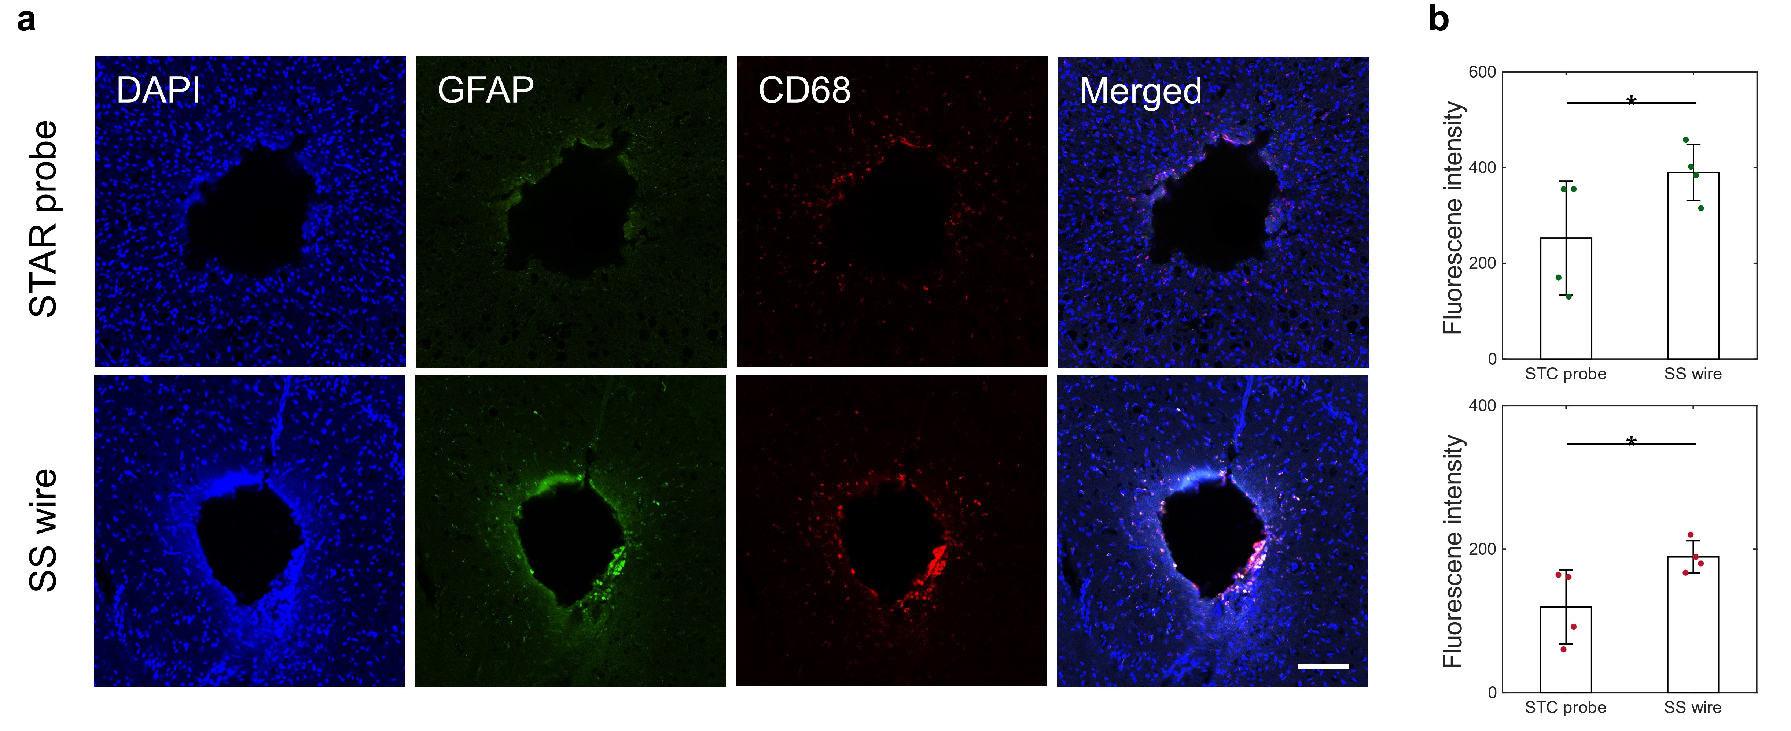
Supplementary Fig. 27 | In vivo biocompatibility of STAR probe. a, Representative confocal images of STAR probe or the stainless-steel wire. Immunohistochemistry staining shows DAPI (blue; 4′,6-diamidino-2-phenylindole) and expression of GFAP (green; glial fibrillary acidic protein) and CD68 (red; cluster of differentiation 68 protein). b, Fluorescent intensity quantifies the expression of GFAP and CD68 after 2 weeks implantation.
Data are means ± standard deviation, n=4 animals per implant. The statistical analysis is one-tailed test. GFAP: P=0.0425, t=-2.0600; d.f. = 6 , CD68: P=0.0241, t=-2.4724; d.f. = 6 (*P < 0.05, paired t test)

Supplementary Video 1. Rigid-to-soft and soft-to-rigid mode conversion of a STAR TES based on phase transition. This video demonstrates the phase transition process, highlighting the nucleation initiation and subsequent phase change propagation through the interconnected gallium network within the STAR TES.

Supplementary Video 2. Demonstration of T-PCB multi-functionality: Rigid mode T-PCB operates as a tabletop computing device; soft mode T-PCB functions as a flexible computing device and wearable PPG sensor.

