Valuation model of HtrA protein of Yersinia pseudotuberculosis.

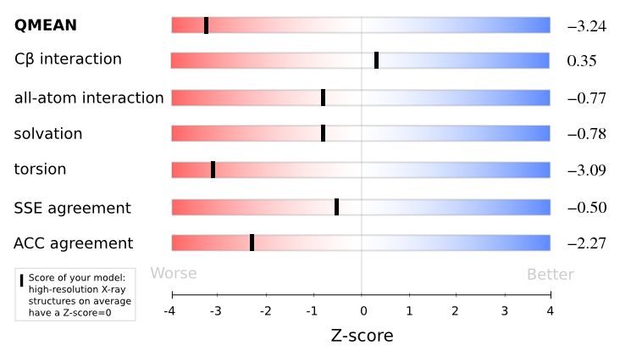

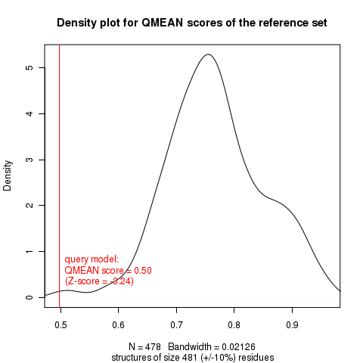

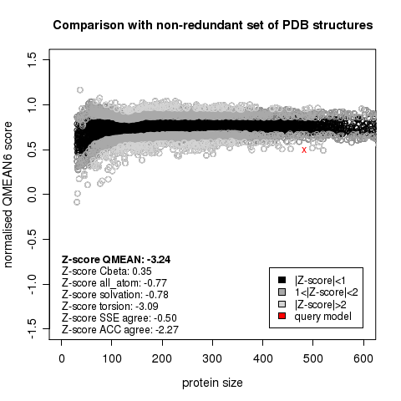

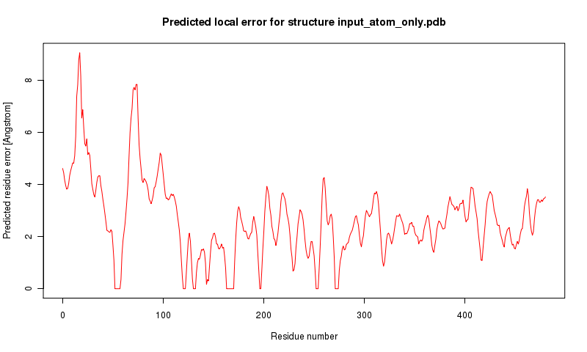

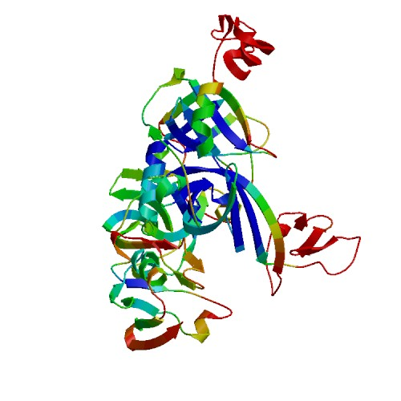

Referencias:
ANOLEA: Melo, F. and Feytmans, E. (1998) Assessing protein structures with a non-local atomic interactions energy. Journal of Molecular Biology. 277: 1141-1152

QMEAN: Benkert, P., Schwede, T. and Tosatto, SCE (2009). QMEANclust: estimation of protein model quality by combining a composite scoring function with structural density information. BMC Struct. Biol. 9: 35. doi:10.1186/1472-6807-9-35

GROMOS: W. F. van Gunsteren, S. R. Billeter, A. A. Eising, P. H. Hünenberger, P. Krüger, A. E. Mark, W. R. P. Scott, and I. G. Tironi. (1996) Biomolecular Simulation: The GROMOS96 Manual and User Guide, Vdf Hochschulverlag AG an der ETH Zürich, Zürich, Switzerland, pp. 1-1042

DFIRE: Zhou, H., and Zhou, Y. (2002). Distance-scaled, finite ideal-gas reference state improves structure-derived potentials of mean force for structure selection and stability prediction. Protein Sci. 11: 2714-2726

QMEAN: Benkert P, Biasini M, and Schwede T. (2011). Toward the estimation of the absolute quality of individual protein structure models. Bioinformatics, 27 (3): 343-50

SWISS-MODEL: Arnold K., Bordoli L., J. Kopp and Schwede T. (2006). The SWISS-MODEL workspace: a web-based environment for protein structure homology modelling. Bioinformatics, 22: 195-201.

PROCHECK: Laskowski RA, MacArthur MW, Moss DS, and Thornton JM (1993). PROCHECK: a program to check the stereochemical quality of protein structures. J. Appl. Cryst, 26, 283-291

Workunit: P000007 Htra_it2
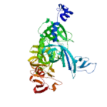

[Anolea] [DFIRE] [GROMOS] [ProCheck] Decenas locales: [+/-] [+/-]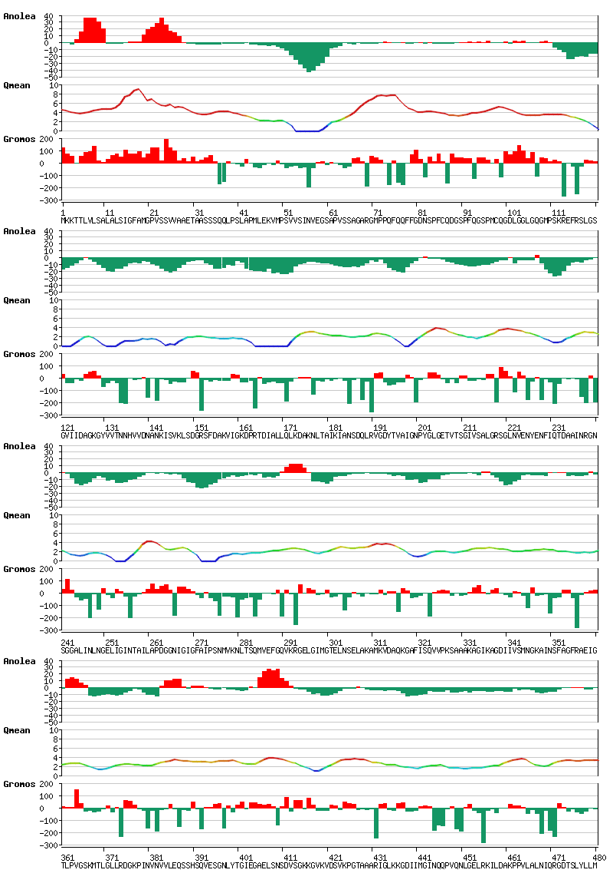

ANOLEA: Melo, F. and Feytmans, E. (1998) Assessing protein structures with a non-local atomic interactions energy. Journal of Molecular Biology. 277: 1141-1152

QMEAN: Benkert, P., Schwede, T. and Tosatto, SCE (2009). QMEANclust: estimation of protein model quality by combining a composite scoring function with structural density information. BMC Struct. Biol. 9: 35. doi:10.1186/1472-6807-9-35

GROMOS: W. F. van Gunsteren, S. R. Billeter, A. A. Eising, P. H. Hünenberger, P. Krüger, A. E. Mark, W. R. P. Scott, and I. G. Tironi. (1996) Biomolecular Simulation: The GROMOS96 Manual and User Guide, Vdf Hochschulverlag AG an der ETH Zürich, Zürich, Switzerland, pp. 1-1042

