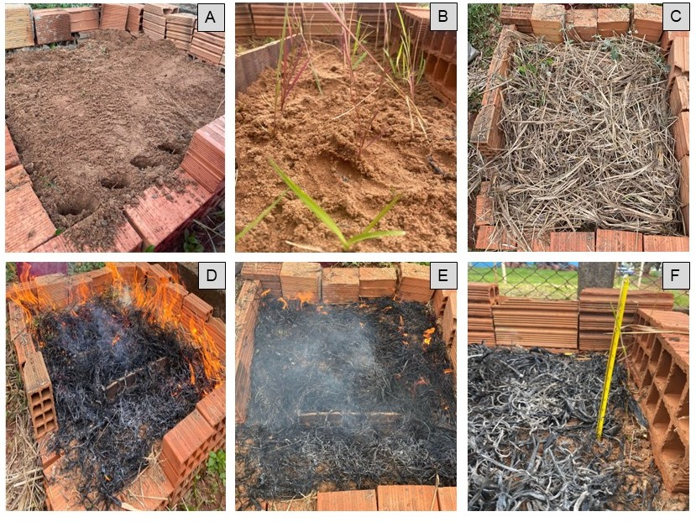
Figure S1 Illustrative experimental scheme. A-B Seedlings spaced at c. 10cm. C Uniform fuel layer of dry grass, spread between and over the seedlings. D-E Burning. F Thermometer measuring soil temperature.

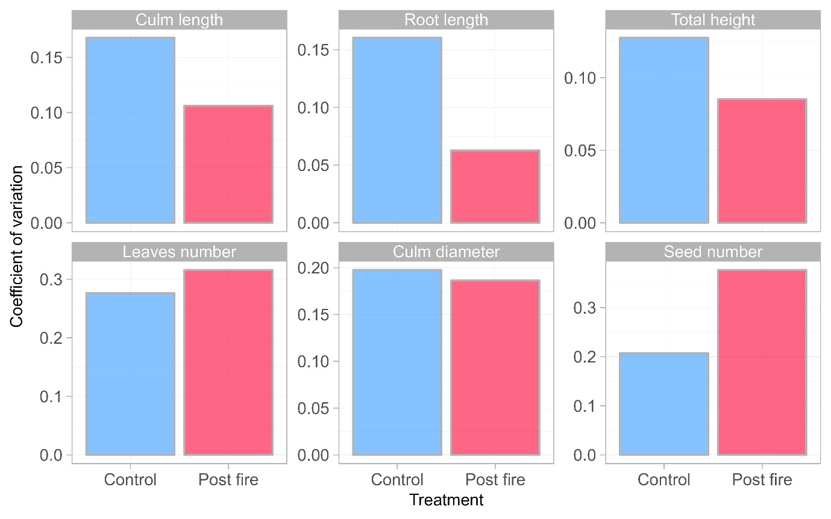
Figure S2 Coefficient of variation of the traits evaluated in the control and post-fire treatments.

