Supplementary Materials for

Two-photon absorption under few-photon irradiation for optical nanoprinting
Zi-Xin Liang et al.
*Corresponding author: xmduan@jnu.edu.cn, zhengmeiling@mail.ipc.ac.cn, yyzhao@jnu.edu.cn

Table of Contents
Supplementary Experimental Details S1-S16 Page 2-12
Supplementary Figures 1-15 Page 13-27
Supplementary Tables 1-2 Page 28
Supplementary References Page 28

S1. Simulation modeling

According to the characteristics of the DMD, the illumination source of the digital projection optical system in this study is described as parallel light illumination emitted by a point light source. The vector imaging model rather than the traditional scalar model at the larger numerical aperture (N.A.) is considered. The point spread function (PSF) is convolved with the complex amplitude transmittance function of the DMD after loading the digital mask to obtain the light intensity distribution in the macro space. According to the experimental results, we must consider the impact of lifetime on two-photon absorption under a few photons according to the quantum theory. The Monte Carlo random algorithm is used to obtain the random distribution of the number of photons in a single pulse based on the intensity distribution (46). The number of photons in the spatial position is also randomly distributed according to the intensity, and the photon number distribution images in space and time are obtained, respectively. MATLAB is then used to statistically screen the number of photons and obtain an effective logarithmic distribution of two-photon reactions based on the space-time conditions met by two-photon absorption.

S2. Modeling of the light intensity distribution during vector imaging model

We define the local coordinate system (s, p) at the same time considering a parallel light ray traveling along a wave vector $\hat{k}=[α,β,γ]$. The coordinate axes in the local coordinate system change with the direction of the wave vector k of the light wave. The s-axis is always perpendicular to the plane formed by the wave vector k and the z-axis. The p-axis is in the plane formed by the wave vector k and the z-axis. At the same time, it is orthogonal to the s-axis. For a parallel light whose polarization component is described using the (s, p) coordinate system, its polarization component in the global coordinate system (x, y, z) can be calculated according to the wave vector k of its light wave, as shown in Fig S1. 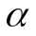 is the cosine value of the angle between the wave vector 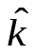and the x-axis, $β$ is the cosine value of the angle between the wave vector and the y-axis,  is the cosine value of the angle between the wave vector and the z-axis, and satisfies the relationship $α^{2}+β^{2}+γ^{2}=1$.
$\left[\begin{aligned}E_{x} \\ E_{y}\end{aligned}\right]=T\left[\begin{aligned}E_{s} \\ E_{p}\end{aligned}\right]$ (S1)
Where T represents the transformation of the (s, p) coordinate system to the (x, y) coordinate system.
First consider that a point source in the illumination pupil coordinate system $(α_{s},β_{s})$ emits parallel light. In the context of the thin mask approximation, the diffraction field in the near field of the mask is as follows:
$E_{mask}(a,β)=m(a-a_{s},β-β_{s})T(α_{s}$,$β_{s})\left[\begin{aligned}Es \\ Ep\end{aligned}\right]$ (S2)
Where m is the complex amplitude transmittance of the digital mask loaded with DMD. According to the characteristics of the digital mask that can be loaded on the DMD digital micromirror:
$m\left(x,y\right)=\sum_{i}{\sum_{j}{M_{i,j}}×k(x-iT_{x}, y-jT_{y})}$ (S3)
$M_{i,j}=1$ on state
$M_{i,j}=0$ off state
Among them, i and j represent the rows and columns of the DMD respectively; $M_{i,j}$ represents the modulation function loaded on a certain row and column of the DMD (the phase difference is not considered in the DMD system, so only normalization is considered.) The amplitude is 1 in the on state or 0 in the off state. w represents the DMD pixel’s size while P is the DMD pixel’s period. In this study, we do not consider the duty cycle of the DMD pixel, that is, P = w = 7.56 μm.
Then, we can get the polarized light field calculated from the object plane mask to the image plane where the sample is located:
$\left[\begin{aligned}E_{x}^{wafer}(α',β') \\ E_{y}^{wafer}(α',β') \\ E_{z}^{wafer}(α',β')\end{aligned}\right]=\left[\begin{aligned}H_{x}(α',β') \\ H_{y}(α',β') \\ H_{z}(α',β')\end{aligned}\right]m(α-αs,β-βs)$ (S4)
$H(α',β')$ is the frequency response function of the vector projection optical system considering the point light source [2]:
$\left[\begin{aligned}H_{x}(α',β') \\ H_{y}(α',β') \\ H_{z}(α',β')\end{aligned}\right]=R(γ,γ')⋅C(α',β')B(α',β')T^{-1}(α,β)T(αs,βs)\left[\begin{aligned}Es \\ Ep\end{aligned}\right]$ (S5)
$T^{\text{-1}}(α，β)=\frac{\text{1}}{γ}\left[\begin{matrix}\text{-}\frac{βγ}{ρ} & \frac{αγ}{ρ} \\ \text{-}\frac{α}{ρ} & \text{-}\frac{β}{ρ}\end{matrix}\right]$ (S6)
$B(α',β')=\left[\begin{matrix}\frac{-β'}{ρ'} & -\frac{α'γ'}{ρ'} \\ \frac{α'}{ρ'} & \frac{-β'γ'}{ρ'} \\ 0 & ρ'\end{matrix}\right]$ (S7)
We transform the light field described in the frequency domain back to the spatial domain through Fourier transformation to obtain the PSF:
$\left[\begin{aligned}h_{x}(x',y') \\ h_{y}(x',y') \\ h_{z}(x',y')\end{aligned}\right]=∬\left[\begin{aligned}H_{x}(α',β') \\ H_{y}(α',β') \\ H_{z}(α',β')\end{aligned}\right]×e^{j2π(f'x'+g'y')}dα'dβ'$ (S8)
After the derivation, for convenience, $(x,y)$represents the image plane where the photoresist is located, and $m(x,y)$ represents the ideal image of the digital mask passing through the projection system. Then we consider the vector model in the spatial calculation, add the point spread function $h_{p}(x,y)$ of a certain polarization direction and the complex amplitude transmittance of the DMD for convolution calculation, and then take the square of its absolute value. Finally, the light intensity distribution function after loading the DMD digital mask was obtained. h_{p} represents the PSF in a certain polarization direction, * is the convolution operation, and I is the projected light intensity distribution.
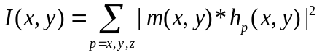 (S9)

S3. Modeling of photon distribution in quantum models

We transition from the light intensity distribution of the semi-classical theory to the fully quantum theory when the dose is gradually reduced. When the macroscopic light field is transferred to the quantized photon distribution, it is inevitable to obtain the photon distribution. Based on the necessary conditions for the occurrence of two-photon absorption, the same molecule must absorb pairs of photons with combined energy exceeding the lowest transition level energy within the lifetime of the virtual state. There are three states for an active molecule in space, namely the ground state, the intermediate state, and the transition state. The area can no longer absorb the photon in the transition state. The active molecule in the ground state will transit after absorbing one photon. To reach the intermediate state, the active molecule absorbs another photon and jumps to the transition state. Recording the binding of a photon pair within the lifetime of the virtual state is identified as a potential instance of TPA. Within its lifetime, it will return to the ground state and will not be counted as part of the eTPA number if the active molecule in the intermediate state does not receive other photons.

- Spatial distribution of photon number within a single pulse:
The spatial probability density function $P_{s}(x,y)$ is obtained by normalizing the light intensity. For a specified two-dimensional area, the probability of a photon appearing under this light intensity is $I(x,y)$.
$P_{S}(x,y)=\frac{I(x,y)}{\iint_{mask}{I(x_{i},y_{j})dxdy}}$ (S10)
$\int_{0}^{x}{\int_{0}^{y}{P_{S}(x,y)dydx=1}}$ (S11)
Given the experimental dose (single pulse single pixel photon number, N_{spp}), a random spatial distribution of the single pulse spatial photon number in position $\left(x,y\right)$is obtained.
$n\left(x,y\right)=N_{spp}*P_{S}(x,y)$ (S12)

- Distribution of photon number in time within a single pulse:
The distribution of pulses in time fits the sech function:
$U\left(t\right)=exp⁡(-iw_{ }t)sech⁡(\frac{t}{Γ})$ (S13)
The center frequency is $w$, $t$ is the local time coordinate. Γ represents the pulse width when the amplitude drops to $1/e$ of the peak value and it is a measurement of the pulse time width.
The time function$P_{T}(t)$ represents the probability density distribution function of the number of photons in a single pulse in time, and the integral within the time of a single pulse is 1:
$P_{T}\left(t\right)=\frac{U(t)}{\iint{U(t)}dt}$ (S14)
$\int_{0 }^{t }{P_{T}(t)dt=1}$ (S15)
Given the experimental dose (single pulse single pixel photon number, N_{spp}), a random time distribution of the single pulse spatial photon number is obtained.
$n\left(t\right)=N_{spp}*P_{T}(t)$ (S16)
The random distribution of photon numbers within a single pulse is shown in Figure S2 (a pulse width of ~238 fs).

- Enhanced spatiotemporal distribution with added lifetime:
Quantifying TPA events at a single point: $(r,t_{n})$ represents a photon sample at a certain position r at a certain time t. The spatial distribution $\left(r\right)$ of the photon conforms to the distribution $r∼P_{S}(r)$, while the temporal distribution $\left(t\right)$ conforms to the distribution $t∼P_{T}(t)$. The state function at this point and moment is represented by $S(r,t_{n})$. When it is 1, it means that two-photon absorption will occur at this point and that moment to produce active molecules. When it is 0, it means that this point and that moment are in a virtual state. It is assumed here that there are no two photons at exactly the same time and in the same place.
$S(r,t_{n+1})=\left\{\begin{matrix}1 & \begin{matrix}t_{n+1}-t_{n}<τ & and & S(r,t_{n})=0\end{matrix} \\ 0 & otherwise\end{matrix}\right\}$ (S17)
If the photons corresponding to the same point$(r,t_{n+1})$ and the same point at the previous moment$(r,t_{n})$ meet the specified conditions, two-photon absorption will occur. According to the Heisenberg Uncertainty Principle, the intrinsic lifetime of virtual state satisfies the following equation:
$τ_{i}=h{(4πΔ{\tilde{v}}_{iλ})}^{-1}$ (S18)
Where $h$ is Planck's constant and $Δ{\tilde{v}}_{iλ}$ is the difference between photon energy and ground state energy. The photoresist exhibits a cutoff wavelength of 353 nm. Utilizing a laser beam with a wavelength of 517 nm, the energy differential between the first excited state and the ground state is quantified at 1.1 eV, resulting in a calculated virtual state lifetime of 0.3 fs. Furthermore, the lifetime of the virtual state extends to 0.8 fs when exposed to a laser with a wavelength of 400 nm.
Finally, the distribution of two-photon absorption pairs, where TPA occurs within a certain point, is calculated as follows:
$TPA(r)=\sum_{n=0}^{N}{S(r,t_{n})}$ (S19)
Although we cannot calculate its specific analytical formula, the distribution of eTPA can be obtained by performing the above calculation based on the number of input pulse photons. According to our statistics, the TPA distribution in a certain situation, in the case of few photons: $TPA(r)∈I^{2}$, the distribution of TPA is proportional to the square of the light intensity. The probability of a photon falling is expected to be the distribution of light intensity, and the probability of a two-photon reaction is expected to be the distribution of the square of the light intensity.
$E_{Nphoton}=norm(I)$ (S20)
$E_{reaction}=norm(I^{2})$ (S21)

- Distribution of reaction site number in time within a single pulse:
The reaction site number R of the photosensitive molecule in the photoresist is consistent with the Dill model (33,34):
$\frac{∂\left[R\right]}{∂t}=-C_{Dill}∙I∙\left[R\right]$ (S22)
Where C is the effective rate constant for the photoreaction and the third Dill photoresist parameter. Subsequently, the concentration distribution of R is obtained following the integration of R's first-order kinetics concerning to incident light intensity:
$\left[R\right]=-e^{{-C}_{Dill}∙I∙t}=-e^{-C_{Dill}∙D}$ (S23)
Where t and D are the exposure time and dose, respectively. We gain a detailed understanding of how the concentration of the R responds to varying levels of incident light by linking the concentration distribution to the previously mentioned incident dose. The actual concentration distribution H of R participating in the reaction is expressed as formula S24, with the initial R concentration (R₀) set to a value greater than or equal to the previously calculated maximum value of N_{eTPA} (as indicated in the main text with R₀=40) at t=0.
$\left[H\right]={\left[R\right]}_{0}(1-e^{{-C}_{Dill}∙\left[TPA\right]})$ (S24)
This correlation provides essential insights into the direct relationship between R concentration and incident light dose, crucial for optimizing processes in applications such as photolithography.

S4. The distribution of eTPA at different wavelengths

Taking N_{spp} = 6000 (2.31 fJ/pulse pixel) and N_{pulse} = 700 as typical cases, the distribution of eTPA at wavelengths of 517 nm and 400 nm and pulse widths of 238 fs and 100 fs were simulated respectively. Given that the photon energy of 400 nm is relatively greater than that of 517 nm (E₅₁₇ = 2.4 ev, E₄₀₀ = 3.1 ev), we additionally computed the distribution at 400 nm with N_{spp} set to 4645 (1.78 fJ/pulse pixel) (Fig. S3 E-F) under the condition where the total energy of 517 nm and 400 nm is equal. We make statistics on the number of eTPA in different situations, as shown in Fig. S3 and Table S1. The efficiency is the ratio of the number of incident photons to eTPA.

S5. Coefficient of variance of TPA occurrence probability under different photon numbers injected

In our random calculation results, the position where photons fall and react is not fixed. Here we show the results of ten random calculations of TPA reaction under three levels of incident photon numbers. The incident photon numbers are as follows: (a) N_{spp} = 600 (0.23 fJ/pulse pixel), (b) N_{spp} = 6000 (2.31 fJ/pulse pixel), (c) N_{spp} = 30000 (11.53 fJ/pulse pixel), with a total pulse number of the pulse is 700 (Fig. S4). The random results are different under the same incident conditions. The probability distribution of the response at a specific moment cannot be determined experimentally, yet the origin of the minimum feature size can be identified. The random fluctuation is more obvious under a few numbers of photons. Due to the varying magnitudes of injected photons, there is a significant difference in the mean values. Therefore, we use the coefficient of variation $C_{V}$ (standard deviation/mean value) to eliminate the influence of different data sets on the degree of dispersion. The degree of dispersion of the entire spot is 9.79 %, 0.82 %, and 0.15 %, respectively, as shown in Table S2.
$C_{V}=\frac{σ}{μ}×100\%$ (S25)

S6. Effect of pulse number at low photons

The efficiency of two-photon absorption is limited by the virtual state. The occurrence efficiency f_{TPA} is only related to the number of photons in a single pulse under a single pixel and has nothing to do with the number of pulses. Taking 517 nm as an example, the number of photons in a single pixel of Fig. S5 A is 514, and the number of pulses is 5 × 10⁴, 1 × 10⁵, 2 × 10⁵, and 4 × 10⁵ in a proportional increasing relationship. Fig. S5 A shows the photon distribution of 1/4 of the light spot, Fig. S5 B is the photon distribution of 1/4 spot under the proportional increasing relationship of 5.14 × 10⁶ photons in a single pulse and single pixel, and the number of pulses is 5, 10, 20, and 40, respectively. Fig. S5 C represents the distribution cross-section of a-4 and b-4, which only aligns with the distribution of the square of the light intensity when the number of photons is low. Fig. S5 D shows the distribution of N_{eTPA} at 517 nm and 400 nm when the number of pulses increases from 1 to 1500 when N_{spp} = 6000 (2.31 fJ/pulse pixel) and N_{spp} = 10000 (3.84 fJ/pulse pixel), indicating that the increase in the number of pulses only results in a linear increase in N_{eTPA} without altering its occurrence efficiency.

S7. Computational model in MATLAB

The computational model was established in MATLAB by numerically representing equations S1-S24. The optical setup uses on-axis point light source illumination with a polarization direction of x-direction and a wavelength of 517 nm. The numerical aperture (NA) of the projection imaging system is 1.49, and the refractive index in object space (such as the plane where the DMD is located) and image space (such as the plane where the photoresist is located) are 1.0 and 1.516, respectively. Subsequently, an optical projection system reduces the size of the image by a factor of 100 and projects it onto a silicon wafer. The size of the DMD pixel is 7.56 μm. Considering 100% filling of DMD pixels, the complex amplitude transmittance of each DMD pixel can be discretized into a 20×20 matrix with all “1”, indicating that the smallest unit on the sampling interval of the image plane where the silicon wafer is located is set to 3.78 nm. The effects of various optical parameters on the distribution of the effective two-photon absorption number are illustrated in Fig. S6.

S8. Optical setup of two-photon optical projection lithography

Femtosecond laser pulses are frequency-doubled (517 nm) by a fiber laser (238 fs, 1 MHz, CAS Microstar) with a fundamental frequency of 1035 nm for all subsequent two photopolymerization (TPP) fabrication experiments. In order to make full use of the DMD (DLP6500, 1920 $×$1080 pixels, Texas Instrument), a 1× - 3× zoom beam expander is used to expand the laser spot diameter to 6 mm, so that the output light of πShaper 6_6_VIS passes through the 1× - 3× zoom beam expander to produce internal focusing a top-hat beam with a diameter of 18 mm without changing the irradiance (47). The optical system can project any binarized pattern loaded on the DMD onto the target photoresist through the tube mirror and the objective lens (NIKON, oil, 100 × /1.49 NA) without moving the stage (Fig. S7 A). DMD (DLP6500 0.65 1080P MVSP S600) with 7.56 μm micromirror pitch, 0.65-inch micromirror array diagonal is optimized for visible light (420 nm-700 nm) (Fig. S7 C).

S9. Photopolymerization

The two-component compound of the non-chemically amplified negative photoresist (AR-N 7520) used in the experiment consists of a bisazide compound and a polyhydroxy phenolic compound. It absorbs two-photon simultaneously and is excited to an excited state by laser irradiation. This excitation can only trigger an insertion reaction between the azide group of the polyoxyethylene bisazide compound, serving as a cross-linking agent, and the alkyl group of the phenolic compound. This reaction forms dimers or polymers, increasing the molecular weight and the polymerized polymers become insoluble in the developer. UV-Vis absorption spectrum shows that there are two absorption peaks at 323 nm and 284 nm in Fig. S8. The single-photon absorption cutoff wavelength is 353 nm, which indicates that a single-photon absorption reaction can hardly occur at 517 nm, thus paving the way for the occurrence of two-photon absorption.

S10. Feasibility of optical projection lithography optical setup

In the optical setup, the πShaper is used for homogenization. This method can achieve a high transmittance of 98%. The energy loss is minimized. The consistency of the laser beam does not deteriorate and there is no focus inside from the homogenized spot in Fig. S9 A–B. The uniformity of the entire light field is authenticated using a photon sieve pattern with a large diameter of 80 μm (N_{pulse} = 6 × 10⁷ and N_{spp} = 2.38 × 10⁴ (9.14 fJ/pulse pixel)) and a resolution plate pattern with a length of 100 μm ( N_{pulse} = 4.8 × 10⁷ and N_{spp} = 3.51 × 10⁴ (13.49 fJ/pulse pixel)). Large-scale pattern exposure at the scale of 100 microns can be achieved in a single exposure under the two-photon surface optical system.

S11. Detailed Analysis of N_{eTPA} Distributions corresponding to the experimental data

Figure S10 corresponds to the experimental results of Fig 3E in the main text. Figure S10 A shows the total distribution of eTPA, with a uniform color bar ranging from 0 to 1000. Figure S10 B displays the distribution after extracting the contour of the linewidth, indicating the distribution where N_{eTPA} exceeds a certain value within a single sampling point, corresponding to the exposure linewidth. The inset shows the distribution of N_{eTPA} at the minimum feature size.

S12. Feature dimensions line edge roughness

Apply an edge extraction algorithm to extract data from the entire polymer line in the SEM, followed by the calculation of edge roughness σ_{LER}. The edge roughness of the feature size due to the influence of quantum noise is shown in Figure S11. The edge roughness (LER) is usually described quantitatively by using 3 times the edge standard error (ie, 3σ_{LER}) in the field of lithography.
$σ_{LER}=\sqrt{\frac{1}{N}\sum_{i=1}^{N}{{\left(δx_{i}\right)}^{2}}}=\sqrt{\frac{1}{N}\sum_{i=1}^{N}{{\left(x_{i}-\overline{x}\right)}^{2}}}$ (S25)
For the top edge,${σ_{LER}}_{\left(a\right)}=4 nm$,${σ_{LER}}_{\left(b\right)}=3 nm$; for the bottom edge,${σ_{LER}}_{\left(a\right)}=4 nm$,${σ_{LER}}_{\left(b\right)}=4 nm$. The standard errors for the difference in the edge extraction data (the line width) and the line width roughness are calculated as 5 nm and 7 nm, respectively.

S13. Raster double exposure detail

The 2:1 periodic lines exhibit misalignment and splitting, while the 2:4 periodic grating pattern is employed for exposure. Fig. S12 illustrates an otherwise indistinguishable single exposure result when exposing the layout at the same exposure dose.

S14. The effect of line spacing on exposure dose perception

The spacing between lines directly influences the degree of reaction between adjacent lines, and the required exposure dose varies for lines with different densities. A comprehensive analysis was conducted on the calculation of optical field intensity between sets of lines, each consisting of a 1-pixel width, where the line spacing gradually increased from 1 pixel to 15 pixels. The optical field intensity experienced by lines at different positions undergoes variations due to interference and diffraction effects between adjacent lines when the spacing is less than 5 pixels. For instance, only two out of the five lines are distinguishable with a 1-pixel spacing, regardless of dosage control. Four lines become discernible at 2-pixel spacing. It’s only when the spacing reaches 3 pixels or more that all five lines can be fully displayed, albeit with a non-uniform intensity distribution. The influence of adjacent lines becomes negligible when the spacing has increased to 5 pixels or beyond, as illustrated in Fig. S13.

S15. Exposure details of chip metal layer

For the basic circuit layout of the metal layer of the chip, a double in-situ exposure is carried out after splitting. Among them, the three regions of primary interest containing a 1-pixel interval are specifically indicated with gray and white squares (Fig. S14 A). As demonstrated in the experimental SEM image (Fig. S14 B), the minimum gap of 37 nm can be obtained under the conditions of N_{spp} = 15200 (2.31 fJ/pulse pixel), N_{pulse} = 1.5 × 10⁷ (T_{MASK1} = T_{MASK2} = 15 s).

S16. Details of a microring waveguide

The number of pulses is increased from 1×10⁶ to 2.1×10⁷ while N_{spp} is fixed (N_{spp} = 1.49×10⁴). The average line width is measured for a local sampling of the microring (220 nm-347 nm), as depicted in Fig. S15. The relationship between the two-photon absorption line width and the exposure dose is employed for fitting to obtain a consistency curve between the experiment and the fitting. Simultaneously, a 480 nm gap is achieved at N_{spp} = 7630 (2.83 fJ/pulse pixel), and a minimum coupling gap exposure of 66 nm (Fig. S15) is attained at N_{spp} = 1.49 ×10⁴ (5.72 fJ/pulse pixel) and N_{pulse} = 2.1 × 10⁷.

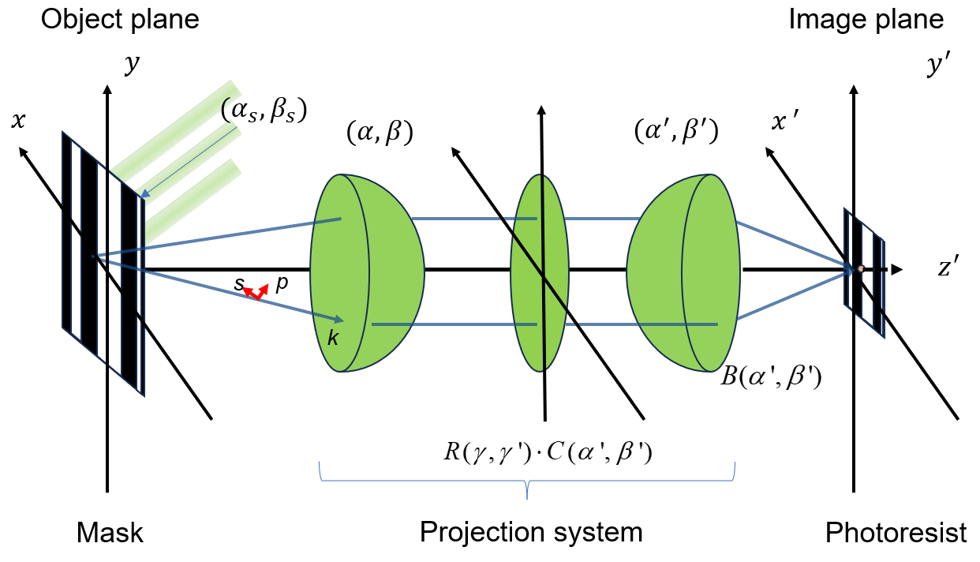

Fig. S1.
Schematic diagram of digital-mask projection lithography. The illumination source is considered to be an axis point light source since the projection system uses parallel light with polarization direction in the x direction to uniformly illuminate the object surface where the DMD is located. The illumination light first shines on the digital mask, and then modulates the light field on each corresponding pixel of the projection system projecting the light field of the object plane onto the image plane where the photoresist is located.
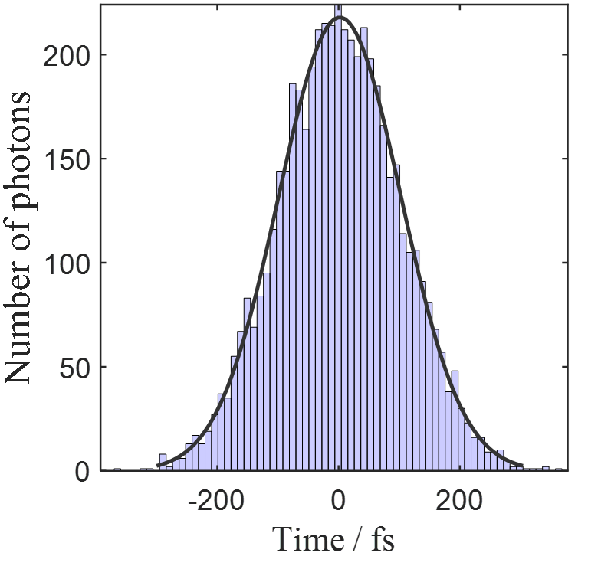

Fig. S2.
Photon distribution within a single pulse (pulse width ~238 fs).

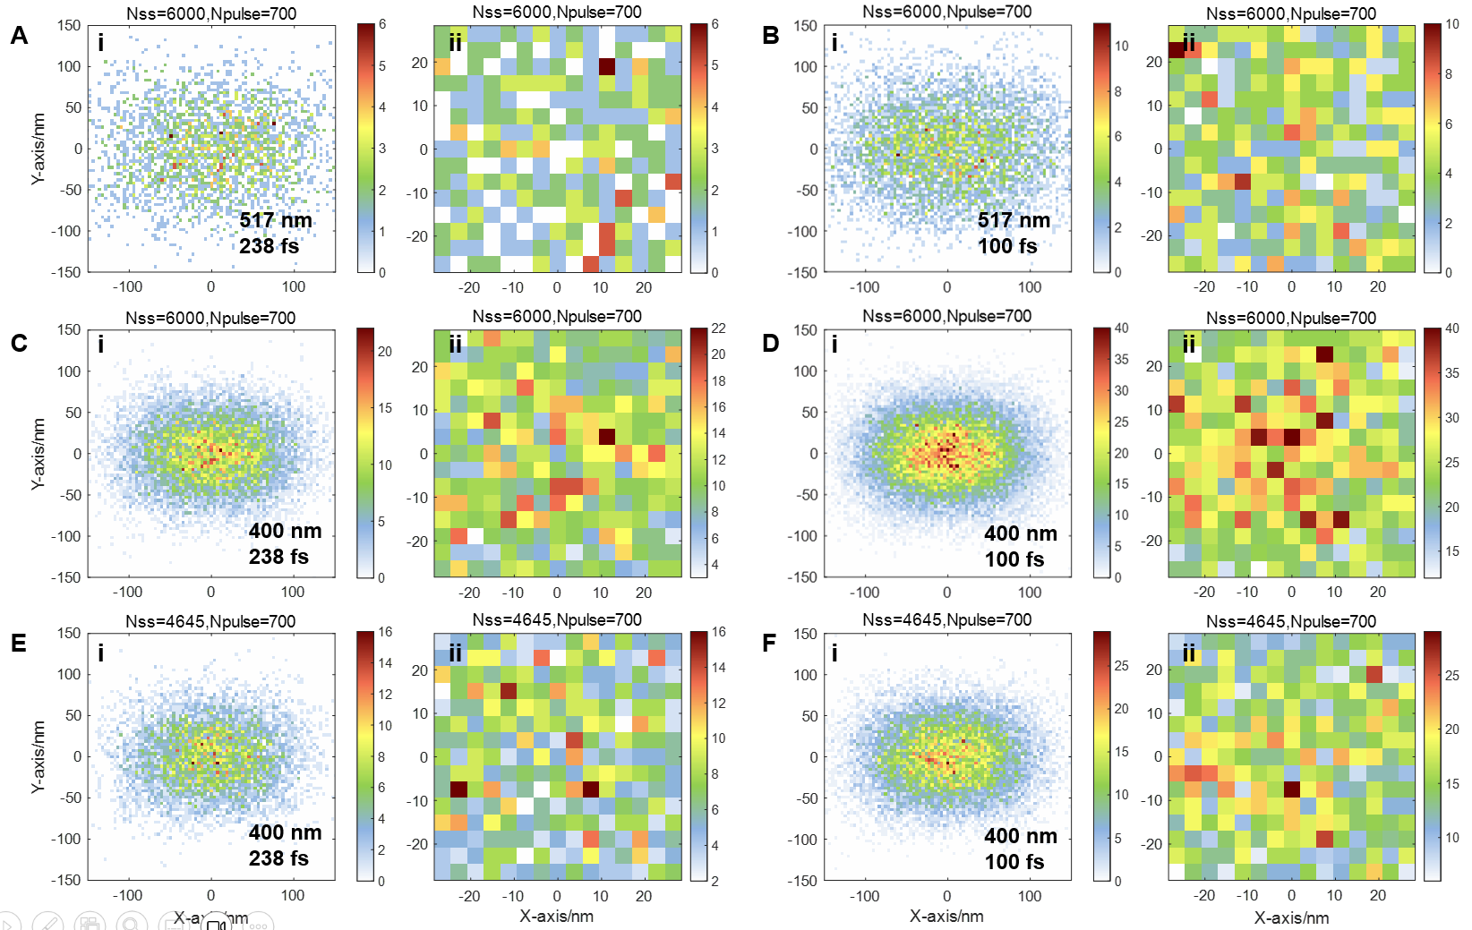

Fig. S3.
The distribution of eTPA at different wavelengths and pulse widths. (A) λ = 517 nm, Γ= 238 fs. (B) λ = 517 nm, Γ= 100 fs. (C) λ = 400 nm, Γ= 238 fs. (D) λ = 400 nm, Γ= 100 fs. (E) λ = 400 nm, Γ= 238 fs, N_{spp} = 4645. (F) λ = 400 nm, Γ= 100 fs, N_{spp} = 4645. (ii) is the distribution at the center 50 nm² of (i).

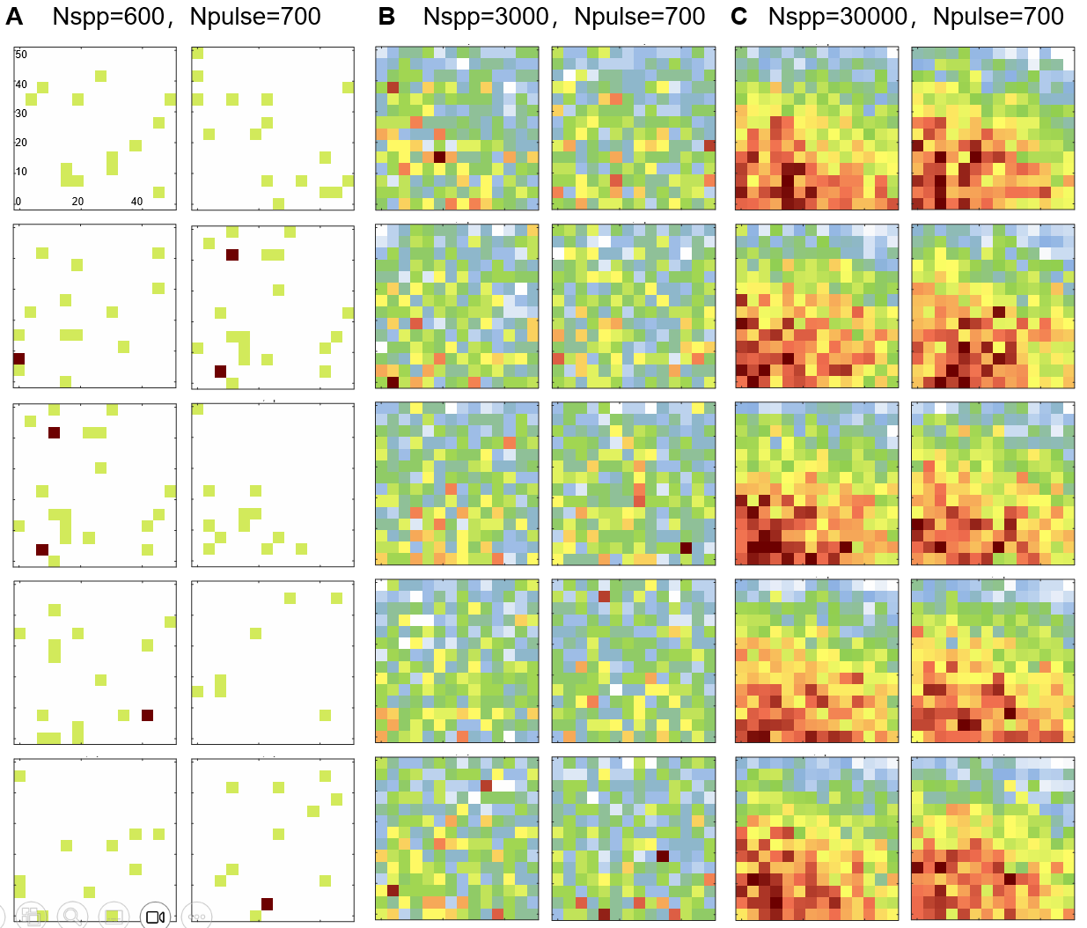

Fig. S4.
Ten random distributions of TPA reaction probability in the 50 nm × 50 nm area at center of the spot under different injected photon numbers. (A) N_{spp} = 600, C.V = 26.38%. (B) N_{spp} = 6000, C.V = 2.76%. (C) N_{spp} = 30000, C.V = 0.65%.

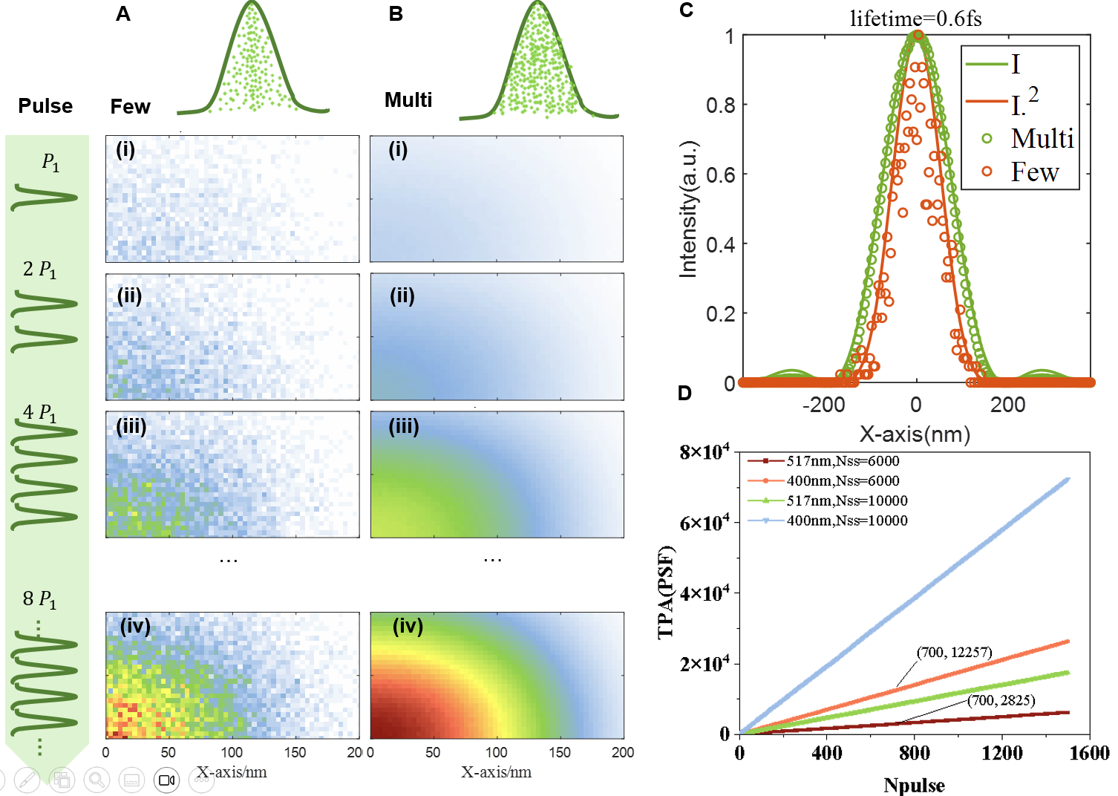

Fig. S5.
(A) TPA distribution of spot with an increased pulse under 517 nm few photons. (B) TPA distribution of spot with an increased pulse under 517 nm multi-photon absorption. (C) 517 nm multi-photon and few-photon spot cross-sectional distribution and the distribution of intensity and square of intensity. (D) The changing trend of spot TPA after increasing the number of pulses at different photon numbers at 400 nm and 517 nm.

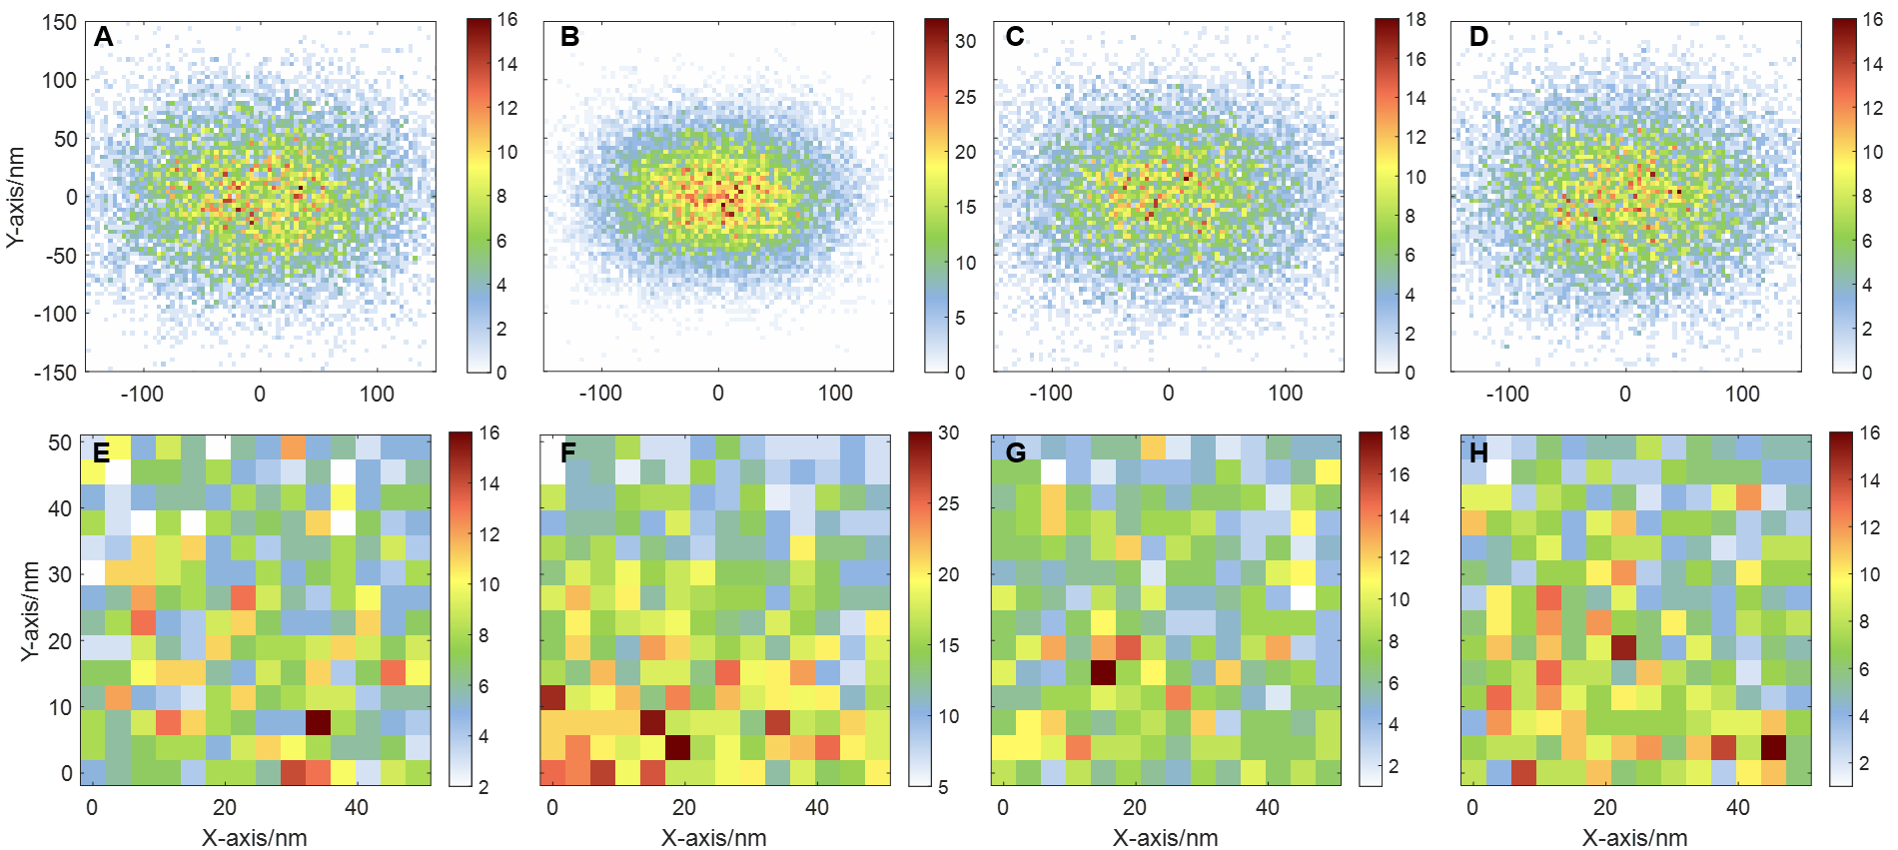

Fig. S6.
（A-D) The probability distribution of TPA in the laser spot under different parameters (N_{pulse} = 700, N_{spp} = 6000). (A) The original parameters of the experimental system, λ = 517 nm, FWHM = 238 fs, NA = 1.49. (B) λ = 400 nm, FWHM = 238 fs, NA = 1.49. (C) Reduce the laser pulse width to 100 fs. (D) λ = 517 nm, FWHM = 238 fs, NA = 1.45. (E-H) eTPA reaction corresponding to 50 nm² in the center of the spot under different parameter conditions.

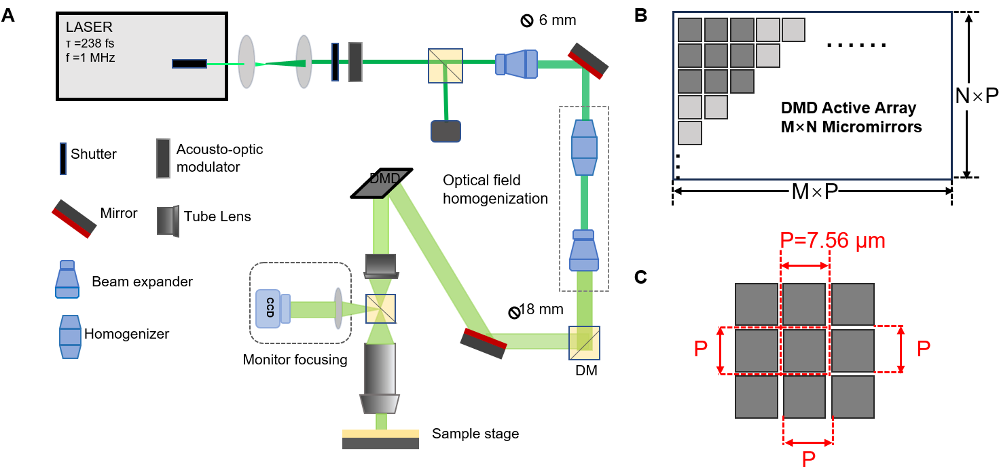

Fig. S7.
Two-photon absorption projection optical system. (A) Schematic illustration of the experimental setup. (B) DMD active array (M = 1920, N = 1080). (C) Micromirror size details (P = 7.56 μm).

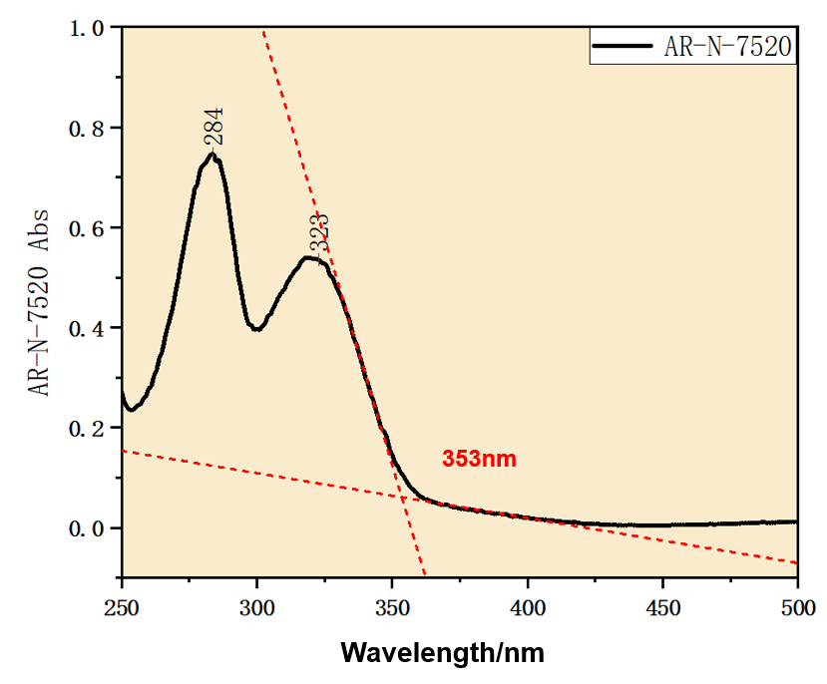

Fig. S8.
UV-Vis absorption spectrum of AR-N-7520.
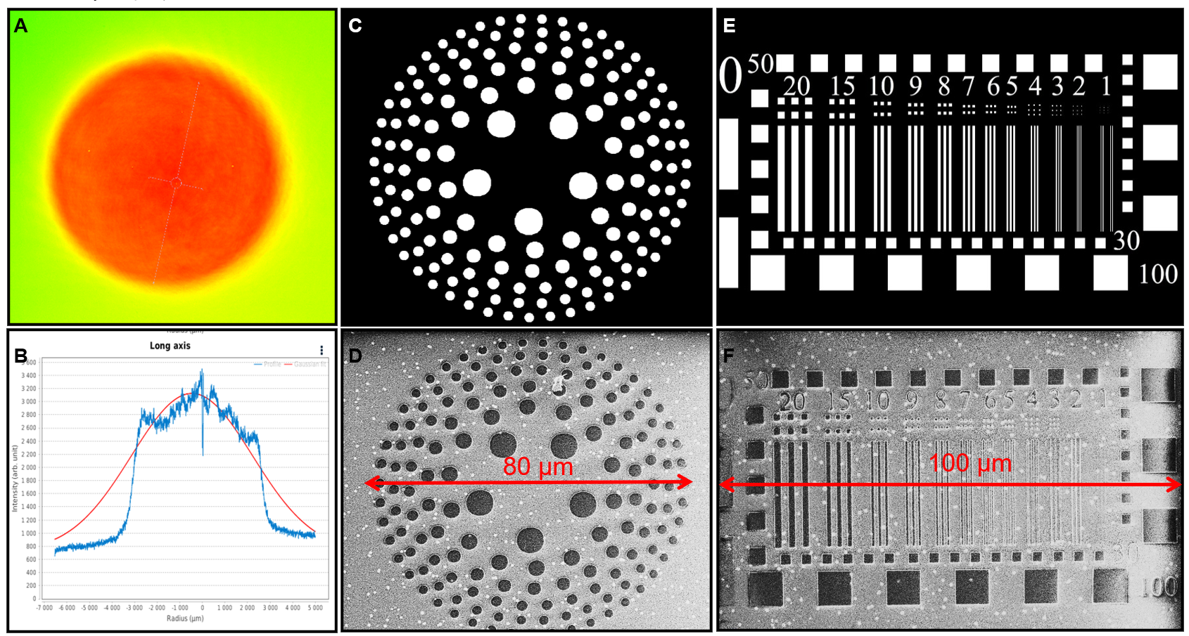

Fig. S9.
Light intensity uniformity characterization. (A-B) Spot shape after homogenization (spot diameter 6.4 mm). (C-D) Design layout and experimental results of photon sieve (diameter 80 μm). (E-F) DMD layout of resolution plate and experimental SEM results (long side 100 μm).

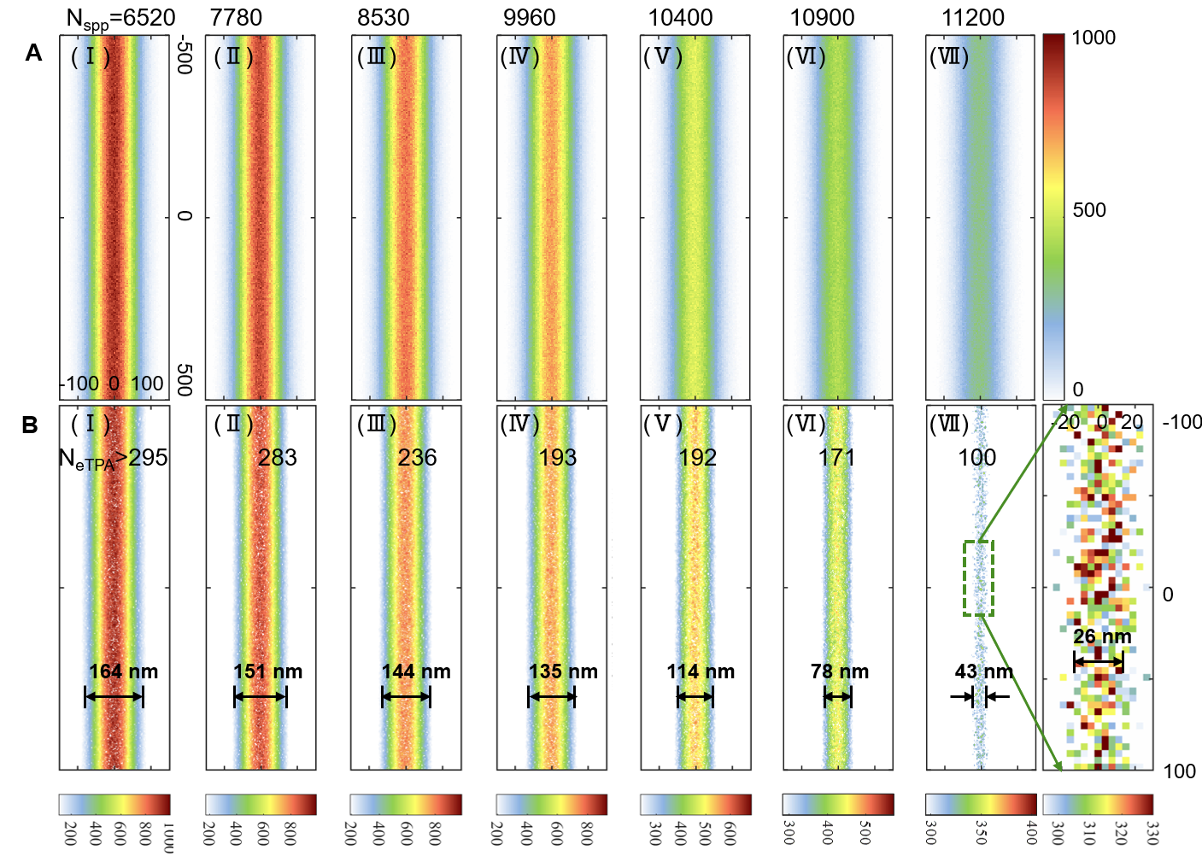

Fig. S10.
Distribution of $N_{eTPA}^{ }$ within a line of 1 pixel width under different N_{spp}. (A) N_{spp} is 6520(Ⅰ), 7780(Ⅱ), 8530(Ⅲ), 9960(Ⅳ), 10400(Ⅴ), 10900(Ⅵ), 11200(Ⅶ), the total distribution of $N_{eTPA}^{ }$ within a line with width of 1 pixel when the N_{pulse} is 6000. (B) The contour map corresponds to the distribution of experimental line widths, and the inset is the $N_{eTPA}^{ }$distribution map corresponding to 26 nm at the N_{spp} = 6520.

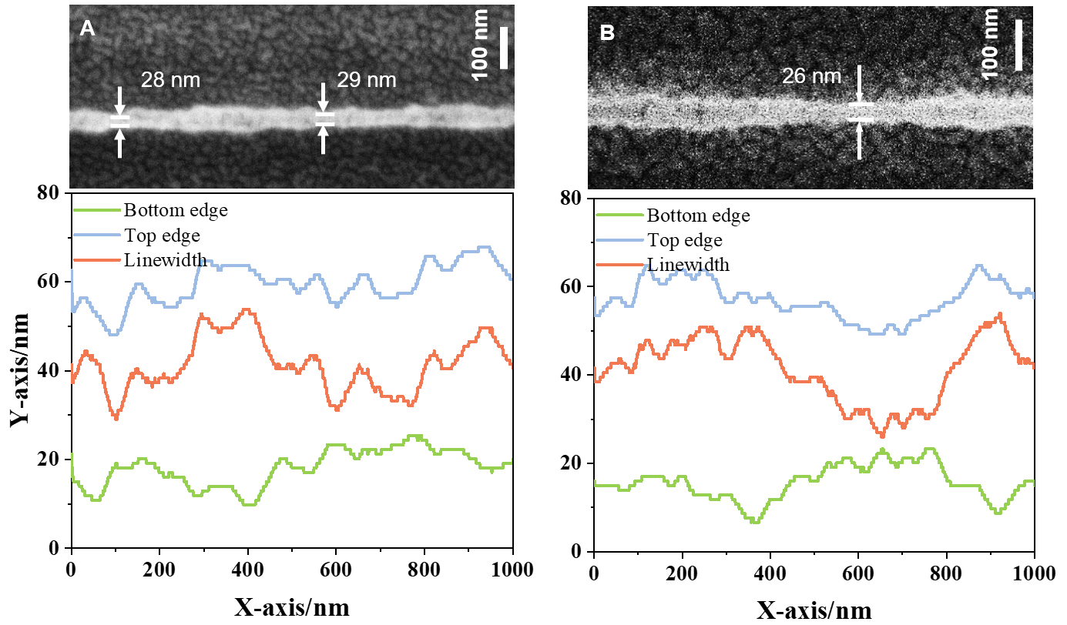

Fig. S11.
Roughness with feature size. (A) Line edge roughness with a feature size of 28 nm. (B) Line edge roughness with a feature size of 26 nm.

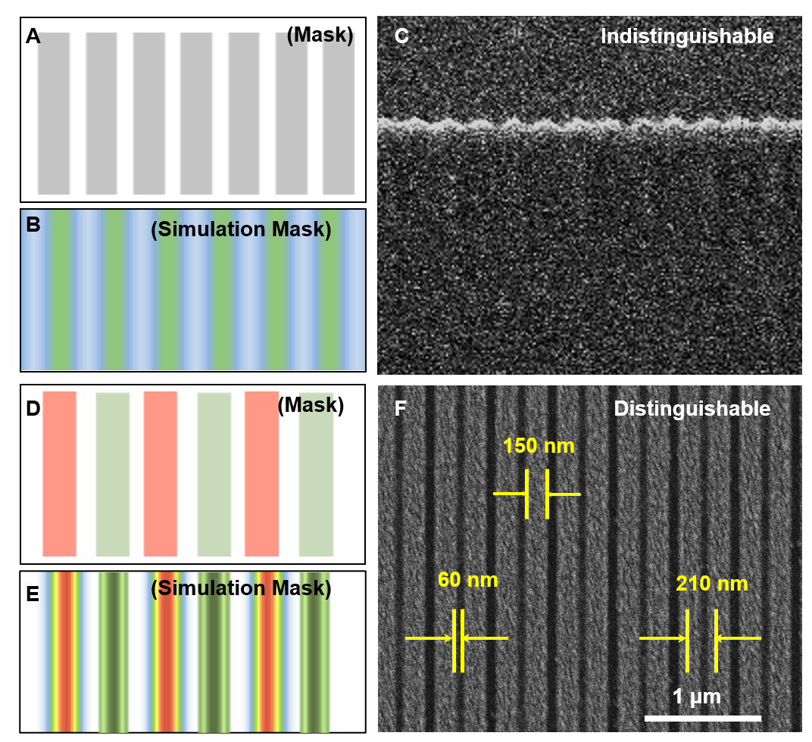

Fig. S12.
Details of iDME processing. (A) Single exposure mask layout, duty cycle 2:1. (B) 2:1 grating single exposure mask calculated square distribution of light intensity. (C) 2:1 grating line group single exposure, indistinguishable. (D) In-situ double exposure layout, single exposure duty cycle 2:4, using two colors represent two exposures respectively. (E) 2:1 grating double exposure mask calculated square distribution of light intensity. (F) 2:1 grating line group single exposure, resolvable period 210 nm.

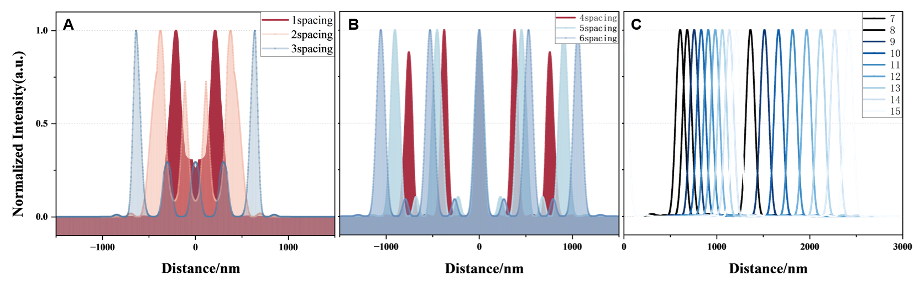

Fig. S13.
Calculation and simulation results of light intensity of 5 lines with different intervals. (A) Line group with a spacing of 1-3 pixels, completely losing its original appearance. (B) Line group with a spacing of 4-6 pixels, uneven intensity distribution. (C) Line group with spacing of 7-15 pixels, appearance and intensity distribution is not affected by adjacent lines.

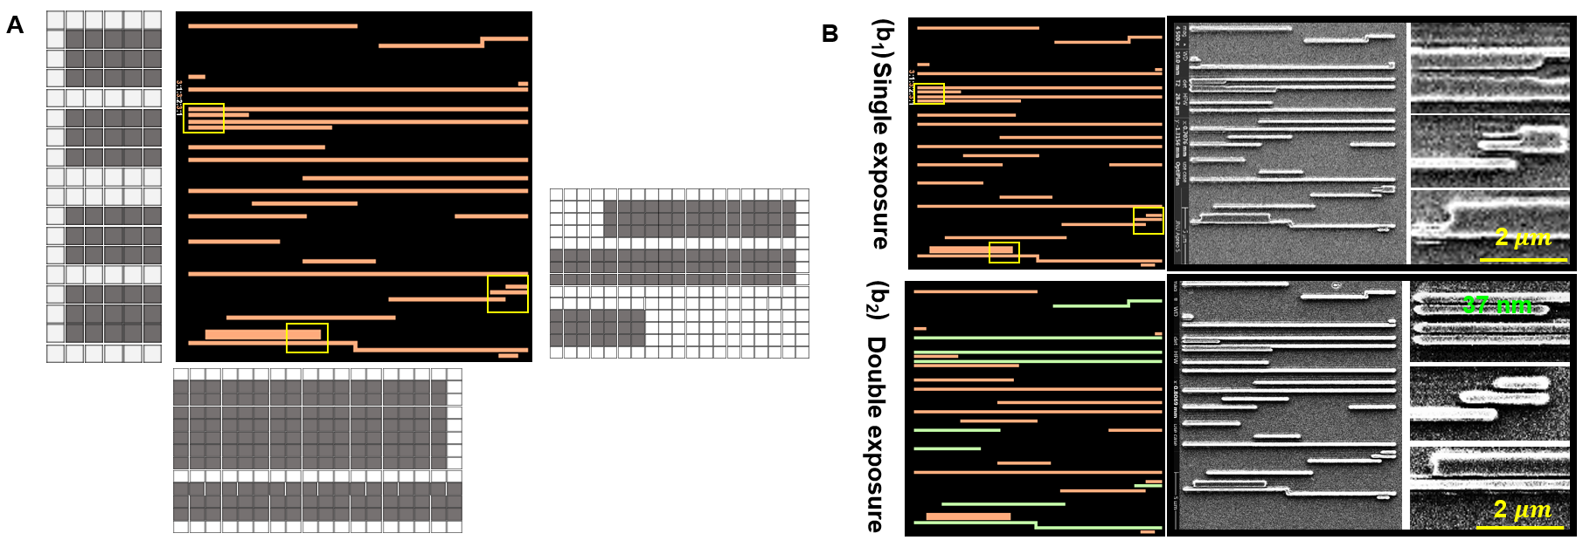

Fig. S14.
(A) Local 1-pixel enlarged view of the basic circuit layout of the metal layer. (B) SEM image of the exposure results with a minimum gap of 37 nm.

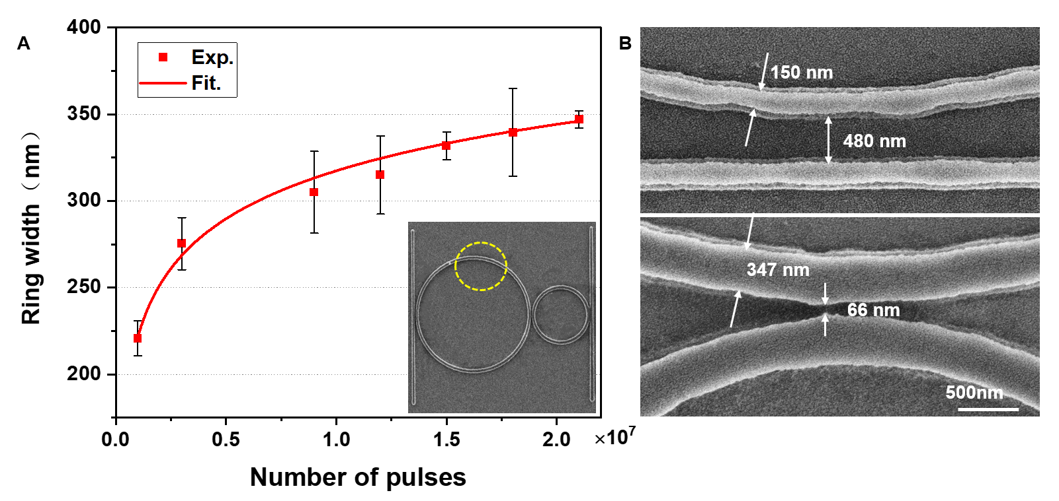

Fig. S15.
(A) The changing trend of the line width of microring diameter with the increase of exposure time. (B) Exposure to different coupling gaps.

Table S1.
The efficiency of TPA occurrence varies under different situations.

Wavelength | Pulse  width | N_{spp} | N_{pulse} | $$N_{eTPA}^{ }$$  （PSF） | $$N_{eTPA}^{ }$$  （50×50 nm²） | Efficiency of PSF (%) | Efficiency of 50×50 nm²(%)
517 | 238 | 6000 | 700 | 2971 | 360 | 0.07 | 0.01
400 | 238 | 6000 | 700 | 12261 | 2481 | 0.29 | 0.06
517 | 100 | 6000 | 700 | 6970 | 857 | 0.17 | 0.02
400 | 100 | 6000 | 700 | 28716 | 5767 | 0.68 | 0.14
400 | 238 | 4645 | 700 | 7198 | 1488 | 0.22 | 0.05
400 | 100 | 4645 | 700 | 17146 | 3372 | 0.53 | 0.10

Table S2.
Analysis of the comprehensive dispersion degree of light spots after 50 random processes.

N_{spp} | N_{pulse} | $N_{eTPA}^{Ave.}$of PSF | $N_{eTPA}^{SD}$ of PSF | $C_{V}$ of PSF | $C_{V}$ of 50 nm² in the  center of PSF
600 | 700 | 143 | 14 | 9.79% | 26.38%
6000 | 700 | 14049 | 115 | 0.82% | 2.76%
30000 | 700 | 340359 | 521 | 0.15% | 0.65%

SD: Standard Deviation ；Ave.：Average Number.

46. X. Yu Yan et al., The photon detection mode of photomultiplier tubes considering the pulse height distribution. Journal of Infrared Millimeter Waves 42, 88-101 (2023).
47. A. Laskin et al., in Components and Packaging for Laser Systems. (SPIE, 2015), vol. 9346, pp. 224-232.

