Supplementary Figure 1.
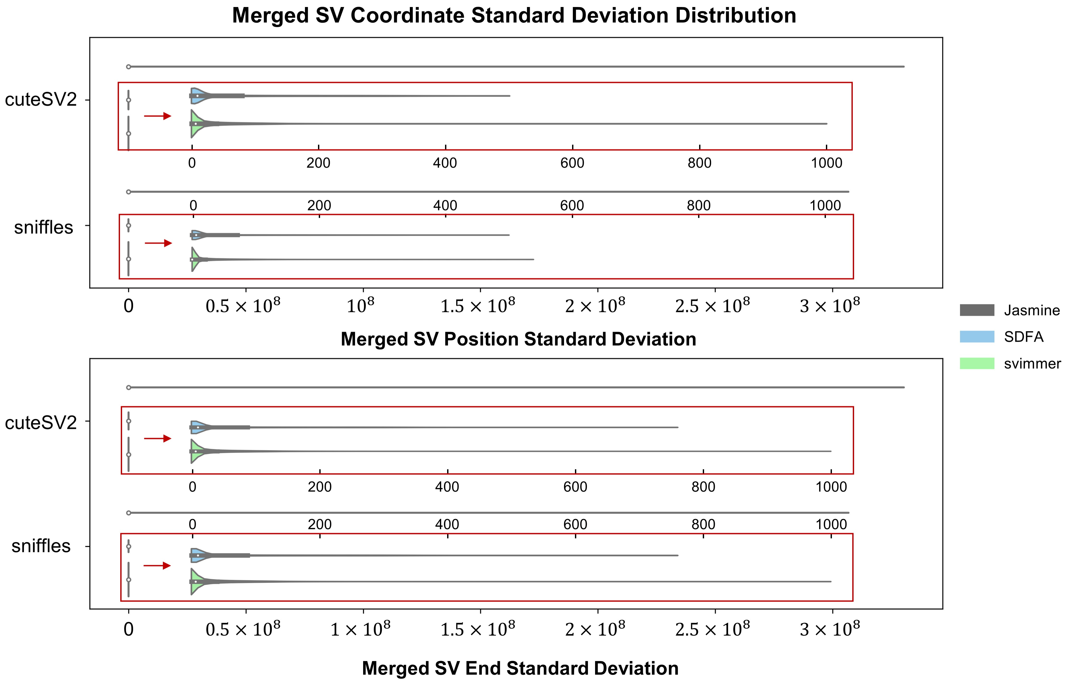
Fig. S1 | Distribution of standard deviation ranges for coordinates in merged SVs across Jasmine, SDFA, and svimmer.

Supplementary Figure 2.
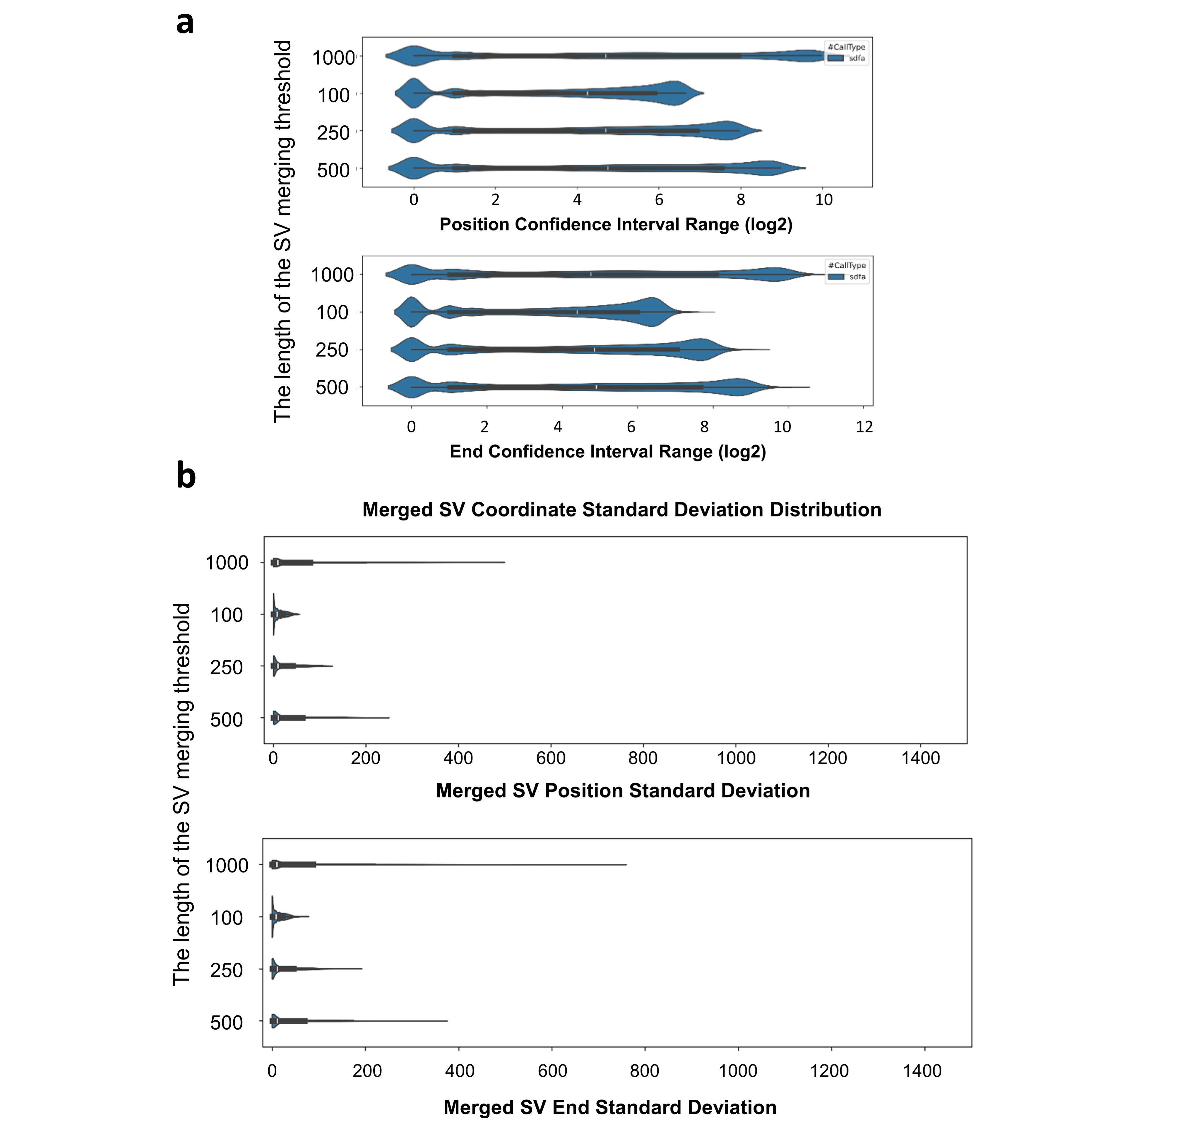
Fig. S2 | Coordinate range distributions in merged SVs using merging thresholds of 100bp, 250bp, 500bp, and 1000bp. a) Distributions of bias ranges for start position and end position. b) Distributions of standard deviation ranges for start position and end position.

Supplementary Figure 3.
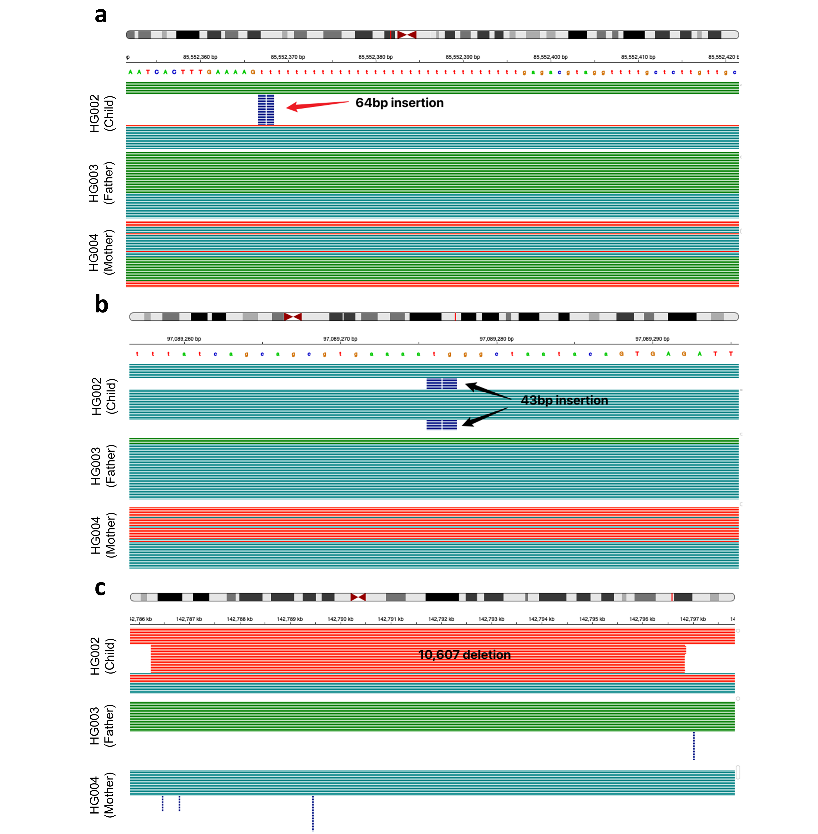
Fig. S3 | Three potential de novo SVs in the HG002 subject.
a) A 64bp insertion at chr3:85552367. This variant is supported as present in HG002 by HiFi and CLR reads but was missed by ONT-based calls, likely due to the adjacent homopolymer.
b) A 43bp insertion at chr5:97089276, supported by all three technologies: HiFi, CLR, and ONT-based reads.
c) A 10,607bp deletion at chr7:142786222, in the highly variable T cell Receptor Beta (TRB) region. This SV is supported by all three technologies as present in HG002.

Supplementary Figure 4.
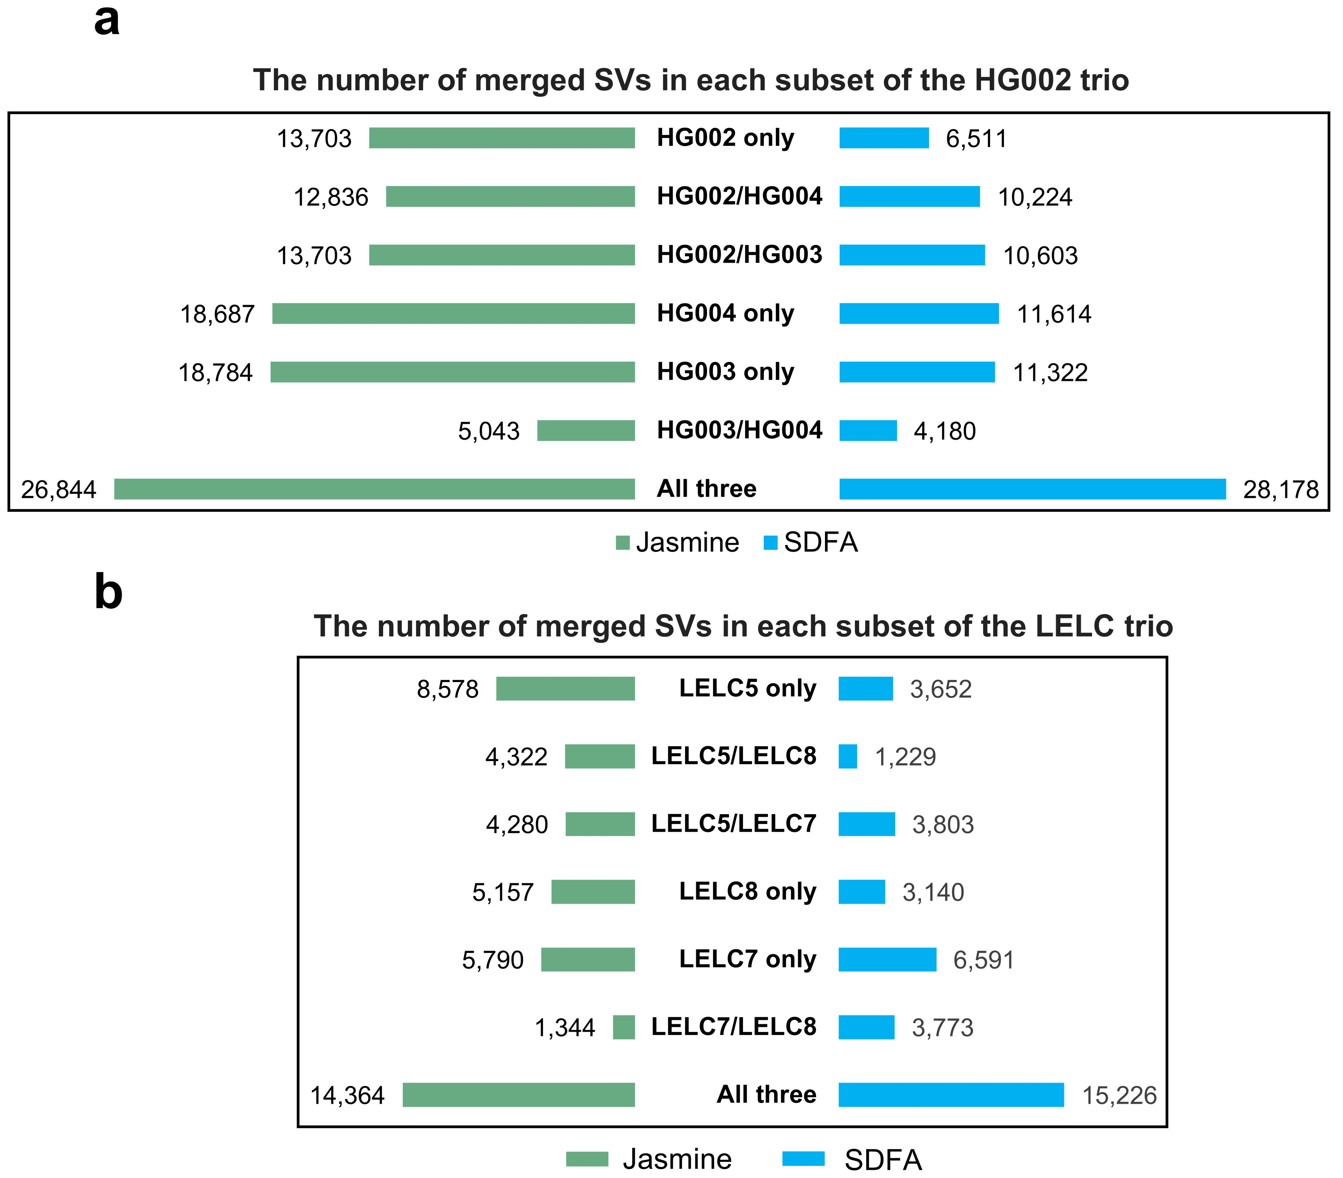
Fig. S4 | The number of merged SVs in each subset of the HG002 and LELC trio. Compared to Jasmine, SDFA demonstrated a lower discordance rate, achieving 0.079 versus 0.125 in the HG002 subset and 0.098 versus 0.196 in the LELC trio subset.

Supplementary Figure 5.
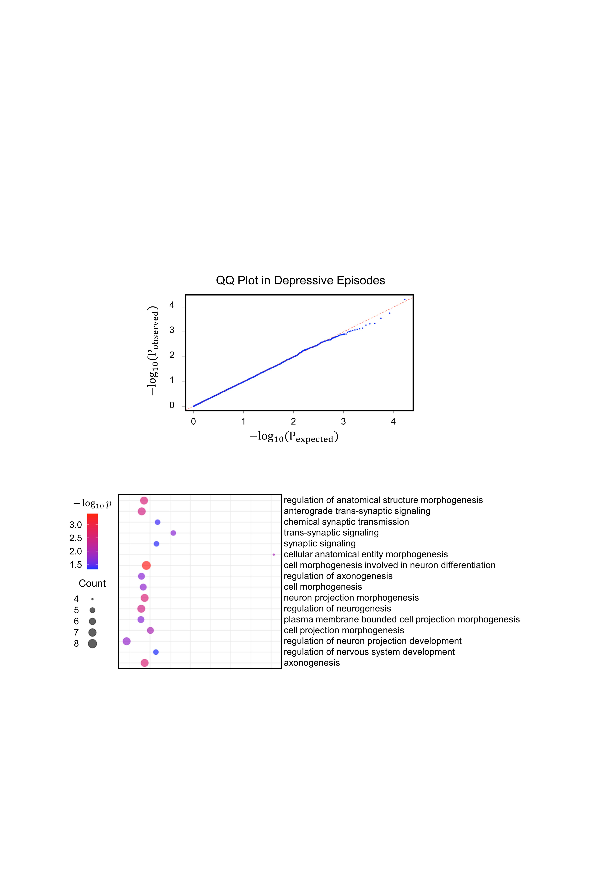
Fig. S5 | Quantile-quantile plot for 304,376 SVs in depressive episodes from the UK Biobank.

Supplementary Figure 6.
Fig. S6 | Biological process enrichment results for the 50 genes affected by SVs, showing the top 120 p-values.

Supplementary Figure 7.
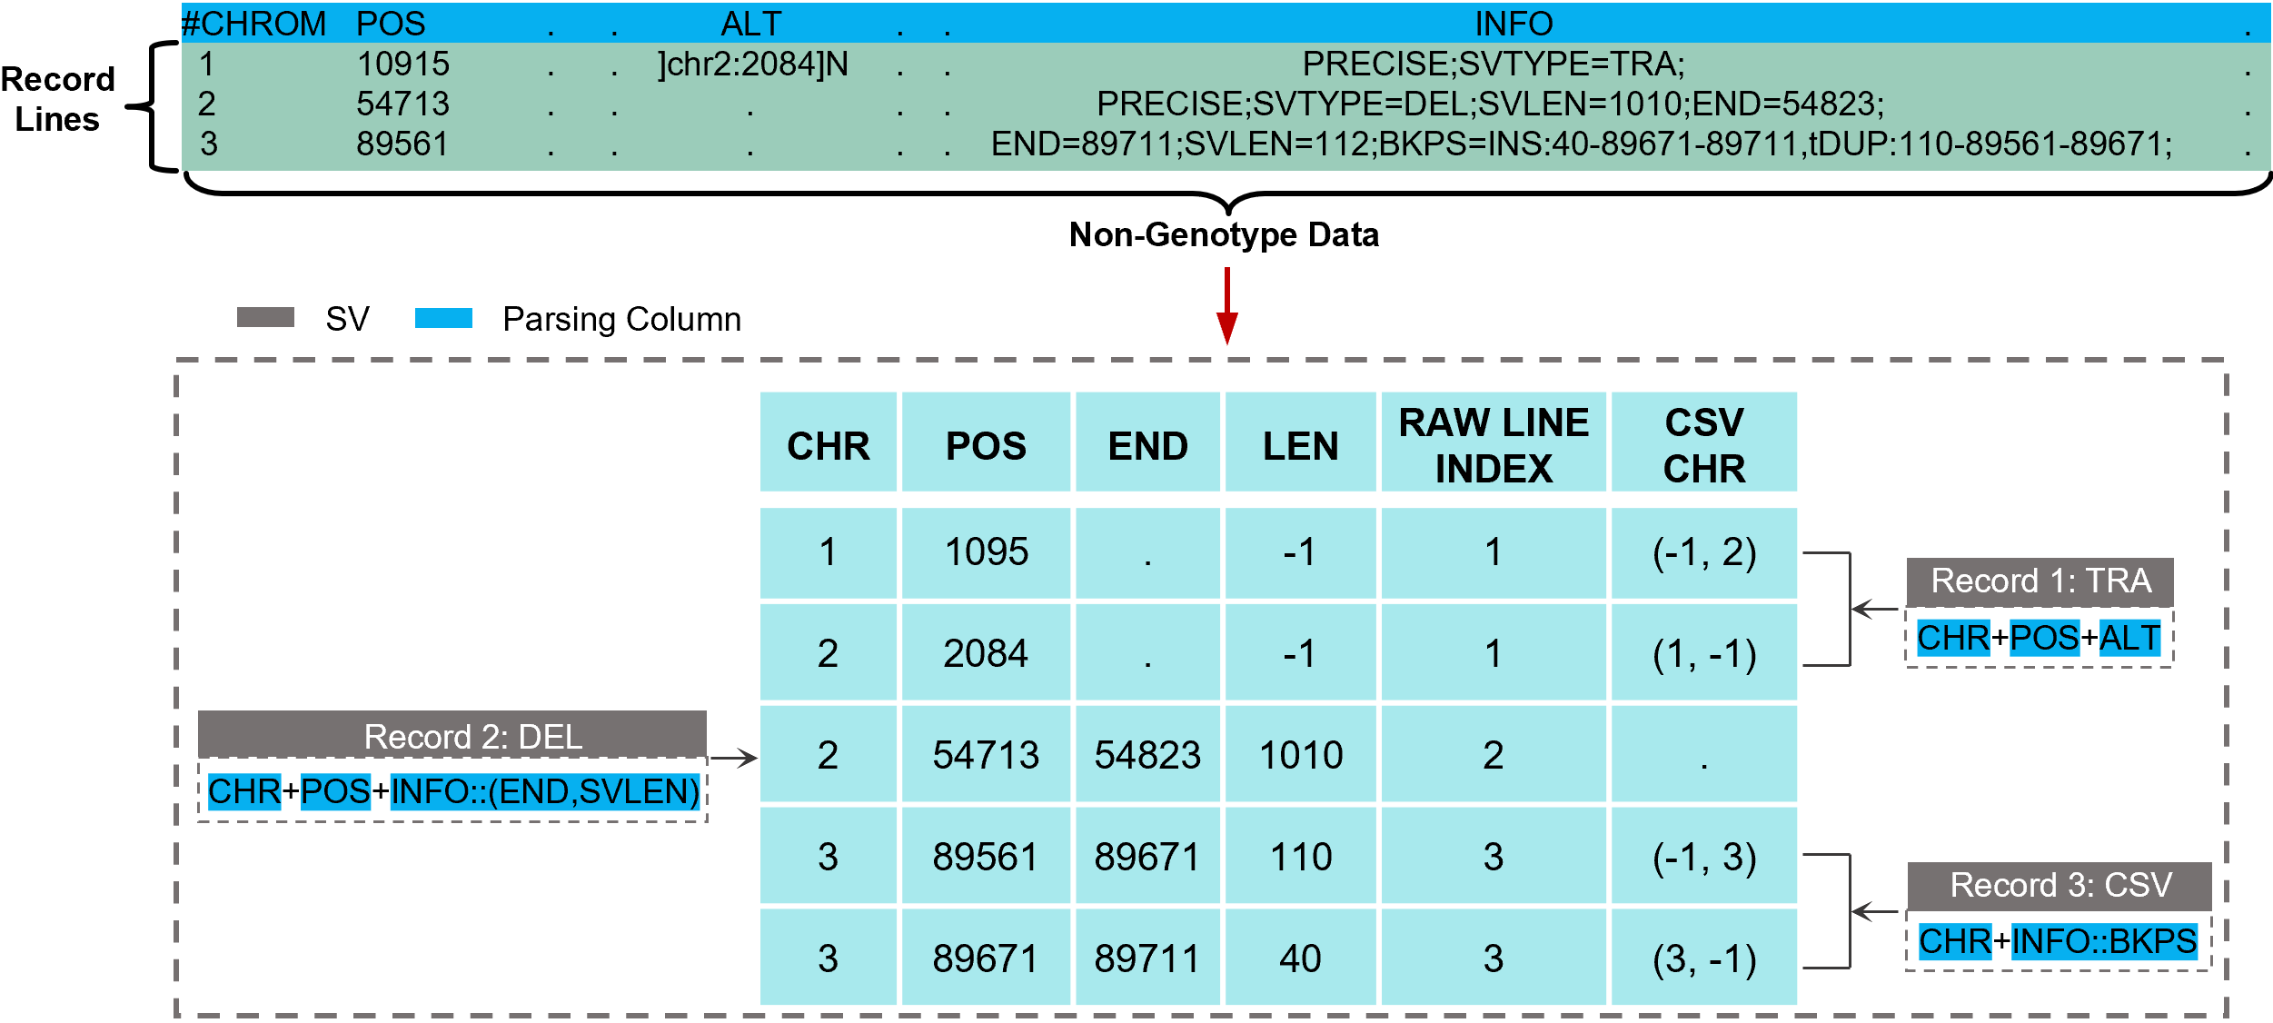
Figure. S7 | Schematic Illustration of Determining Start and End Points for Different Types of Structural Variants (SVs) Extracted from VCF Files.

Supplementary Figure 8.
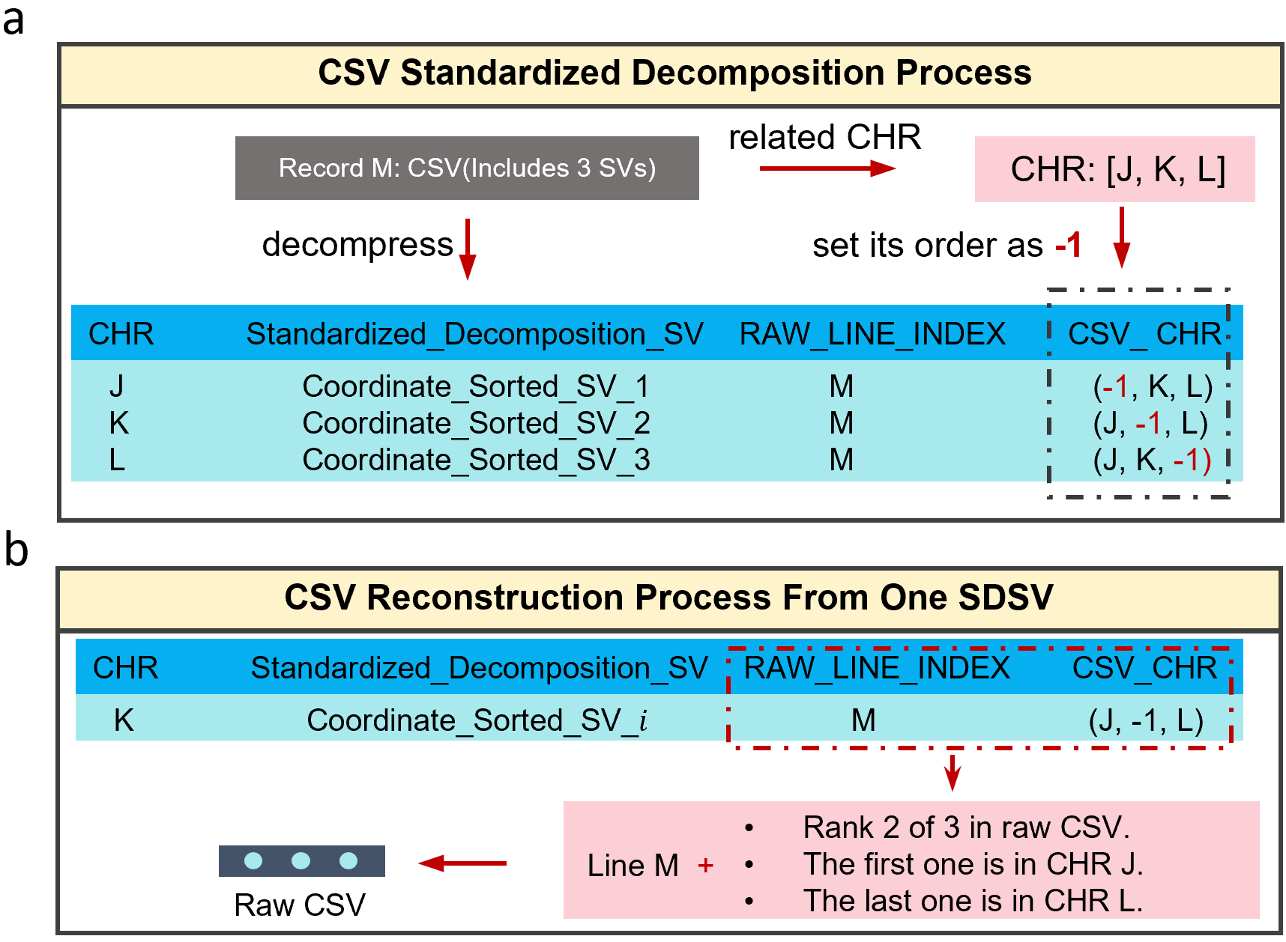
Figure. S8 | Decomposition and Reconstruction of Complex SVs in SDF.

