Supplementary Data
Table S1. Comparison of Diagnostic Potential of Zika Antigens and Cut-off Point Determination
Capture Antigen | Test Parameter | AUC (95% CI) | p-value | Maximum Sensitivity and Specificity trade-off values
 |  |  |  | Youden’s  Index | Cut-off point | Suggested Sensitivity | Suggested Specificity | Likelihood Ratio
ED(III) | Z/D P/N Ratio | 0.7686 (0.6094 to 0.9278) | 0.01 | 0.6364 | 0.75 | 100% | 63.64% | 2.75
ED(III) | Z/D OD Ratio | 0.8264 (0.6765 to 0.9764) | 0.003 | 0.5455 | 0.90 | 72.73% | 81.82% | 4.00
ED(III) | Z/D rOD Ratio | 0.7769 (0.6009 to 0.9529) | 0.01 | 0.5000 | 2.75 | 72.73% | 77.27% | 3.20
MR766  NS1 | Z/D P/N Ratio | 0.7273 (0.5304 to 0.9241) | 0.04 | 0.4545 | 1.40 | 63.64% | 81.82% | 3.50
MR766  NS1 | Z/D OD Ratio | 0.7190 (0.5213 to 0.9168) | 0.04 | 0.4091 | 3.30 | 72.73% | 68.18% | 2.29
MR766  NS1 | Z/D rOD Ratio | 0.7727 (0.5735 to 0.9719) | 0.01 | 0.5455 | 4.25 | 63.64% | 90.91% | 7.00
SV0127  NS1 | Z/D P/N Ratio | 0.8388 (0.6879 to 0.9898) | 0.002 | 0.4545 | 2.50 | 63.64% | 81.82% | 3.5
SV0127  NS1 | Z/D OD Ratio | 0.8264 (0.6714 to 0.9815) | 0.003 | 0.5000 | 2.35 | 63.63% | 86.36% | 4.7
SV0127  NS1 | Z/D rOD Ratio | 0.8843 (0.7658 to 1.000) | <0.001 | 0.5455 | 3.30 | 81.82% | 77.27% | 3.60

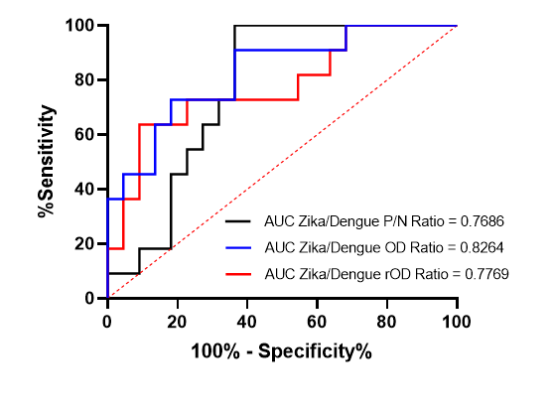
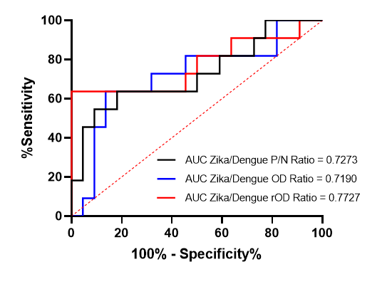
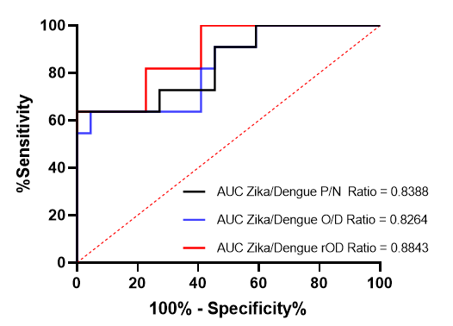
A. ROC Curve Measurement for ZIKV ED(III) B. ROC Curve Measurement for ZIKV MR766 NS1 C. ROC Curve Measurement for ZIKV SV0127 NS1

Figure S1 A-C: . ROC Curves of Different Zika Antigens against Serological Test Measurements
Fig. S2 A and B. Comparison of Zika/Dengue ELISA and Commercial ELISA performance based on Serum Category

- ANOVA Comparison of IgG units per serum category of commercial ZIKA ELISA IgG Kit
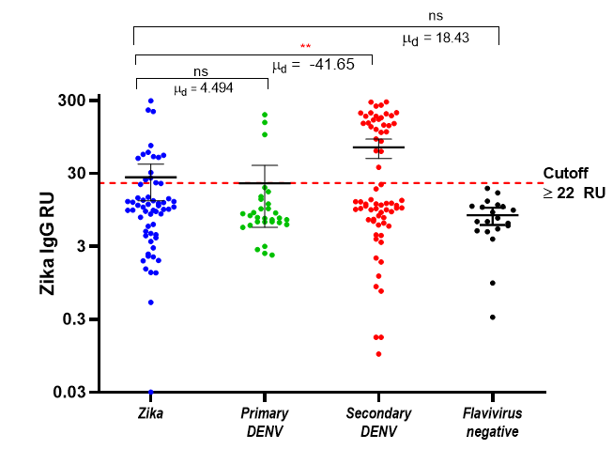

- ANOVA Comparison of Zika/Dengue ELISA OD Ratio per serum category
