CeO₂/CdS heterojunctions decorated cotton fabrics as facile recyclable photocatalysts for highly efficient visible light driven degradation of methylene blue
Rui Zouª, Linhua Liª, Lin Yangª, Jianwu Lan^{a*}, Hongyu Liuª, Baojie Douª, Jiaojiao Shang^{ab}, Shaojian Lin^{a*}
a College of Biomass Science and Engineering, Sichuan University, Chengdu 610065, P. R. China
b National Engineering Laboratory for Clean Technology of Leather Manufacture, Sichuan University, Chengdu 610065, P. R. China
* Corresponding authors.
E-mail address: lanjw@scu.edu.cn (J. Lan), sjlin@scu.edu.cn (S. Lin).

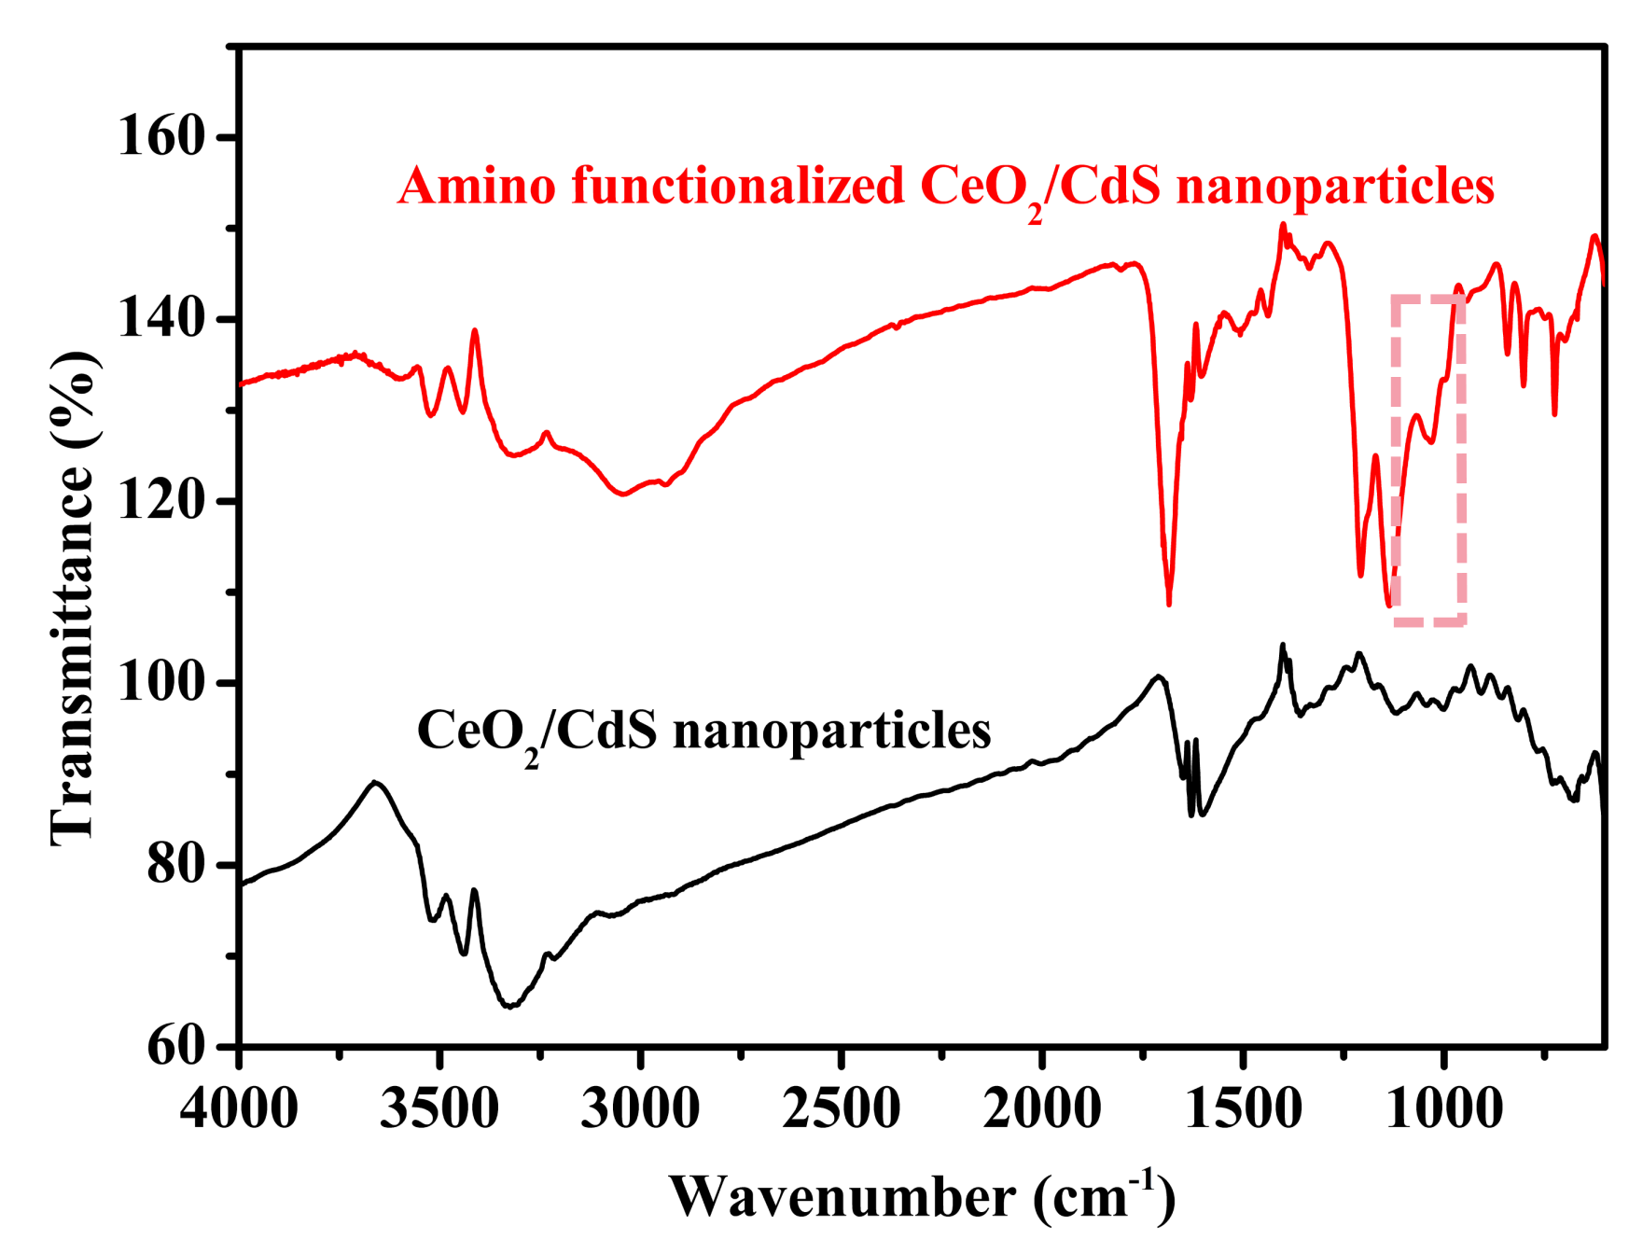
Fig. S1 FTIR spectra of amino functionalized CeO₂/CdS nanoparticles and CeO₂/CdS nanoparticles.

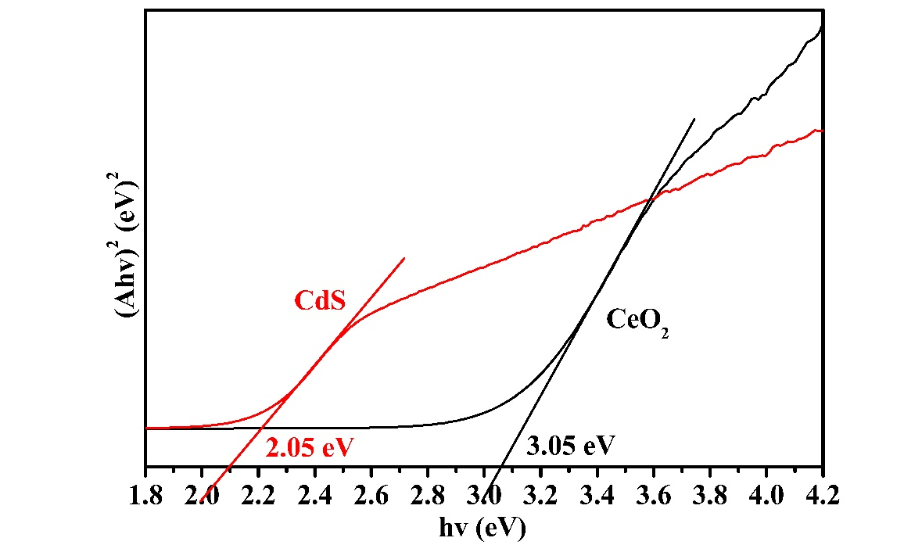
Fig. S2 Plots of (Ahv)² vs photon energy (hv) for CeO₂ and CdS.

