Inoculum information
Arbuscular mycorrhizal fungi (AMF) inoculum included matrix, spores, mycelia and plant root segments, among which AMF colonization was 60.86%, the hyphal length density was 8.36 m/g, the number of spores was 13 (spore/g). Soil DNA was extracted from 0.5 g of soil sample (fresh weight) using the PowerSoil®DNA Isolation Kit (MoBio Laboratories, Inc., Carlsbad, CA, USA) following the instructions of the manufacturer. A NanoDrop 8000 Ultramicro UV spectrophotometer (NanoDrop Technologies, Wilmington, DE, United States) was used to determine the quantity and purity of DNA samples. A two-step polymerase chain reaction (PCR) was performed to amplify the 18S ribosomal RNA (rRNA) gene. The PCR products were separated through a 1.5% agarose gel containing GelRedTM (Biotium) and purified with the AxyPrepDNA GEL Extraction Kit (Axygen, Union City, CA, USA), and quantified using a NanoDrop 8000. The purified products were pooled in equimolar amounts and then sequenced on the Illumina-MiSeq platform (Shanghai Magigene Inc., Shanghai, China). We used the Quantitative Insights into Microbial Ecology (QIIME v1.7.0) and the UPARSE pipeline to treat raw sequences. The operational taxonomic units (OTUs) were clustered at 97% similarity. Representative sequences were selected from each OTU. Sequences that had no match against the MaarjAM database were subjected to further BLAST search against the International Nucleotide Sequence Database (INSD) using the same parameters, but with a similarity threshold of 90% and alignment (Sepp et al., 2018). Alpha diversity metrics (richness) were calculated using the rarefied OTUs table. Soil AMF OTUs richness was 99.6; the majority of the mycorrhizal fungal soil inoculum belonged to Claroideoglomus (corresponding to 30.96% of the total) and Septoglomus (corresponding to 26.31% of the total) and Diversispora (corresponding to 21.62% of the total).

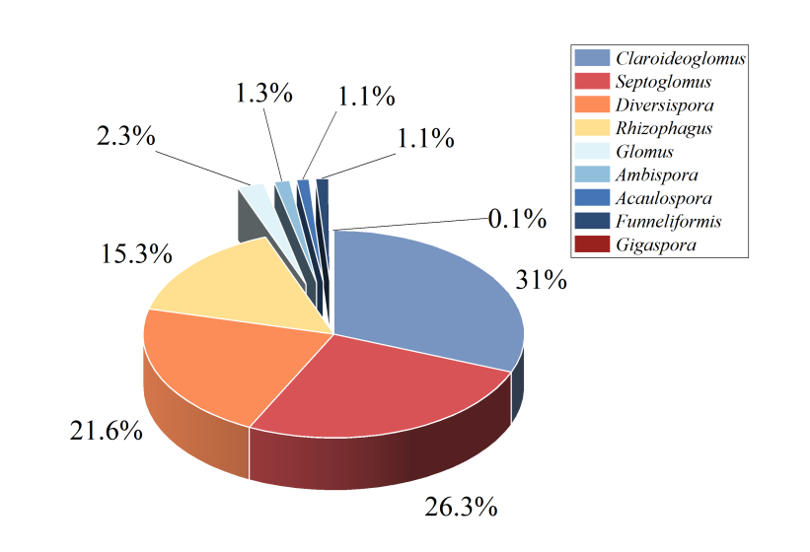
Fig. S1. Relative abundance (%, proportion of OTUs) of AMF genus in each soil inoculum.

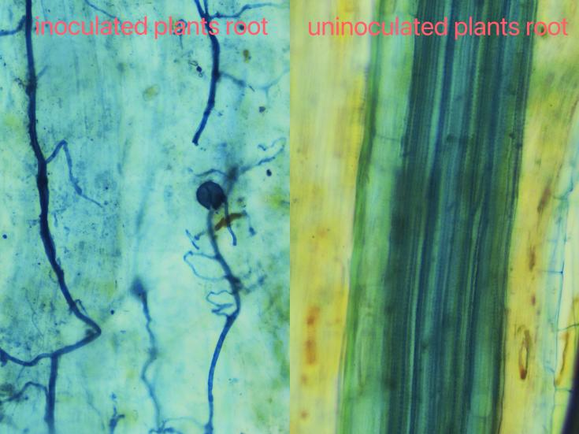
Fig. S2. Arbuscular mycorrhizal fungi colonization status.

Table S1. The plant ¹⁵N recovery (%) in HC and RHC under different N addition levels
 | Control | Low N | High N
HC | 0.67 ± 0.18 Bb | 1.31 ± 0.19 Aa | 1.10 ± 0.19 Bab
RHC | 2.39 ± 0.27 Aa | 2.64 ± 0.92 Aa | 3.19 ± 0.23 Aa
Values are means of four replicates (±SE). All values were sqrt transformed. Different uppercase letters denote significant difference between HC and RHC (P ≤ 0.05). Different lowercase letters denote significant difference among different N addition levels (P ≤ 0.05).

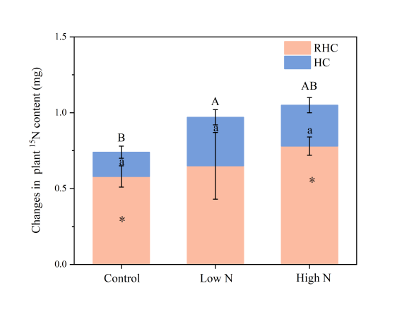
Fig. S3. The plant ¹⁵N content under different N addition levels. All values were sqrt transformed. Different uppercase letters denote significant difference in the HC among different N levels (P ≤ 0.05). Different lowercase letters denote significant difference in the RHC among different N levels (P ≤ 0.05). An asterisk indicates a significant difference between HC and RHC (P ≤ 0.05).
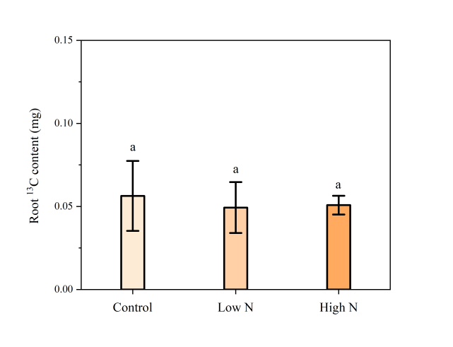
Fig. S4. The root ¹³C content under different N addition levels.

