Supplementary Figures

A 27 cm long straight square microchannel in viscoelastic fluid for submicron-sized particle and bacteria focusing

Youngseo Cho¹, Min-Ho Lee², SangWook Lee^{3,#}, Younghak Cho^{1,4,#}

1 Department of Mechanical Design and Robot Engineering, Seoul National University of Science and Technology, Seoul, 01811, Republic of Korea
2 School of Integrative Engineering, Chung-Ang University, Seoul, 06974, Republic of Korea
3 PCL Inc., Seoul, 08510, Republic of Korea
4 Department of Mechanical System Design Engineering, Seoul National University of Science and Technology, Seoul, 01811, Republic of Korea
# Corresponding Author/E-mail: swlee@pclchip.com, TEL: +82-2-970-6361; yhcho@seoultech.ac.kr, TEL: +82-2-970-6361

.
Fig. S1 Focusing efficiency of submicron-sized particle at 0.1 wt% PEO concertation. (a) Flow stream images of fluorescent PS particles with 510, 250, 180 and 100 nm diameter obtained for the flow rate of > 20 µL/min. (b) Focusing efficiencies are plotted as different flow rates. (c) Normalized fluorescence intensity profiles of 510 nm particles along the channel width is plotted as the flow rate of > 20 µL/min

Fig. S2 Normalized fluorescence intensity profiles of (a) 250 nm, (b) 180 nm and (c) 100 nm particles along the channel width is plotted as five different flow rates

8
Fig. S3 50 nm particle at 0.5 wt% PEO concertation. (a) Flow stream images of fluorescent PS particles with 50 nm diameter obtained for three different flow conditions. (b) Focusing efficiencies are plotted as different flow rates. (c) Normalized fluorescence intensity profiles of 50 nm particles along the channel width is plotted as three different flow rates

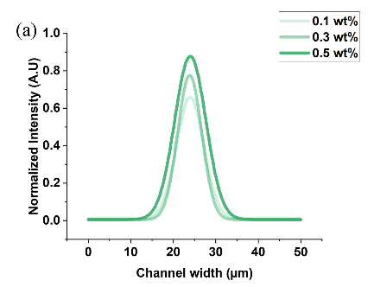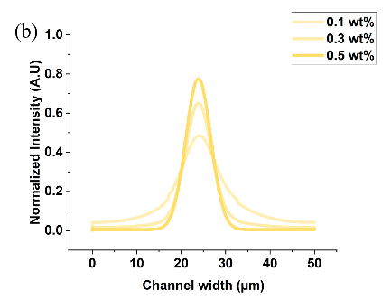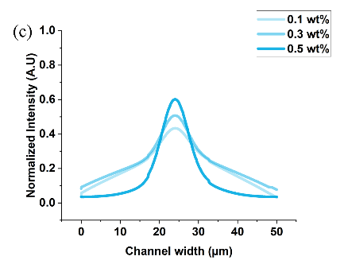
Fig. S4 Normalized fluorescence intensity profiles of (a) 250 nm, (b) 180 nm and (c) 100 nm particles along the channel width is plotted as three different PEO concentrations

