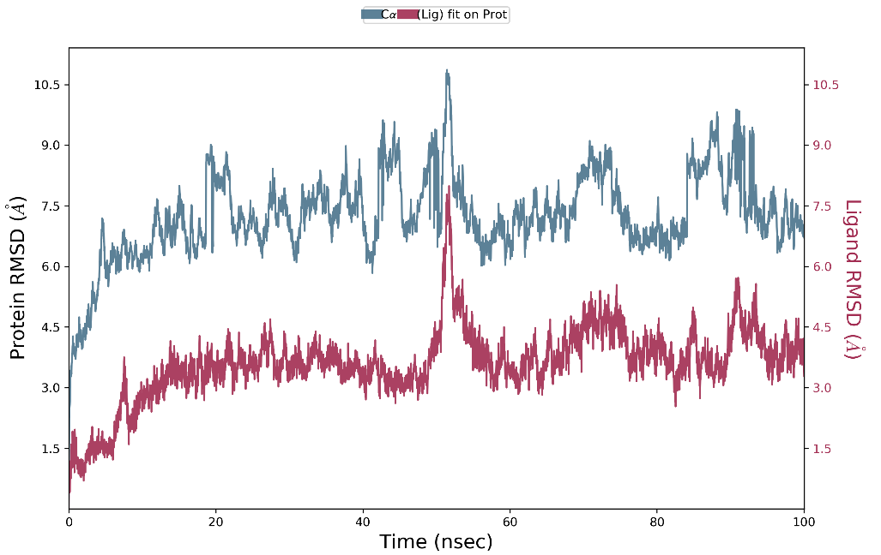
Figure S1 RMSD of sucrose and T1R2/T1R3

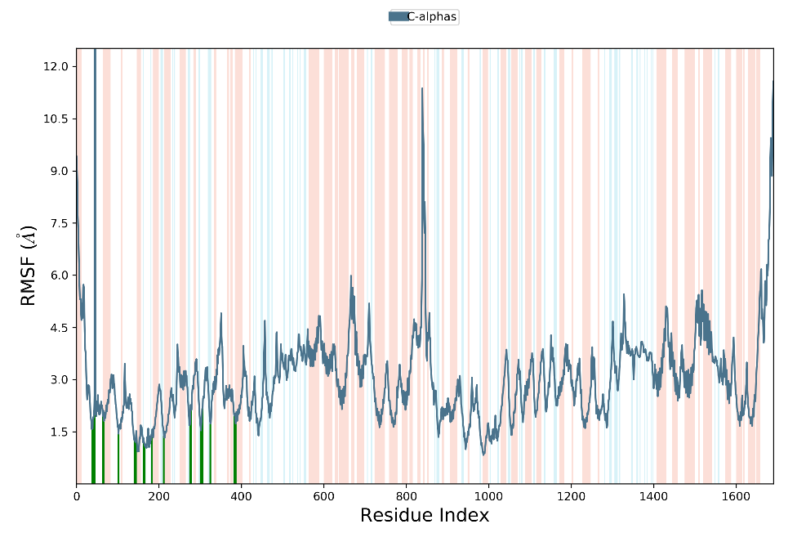
Figure S2 RMSF of sucrose and T1R2/T1R3

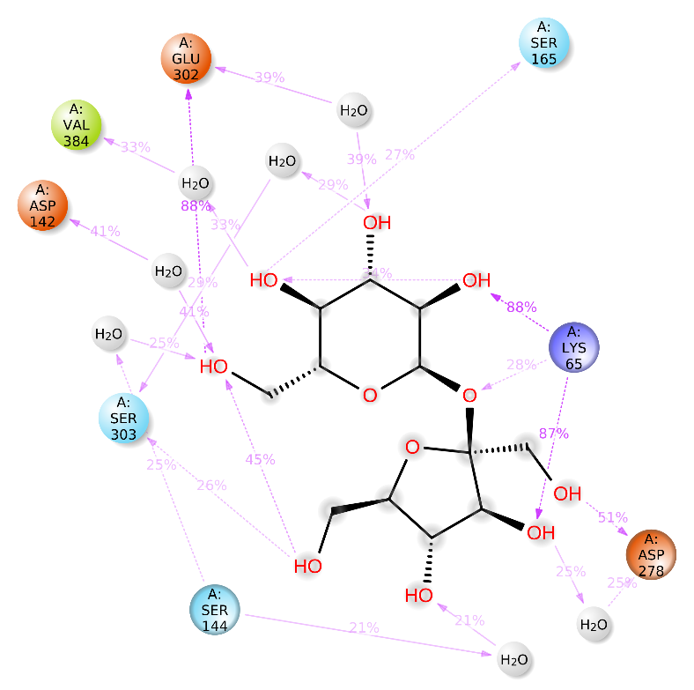
Figure S3 interaction between sucrose and T1R2/T1R3 that occurs over 20.0% of the simulation time (over 20ns of interaction time in 100ns) .

Table S1 The concentration range of aroma compounds
Aroma compounds | Concentration(mg/L)
Acetic acid | 1, 5, 25, 40, 55, 70, 85
Propionic acid | 0.001, 0.01, 0.1, 1, 5, 10, 20, 40, 80
Butyric acid | 0.001, 0.01, 0.1, 1, 2.5, 5, 10, 20, 40, 80
Hexenoic acid | 0.001, 0.01, 0.1, 1, 5, 10, 20, 30
Nonanoic acid | 0.001, 0.01, 0.1, 1, 5, 7.5, 10, 15, 20
Octanoic acid | 0.001, 0.01, 0.1, 1, 5, 7.5, 10, 12.5, 15, 17.5
Decanoic acid | 0.001, 0.01, 0.05, 0.25, 0.5, 1
Trans-2-hexenoic acid | 0.001, 0.01, 0.1, 1, 5, 10, 20, 40
2-methylbutyric acid | 0.001, 0.01, 0.1, 1, 2.5, 5, 10, 15, 20
3-methylbutyric acid | 0.001, 0.01, 0.1, 0.5, 1, 2, 4, 8, 16

Table S2 Whether the ten acids are soluble in water or propylene glycol
Acids | Soluble in water or propylene glycol
Acetic acid | water
Propionic acid | water
Butyric acid | water
Hexenoic acid | propylene glycol
Nonanoic acid | propylene glycol
Octanoic acid | propylene glycol
Decanoic acid | propylene glycol
Trans-2-hexenoic acid | water
2-methylbutyric acid | propylene glycol
3-methylbutyric acid | water

Sweetness scale
Table S3 Propionic acid
 | 1 | 2 | 3 | 4 | 5 | 6 | 7 | 8 | 9
0(mg/L) | 5 | 5 | 5 | 5 | 5 | 5 | 5 | 5 | 5
0.001(mg/L)
0.01(mg/L)
0.1(mg/L)
1(mg/L)
5(mg/L)
10(mg/L)
20(mg/L)
40(mg/L)
80(mg/L)

Comfort scale
Table S4 Propionic acid
 | 1 | 2 | 3 | 4 | 5 | 6 | 7 | 8 | 9
0(mg/L) | 5 | 5 | 5 | 5 | 5 | 5 | 5 | 5 | 5
0.001(mg/L)
0.01(mg/L)
0.1(mg/L)
1(mg/L)
5(mg/L)
10(mg/L)
20(mg/L)
40(mg/L)
80(mg/L)

