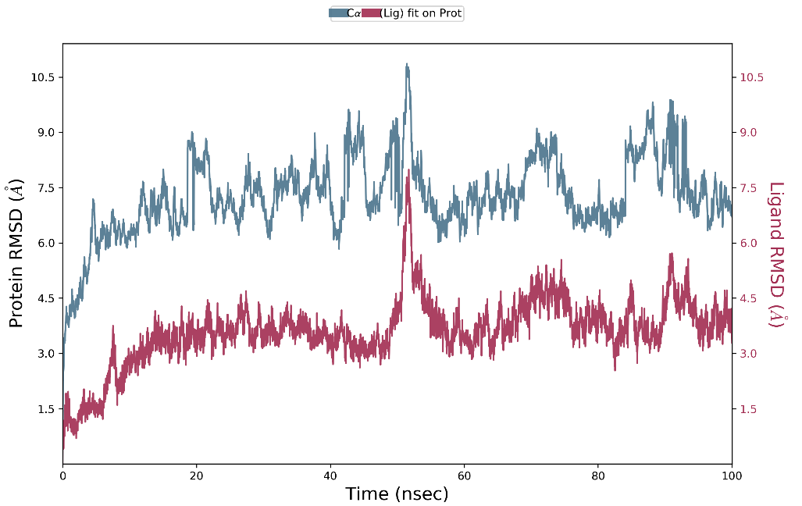
Figure S1 RMSD of sucrose and T1R2/T1R3

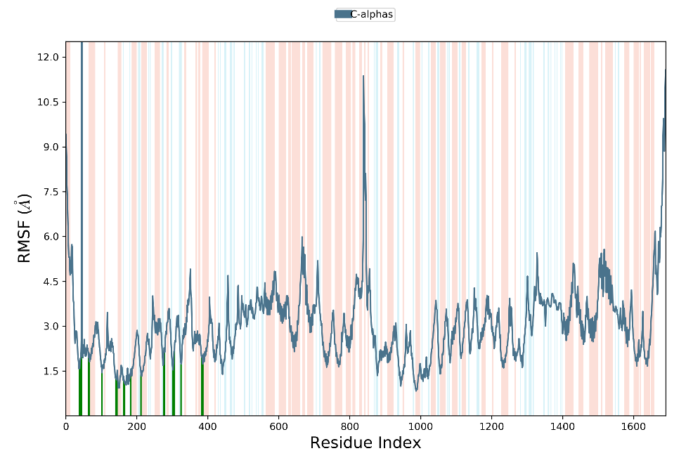
Figure S2 RMSF of sucrose and T1R2/T1R3

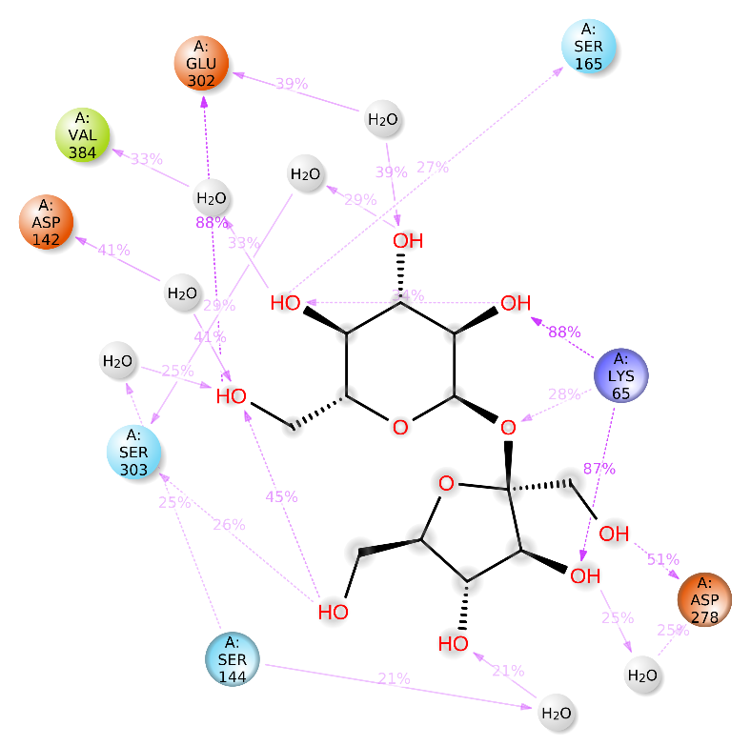
Figure S3 interaction between sucrose and T1R2/T1R3 that occurs over 20.0% of the simulation time (over 20ns of interaction time in 100ns) .

