Supplementary Figure

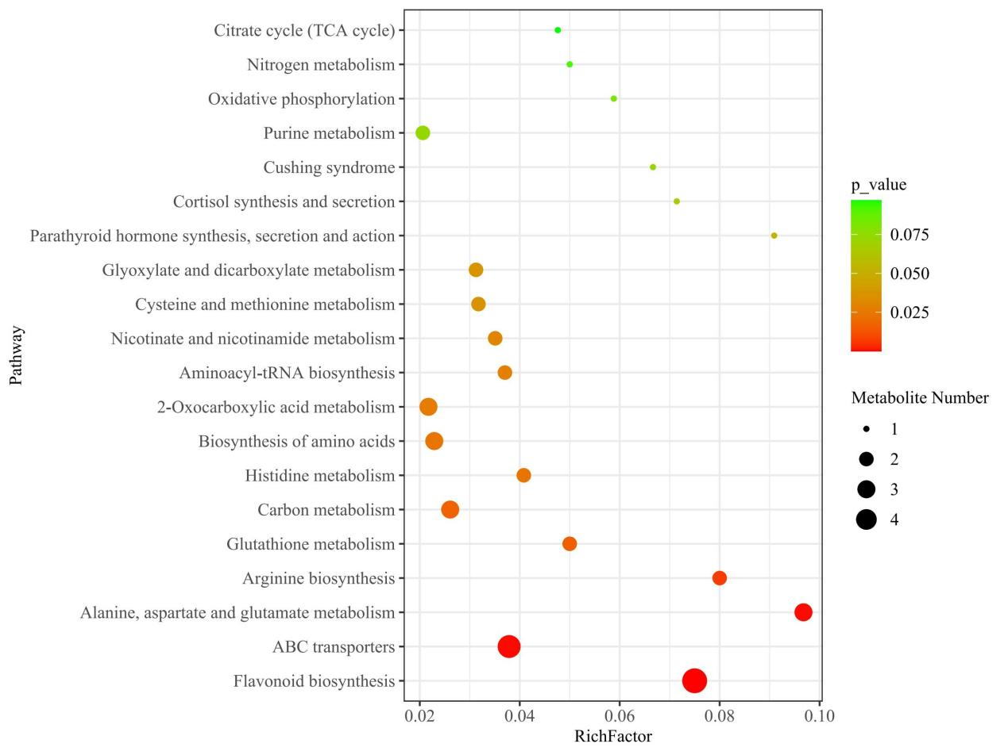
Fig S1. KEGG enrichment of metabolites (XFZ vs YSD)
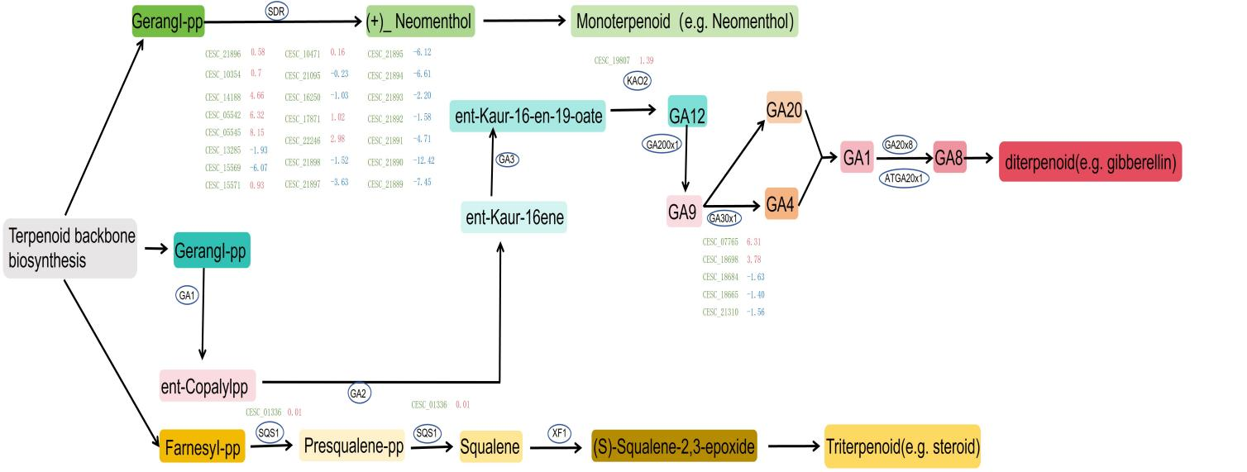
Fig S2. Proposed terpenoid biosynthetic pathway. Upregulated genes are indicated by red positive numbers, while downregulated genes are marked with green negative numbers. Abbreviations: GA: gibberellic acid 1, GA20ox1: gibberellin 20 oxidase 1, GA3ox1: gibberellin 3β-hydroxylase 1, GA2ox8: gibberellin 2 oxidase 8, ATGA2ox1: gibberellin 20 oxidase 1, SQS1: squalene synthase 1, SDR: short-chain dehydrogenase reductase, KAO2: ent-kaurenoic acid hydroxylase 2.
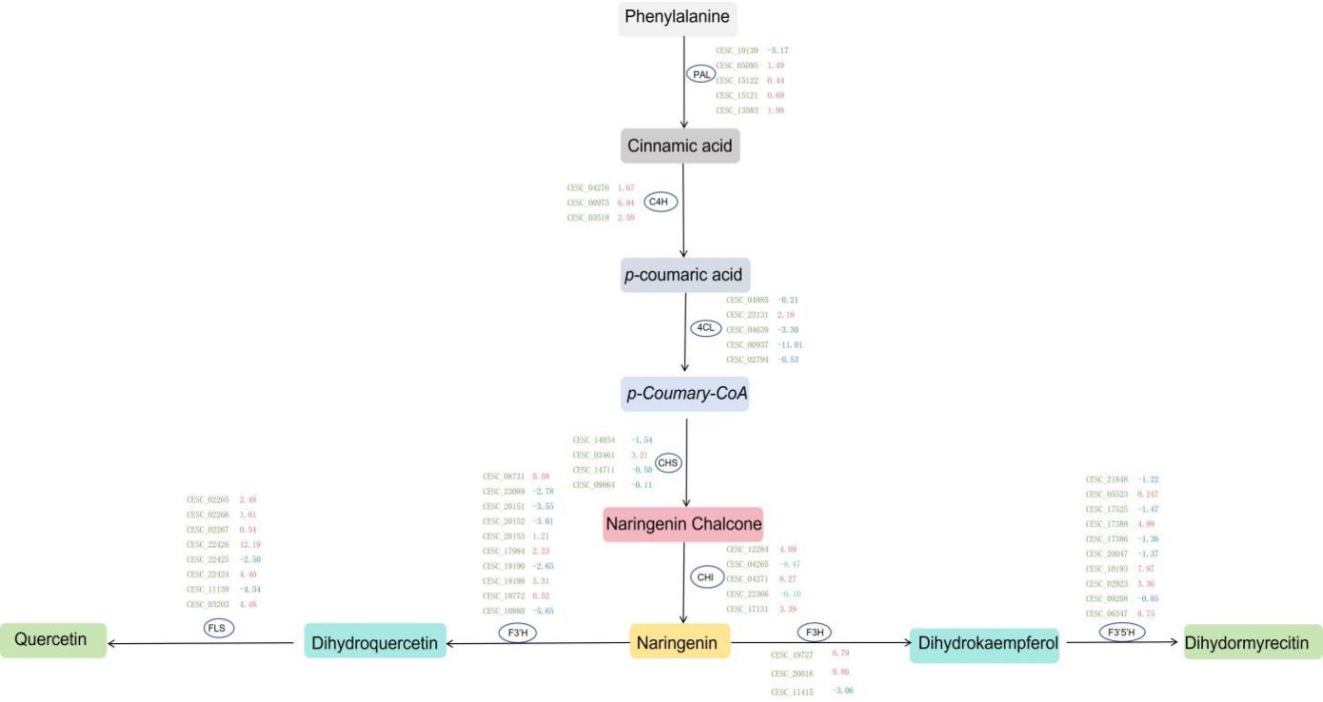
Fig S3. Proposed flavonoid biosynthetic pathway. Upregulated genes are indicated by red positive numbers, while downregulated genes are marked with green negative numbers. Abbreviations: PAL: L-phenylalanine ammonia-lyase, C4H: cinnamate 4-Hydroxylase, 4CL: 4-coumarate: CoA ligase, CHS: chalcone isomerase, F3H: flavanone 3-hydroxylase, F3'5'H: flavonoid 3’, 5’-hydroxylase, FLS: flavonol synthase.

