Table 1. Scope for ring fused [1,2]-azaborinesª
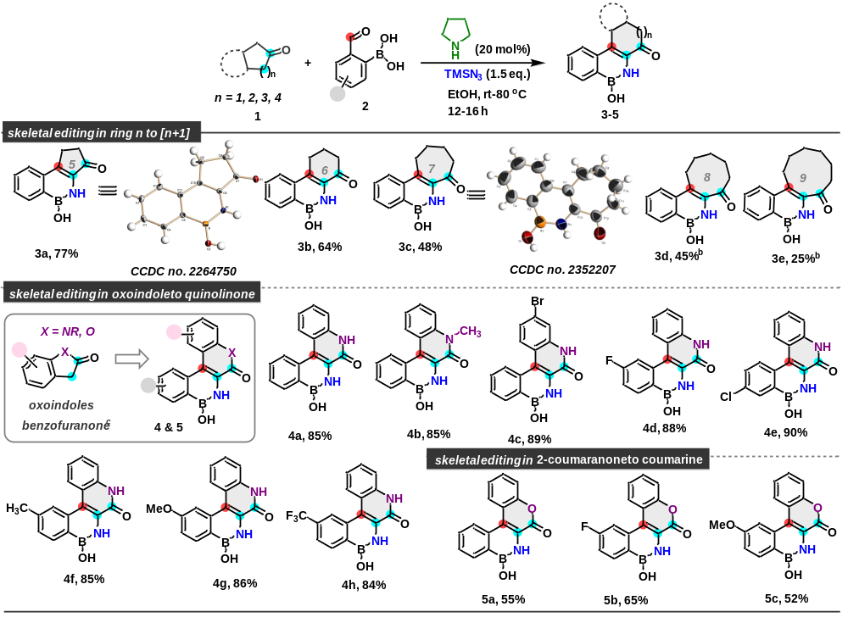
ªReaction was carried out in 0.33 mmol scale. Isolated yields are mentioned. ^{b}3.0 equiv of pyrrolidine was used, 80 ºC for 14 h. ^{c}Reaction was carried out with 20 mol% pyrrolidine in 1,4-dioxane at rt.
Table 2. Scope for benzazaborines from acyclic ketonesª
ªReaction was carried out in 0.33 mmol scale. Isolated yields are mentioned. ^{b}Reaction was carried out with 20 mol% pyrrolidine. ^{c}Reaction was carried out with 300 mol% pyrrolidine. ^{d}Reaction was carried out with at 4.4 mmol scale, 72% yield (0.80 g).
Table 3. Scope of late stage function in drug molecules and natural product

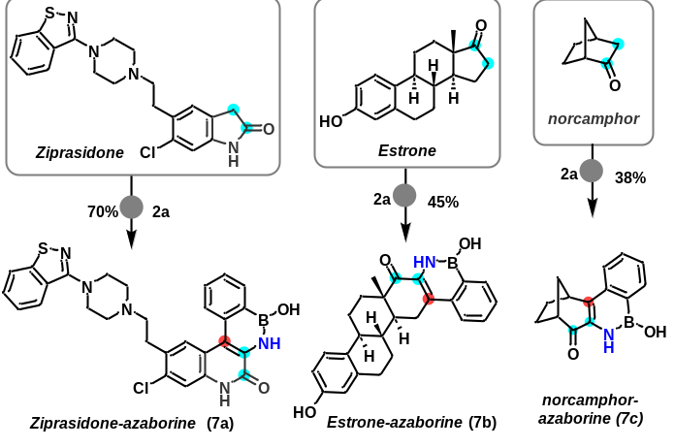
ªReaction was carried out in 0.33 mmol scale. Isolated yields are mentioned. ^{b}reaction was done at 80 ºC.

