Extended Data Figures

Extended Data Figure 1
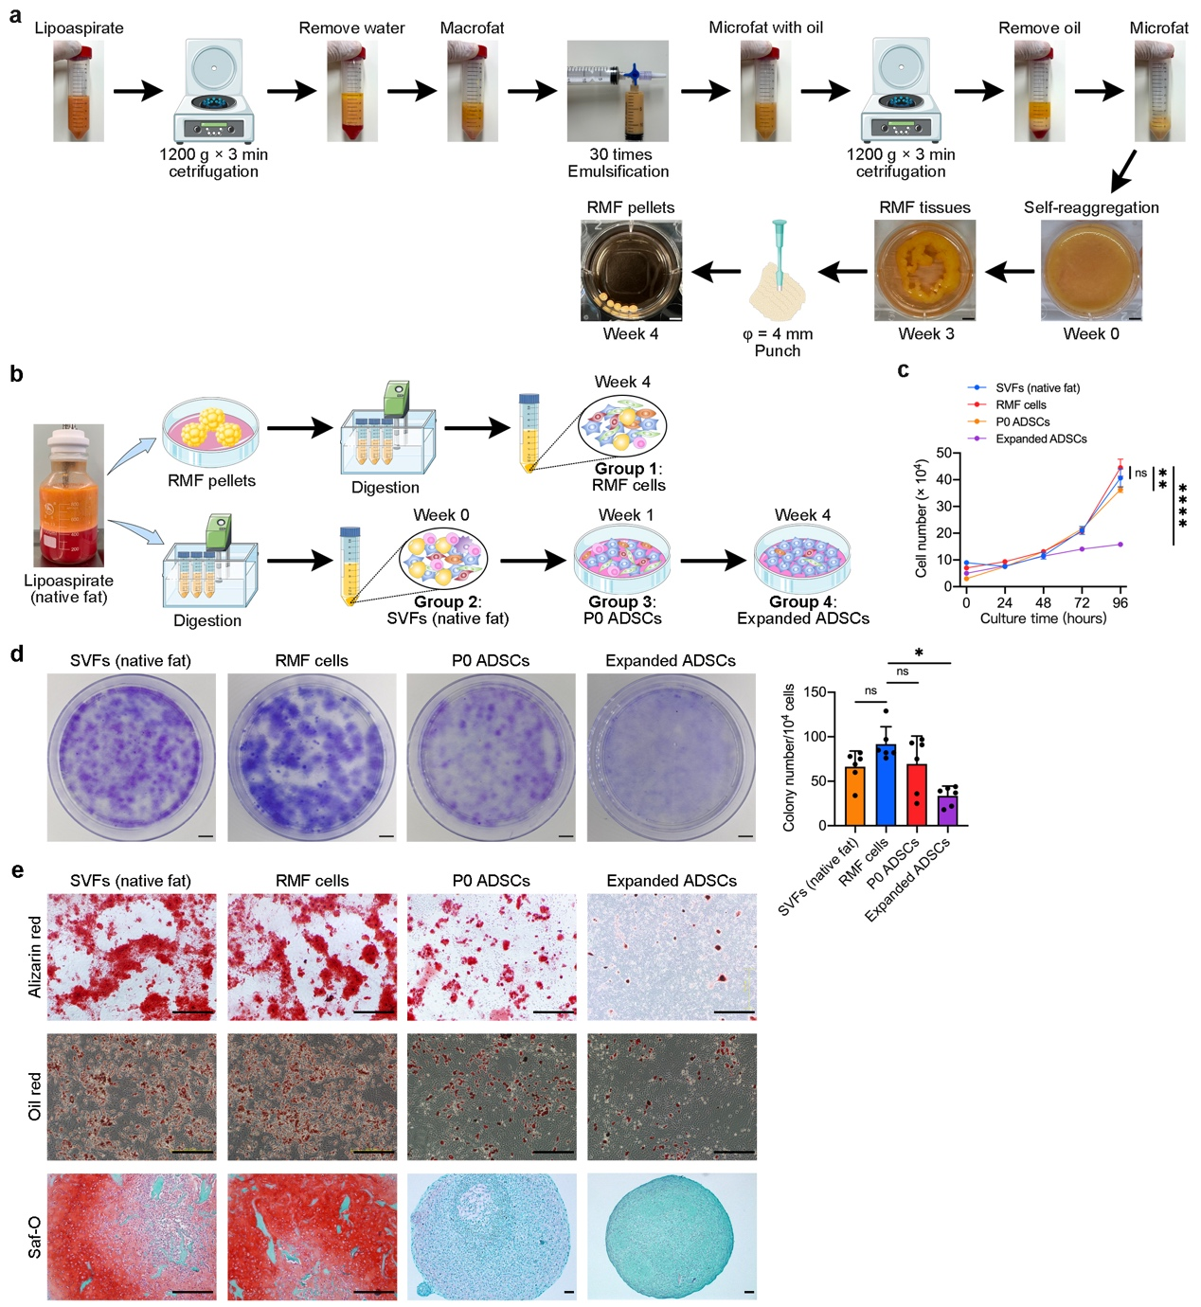
Extended Data Fig. 1. Protocol for generating RMF pellets and characterization of RMF pellet-derived cells, related to Fig. 1
a, Schematic protocol for generating 4-mm RMF pellets from human adipose tissue.
b, Schematic showing the harvesting of SVFs (native fat), RMF cells, P0 ADSCs, and expended ADSCs for characterization of cell populations. RMF cells were obtained from RMF pellets by collagenase digestion; SVFs were isolated from native fat tissues by collagenase digestion; The SVFs were then seeded onto plastic cell culture plates for adhesive culture in growth medium for 5 to 7 days. The resulting cells were detached using Trypsin-EDTA and used as primary ADSCs (P0 ADSCs). The ADSCs cultured in growth medium and passaged 5 to 7 times until day 28 were harvested and used as expanded ADSCs in subsequent experiments.
c, Proliferation capacity of the SVFs (native fat), RMF cells, P0 ADSCs, and expanded ADSCs. Data are presented as mean ± SD (n = 6 biological replicates). Two-way ANOVA with Dunnett’s test is used for comparison of multiple groups. **p < 0. 01, ****p < 0. 0001; ns, not significant.
d, Colony-forming capacity of the SVFs (native fat), RMF cells, P0 ADSCs, and expanded ADSCs. The colony numbers generated from 1 × 10⁴ of RMF cells, SVFs (native fat), P0 ADSCs, and expanded ADSCs are shown on the right. Data are presented as mean ± SD (n = 6 biological replicates). One-way ANOVA with Tukey’s test is used for comparison of multiple groups. Scale bars, 1 cm. *p < 0.05.
e, SVFs (native fat), RMF cells, P0 ADSCs, and expanded ADSCs were submitted for osteogenic, adipogenic, and chondrogenic differentiation in corresponding differentiation induction media for indicated days. Representative images of Alizarin Red staining for osteogenic differentiation, Oil red staining for adipogenic differentiation, and Safranin O staining for chondrogenic differentiation for the induced SVFs (native fat), RMF cells, P0 ADSCs, and expanded ADSCs. Scale bars, 20 μm.

Extended Data Figure 2
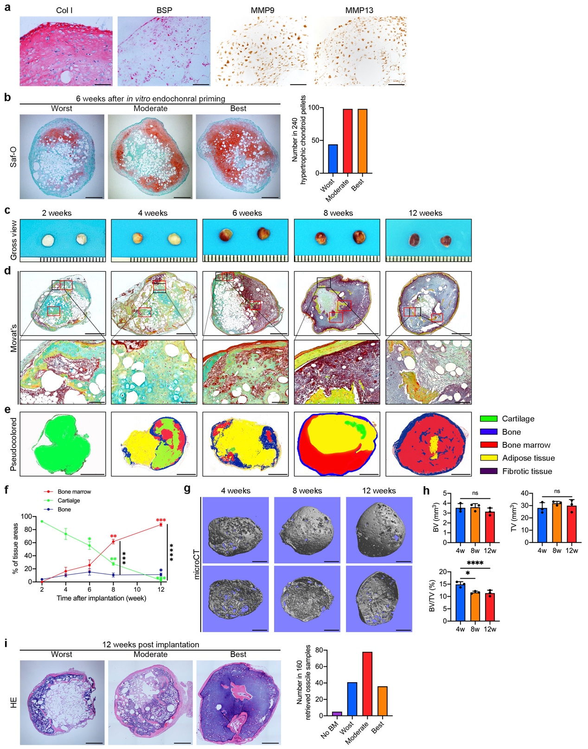
Extended Data Fig. 2. Characterization of RMF-derived chondroids and hOssicles, related to Fig. 2
a, Immunohistochemistry of Col I, BSP, MMP9, and MMP13 in RMF pellets after 6 weeks of endochondral priming. Col I and BSP staining were revealed with Vector red, MMP9 and MMP13 staining were revealed with DAB. Representative of 6 independent biological replicates. Scale bars, 100 μm.
b, Safranin O images demonstrating the worst, moderate, and best chondroid pellets after 6 weeks of in vitro endochondral priming. Percentage of each type of chondroid pellet samples is shown on the right. Scale bars, 1 mm. Data are presented as mean ± SD (n = 6 biological replicates, each biological replicate contained 10 mice, each mouse carried 4 pellets).
c, Gross view of explanted ossicle samples explanted at 2, 4, 6, 8, and 12 weeks following transplantation in NPSG mice. Representative of 3 biological replicates. Scale bars, 1 mm.
d, Movat’s pentachrome staining images of explanted ossicles. The cartilage matrix is stained blue, dense bone tissue is stained red, and new bone tissue is stained yellow. Magnified images of boxed areas on the below illustrating the residual cartilage, bone, or bone marrow. Representative of 3 biological replicates. Scale bars, 1 mm in large images, 100 μm in magnified images. B, bone; BM, bone marrow; C, cartilage.
e, Pseudocolored images for demonstrating the area of cartilage, bone, bone marrow, adipose, and fibrotic tissues in explanted ossicles, which outlined on the Movat’s pentachrome staining images using the area calculation tool in ImageJ software. Cartilage, green; bone, blue; bone marrow, red; adipose tissue, yellow; fibrotic tissues, purple. Representative of 3 biological replicates. Scale bars, 1 mm.
f, Time-course quantification analysis of bone, cartilage, and bone marrow tissue areas within explanted ossicles at each time points following transplantation. Data are presented as mean ± SD (n = 4 biological replicates, 4 ossicles per time points). Two-way ANOVA with Dunnett’s test is used for comparison of multiple groups. Within a group, each time point is compared with the 2 weeks; between tissue types, each tissue type is compared with the bone marrow. *p < 0.05, **p < 0. 01.
g, microCT images of ossicles explanted at 4, 8, and 12 weeks post-transplantation. Representative of 3 independent biological replicates. Scale bars, 1 mm.
h, Quantification of bone volume (BV), total volume (TV) and BV/TV of explanted ossicles, based on microCT data. Data are presented as mean ± SD (n = 3 biological replicates, 4 ossicles per time points). One-way ANOVA with Tukey’s test is used for comparison of multiple groups. *p < 0.05, ****p < 0. 0001; ns, not significant.
i, HE images demonstrating the worst, moderate, and best retrieved ossicle samples after 12 weeks of implantation. Percentage of each type of ossicle samples is shown on the right. Scale bars, 1 mm. Data are presented as mean ± SD (n = 4 biological replicates, each biological replicate contained 10 mice, each mouse carried 4 pellets).

Extended Data Figure 3
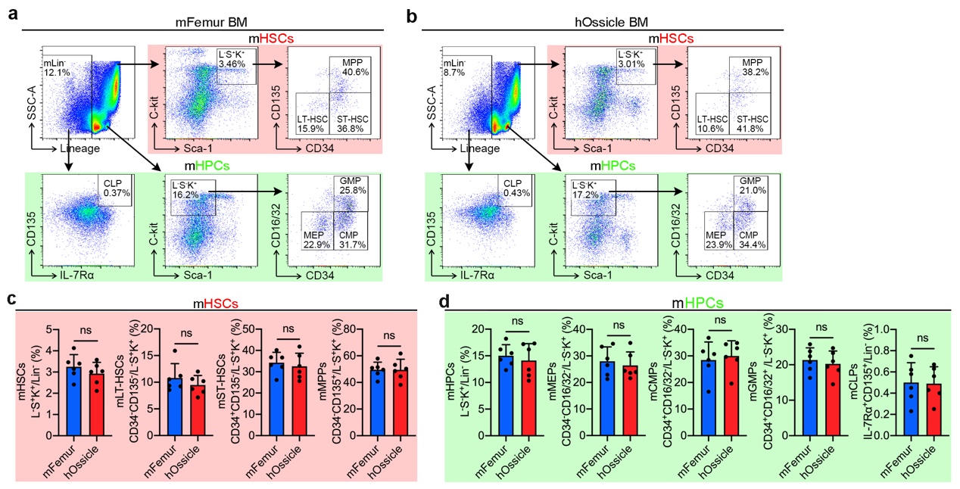
Extended Data Fig. 3. Flow cytometry analysis of bone marrow cells within hOssicles, related to Fig. 2
a, b, Flow cytometry plots for showing gating strategy of murine HSCs (a) and murine HPCs (b) in bone marrow cells harvested from eFemurs and 12-week hOssicles. Representative of 6 biological replicates. HSCs, hematopoietic stem cells; HPCs, hematopoietic progenitor cells; hOssicle, humanized ossicle; mFemur, mouse femur.
c, d, Quantitative flow cytometry of different subpopulation of HSCs (c) and HPCs (d) in bone marrow cells harvested from mouse femurs and 12-week hOssicles. Data are presented as mean ± SD (n = 6 biological replicates). L⁻S⁺K⁺ cells, lineage⁻ sca-1⁺ c-kit⁺ cells; ST-HSCs, short-term hematopoietic stem cells, were gated as L⁻S⁺K⁺CD34⁺CD135⁻ cells; LT-HSCs, long-term hematopoietic stem cells, were gated as L⁻S⁺K⁺CD34⁻CD135⁻ cells; MPPs, multipotent progenitors, were gated as L⁻S⁺K⁺CD34⁺CD135⁺ cells; GMPs, granulocyte-monocyte progenitors, were gated as L⁻S⁻K⁺CD34⁺CD16/32⁺ cells; CMPs, common myeloid progenitors, were gated as L⁻S⁻K⁺CD34⁺CD16/32⁻ cells; MEPs, megakaryocyte-erythroid progenitors, were gated as L⁻S⁻K⁺CD34⁻CD16/32⁻ cells; L⁻S⁻K⁺ cells, lineage⁻ sca-1⁺ c-kit⁻ cells; CLPs, common lymphoid precursors, were gated as Lin⁻IL-7R⁺CD135⁺ cells. ns, not significant.

Extended Data Figure 4
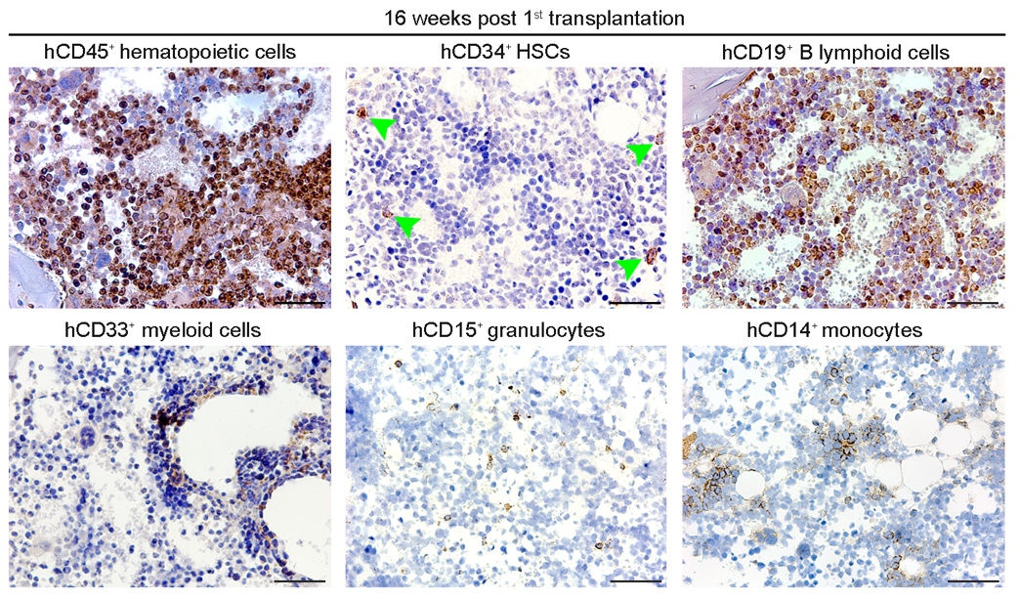
Extended Data Fig. 4. Immunohistochemistry of engraftment and differentiation of the transplanted hUCB-CD34⁺ cells, related to Fig. 3
Immunohistochemistry for showing the presence of human hematopoietic cells (hCD45⁺ cells), human HSCs (hCD34⁺ cells), human B lymphoid cells (hCD19⁺ cells), human myeloid cells (hCD33⁺ cells), human granule cells (hCD15⁺ cells), and human monocytes (hCD14⁺ cells) in hOssicles retrieved at 16 weeks post 1st xenotransplantation. Representative of 3 biological replicates. Scale bars, 50 μm.

Extended Data Figure 5
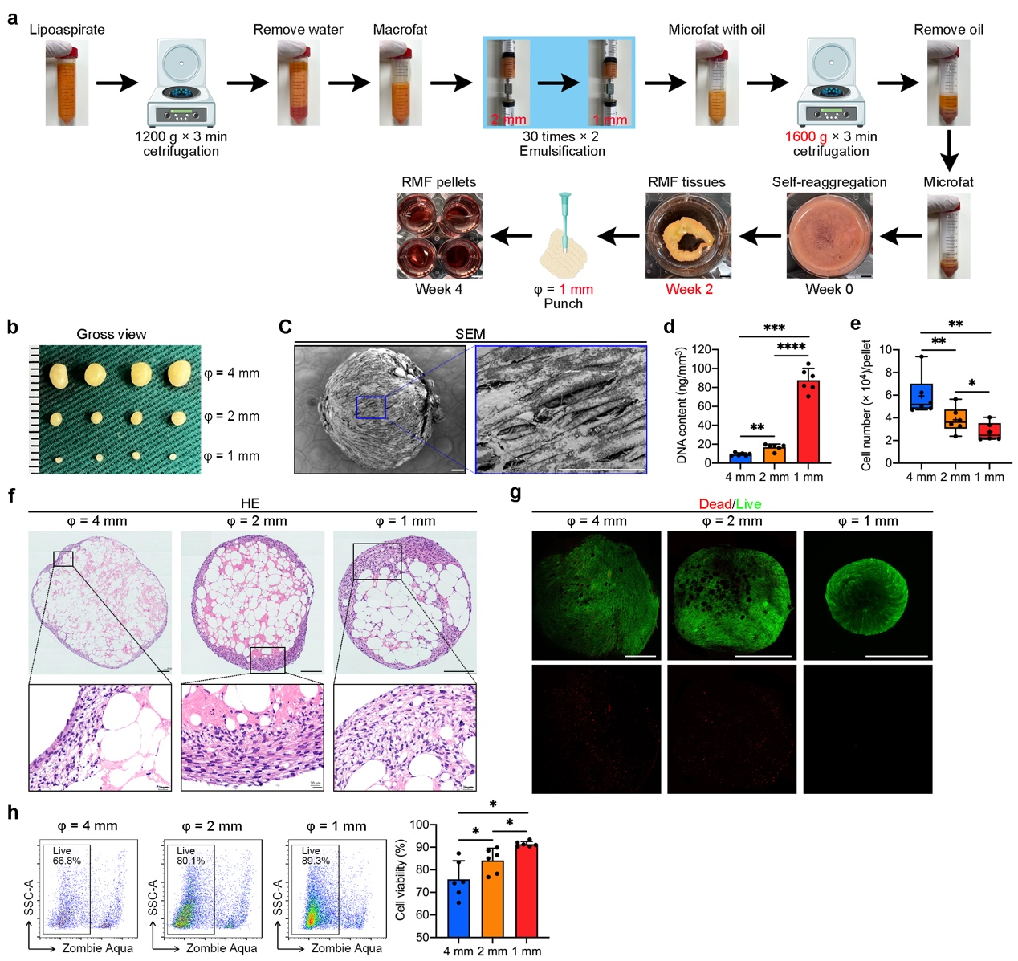
Extended Data Fig. 5. Modified protocol and characterization of 1-mm RMF pellets
a, Modified protocol for generating 1-mm RMF pellets from human adipose tissue.
b, Representative gross view images of 4-mm, 2-mm, and 1-mm RMF pellets. Scale bar, 1 mm.
c, SEM images of 1-mm RMF pellets. Representative of 6 biological replicates. Scale bars, 100 μm.
d, Quantification of DNA content per mm³ of RMF pellets. Data are presented as mean ± SD (n = 6 biological replicates). One-way ANOVA with Tukey’s test is used for comparison of multiple groups. **p < 0.01, ***p < 0.001, ****p < 0.0001.
e, Box and whisker plot of the number of living cells in 4-mm, 2-mm, and 1-mm RMF pellets after collagenase digestion. Data are presented as mean ± SD (n = 6 biological replicates). The cross indicates mean, and the thick horizontal line indicates median. n = 6 biological replicates. One-way ANOVA with Tukey’s test is used for comparison of multiple groups. *p < 0.05, **p < 0.01, ***p < 0.001.
f, HE images of 4-mm, 2-mm, and 1-mm RMF pellets. Magnified images of boxed areas on the below showing the proliferating cells within RMF pellets. Representative of 6 biological replicates. Scale bars, 50 μm.
g, Immunofluorescence of live (green) and dead cells (red) in 4-mm, 2-mm, and 1-mm RMF pellets. Representative of 3 biological replicates. Scale bars, 1 mm.
h, Flow cytometry plots and quantification of live cells in 4-mm, 2-mm, and 1-mm RMF pellets. Data are presented as mean ± SD (n = 6 biological replicates). One-way ANOVA with Tukey’s test is used for comparison of multiple groups. *p < 0.05.

Extended Data Figure 6
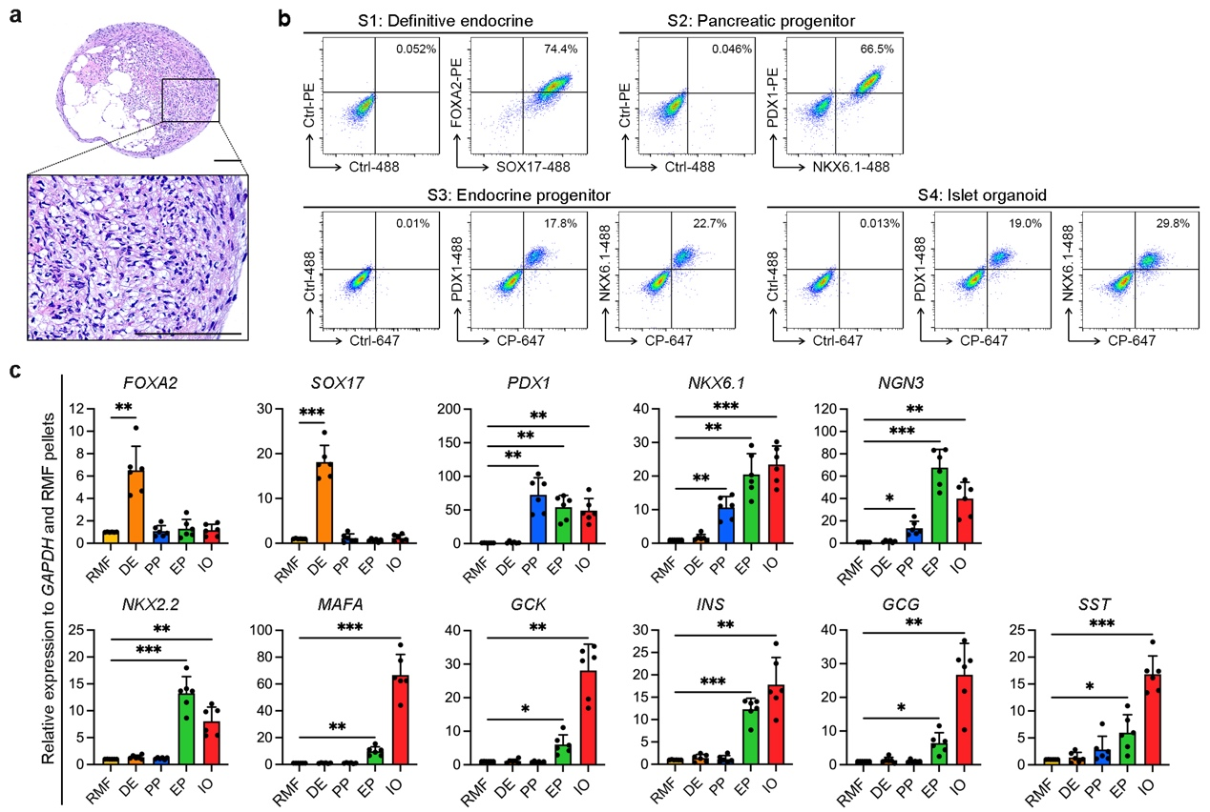
Extended Data Fig. 6. Characterization of RMF-islet organoids, related to Fig. 4
a, HE images of RMF pellets at islet organoid stage. Representative of 6 independent biological replicates. Scale bars, 100 μm.
b, Flow cytometry plots of SOX17⁺FOXA2⁺ cells at definitive endoderm stage, PDX1⁺NKX6.1⁺ cells at pancreatic progenitor stage, and CP⁺PDX1⁺ and CP⁺NKX6.1⁺ cells at both endocrine progenitor and islet organoid stages. Representative of 6 biological replicates.
c, qPCR analysis of 11 stage-specific genes in RMF pellets at the definitive endoderm stage, the pancreatic progenitor stage, the endocrine progenitor stage, and the islet organoid stage. Data are presented as mean ± SD (n = 6 biological replicates). One-way ANOVA with Dunnett’s test is used for comparison of multiple groups. *p < 0.05, **p < 0.01, ***p < 0.001, ****p < 0.0001. DE, definitive endoderm; IO, islet organoid; EP, endocrine progenitor; GCK, glucokinase; PP, pancreatic progenitor; RMF, reaggregated microfat.

Extended Data Figure 7
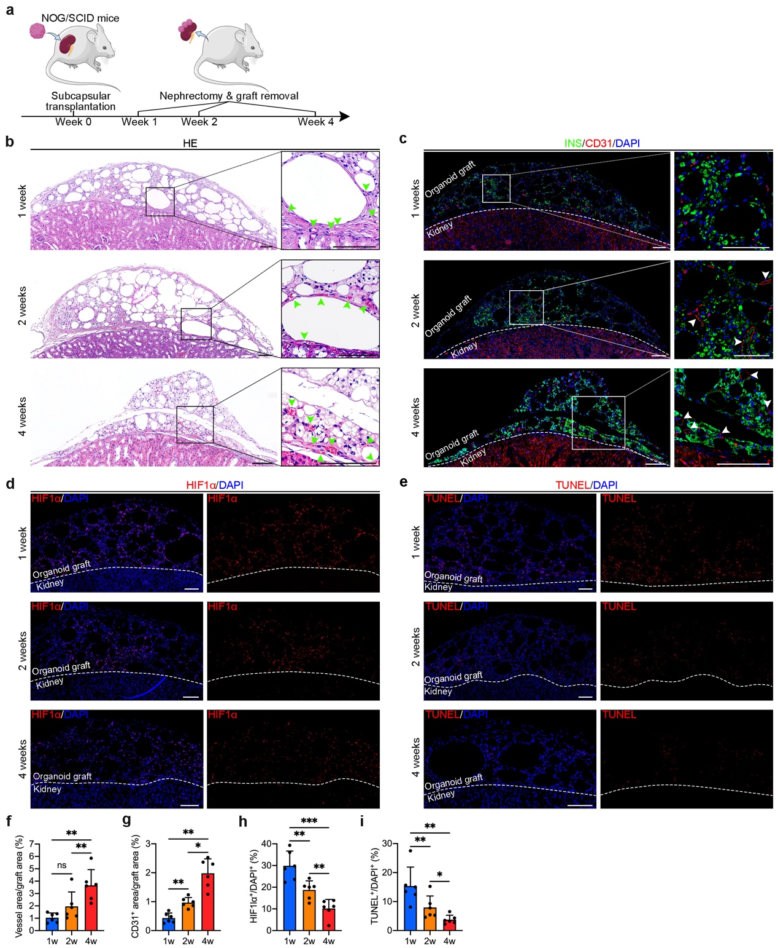
Extended Data Fig. 7. Kidney capsular transplantation of RMF-islet organoids results in fast graft vascularization and engraftment
a, Schematic protocol for kidney subcapsular transplantation of RMF-islet organoids into non-diabetic mice.
b, HE images of the organoid grafts explanted at 1, 2, and 4 weeks post-transplantation. Green arrows showing perfused blood vessels within the grafts. Representative of 3 biological replicates. Scale bars, 100 μm.
c, Immunofluorescence images for showing INS⁺ cells (green) and CD31⁺ (red) vascular cells within and around the grafts. White arrows showing CD31⁺ blood vessels within the grafts. Representative of 3 biological replicates. Scale bars, 100 μm.
d, e, Immunofluorescence images for showing HIF1α⁺ cells (d; red) and TUNEL⁺ (e; red) cells within the grafts. Representative of 3 biological replicates. Scale bars, 100 μm.
f, g, Percentage of blood vessel area in Extended Data Fig. 7b (f) and CD31⁺ area in Fig. 7c (g). Data are presented as mean ± SD (n = 6 grafts derived from 3 biological replicates). One-way ANOVA with Tukey’s test is used for comparison of multiple groups. *p < 0.05, **p < 0.01; ns, not significant.
h, I, Quantification of HIF1α⁺ cells in Extended Data Fig. 7d (h) and TUNEL⁺ cells in Extended Data Fig. 7e (i). Data are presented as mean ± SD (n = 6 grafts derived from 3 biological replicates). One-way ANOVA with Tukey’s test is used for comparison of multiple groups. *p < 0.05, **p < 0.01, ***p < 0.001.

Extended Data Figure 8
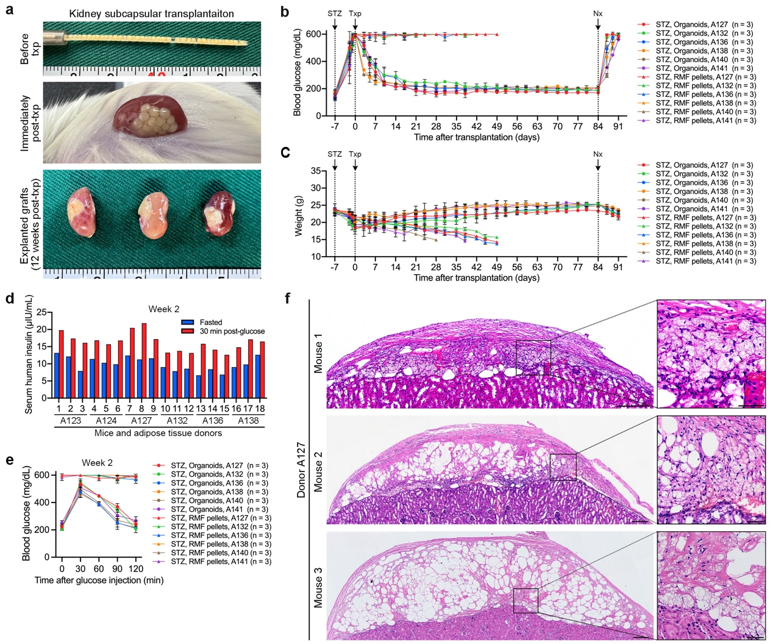
Extended Data Fig. 8. RMF-islet pellets restore blood glucose homeostasis in diabetic mice, related to Fig. 5
a, RMF-islet organoids before transplantation and immediately post-transplantation, and nephrectomized kidneys showing islet organoid grafts beneath the kidney capsule at 12 weeks post-transplantation. Representative of 6 independent biological replicates. Scale bars, 1 mm.
b, c, Random-fed blood glucose levels and body weight in STZ-induced diabetic mice transplanted with RMF-islet organoids and RMF pellets (n = 3 mice). Data are presented as mean ± SD. Txp, transplantation; Nx, nephrectomy.
d, In vivo GSIS levels of mice transplanted with islet organoids at 2 weeks post-transplantation.
e, IPGTT of mice transplanted with islet organoids and RMF pellets at 2 weeks post-transplantation. Data are presented as mean ± SD (n = 3 mice).
f, HE images of the three explanted islet organoid grafts derived from the donor A127. Scale bars, 200 μm in large images and 50 μm in magnified images.

Extended Data Figure 9
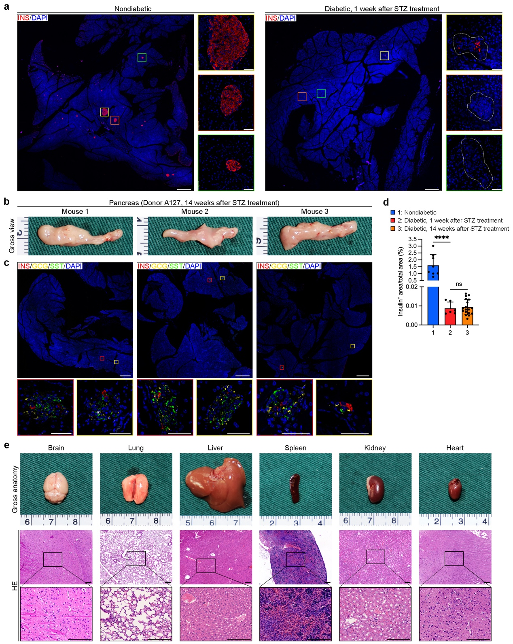
Extended Data Fig. 9. Immunohistological analysis of native pancreas of STZ-induced diabetic mice
a, Immunofluorescence images showing expression of insulin (red) in the pancreatic tissues of nondiabetic mice and STZ-treated diabetic mice. Magnified images of boxed areas on the left showing large (yellow), moderate (orange), and small islets (green). Magnified images of boxed areas on the right showing partial (yellow) and complete destroyed islets (green) in the pancreatic tissues. Representative of 6 to 8 mice in each group. Scale bars, 500 μm in the large images and 50 μm in magnified images.
b, Gross anatomy images of pancreas harvested from the three mice received islet organoids from donor A127. Scale bars, 1 mm.
c, Immunofluorescence images showing expression of insulin (INS; red), glucagon (GCG; yellow), and somatostatin (SST; green) in pancreatic tissues of the diabetic mice received islet organoid from donor A127. Magnified images of boxed areas on the below showing residual islets. Scale bars, 500 μm in the large images and 50 μm in magnified images.
d, Quantification of insulin positive area in the pancreatic tissues. Data are presented as mean ± SD (Nondiabetic, n = 8 mice; diabetic, 1 week post STZ treatment, n = 6 mice; diabetic, 14 weeks post STZ treatment, n = 18 mice). One-way ANOVA with Dunnett’s test is used for comparison of multiple groups. ****p < 0.0001; ns, not significant.
e, Gross anatomy (above) and HE (below) images of major organs harvested from diabetic mice received islet organoid treatment. Scale bars, 1 mm in gross anatomy images and 200 μm in HE images.

Extended Data Figure 10
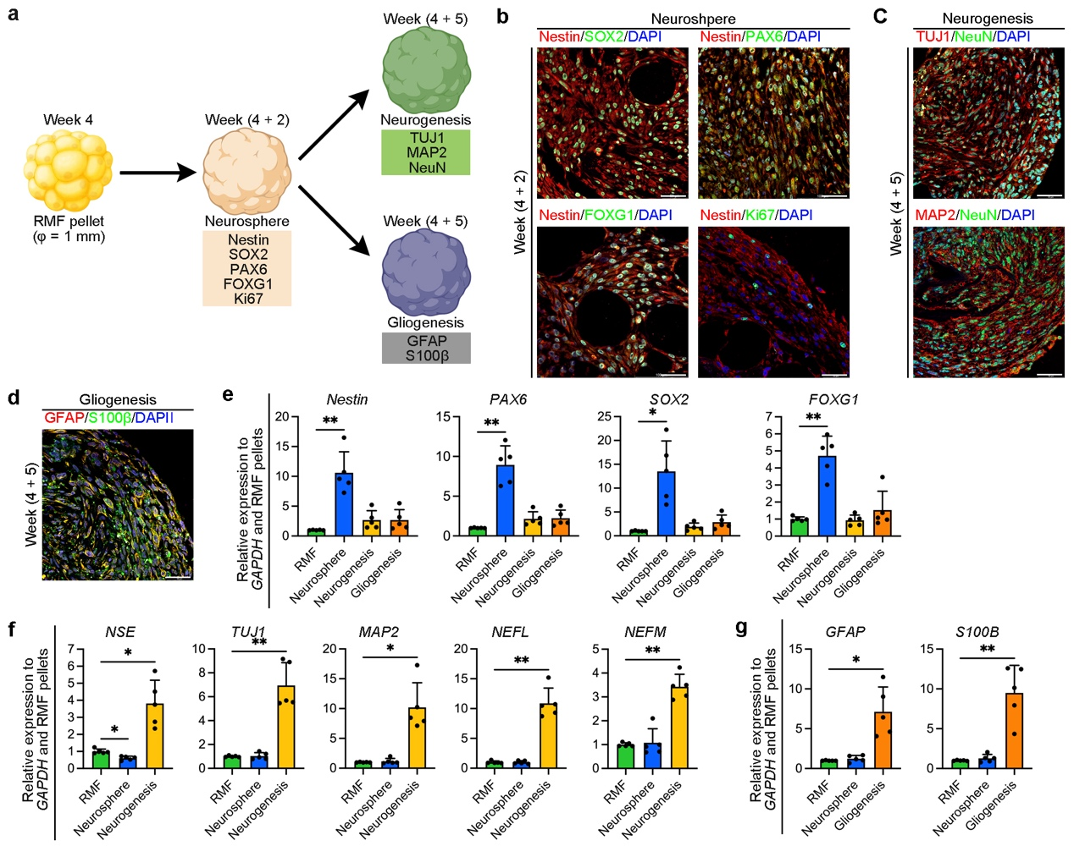
Extended Data Fig. 10. Engineering nerve-like tissues from RMF pellets
a, Schematic and timeline showing generation of neuronal and neuroglial tissues from RMF pellets and stage specific transcription factors for quality control at each stages.
b, Immunofluorescence of RMF pellets at neurosphere stage at 2 and 3 weeks after neurogenic differentiation showing coexpression of Nestin (red) and SOX2 (green), Nestin (red) and PAX6 (green), as well as Nestin (red) and FOXG1 (green). Representative of 3 independent biological replicates. Scale bar, 50 μm.
c, Immunofluorescence of RMF pellets at neuros stage showing coexpression of TUJ1 (red) and NeuN (green), as well as MAP2 (red) and NeuN (green). Representative of 3 independent biological replicates. Scale bar, 50 μm.
d, Immunofluorescence of RMF pellets at neuroglia cell stage showing coexpression of GFAP (red) and S100β (green). Representative of 3 independent biological replicates. Scale bar, 50 μm.
e-g, qPCR analysis of stage-specific genes in RMF pellets at the neurosphere stage (e), neurogenesis stage (f), and gliogenesis stage (g). Data are presented as mean ± SD (n = 5 biological replicates). One-way ANOVA with Dunnett’s test is used for comparison of multiple groups. *p < 0.05, **p < 0.01. NEFL, neurofilament light chain; NEFM, neurofilament medium chain; NSE, neuron-specific enolase.

