Supplementary Information

Supplementary Figure 1
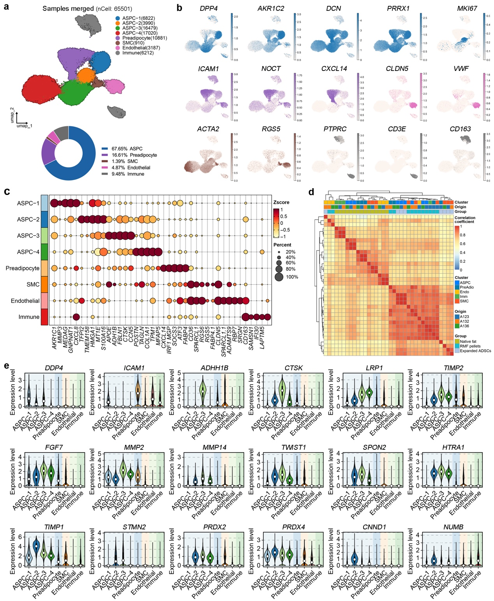
Supplementary Fig. 1. Single-cell sequencing analysis of RMF tissues, related to Fig. 1
a, UMAP plot of scRNA-seq cells derived from the merged native fat, RMF pellets, and expanded ADSCs, assigned into the main cell classes. Pie charts on the below depicting the percentages of each cell population. n = 3 biological replicates. ASPC, adipose-derived stem and progenitor cells; nCell, number of cells; SMC, smooth muscle cells.
b, UMAP plots showcasing the expression of signature genes in ASPCs, preadipocytes, smooth muscle cells, endothelial cells, and immune cells, as defined in (a).
c, Dot plot showing the top 5 expressed genes markers in the eight main cell clusters.
d, Correlation plot comparing identified cell clusters between native fat, RMF pellets, and expanded ADSCs.
e, Violin plots for signature, mesodermal lineage differentiation-related, cell cycle-related, and stemness-related genes showing specific expression in the different main cell clusters, as defined in (a).

Supplementary Figure 2
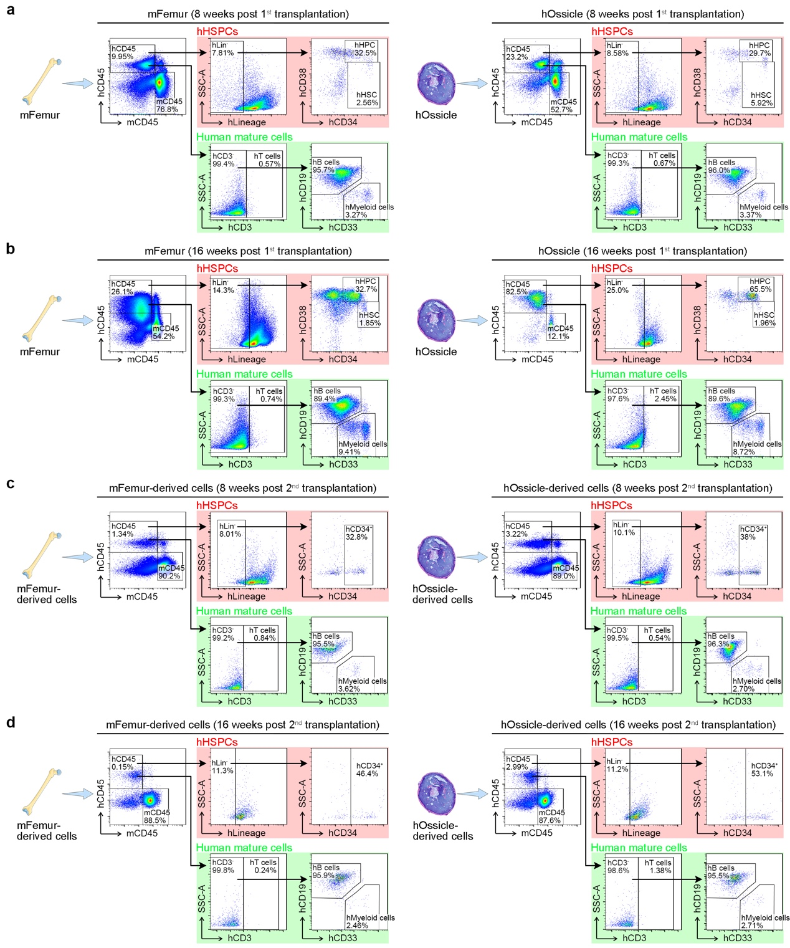
Supplementary Fig. 2. Flow cytometry of engraftment level, self-renewal, and differentiation of the transplanted hUCB-CD34⁺ cells, related to Fig. 3
a, b, Flow cytometry plots for showing gating strategy of human hematopoietic cells extracted from mFemur and hOssicle at 8 (a) and 16 weeks (b) post 1st xenotransplantation. Human HSCs were gated as hCD45⁺CD34⁺CD38⁻ cells; human HPCs were gated as hCD45⁺CD34⁺CD38⁺ cells; human T cells were gated as hCD45⁺CD3⁺ cells; human B cells were gated as hCD45⁺CD3⁻CD19⁺ cells; human myeloid cells were gated as hCD45⁺CD3⁻CD33⁺ cells. Representative of 6 biological replicates. hHSCs, human hematopoietic stem cells; hHPCs, human hematopoietic progenitor cells; hOssicle, humanized ossicle; mFemur, mouse femur.
c, d, Flow cytometry plots for showing gating strategy of human hematopoietic cells extracted from mFemur at 8 (c) and 16 weeks (d) weeks post 2nd xenotransplantation. Human HSPCs were gated as hCD45⁺CD34⁺ cells; human T cells were gated as hCD45⁺CD3⁺ cells; human B cells were gated as hCD45⁺CD3⁻CD19⁺ cells; human myeloid cells were gated as hCD45⁺CD3⁻CD33⁺ cells. Representative of 4 biological replicates.

Supplementary Figure 3
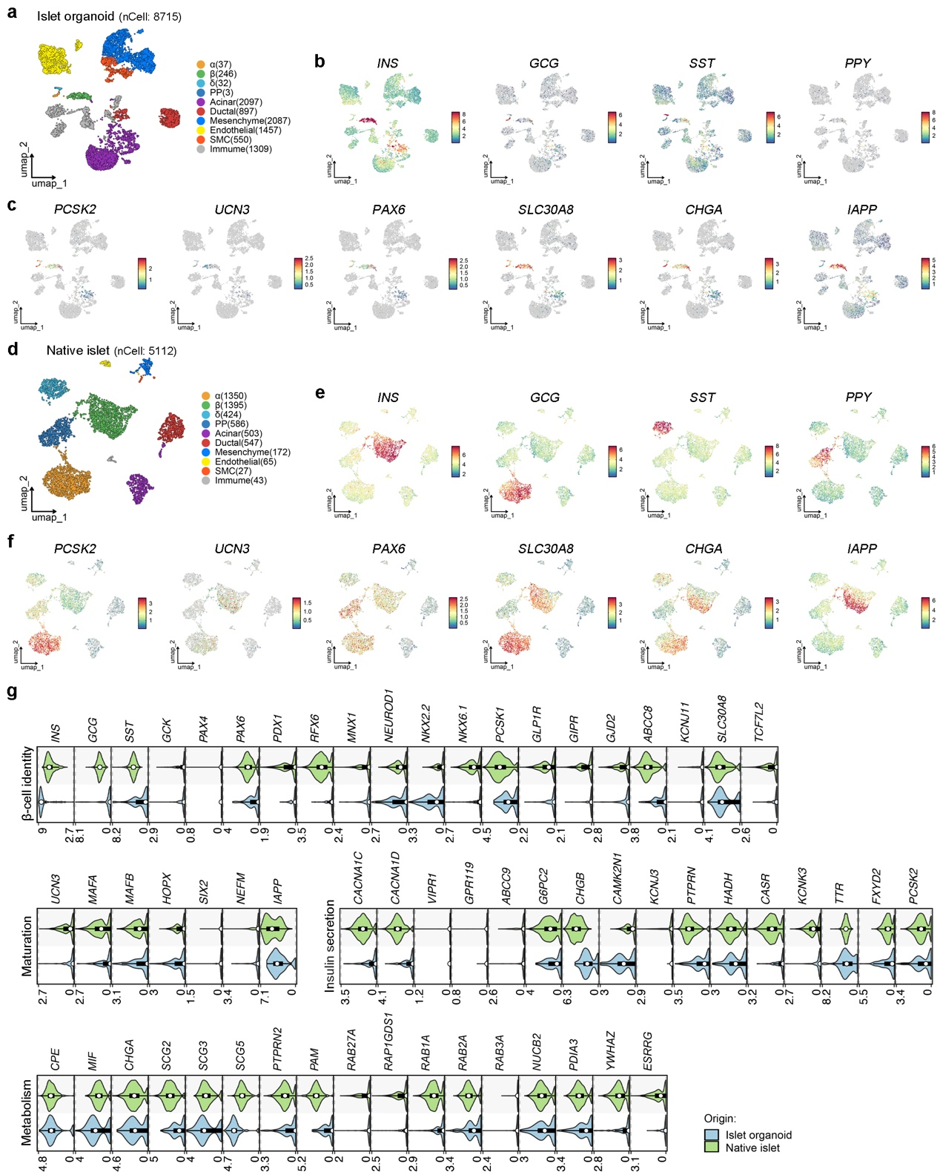
Supplementary Fig. 3. Single-cell sequencing analysis of islet organoids, related to Fig. 4
a, d, UMAP plot of scRNA-seq cells derived from RMF-islet organoids (a; n = 2 biological replicates) and human native islets (d; n = 1 biological replicates).
b, c, e, f, Expression of islet hormone genes (b, e) and other endocrine transcription factors and key marker genes of assigned cell clusters in RMF-islet organoid and human native islet samples (c, f).
g, Comparison of β-like cells from RMF-islet organoids and β-cells from human native islets in expression profiles of key genes for β-cell identity, maturation, insulin secretion, and metabolism functions. n = 246 β-like cells from islet organoid samples and 1395 β-cells from human native islet samples.

Supplementary Figure 4
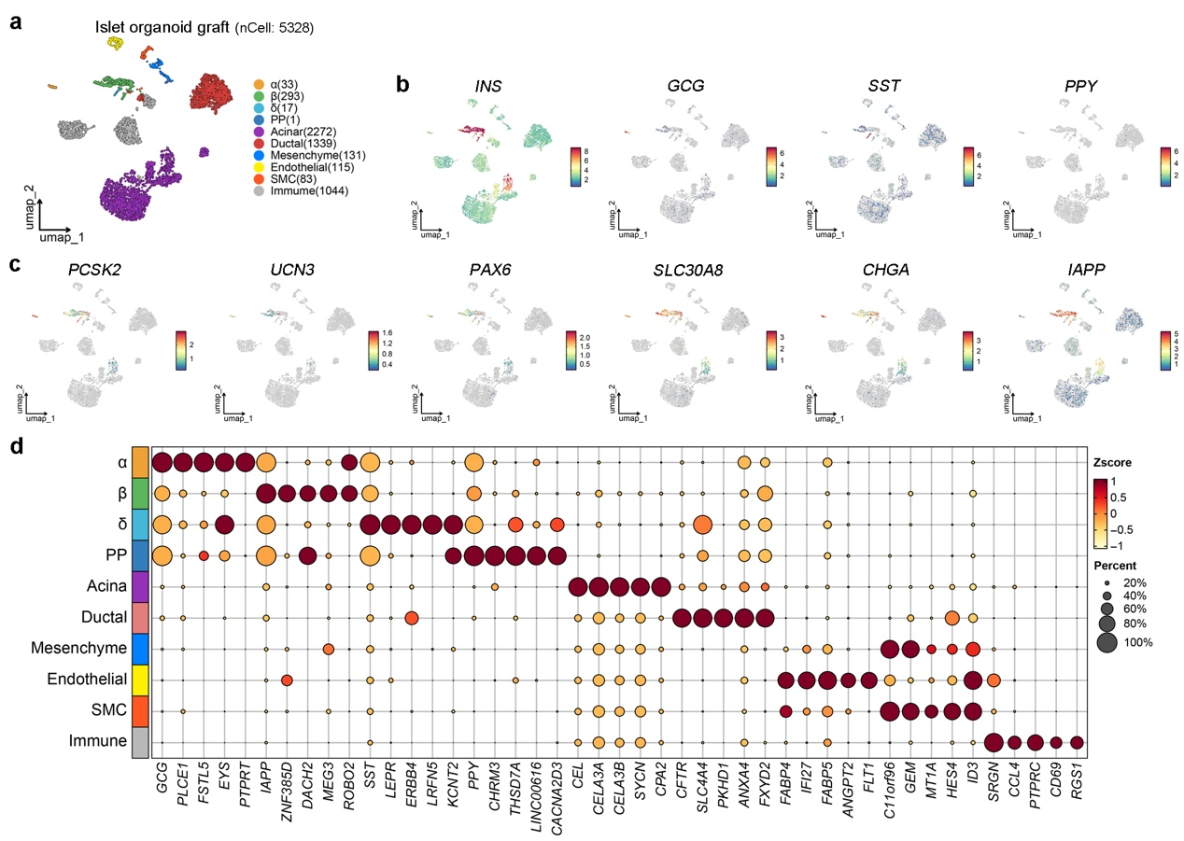
Supplementary Fig. 4. Single-cell sequencing analysis of islet organoid grafts after 12-week transplantation, related to Fig. 5
a, UMAP plot of scRNA-seq cells derived from islet organoid grafts (n = 2 biological replicates).
b, c, Expression of islet hormone genes (b) and other endocrine transcription factors and key marker genes of assigned cell clusters (c).
d, Dot plot showing the relative expression of genes in the ten main cell clusters.

Supplementary Table 1
Supplementary Table 1. Human adipose tissues used in this study

Supplementary Table 2
Supplementary Table 2. Sequence for qRT-PCR primers

