Supplementary Information for
Maglev-like droplet-based transporters co-regulated by wettability and magnetic field
Yonghui Zhang¹, Huanxi Zheng^{1*}, Jiahao Zhang¹, Yuheng Li¹, Shanyi Mao¹, Yanan Wang¹, Ziheng Wang¹, Zizhen Yuan¹, Xin Liu^{1*}

¹State Key Laboratory of High-performance Precision Manufacturing, Dalian University of Technology, Dalian 116024, P. R. China

*Corresponding author: huanxizh@dlut.edu.cn (H.Z.); xinliu@dlut.edu.cn (X.L.)

Content
Figure S1. Schematic diagram of the fabrication processes of hybrid wetting surfaces.
Figure S2. Elemental distributions on different surfaces: (a) superhydrophobic and (b) superhydrophilic surfaces. (c) Schematic of the superhydrophilic (surface 2) and superhydrophobic (surface 1) surfaces and (d) corresponding elemental atomic ratios.
Figure S3. Comparison of (a) processes and (b) stresses for different models under pressure. Model 1: Upper and lower plates are superhydrophobic with a water droplet in the center. Model 2: Upper and lower plates are superhydrophobic with a ferrofluid droplet in the center. Model 3: Upper plate is hybrid wetted, and lower plate is superhydrophobic, with a water droplet in the center. Model 4: Upper and lower plates are hybrid wetted with a ferrofluid droplet in the center. Model 5: Upper plate is hybrid wetted, and lower plate is superhydrophobic, with a water droplet in the center and a magnet at the bottom. The pressure feed speed is 400 μm·s⁻¹. The volume of the liquids used are all 18 μL. The minimum gap between the upper and lower plates is 0.2 mm after loading.
Figure S4. Self-recovery of MDTs subjected to glass beads (weight 0.65 g, diameter 8 mm) impacting on the upper plate from a height of 30 cm.
Figure S5. (a) The process by which the upper surface of the MDTs was subjected to lateral thrust and can recovered automatically after release. (b) Lateral force that the MDTs can withstand with or without load, and the upper plate of the MDTs can be restored after the lateral force is released. (c) Schematic of lateral forces on MDTs with and without loads.
Figure S6. Three transport states of MDTs: stable transport, unstable transport and unable transport.
Figure S7. Self-assembly and cargo transportation processes of MDTs and changes in the advancing angle 𝜃₂, receding angle 𝜃₁, and load angle (𝛼₁ and 𝛼₂) of ferrofluid droplets during transportation.
Figure S8. Programmable path transportation for MDTs.
Figure S9. Controllable motion of MDTs on inclined surfaces, both (a) planar and (b) curved.
Figure S10. Inverted MDTs for underwater cargo transportation.
Figure S11. External circuit for driving LEDs.
Video S1. Compression of processes for different models under pressure.
Video S2. Mechanical stability and lateral recovery of MDTs under long-term compression, which can be used for cargo transportation.
Video S3. Transportation of MDTs on planar and curved surfaces.
Video S4. Inverted MDTs for underwater cargo transportation.
Video S5. Energy conversion from mechanical energy to electricity of MDTs.

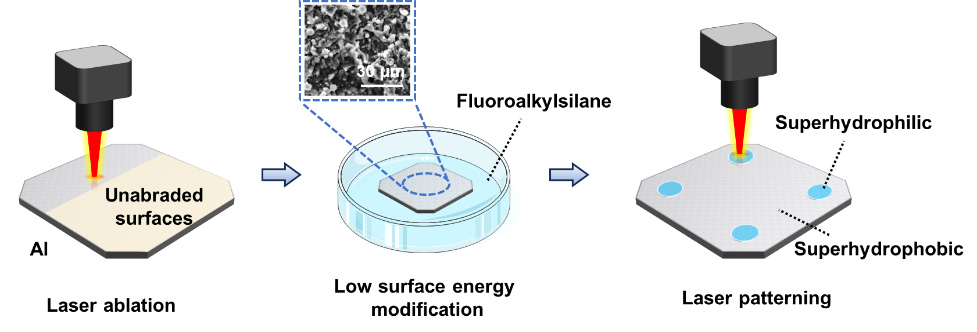
Figure S1. Schematic diagram of the fabrication processes of hybrid wetting surfaces.

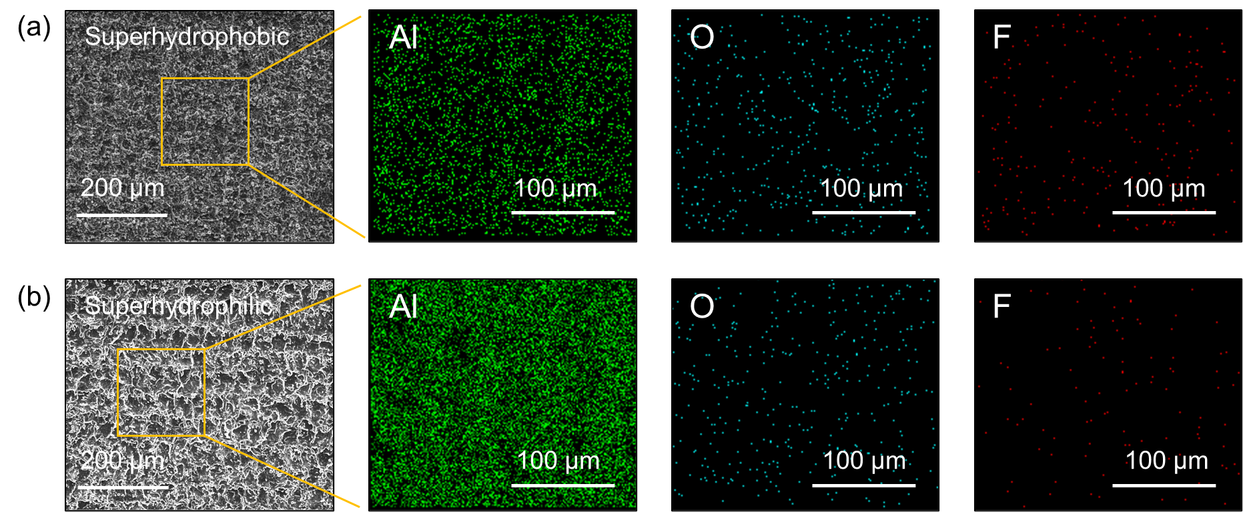
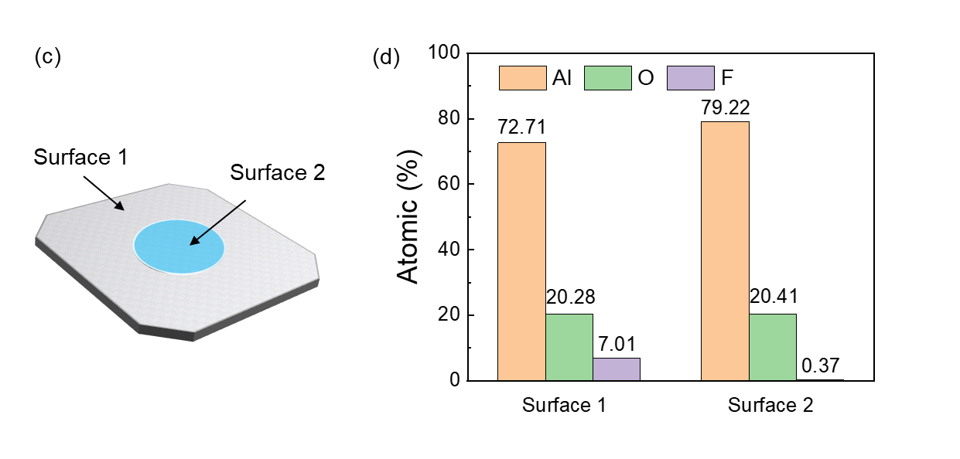
Figure S2. Elemental distributions on different surfaces: (a) superhydrophobic and (b) superhydrophilic surfaces. (c) Schematic of the superhydrophilic (surface 2) and superhydrophobic (surface 1) surfaces and (d) corresponding elemental atomic ratios.

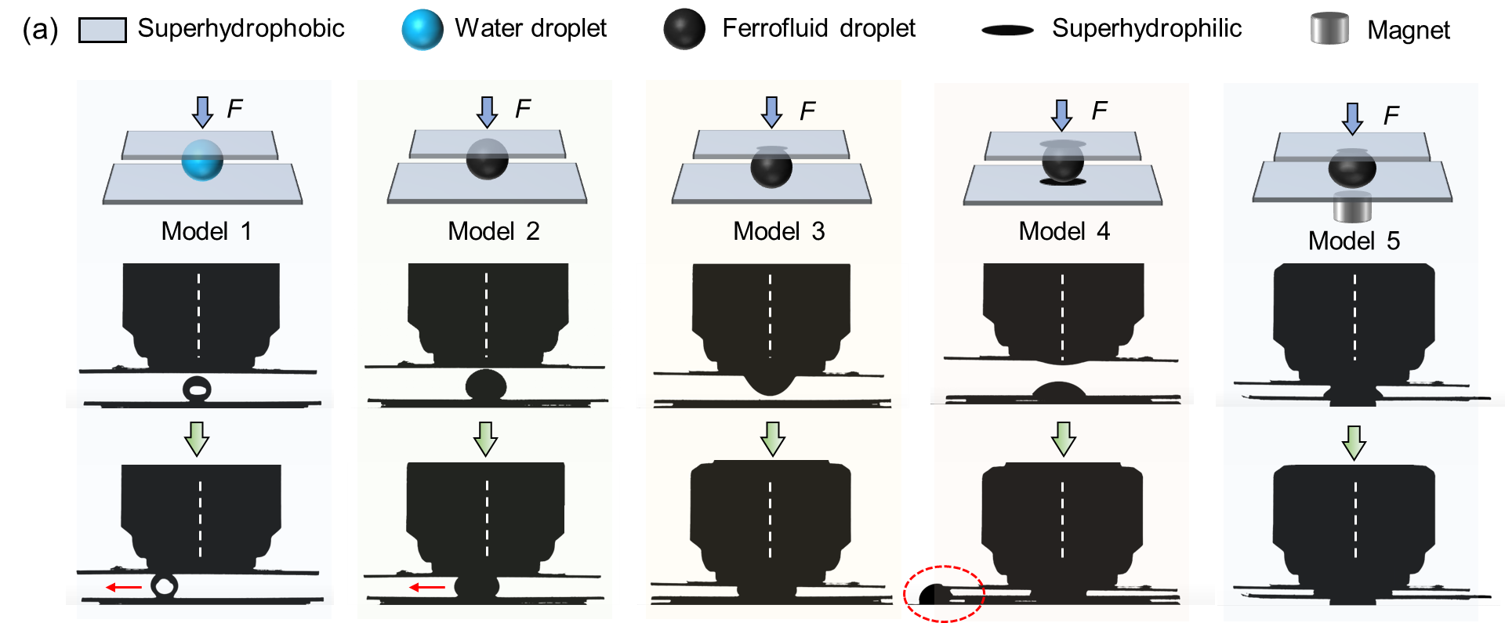
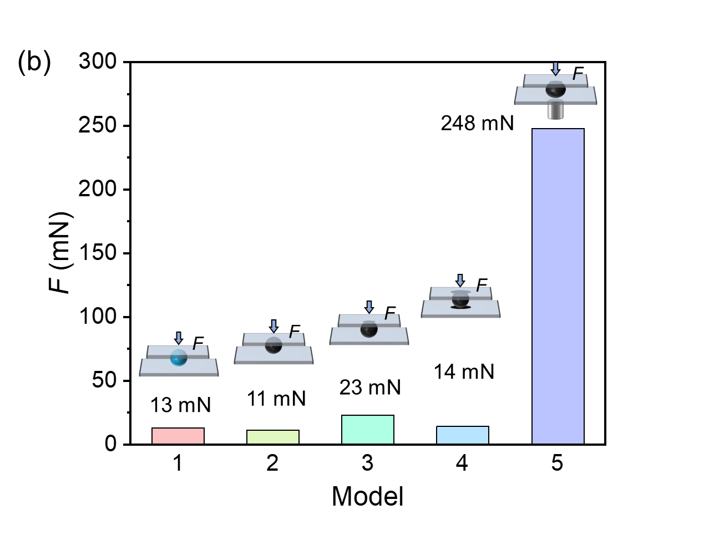
Figure S3. Comparison of (a) processes and (b) stresses for different models under pressure. Model 1: Upper and lower plates are superhydrophobic with a water droplet in the center. Model 2: Upper and lower plates are superhydrophobic with a ferrofluid droplet in the center. Model 3: Upper plate is hybrid wetted, and lower plate is superhydrophobic, with a water droplet in the center. Model 4: Upper and lower plates are hybrid wetted with a ferrofluid droplet in the center. Model 5: Upper plate is hybrid wetted, and lower plate is superhydrophobic, with a water droplet in the center and a magnet at the bottom. The pressure feed speed is 400 μm·s⁻¹. The volume of the liquids used are all 18 μL. The minimum gap between the upper and lower plates is 0.2 mm after loading.

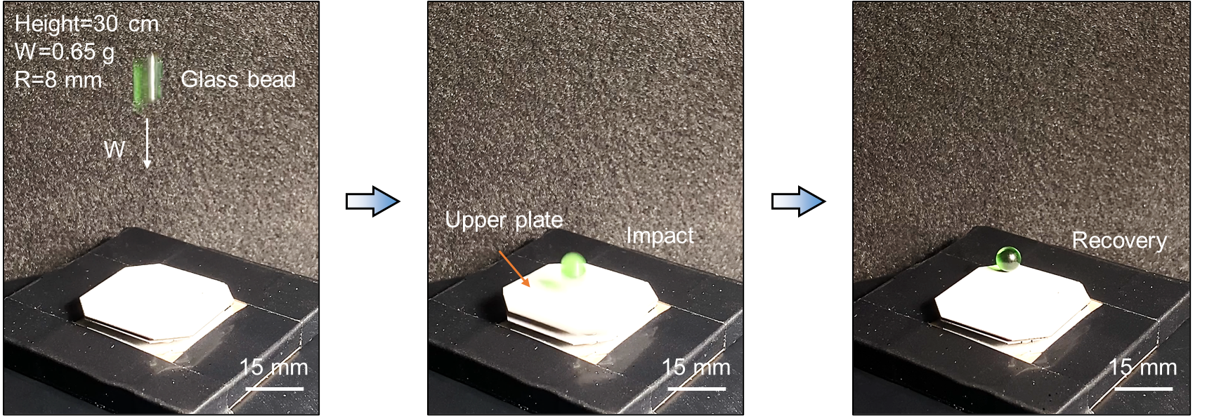
Figure S4. Self-recovery of MDTs subjected to glass beads (weight 0.65 g, diameter 8 mm) impacting on the upper plate from a height of 30 cm.

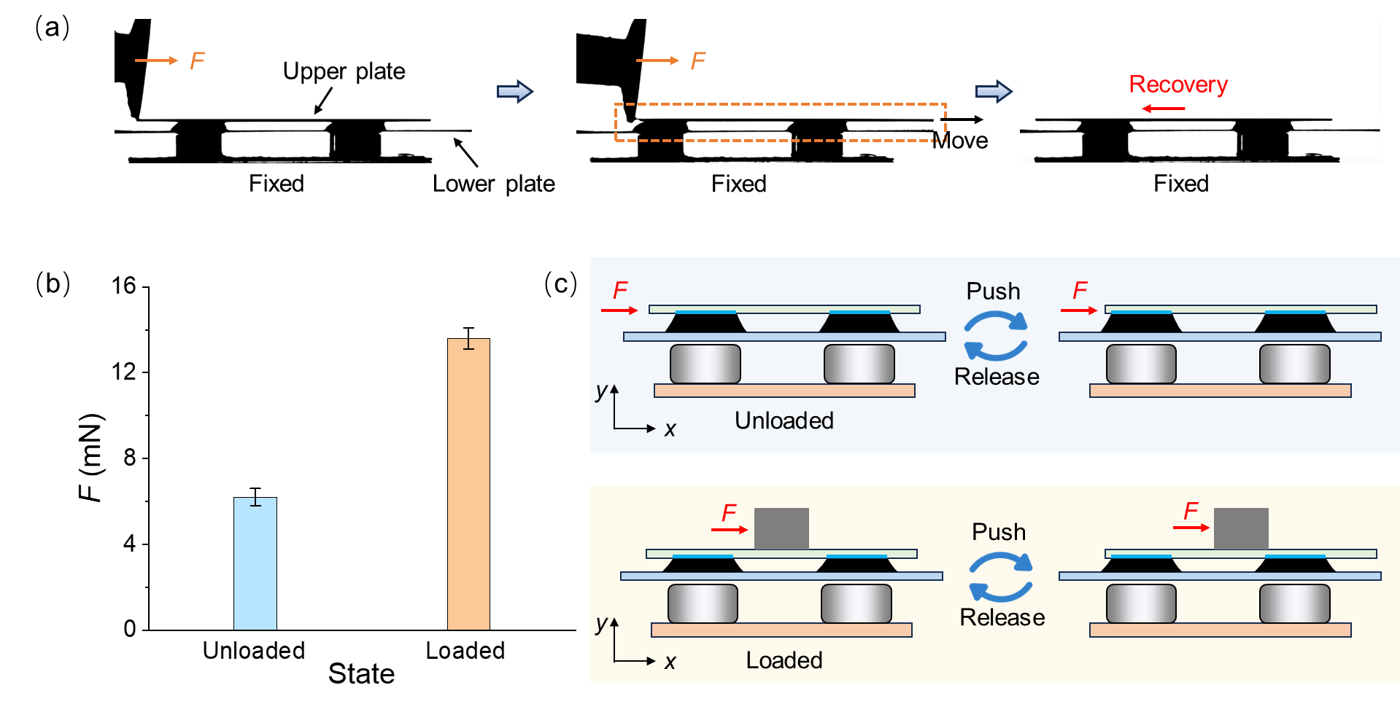
Figure S5. (a) The process by which the upper surface of the MDTs was subjected to lateral thrust and can recovered automatically after release. (b) Lateral force that the MDTs can withstand with or without load, and the upper plate of the MDTs can be restored after the lateral force is released. (c) Schematic of lateral forces on MDTs with and without loads.

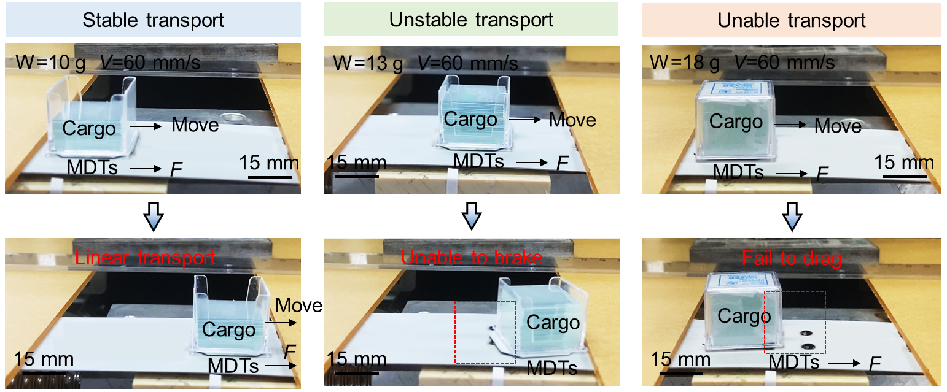
Figure S6. Three transport states of MDTs: stable transport, unstable transport and unable transport.

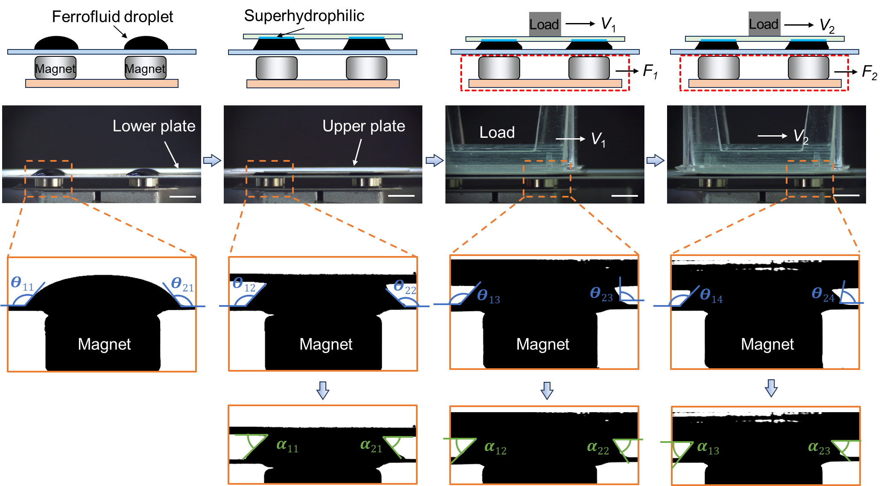
Figure S7. Self-assembly and cargo transportation processes of MDTs and changes in the advancing angle 𝜃₂, receding angle 𝜃₁, and load angle (𝛼₁ and 𝛼₂) of ferrofluid droplets during transportation.

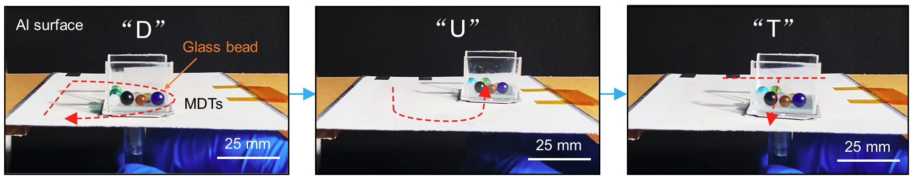
Figure S8. Programmable path transportation for MDTs.

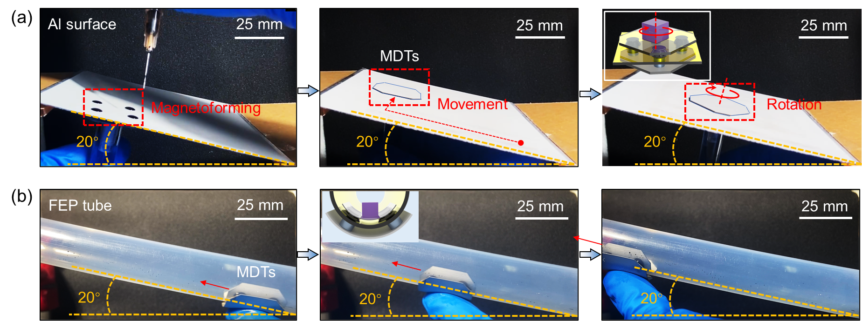
Figure S9. Controllable motion of MDTs on inclined surfaces, both (a) planar and (b) curved.

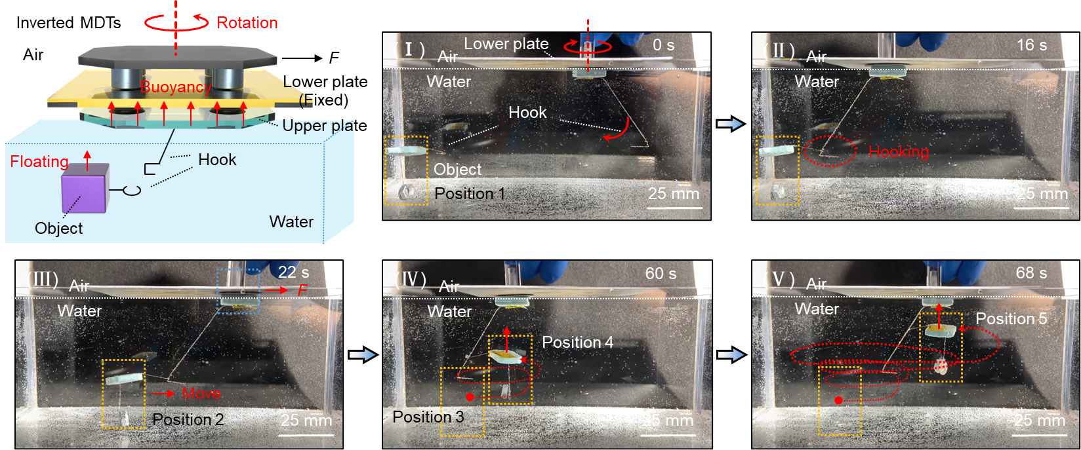
Figure S10. Inverted MDTs for underwater cargo transportation.

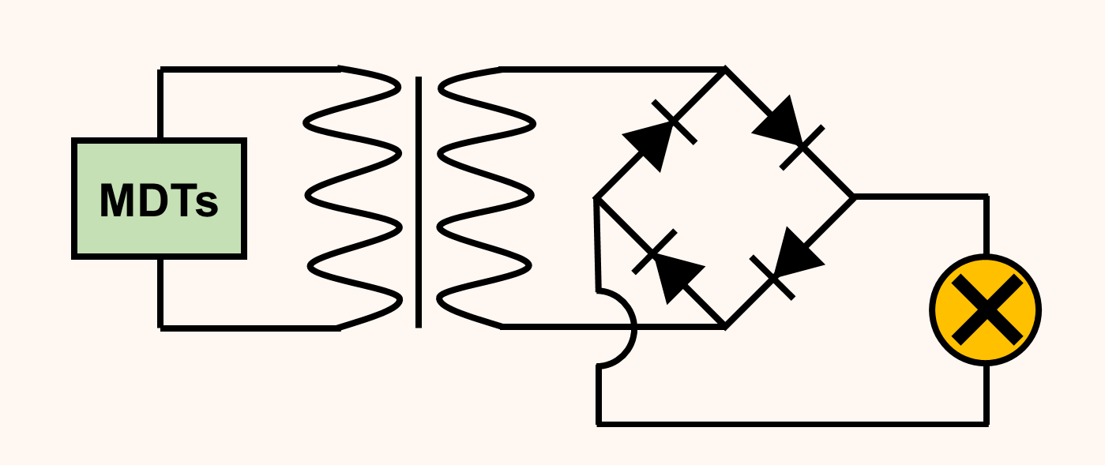
Figure S11. External circuit for driving LEDs.

