Supplementary material: 2

Vulture, culture and more: putting human-dimensions back in the saddle for conservation policy

Urvi Gupta, Nishant Kumar
Fig. S1. Research team explaining scientific objectives and informing citizens of Delhi on the ecological importance of predatory kites (as well as other birds) while ringing kite chicks. This sort of citizen-group assembles constantly in a megacity of more than 29 million inhabitants like Delhi, as we move from nest to nest during our routine fieldwork activities, offering a unique opportunity to reach thousands of people in disseminating science, and educating the population on urban environmental issues of conservation importance. Since 2013, we have reached more than 50,000 citizens through this mobile conservation education initiative, which we see as a mobile laboratory. For many of these people, this may be one of their few opportunities to empathize and get in contact with nature, but our conversations with people have often surprised us by the depth of concern that they already have, for example for the decline in numbers of small birds that they have noticed over recent years. We, therefore, conducted a structured ethnographic study to document and understand their knowledge and how it integrates into their belief systems.
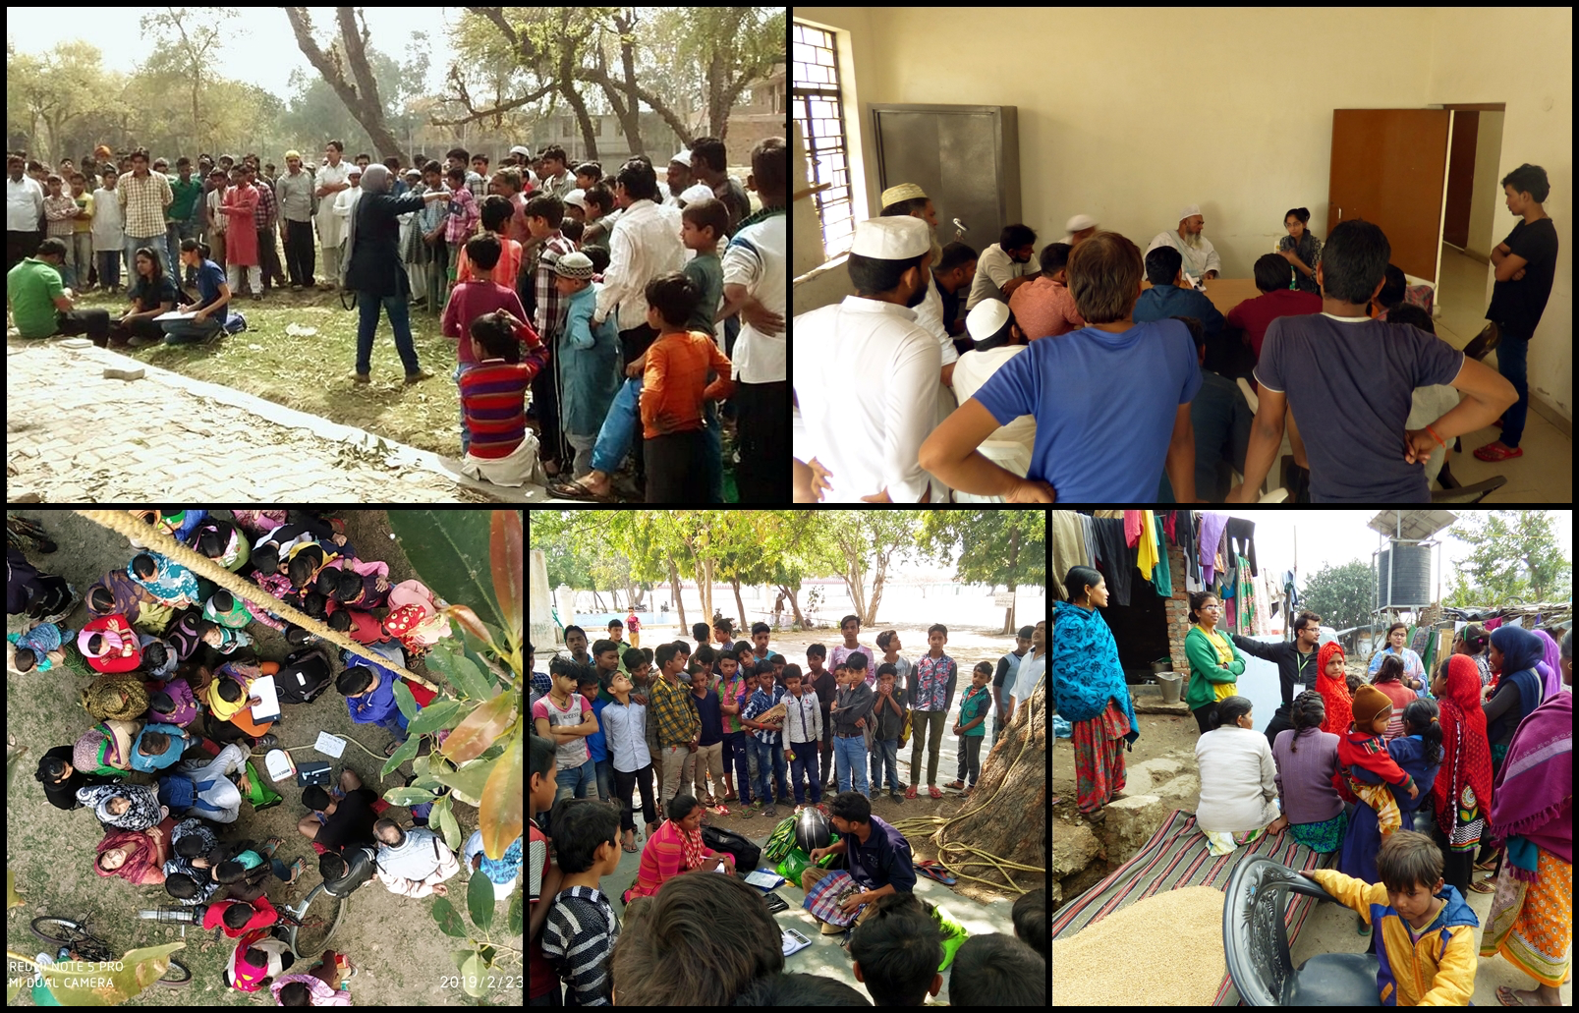
Appendix S2: Description of stakeholder choice while identifying 71 interviewees for this study in the city of Delhi (India).

Stakeholder Groups (number of respondents) | Description, rationale for choice and predicted trends in levels and types of association
Butchers (n=3) | They belong to the informal labour sector and are confined to the slaughterhouses while working. This allows them to have significantly close interaction with prominent opportunistic scavengers on a daily basis. Additionally, in Delhi, they also feed the choicest portions of meat to kites and other animals to request relief from the sinful act of slaughter. Most of my respondents were migrants from neighbouring states
Rag-pickers/slum-dwellers (n=6) | They have been noticed working at garbage dumps based within residential blocks and on landfill sites. Rag-pickers were expected to have regular close encounters with scavenging birds. It was also very likely that these people had recently immigrated to the city and had a very different native basis of association with the avian scavengers in the city.
Civic bodies (Governmental) - officials related to urban fauna and waste management – Municipal Corporation of Delhi (MCD) and Public works Department (PWD) (n=4) | Respondents from this group are involved in planning and implementation of garbage maintenance, and managing green cover. As major stakeholders, they were chosen to understand the consideration officials have for urban biodiversity; also to understand political ecologies in relation to the human-animal conflicts involving the target species.
Bird watchers (n=7) | This group included individuals who observed birds as a hobby/professionally. This group was also chosen to understand if commonly scavenging target species help their attention.
Non-Governmental Organisations (NGOs) and animal welfare groups: Jain bird hospital, Wildlife SOS, World Wildlife Fund for Nature (WWF, India), Wildlife Trust of India (WTI) (n=10) | Respondents from this group are professionally associated with animal welfare and conservation sector. I targeted them to understand how much attention do large conservation organisations extend to common urban species. It also allowed me to understand individual opinions of regional experts at the helm of science and policy of conservation
Tourists and employees at Delhi zoo (n=20) | Delhi zoo is a centre of environment and conservation education. Visitors from within and outside Delhi come to the zoo as (I) a centre of learning and sharing with children (II) a tourist attraction. This group was vital under the expectation that such visitors will be inclined to discuss their appreciation for animals while zoo employees have regular commitment towards animal welfare and conservation education.
Resident citizens (n=20) | People who were born in Delhi treat themselves as long-term permanent residents of the capital and not as immigrants from elsewhere. This group allowed us to understand the perceptions of respondents as residents whose native folk biological expressions to animals was assumed to be urban.
Priests/ employees of temples and mosques (n=4) | Representatives of their religious/cultural, this group allowed us to understand and verify socio-religions perceptions other people had about target species, and to factor differences, if any. These stakeholders are vital in orienting the public about ritual feeding to birds and other species, often citing the need as a religious-custom suggesting relief from sins, treating them as bad omens, etc
Respondents of multiple age category  (18-80 years in age) | We expected extinction of experience and memory with younger generations as compared to older ones.

Appendix S3: Summary of the etymology of folk names given to the target research species, namely Black Kites, Crows and Vultures, and the associated urban legends and major perceptions of citizens within the city of Delhi (India).
Species | Morphology | Call | Names given on color/call | Familial structure in animal kingdom | Name given of ecosystem service or extinction of experience | Experience | Story/urban legend | Religious symbol | Perception
Crow | Black, straight beak | Distinct cau | Kauva, kaag, kaak, crow |  | Same | Feeding at home, attack during failed nesting attempt | Crow and the pitcher; blind by one eye as Lord Ram shot one in Ramayana, crow’s cau signals guest arrival; crows go to far off places to die | Messenger of God of death (Yam), Vehicle of Shani, form of deceased ancestors | Mystery, cunning,  intelligence,
Kite | Dark coloured, hook like beak | Shrill | Cheel  Baaz | Pakshiyon ki naani (grandmother of kites) | Eagle,  Giddh/gradh (vulture) | Snatches food from hand, attacks during nesting season, elegant flight | If you look at them, they will snatch your eyes, feeding them takes away sins |  | Strong birds, powerful eyesight,  Angel from heaven, bad omen
Egyptian vulture | White | - | Safed cheel | Cheelon ki naani | Safed cheel, chhotte giddh | Feed on carcass |  |  | Powerful eyesight
Other vulture species | Long, bare necks, large wingspans | - | Giddh | Giddh | Giddh | Used to clean a carcass, once present in large numbers, now rarely seen | Population declined due to pollution, technology advancements | Garuda and Jatayu | Powerful eyesight, large distance fliers,  Bad omen

