Appendix 1] Sample size
According to the previous clinical application, the author estimated that the improvement rate of Tinetti Gait Scale (change of Tinetti Gait Scale more than one score) of the customized insoles group was 81% and that of control group was 48%, Set α = 0.05 (one tails test) and the subjects were included in the two groups according to the ratio of 1:1. By G*Power 3.1 calculation, a total of 50 women would be needed (25 in each group) (Figure 4).At the same time, considering the 15% abscission rate and the need for randomization of parallel groups, the statistical recommendation was to target 30 participants in each group, the final sample size was 60 cases.
When the experiment reached 50 cases, the experiment could not continue due to the failure of our evaluation tool plantar pressure plate. Based on 50 cases, we conducted a statistical analysis and the results showed a 68% improvement rate of Tinetti Gait Scale (change of Tinetti Gait Scale more than one score) of the customized insoles group and that of control group was 24 %. Set α = 0.05 (one tails test). By G*Power (3.1.9.7 version) calculation, Power was 0.95, effective size was 0.91(Figure 5), so the conclusion of this study was reliable.

Appendix 2] plantar pressure test (right-sided hemiplegia)
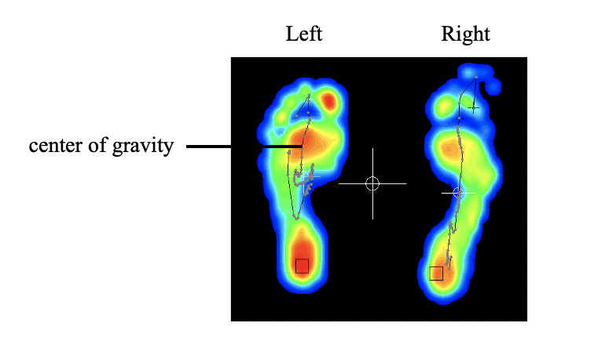
The center of gravity moved back-and-forth, inward-and-outward on the uninvolved side in the forefoot and midfoot.

