Supplemental Information

Resilience Measurement for Environmental Shocks and Stressors: Scale Development and Validation for Urban Populations in Low- and Middle-Income Countries

Hemali H. Oza¹, Allison P. Salinger², Ruzka Taruc³, Autiko Tela⁴, Fiona Barker⁵, Karin Leder⁵, Matthew C. Freeman¹, Thomas Clasen¹, Sheela Sinharoy²

¹Gangarosa Department of Environmental Health, Rollins School of Public Health, Emory University, Atlanta, Georgia, USA
²Hubert Department of Global Health, Rollins School of Public Health, Emory University, Atlanta, Georgia, USA
³Faculty of Public Health, Hasanuddin University, Makassar, Indonesia
⁴School of Public Health and Primary Care, Fiji National University, college of Medicine, Nursing and Health Sciences, Suva, Fiji
⁵School of Public Health and Preventative Medicine, Faculty of Medicine, Nursing and Health Sciences, Monash University, Melbourne, Australia

Table S1 Age, gender, and economic satisfaction among resilience survey participants and non-participants

 | Central Tendency |  |  | Test | P-value
 | Type | Participant  (n = 882) | Non-participant  (n = 514) | Test | P-value
Age (years) | Mean | 42.0 | 45.7 | 2-sample t-test | < 0.05
Gender (female or male) | % Female | 82.4% | 67.4% | Chi-square test | < 0.05
Economic Satisfaction  (scale 0 to 10 with 0: not satisfied – 10: most satisfied) | Median | 6 | 6 | 2-sample Wilcoxon Rank Sum test | < 0.05

Figure S1 | Proportions of responses for ordinal economic resilience questions EC1-EC4

Figure S2 | Proportions of responses for binary economic resilience questions EC5-EC10

Figure S3 | Proportion of responses to ordinal environmental resilience questions EN11-EN20

Figure S4 | Proportion of responses to social resilience questions SO21-SO25

Figure S5 | Proportion of responses to social resilience question SO26-SO40

Questions EC5-Access to savings, EC6-Access to assets, and EC10-Access to loans are binary questions with one ICC each, representing the probability of a respondent answering ‘yes’ for each level of the economic resilience construct. Question EC5 performed moderately well with an S-shaped curve indicating that those with higher levels of economic resilience (on the x-axis) are more likely (y-axis) to answer the questions to affirm economic resilience. Both EC6 and EC10 however, did not perform well. The ICCs for these two questions do not show a clear S-shaped curve with very low slopes, indicating the questions did not properly distinguish between those with low and high levels of economic resilience.

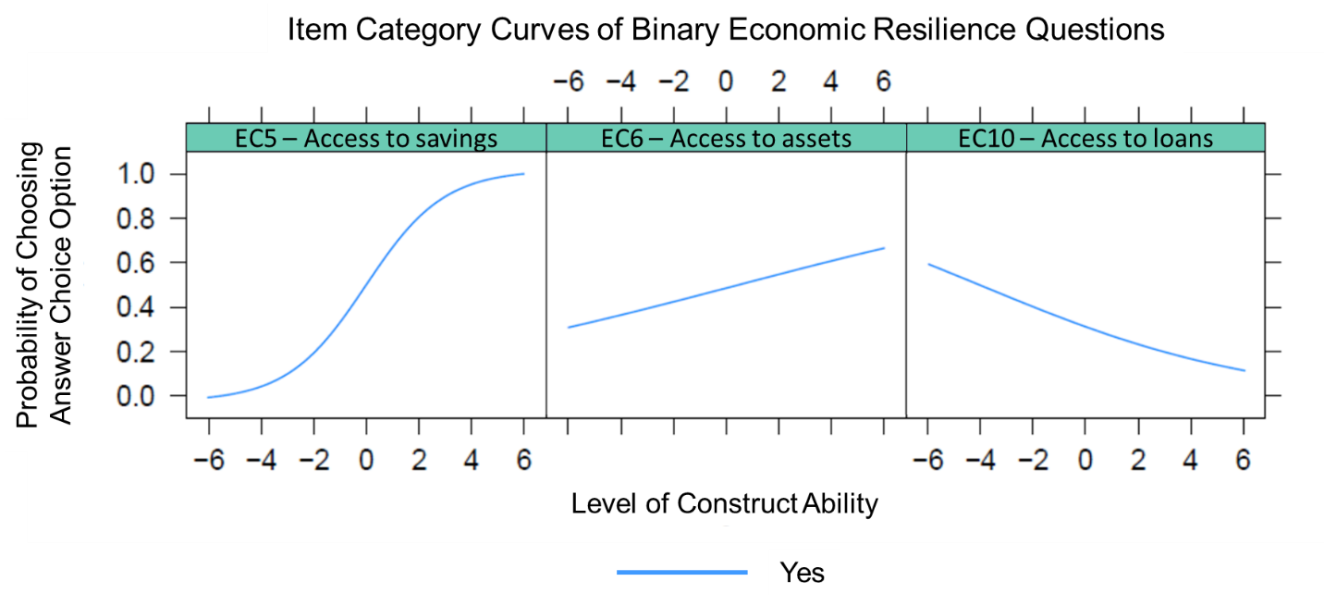

Figure S6a | Binary economic resilience item category curves

Figure S7b displays the ICCs of the ordinal economic resilience survey questions. Questions EC2-Ends meet in disaster, EC3-Ends meet after job loss, and EC4-Find another job contained six response options which are represented by the six ICCs. These three economic resilience questions performed well, each having distinct and clearly separated response curves for each response option.

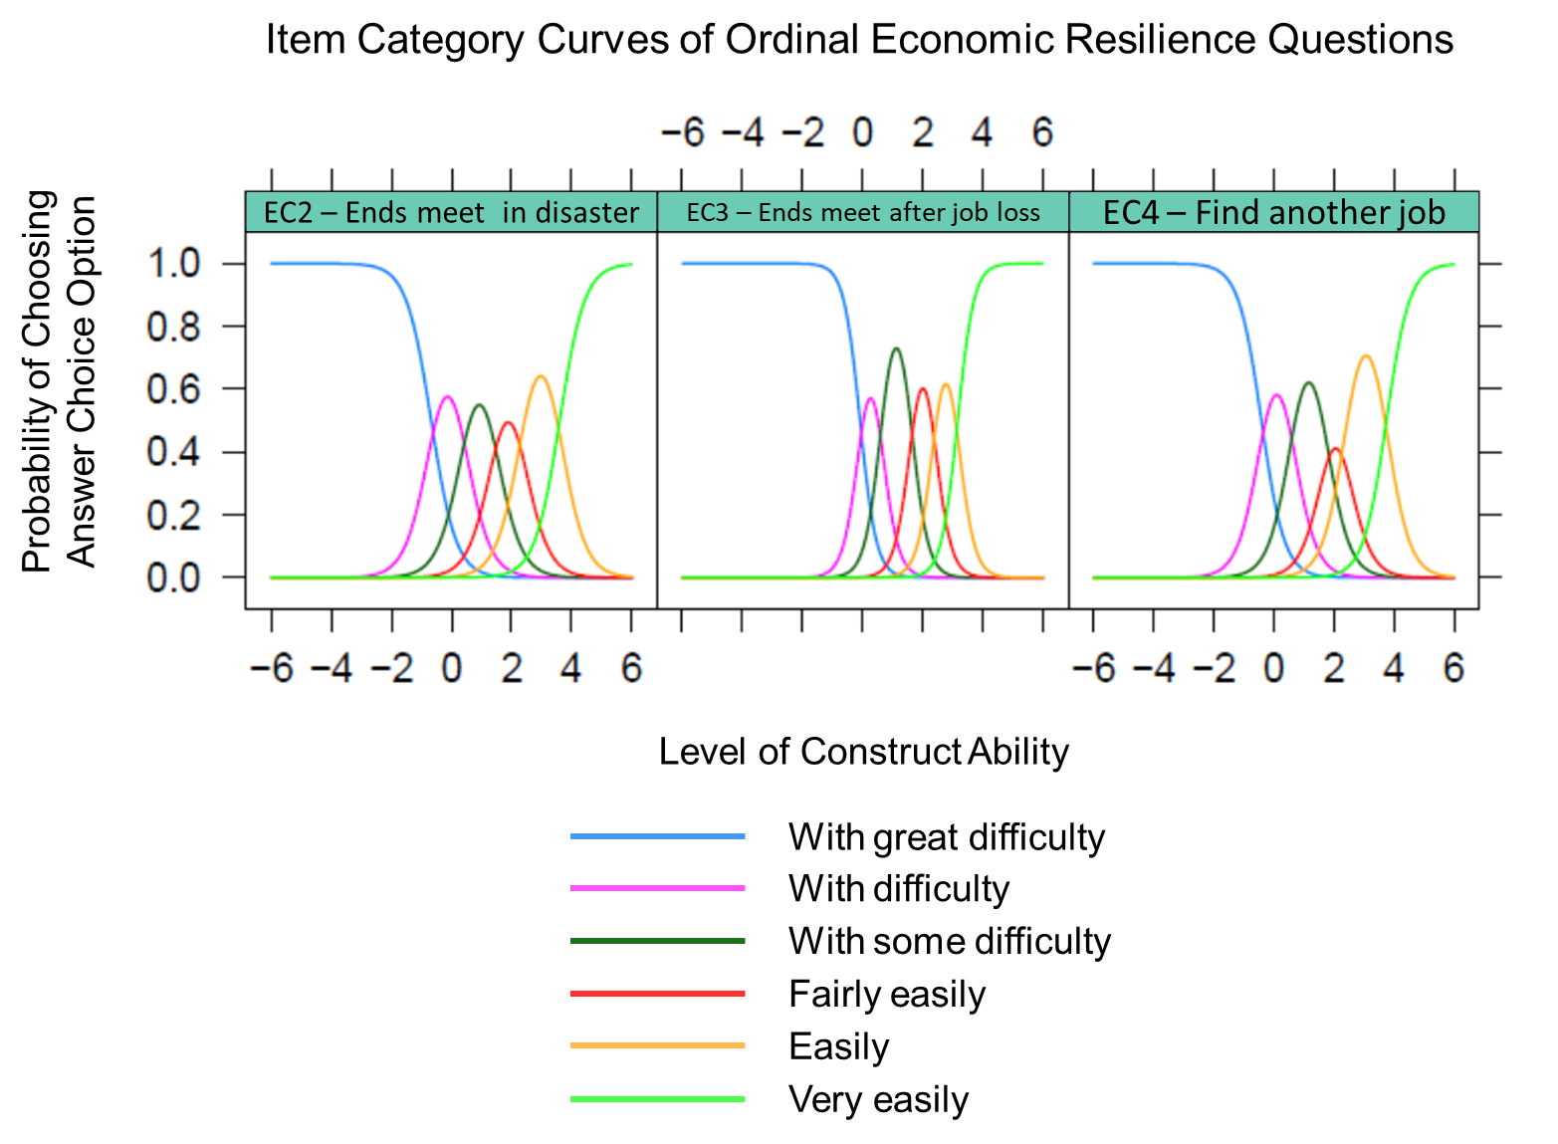

Figure S6b Ordinal economic resilience item category curves

Figure S8 displays ICCs for each of the eight ordinal question within the environmental resilience scale. Questions EN11-EN18 contained five responses each represented by the five ICCs. Four of the eight questions, all within the infrastructure & energy factor (EN11; EN16-EN18) performed poorly, each having overlapping and indistinct response curves. This means the questions are not successfully differentializing among people with different levels of environmental resilience (indicated by theta).

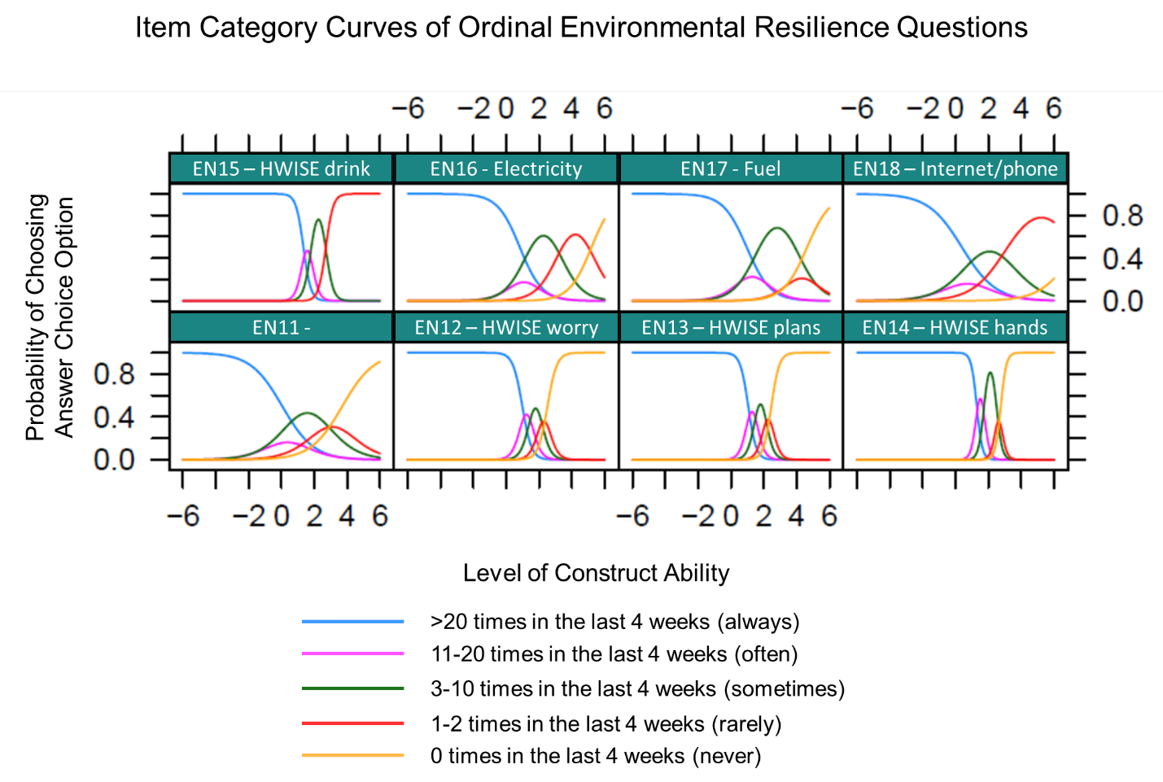

Figure S7 | Environmental resilience item category curves

While the four items in the water sub-scale (which consisted of the four item HWISE short form scale⁴⁹) performed well in the IRT analysis, we did not feel that this sub-scale alone would be appropriate for the whole environmental resilience scale. Therefore, we chose to drop the environmental scale entirely and recommended these set of questions be further refined. We have further discussed potential reasons for poor performance of the environmental scale and future directions to refine the scale in the discussion section.

Figure S9a displays ICCs foreach of the three binary social resilience questions. Items in the emergency response factor (SO2-Evacuate, SO23-Kit, SO25-Knowledge) performed well with an S-shaped curve indicating that those with higher levels of social resilience (on the x-axis) are more likely (y-axis) to answer the questions to affirm social resilience.
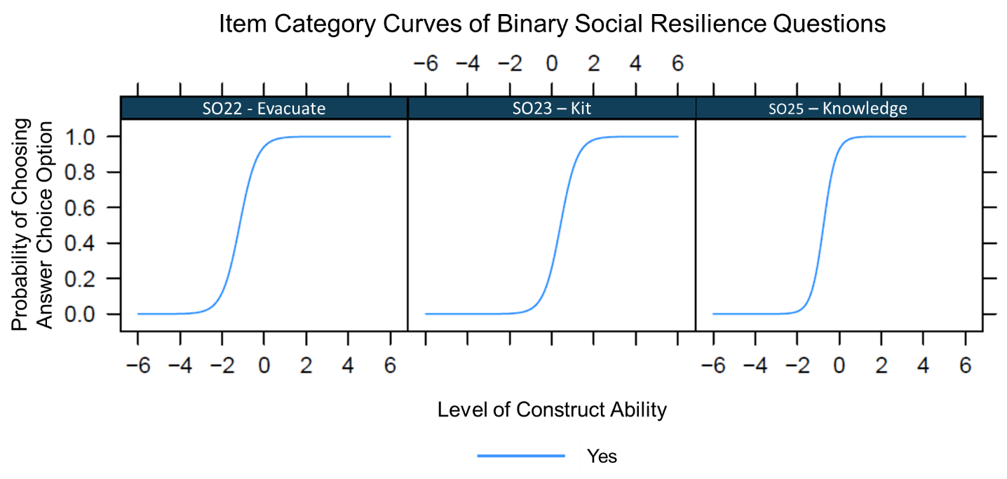

Figure S8a | Ordinal social resilience item category curves

The remaining 13 questions contained four response options, each represented by the four ICCs per plot. These 13 social resilience questions performed well, each having distinct and clearly separated response curves for each response option. All 13 sets of curves indicated the response options successfully differentiated across varying degrees of social resilience.

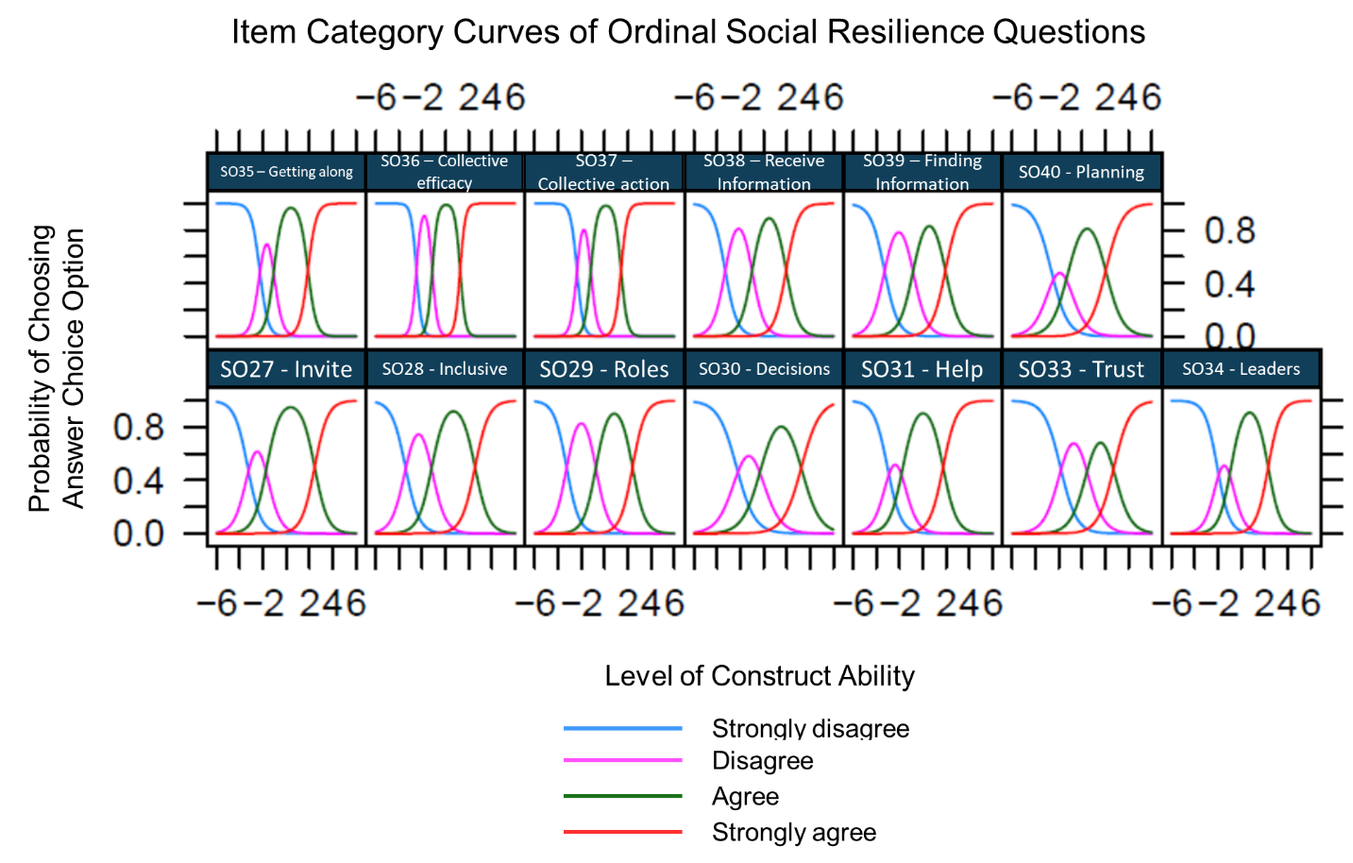

Figure S8b | Ordinal social resilience item category curves

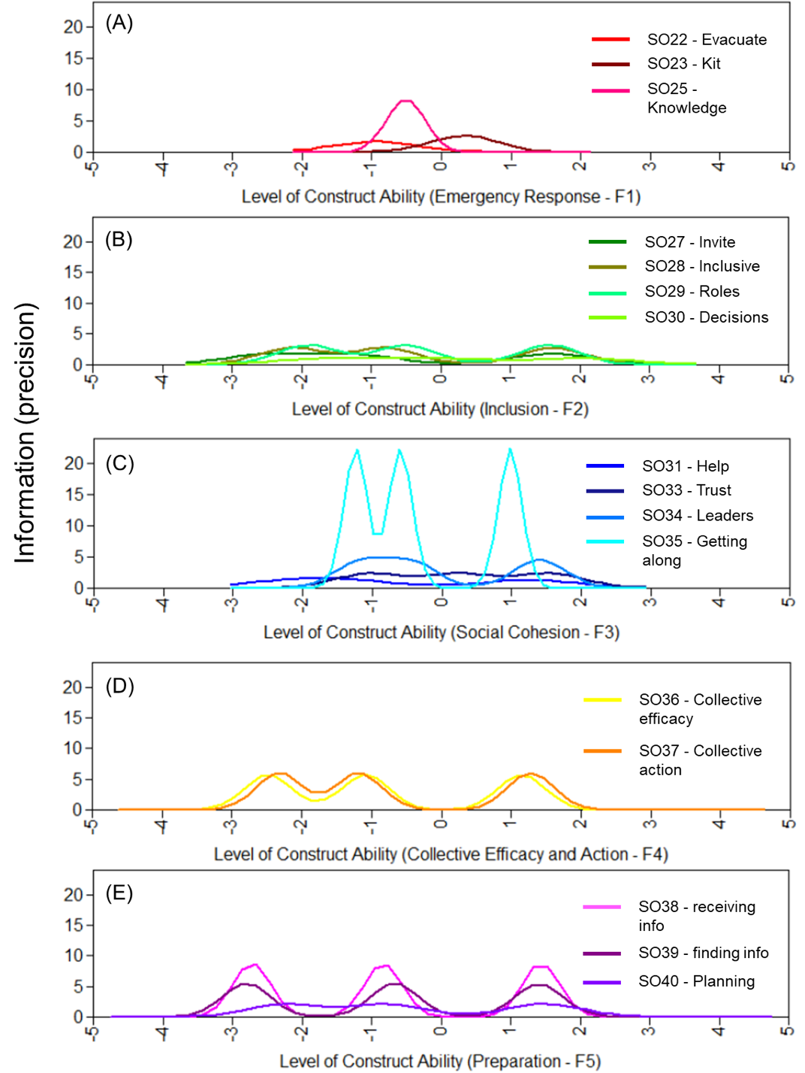
Figure S9 | Social resilience scale item information curve per item and by factor
The IICs provide insights into the relationship between the amount of information or measurement precision contributed (y-axis) at each level of the construct trait (x-axis). Figure S10 showcases IICs for each of the five factors which contains a curve for each question within the factor (Figure S10 panels A-E). IICs for questions within the emergency response factor (A), inclusion factor (B), and collective efficacy and action factor (D) had relatively low vertical spread across the y-axis, meaning questions in among these factors had lower levels of precision.When comparing the horizontal spread on the x-axis, the inclusion factor (B) and collective efficacy and action factor (D) ICCs horizontal spread across the x-axis was larger than that of the emergency response (A) factor, indicating questions within the former two factors (B and D) provided information across a broader range of social resilience levels compared to those in the emergency response factor (A). Because the emergency response factor provided little information, or precision, over a relatively small range of the construct, we removed this factor and the corresponding three questions (SO22, SO23, and SO25) from the social resilience scale.

The discrimination parameters, displayed in Figure S11a, indicate the ability of each question to differentiate respondents based on their level of social resilience with higher values per question indicating better discriminant ability.⁶ The discrimination parameters for questions within the full scale ranged from 1.60 to 8.71 (Figure S11a).
The difficulty ranges by question, as shown in Figure S11b, provides insights into the specific range of the trait that each question is capable of capturing. These assessments establish thresholds, or boundaries that divide the response options into distinct categories (represented by square, triangle, and circle markers on Figure S11b). These thresholds translate the response options into different ranges of the trait.
In this study, questions within factors F2 to F5 were designed with four response options. The thresholds for these questions depicted in Figure S4.2b indicate the points where respondents are likely to transition from one response option to another based on their level of agreement with the question and, consequently, their position on the trait (displayed on the y-axis). For instance, consider question SO27 (invite), which covers levels of social resilience from approximately -3 to 2. If a respondent chooses to 'disagree' with this question, it generally implies that their position on the social resilience trait falls somewhere between -3 and -2. Conversely, answering 'agree' typically indicates a position on the social resilience trait ranging from -2 to 2.
We were unable to calculate the difficulty range for the three items pertaining to emergency response (SO22-evacuate, SO23-kit, and SO25-knowledge) due to their dichotomous response options. Considering their relatively poor performance illustrated in the IICs, we decided to drop these three items from the scale. These items may perform better after refinement and could be integrated into an environmental resilience domain instead.
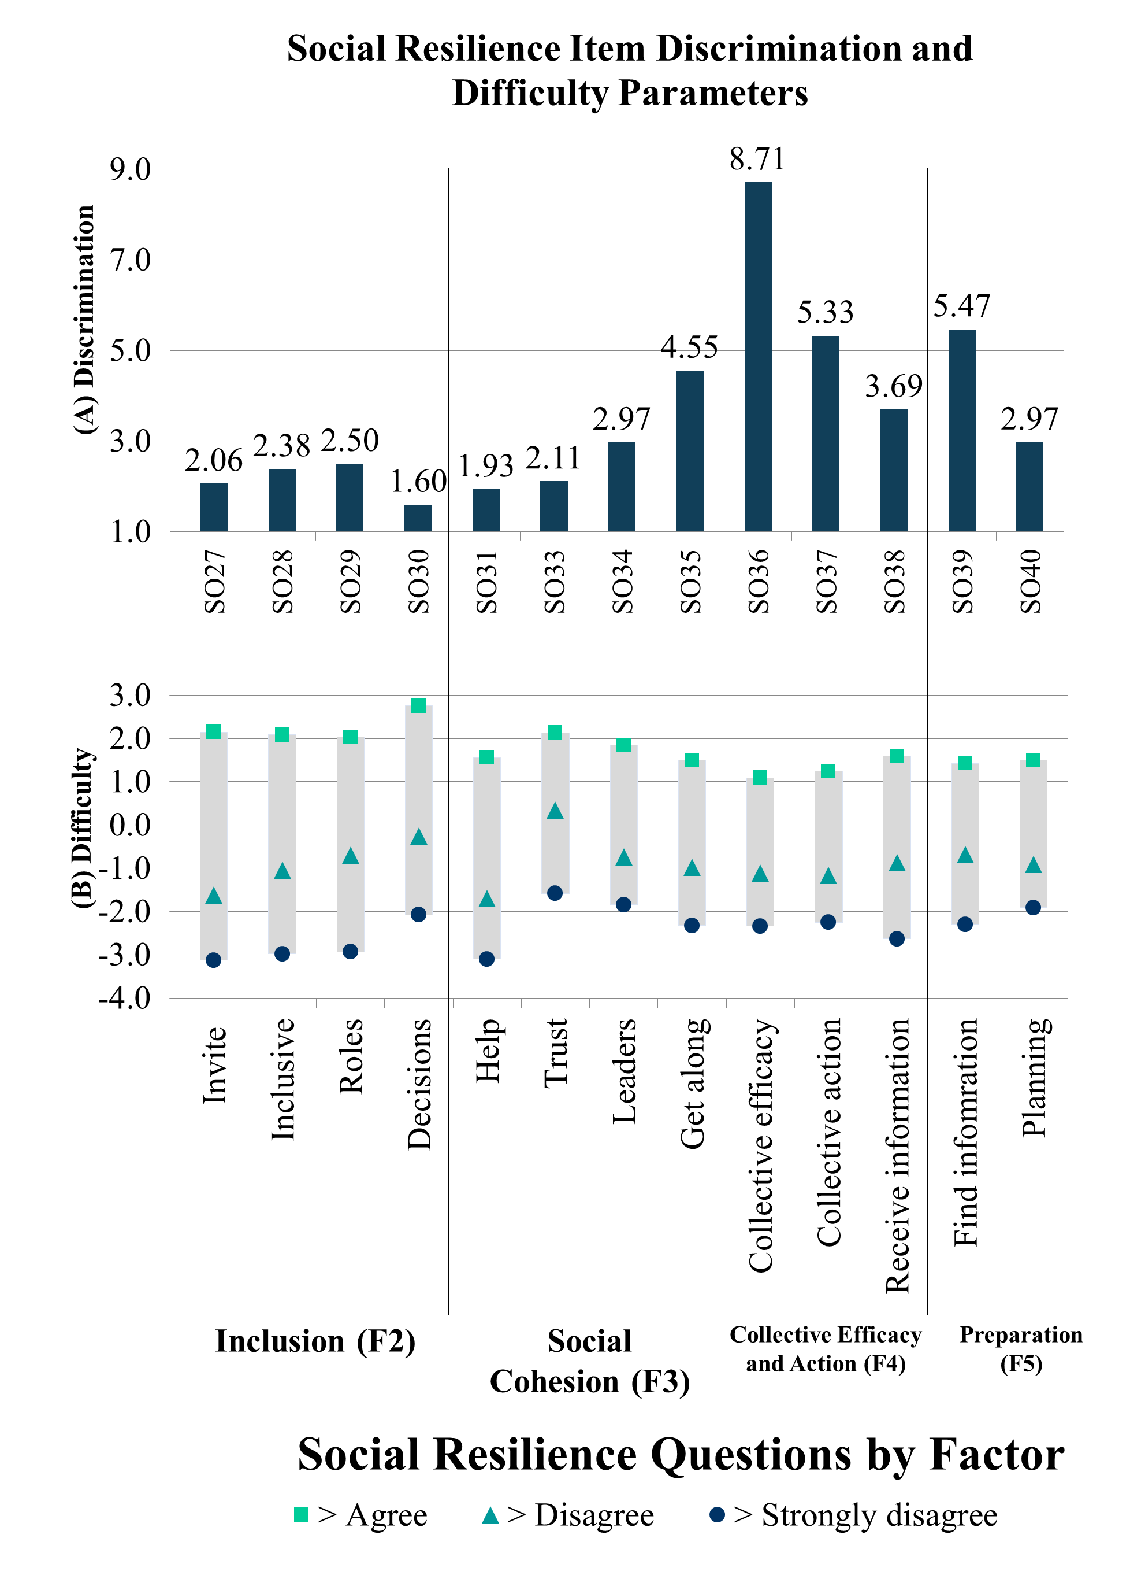

Figure S10 | Social resilience item (A) discrimination and (B) difficulty parameters

The inclusion factor (F2) exhibited discrimination parameters ranging from 1.60 to 2.50, with the item on decisions (SO30) having the lowest discrimination level. However, SO30 accounted for the highest range of difficulty on the latent trait. We concluded that item SO27-invite, which displayed the second lowest discrimination level, was not essential to the measurement of the latent construct as its difficulty range on the latent trait was adequately covered by the remaining items in the scale.
The social cohesion factor (F3) exhibited discrimination parameters ranging from 1.93-4.55. The item on willingness to help a neighbor (SO31) had the lowest discrimination level, but also accounted for the lowest range of difficulty on the latent trait. Although items SO34 on leaders and SO35 on getting alone had overlapping difficulty ranges, their discrimination levels were relatively high, and SO34 was the only item that asked about thoughts on community leaders. Item SO33 on trust had the second lowest discrimination level. While it accounted for the highest difficulty range, after visually analyzing Figure S11b, we felt that the range was only marginally higher than that of SO34 (leaders).
We did not consider reducing the collective efficacy and collective action factor (F4) since a factor must have at least two items. The items also demonstrated high discrimination levels ranging from 5.33-8.71, and a satisfactory spread of difficulty on the latent trait.
The preparation factor (F5) discrimination ranged from 2.97-5.47. Although SO40 on planning had the lowest discrimination level among items in this factor, it was the only item asking about prioritizing preparing for disturbances. Item SO38 on receiving information had the second lowest discrimination level but covered the largest range on the latent trait. Item SO39 on finding information had the highest discrimination level. We also felt that SO39 well represented household social resilience by asking if the respondents knew where to get information, rather than if their household received information from external sources. Because the items in F5 performed well, we opted to retain all three items.

Table S2 | Equivalence model fit parameters by scale

 | Model | CFI | TLI | SRMR | RMSEA  Estimate | RMSEA  Lower CI | RMSEA  Higher CI
 | Criteria for ‘good’ fit | >0.95 | >0.95 | <0.08 | <0.06
Economic Resilience Scale | Configural Model | 0.987 | 0.991 | 0.103 | 0.312 | 0.285 | 0.341
Economic Resilience Scale | Metric Model | 0.988 | 0.993 | 0.085 | 0.276 | 0.216 | 0.251
Economic Resilience Scale | Scalar Model | 0.985 | 0.993 | 0.076 | 0.285 | 0.262 | 0.309
Social Resilience Scale | Configural Model | 0.985 | 0.983 | 0.066 | 0.097 | 0.087 | 0.108
Social Resilience Scale | Metric Model | 0.950 | 0.946 | 0.086 | 0.174 | 0.165 | 0.184
Social Resilience Scale | Scalar Model | 0.984 | 0.983 | 0.074 | 0.097 | 0.087 | 0.106

Economic resilience scale model fit statistics are reported after dropping EC5, EC6, and EC10. Social resilience scale model fit statistics are reported after dropping SO22, SO23, SO25, SO27, SO33.

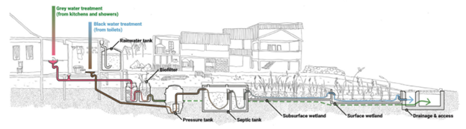

Figure S11 | Schematic of proposed sanitation intervention adapted from Leder et al.²⁶

Table S3 | Conceptual framework of urban household resilience measurement in LMICs

Resilience Domain | Sub-domain | Description & Examples
Resilience Domain | Sub-domain | Static | Dynamic
Resilience Domain | Sub-domain | Capital | Absorptive Capacity | Adaptive & Transformative Capacities
Economic Resilience | Livelihood (Stability) | Income | Ability to maintain income stability and swift recovery of income in the face of disturbances  Income stability  Number of income sources  ability to continue earning during disturbances | Ability to maintain income stability and swift recovery of income if income sources are lost due to disturbances  Alternative livelihoods  Diversification of income  occupational and skillset diversity  ability to secure another source of income or employment if current job is lost
 | Financial Resources (Stabilizing) | Availability of and access to assets, savings, loans, credits, money transfers, and aid | Capacity of financial resources to aid in preparation for, coping with, or recovery from disturbances  Insurance, relief aid, crisis subsidies, mutual aid, household emergency funds | Capacity to access further financial resources or expand current available resources as needs change  Capacity to save, savings practice of household in preparation of disturbances, budget for disaster risk reduction
Environmental Resilience | Ecological services | The natural environment, which is composed of various ecologies, water, soil, atmosphere, etc. | Use of current natural environment to guard against and cope with known disturbances  Ecological and natural buffers  Ecological services that help to cope with disturbances | Developing, augmenting, and adjusting the natural environment to provide further safeguarding and coping opportunities for disturbances  Policies to protect and expand the environment and ecological services (e.g., mangrove tree preservation)
 | Energy/  electricity | Availability of and access to electricity/energy service (gas, electricity, etc.) | Alternate capacity; supply capacity; power stability during disturbance  Supply vs demand of electricity during disturbances, outages or service gaps during disturbances | The capacity to adapt and innovate in response to changing energy and climate conditions  Diversification in energy sources, use of renewable energy sources, increase energy efficiency,
 | Housing and Shelter | Infrastructure that provides permanent, stable, autonomous living situation | Housing built to withstand disturbances  Capacity to repair housing  Insurance for housing damage and repairs  Shelter from disturbances if needed  Temporary shelter and evacuation centers | Capacity to improve and change housing as needs change  Capacity for adaptation, housing renovations to prepare for future and changing disturbances, location of housing/shelter, use of land use information to dictate residential areas, energy efficient and low-carbon housing,
 | Information and communication technology (ICT) | Availability of and access to telephones, radios, and the internet | Use of ICT resources to prepare for, cope with, and recover from disturbances; ability of ICT infrastructure and services to withstand and recovery quickly after disturbances  Early warning systems to prepare for disturbances, use of ICT technologies during disturbances | Capacity to expand service coverage and improve use of technologies to prepare, cope, and recover from disturbances  Use of ICT technology and information to prepare for disturbances
 | Land use | The human use of land | Land use practices at current time implemented to protect from the impacts of disturbance  Land developed as wetlands to absorb partial impact of flooding | Use of land use and hazard mapping to inform potential impacts of disturbances  Capacity to improve land use and land conservation regulations  Diversification of land use, land use planning and zoning,
 | Sanitation | Availability of and access to sanitation facilities and infrastructure that manage waste | Waste management and sanitation services and infrastructure can withstand or recover quickly after disturbances | Capacity to improve sanitation services and infrastructure as needs and disturbances change
 | Transportation | The natural and built environment, infrastructure, and services that allow for the motility of people | Transportation services and infrastructure can withstand or recover quickly after disturbances | Capacity to improve transportation services and infrastructure as needs and disturbances change
 | Water | Availability of and access to safe water | Water services and infrastructure can withstand and recover quickly after disturbances | Capacity to improve water services and infrastructure as needs and disturbances change
Social Resilience | Community & institutional environments | Formal and informal institutions that operate within a community and are ideally controlled by their members | Use of social capital to prepare and recovery from disturbances to minimize short- and long-term harm and damage | Use of social capital to strengthen capacities
 | Education | educational attainment; availability of educational services | Functionality of schools after disturbance | Disturbance awareness; effectiveness in learning from previous disasters; disaster awareness programs; awareness and preparation programs
 | Food | Food availability; diverse food sources; income level | Buffer stocks; food aid for emergency response | Crop diversification; technology adaptation; land use change; policy reform;  Change in land use practices and policies to better reflect food security needs
 | Health | Availability of and access to healthcare | Capacity of healthcare institutions to serve the community and the needs during disturbances | Capacity of healthcare institutions to expand with an increase in need
 | Preparation | Actions taken in anticipation of disturbances | Capacity to prepare for disturbances to minimize damage | Capacity to improve preparation activities as needs change
 | Rescue | Actions take in response to disturbances to minimize harm to people | Capacity to provide rescue, aid, and relief during a disturbance to minimize damage and harm to people. | Capacity to improve rescue activities as needs change
 | Recovery | Actions take in response to a disturbance to address damage and bounce back | Capacity to provide aid, relief, resources, and services after a disturbance to address damage and bounce back | Capacity to improve recovery activities as needs change

Table S4 | Original and revised survey questions by resilience domains and sub-domains with justifications for revision or removal

Domain | Sub-domain | Pre-existing vs. newly designed questions | Original Question | Reason for revision | Finalized questions*
Economic Resilience | Livelihood (Stability) | Pre-existing | Thinking of your household's total monthly income or weekly income, how difficult is it for your household to make ends meet, that is pay your usual expenses? | No revision | EC1 Thinking of your household's total monthly income or weekly income, how difficult is it for your household to make ends meet, that is pay your usual expenses?
Economic Resilience | Livelihood (Stability) | New | How difficult is it for your household to make ends meet after an environmental shocks and stressors such as a typhoon, flood, or disease outbreak? | Revised – Clearer wording | EC2 How difficult would it be for your household to make ends meet after natural disasters such as [example]?
Economic Resilience | Livelihood (Stability) | New | If someone in your household loses their job, how difficult is it to make ends meet? | Revised – Added ‘main income earner’ to standardize who respondent thinks of losing their job | EC3 If the main income earner in your household loses their job, how difficult would it be to make ends meet?
Economic Resilience | Livelihood (Stability) | New | How difficult is it for the main income earner to find another job if they lost their current job? | Revised – Added ‘main income earner’ to standardize who respondent thinks of losing their job and having to find a new one | EC4 How difficult would it be for the main income earner to find another job if they lost their current job?
Economic Resilience | Financial Resources (Stabilizing) | New | During or after environmental shocks and stressors such as typhoons, floods, droughts, or disease outbreaks, does your household have access to savings that could be used to help support you and your household? | Revised – Simplified into one question with the responder prompted to indicate all that apply. We also added questions to ask about additional income sources and loans. | EC5 Does your household have access to any of the following to help make ends meet if you need extra income?  1. Access to savings  2. Household assets (e.g., [example]) that you could sell or pawn  3. Additional income sources (e.g., [examples])  4. Money transfers from abroad (not including loans)  5. Aid such as good or cash from either non-profit organization, non-governmental organizations ([example]), religious or service groups or the government  6. Loans
Economic Resilience | Financial Resources (Stabilizing) | New | Does your household have assets that could be sold for additional income if needed? This may include household assets or other assets such a livestock.
Economic Resilience | Financial Resources (Stabilizing) | New | If your household is need of additional income, do you or someone in your household have access to money transfers from outside your community or abroad?
Economic Resilience | Financial Resources (Stabilizing) | New | After environmental shocks or stressors, do you or someone in your household (including children) receive any aid or assistance such as food, cash, or other support from anyone? This could include local, regional, or national government, non-profits, religious organizations, non-governmental organizations, or other service groups.
Environmental Resilience | Ecological services | NA | No question asked | NA | NA
Environmental Resilience | Energy/  electricity | New | In the last 4 weeks, how frequently did you or anyone in your household worry that your main source of electricity, internet, phone, and gas may stop working? | Revised – The original question was separated out to only ask about one utility at a time. Original question was also separated into EN18 (see ICT sub-domain). | EN16 In the last 4 weeks, how frequently was your household unable to afford electricity?  EN17 In the last 4 weeks, how frequently was your household unable to afford fuel such as [examples of fuel]?
Environmental Resilience | Housing and Shelter | New | In the last 4 weeks, how many times did you worry about the quality or structural integrity of your house? |  | EN11 In the last 4 weeks, how many times did you worry about the quality or structure of your house?
Environmental Resilience | Information and communication technology (ICT) | New | *See question for ‘Energy/electricity’ sub-domain* | Revised – *See question for ‘Energy/electricity’ sub-domain* | EN18 In the last 4 weeks, how frequently was your household unable to afford internet or phone?
Environmental Resilience | Land use | NA | No question asked | NA | NA
Environmental Resilience | Sanitation | NA | No question asked | NA | NA
Environmental Resilience | Transportation | New | In the last 4 weeks, how many times were you unable to access transportation to get to somewhere you needed to be? | Revised – We added ‘afford’ as we got feedback that sometimes transportation is prohibited by affordability as well. | EN19 In the last 4 weeks, how many times were you unable to access and afford your usual mode of transportation to get to where you needed to be?
Environmental Resilience | Transportation |  | In the last 4 weeks, how many times were you concerned that you would not be able to use the roads and/or accessways to get to where you needed to be? This may have been because of floods or high-water levels, obstacles in your path, or damage to the road that made it unusable. | Revised – We added the aspect of being injured when trying to use roads and access ways because we received feedback that even though roads may be flooded or have obstacles, many people still use them but are injured in the process. | EN20 In the last 4 weeks, how many times were you unable to use the roads, access ways, or paths or were injured trying to use them? This may have been because of floods or high-water levels, obstacles in your path, or damage to the roads?
Environmental Resilience | Water | Pre-existing | HWISE_WORRY: In the last 4 weeks, how frequently did you or anyone in your household (including children) worry you would not have enough water for all of your household needs? | No revision | EN12: HWISE_WORRY: In the last 4 weeks, how frequently did you or anyone in your household (including children) worry you would not have enough water for all of your household needs?
Environmental Resilience | Water | Pre-existing | HWISE_PLANS: In the last 4 weeks, how frequently have you or anyone in your household (including children) had to change activities or timing of activities due to problems with your water situation? | No revision | EN13 HWISE_PLANS: In the last 4 weeks, how frequently have you or anyone in your household (including children) had to change activities or timing of activities due to problems with your water situation?
Environmental Resilience | Water | Pre-existing | HWISE_HANDS: In the last 4 weeks, how frequently have you or anyone in your household (*including children) were not able to wash hands after dirty activities (e.g., defecating or changing diapers, cleaning animal dung) because of problems with water? | No revision | EN14 HWISE_HANDS: In the last 4 weeks, how frequently have you or anyone in your household (*including children) were not able to wash hands after dirty activities (e.g., defecating or changing diapers, cleaning animal dung) because of problems with water?
Environmental Resilience | Water | Pre-existing | HWISE_DRINK: in the last 4 weeks, how frequently has there not been as much water to drink as you would like for you or anyone in your household (including children)? | No revision | EN15 HWISE_DRINK: in the last 4 weeks, how frequently has there not been as much water to drink as you would like for you or anyone in your household (including children)?
Social Resilience | Community & institutional environments | New |  | Added – We added this new question because we received feedback that community authorities and local leaders are crucial in coping with disturbances. | SO24 During natural disasters, are you and your household able to get help from [example]?
Social Resilience | Community & institutional environments | New | Do you agree or disagree: When most of the leaders of this settlement make decisions/policies, they are accepted and good for most households in your settlement. | Revised – We received feedback that while, this is a culturally appropriate way to ask the question in Indonesia where the political culture is more sensitive, we can ask in a more straightforward manner in Fiji. | SO34 ***Depending on level of cultural sensitivity***  In less politically sensitive context (Fiji):  Most of the leaders in this settlement can be trusted.  In more politically sensitive contexts (Indonesia):  When most of the leaders of this settlement make decisions/policies, the decisions are good for most households in your settlement.
Social Resilience | Community & institutional environments | New | Do you agree or disagree: You and your household have access to the authorities, local government, community leaders who are in charge of the decisions that impact your day to day lives. | Revised – We changed the wording of “access to” to “communicate with” for clarity | SO26 You and your household are able to communicate with [example] who are in charge of the decisions that impact your day to day lives. [This could include [example]].
Social Resilience | Community & institutional environments | New | Do you agree or disagree: When there is a community events, gatherings, trainings, or meetings, someone from my household is usually invited to attend. | Revised – We separated this question to ask about formal and informal events separately, since many of the settlement events are related to RISE. | SO27 Outside of RISE related events, when there is a [[informal/formal]] community event or gathering such as [example], someone from your household is usually invited to attend.  SO28 Outside of RISE events, when there is a formal community event such as a training or community meeting where decisions are discussed and made, someone from your household is usually invited.
Social Resilience | Community & institutional environments | New | Do you agree or disagree: Some community members have pre-defined responsibilities or jobs that they do to help the community when there is a disaster, shock, stressor or emergency. | Revised the wording for clarity. We received feedback that some of the roles can be formally bestowed onto a community member or may be an informal role. We revised the question to reflect this feedback. | SO29 Some community members have roles or jobs that they do to help the community before, during, and after a natural disaster. These could include formal or informal responsibilities.
Social Resilience | Community & institutional environments | New | Do you agree or disagree: You and your household feel involved in community decisions that will affect your household, cluster, or community. | Revised – We removed the term ‘cluster’ as the meaning of the term was unclear and confusing. | SO30 You and your household feel involved in community decisions that will affect your household or community.
Social Resilience | Community & institutional environments | Pre-existing | Do you agree or disagree: people living here are willing to help their neighbor | No revision | SO31 People living here are willing to help their neighbor.
Social Resilience | Community & institutional environments | New | Do you agree or disagree: most people living in this settlement can be trusted | Revised – We received feedback that whether or not someone knows the person in the community may change if they trust them. We split the question to ask about people respondents know personally and those they may not know personally. | SO32 Most of the people you don't know personally in this settlement can be trusted.  SO33 Most of your neighbors in this settlement can be trusted.
Social Resilience | Community & institutional environments | Pre-  existing | Do you agree or disagree:  People in this community generally do not get along with each other | Revised – This question was originally negatively worded, meaning the question was inversely related to social resilience. We removed ‘do not’ to make sure the question would be directly related to the construct. | SO35 People in this settlement generally get along with each other.
Social Resilience | Community & institutional environments | New | Do you agree or disagree: People in this community would contribute money or labor to households that needed repairs after a disaster even if they were not family. | Removed – We received feedback that respondents would likely only answer strongly disagree as they very rarely had funds to spare and would not be willing to spare extra funds in this manner.
Social Resilience | Community & institutional environments | New | I feel confident in my ability to contribute to the community's efforts to overcome shocks/stressors | Removed – We received feedback that this was similar to question SO36.
Social Resilience | Community & institutional environments | New | I feel confident that this community has the ability to successfully work together to overcome shocks/stressors | No revision | SO36 I feel confident that this community has the ability to successfully work together to overcome shocks or stressors such as natural disasters or disease outbreaks.
Social Resilience | Community & institutional environments | New | I can influence decisions about how the community will protect itself from or respond to shocks/stressors | Removed – similar to SO30
Social Resilience | Community & institutional environments | New | Anyone in the community who wants to can be involved in decision-making about how the community will protect itself from or respond to shocks/stressors | Removed – we received feedback that this question was confusing in terms of what “who wants to can be involved.” We felt that SO30 covered the information we were seeking.
Social Resilience | Community & institutional environments | New | I or members of my household usually contribute to community efforts to protect from or respond to shocks/stressors | Removed
Social Resilience | Community & institutional environments | New | It is normal for people in this community to work together (meaning NOT every household for themselves) to protect from or respond to shocks/stressors. | Revised – Revised to reduce unnecessary and unclear wording. | SO37 It is normal for people in this community to work together to protect from or respond to shocks or stressors like natural disasters or disease outbreak.
Social Resilience | Community & institutional environments | New | People in this community are motivated to overcome shocks/stressors, even when it seems challenging to do so | Removed – similar to question SO37
Social Resilience | Community & institutional environments | New | Working together/doing communal work to protect the community from shocks/stressors before they happen is a good use of our time and/or money. This might include giving money, labor, or land for digging drainage ditches or building sea walls. | Removed – similar to question SO37
Social Resilience | Community & institutional environments | New | Working together/doing communal work to clean up or rebuild the community after shocks/stressors is a good use of our time and/or money. This might include community clean ups to clear debris or giving money or labor to rebuild communal structures. | Removed – similar to question SO37
Social Resilience | Education | NA | No question asked | NA | NA
Social Resilience | Food | NA | No question asked | NA | NA
Social Resilience | Health | New | Do you agree or disagree: Your household has access to a doctor/healthcare worker in a timely manner when you or someone in your household needs medical attention | Revised – Revised for clarity and to standardize how the respondent may define access and amount of access (your household has access vs. a majority of your household is able to see a doctor or healthcare worker…) | SO21 : Is a majority of your household able to see a doctor or healthcare worker when you or someone in your household needs medical attention?
Social Resilience | Preparation | New | Do you agree or disagree: You and your household know what to do and where to go during a weather-related hazard. | Revised – Revised wording for clarity | SO25 Do you and your household know what to do and where to go before, during, and after a natural disaster?
Social Resilience | Preparation | New | Do you agree or disagree: Your household receives information about potential or predicted storms, floods, disasters, droughts etc., with enough time to plan and make decisions for the safety of your household and/or livelihoods. | Revised – Removed list to just ask about natural disasters to reduce confusion. | SO38 Your household receives information about potential or predicted natural disasters with enough time to plan and make decisions for the safety of your household.
Social Resilience | Preparation | New | Do you agree or disagree: I would know where to go to get information on how to protect myself and my household from environmental shocks and stressors such as typhoons, floods, droughts, or disease outbreaks. | Revised – Revised wording for clarity and removed unnecessary words. | SO39 I know where to find information on how to protect myself and my household from natural disasters.
Social Resilience | Preparation | New | Do you agree or disagree: Planning and preparing for natural disasters and weather-related hazards is a priority for my household. | Revised – Revised wording for clarity. | SO40 Planning and preparing for natural disasters is a priority for my household.
Social Resilience | Preparation | New |  | Added – We added this question to understand behavior around preparation. | SO23 Has your household prepared a disaster supply kit in case of emergencies which may include things such as cash, drinking water, food, flashlight, extra batteries, radio, whistle, local maps, etc.…?
Social Resilience | Rescue | New | Do you agree or disagree: Your household is able to access safe shelter if you need to evacuate your home before or during weather related hazards. | Revised – Revised wording for clarity | SO22 If your household needs to evacuate because of a natural disaster, does your household has access to shelter that you feel safe going to such as [example]?
Social Resilience | Recovery | New | Do you agree or disagree: You or someone in your household has knowledge or training on what to do before, during, and after a natural disaster or weather-related hazard. | Removed – We received feedback that the idea of “training” was not common. Additionally, we felt this question was similar to SO25.
* During the cognitive interviews, the in-country staff members recommended using the term 'disasters' instead of specifying particular hazards in several survey questions. This choice of terminology was made to enhance the effectiveness and relatability of the survey for community members responding to it.

