“Development and Characterization of Metalloantibiotics for Pathogen Removal from Water: Insights from Antibacterial and Antiviral Activities”

Physical Measurements
The physicochemical properties of the synthesized compounds were investigated using the CHNS Vario automatic analyzer to determine Carbon, Hydrogen and Nitrogen percentages. Shimadzu FTIR spectrometer was used to obtain FT-IR spectra on the scale of 250-4000 cm⁻¹ using cesium bromide (CsBr). The ¹H-NMR spectra for our compounds were recorded using DMSO-d₆ as a solvent and the chemical shifts were recorded in ppm relative to an internal standard (TMS). The instrument used is 300 MHz Varian-Oxford. The molar magnetic properties of our compounds whether paramagnetic or diamagnetic were measured using the Faraday method. the calibrant used is Pascal's constant and Hg [Co (SCN)₄] for the diamagnetic corrections. To know the electrolytic nature of our compounds, we use the conductivity meter ORION model 150 of 0.6 cell constant by preparing 1.00 x 10 ⁻³ M DMSO solutions [5]. To evaluate the thermal behavior of the synthesized compounds, we use the TGA-50H-Shimadzu thermal analyzer from room temperature to 800 ºC at a heating rate 10ºC min⁻¹.

Computational methods
MOE 2009 (Molecular Operating Environment) software was used to simulate every enzyme inhibitor. The docking method involves the following steps: First, the investigated compounds, and 3D models were constructed in Chembio3D- ultra software and were optimized using MMFF94 minimization method. The second step required protein was downloaded from Protein Data Bank PDB. The three crystal structures of docked proteins are:
a- The protein symbolized (ID: 1NJ4) that represents penicillin-binding protein 5 crystal structure was taken from Protein Data Bank.
b- The protein symbolized (ID: 1moq) that represents glucosamine-6-phosphate synthase (GlcN-6-P) crystal structure was taken from Protein Data Bank.
c-The DNA-gyrase receptor crystal structure was taken from the Protein Data Bank (ID: 5BS8).
d- The COVID-19 main protease crystal structure was taken from the Protein Data Bank (ID: 6LU7)
The third step is the identification of binding affinity by the extent of binding of the compound to the protein. [6]

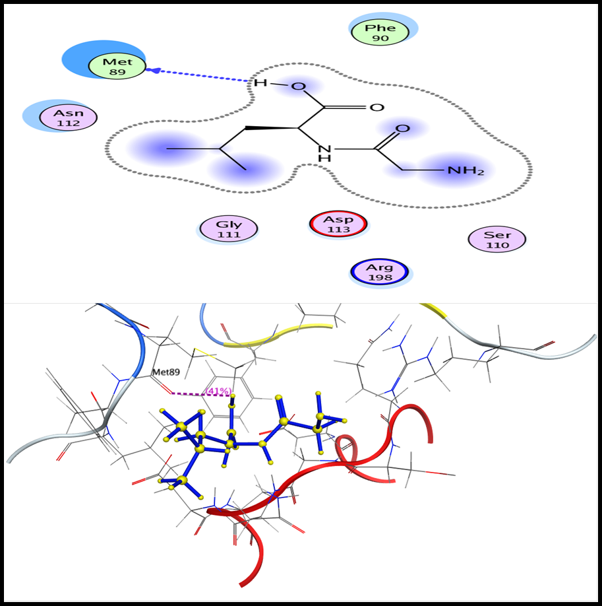
Figure S1. 2D and 3D Diagrams of the interaction between (Gly-Leu) and Mutant PBP5 binding site.
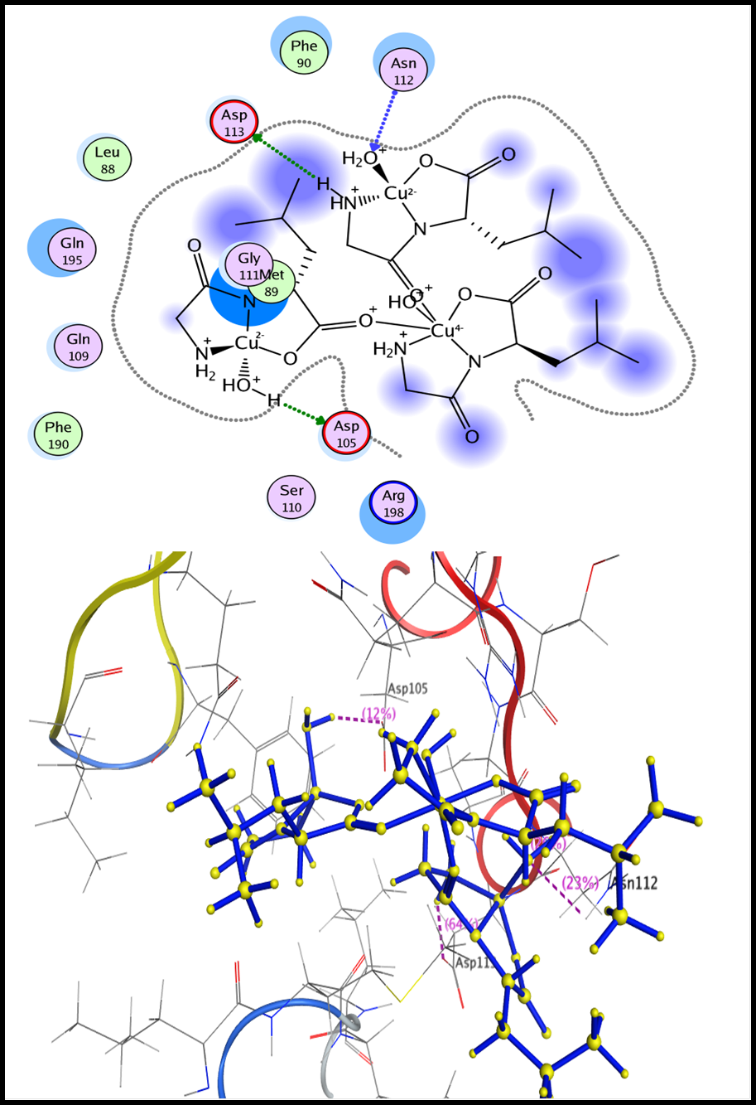
Figure S2. 2D and 3D Diagrams of the interaction between Cu-(Gly-Leu) and Mutant PBP5 binding site.
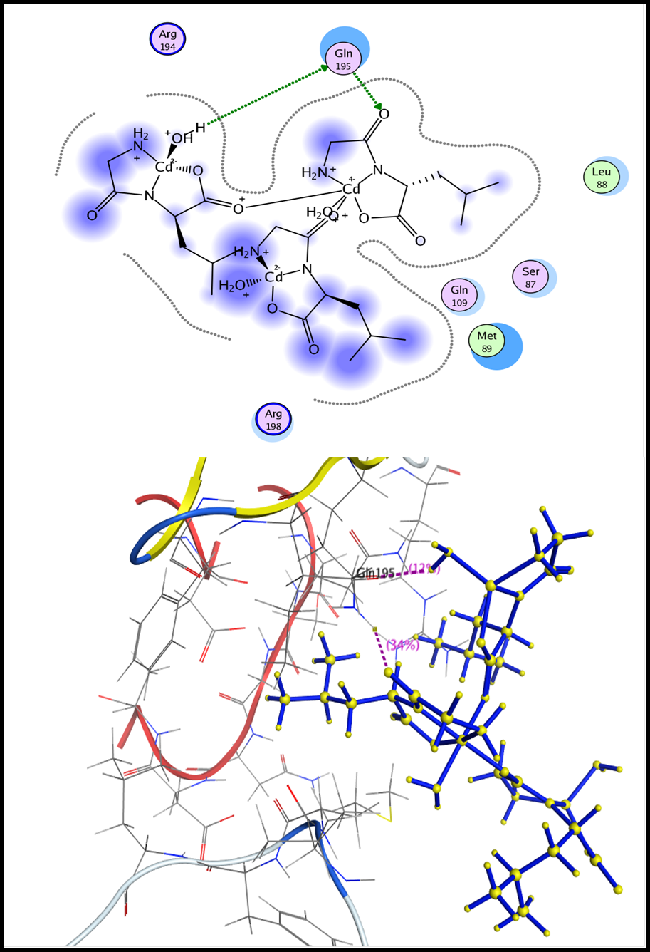
Figure S3. 2D and 3D Diagrams of the interaction between Cd-(Gly-Leu) and Mutant PBP5 binding site.
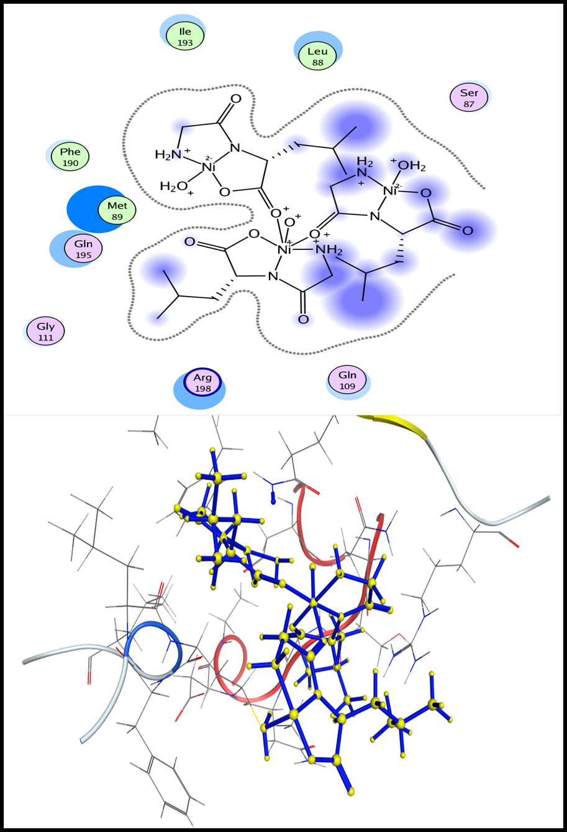
Figure S4. 2D and 3D Diagrams of the interaction between Ni-(Gly-Leu) and Mutant PBP5 binding site.
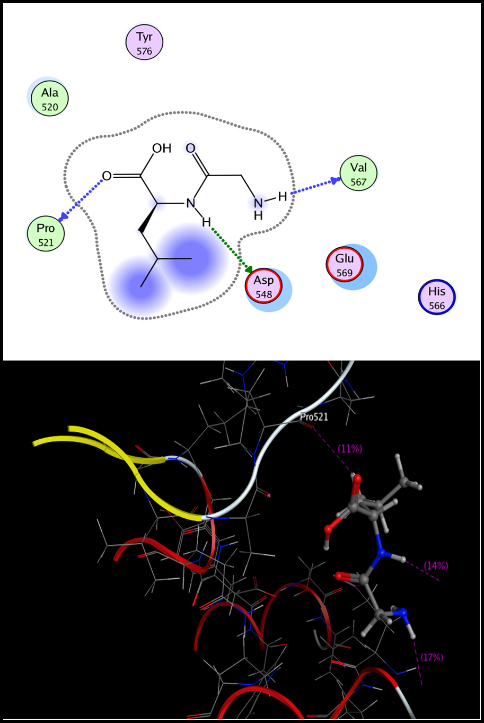
Figure S5. 2D and 3D Diagrams of the interaction between (Gly-Leu) and the glucosamine-6-phosphate enzyme binding site (PDB Code: 1moq).
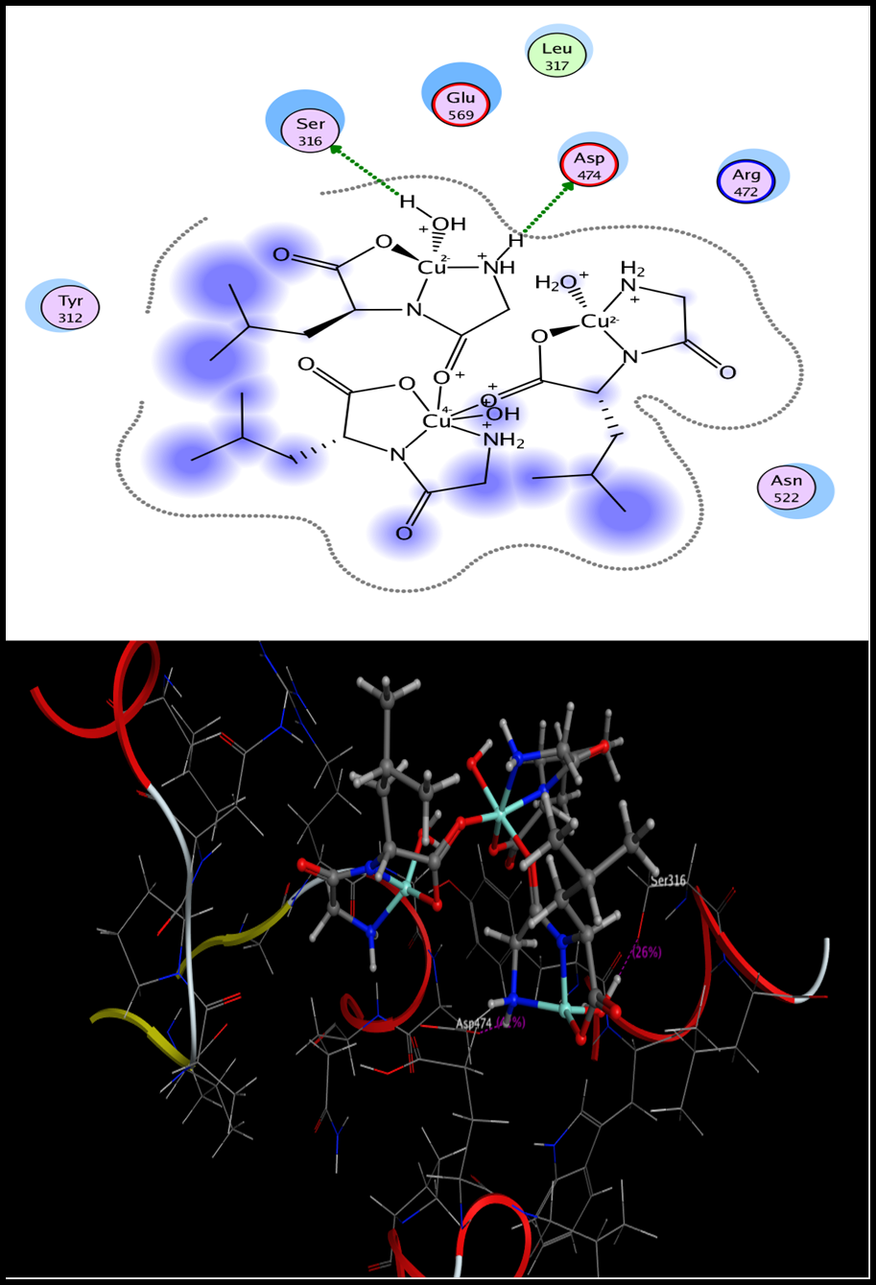
Figure S6. 2D and 3D Diagrams of the interaction between Cu-(Gly-Leu) and the glucosamine-6-phosphate enzyme binding site (PDB Code: 1moq).
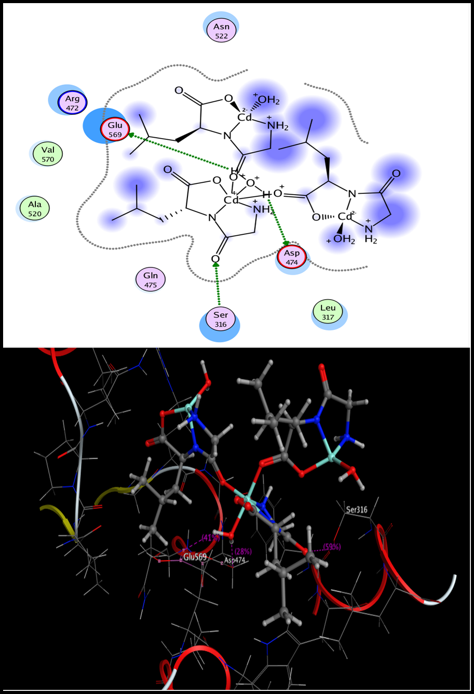
Figure S7. 2D and 3D Diagrams of the interaction between Cd-(Gly-Leu) and the glucosamine-6-phosphate enzyme binding site (PDB Code: 1moq).

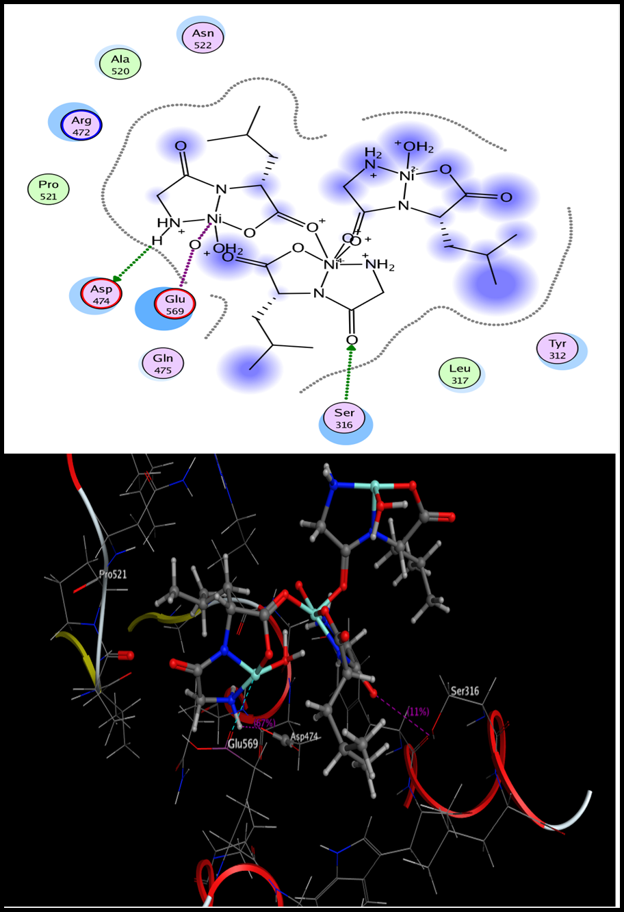
Figure S8. 2D and 3D Diagrams of the interaction between Ni-(Gly-Leu) and the glucosamine-6-phosphate enzyme binding site (PDB Code: 1moq).
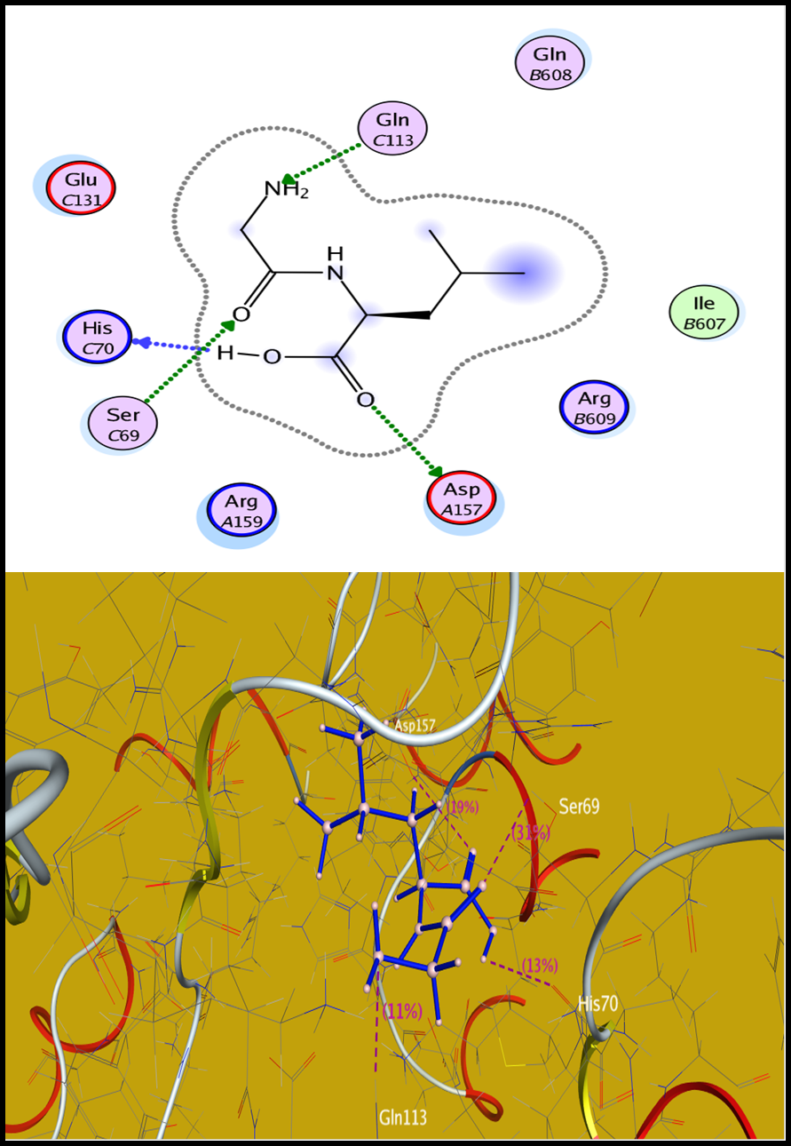
Figure S9. 2D and 3D Diagrams of the interaction between (Gly-Leu) and the DNA gyrase enzyme binding site (PDB Code: 5BS8).
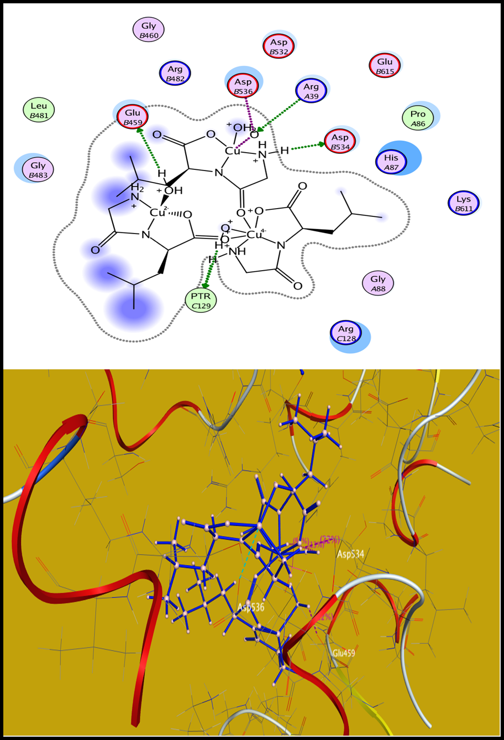
Figure S10. 2D and 3D Diagrams of the interaction between Cu-(Gly-Leu) and the DNA gyrase enzyme binding site (PDB Code: 5BS8).
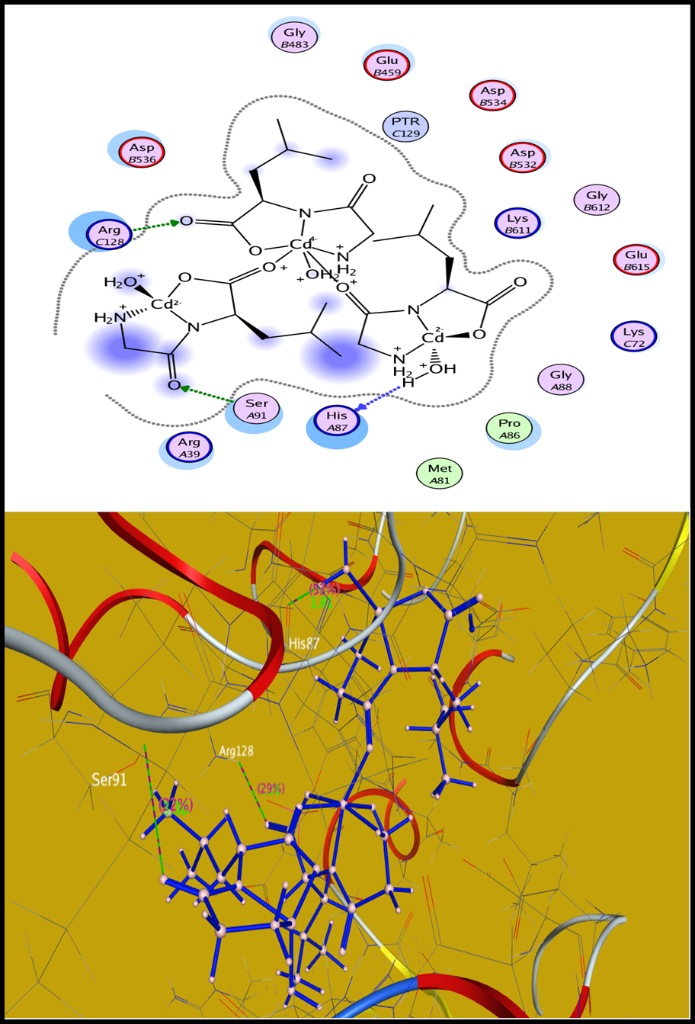
Figure S11 . 2D and 3D Diagrams of the interaction between Cd-(Gly-Leu) and the DNA gyrase enzyme binding site (PDB Code: 5BS8).
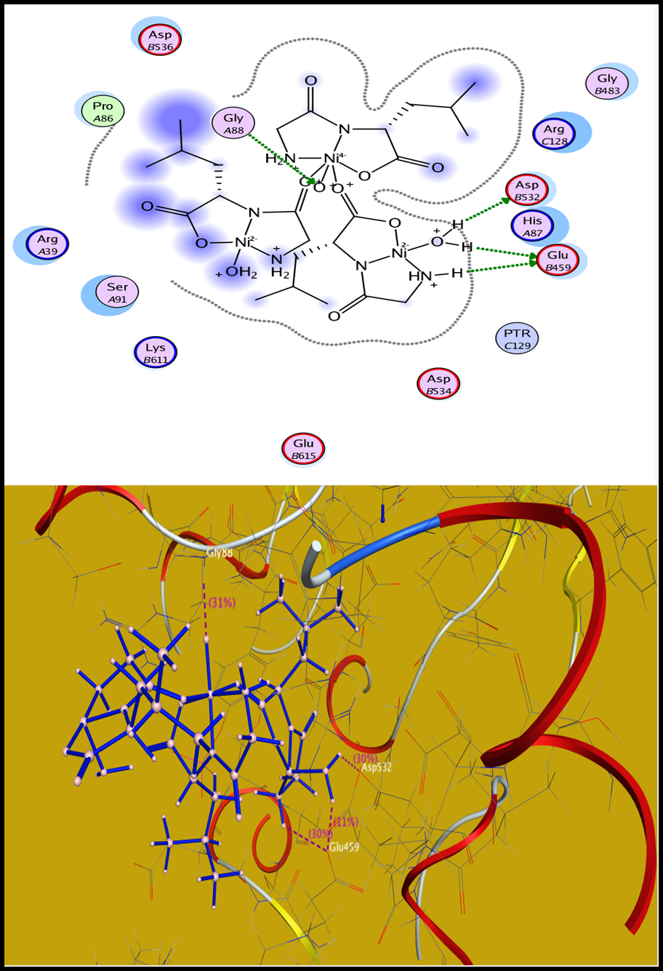
Figure S12. 2D and 3D Diagrams of the interaction between Ni-(Gly-Leu) and the DNA gyrase enzyme binding site (PDB Code: 5BS8).

