Supplementary data

Synthesis and Biological Assessment of Triazolo-Quinazoline Carbothioamide Derivatives for p38 MAP Kinase Inhibition: In-Silico and In-Vitro Approaches

¹H NMR of 4-methyl-5-oxo-N-(pyridin-3-yl)-4,5-dihydro-[1,2,3]triazolo[1,5-a]quinazoline-3-carbothioamide (8a)
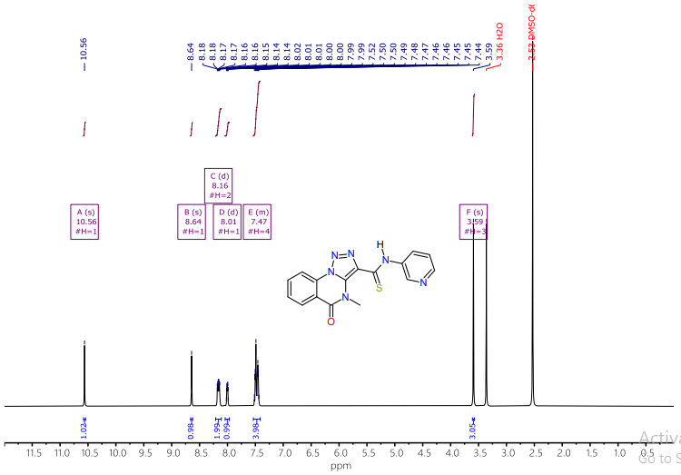
¹³C NMR of 4-methyl-5-oxo-N-(pyridin-3-yl)-4,5-dihydro-[1,2,3]triazolo[1,5-a]quinazoline-3-carbothioamide (8a)

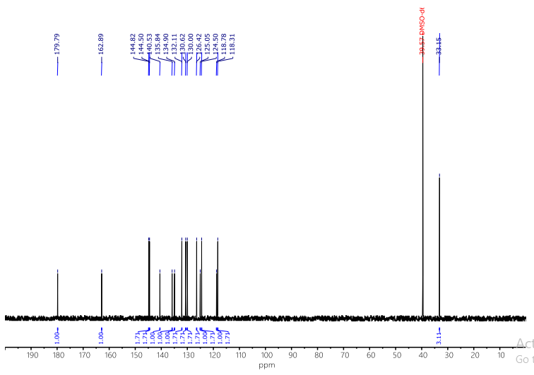

¹³C NMR of 4-methyl-5-oxo-N-(pyridin-3-yl)-4,5-dihydro-[1,2,3]triazolo[1,5-a]quinazoline-3-carbothioamide (8a)

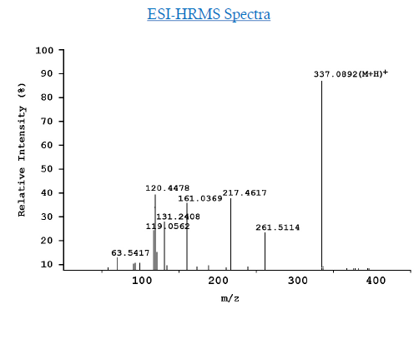

ESI-HRMS (m/z), of (C16H12N6OS)
Calcd: 337.0866 [M+H]+
Found: 337.0892 [M+H]+

¹H NMR of 7-methoxy-4-methyl-5-oxo-N-(pyridin-3-yl)-4,5-dihydro-[1,2,3]triazolo[1,5-a]quinazoline-3-carbothioamide (8b)

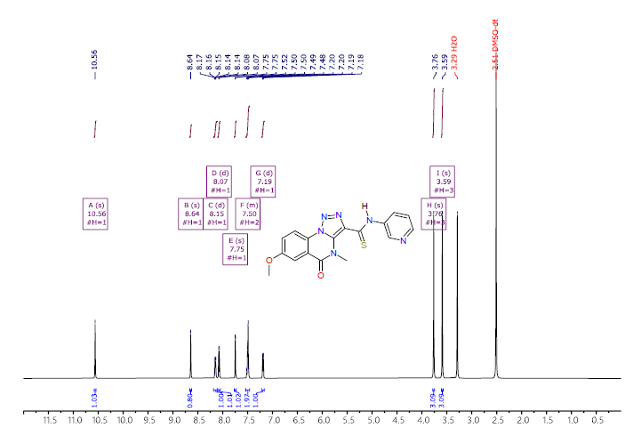

¹³C NMR of 7-methoxy-4-methyl-5-oxo-N-(pyridin-3-yl)-4,5-dihydro-[1,2,3]triazolo[1,5-a]quinazoline-3-carbothioamide (8b)
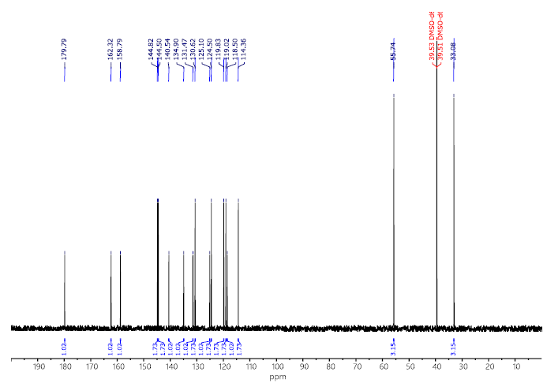

HRMS of 7-methoxy-4-methyl-5-oxo-N-(pyridin-3-yl)-4,5-dihydro-[1,2,3]triazolo[1,5-a]quinazoline-3-carbothioamide (8b)

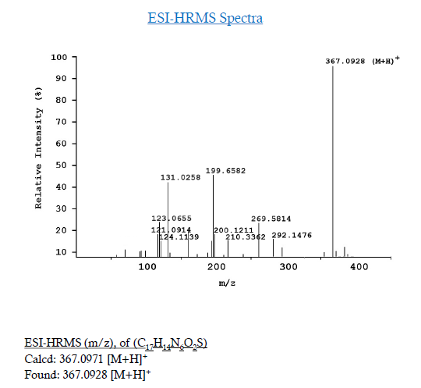

¹H NMR of N-(5-chloropyridin-3-yl)-7-methoxy-4-methyl-5-oxo-4,5-dihydro-[1,2,3]triazolo[1,5-a]quinazoline-3-carbothioamide (8c)

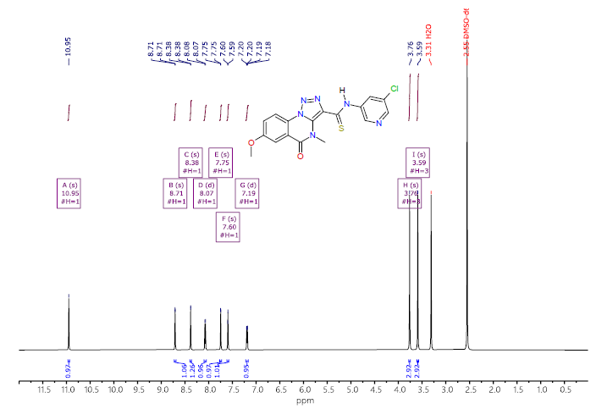

¹³C NMR of N-(5-chloropyridin-3-yl)-7-methoxy-4-methyl-5-oxo-4,5-dihydro-[1,2,3]triazolo[1,5-a]quinazoline-3-carbothioamide (8c)

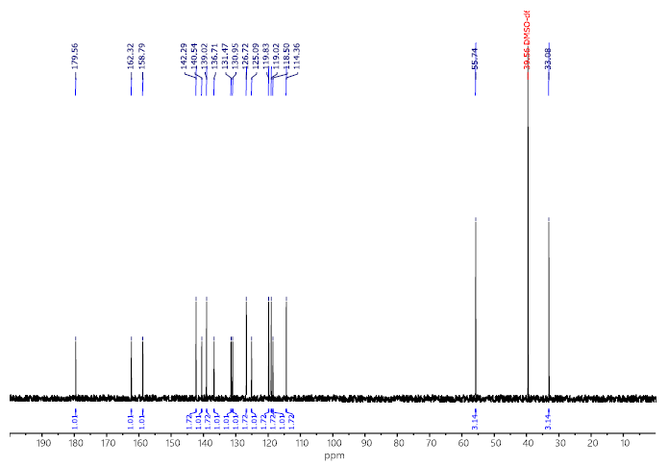
HRMS of N-(5-chloropyridin-3-yl)-7-methoxy-4-methyl-5-oxo-4,5-dihydro-[1,2,3]triazolo[1,5-a]quinazoline-3-carbothioamide (8c)
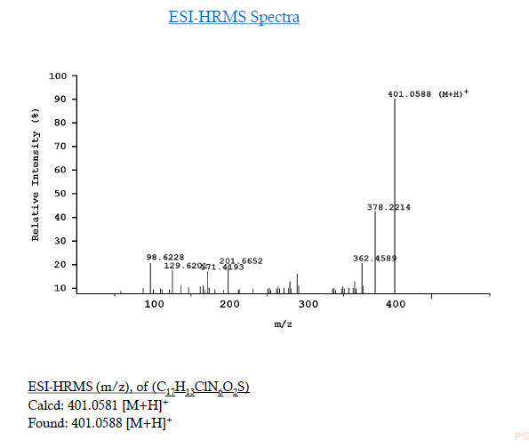

¹H NMR N-(4-bromopyridin-3-yl)-7-methoxy-4-methyl-5-oxo-4,5-dihydro-[1,2,3]triazolo[1,5-a]quinazoline-3-carbothioamide (8d)

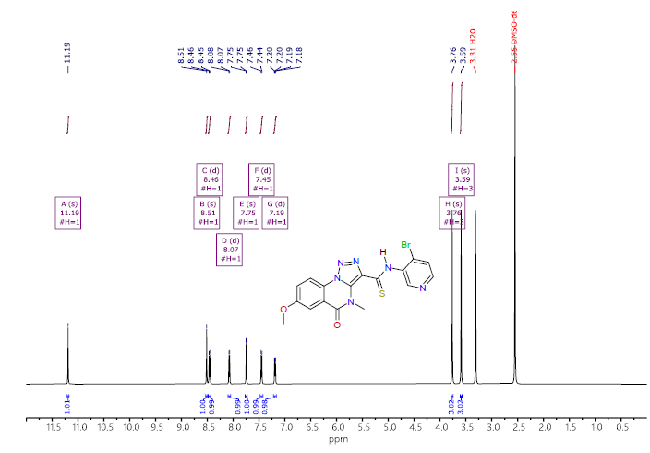

¹³C NMR N-(4-bromopyridin-3-yl)-7-methoxy-4-methyl-5-oxo-4,5-dihydro-[1,2,3]triazolo[1,5-a]quinazoline-3-carbothioamide (8d)

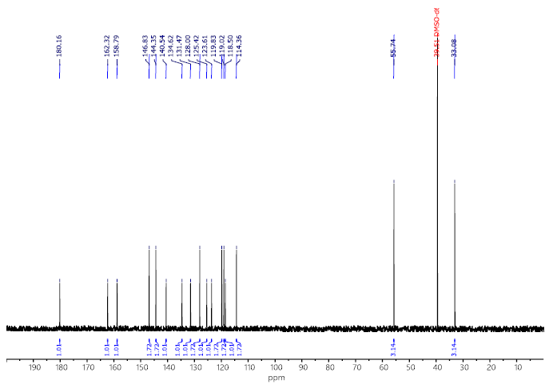

HRMS N-(4-bromopyridin-3-yl)-7-methoxy-4-methyl-5-oxo-4,5-dihydro-[1,2,3]triazolo[1,5-a]quinazoline-3-carbothioamide (8d)

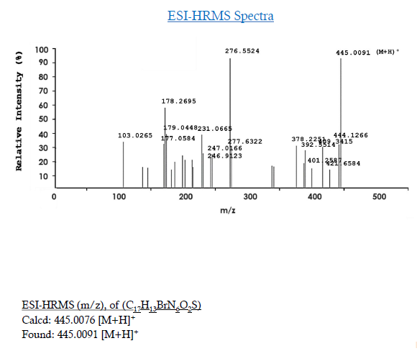

¹H NMR N-(6-acetylpyridin-3-yl)-4-methyl-5-oxo-7-(trifluoromethyl)-4,5-dihydro-[1,2,3]triazolo[1,5-a]quinazoline-3-carbothioamide (8e)

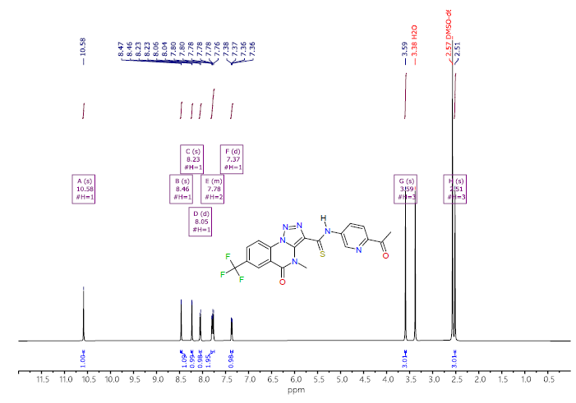

¹³C NMR N-(6-acetylpyridin-3-yl)-4-methyl-5-oxo-7-(trifluoromethyl)-4,5-dihydro-[1,2,3]triazolo[1,5-a]quinazoline-3-carbothioamide (8e)

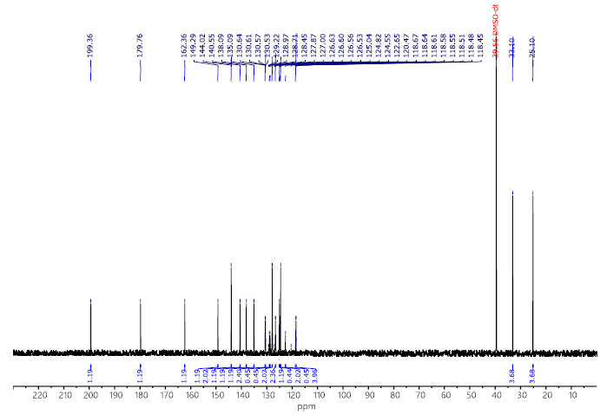

HRMS N-(6-acetylpyridin-3-yl)-4-methyl-5-oxo-7-(trifluoromethyl)-4,5-dihydro-[1,2,3]triazolo[1,5-a]quinazoline-3-carbothioamide (8e)

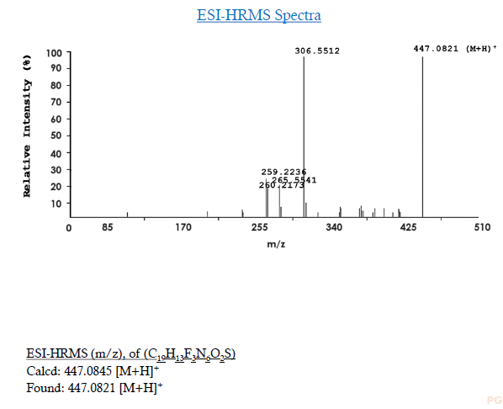

¹H NMR of 7-(dimethylglycyl)-4-methyl-5-oxo-N-(5-(trifluoromethyl)pyridin-3-yl)-4,5-dihydro-[1,2,3]triazolo[1,5-a]quinazoline-3-carbothioamide (8f)
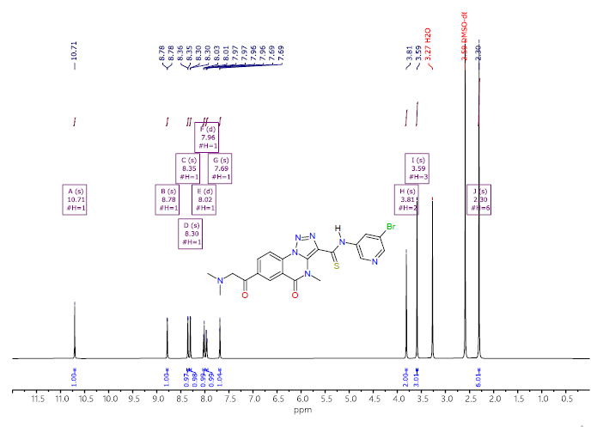

¹³C NMR 7-(dimethylglycyl)-4-methyl-5-oxo-N-(5-(trifluoromethyl)pyridin-3-yl)-4,5-dihydro-[1,2,3]triazolo[1,5-a]quinazoline-3-carbothioamide (8f)
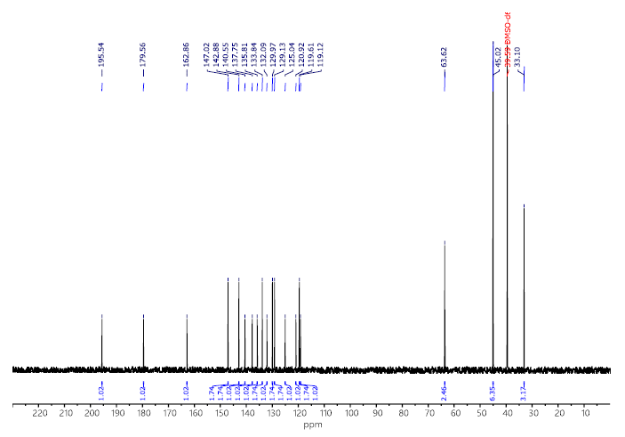

HRMS of 7-(dimethylglycyl)-4-methyl-5-oxo-N-(5-(trifluoromethyl)pyridin-3-yl)-4,5-dihydro-[1,2,3]triazolo[1,5-a]quinazoline-3-carbothioamide (8f)
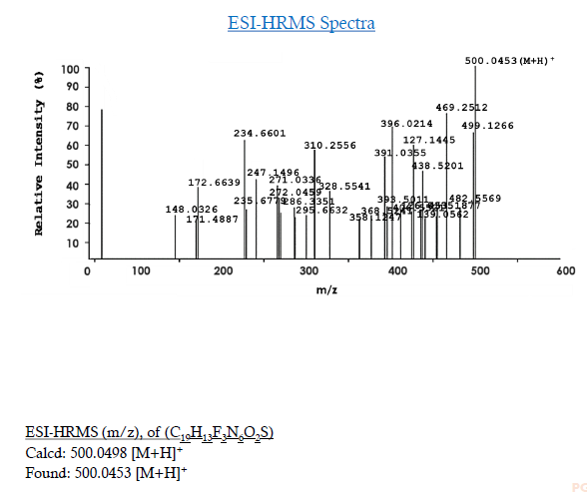

¹H NMR of 7-(dimethylglycyl)-4-methyl-N-(4-methylpyridin-3-yl)-5-oxo-4,5-dihydro-[1,2,3]triazolo[1,5-a]quinazoline-3-carbothioamide (8g)
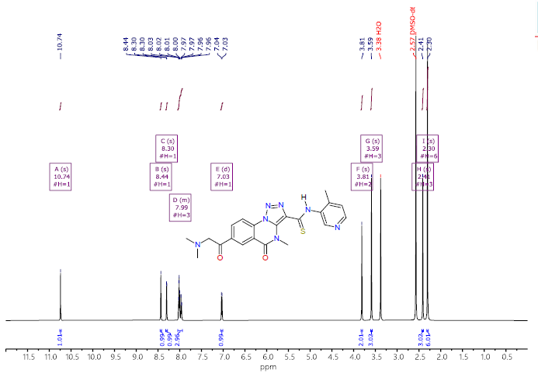

¹³C NMR of 7-(dimethylglycyl)-4-methyl-N-(4-methylpyridin-3-yl)-5-oxo-4,5-dihydro-[1,2,3]triazolo[1,5-a]quinazoline-3-carbothioamide (8g)
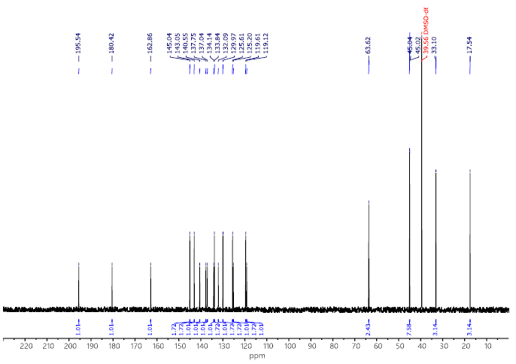

HRMS of 7-(dimethylglycyl)-4-methyl-N-(4-methylpyridin-3-yl)-5-oxo-4,5-dihydro-[1,2,3]triazolo[1,5-a]quinazoline-3-carbothioamide (8g)

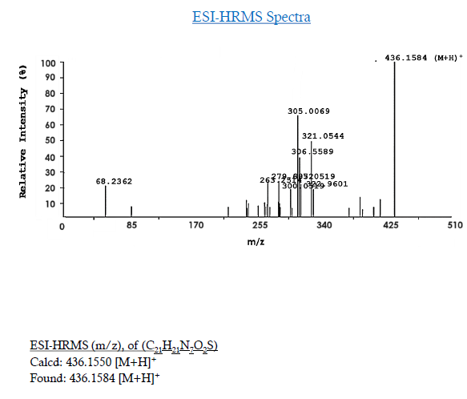

¹H NMR of 7-(dimethylglycyl)-4-methyl-5-oxo-N-(5-(trifluoromethyl)pyridin-3-yl)-4,5-dihydro-[1,2,3]triazolo[1,5-a]quinazoline-3-carbothioamide (8h)

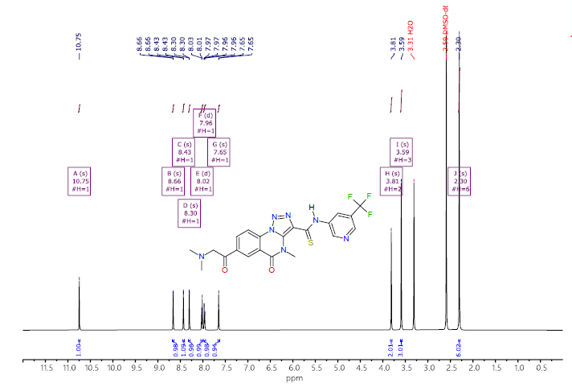

¹³C NMR of 7-(dimethylglycyl)-4-methyl-5-oxo-N-(5-(trifluoromethyl)pyridin-3-yl)-4,5-dihydro-[1,2,3]triazolo[1,5-a]quinazoline-3-carbothioamide (8h)
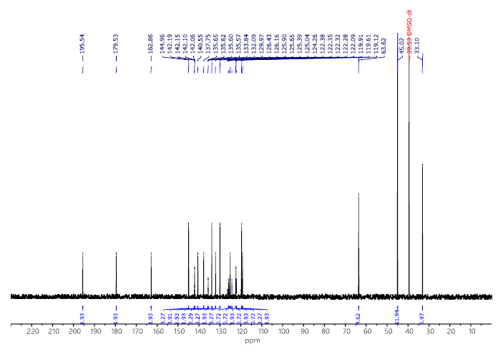

HRMS of 7-(dimethylglycyl)-4-methyl-5-oxo-N-(5-(trifluoromethyl)pyridin-3-yl)-4,5-dihydro-[1,2,3]triazolo[1,5-a]quinazoline-3-carbothioamide (8h)
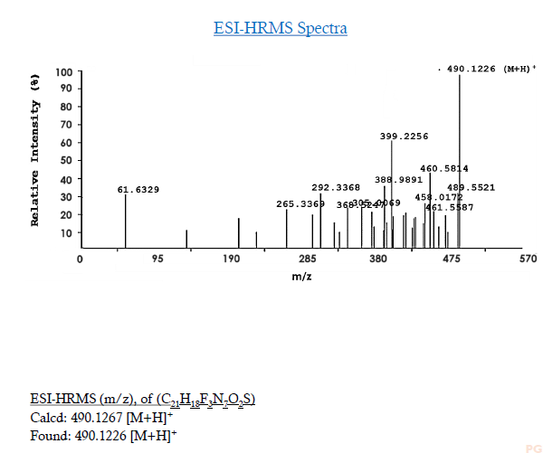

¹H NMR of N-(5-chloropyridin-3-yl)-7-(dimethylglycyl)-4-ethyl-5-oxo-4,5-dihydro-[1,2,3]triazolo[1,5-a]quinazoline-3-carbothioamide (8i)

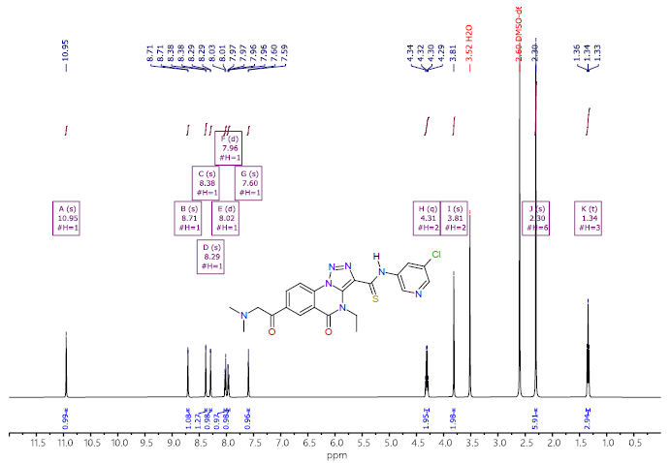

¹³C NMR of N-(5-chloropyridin-3-yl)-7-(dimethylglycyl)-4-ethyl-5-oxo-4,5-dihydro-[1,2,3]triazolo[1,5-a]quinazoline-3-carbothioamide (8i)
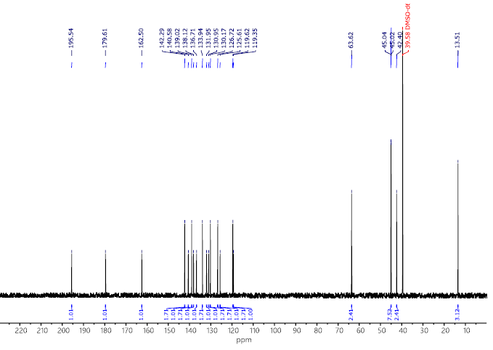

HRMS of N-(5-chloropyridin-3-yl)-7-(dimethylglycyl)-4-ethyl-5-oxo-4,5-dihydro-[1,2,3]triazolo[1,5-a]quinazoline-3-carbothioamide (8i)
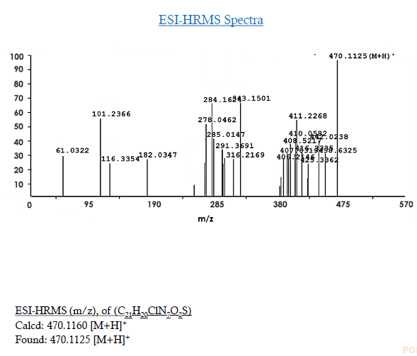

¹H NMR 7-(dimethylglycyl)-4-methyl-N-(4-methylpyridin-3-yl)-5-oxo-4,5-dihydro-[1,2,3]triazolo[1,5-a]quinazoline-3-carbothioamide (8j)

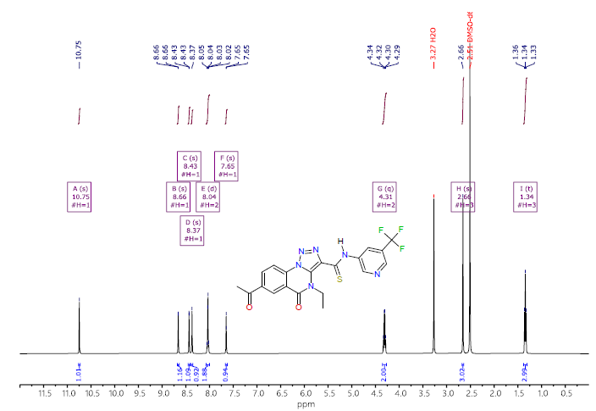

¹³C NMR 7-(dimethylglycyl)-4-methyl-N-(4-methylpyridin-3-yl)-5-oxo-4,5-dihydro-[1,2,3]triazolo[1,5-a]quinazoline-3-carbothioamide (8j)
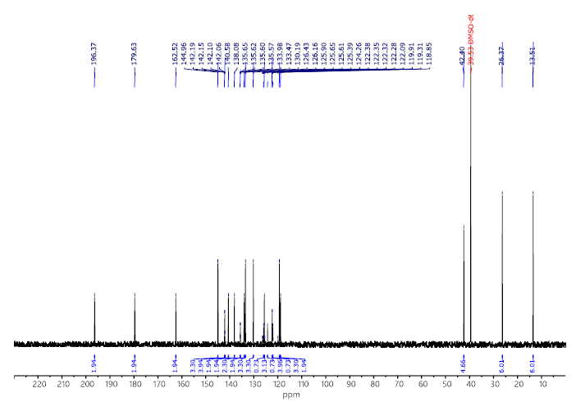

HRMS of 7-(dimethylglycyl)-4-methyl-N-(4-methylpyridin-3-yl)-5-oxo-4,5-dihydro-[1,2,3]triazolo[1,5-a]quinazoline-3-carbothioamide (8j)
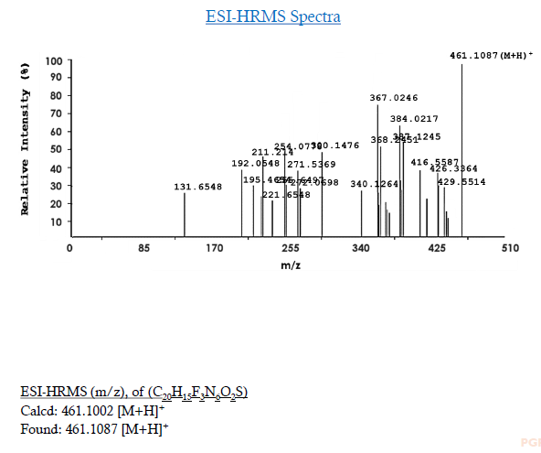

¹H NMR of 7-(dimethylglycyl)-4-methyl-N-(5-methylpyridin-3-yl)-5-oxo-4,5-dihydro-[1,2,3]triazolo[1,5-a]quinazoline-3-carbothioamide (8k)
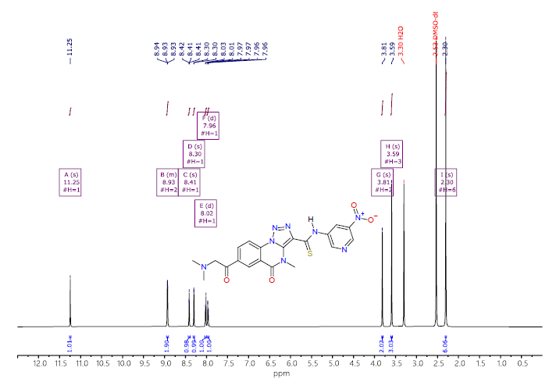

¹³C NMR of 7-(dimethylglycyl)-4-methyl-N-(5-methylpyridin-3-yl)-5-oxo-4,5-dihydro-[1,2,3]triazolo[1,5-a]quinazoline-3-carbothioamide (8k)
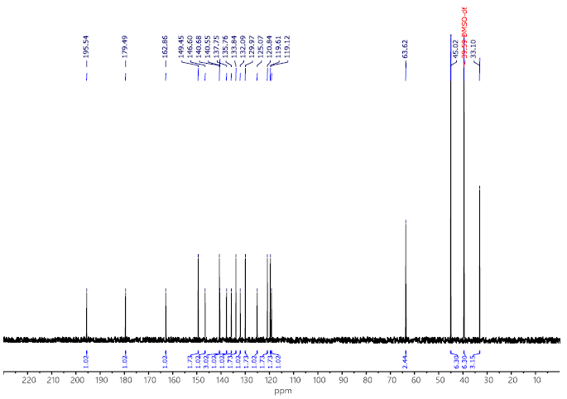

HRMS of 7-(dimethylglycyl)-4-methyl-N-(5-methylpyridin-3-yl)-5-oxo-4,5-dihydro-[1,2,3]triazolo[1,5-a]quinazoline-3-carbothioamide (8k)
