Supplementary Figure 1. The scatter plots of the effects of IVs on LTL against their effects on cancers.

Supplementary Figure 2. The funnel plots of the causal effect of LTL on cancers.

Supplementary Figure 3. Leave-one-out analysis of the causal effect of LTL on cancers.

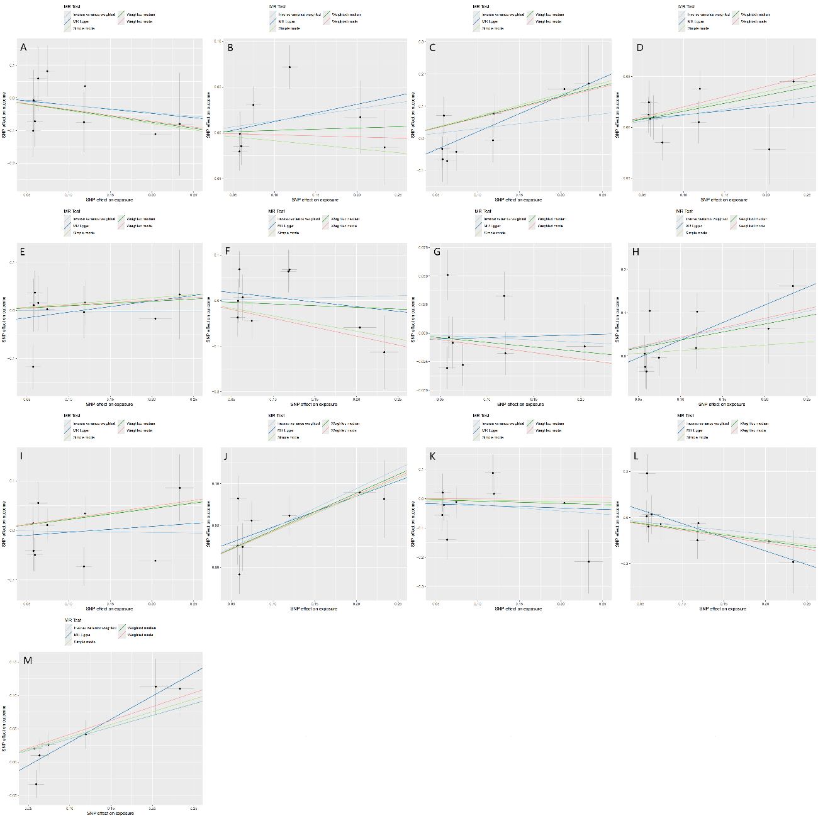
Figure S1. The scatter plots of the effects of IVs on LTL against their effects on cancers. The effect of LTL on biliary tract cancer(A), breast cancer(B), cervical cancer(C), colorectal cancer(D), endometrial cancer(E), esophageal cancer(F), gastric cancer(G), hematological malignancy(H), hepatocellular carcinoma(I), lung cancer(J), ovarian cancer(K), pancreatic cancer(L), prostate cancer(M). MR, Mendelian randomization; SNP, single-nucleotide polymorphisms.

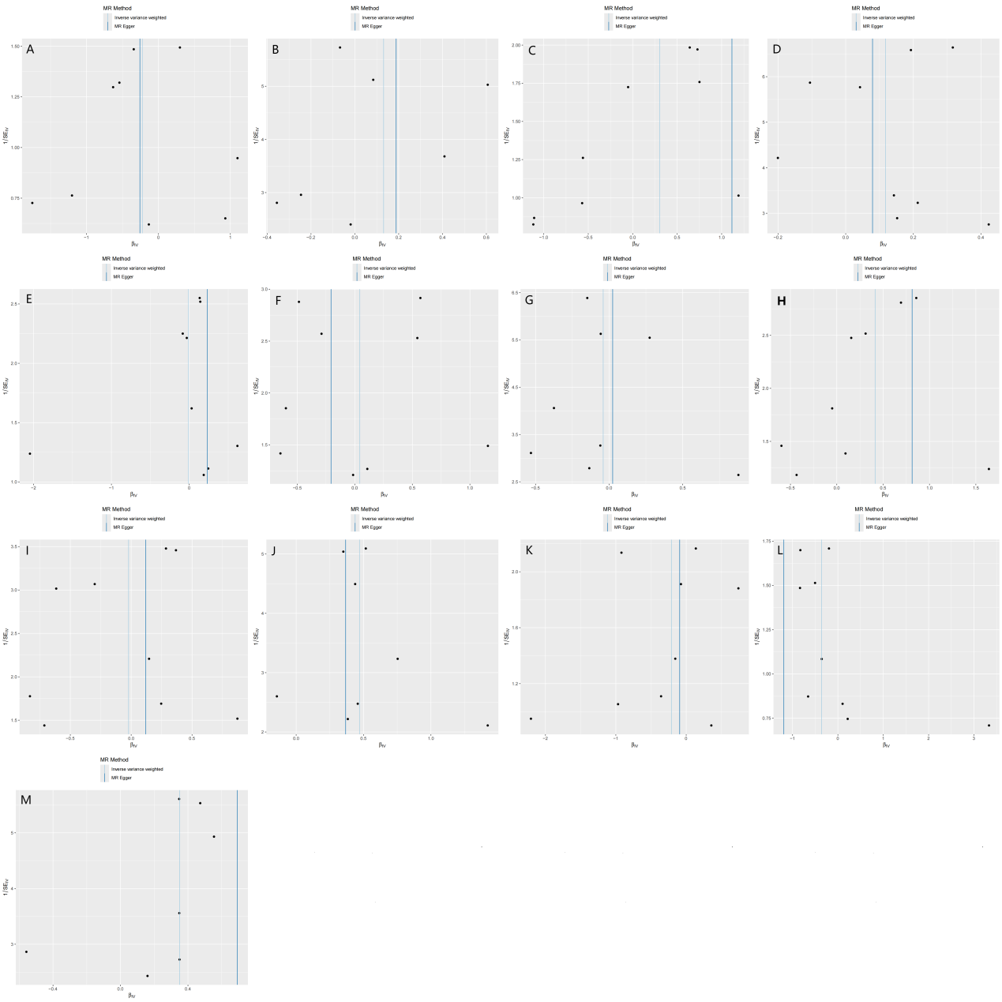Fig S2. The funnel plots of the causal effect of LTL on cancers. The effect of LTL on biliary tract cancer(A), breast cancer(B), cervical cancer(C), colorectal cancer(D), endometrial cancer(E), esophageal cancer(F), gastric cancer(G), hematological malignancy(H), hepatocellular carcinoma(I), lung cancer(J), ovarian cancer(K), pancreatic cancer(L), prostate cancer(M). MR: Mendelian randomization, βIV: Mendelian randomization estimates of LTL effect on cancers, SEIV: standard error of Mendelian randomization estimates

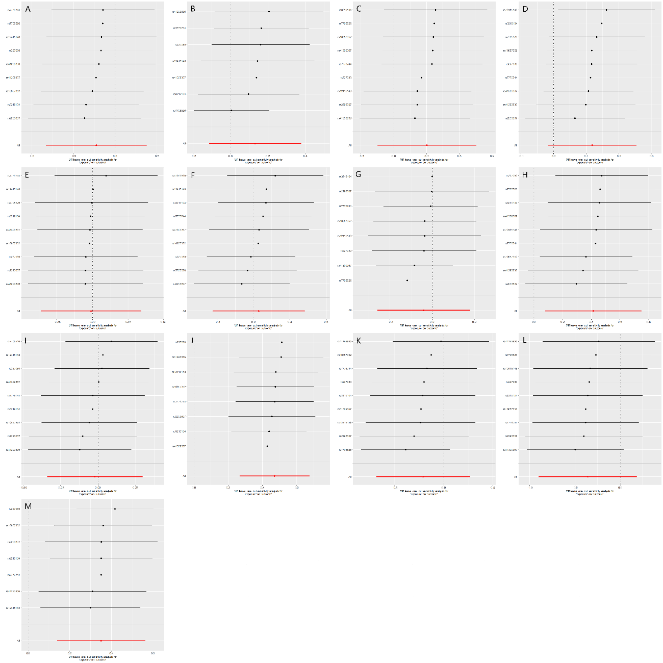
Figure S3. Leave-one-out analysis of the causal effect of LTL on cancers. The effect of LTL on biliary tract cancer(A), breast cancer(B), cervical cancer(C), colorectal cancer(D), endometrial cancer(E), esophageal cancer(F), gastric cancer(G), hematological malignancy(H), hepatocellular carcinoma(I), lung cancer(J), ovarian cancer(K), pancreatic cancer(L), prostate cancer(M). MR: Mendelian randomization.

