Enhancement of the catalytic activity of Pt nanoparticles toward methanol electro-oxidation using La-doped-Ta₂O₅/MWCNTs supporting materials
Bohua Wu*, Xicheng Lu, Fengxiao Du, Yifan Liu, Xiaoqin Wang & Shanxin Xiong
¹College of Chemistry and Chemical Engineering, Xi’an University of Science & Technology, Xi'an, 710054, PR China

Figure S.1. Particles size distribution of Pt/Ta₂O₅-La/MWCNTs
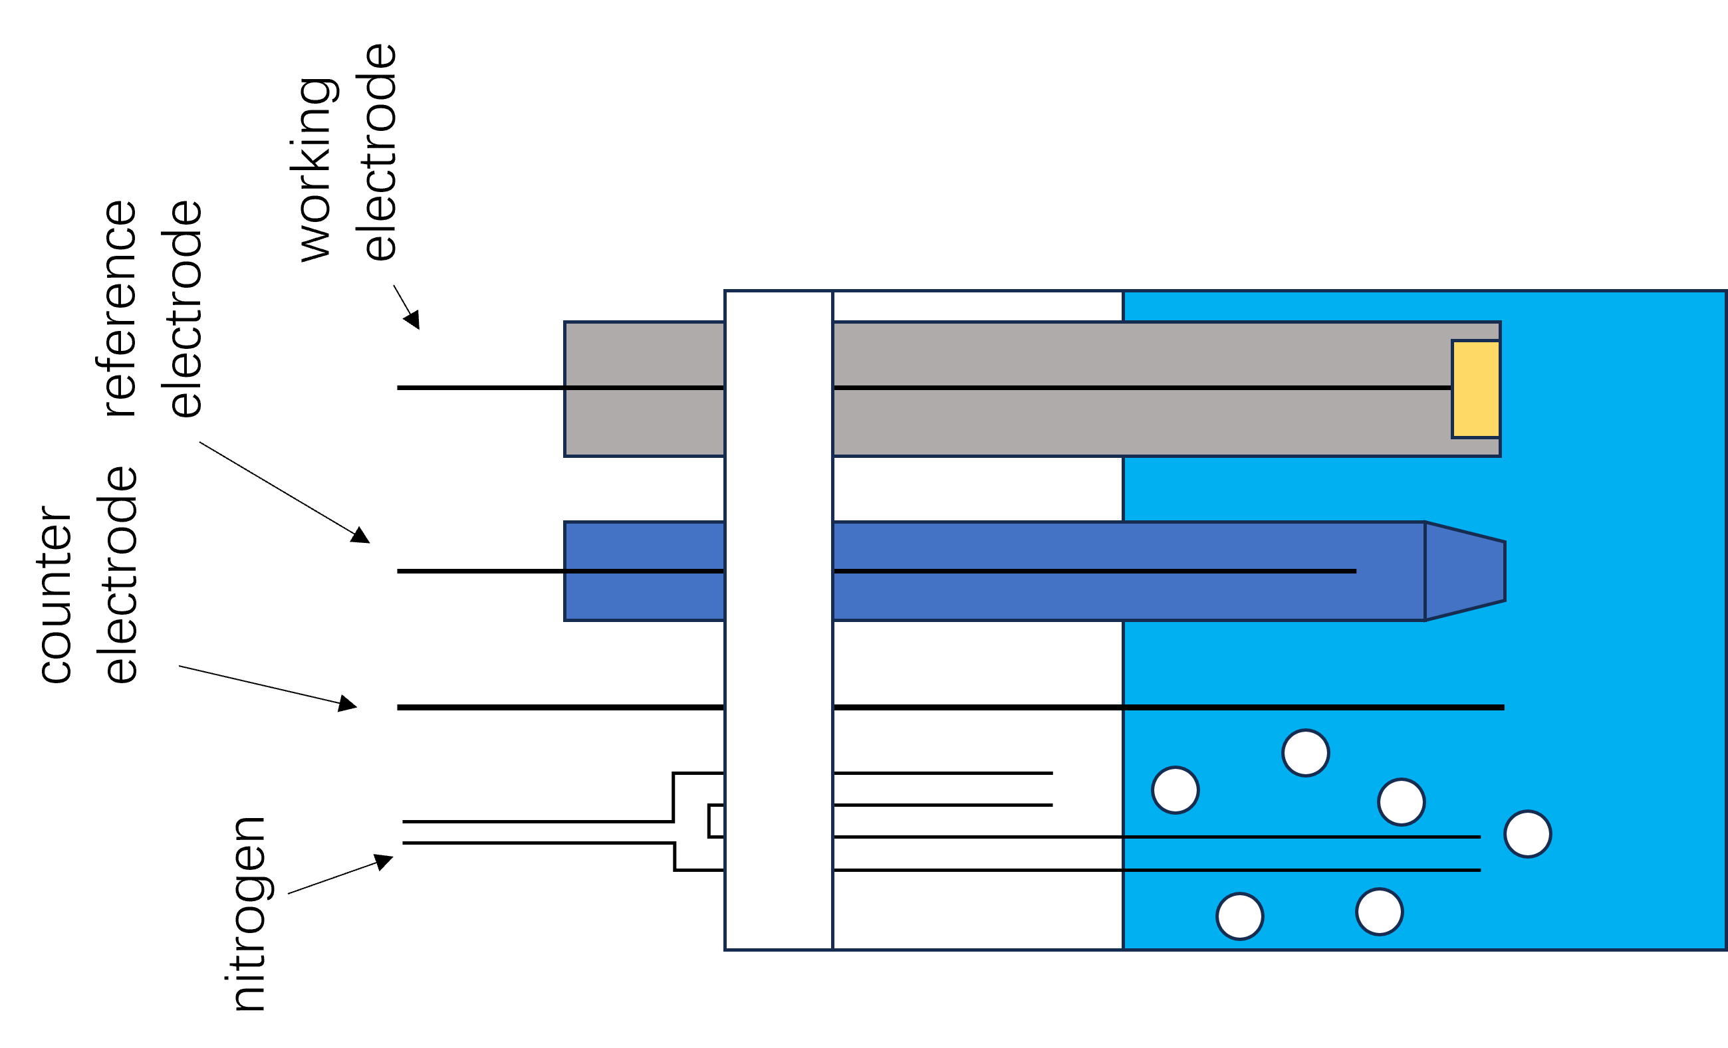
Figure S.2. Schematic diagram of the electrochemical test setup

Figure S3. CV curves(current per electrochemically active surface area of Pt) of Pt/Ta₂O₅-La/MWCNTs catalysts with 15%, 20%, 25%, and 30% La content and Pt/Ta₂O₅/MWCNTs in 0.5 M H₂SO₄ + 1 M CH₃OH solution at a scan rate of 50 mV s⁻¹.

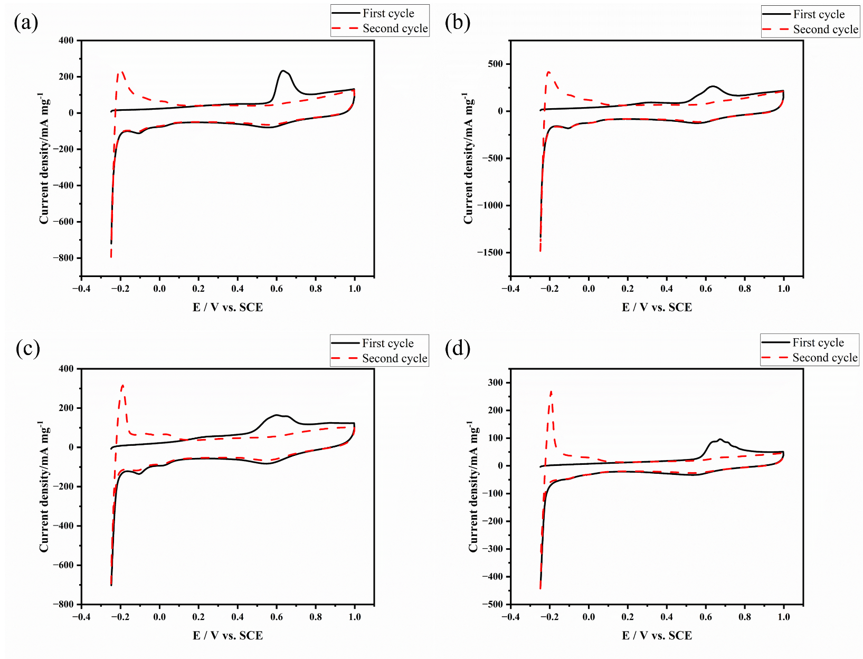
Figure S.4. CO-stripping curves of Pt/Ta₂O₅-La/MWCNTs catalysts with 15%, 20%, 25%, and 30% La content in 0.5 M H₂SO₄ at a scan rate of 50 mV s⁻¹ and under potential of -0.25V to 1V.

* Corresponding author. Tel. /Fax: +86-29-85583813, E-mail address: wubohua2005@126. com

