Genome-wide analysis of DnaJA proteins in Nicotiana tabacum reveals that NtDnaJA3 responses to drought stress
Qiao Wang^{1,2}, Lijun Meng², Zechao Qu², Huan Su^{1,2}, Jiemeng Tao^{1,2}, Peng Lu^{1,2}, Jianfeng Zhang^{1,2}, Peijian Cao^{1,2,3*}, Jingjing Jin^{1,2*}
¹Beijing Life Science Academy, Beijing 102200, China
²China Tobacco Gene Research Center, Zhengzhou Tobacco Research Institute of CNTC, Zhengzhou 450001, China
³School of Agricultural Sciences, Zhengzhou University, Zhengzhou 450001, China
*Correspondence: jinjingjing1218@126.com; peijiancao@163.com

Fig. S1 The number of DnaJA genes identified in tobacco based on conserved domains and homolog analysis.
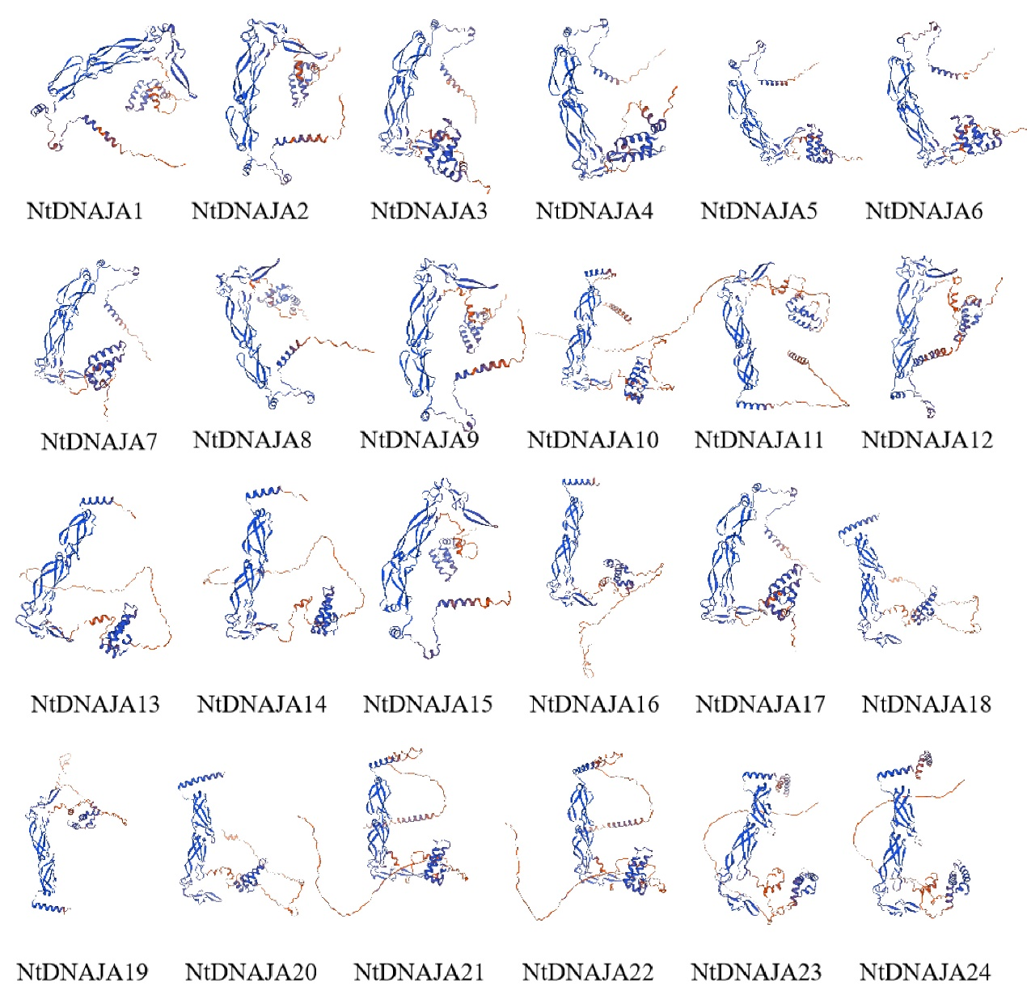
Fig. S2 The predicted three-dimensional structure of NtDnaJA genes.

Fig. S3 The chromosomal localization of NtDnaJA genes in tobacco.
Fig. S4 The number of miRNAs and transcription factors (TFs) predicted to target the NtDnaJA genes in tobacco.

