Supplementary Material

Supplementary Figure and Table lengends

Supplementary Figures
Supplementary Figure 1. Quality control and dimension reduction analysis of single-cell sequencing data. (A) Excluded cells that did not meet the criteria for quality control. (B) Correlation of sequencing depth and total intracellular sequence. (C) The principal component analysis for cell cycle. (D) Expression of marker genes that identify cell types.
Supplementary Figure 2. Clustering based on overlapping genes between DEGs of DSR clusters, WGCNA gene modules as well as DEGs obtained from scRNA-Seq analysis. (A) Overlapping genes (DPRGs) between DEGs and DSR clusters, WGCNA gene modules, and DEGs obtained from scRNA-Seq analysis. (B) KEGG enrichment analysis of DPRGs. (C) Consensus clustering of OS-related DPRGs. (D) Kaplan–Meier curves for LUAD patients in two DPRG clusters. (E–G) PCA, t-SNE, and UMAP analysis for the two clusters, respectively. (H) Differential expression levels of the nine DSRs in two DPRG clusters.

Supplementary Figure 3. Validation of the risk model. (A) Kaplan–Meier OS curves for LUAD patients in the low-risk and high-risk groups based on the risk signature in the indicated datasets. (B) ROC curves validate the prognostic capability of risk signature in the indicated datasets at 1, 3, and 5 years, respectively. (C) Differential gene expression in the risk signature between low-risk and high-risk groups in the indicated datasets. (D) Survival time and survival status of LUAD patients with various risk scores in the indicated datasets. (E–F) Correlation of the seven genes in risk signature with DSRs (E) and PPP related genes (F). (G–H) Risk score differences among DSR clusters (G) and DPRG clusters (H). *p < 0.05, and **p < 0.01.
Supplementary Figure 4. Associations of the risk signature with TIME and cytokine expression. (A) Correlation of the risk signature with infiltrating immune cell populations. (B) Differences in mRNA expression of cytokines and their receptors in low-risk and high-risk groups. *p < 0.05, **p < 0.01, and ***p < 0.001.
Supplementary Figure 5. Kaplan–Meier curves for LUAD patients based on risk score and immune checkpoint expression level.
Supplementary Figure 6. Drug sensitivity of the risk signature. (A) Sensitivity to commonly used drugs in low-risk and high-risk groups. (B) Screening for drugs that are more effective to the high-risk group.
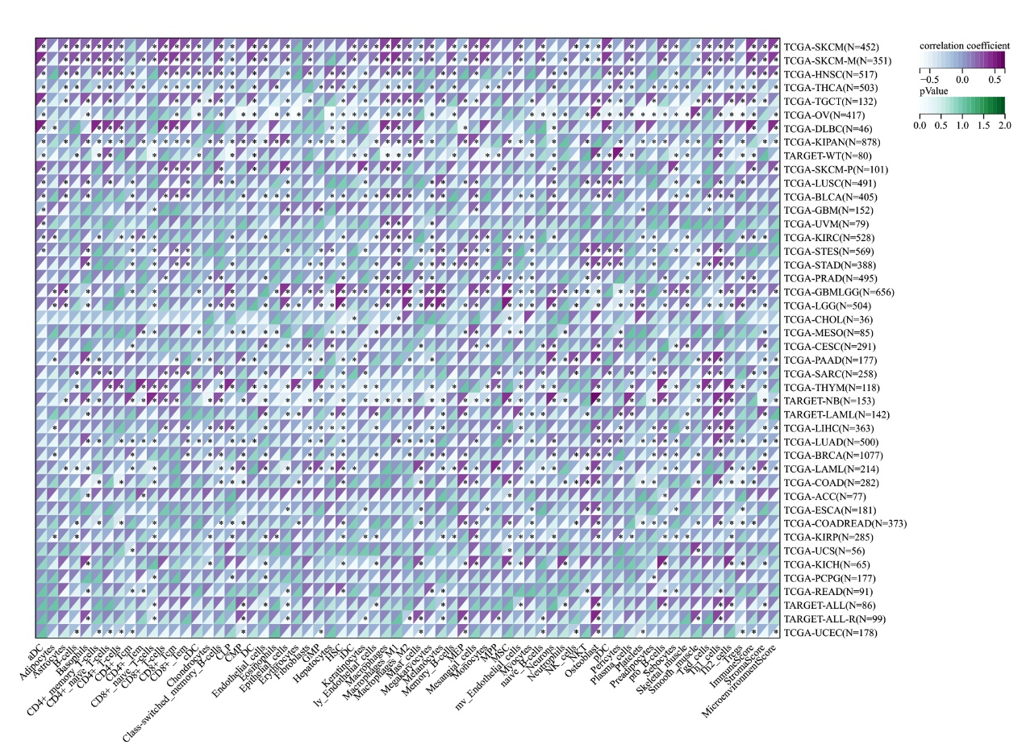
Supplementary Figure 7. Correlation of LRRC61 expression with immune cell populations in pan-cancer.
Supplementary Figure 8. Correlation of LRRC61 expression with immune checkpoint expression in pan-cancer.

1.2 Supplementary Tables
Supplementary Table 1. Oligonucleotides used in this study.
Supplementary Table 2. Different DSR clusters of patients with LUAD from the TCGA and GEO databases.
Supplementary Table 3. Genes related to pentose phosphate pathway.
Supplementary Table 4. Overall survival (OS)-related DPRGs.
Supplementary Table 5. The coefficients of the risk signature.

